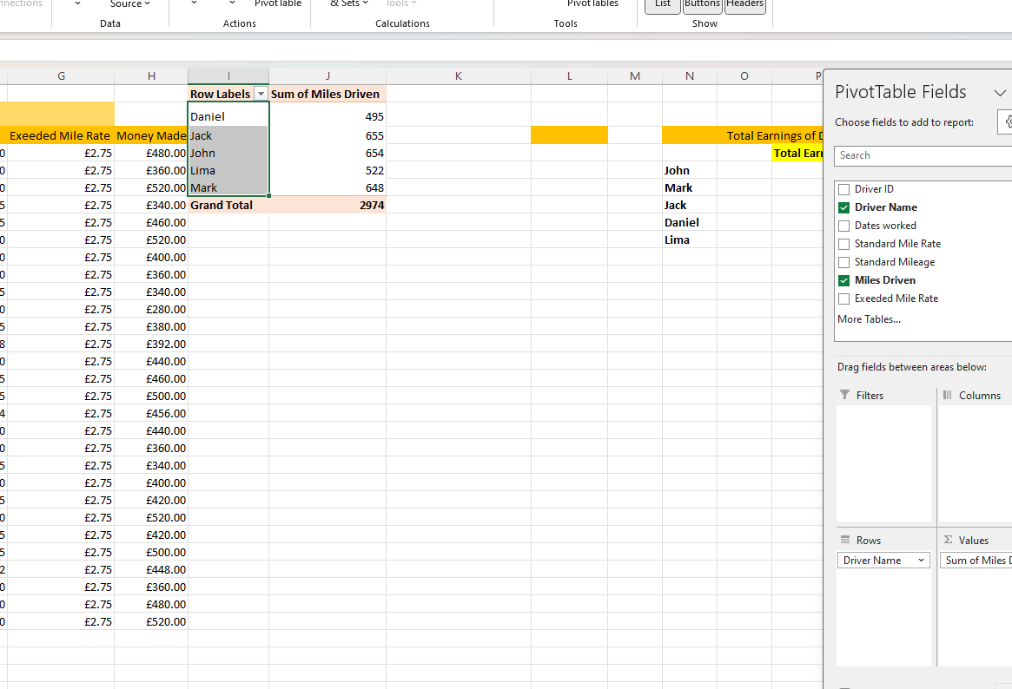
Lecturer: Dr Mobolanle Bello

University of Wales Trinity Saint David (UWTSD)
Institute of Inner City Learning (IICL)
Birmingham Campus Quay Place

Independent Project
ACCA6020_BIRM

3 July 2026
BSc Computing Skills for the Workplace

Krzysztof Waldemar Zakrzewski
Student ID: 2325092

Table of Contents
1.0 Introduction
1.1 Background 3
1.2 Problem Statement 3
1.3 Aim and Objectives 4
1.4 Scope and Limitations 4
2.0 Literature Review
2.1 Review of Existing Research 4
2.2 Rationale and Research Gap 5
3.0 Methodology
3.1 System Development Approach 5
3.2 Tools and Technologies 6
3.3 Requirements Analysis 6
3.4 System Architecture 6
3.5 Data Collection Method 7
4.0 Expected Outcomes and Impacts 7
5.0 Project Timeline 8
References 9

- Introduction
Development of an AI-Powered Browser Extension for Real-Time Spam and Phishing Detection Using Machine Learning
1.1 Background

The increasing reliance on digital communication has significantly improved access to online services, but it has also contributed to a rapid growth in spam messages and phishing attacks. Cybercriminals increasingly exploit websites, emails, and online platforms to distribute malicious content that attempts to steal personal information, financial credentials, or install harmful software. Although modern web browsers incorporate security features such as phishing warnings and malicious website detection, many threats continue to evade traditional rule-based filtering systems by continually adapting their content and delivery methods.
Artificial Intelligence (AI) and Machine Learning (ML) have emerged as effective approaches for identifying malicious content because they learn patterns from historical data rather than relying solely on predefined rules. Unlike conventional filtering techniques, supervised machine learning models can recognize previously unseen spam by analyzing textual characteristics and classification patterns. This capability has led to growing interest in AI-driven cybersecurity applications capable of providing intelligent, real-time protection.
This project proposes the development of an AI-powered browser extension that will utilize a machine learning model developed in Python to detect spam and phishing-related content during web browsing. By combining browser technologies with Natural Language Processing (NLP) and supervised learning techniques, the proposed solution aims to provide users with an additional layer of intelligent protection while demonstrating the practical application of AI within modern web security.

1.2 Problem Statement
Existing spam detection systems are primarily integrated within email providers or enterprise security platforms and often rely on predefined filtering rules or signature-based detection. These approaches may struggle to identify newly emerging threats or provide consistent protection across different online environments. Consequently, there is a need for a lightweight browser-based solution capable of analysing online content dynamically using machine learning to improve the detection of spam and phishing attempts in real time [1].

1.3 Aim and Objectives
The aim of this project is to design and develop an AI-powered browser extension capable of detecting spam and phishing-related content using supervised machine learning techniques.
The project objectives are to investigate existing AI-based spam detection methods, develop and evaluate a machine learning classification model using a publicly available Kaggle dataset, integrate the trained model with a browser extension, and assess system performance using recognized evaluation metrics including accuracy, precision, recall, and F1-score.

1.4 Scope and Limitations
The project will develop a proof-of-concept browser extension designed to classify English-language text using publicly available datasets rather than live user data. The system will focus on demonstrating the integration of machine learning with browser technology and will not replace existing browser security mechanisms. Time constraints also limit the project to supervised machine learning techniques, although the proposed architecture will support future enhancements such as multilingual detection, cloud deployment, and advanced deep learning models [2].

2.0 Literature Review
This section reviews current research on Artificial Intelligence, machine learning, and Natural Language Processing for spam detection, identifies limitations in existing browser-based solutions, and establishes the research gap addressed by the proposed system.
2.1 Review of Existing Research
Artificial Intelligence (AI) has become an essential component of modern cybersecurity, particularly in detecting spam and phishing attacks. Traditional spam filters relied mainly on predefined rules, keyword matching, and blacklists, which were effective against known threats but struggled with newly developed attack techniques. As cybercriminals continuously modify message content and delivery strategies, researchers have increasingly adopted supervised machine learning methods capable of identifying complex patterns within large-scale textual datasets [3].
Several classification algorithms have shown strong performance in spam detection research. Multinomial Naïve Bayes remains widely used due to its efficiency and effectiveness in text classification tasks. Logistic Regression and Support Vector Machines (SVM) [4] have also achieved high accuracy by analyzing relationships between extracted textual features and message categories. Ensemble methods, including Random Forest and Extreme Gradient Boosting (XGBoost) [5], enhance prediction performance by combining multiple decision trees. Transformer-based models such as Bidirectional Encoder Representations from Transformers (BERT) provide advanced contextual language understanding; however, their high computational requirements make them less suitable for lightweight browser-based applications.
Natural Language Processing (NLP) is a key component of AI-driven spam detection, transforming unstructured text into numerical representations for machine learning models. Common preprocessing techniques include tokenization, stop-word removal, stemming, lemmatization, and feature extraction methods such as Bag of Words and Term Frequency–Inverse Document Frequency (TF-IDF). These approaches reduce data complexity while maintaining important linguistic patterns [6][7].
The quality and structure of training datasets significantly affect model performance. The SMS Spam Collection Dataset from Kaggle is one of the most used benchmarks, containing approximately 5,500 labelled SMS messages categorized as spam or legitimate. Other widely used datasets include the Enron Email Dataset and Spam Email Classification Dataset, which provide realistic email-based samples for Natural Language Processing research. These datasets support the evaluation and comparison of machine learning algorithms for effective spam classification.

2.2 Rationale and Research Gap
Although research demonstrates that machine learning improves spam detection accuracy, many existing solutions are integrated within email providers or enterprise security platforms rather than lightweight browser extensions. Additionally, recent studies increasingly focus on computationally intensive deep learning models that may be unsuitable for real-time deployment on consumer devices. Consequently, there is limited research into browser-based solutions that balance predictive accuracy with computational efficiency.
This project addresses this gap by developing a browser extension that combines Natural Language Processing with a supervised machine learning model developed in Python. The system will learn from labelled datasets rather than relying on predefined filtering rules to classify suspicious content in real time. By evaluating multiple classification algorithms, the project aims to identify the most suitable model for browser deployment while providing a scalable foundation for future enhancements, including multilingual spam detection, phishing website analysis, and cloud-based implementation.

3.0 Methodology
This section outlines the methodology adopted for the project, including the development approach, technologies, system requirements, architecture, and data collection process used to design and evaluate the proposed AI-powered browser extension.
3.1 System Development Approach
The project will adopt the Agile software development methodology because it provides the flexibility required for machine learning applications. Unlike traditional software development, AI models require continuous experimentation, evaluation, and refinement to achieve acceptable performance. An iterative approach is therefore more appropriate than Waterfall, allowing improvements throughout the development process.
Development will progress through requirements analysis, dataset selection, data preprocessing, machine learning model development, browser extension implementation, integration, and testing. Each stage will be evaluated before progressing, enabling continuous refinement of both the AI model and browser extension while reducing development risks and ensuring the project meets its objectives.

3.2 Tools and Technologies
Python will be the primary programming language due to its extensive machine learning and Natural Language Processing capabilities. Pandas and Scikit-learn will support data preprocessing, model development, and evaluation, while NLTK will perform tokenization, stop-word removal, stemming, and TF-IDF feature extraction. The browser extension will be developed using HTML, CSS, and JavaScript for compatibility with Chromium-based browsers. A lightweight Flask API will enable communication between the extension and the trained machine learning model, creating a modular architecture that allows the classifier to be updated independently without requiring changes to the browser extension [8][9].

3.3 Requirements Analysis
The primary functional requirement is to analyze textual content extracted from webpages and classify it as either legitimate or spam. Following analysis, the browser extension will present users with an immediate prediction while maintaining compatibility with future machine learning models through a flexible architecture. Non-functional requirements include high classification accuracy, low response times, and reliable performance to minimize disruption to the browsing experience. Security and privacy are also essential considerations. Therefore, the project will use publicly available Kaggle datasets rather than personal user data, ensuring ethical research practices while reducing privacy risks and supporting compliance with relevant data protection principles.

3.4 System Architecture
The proposed architecture consists of four integrated components that operate together to provide real-time spam detection. Initially, the browser extension captures textual content from the webpage currently being viewed. The extracted information is transmitted securely to a Python-based classification service through an Application Programming Interface (API). Before prediction, the incoming text undergoes the same preprocessing procedures applied during model training, including text cleaning, tokenization, and TF-IDF feature extraction [10].
The processed data is then analyzed using the trained machine learning model, which generates a prediction indicating whether the content is likely to be legitimate or spam. The prediction is returned to the browser extension, where the result is displayed through a simple visual notification. Separating the browser interface from the machine learning model improves scalability and maintainability while allowing the classifier to be retrained using updated datasets without modifying the browser extension itself.

3.5 Data Collection Method
The machine learning model will be trained using publicly available datasets obtained from Kaggle. Following an evaluation of several widely recognized datasets, the SMS Spam Collection Dataset has been selected as the primary training dataset because of its balanced structure, high-quality labelling, and widespread use within academic research. Containing approximately 5,500 labelled text messages, the dataset provides an appropriate foundation for developing supervised classification models while enabling direct comparison with existing studies [11][12].
Prior to training, the dataset will undergo preprocessing to remove unnecessary symbols, standardize text formatting, eliminate stop words, and convert textual information into numerical features using TF-IDF. The processed dataset will then be divided into training and testing subsets to enable objective model evaluation. Performance will be assessed using accuracy, precision, recall, F1-score, and confusion matrix analysis, ensuring that the selected classifier demonstrates both reliability and suitability for real-time browser integration.

4.0 Expected Outcomes and Impact
The primary outcome of this project will be a proof-of-concept browser extension capable of detecting spam and phishing-related content using a supervised machine learning model developed in Python. The system will demonstrate the integration of Artificial Intelligence, Natural Language Processing, and browser technologies to provide users with real-time threat detection.
The project will evaluate several supervised machine learning algorithms to identify the most suitable model for browser deployment using recognized evaluation metrics such as accuracy, precision, recall, and F1-score. In addition to the software implementation, the project will produce system documentation, architectural designs, and model evaluation results.
The proposed solution demonstrates how Artificial Intelligence can strengthen browser security by complementing existing protection mechanisms. Its modular architecture also supports future enhancements, including multilingual text classification, phishing website detection, cloud deployment, and advanced deep learning models, providing a scalable foundation for future cybersecurity applications.

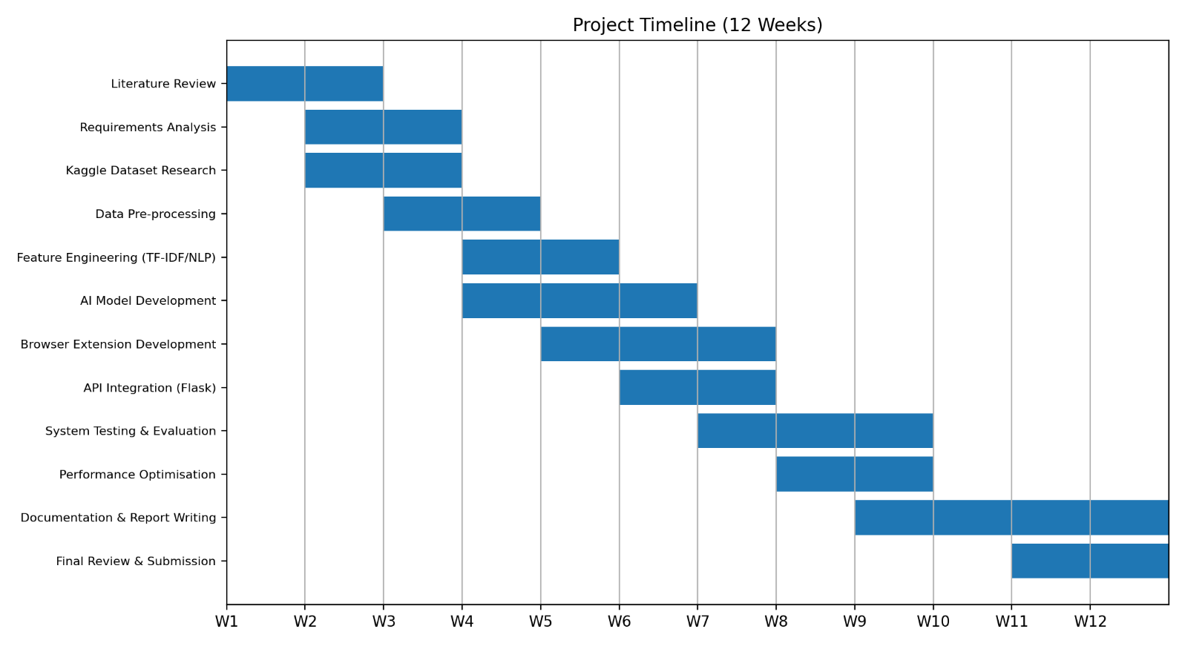
5.0 Project Timeline
Figure 1. Gant Chart, representing a Project Timeline and Progression.

References:
[1] Douzi, S., AlShahwan, F.A., Lemoudden, M. and El Ouahidi, B., 2020. Hybrid email spam detection model using artificial intelligence. International Journal of Machine Learning and Computing, 10(2), pp.316-322.
[2] Kontsewaya, Y., Antonov, E. and Artamonov, A., 2021. Evaluating the effectiveness of machine learning methods for spam detection. Procedia Computer Science, 190, pp.479-486.
[3] Rao, S., Verma, A.K. and Bhatia, T., 2021. A review on social spam detection: Challenges, open issues, and future directions. Expert Systems with Applications, 186, p.115742.
[4] Mammone, A., Turchi, M. and Cristianini, N., 2009. Support vector machines. Wiley Interdisciplinary Reviews: Computational Statistics, 1(3), pp.283-289.
[5] Chen, T., He, T., Benesty, M., Khotilovich, V., Tang, Y., Cho, H., Chen, K., Mitchell, R., Cano, I. and Zhou, T., 2015. Xgboost: extreme gradient boosting. R package version 0.4-2, 1(4), pp.1-4.
[6] Chowdhary, K., 2020. Natural language processing. Fundamentals of artificial intelligence, pp.603-649.
[7] Hirschberg, J. and Manning, C.D., 2015. Advances in natural language processing. Science, 349(6245), pp.261-266.
[8] Ramos, J., 2003, December. Using tf-idf to determine word relevance in document queries. In Proceedings of the first instructional conference on machine learning (Vol. 242, No. 1, pp. 29-48).
[9] Qaiser, S. and Ali, R., 2018. Text mining: use of TF-IDF to examine the relevance of words to documents. International journal of computer applications, 181(1), pp.25-29.
[10] Ofoeda, J., Boateng, R. and Effah, J., 2019. Application programming interface (API) research: A review of the past to inform the future. International Journal of Enterprise Information Systems (IJEIS), 15(3), pp.76-95.
[11] Almeida, T.A., Hidalgo, J.M.G. and Yamakami, A., 2011, September. Contributions to the study of SMS spam filtering: new collection and results. In Proceedings of the 11th ACM symposium on Document engineering (pp. 259-262).
[12] Delany, S.J., Buckley, M. and Greene, D., 2012. SMS spam filtering: Methods and data. Expert Systems with Applications, 39(10), pp.9899-9908.

