"Strategic Human Resource Management in the Public Sector: A Case Study of East Coast County"
Table of Contents
1. Introduction 4
2. Comparing Human Resources in the Public Sector with the Private Sector 5
3. Influence of Sector on the Effectiveness of HR Strategy 7
4. Training and Development of Staff to Achieve Strategic Objectives 9
5. Organizational Climate Factors Affecting Effectiveness of Human Resources Strategy 11
6. Conclusion 13
References 15

List of Figures
Figure 1. Agency Theory (Vaidya, 2022) 7
Figure 2. Institutional Theory (Khassawneh and Elrehail, 2022) 8
Figure 3. Resource Based View (Jurevicius, 2021) 9
Figure 4. Diagram illustrating how the four organisational climate factors (trust, fairness, sustainability, supportive environment) influence HR strategy effectiveness (Platania et al., 2022) 12

List of Tables
Table 1. Comparative Table showing differences in key HR practices between the public and private sector. 6
Table 2. Key resources relevant to ECC's situation and corresponding HR development strategies. 10

Introduction
According to Kramar (2014), Human Resource Management (HRM) plays an essential part in the process of formulating the business strategies of organizations, irrespective of whether such organizations are in the private or public sectors. It does this through improving the productivity and efficiency of the workforce, cultivating a happy work environment, and ensuring that individual performance is aligned with strategic objectives (Stone et al., 2020). This makes a significant contribution to the achievement of the organization's goals.
The case of East Coast County (ECC), a public sector organization that offers help to its client base on a wide variety of HR and organizational development projects, is investigated in this study. ECC has identified a shortage of strategic HR business partnering skills in the public sector as a significant concern that is harming its capacity to fill senior HR posts. This shortfall is negatively affecting ECC's ability to recruit qualified candidates. As a direct response to this issue, ECC has begun a journey to strengthen its talent pipeline, with the primary objective of filling these important HR jobs.
However, the success of this endeavor is contingent on having a comprehensive awareness of the differences in HRM practices that exist in the public sector and the private sector. We will go into the specifics of HR practices across these industries and the implications that they hold for ECC's HR strategy in this paper. We will place a special emphasis on the Agency Theory and the Resource-Based View (RBV) as theoretical frameworks for the purpose of better comprehending the dynamic relationship that exists between the sector, the strategy, and the personnel development.
In addition, the report will investigate the impact that the culture of the organization has on the success of HR strategies, with a particular focus on the importance of trust, justice, sustainability, and an atmosphere of encouragement. Last but not least, the paper will wrap up by offering some recommendations for the HR strategy that ECC should implement, combining the RBV principles with those of sustainability.

Comparing Human Resources in the Public Sector with the Private Sector
According to Berman et al. (2021), Human Resource Management (HRM) in the public and private sectors is distinct from one another in a number of ways because of the dissimilarities between their organizational goals, accountability mechanisms, operational processes, and legal frameworks.
Legal and regulatory requirements are the major force behind human resource management in the public sector, with equity, openness, and justice serving as the primary foci of attention. According to Van der Voet et al. (2017), these types of organizations often have a bureaucracy that is well organized and function within a political environment in which choices are impacted by public policy. For instance, human resources decisions in the public sector, such as those pertaining to hiring, salary, promotion, and layoffs, are subject to extensive regulation, which requires adherence to particular regulations and norms in order to guarantee fairness and equal opportunity.
According to Berman et al. (2021), human resource management in the private sector is distinguished by the presence of market-driven elements such as competition, innovation, and profitability. In most cases, there is a greater degree of latitude and independence in decision-making. Organizations in the private sector are more likely to use HR strategies such as pay based on performance, incentive programs, and flexible working arrangements.
For instance, a private technology business might use performance-based bonuses and flexible work schedules in order to entice potential employees and keep them on board. A public sector firm, such as a local government, on the other hand, would promote standardized compensation and fixed working hours to ensure fairness and compliance with rules.
The ways in which human resources (HR) are handled differently in the public and private sectors each have their own unique and important bearing on East Coast County's (ECC) approach to HR. Due to the fact that ECC is part of the public sector, the HR practices and tactics it employs need to be in line with the overarching goals of public policy, maintain a high level of transparency, and encourage justice. However, in order to address the identified skills shortage, ECC may need to adopt certain practices that are common in the private sector. These practices include increased performance recognition, enhanced professional development programs, and strategic talent management (Van der Voet et al., 2017). These practices are intended to attract and retain skilled HR partners.
Therefore, for ECC to be able to improve its strategic HR partnering competence, which will, in the end, contribute to the delivery of public services that are more efficient and effective, it is essential for the organization to comprehend these distinctions.
Table 1. Comparative Table showing differences in key HR practices between the public and private sector.
HR Practice | Public Sector | Private Sector
Recruitment | Recruitment often follows rigid processes due to rules and regulations (Bouckaert et al., 2021) | Recruitment can be more flexible, focused on fast hiring and onboarding (Berman et al., 2021)
Employee Benefits and Compensation | Typically provide stable pensions, health benefits, and job security (Rainey, 2014) | Greater variability in compensation, often with the potential for higher earnings and bonuses (Rainey, 2014)
Performance Management | Performance metrics are often less straightforward due to multiple stakeholders (Bouckaert et al., 2021) | Typically use clear, profit-driven performance metrics (Berman et al., 2021)
Employee Development | Training and development opportunities may be constrained by budget limitations (Bouckaert et al., 2021) | Often invest significantly in employee development programs (Berman et al., 2021)

Influence of Sector on the Effectiveness of HR Strategy
It is necessary to have a theoretical foundation in order to understand the effects of industry-specific dynamics on the efficiency of HR strategy. One such paradigm is the Agency Theory, which was initially proposed by Jensen and Meckling (1976). This theory investigates the interaction between 'principals' (such as shareholders or taxpayers) and 'agents' (such as managers or public workers), as well as how the divergent interests of these two groups might lead to agency difficulties.
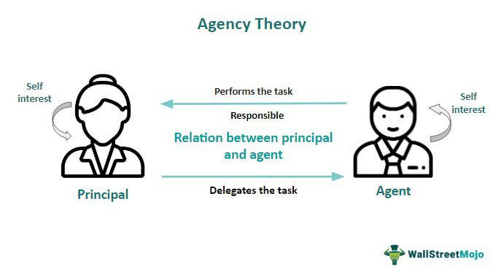
Figure 1. Agency Theory (Vaidya, 2022)
According to Eisenhardt (1989), in the public sector, principals and agents are frequently kept apart by multiple layers of bureaucracy, which results in a diffused sense of accountability. According to Rainey (2009), the complicated and varied set of goals in the public sector, in addition to budget limits and legislative oversight, could muddy the clarity of an HR strategy, which could potentially have an impact on the plan's overall success.
On the other hand, the Agency Theory posits that principals and agents have a more transparent connection in the private sector than in the public sector. According to Daily et al. (2003), more transparently profit-driven goals and incentives for agents might lead to more effective human resource strategies that concentrate on the recruitment, retention, and development of talented employees.
The Institutional Theory is another significant theory that highlights the significance of societal and regulatory frameworks in affecting organizational behavior (Scott, 2014). This theory was developed by James G. Scott and first published in 1974. According to Tolbert and Zucker (1996), organizations in the public sector, which are subject to a higher degree of regulatory inspection and public scrutiny, may have HR strategies that are significantly influenced by legal requirements and the expectations of society, which may limit the organizations' flexibility and adaptability.
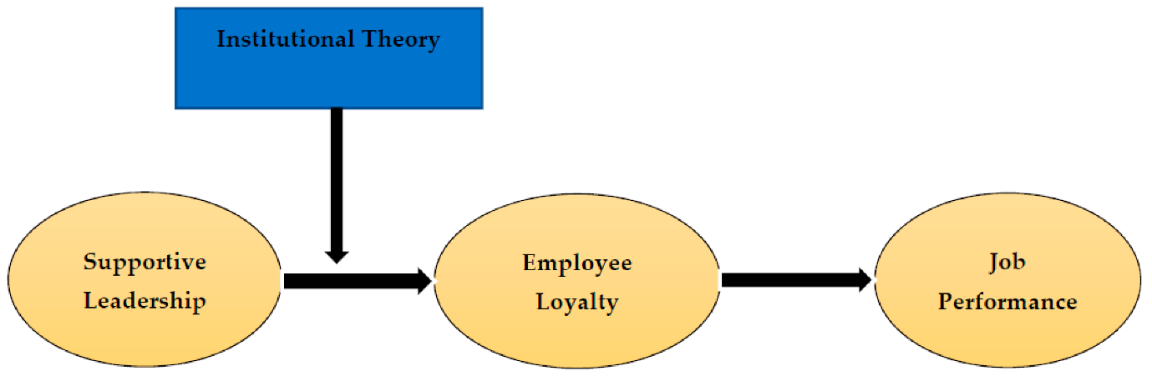
Figure 2. Institutional Theory (Khassawneh and Elrehail, 2022)
Although companies in the private sector are similarly influenced by institutional forces, they may have greater leeway to innovate and modify their HR strategies in response to shifting market conditions and increased competition (Powell & DiMaggio, 2012). This could result in an increase in the efficacy of the private sector's HR strategy.
When these theories are applied to the environment in which ECC operates, it becomes apparent that agency problems resulting from bureaucratic structures and the complicated goals of the public sector may have an impact on the efficiency of ECC's human resources strategy. The ECC's human resources strategy might also be influenced by institutional constraints for transparency, justice, and conformity to regulatory norms. However, if ECC were to acknowledge these limitations and include aspects of HR techniques used in the private sector, it would be able to improve the success of its HR strategy in terms of attracting, developing, and maintaining HR partners who have strategic business capabilities.

Training and Development of Staff to Achieve Strategic Objectives
The Resource-Based View (RBV), which was established by Barney (1991), is an essential standpoint for strategic human resource management. The RBV places an emphasis on the strategic role that distinctive resources and competencies play in the acquisition of a durable advantage in the market. People are the most important resources in the case of ECC, and they are the ones that can make a difference. The purpose of this section is to identify critical resources and describe how HR development might assist ECC in achieving its strategic goals.
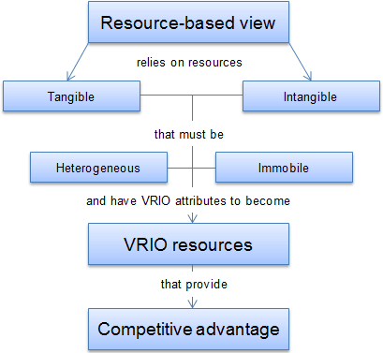
Figure 3. Resource Based View (Jurevicius, 2021)
Business Partnering Skills: The value of one's skills cannot be overstated in RBV. According to Barney et al. (2011), one of the deficiencies in the HR landscape of the ECC region is a lack of business partnership abilities among public sector employees. Therefore, HR development programs might include particular training modules aimed at developing these abilities among existing HR workers as well as potential HR candidates. These modules could also be included in HR recruitment programs.
Capabilities for Leadership: According to Carmeli et al. (2012), effective leaders are resources that are priceless. The ECC is now struggling with a lack of available leaders at the Head of HR level. The creation of a talent pipeline for these senior roles can be facilitated by leadership development programs that are geared toward mid-level HR professionals.
HR Experience: Experience in human resource management can be a valuable, one-of-a-kind resource that is difficult to replace (Hatch & Dyer, 2004). ECC may focus on keeping and developing experienced HR employees who have a solid awareness of the difficulties and opportunities presented by the public sector in terms of human resources.
Knowledge and Competence: According to Wright et al. (2001), HR personnel's knowledge and competence in HR laws, rules, and best practices can be considered a strategic resource. This might be fostered by ECC through the implementation of programs for continual professional development and initiatives for knowledge sharing.
Capability for Innovation: According to Volberda et al. (2013), innovation is essential for handling complicated HR issues like the one that ECC is currently dealing with. It is possible to assist in the development of this resource within the HR department by fostering an environment that is open to new ideas and offering occasions for creative problem-solving.
Table 2. Key resources relevant to ECC's situation and corresponding HR development strategies.
Key Resource | HR Development Strategy
Advanced HR competencies | Implement comprehensive training programs to develop advanced HR skills such as strategic planning and talent management.
Strategic capabilities | Encourage strategic thinking through leadership development programs and strategic HR workshops.
Organisational culture | Cultivate a supportive and inclusive culture through team-building activities and diversity training.
Employee motivation | Establish reward and recognition programs to increase employee motivation.
Leadership skills | Develop future leaders through leadership development programs and mentoring.

Using RBV as a guide, ECC's Human Resource Development might concentrate on improving these five resources. By aligning HR development programs with ECC's strategic aim of developing a robust talent pipeline for important HR jobs, this method addresses the identified skill shortfall and helps to meet ECC's strategic goal.

Organizational Climate Factors Affecting Effectiveness of Human Resources Strategy
According to Patterson et al. (2005), the term "organizational climate" is a notion that relates to the collective perceptions of an organization's policies, practices, and procedures that are implemented formally and informally by the company. This atmosphere has a substantial impact on the efficiency of the HR strategy in a number of ways, which will be discussed in more detail below.
Trust: Trust is an essential component of an efficient HR strategy as well as the atmosphere of an organization. Trust influences the readiness of employees to tolerate vulnerability based upon positive expectations of the conduct of others, as stated by Rousseau, Sitkin, Burt, and Camerer (1998). When employees have faith in their employer, they are more inclined to participate in activities that contribute to the achievement of corporate goals. Therefore, cultivating an environment of trust can assist ECC in attracting, retaining, and developing qualified human resource employees.
Fairness: According to Colquitt et al. (2001), fairness is defined as the perceived fairness of an organization's decision-making procedures and outcomes. Fairness is sometimes referred to as organizational justice. According to Li and Cropanzano (2009), when employees have the impression that they are being treated fairly, it has a favorable impact on their job satisfaction as well as their commitment and performance on the job, all of which are essential for the successful execution of HR strategy. Therefore, ECC ought to make certain that their HR policies are open to scrutiny, uniform, and fair for all employees.
Sustainability: According to Ehnert (2014), the term "sustainability" in the context of human resource management refers to methods that are beneficial not just to the firm but also to its employees, the environment, and society as a whole. ECC will be able to better fill its human resource openings with the assistance of a sustainable HRM strategy that can attract skilled professionals who are committed to corporate social responsibility.
Supportive Environment: According to Rhoades and Eisenberger (2002), an atmosphere that is supportive at work, which is defined by supportive management and good interpersonal interactions, can raise job satisfaction, reduce stress, and improve performance. In order for ECC to increase the efficiency of their HR strategy, they need to cultivate an environment like this.
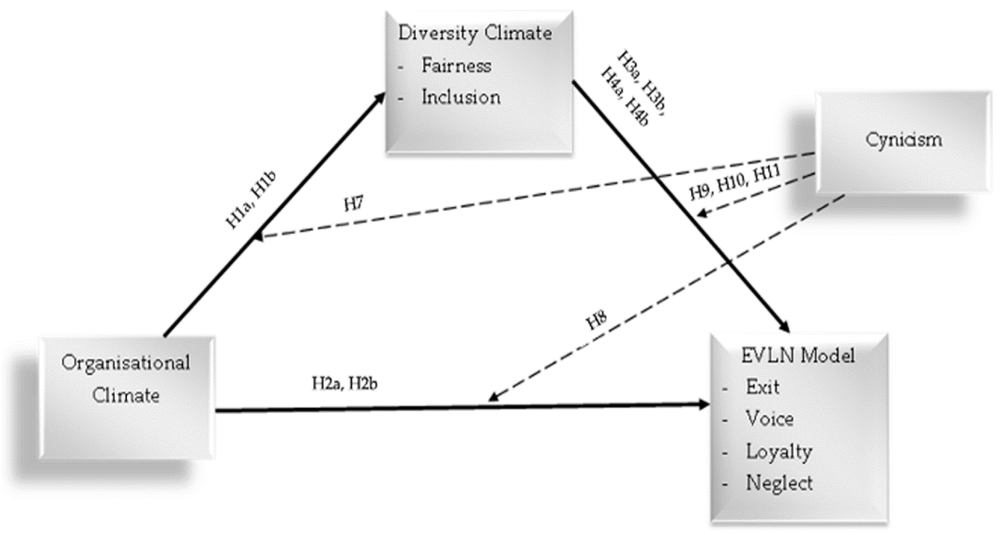
Figure 4. Diagram illustrating how the four organisational climate factors (trust, fairness, sustainability, supportive environment) influence HR strategy effectiveness (Platania et al., 2022)

Conclusion
This report has discussed the most important parts of HR strategy in the public sector, as well as the obstacles that ECC faces in addressing those aspects. It is abundantly obvious that human resources (HR) procedures in the public sector and the private sector are not the same, which calls for distinctive methods of strategy in each setting. A specific HR approach is necessary because of the one-of-a-kind circumstances that prevail in the public sector. These conditions are exemplified by the impact of political institutions, the limitations imposed by budgetary constraints, and the emphasis placed on protecting the public interest.
Using Agency Theory and Institutional Theory as a foundation, the paper also investigated the part that sector plays in determining how successfully HR strategy is implemented. The principal-agent dynamic that exists in the public sector, the pursuit of numerous goals, and the role that political actors play all contribute to the complexity that exists in HR strategy in the public sector. In order for ECC to ensure that its HR strategy is effective, it is vital for the company to establish a strategy that takes into consideration the intricacies involved.
The paper recommended taking a Resource-Based View (RBV) strategy in order to accomplish the strategic goals that were outlined. It was proposed that ECC might center its efforts on building important resources such as advanced human resource competences, strategic capabilities, organizational culture, employee motivation, and leadership skills. ECC would be in a better position to grow the talent essential for senior HR posts if it developed these resources and used them.
Additionally investigated was the impact that the culture of the organization had on the efficiency of the HR strategy. It has been determined that fostering an atmosphere that is favorable to the implementation of an efficient HR strategy requires the incorporation of factors such as trust, justice, sustainability, and a supportive environment.
Establishing a connection between the RBV and sustainable HRM practices offers ECC a compelling path forward. ECC is in a position to create a solid talent pipeline for senior HR roles if it places its attention on human resource (HR) resources that not only meet the immediate needs of the organization but also contribute to its long-term viability. This strategy is in line with contemporary perspectives on sustainable human resource management, which place an emphasis on the necessity of implementing methods that are beneficial to employees, the firm, and society as a whole.
Moving forward, ECC ought to give some thought to modifying its HR strategy in order to incorporate the ideas and insights presented in this research. If ECC does this, it will be in a good position to address the HR difficulties it currently faces and to establish an HR function that is stronger and more successful.

References
Barney, J., 1991. Firm resources and sustained competitive advantage. Journal of management, 17(1), pp.99-120.

Barney, J.B., Ketchen Jr, D.J. and Wright, M., 2011. The future of resource-based theory: revitalization or decline?. Journal of management, 37(5), pp.1299-1315.

Berman, E.M., Bowman, J.S., West, J.P. and Van Wart, M.R., 2021. Human resource management in public service: Paradoxes, processes, and problems. CQ Press.

Bouckaert, G., Peters, B.G. and Verhoest, K., 2022. Policy design for policy coordination. In Research Handbook of Policy Design (pp. 351-370). Edward Elgar Publishing.

Carmeli, A., Tishler, A. and Edmondson, A.C., 2012. CEO relational leadership and strategic decision quality in top management teams: The role of team trust and learning from failure. Strategic Organization, 10(1), pp.31-54.

Colquitt, J.A., Conlon, D.E., Wesson, M.J., Porter, C.O. and Ng, K.Y., 2001. Justice at the millennium: a meta-analytic review of 25 years of organizational justice research. Journal of applied psychology, 86(3), p.425.

Daily, C.M., Dalton, D.R. and Cannella Jr, A.A., 2003. Corporate governance: Decades of dialogue and data. Academy of management review, 28(3), pp.371-382.

Ehnert, I., 2014. Sustainability and Human Resource Management Developing Sustainable Business Organizations. Springer.

Eisenhardt, K.M., 1989. Agency theory: An assessment and review. Academy of management review, 14(1), pp.57-74.

Hatch, N.W. and Dyer, J.H., 2004. Human capital and learning as a source of sustainable competitive advantage. Strategic management journal, 25(12), pp.1155-1178.
Jensen, M.C. and Meckling, W.H., 1976. Theory of the firm: Managerial behavior, agency costs and ownership structure. Journal of financial economics, 3(4), pp.305-360.

Jurevicius, O. (2021). Resource-Based View. [online] Strategic Management Insight. Available at: https://strategicmanagementinsight.com/tools/resource-based-view/.

Khassawneh, O. and Elrehail, H. (2022). The Effect of Participative Leadership Style on Employees’ Performance: The Contingent Role of Institutional Theory. Administrative Sciences, [online] 12(4), p.195.

Kramar, R., 2014. Beyond strategic human resource management: is sustainable human resource management the next approach?. The international journal of human resource management, 25(8), pp.1069-1089.

Li, A. and Cropanzano, R., 2009. Fairness at the group level: Justice climate and intraunit justice climate. Journal of management, 35(3), pp.564-599.

Patterson, M.G., West, M.A., Shackleton, V.J., Dawson, J.F., Lawthom, R., Maitlis, S., Robinson, D.L. and Wallace, A.M., 2005. Validating the organizational climate measure: links to managerial practices, productivity and innovation. Journal of organizational behavior, 26(4), pp.379-408.

Platania, S., Morando, M. and Santisi, G. (2022). Organisational Climate, Diversity Climate and Job Dissatisfaction: A Multi-Group Analysis of High and Low Cynicism. Sustainability, 14(8), p.4458.

Powell, W.W. and DiMaggio, P.J. eds., 2012. The new institutionalism in organizational analysis. University of Chicago press.

Rainey, H.G., 2009. Understanding and managing public organizations. John Wiley & Sons.

Rhoades, L. and Eisenberger, R., 2002. Perceived organizational support: a review of the literature. Journal of applied psychology, 87(4), p.698.

Rousseau, D.M., Sitkin, S.B., Burt, R.S. and Camerer, C., 1998. Not so different after all: A cross-discipline view of trust. Academy of management review, 23(3), pp.393-404.

Scott, W.R., 2013. Institutions and organizations: Ideas, interests, and identities. Sage publications.

Stone, R.J., Cox, A. and Gavin, M., 2020. Human resource management. John Wiley & Sons.
Tolbert, P.S. and Zucker, L.G., 1996. The institutionalization of institutional theory. InS. Clegg, C. Hardy, &W. R. Nord (Eds.), Handbooko forganization studies (pp. 175–190).

Vaidya, D. (2022). Agency Theory. [online] WallStreetMojo. Available at: https://www.wallstreetmojo.com/agency-theory/.

Van der Voet, J., Steijn, B. and Kuipers, B.S., 2017. What’s in it for others? The relationship between prosocial motivation and commitment to change among youth care professionals. Public Management Review, 19(4), pp.443-462.

Volberda, H.W., Van Den Bosch, F.A. and Heij, C.V., 2013. Management innovation: Management as fertile ground for innovation. European Management Review, 10(1), pp.1-15.

Wright, P.M., Dunford, B.B. and Snell, S.A., 2001. Human resources and the resource based view of the firm. Journal of management, 27(6), pp.701-721.

