Family Life Cycle Theory Exercise Support
This exercise is designed to allow you to rehearse applying a model to examples from your experience. Your team’s answers are valid for your personal observations. If you were to develop these ideas and this concept for deeper analysis, you would be expected to research the origins and development of the theory and review what academic literature and real world applications have identified. This will allow a more objective and less subjective account. Your ideas are of interest but you must back them up with research or appeal for “support” from experts, who have already written on this topic.
Task
- Check out the Handout.

Think of products, services and processes that would be appropriate to the stage you have been allocated. Think transport, accommodation, food & drink, recreation & leisure, health and wellbeing, etc.
Wells & Gruber (1966) Family Life Cycle (FLC)
Bachelor Stage, Newly Married Couple, Full Nest 1, Full Nest 2, Full Nest 3, Empty Nest 1, Empty Nest 2, Solitary Survivor 1 and Solitary Survivor 2

- What media would you use to communicate with your stage of the lifecycle? Newspapers, TV, radio, Internet, word of mouth, viral campaigns, personal selling, telesales, etc.

- Can you think of an advertising strap line to summarise your stage?

“Live life to the full, tomorrow you die!” I wouldn’t use this, but which stage does it refer to?
- Review the common and different suggestions for different phases of the Life Cycle.

Discuss why this model is still useful or may now be redundant in the early C21st. Think of ways in which you might use the model to inform your debate in other modules
- For future reference I will upload resources for this topic on the Moodle site.

http://tutor2u.net/business/presentations/marketing/familylifecycle/default.html (Accessed 01-09-19)

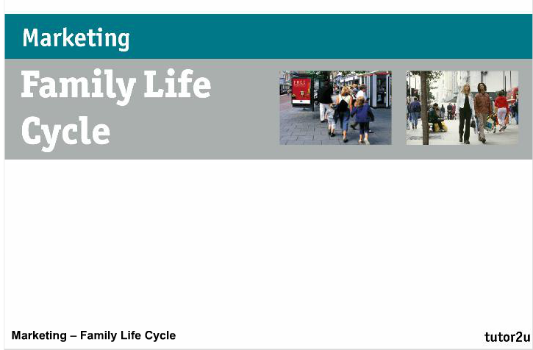
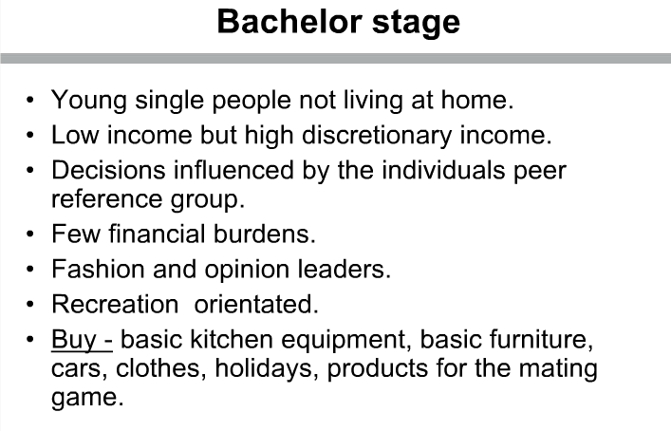
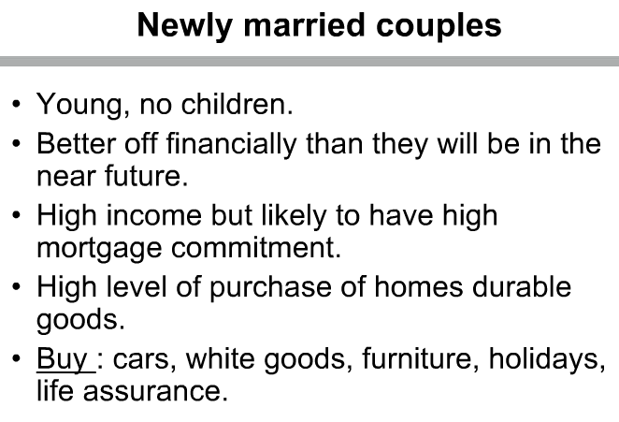

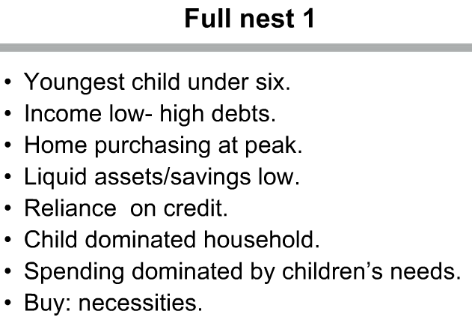
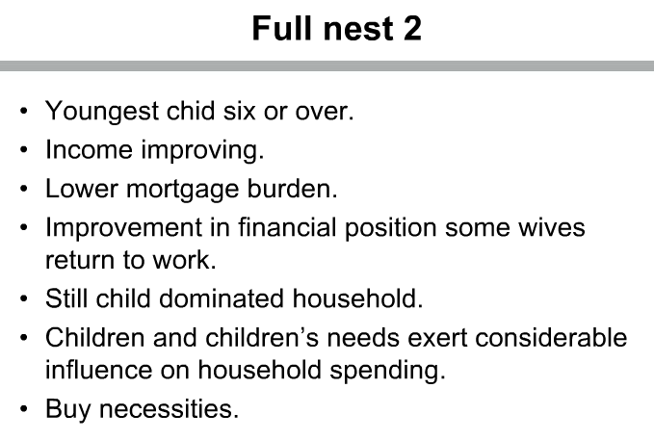
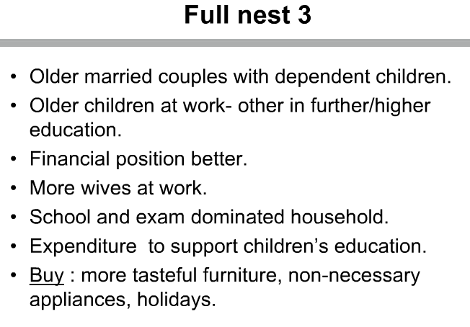
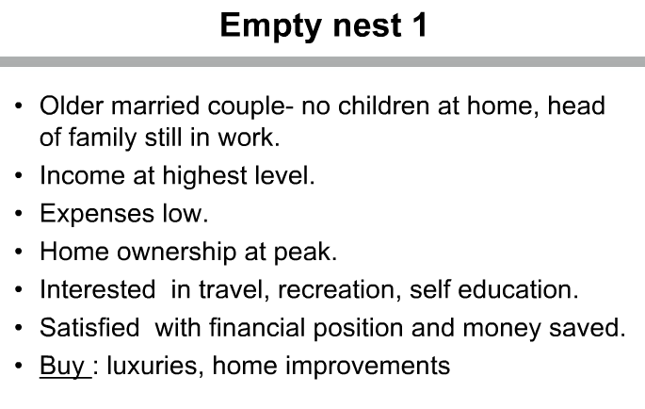
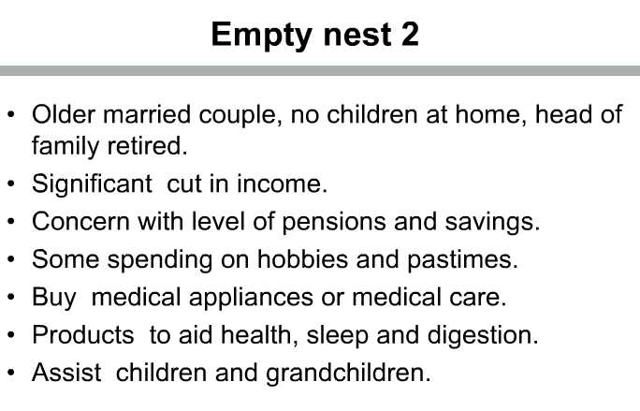
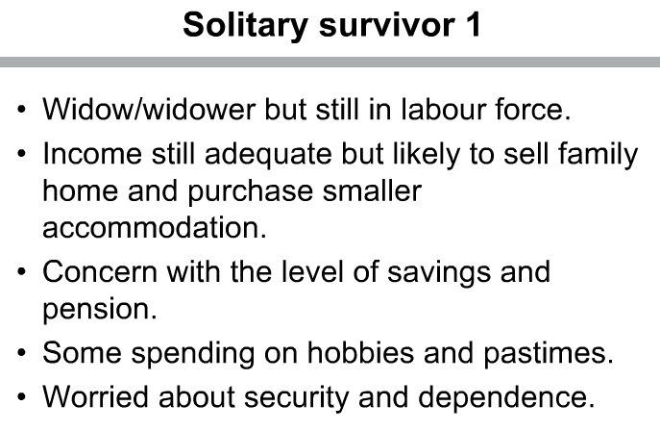
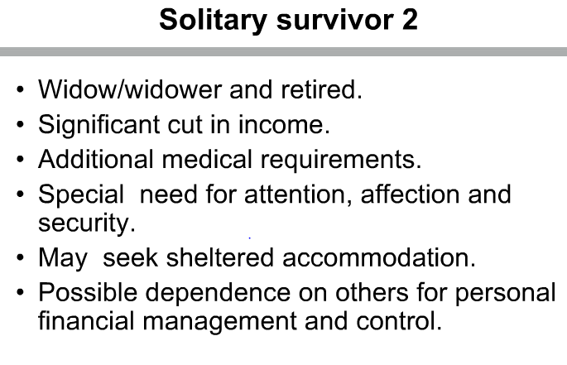

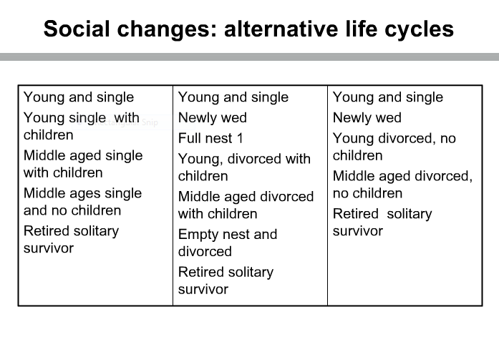
Typical applications of the Family Life Cycle (FLC) to various module assignment plans.
Economics
- Estimate the likely change in the various elasticities of demand for food, fashion wear and transport, at the Bachelor, Full Nest and Empty Nest stages of the FLC. Specify goods/services in the various categories in your discussion.
- Choose one category. Evaluate what a provider of this category (specify a product item) can do to impact on the demand and elasticity factors at the 3 FLC stages discussed in section a.
Marketing
- Choose a good or service. Analyse how the application of the marketing mix should change depending on which stage target consumers are at in the FLC.
- What social and political changes in the environment challenge the relevance of the original concept of the FLC as determined in 1966?
e-Business
- How does the FLC create problems for companies which want to use predominantly eBusiness models to manage their operations?
- Evaluate tactics which might be adopted to overcome the problems of the “digital divide” and “internet adoption laggards”.
Public Service Management
- For a public service of your choice, evaluate how the service responds to clients who are located at different stages of the FLC.
- Identify social trends which might influence the usefulness of the FLC and in the light of this critically evaluate plans for the reform of the service for future delivery
Strategy
- Choose a product supplied in a national economy. Evaluate the strategic environment, which impacts on the application of the FLC.
- Analyse a targeted campaign to launch a new product at a particular stage and target segment of the FLC. Note the campaign, resources used, implementation and audit of the campaign’s success.
HRM
- What challenges exist for a service provider in recruiting and training staff to deal with the changing needs of loyal customers over the FLC?
- What future recommendations would you make to organisations to respond with customer service practice training as the evolution of social and political factors force modification of the FLC?
Finance
- How does an application of the FLC impact on the financial services industry? Please evaluate the supply of and the demand for finance by referencing different stages of the FLC.
- How does the aging of westerns societies create challenges for the financial services industry and the need to develop new and modification of old products?
Research Methods
- Discuss the research conducted by Cornwall et al (2008) to update the FLC. Incorporate in your analysis at least one other source which seeks to update the original 1966 theory for the late 20th and 21st centuries.
- Cornwall at al (2008) use focus groups to evaluate the impact of dependency in the application of the FLC. Analyse the strengths and weaknesses of this method. Suggest an alternative methodology and series of research questions linked to the FLC that could be tested. Please incorporate references to the standard research paradigms in your analysis.
Please read and discuss in class sessions:
Cornwall, T.B., Wanwara-Mbugua, L.W. & Nicovich, S.G. (2008) Dependant Patterns in Consumer behaviour: exploration and refinement of a concept, Journal of Consumer Behavior, No 7, pp 51-71
Management of change
- Choose an industry that targets family consumers. Evaluate what factors have forced changes in organisational structure, product portfolios and communications to service consumers at different stages of the FLC.
- Evaluate how management of change theory identifies opportunities and threats to reform in adapting to the challenges of the FLC.
International Business
- The FLC was originally developed in the USA in the 1960s. Identify whether it is relevant to another culture you have studied.
- What other key influences on managing and developing relationships, satisfying consumers in your chosen culture, might be used as an alternative to the FLC?

Public Relations
- Choose a topic from the list of management ‘current and emerging issues’ (globalisation, ecology, sustainability, CSR, governance etc). Identify how PR theory advises communications about your chosen issue to consumers at various stages of the FLC, in order to help achieve corporate objectives in managing a brand.
- What ‘Plan B’ or alternative policy would you advise, given the strong challenge that the FLC as originally envisaged is redundant in a post modernist 21st century business environment?
Management Ethics
- How might the” ethical risk” vary in selling goods and services to consumers at different stages of the FLC?
- How might a company defend itself from criticisms that it is using a morally relativist approach in varying its CSR communications to different consumers at different stages , even incorporating different cultures as they impact on the reality of the FLC?
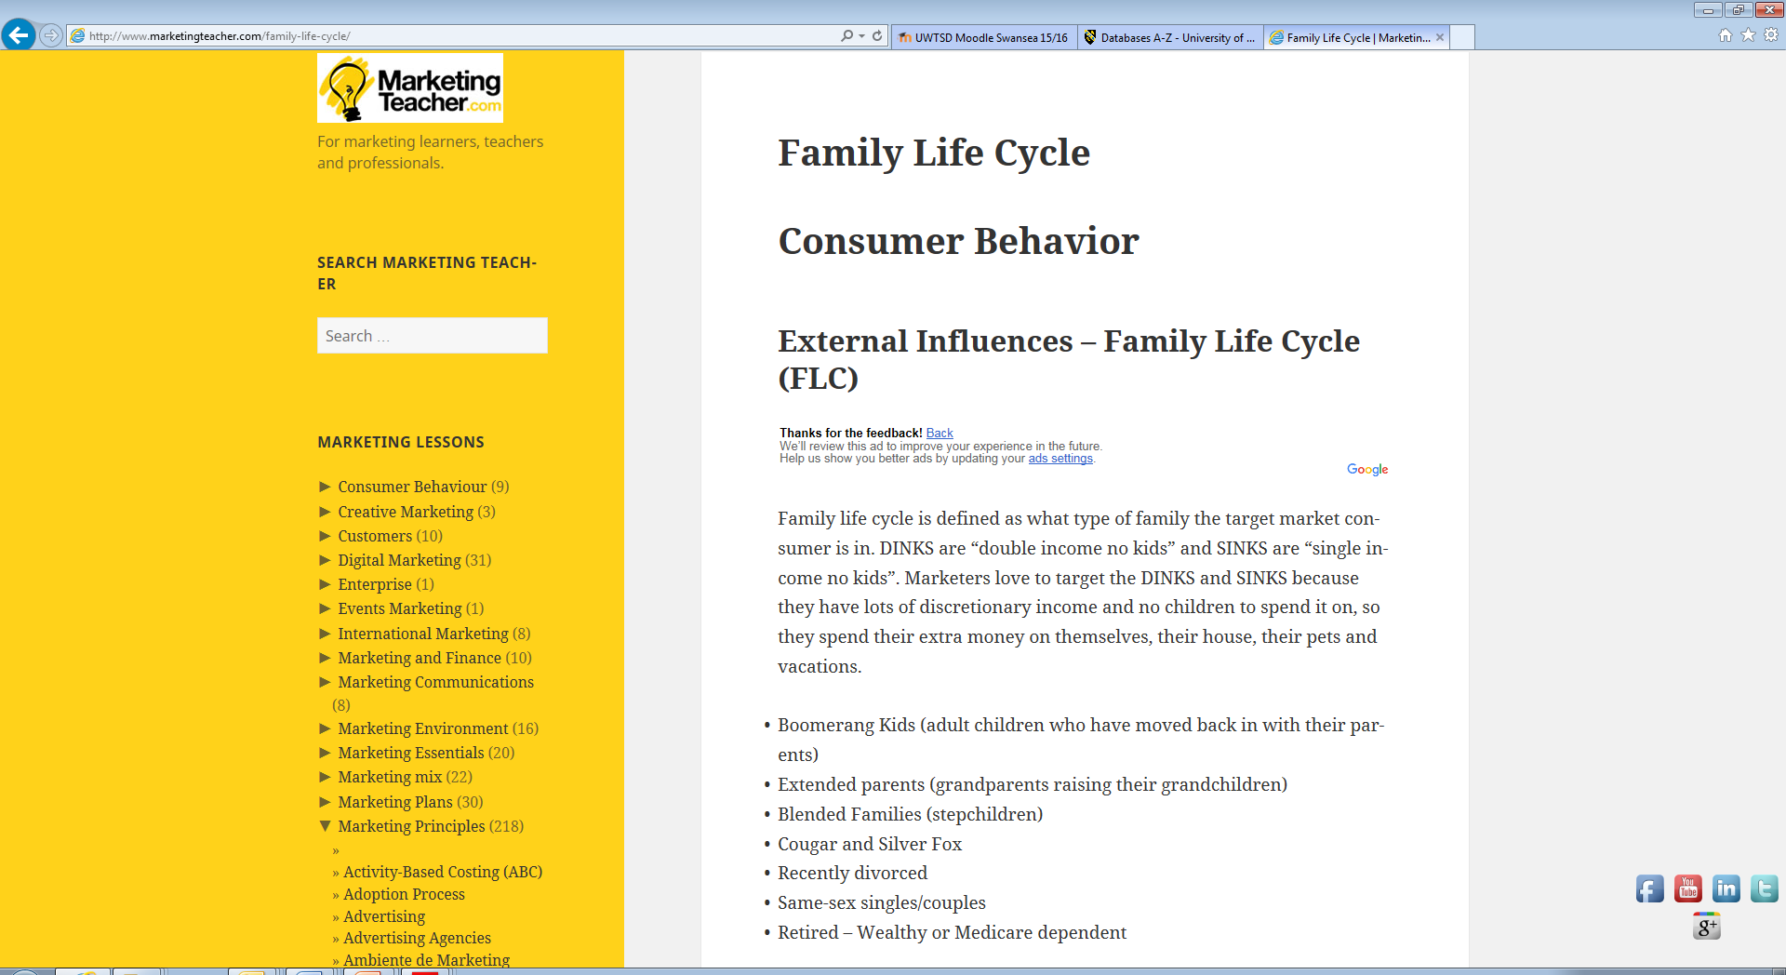
Family Life cycle abstracts

Marketing communications in a post-modern world
Kitchen, Philip J. & Proctor, Tony. The Journal of Business Strategy36.5 (2015): 34-42.

- The purpose of this paper is to present and discuss information accessibility in today's world alongside the accompanying demise of corporate invisibility. This is an ever-present communications reality for businesses and consumers in the twenty-first century.
- This paper reviews the relevant extant literature relating to economic, social and technological developments and their impact on the post-modern world of marketing communications. It discusses the rip tides of change that impact on that world. Discussion focuses on the changing global environment as a backdrop to observing new trends in the marketplace underpinned by an information explosion. Consumer typologies and their significance are considered generationally in terms of X, Y and Z and explored in the context of postmodernism.
- The pace of change in marketplaces and market-spaces everywhere is continuous and accelerating. Inexorably - and perhaps inevitably - marketing communications are changing shape, metamorphosing into new configurations and forms as a result of underlying technological changes and in the face of ongoing recessionary influences. For the first time in history, people are exerting more influence and control over marketing processes. Medias are moving in tandem with the technological drivers, implying that managers, brands and companies should all be proactive in taking advantage of the changing times.
- Different communications are needed for different markets, but always based on a sound understanding of the dynamics of the markets they address. Not only is an understanding of the needs and wants of different generations important, but also the different economic, social and cultural settings in which consumption takes place.
- Constant technological change is here to stay and has consequences for the ways companies design and implement marketing communications.
- This paper is original in its assessment of the problems of creating effective marketing communication and in highlighting the issues facing companies in today's post-modern world. Using generational types presents an interesting way of examining and addressing different markets with different needs.

The effect of age, gender and education level on customer evaluations of retail furniture store atmospheric attributes
Yildirim, Kemal Cagatay, Kubulay; Hidayetoglu, Lutfi Mehmet. International Journal of Retail & Distribution Management43.8 (2015): 712-726.

- The purpose of this paper is to ascertain the effect of age, gender and education level on customer evaluations of store atmospheric attributes (colour, lighting type, musical genre/tempo/volume, circulation area, lighting, climatic conditions, ambient scent and cleanliness) in the context of retail furniture stores.
- To that end, a questionnaire was administered to 273 customers who shopped at furniture stores in the Siteler district of Ankara. The reliability coefficients of the data were defined based on their percentage values. Then, to examine the effect of age, gender and education level on customer evaluations of store atmospheric attributes, the appropriate[chi] 2 analysis was applied.

- Significant differences in customer evaluations of store atmospheric attributes emerged based on age, gender and education level. Based on those results, certain store atmospheric attributes (colour, lighting type, musical genre/tempo/volume) preferred by customers were suggested to enhance the design of furniture stores. In addition, the store's circulation area, lighting, climatic conditions, ambient scent and cleanliness were found to have a significant impact on the duration of customer visits to furniture stores.
- The study scientifically assessed the effects of age, gender and education on the perceptions of customers in terms of ambient atmosphere. Application of these findings to store design should have positive effects on the willingness of customers to remain in the store and should positively affect their shopping decisions.

Drivers of long-term savings behavior from the consumers' perspective
Ruefenacht, Matthias; Schlager, Tobias; Maas, Peter; Puustinen, Pekka

. The International Journal of Bank Marketing33.7 (2015): 922-943.
- The purpose of this paper is to delineate the impact of social context and savings attitudes on consumers' self-reported long-term savings and discuss how these drivers can be influenced to increase an individual's savings rate.
- An online survey was conducted among 993 German savers. A structural equation model quantified the influence of the social context and an individual's attitudes on long-term savings behavior, as stated by consumers.
- Both social context constructs - subjective norms and relationship quality - exert a significant influence on the savings attitudes of perceived anxiety and perceived importance, which in turn significantly affect long-term savings. Furthermore, the results of a mediation analysis indicated that the social context only has an indirect effect on long-term savings.
- The study was conducted in Germany only. Therefore, the results may not apply across cultures. In addition, the salient belief structures, access channels used, and savings product categories were not part of this study.
- The results showed that financial institutions can influence an individual's attitudes toward long-term savings by providing a satisfying and trusted relationship. The positive effect on savings attitudes will translate to an increased long-term savings rate. According to the analysis, financial service providers can only have an indirect effect on long-term savings behavior.
- This paper delineates the impact of the social environment on long-term savings. This relationship has not been investigated in previous research. In addition, the influence of the social context within the attitudes-behavior framework for long-term savings is expounded.

Family labor supply, taxation and saving in an imperfect capital market
Apps, Patricia
Department of Business Law and Taxation, Monash University
; Rees, Ray. Review of Economics of the Household8. 3 (Sep 2010): 297-323.
This paper combines income and expenditure with time use data to provide a unique picture of the labor supply, household production, saving and consumption decisions of two-adult households over a life cycle defined in terms of the presence and ages of children. The study also draws on data for household borrowing and lending, direct and indirect benefits and taxes to calibrate a family life cycle model at the core of which is the hypothesis that households face a borrowing interest rate that rises with the amount of non-collateral based borrowing. The household members jointly choose time paths of time use, consumption and saving over their life cycle in the face of this capital market imperfection. Importantly, households are shown to differ significantly in their saving behavior in a way that depends on secondary earner labor supply, with a strong positive association between saving and the income of the second earner. The results differ sharply from those of the existing literature

The Effectiveness of Family Life Cycle Variables in Consumer Expenditure Research

