
ACDC50029: Electromagnetic Radiation
Bradley Gillies
Word Count: 2337 (-6.52%)
—
Embedded Electronic Systems Degree Apprenticeship
—
Electromagnetic Radiation
—
2310950

Contents
Table of Figures 3
Table of Tables 4
Abstract 5
Task 1A 6
Introduction 6
Methodology 6
Results 7
Discussion 12
Conclusion 13
Task 1B 14
Introduction 14
Methodology 14
Results 14
Discussion 19
Conclusion 20
Task 2 21
Introduction 21
Methodology 21
Results 22
Discussion 22
Conclusion 23
Task 3 24
Introduction 24
Literature Review 24
Discussion 24
Conclusion 25
References 26

Table of Figures
Figure 1: Create Box Dialogue. 6
Figure 2: Wave Port Modes. 6
Figure 3: Initial Analysis Setup. 7
Figure 4: Validate Simulation and Analyse All Buttons. 7
Figure 5: Cut-Off Frequencies for the Three Dominant Modes. 8
Figure 6: Magnetic Field Magnitude TE01. 8
Figure 7: Magnetic Field Vectors TE01. 9
Figure 8: Electric Field Magnitude TE01. 9
Figure 9: Electric Field Vectors TE01. 9
Figure 10: Electric Field Magnitude TE20. 10
Figure 11: Electric Field Vector Field TE20. 10
Figure 12: Magnetic Field Magnitude TE20. 10
Figure 13: Magnetic Field Vectors TE20. 11
Figure 14: Electric Field Magnitude TE30. 11
Figure 15: Electric Field Vectors TE30. 11
Figure 16: Magnetic Field Magnitude TE30. 12
Figure 17: Electric Field Vectors TE30. 12
Figure 18: Change Waveguide Fill Material to Teflon. 14
Figure 19: Cut-Off Frequency Graph for Teflon Waveguide. 15
Figure 20: Electric Field Magnitude for Teflon Waveguide Mode TE10. 15
Figure 21: Electric Field Vectors for Teflon Waveguide Mode TE10. 16
Figure 22: Magnetic Field Magnitude for Teflon Waveguide Mode TE10. 16
Figure 23: Magnetic Field Vectors for Teflon Waveguide Mode TE10. 16
Figure 24: Electric Field Magnitude for Teflon Waveguide Mode TE20. 17
Figure 25: Electric Field Vectors for Teflon Waveguide Mode TE20. 17
Figure 26: Magnetic Field Magnitude for Teflon Waveguide Mode TE20. 17
Figure 27: Magnetic Field Vectors for Teflon Waveguide Mode TE20. 18
Figure 28: Electric Field Magnitude for Teflon Waveguide Mode TE30. 18
Figure 29: Electric Field Vectors for Teflon Waveguide Mode TE30. 18
Figure 30: Magnetic Field Magnitude for Teflon Waveguide Mode TE30. 19
Figure 31: Magnetic Field Vectors for Teflon Waveguide Mode TE30. 19
Figure 32: Half-Wave Dipole Antenna in CST Studio Suite. 21
Figure 33: Creation and Application of Scale Factor. 22
Figure 34: S-Parameter Results for Half-Wave Dipole Antennas. 22
Figure 35: Far-Field Results for Scaled Half-Wave Dipole Antenna. 22

Table of Tables
Table 1: Cut-Off Frequencies for Rectangular Waveguide. 8
Table 2: Calculated Cut-Off Frequencies. 12
Table 3: Cut-Off Frequencies for Teflon Rectangular Waveguide. 15
Table 4: Calculated Cut-Off Frequencies for Teflon Waveguide. 19

Abstract
This report will cover the design and development of two waveguides, a half-wave dipole antenna, and research into RADAR technologies that can detect and monitor unmanned aerial vehicles (UAVs) and drones.

Two waveguides were created, using the Ansys simulation software, to the specified dimensions set out in the criteria. One waveguide was filled with a vacuum whilst the second was filled with the Teflon material. Both waveguides were simulated and the results were compared against the theoretical values derived from mathematical equations. Suggestions as to why these values deviated were also explored.

A half-wave dipole antenna was created using the CST Studio Suite simulation software. Similarly, to the waveguides, the design of the antenna was matched to the criteria set out in the specification. Once the design had been created, it was then simulated to obtain S-Parameter and far field results. These results were compared to the theoretical values obtained from mathematical equations and explored by adding real-world context to the values obtained.

A research activity was then undertaken to explore recent RADAR developments for the detection and monitoring of UAVs and drones. This resulted in the findings that this field is still actively being researched around the world and some products have started coming to market that claim to be able to solve this issue. Theoretical understanding of how to counter this issue is well understood, however, the regulations surrounding RADAR technologies and real-world phenomena, such as noise, are proving challenging to overcome.

Task 1A

Introduction
The purpose of this task is to create a rectangular waveguide with a perfect electric conductor (PEC) walls and filled with a vacuum. The dimensions of this waveguide are defined by a width (23mm), height (5mm), and length (50mm).

Methodology
Simulation and design software called Ansys was used to design and test the waveguide being built. Within Ansys is a high frequency structure simulation (HFSS) component which enables 3D electromagnetic (EM) design and simulation for electronic products such as antennas, antenna arrays, RF or microwave components, high-speed interconnects, filters, connections, IC packages, and printed circuit boards. Hence this simulation type was selected for the design and simulation of the waveguide model. [1]

Initially, a rectangle is added to the simulation with the dimensions previously mentioned. The precise measurements of the rectangle were entered in the “Create Box” dialogue as shown in Figure 1. By default, the rectangular shape is filled with a vacuum so no settings needed to be changed.

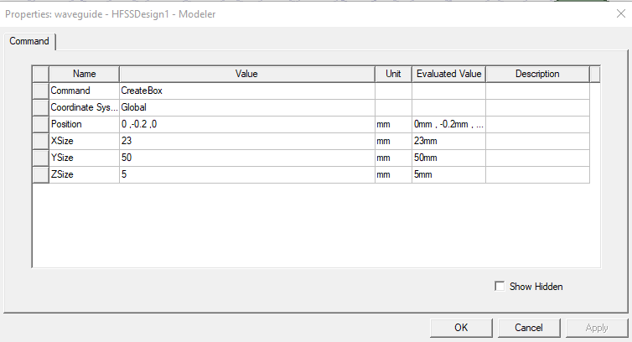
Figure 1: Create Box Dialogue.
After this, two modal wave ports were added to the two ends of the rectangular waveguide. The amount of modes was set to the specified value of three as shown in Figure 2. The rest of the modal wave port settings were left at the default values.

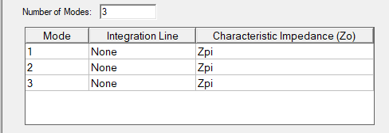
Figure 2: Wave Port Modes.
This resulted in the waveguide specified being created. Now a analysis setup was added to the design. In the dialogue box presented, the frequency was changed to be 15GHz and maximum number of passes set to 6 as shown in Figure 3.

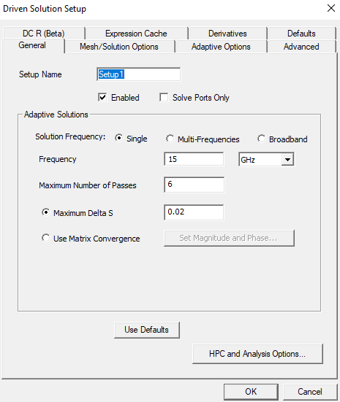
Figure 3: Initial Analysis Setup.
Once these values had been set, the simulation was validated to ensure no errors were present and then the analysis was run on the waveguide. These buttons can be seen in Figure 4.


Figure 4: Validate Simulation and Analyse All Buttons.

Results
The methodology outlined above enabled the generation of the results outlined in this section of the report.

A plot of the cut off frequencies for the three dominant modes of the waveguide could be created and is shown in Figure 5. Shown in Table 1 are the dominant modes and the cut off frequency generated by the simulation of the waveguide.

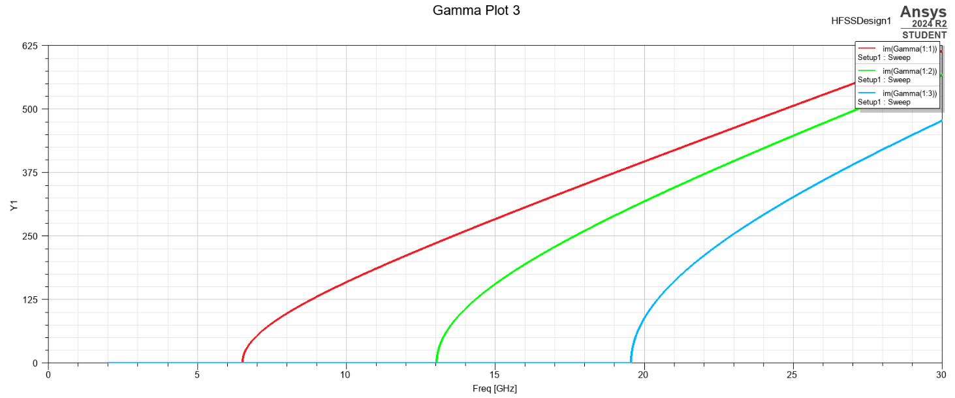
Figure 5: Cut-Off Frequencies for the Three Dominant Modes.
Mode | Cut-Off Frequency (GHz)
TE₁₀ | 6.5405
TE₂₀ | 13.043
TE₃₀ | 19.5455
Table 1: Cut-Off Frequencies for Rectangular Waveguide.
Additionally, the magnitude and vectors of the magnetic and electric fields for the modes has been plotted on the rectangular waveguide. Shown in Figure 6 through Figure 17 are the magnetic and electric field vectors and magnitudes for the three dominant modes of the waveguide.

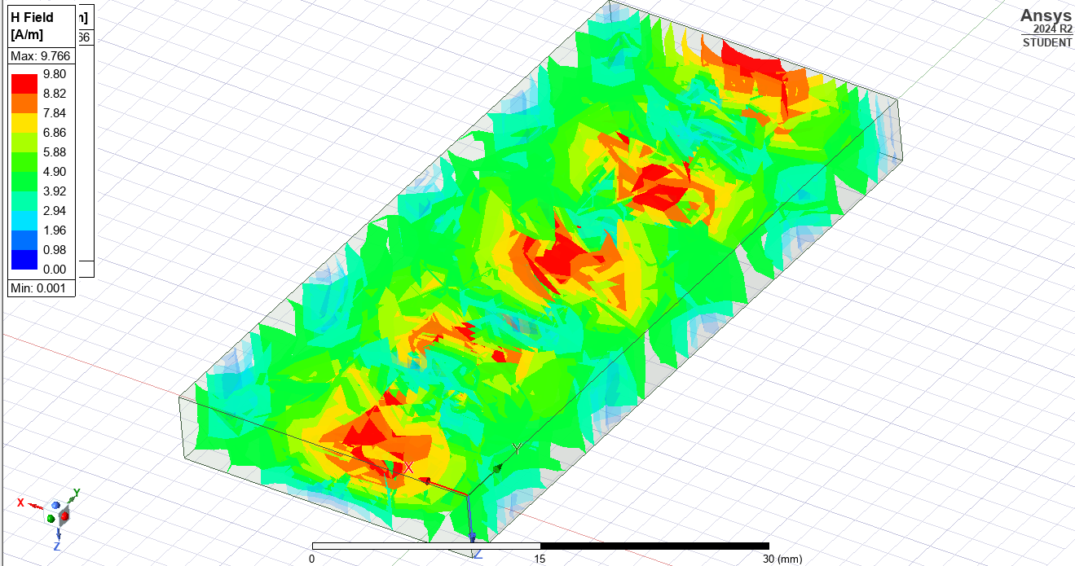
Figure 6: Magnetic Field Magnitude TE01.
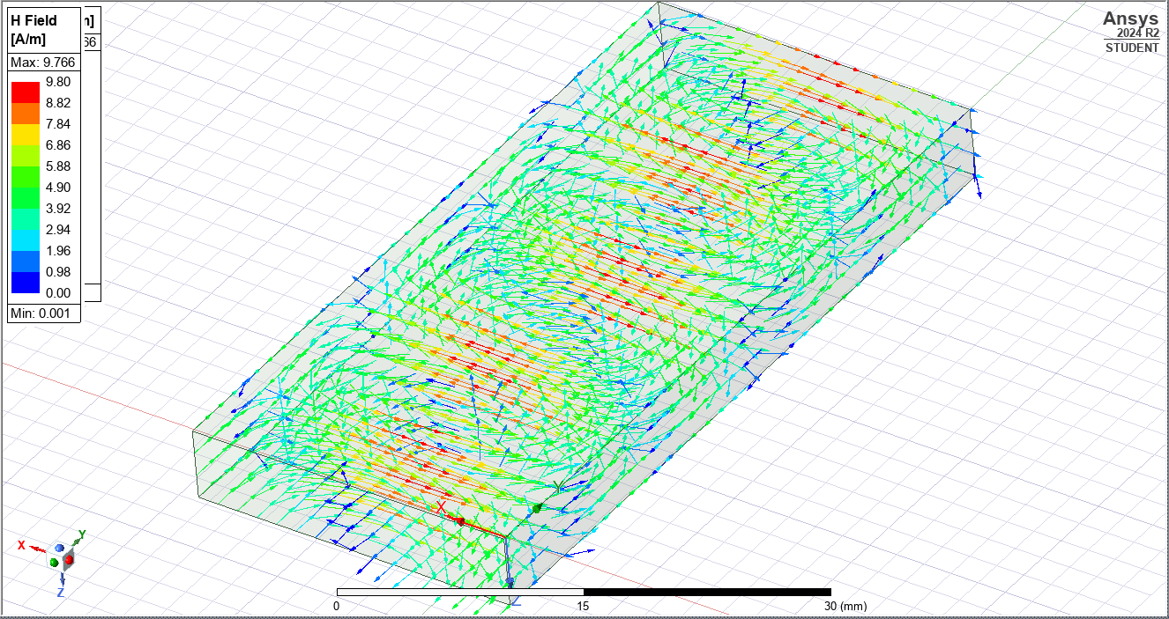
Figure 7: Magnetic Field Vectors TE01.
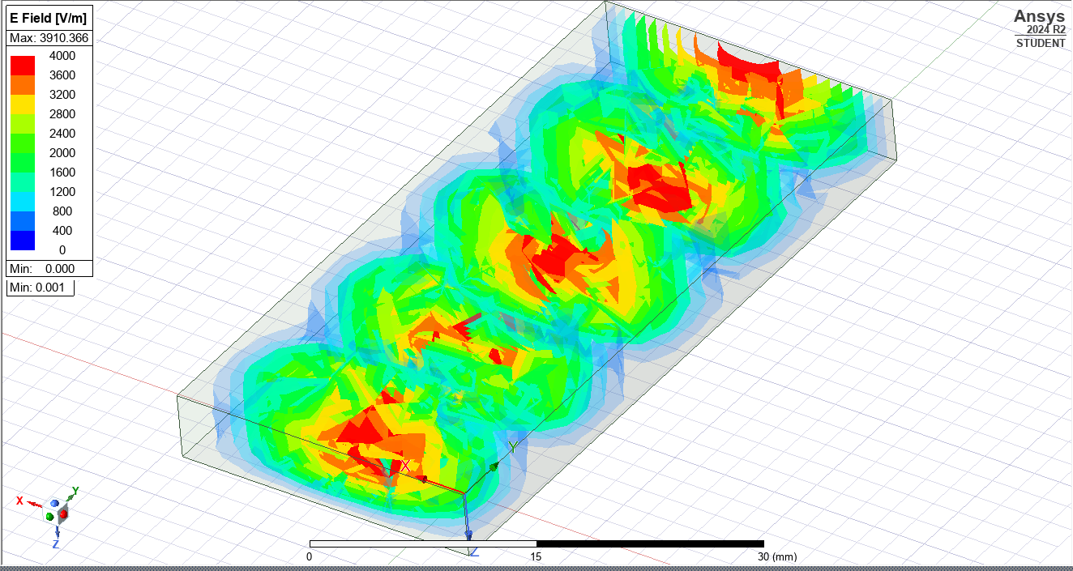
Figure 8: Electric Field Magnitude TE01.
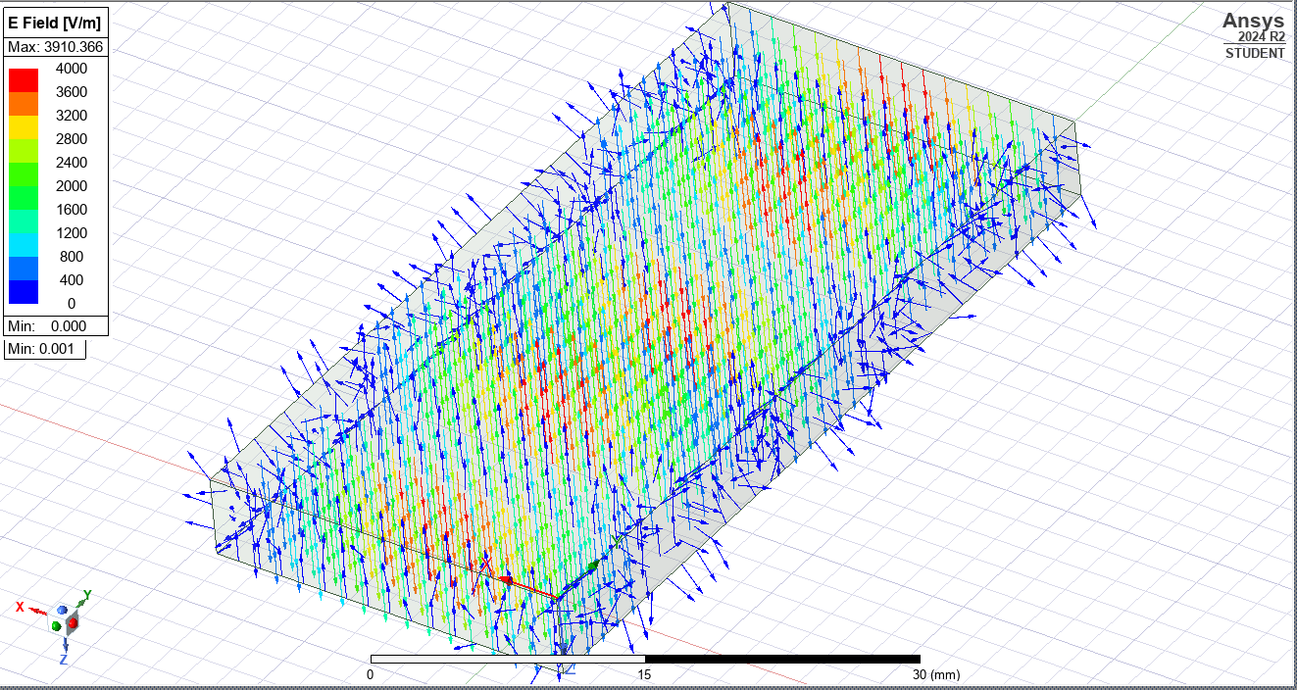
Figure 9: Electric Field Vectors TE01.
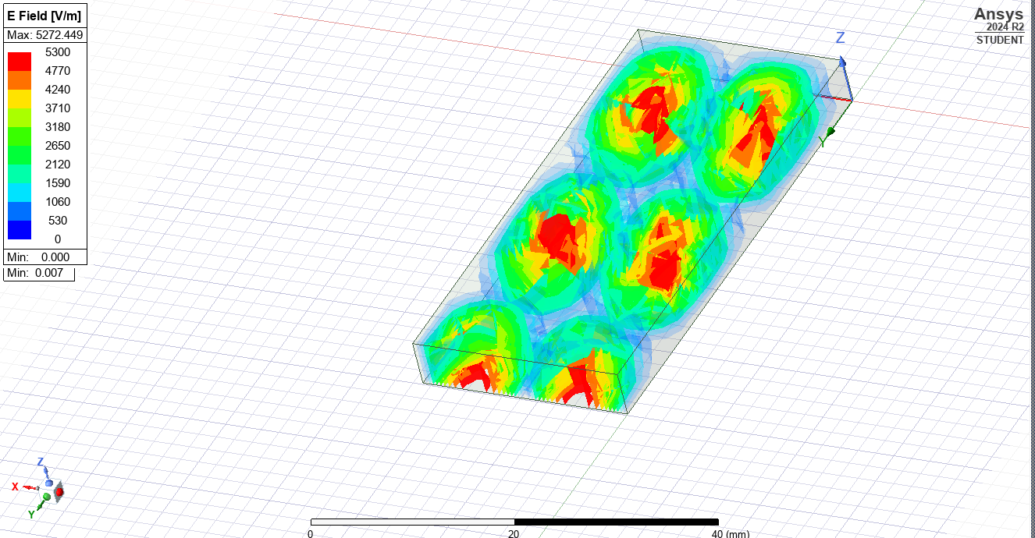
Figure 10: Electric Field Magnitude TE20.
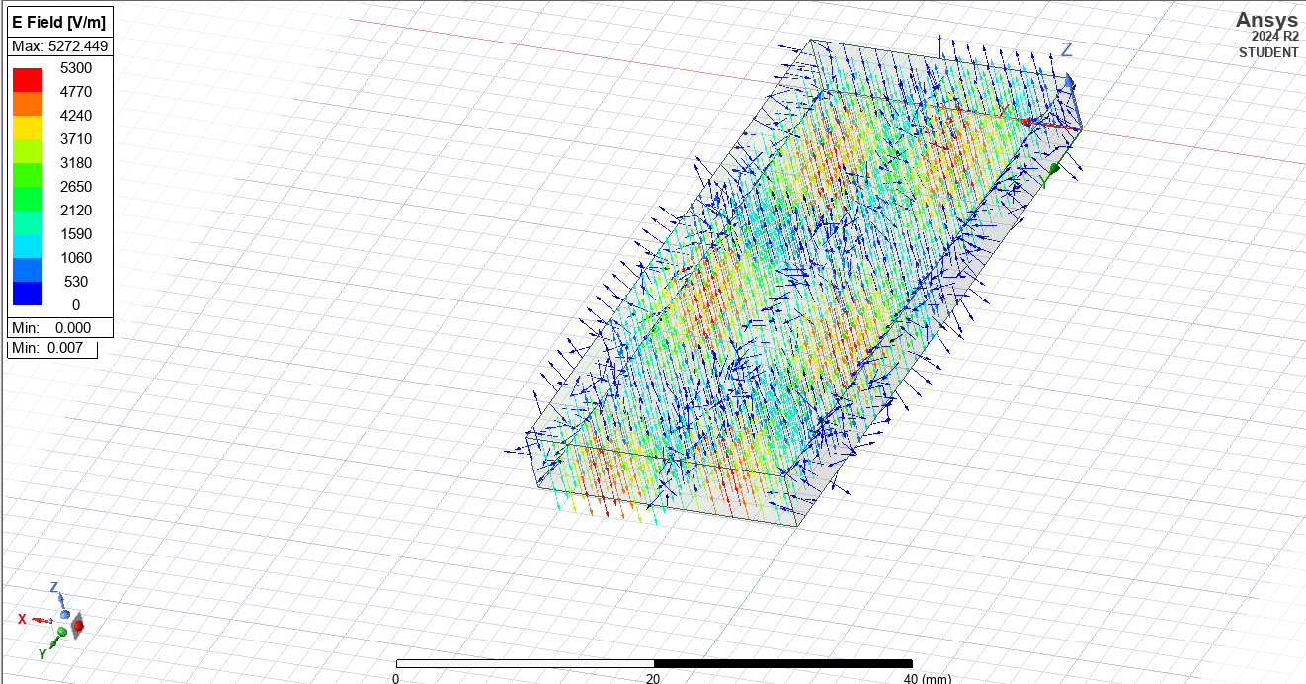
Figure 11: Electric Field Vector Field TE20.
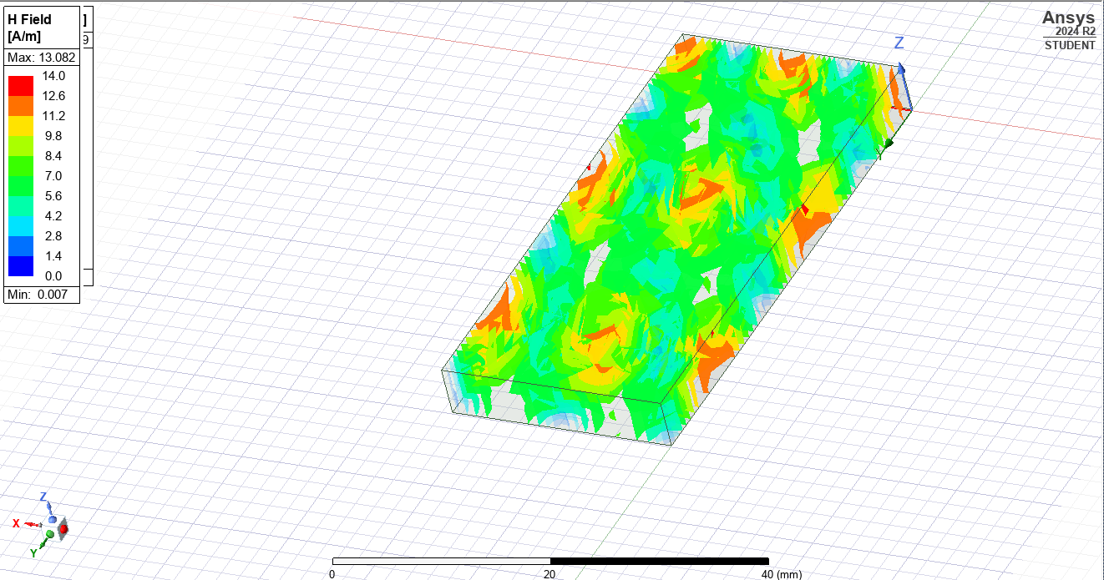
Figure 12: Magnetic Field Magnitude TE20.
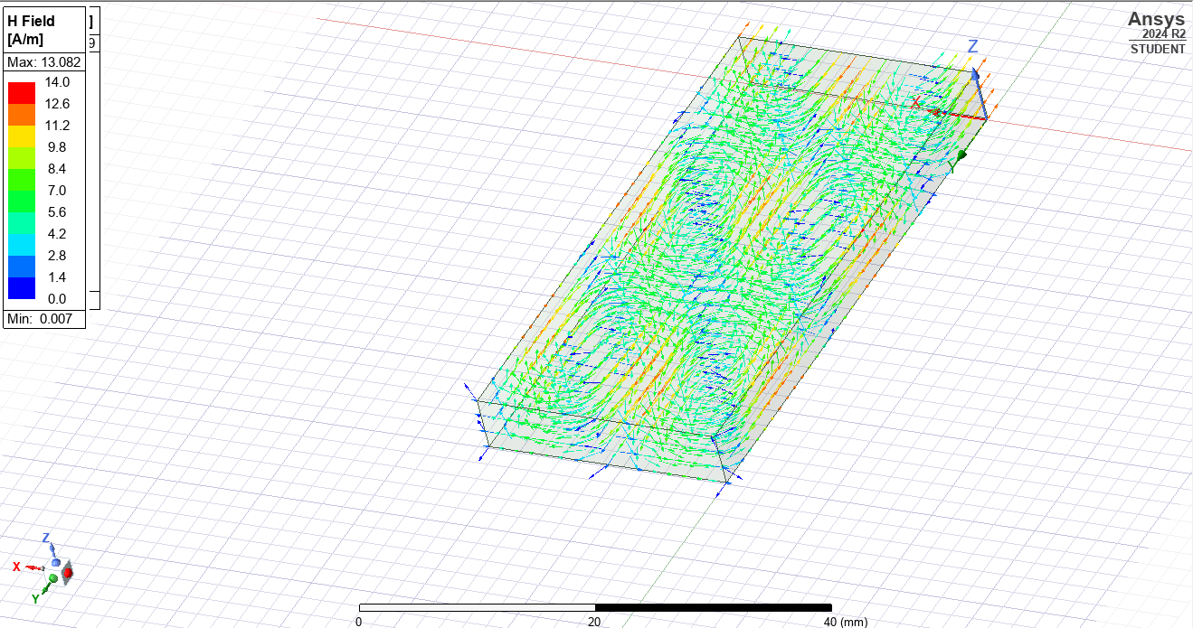
Figure 13: Magnetic Field Vectors TE20.
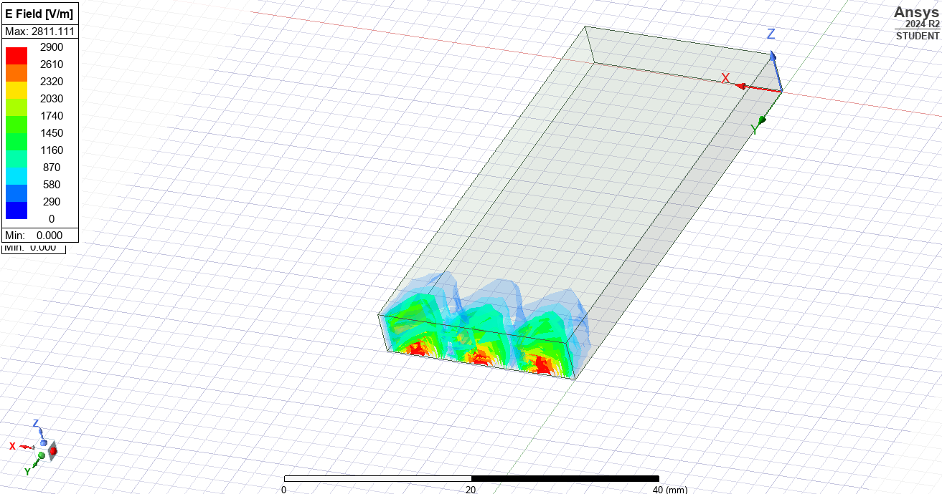
Figure 14: Electric Field Magnitude TE30.
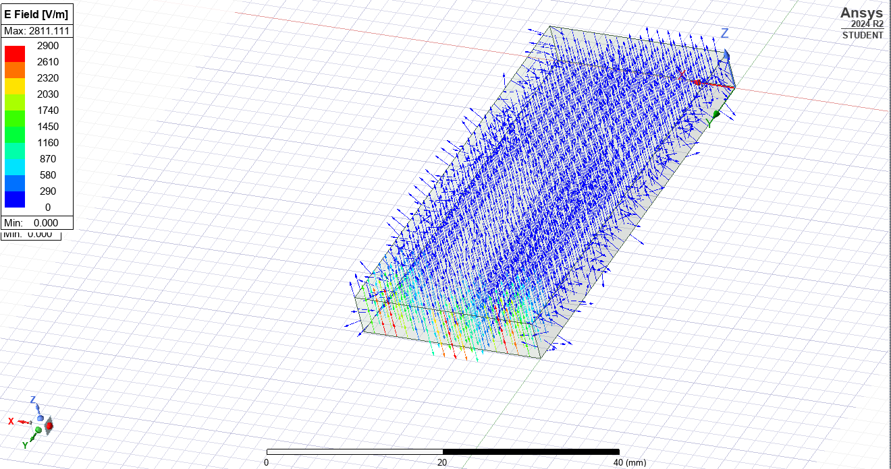
Figure 15: Electric Field Vectors TE30.
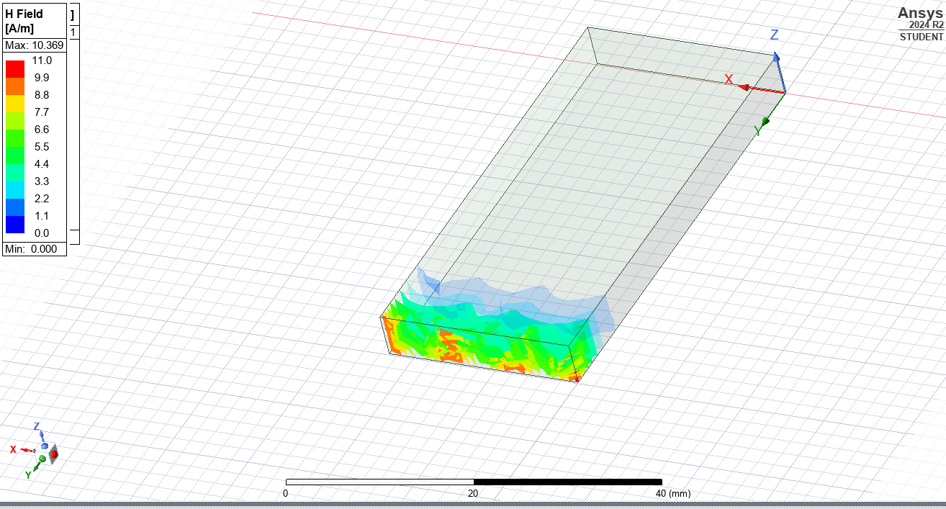
Figure 16: Magnetic Field Magnitude TE30.
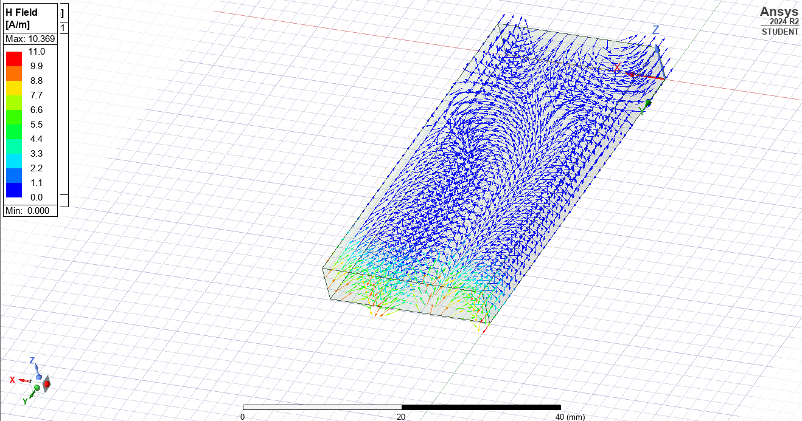
Figure 17: Electric Field Vectors TE30.

Discussion
The simulation results from Ansys show the cut-off frequencies for the first three modes of the rectangular waveguide. These values can also be calculated theoretically using a mathematical equation (Equation 1) and the expected values for the modes identified can be seen in Table 2.
$$f_{c}=\frac{c}{2}\sqrt{{(\frac{m}{a})}^{2}+({\frac{n}{b})}^{2}}$$
Equation 1
Where:
- ‘a’ is the width (23mm);
- ‘b’ is the thickness (5mm);
- TE_{mn} is the mode active in the waveguide.

Mode | Calculated Cut-Off Frequency (GHz)
TE₁₀ | 6.5217
TE₂₀ | 13.0435
TE₃₀ | 19.5652
Table 2: Calculated Cut-Off Frequencies.
Comparing the simulated results from Ansys and the calculated cut-off frequencies for the three modes in the rectangular waveguide, the values only deviate by a small amount. The differences in the values is due to the equations used in Ansys being more complex than the singular equation used above.

Additionally, as shown in Figure 6 through Figure 17, the waveguide can propagate in the modes of 10 and 20, but fails to propagate appropriately in mode 30. The lack of propagation present in mode 30 is likely due to the dimensions of the waveguide not being appropriate for the wavelength of waves that are being passed into it.

Conclusion
Overall, a waveguide with the specified dimensions was successfully created in a simulation software suite called Ansys. Once simulations had been processed for the waveguide, cut-off frequencies were identified and compared to the theoretical values. Finally, the propagation of the magnetic and electric fields was analysed, resulting in the discovery that the waveguide does not work appropriately for TE mode 30.

Task 1B

Introduction
The purpose of this task is to build off of Task 1A and change the material that the waveguide is filled with from a vacuum to Teflon. The same simulation parameters are being used and the same results are being generated to allow analysis of the two different waveguides.

Methodology
A copy of the Task 1A workspace was created and the material that is filling the waveguide was changed from being a vacuum to be Teflon as shown in Figure 18.

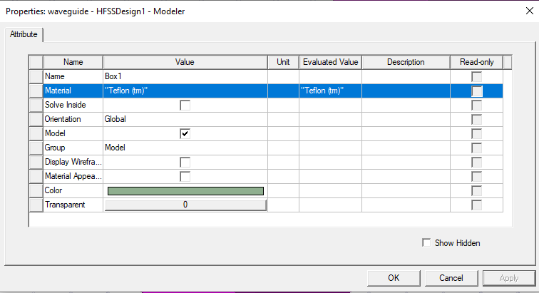
Figure 18: Change Waveguide Fill Material to Teflon.
Similarly, to the previous waveguide, the simulation was validated and then analysed to generate the results shown later in this report.

Results
The methodology outlined above enabled the generation of the results outlined in this section of the report.

A plot of the cut off frequencies for the three dominant modes of the waveguide could be created and is shown in Figure 19. Shown in Table 3 are the dominant modes and the cut off frequency generated by the simulation of the waveguide.

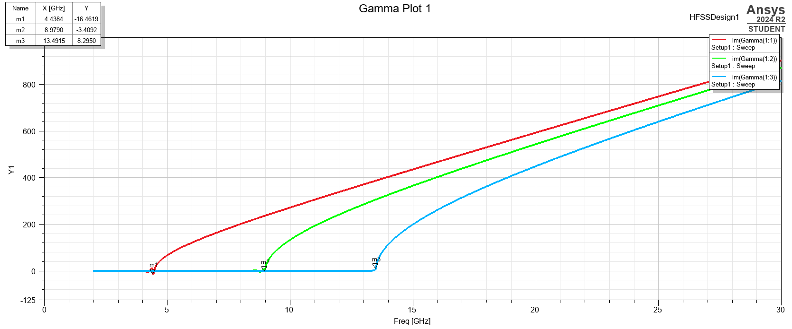
Figure 19: Cut-Off Frequency Graph for Teflon Waveguide.
Mode | Cut-Off Frequency (GHz)
TE₁₀ | 4.4384
TE₂₀ | 8.979
TE₃₀ | 13.4915
Table 3: Cut-Off Frequencies for Teflon Rectangular Waveguide.
Additionally, the magnitude and vectors of the magnetic and electric fields for the modes has been plotted on the Teflon rectangular waveguide. Shown in Figure 20 through Figure 31 are the magnetic and electric field vectors and magnitudes for the three dominant modes of the waveguide.

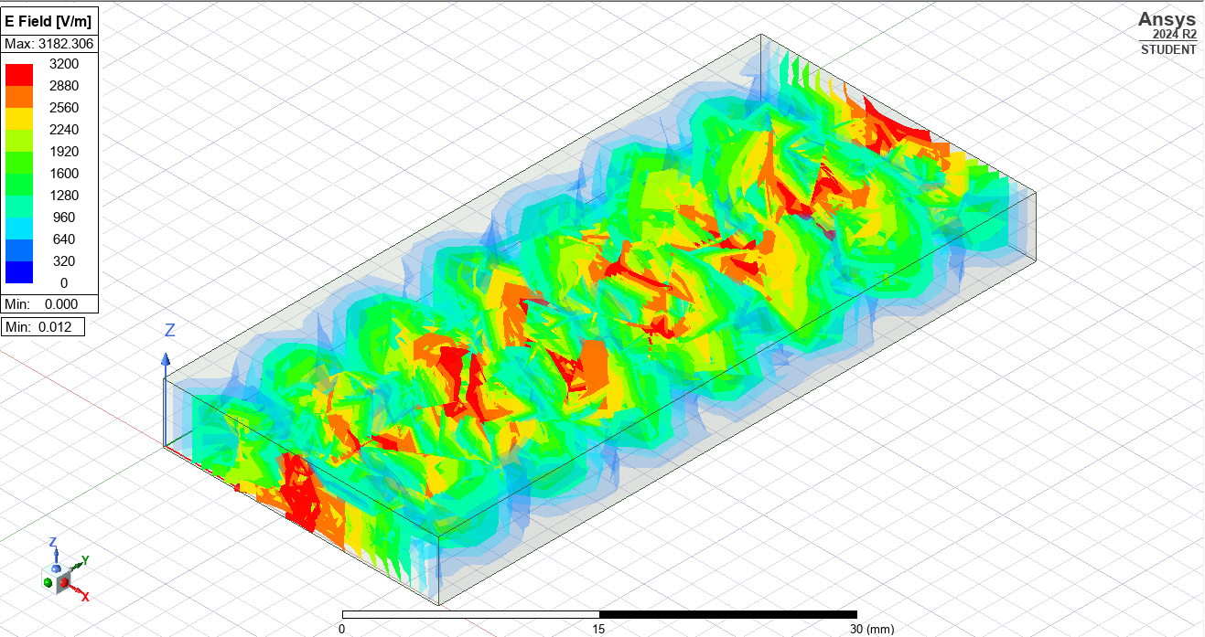
Figure 20: Electric Field Magnitude for Teflon Waveguide Mode TE10.
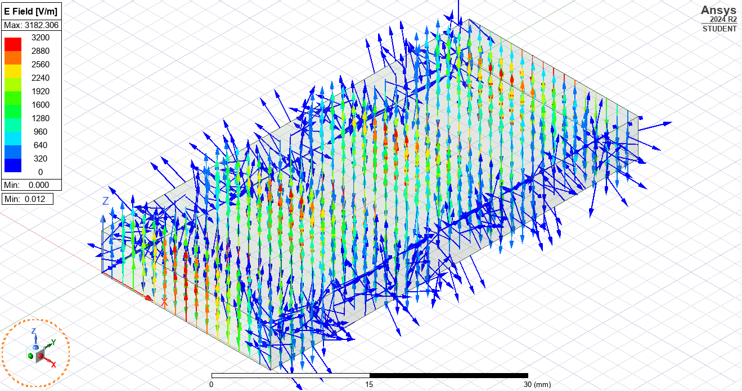
Figure 21: Electric Field Vectors for Teflon Waveguide Mode TE10.
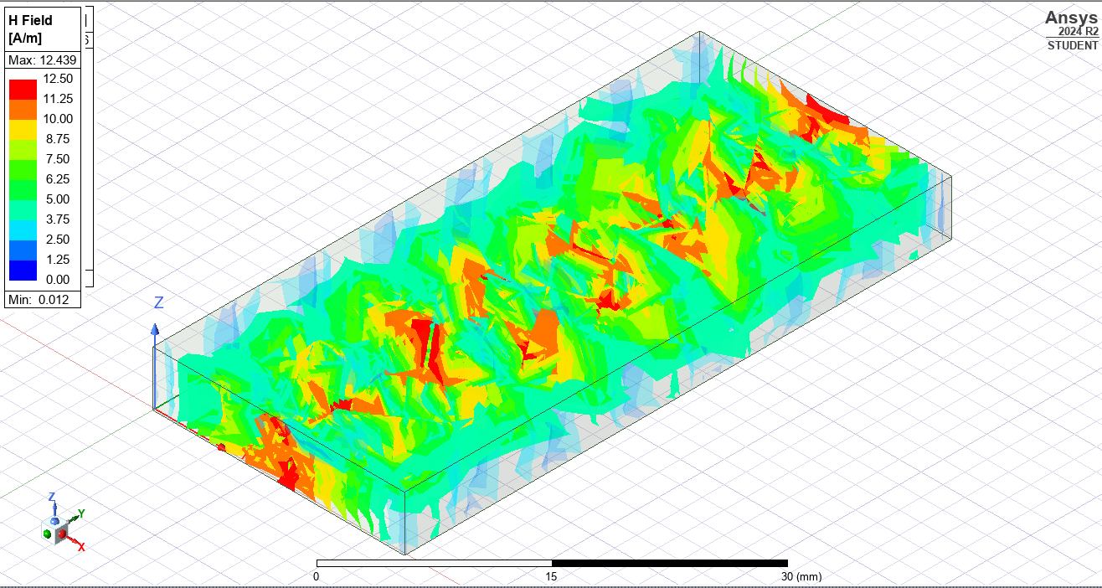
Figure 22: Magnetic Field Magnitude for Teflon Waveguide Mode TE10.
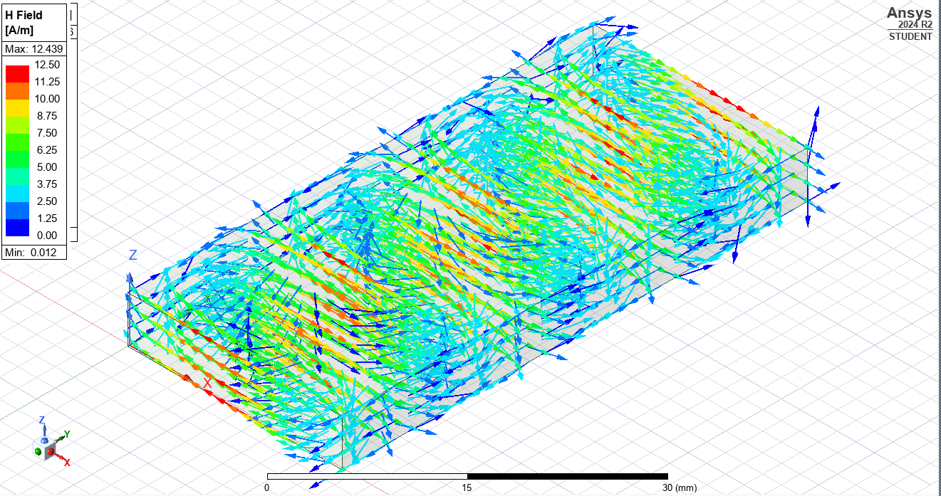
Figure 23: Magnetic Field Vectors for Teflon Waveguide Mode TE10.
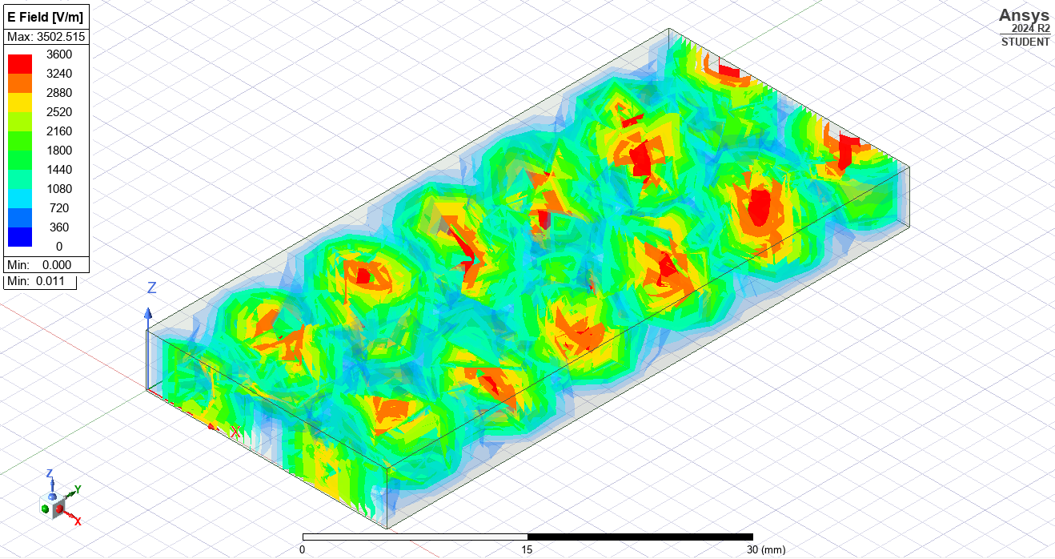
Figure 24: Electric Field Magnitude for Teflon Waveguide Mode TE20.
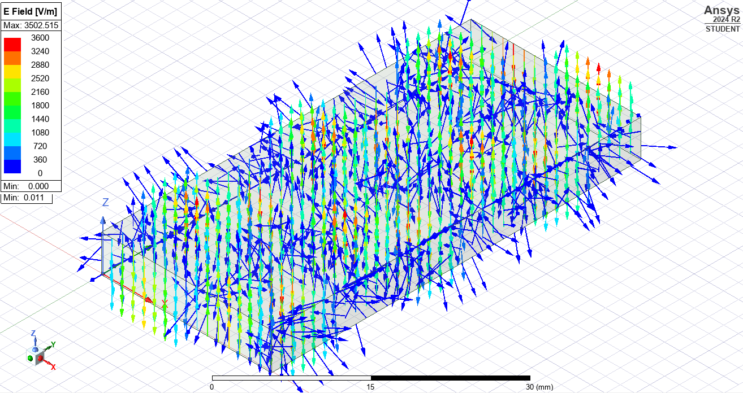
Figure 25: Electric Field Vectors for Teflon Waveguide Mode TE20.
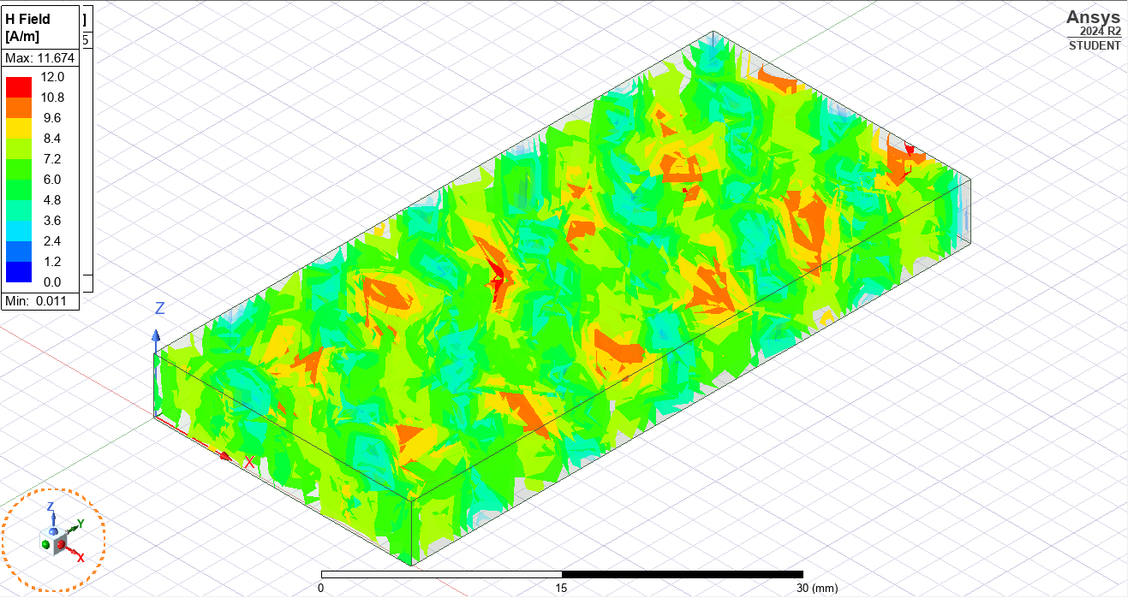
Figure 26: Magnetic Field Magnitude for Teflon Waveguide Mode TE20.
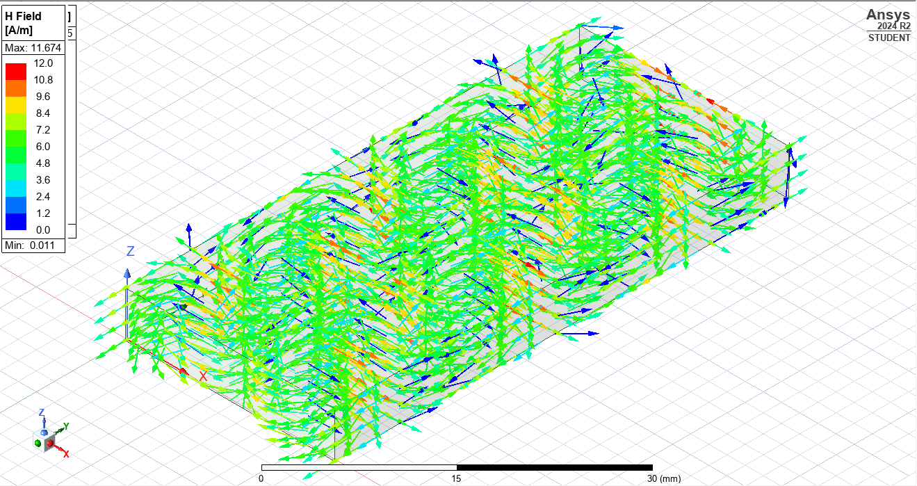
Figure 27: Magnetic Field Vectors for Teflon Waveguide Mode TE20.
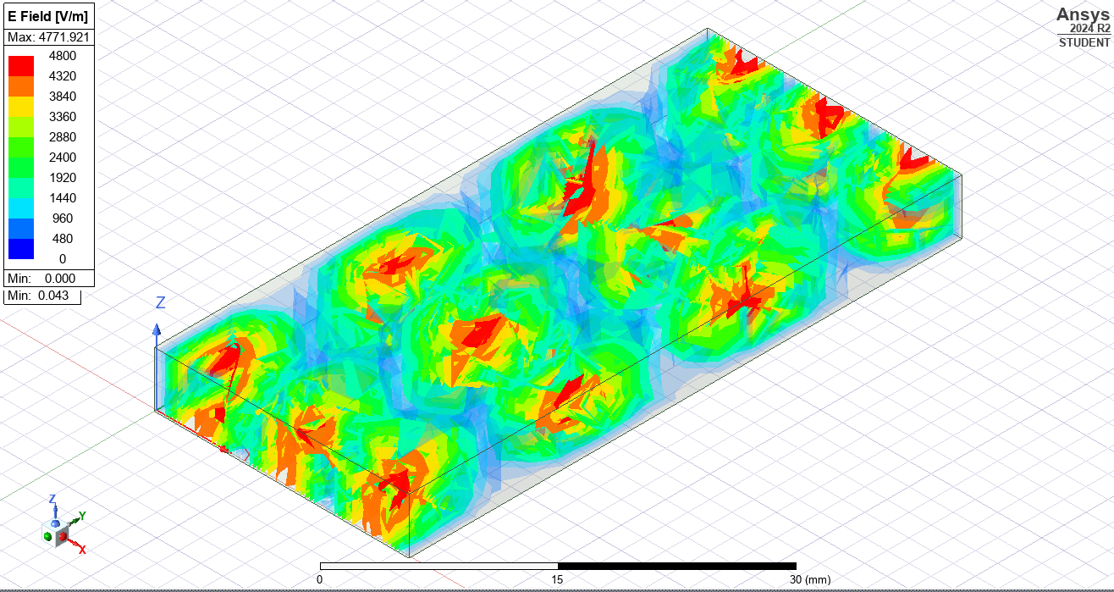
Figure 28: Electric Field Magnitude for Teflon Waveguide Mode TE30.
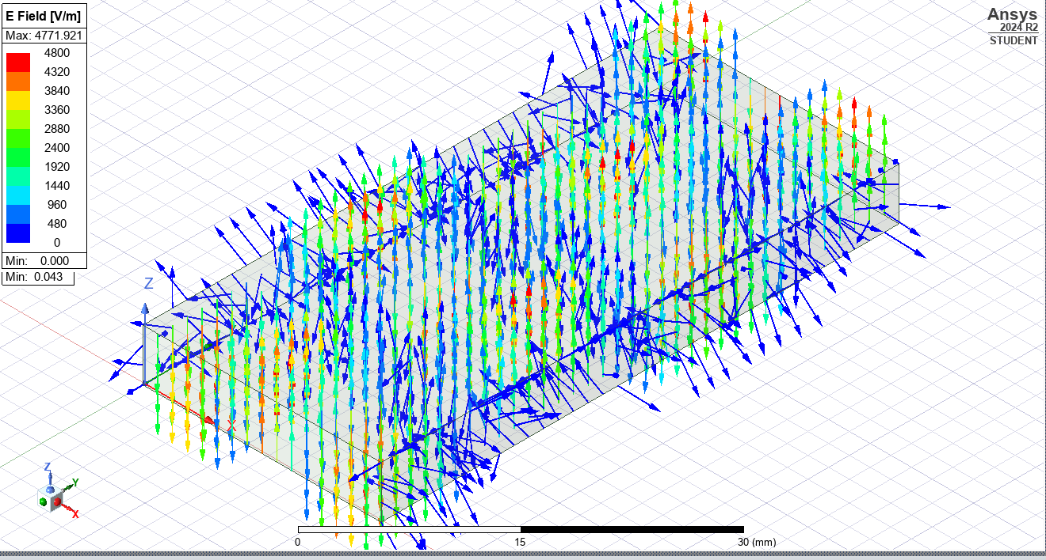
Figure 29: Electric Field Vectors for Teflon Waveguide Mode TE30.
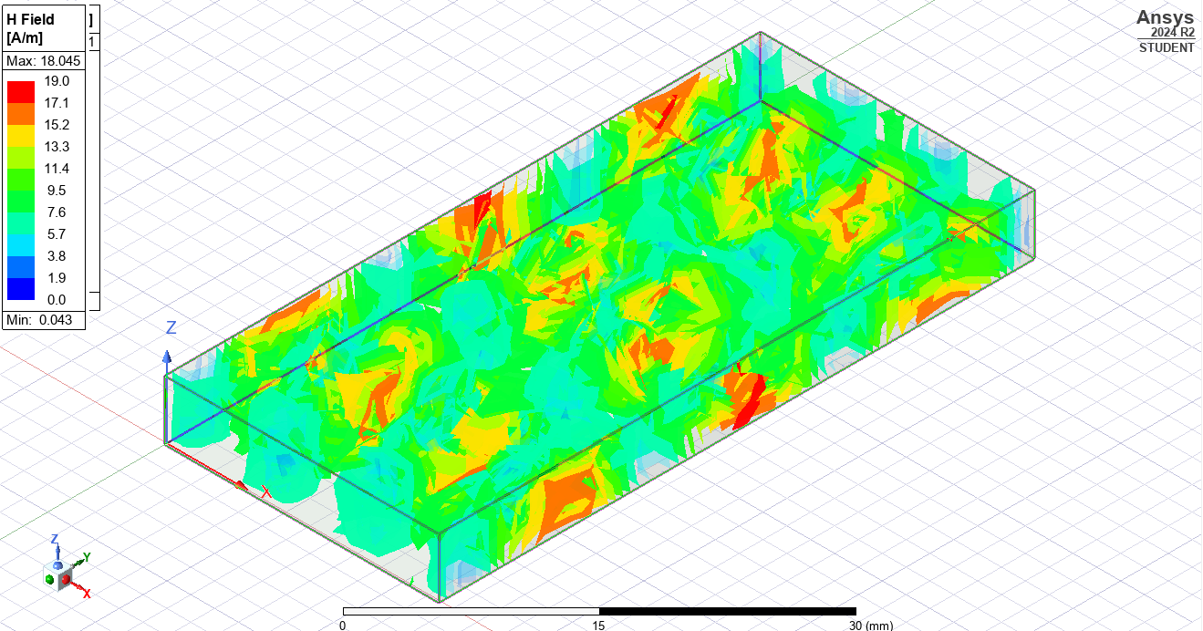
Figure 30: Magnetic Field Magnitude for Teflon Waveguide Mode TE30.
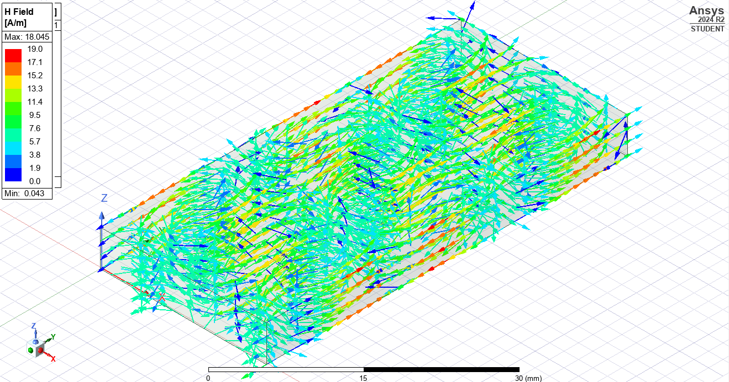
Figure 31: Magnetic Field Vectors for Teflon Waveguide Mode TE30.

Discussion
The simulation results from Ansys show the cut-off frequencies for the first three modes of the Teflon rectangular waveguide. These values can also be calculated theoretically using a mathematical equation (Equation 2) and the expected values for the modes identified can be seen in Table 4.
$$f_{c}=\frac{1}{2*\sqrt{μ*ϵ}}\sqrt{{(\frac{m}{a})}^{2}+({\frac{n}{b})}^{2}}$$
Equation 2
Where:
- ‘a’ is the width (23mm);
- ‘b’ is the thickness (5mm);
- TE_{mn} is the mode active in the waveguide.
- $μ$ is the permeability of the Teflon material ($4π*{10}^{-7}$H/m).
- $ϵ$ is the permittivity of the Teflon material ($1.90361*{10}^{-11}$).
Mode | Calculated Cut-Off Frequency (GHz)
TE₁₀ | 4.4448
TE₂₀ | 8.8895
TE₃₀ | 13.3343
Table 4: Calculated Cut-Off Frequencies for Teflon Waveguide.
Once again, comparing the simulated cut-off frequencies to the cut-off frequencies using the mathematical equation, there is a slight deviation in the results. Similarly, to the previous waveguide, this is due to Ansys performing more complex equations compared to the singular performed in this report.

Additionally, as shown in Figure 20 through Figure 31, the Teflon filled rectangular waveguide can propagate in all three of the dominant modes.

Conclusion
Overall, a waveguide with the specified dimensions and filled with the Teflon material was successfully created in a simulation software suite called Ansys. Once simulations had been processed for the waveguide, cut-off frequencies were identified and compared to the theoretical values. Finally, the propagation of the magnetic and electric fields was analysed, resulting in the discovery that the waveguide works appropriately in all three of the dominant modes.

Task 2

Introduction
For this task, a half-wave dipole antenna is to be designed and simulated in a high frequency simulation software suite. This dipole antenna is to have a radius of 1mm and wavelength of 231mm. Excitation is to be applied to the dipole antenna through the use of a 50Ω lumped port.

Methodology
The simulation software Computer Simulated Technology (CST) Studio Suite was used to design and simulate the half-wave dipole antenna. CST Studio Suite was used due it’s powerful electromagnetic simulation capabilities and ability to handle complex geometries. [2]

The half-wave dipole antenna (Figure 32) was created by drawing two cylindrical objects of radius 1mm and length 115.5mm (wavelength / 2) and joining the two shapes together with a 50Ω lumped port. [3]

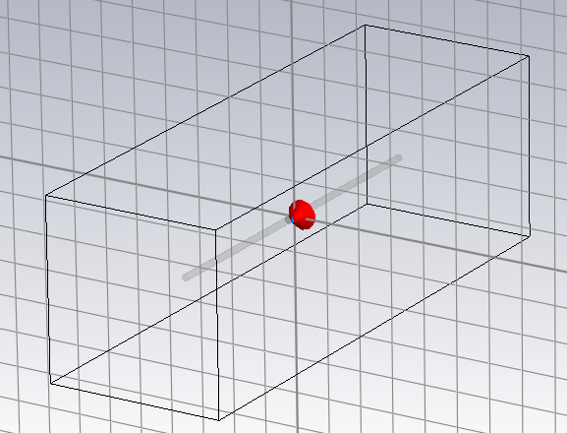
Figure 32: Half-Wave Dipole Antenna in CST Studio Suite.
The simulation was then executed but to the mismatching of impedances, the antenna did not behave in the appropriate manner. A common way of resolving this in the real world would be to use a 73Ω lumped port, but due to the specification criteria listed above, this was not an option. However, a scaling of the antenna could occur to modify the overall size of the antenna to ensure that the impedances did match. [4]

The scaling was performed by taking the initial operation frequency of the designed antenna (1.19GHz) and dividing this by the expected operating frequency of 1.29GHz. This resulted in a scaling factor of 0.922 which was applied to the overall length of the half-wave dipole antenna (Figure 33).

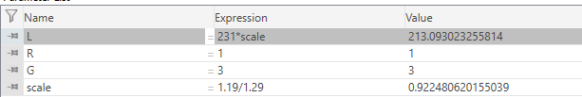
Figure 33: Creation and Application of Scale Factor.

Results
The methodology outlined previously enabled the recording of the S-parameters for the two different variations of the half-wave dipole antenna. Shown in Figure 34, in red is the half-wave dipole antenna with the scaling factor applied to the length and in green is the original half-wave dipole antenna.

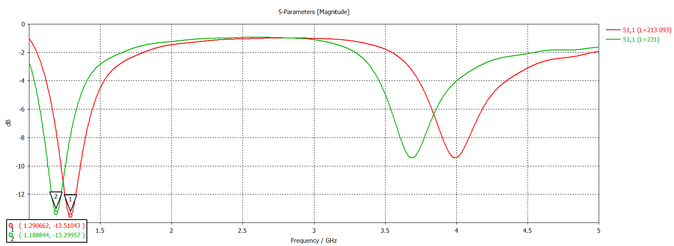
Figure 34: S-Parameter Results for Half-Wave Dipole Antennas.
Additionally, the far field radiation pattern for the scaled half-wave dipole antenna was generated and is shown in Figure 35.
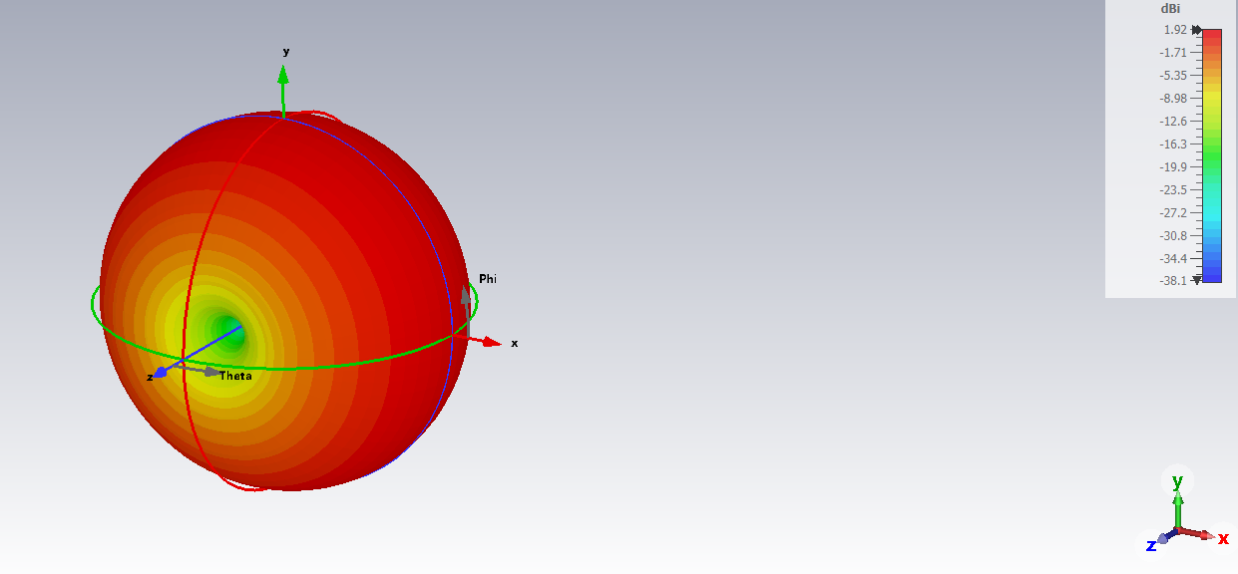
Figure 35: Far-Field Results for Scaled Half-Wave Dipole Antenna.

Discussion
Using Equation 3, the theoretical operating frequency of the half-wave dipole antenna is 1.2987GHz.

$$f=\frac{c}{λ}$$
Equation 3
As shown in Figure 34, the initial design (green) of the half-wave dipole antenna gave a simulated operating frequency of 1.188GHz which does not match the expected value. After performing the scaling outlined previously, the modified half-wave dipole antenna gave a simulated operating frequency of 1.2906GHz which matches with the expected value. The slight deviation is likely due to rounding error, or similarly to Ansys, CST will be using more complex mathematical formula to calculate the results.

The decibels relative to isotropic (dBi) is a unit of measurement that describes how much power an antenna transmits when compared to an isotropic radiator. [5] Due to a dipole antenna having a different radiation pattern when compared to an isotropic radiator, the results in a 2.154dBi as shown in Figure 35.

Conclusion
Overall, a half-wave dipole antenna was designed and simulated to the required specification using the CST Studio Suite simulation software. Once simulations had been processed, the S-Parameters and Far Field results were plotted respectively and analysed. This resulted in the creation of a scaling factor that was applied to the length of the antenna to ensure that the theoretical operating frequency matched with the simulated results. This activity helped highlight the importance of impedance matching.

Task 3

Introduction
Radio detection and ranging (RADAR) has been used since 1935 for military, civilian, and commercial purposes. [6]

Since 1935 RADARs have significantly advanced to become more accurate, real-time, cost effective, and more environmentally friendly. However, in recent times, RADARs have been needing to adapt to tackle the increasingly more common use of unmanned aerial vehicles (UAVs) and drones. This issue is prevalent from a military and commercial airline perspective with London Heathrow Airport cancelling about 1000 flights over the course of three days due to drone sightings. [7]

This report will be covering some of the latest developments in RADAR technology to tackle the issue of UAV and drones, as well as suggesting theoretical ways of improving RADARs to combat the issue. Additionally, consideration for environmental and societal impacts will be explored.

Literature Review
In the past 10 years there has been a lot of research effort put into developing proof-of-concept and functional RADAR systems that can detect drones and UAVs for commercial and military use-cases. A lot of the systems utilise the X-band and complex digital signal processing (DSP) algorithms and processors. As well as digital processing of the RADAR cross section (RCS) of the detected UAV or drone for classification purposes. [8]

The challenge of detecting UAVs and drones come from the relatively small RCS, unconventional flight patterns in low airspaces, terrain masking effects, or complex urban environments which all contribute to high false alarm rates. Current systems on the market use improved radar components, originally considered for very short-range air defence (VSHORAD) RADAR, battlefield RADAR or bird detection RADAR. The evolution of advanced air threats such as reduced signature drones or swarms need to be taken into consideration for the next generation of these types of RADAR systems. [9]

Discussion
Taking into consideration the variation of the RADAR range equation shown in Equation 4, and the fact that UAVs and drones typically have a much smaller RCS when compared to conventional aircraft, potential improvements to current RADARs can be identified.

$$R_{max}=\sqrt[4]{\frac{P_{t}G^{2}λ^{2}σ}{{(4π)}^{3}P_{min}}}=\sqrt[4]{\frac{P_{t}G^{2}C^{2}σ}{f_{0}^{2}{(4π)}^{3}P_{min}}}$$
Equation 4
Where:
- $P_{t}$ is transmit power;
- $P_{min}$ is the minimum detectable signal;
- $λ$ is the transmitted wavelength;
- $σ$ is the target RCS;
- $f_{0}$ is the frequency;
- $G$ is the antenna gain;
- $C$ is the speed of light. [10]

Assuming that the range of the RADAR ($R_{max}$) is to remain fixed, if the RCS value is reduced, either the transmit power, antenna gain or wavelength need to be increased. Or similarly, the minimum detectable signal or frequency need to be decreased.
None of these adjustments are trivial to do in the real-world. For example, increasing the transmit power of the RADAR can lead to exceeding safety regulations, increased noise and distortion in the receiver, and the possibility of false alarms due to interference of reflections from non-target objects.

However, Robin Radar, a Dutch RADAR design and development company, has developed two small and lightweight RADAR systems that can detect UAVs and drones from five kilometres away. These systems are being widely tested and used across civilian and commercial applications and the results have proved to be promising. [11]

Conclusion
Overall, the challenge of detecting UAVs and drones with RADAR technology is still a problem that is being actively researched, designed, and developed by academic institutes, industry, and military bodies across the world. The theoretical understanding of how to do this is relatively simple, however, real-world challenges such as noise and regulations are adding challenges that are not as trivial to overcome.

References

[1] | Ansys, “3D EM SIMULATION SOFTWARE,” 2025. [Online]. Available: https://www.ansys.com/en-gb/products/electronics/ansys-hfss#:. [Accessed 26 April 2025].
[2] | Dassault Systemes, “CST Studio Suite,” 2025. [Online]. Available: https://www.3ds.com/products/simulia/cst-studio-suite. [Accessed 28 pril 2025].
[3] | Tensorbundle, “CST Tutorial: Design of a Half-wave Dipole,” 20 March 2012. [Online]. Available: https://www.youtube.com/watch?v=hiU5YpIdUaY. [Accessed 28 April 2025].
[4] | D. A. Govind, “Antenna Impedance Matching - Simplified,” Abracon, Spicewood, 2023.
[5] | R. Sheldon, “decibels relative to isotropic (dBi),” February 2023. [Online]. Available: https://www.techtarget.com/whatis/definition/decibels-relative-to-isotropic-radiator-dBi#. [Accessed 28 April 2025].
[6] | RAF, “The Birth of Radar and The Second World War,” 2025. [Online]. Available: https://www.radarmuseum.co.uk/history/world-war-two/. [Accessed 28 April 2025].
[7] | BBC News, “Heathrow airport drone investigated by police and military,” 9 January 2019. [Online]. Available: https://www.bbc.co.uk/news/uk-46804425. [Accessed 28 April 2025].
[8] | Á. D. d. Quevedo, F. I. Urzaiz, J. G. Menoyo and A. A. López, “Drone Detection With X-Band Ubiquitous Radar,” IEEE, Bonn, 2018.
[9] | P. W. e. al, “Radar Systems and Challenges for C-UAV,” IEEE, Bonn, 2018.
[10] | CopRadar, “Radar Range Equation,” 2025. [Online]. Available: https://copradar.com/rdrrange/index.html. [Accessed 28 April 2025].
[11] | Robin Radar, “Precision Drone Detection Radar,” 2025. [Online]. Available: https://www.robinradar.com/solutions/drone-detection-radar. [Accessed 28 April 2025].

