MSc Managing Digital Strategy to Enhance Health and Care
BMDS7007
Digital strategy evaluation report

Table of contents
Page 1 | Introduction
Page 1 | Executive Summary
Page 2 | Executive summary continued
Page 3 | Business Drivers
Page 4 | Business drivers continued
Page 4 – Page 9 | Technology & Digital Transformation
Page 9 – 13 | Strategic Analysis
Page 14 | Other analysis tools
Page 15 | Reference list

Digital strategy evaluation report
Introduction
The purpose of this report is to critically evaluate the Digital strategy of Welsh Ambulance Service NHS Trust (WAST). Although the strategy was developed and published in 2020 it is still valid and the organisation is still working towards achieving the goals/targets set out within the strategy.
Executive Summary
This is the first digital strategy developed by WAST and this therefore provides the foundation for any future improvements in terms of strategic planning for digital transformation. The use of a black background and white text make the strategy visually challenging to read. The strategy is ambitious in the objectives set out but clear in its aims.
When it comes to utilising digital tools and technology like Telemedicine and Electronic Patient Care Records, WAST has made tremendous strides. Their Digital Transformation Strategy, which demonstrates their commitment to adopting digital technologies to enhance patient care, is very strong. But their strategy still has significant flaws, such as the need to strengthen digital integration and guarantee that all patients can access their digital projects.
Following a review of WAST's digital transformation strategy, there are a few areas where it could be strengthened.
- Improper prioritisation: The strategy lists a lot of goals and projects, but it doesn't explain how to prioritise them or which ones are more crucial or urgent. Without a defined set of priorities, it might be challenging for WAST to concentrate on the projects that will have the biggest impact on patient care and results.
- Absence of implementation information: The strategy lists the initiatives that WAST intends to implement, but it does not go into great detail on how they will be carried out, who will be in responsible for the project, or what resources would be needed. This lack of information could make it challenging for WAST to carry out the work and get the intended results.
- Insufficient emphasis on data management: Although the strategy recognises the value of utilising data to enhance patient care and outcomes, it does not go into great length regarding how WAST intends to successfully manage and utilise the data. Without a well-defined data management strategy, it might be challenging for WAST to use the data it gathers in a useful way.
- A scant attention to cybersecurity: While acknowledging the value of cybersecurity, the strategy does not offer a detailed plan for how WAST intends to deal with the growing threat of cyberattack. It is essential that WAST take preventative measures to safeguard against cyber threats given the sensitive nature of patient data.
- Lack of clarity regarding funding and resource required: The strategy lists a variety of efforts, but it does not make clear how these initiatives will be funded or what resources will be needed. It might be challenging for WAST to properly implement their strategy without a clear financial and resource plan.
Despite the fact that WAST's digital transformation strategy serves as a good road map for the organisation, it may be made even better by filling in these gaps and including more information on implementation, data management, cybersecurity, prioritisation, and funding.
In conclusion, WAST has made progress towards becoming more digital, but more work has to be done to realise the full potential of digital technology. They must prioritise enhancing data integration and making sure all patients can access digital initiatives, while also addressing outside concerns like financial restrictions and cybersecurity risks. WAST can create a successful digital strategy that enhances patient care and results by addressing these issues and taking advantage of their strengths and opportunities.
Business Drivers
WAST provide support for over three million patients, with over 3,500 devoted employees, and hundreds of volunteers who are dispersed across an area of 8,000 square miles. With a variety of topography, from bustling towns to some of the UK's most remote and mountainous regions. WAST has always depended on technology and data in order to deliver high quality patient care, but as stated in the long-term strategy Delivering Excellence – ‘WAST Vision for 2030 is to do much more.’
WAST has a strong culture of patient-centred care, with an emphasis on always providing patients with high-quality, safe care. The trust is dedicated to training employees and making sure they have the tools and resources they need to deliver top-notch care. The service has also created strong mechanisms for risk management and quality improvement, ensuring that patient safety comes first.
Several business drivers are listed in the digital transformation strategy for WAST. Following are a few of the primary business drivers mentioned in the strategy:
Enhanced patient experiences and outcomes: The strategy acknowledges that technology have the ability to enhance patient experiences and outcomes, which in turn promote patient happiness.
Increased productivity and efficiency: The strategy underlines the need to embrace digital technologies, such as telemedicine and digital patient records, to improve productivity and efficiency of its services. These technologies can simplify procedures and lessen administrative responsibilities.
Reductions on administrative expenses, better resource allocation, and more efficient use of healthcare resources are all possible sources of cost reductions, according to the strategy.
WAST is faced with a number of difficulties, such as an ageing population, rising service demand, and limited resources. The business also spans a big rural area, which makes it challenging to offer services promptly. However, by adopting new technologies, creating novel care models, and cooperating with other healthcare partners, the trust has opportunities to enhance service delivery.
WAST continues to develop and improve access to its service by introducing new and innovative technology. The Trust have effective and ambitious plans to improve access, empower patients and to use technology as a way of reducing demand on the service. As part of the Trust’s Integrated Medium-Term Plan (IMTP) the trust is continually looking at ways to adapt and introduce measures to ensure their plans are achievable and sustainable.
Digital technology and data are the forefront of most operations within WAST but there is still lots to be achieved. WAST have introduced a number of digital platforms for staff and patients that not only improve access to the service but also improve the way in which staff work. Increasing demand means systems need to be more streamlined, reliable and efficient. The digital strategy outlines who need to be considered when introducing/developing new technologies and provides opportunities for questions to be asked for future improvement.
Technology and Digital Transformation
Core operational Systems
WAST already employs a number of essential operational systems to help with day-to-day operations.
- Ambulances and other resources are dispatched in response to emergency calls using the computer-aided dispatch (CAD) system, which is a computer-based system. The CAD system offers real-time resource management and tracking for ambulances.
- Patient Care Record (PCR) System: A digital system that enables ambulance workers to document patient data, medical history, and treatments given. By ensuring accurate and timely documentation of patient information, this system assists in the delivery of high-quality care.
- Fleet management system: This programme controls the fleet of ambulances used by WAST. The system tracks information about vehicles, maintenance, and resource distribution.
- The Electronic employees Rostering (ESR) system coordinates the scheduling and distribution of ambulance employees. This system makes sure that the appropriate personnel are on hand at the appropriate moments to handle crises and provide patient care.
- CSD, or clinical support desk The CSD system offers field ambulance professionals remote clinical support. With the aid of this technology, ambulance employees can access professional clinical advice and direction to aid in decision-making and patient care.
Vision
‘Patients will have all the skills, information and tools required to manage their own care, but know exactly where to go for help and what to expect when that’s no longer possible. The digital patient mission will look at where value exists for the patient across all of WAST’s services, utilizing the patient voice and the knowledge and experience of our clinical and operational colleagues. The intent will be to identify challenges across our emergency, urgent and non-emergency pathways and reduce unnecessary waste through innovative uses of data and technology and support to our people providing the services in order to give our patients the best possible standard of care. WAST will work with other healthcare providers across Wales to look at the whole patient pathway to reduce unnecessary conveyance to hospital and empower more of our patients and their carers independently manage their own care.’ (Welsh Ambulance Service NHS Trust 2020)
These fundamental mechanisms are essential to WAST's ability to provide emergency medical care to patients in a timely manner and of a high standard.
The key aims of WAST digital strategy are
- Patient empowerment
- Provide a service that is accessible to all
- Deliver a sustainable change
- Collaboration
- Building a digital workplace
- Intelligence through data
- Building digital foundations
WAST have set out 5 Principles and 4 visions with the aim of achieving them in 3 phases. 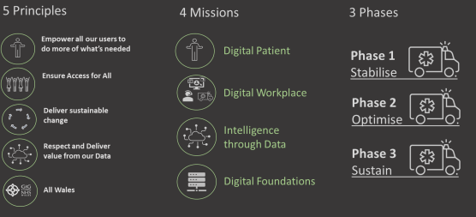 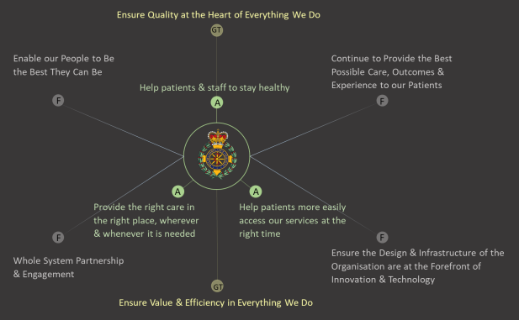
- (Welsh Ambulance Service NHS Trust 2020)

In order to modernise its operations and enhance the provision of emergency medical services, WAST has developed a digital transformation strategy that outlines major objectives, guiding principles, and initiatives.
Aims:
- Utilise technology to enhance patient care and outcomes.
- Increase operational effectiveness and efficiency, as well as worker safety
- Create a culture that values innovation and constant development.
Principles:
- Patient-centred: The concept emphasises leveraging technology to enhance patient outcomes and providing patient-centred care.
- Collaboration: To enhance the delivery of medical services, the strategy underlines the value of working cooperatively with other healthcare professionals, emergency services, and community partners.
- Agile: The strategy is made to be flexible and adaptive to changing conditions, enabling WAST to act swiftly in response to new possibilities and problems.
- Data-driven: The strategy places a strong emphasis on the value of utilising data to guide decisions and gauge the success of digital transformation activities.
Programmes:
- Digital infrastructure: This programme aims to strengthen WAST's network, hardware, and software systems, as well as its digital infrastructure.
- Digital services: EPCR, mobile working solutions, and clinical decision support tools are just a few of the digital services that the strategy wants to improve.
- Digital transformation: This plan attempts to use technology to change how WAST operates and conducts its business. This includes integrating its systems and creating new digital services.
- Digital innovation: This programme aims to promote an innovative culture within WAST by motivating employees to provide fresh concepts and solutions to enhance the provision of emergency medical care.
The overall vision of WAST's digital transformation strategy is to assist the service's efforts in using technology to improve patient care and operational efficiency and effectiveness. ‘The intent will be to identify challenges across our emergency, urgent and non-emergency pathways and reduce unnecessary waste through innovative uses of data and technology and support to our people providing the services in order to give our patients the best possible standard of care.’ (Welsh Ambulance Service NHS Trust 2020).
Infrastructure
WAST has a robust infrastructure in place to provide all users with services that are secure, dependable, and efficient. The Trust is dedicated to enhancing its functionality, dependability, and capability to cater to those patients' needs.
As mentioned in the strategy, CAD systems, mobile data terminals, and EPCR are just a few of the many systems that make up WAST's current infrastructure. Mobile phones, iPads, and digital radios are some of the tools the service employs to enhance patient care.
The current infrastructure faces a number of difficulties, such as restrictions on data integration and sharing, a lack of system compatibility, and problems with system security and resilience. WAST may also face challenges with the service's physical infrastructure, including the requirement to modernise buildings and vehicles to support digital technologies.
WAST takes security very seriously and has solid policies in place to safeguard patient data and make sure IT systems are reliable and secure. To prevent unauthorised access to its systems and data, the trust adheres to data protection laws and upholds strict security protocols. Firewalls, biometric authentication, and ‘Trustwave Link Validator’ (cybersecurity software) are some examples of this. ‘The Trustwave link validator is part of the ‘Trustwave SEG Blended Threat Module’. ‘A blended threat is an attempt to compromise information security that uses multiple vectors. ‘The Trustwave SEG Blended Threat Module uses a number of validation methods, including real-time behavioural analysis and content inspection, to identify and block sites that serve suspicious or malicious code.’ (Trustwave 2022).
Interoperability
WAST has increased system interoperability significantly during the past few years. In order to enhance data sharing and facilitate clinical decision making, the service has placed a special emphasis on integrating its CAD system, ePCR, and other clinical systems.
The National Welsh Caller Handling Platform and the CAD system are now completely connected, allowing WAST to communicate with other healthcare professionals and emergency services. The service has implemented the Welsh Clinical Portal (WCP), which gives clinicians access to a variety of patient data, hospital records, test results, and prescription information, enhancing the coordination of care across various settings. WAST has also made investments in mobile working solutions that give staff members access to patient data and clinical decision-making tools while they're on the go. The service has also put the ePCR into use, allowing employees to gather and communicate patient data in real-time, lowering the chance of mistakes and enhancing patient safety.
Due to the demographic reach of WAST some patients live in areas bordering NHS England but at this moment in time the systems used by WAST and NHS England do not always communicate meaning patient information is not always transferrable. WAST have a solid working relationship with English hospitals on the Welsh Borders, and they have access to the ePCR Portal as well.
Information standards
In order to ensure consistent and correct recording of patient and clinical information, the Trust employs a range of controlled terminology. These include codified systems like SNOMED CT (Systematised Nomenclature of Medicine Clinical Terms) for clinical terms and procedures and ICD-10 (International Classification of Diseases, 10th revision) for diagnosis coding.
To make sure that every data element is precisely specified and explained, data dictionaries are employed. Data dictionaries give a thorough explanation of each element, including its name, meaning, and use. This makes it possible to guarantee that every member of staff who records, accesses, or uses patient data is aware of its meaning and use.
To make sure that every data element is precisely specified and explained, data dictionaries are employed. Data dictionaries give a thorough explanation of each element, including its name, meaning, and use. This makes it possible to guarantee that every member of staff who records, accesses, or uses patient data is aware of its meaning and use.
Data analytics capabilities
WAST uses a business intelligence tool or performance dashboard for performance metric analysis and reporting. Real-time information on critical performance parameters, including response times, patient outcomes, and operational effectiveness, is provided through this platform. This information is used to pinpoint areas that need improvement and to support decisions about how to allocate resources and provide services. Teams may monitor the metrics most pertinent to their work thanks to its configurable visualisation, which also offers more in-depth research and data analysis.
Strategic Analysis
In order to evaluate the WAST digital strategy two tools were used and are discussed below-.
PESTLE analysis is one of the most often utilised models for assessing the extremely dynamic external business environment is the PESTLE analysis. It provides a tool for situational analysis in evaluation processes. A firm connects with the outside environment in the course of its activities, and it has no control over these elements. The foundation for identifying opportunities and risks is the PESTLE analysis. This tool can be used by the organisation to update its strategies in light of emerging trends or to analyse risk in order to generate response strategies. An organisation will be able to build or introduce better systems or processes to improve services or outcomes by having a better understanding of external trends and threats. (Perera, R 2017). In terms of WAST it is important to always evaluate the digital technology used for individual services e.g., NHS 111 or 999 to ensure opportunities are not missed to improve the access to all. One of the limitations of this model is that technology develops very quickly which means they may become outdated quicky.
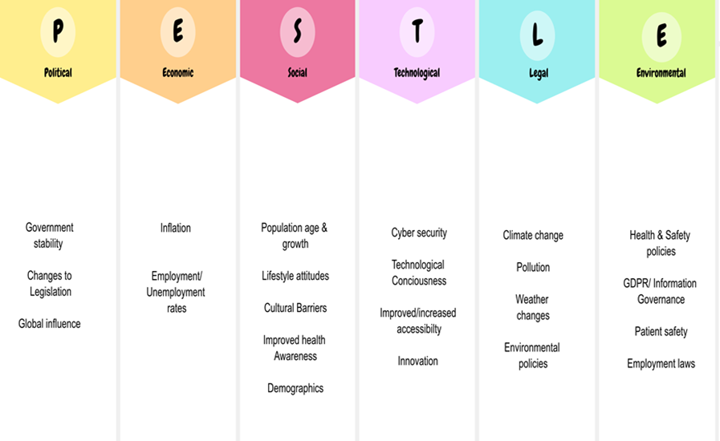

Factor | Impact on Digital Transformation Strategy Score (1 = low 10 = High) | Explanation
Political | 6/10 | The Welsh government have made a point of expressing its dedication to enhancing healthcare through technology, which may benefit WAST’s digital strategy. Political choices, however, may also have an impact on the budget and funding for digital projects. WAST’s strategy recognises the political climate and the government's influence on the development of healthcare laws and regulations. However, there is little discussion of how political factors might affect the way in which the strategy is implemented.
Economical | 6/10 | Through the creation of jobs, improved efficiency, and improved health outcomes, WAST’s digital approach may have a substantial impact on the economy. Economic effects could also result from the strategy’s implementation costs and the requirement for continuous maintenance. In the strategy document, it is discussed how the digital transformation of healthcare could have positive economic effects like higher productivity and lower prices. It does not, however, offer a thorough evaluation of the strategy's economic effects or how they will be paid for.
Sociological | 8/10 | WAST’s digital transformation strategy is likely to be well-received by both patients and healthcare providers given the growing acceptance of technology. However, it is crucial to make sure that the plan is inclusive of all facets of society. When implementing digital transformation initiatives, such as the need to address health inequalities and ensure patient-centred care, the strategy document recognises the significance of taking sociological factors into account. The necessity of cooperation and relationships with other groups and stakeholders is also emphasised in the strategy.
Technological | 9/10 | The digital transformation strategy for WAST is inextricably linked to technology, and there are lots of interesting potential to use new platforms and technologies to enhance patient outcomes. The need to ensure security and privacy, for example, is one of the new issues that technology improvements may bring about. WAST’s strategy details a number of specific initiatives relating to technology, including telemedicine and digital patient records, and places a strong emphasis on using technology to enhance healthcare outcomes.
Legal | 8/10 | Legal aspects such as data protection laws may have an impact on the digital transformation strategy of WAST. However, there are also chances to use legal frameworks, like telemedicine laws, to the strategy’s advantage. The strategy recognises the legal and regulatory framework, such as data protection legislation, under which NHS Wales operates. However, it does not offer a thorough analysis of the legal ramifications or how potential legal issues might affect how the strategy is implemented.
Environmental | 6/10 | Despite WAST’s digital transformation strategy’s low likelihood of having substantial, direct environmental impact, it might have an indirect effect, such as reducing healthcare provider’s travel time. To avoid having a negative environmental impact, it’s crucial to make sure that any digital infrastructure installed is sustainable. WAST’s digital strategy makes no specific mention of environmental considerations, such as the environmental effects of digital transformation.

The digital strategy scores relatively high overall in terms of sociocultural and technological aspects, but low in terms of economic, legal, and environmental aspects. WAST may be better able to foresee and address any risks and difficulties to the successful implementation of their plan by adopting a more thorough approach to taking into account these aspects.
SWOT analysis
According to (Helms and Nixon, 2010), a technique called SWOT analysis can be applied to planning. SWOT analysis is a tool for strategic positioning that is utilised in practically every published business case meant for company analysis, and it has been extended beyond enterprises to encompass nations and industries. SWOT is also used as a teaching tool by consultants, trainers, and educators.
SWOT has many advantages – it is easy to understand, it can be applied to different levels within an organisation/strategy, it can be applied at different depths – for simple use or more detailed and complex issues. It is easy to demonstrate ideas to stakeholders when using SWOT.
Despite being widely used there are also disadvantages to using the tool. These include skewed perceptions and failing to distinguish between the data gathering and analysis phases and the ensuing decision-making.
When used well SWOT can aid decision making when developing strategies. The SWOT analysis can be used to help interpret the findings of the PESTLE analysis and is a vital part of risk management when developing a strategy.
The SWOT framework
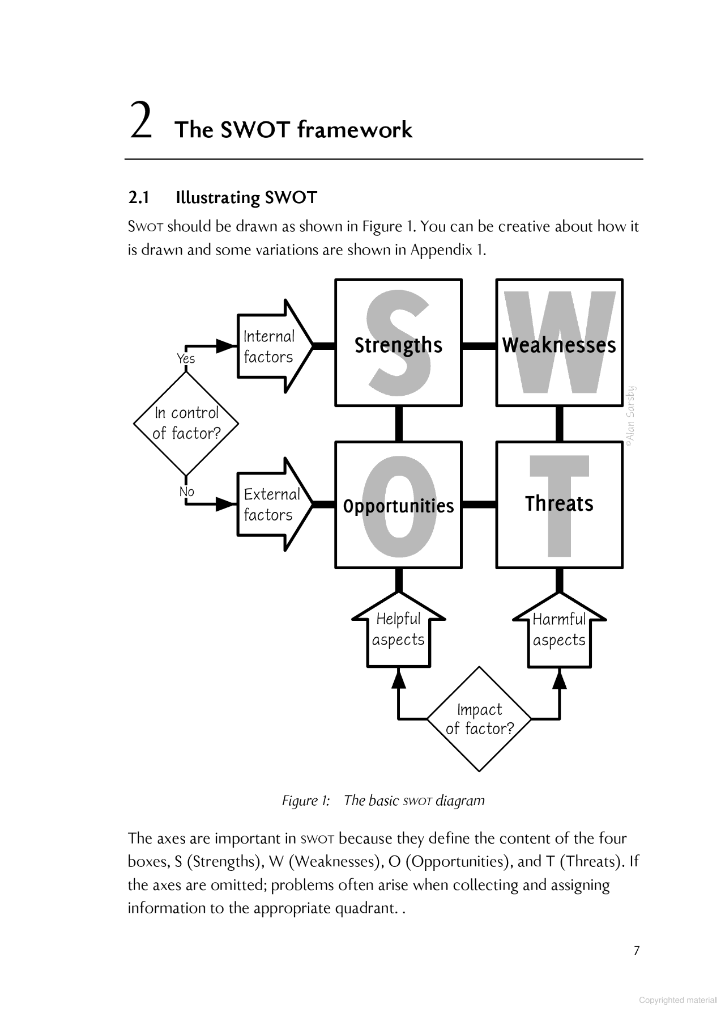(Helms and Nixon, 2010)
Strengths
- When it comes to incorporating digital tools and technology like telemedicine and electronic patient data, WAST has already achieved tremendous progress.
- As seen by its Digital Transformation Strategy, WAST has a strong commitment to utilising digital technology to enhance patient care and experience.
- A skilled and committed team that is receptive of digital efforts can be found in WAST.
Weaknesses
- With a limited healthcare budget, it may be difficult for WAST to find money for its digital efforts.
- WAST might not have the internal knowledge required to create and execute sophisticated digital tools and systems.
- WAST may have difficulties making sure that all patients, especially those with disabilities, can access and benefit from its digital efforts.
- To ensure that its digital initiatives are inclusive and accessible for all patients, especially those with poor digital literacy or access to technology, WAST may encounter difficulties.
- The strategy may be overly ambitious given the current financial climate.
Opportunities
- WAST has a lot of chances to use cutting-edge digital innovations like wearables, AI, and machine learning to enhance patient care.
- To create a more comprehensive and integrated digital healthcare ecosystem, WAST can collaborate with other healthcare institutions and providers.
- WAST can look into collaborating with digital companies to create digital tools and systems that are tailored to its specific requirements.
- Digital transformation has the potential to improve patient care and outcomes and to increase the effectiveness and efficiency of the service.
Threats
- As it adopts new digital tools and systems, WAST can run into cybersecurity risks and data protection issues.
- There may be resistance from staff or patients to adopt new technology which may limit the success of the strategy.
- WAST development and implementation of its digital strategy may present regulatory and legal problems.
Overall, SWOT analysis is a helpful tool for assessing WAST’s digital strategy. By taking into account the organization's advantages, disadvantages, possibilities, and dangers, the service can gain a deeper awareness of the digital environment in which it operates and pinpoint areas for development. In order to design and implement effective strategies, WAST can benefit from this analysis's ability to identify its strengths and opportunities while minimising its weaknesses and risks. In order to design and implement effective strategies, WAST can benefit from this analysis's ability to identify its strengths and opportunities while minimising its weaknesses and risks.
The GAP analysis is another helpful technique which could be used for assessing the WAST's digital strategy since it may show where the organization's digital capabilities are misaligned or where there are gaps. WAST could create a road map for implementing changes that will help the organisation accomplish its goals and objectives more successfully by identifying these gaps. The image below was taken from WAST digital strategy progress update document and shows the progress of some new digital initiatives being implemented and what is still required.
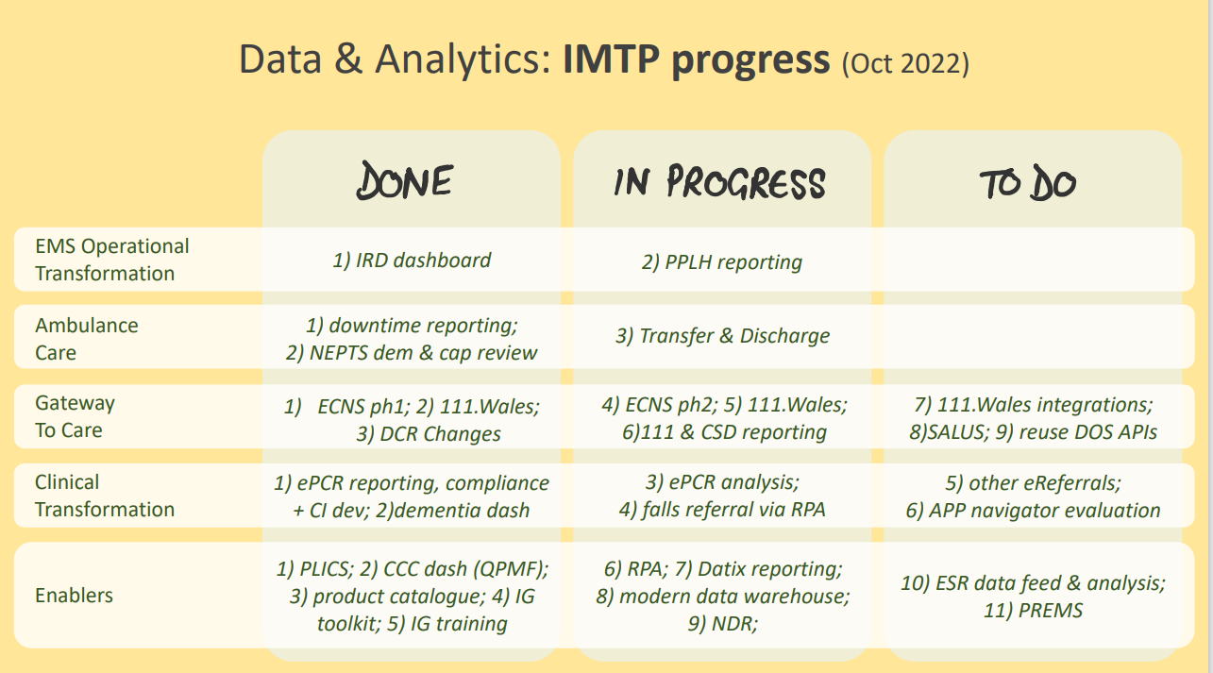
(Strategic Transformation Board November 2022)
Other analysis tools
Five Forces of Porter: To analyse the competitive pressures within an industry, a framework is used. It examines elements including supplier bargaining strength, the threat of new competitors, and the level of fierce competition. WAST can evaluate the competitive environment in which it operates and create plans to deal with the problems of competition using this framework.
Value chain analysis is a tool that assists in identifying the important tasks and procedures within a company and determining the value they provide to the enterprise. It can assist the WAST in determining how to enhance procedures and benefit all of its stakeholders.

References
- Helms, M.M. and Nixon, J. (2010). Exploring SWOT analysis – where are we now? :A review of academic research from the last decade. Journal of Strategy Management, 3(3), pp. 215-251. (online) Available at:
https://www.emerald.com/insight/content/doi/10.1108/17554251011064837/full/html
- MindTools (2021). SWOT Analysis: Discover New Opportunities, Manage and Eliminate Threats. Mind Tools Ltd (Online) Available at:
https://www.mindtools.com/pages/article/newTMC_05.htm (Accessed April 2023)
- Perera, R. (2017). The PESTLE Analysis. (Online) Available at: https://books.google.co.uk/books?id=ZWpLDwAAQBAJ&printsec=frontcover&source=gbs_atb&redir_esc=y#v=onepage&q&f=false (Accessed March 2023)
- Smartsheet. (2022). GAP Analysis Template. Smartsheet Inc. (Online) Available at:
https://www.smartsheet.com/free-gap-analysis-templates (Accessed April 2023)
- Trustwave. (2022). Trustwave Link Validator (Computer software). Trustwave holdings. Available at: https://www.trustwave.com/en-us/ (Accessed April 2023)
- Welsh Ambulance Service NHS Trust. (2021) Delivering Excellence – Our vision for 2030. Welsh Ambulance Service NHS Trust. (Online) Available at:
https://ambulance.nhs.wales/files/publications/strategies-and-plans/long-term-strategic-framework-our-vision-for-2030-pdf/#:~:text=We%20want%20to%20become%20a,and%20whenever%20it%20is%20needed. (Accessed March 2023)
- Welsh Ambulance Service NHS Trust. (2020). Our Digital Strategy 2020 – 2025. Welsh Ambulance Service NHS Trust. (Online) Available at:
https://ambulance.nhs.wales/files/publications/strategies-and-plans/digital-strategypdf/ (Accessed March 2023)
- Welsh Ambulance Service NHS Trust. (2019). The Integrated Medium-Term Plan (IMTP) 2019/20 – 2020/21. Welsh Ambulance Service NHS Trust. (Online). Available at:
https://pgab.gig.cymru/y-pwyllgor/archif-papurau/mawrth-2021/32-wast-imtp-202124-v07-draft-easc-9-march-2021/ (Accessed April 2023)
- Welsh Ambulance Service NHS Trust – Strategic Transformation Board (2022) – Digital Strategy Progress update – Data & Analytics. Available at:
STB Nov22 - data elements of digital strategy v1.pdf (Accessed April 2023)

