ACDB4011 OME Chemistry
PRACTICE PROBLEMS, Lecture 1, Precision and Accuracy in Chemical Measurements

Basic Level
- You have 3 kg of ammonium nitrate, NH₄NO₃. Convert this mass to grams and milligrams.
- An industrial nitration process to synthesise certain explosive requires a mixture of 1.58 L of sulfuric acid, H₂SO₄ and 0.21 L of nitric acid, HNO₃. What is the overall volume of the acids in mL?
- You are instructed to heat a chemical mixture to 350 K. What is this temperature in Celsius?
- You measure the mass of an explosive compound as 0.0450 g on an analytical balance. How many significant figures are in your measurement?
- Use ach diagram to report a measurement to proper number of significant figures:

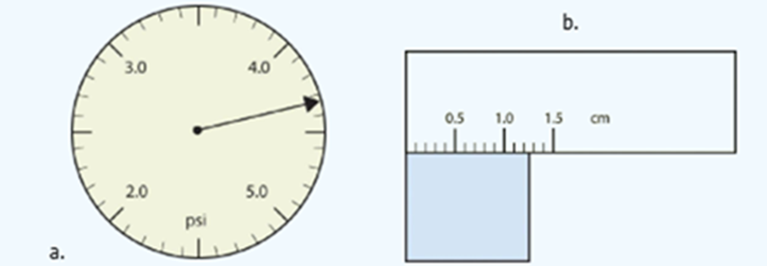

- Round 535.602 to 3 significant figures.
Intermediate Level
- The density of a liquid explosive is 1.25 g/cm³. Convert this to kg/m³ to match the units required in your safety report.
- You use a 50 mL measuring cylinder with divisions marked every 1 mL to measure 25 mL of liquid. What is the uncertainty of this measurement?
- You need to deliver exactly 10.00 mL of a solution for an explosive test. Which piece of glassware would you choose for the most accurate measurement: a 10 mL pipette, a 25 mL burette, or a 50 mL measuring cylinder? Justify your choice.
- OME technician prepares a sample of gunpowder from 24.6 g of saltpetre (potassium nitrate, KNO3), 4.913 g of charcoal (carbon) and 3.27 g of sulphur. Calculate the total mass of the gunpowder and report the answer with the correct number of significant figures.
- Complete the calculations and report your answers using the correct number of significant figures:
(a) 87.25 mL + 3.0201 mL
(b) 6 × 12.011
(c) 118.72 g − 35.5 g
(d) 77.60 / 46.467 − 4.8
(e) 24.86 / 2.0 − 3.26 × (0.98)
(f) (15.9994 × 9) + 2.015
- You are preparing a nitration reaction for synthesising an energetic material and you weigh 61.08 g of organic solvent, toluene, that has volume of 70.5 mL at room temperature (22°C). However, the experiment requires toluene to be at an elevated temperature to maintain the proper reaction kinetics. What might happen to the density of the solvent when heated from 22°C to 40°C?
Advanced Level
- Perform the following operations and express your answers in scientific notation:
(a) 3.58×10¹⁶ + 1.71×10¹⁵
(b) (6.022×10²³)×(6.42×10⁻²)
(c) 1.67×10⁻²⁴ / 9.12×10⁻²⁸
(d) (6.63×10⁻³⁴) × (6.0×10²⁹) / 8.52×10⁻²
- The pressure generated in a blast chamber is 2.5 × 10⁶ Pa. Convert this to atmospheres (atm). (1 atm = 1.013 × 10⁵ Pa)
- You need to prepare 100.0 mL of a sensitive solution. Choose the appropriate glassware for each of the following tasks:
(a) Measuring exactly 25 mL of a reagent.
(b) Mixing the solution safely without losing accuracy.
(c) Transferring precisely 35 mL of this solution into another container for testing.

