
Programme: BSC Applied computing
Module: Business and Web Management
Module Code: ACCA5019
Lecturer: Dr. Mobolanle Bello
Component 1: Website Redesign for Online Business Presence
Student Name: David Nyadu Larbi
Student Number: 2407275
June 26, 2026
Table of Contents
INTRODUCTION 1
2.0 HEALTHY HARVEST WEBSITE REDESIGN 1
Critical Analysis of the Existing Website 1
Recommendations for Improvement 2
3.0 RESPONSIVE DESIGN IMPLEMENTATION 3
4.0 IMPLEMENTATION SECTION 4
Mood Board Screenshot 4
Wireframe Screenshots 5
Web Design Screenshots 7
4.1 MOODBOARD AND WIREFRAME DESIGN 10
5.0 CONCLUSION 11
Bibliography 11

INTRODUCTION
The online retail sector, particularly within the organic produce niche, demands websites that are not only visually appealing but also highly usable, accessible, and aligned with consumer values around health, sustainability, and transparency. Customers shopping for organic products are motivated by a desire for authenticity and eco-consciousness, so their online experience needs to reflect these principles clearly. Currently, the HealthyHarvest website suffers from multiple user experience and user interface issues, including confusing navigation that makes it difficult for users to find products, outdated aesthetics that diminish brand credibility, and poor mobile responsiveness that hampers accessibility on smartphones and tablets. Additionally, the site lacks adequate transparency about product sourcing and sustainability practices, which are crucial for building trust with environmentally conscious consumers. These deficiencies collectively undermine user confidence, reduce engagement, and hinder conversion rates.
This report proposes a comprehensive redesign strategy rooted in user-centred design principles, aiming to develop an engaging, accessible, and sustainable e-commerce platform. It includes a thorough analysis of the current site, the creation of a brand-aligned visual identity, detailed wireframes for key pages, and an illustrative prototype that demonstrates seamless user flow. The focus is on technical responsiveness, aesthetic coherence, and strategic functionalities that support HealthyHarvest’s core business goals and values, ultimately enhancing user trust, increasing engagement, and driving sales in the competitive organic produce market.

2.0 HEALTHY HARVEST WEBSITE REDESIGN

Critical Analysis of the Existing Website
The current HealthyHarvest website exhibits numerous usability and user experience shortcomings that significantly hinder visitor engagement and reduce the likelihood of conversions, thereby negatively impacting the overall success of the platform. One of the primary issues is the website’s navigation and information architecture, which are cluttered and poorly organized, making it difficult for users to efficiently locate specific product categories or relevant information. Labels such as “Shop” and “Our Products” are overly generic and ambiguous, offering little guidance to users unfamiliar with the site’s structure, which can lead to frustration and increased bounce rates. Furthermore, the visual design appears outdated, characterized by dull color schemes and low-resolution imagery, which not only diminishes the brand's visual appeal but also erodes consumer trust, as modern users expect a fresh, professional aesthetic that aligns with current design standards. This outdated appearance can create an impression of neglect or lack of credibility, ultimately discouraging potential customers from making purchases.
In addition to aesthetic concerns, the website demonstrates poor responsiveness on mobile devices, which is increasingly problematic given the rising trend of mobile shopping. Layouts often break or become misaligned on smaller screens, fonts become difficult to read, and navigation becomes cumbersome, creating a frustrating user experience that deters mobile users from completing transactions. The product pages further exacerbate these issues by lacking detailed descriptions, sourcing information, and high-quality images, which are crucial for consumers seeking transparency and confidence in their purchases of organic produce. Without comprehensive product information, users are less likely to make informed decisions, leading to lower conversion rates. The checkout process itself is lengthy and redundant, often involving multiple unnecessary steps, which results in high cart abandonment rates—especially on mobile platforms where users tend to prefer quick, seamless transactions.
Moreover, the site’s functionality suffers from the absence of personalized recommendations and related product suggestions, limiting opportunities for cross-selling and upselling that could increase average order value. Accessibility features such as screen reader compatibility, keyboard navigation, or adjustable text sizes are completely missing, making the platform less inclusive for users with disabilities. Additionally, the lack of trust signals, such as customer reviews, badges, or secure payment icons, further diminishes credibility and user confidence. Performance issues, caused by unoptimized images and scripts, lead to slow page load times, which frustrate users and negatively impact search engine optimization (SEO). These technical deficiencies collectively create a poor user experience, reduce engagement, and inhibit the site’s ability to retain and convert visitors effectively.

Recommendations for Improvement
These numerous deficiencies collectively undermine user satisfaction, lower conversion rates, and impede customer retention, especially in a competitive organic produce market where trust and usability are paramount. To address these critical issues, a comprehensive, strategic redesign of the HealthyHarvest website is essential, emphasizing improvements in usability, visual coherence, accessibility, and technical performance. Simplifying the navigation structure by organizing product categories logically and labeling them clearly will make it easier for users to find what they need quickly, reducing frustration and increasing engagement. Modernizing the visual aesthetic through a fresh color palette, high-quality imagery, and contemporary design elements will help re-establish credibility and appeal to a broader audience. Ensuring the website is fully responsive on all devices is vital; layouts must adapt seamlessly to different screen sizes, fonts should remain legible, and navigation should be intuitive on smartphones and tablets.
Enhancing product transparency is another crucial step. Providing detailed product descriptions, sourcing information, and high-resolution images will empower consumers to make informed decisions and build trust in the brand’s commitment to quality and sustainability. Streamlining the checkout process by reducing the number of steps, eliminating redundant fields, and offering multiple payment options will improve the user experience and decrease cart abandonment rates. Incorporating personalized recommendations and related product suggestions will open opportunities for cross-selling and upselling, increasing overall sales and customer lifetime value.
Furthermore, implementing accessibility features such as screen reader compatibility, adjustable font sizes, and keyboard navigation will make the site more inclusive and compliant with accessibility standards. Displaying trust signals like customer reviews, badges, and secure payment icons will enhance credibility and reassure users about the safety and reliability of their transactions. Optimizing images and scripts to improve site load times will significantly enhance user experience and boost attracting more organic traffic.
Overall, a research-driven, holistic approach that targets these core areas will transform the HealthyHarvest website into a more engaging, trustworthy, and efficient e-commerce platform. This transformation will not only improve user satisfaction and foster loyalty but will also support the company’s broader business objectives by increasing conversions, expanding its customer base, and reinforcing its position in the organic produce market.

3.0 RESPONSIVE DESIGN IMPLEMENTATION
E-commerce, or electronic commerce, refers to the buying and selling of goods and services over the internet. It has revolutionized the way businesses operate and consumers shop, offering convenience, a wider selection of products, and the ability to compare prices instantly [1]. With the rapid growth of mobile device usage, e-commerce has become increasingly mobile-centric, making it essential for online retailers to optimize their websites for various devices. A well-designed e-commerce platform not only facilitates transactions but also enhances user experience, builds brand loyalty, and drives sales growth.
Implications of Responsive Design Implementation in E-Commerce Websites for Improving User Experience
Implementing responsive design in e-commerce websites significantly enhances user experience by providing a seamless and consistent interface across all devices. Responsive design ensures that website layout, images, and navigation adapt to different screen sizes, making browsing intuitive and easy whether users access the site via desktops, tablets, or smartphones. This adaptability reduces frustration caused by distorted layouts or difficult navigation, encouraging users to stay longer and explore more products. Moreover, responsive websites improve accessibility by accommodating various devices and assistive technologies, broadening the potential customer base. Additionally, a well-implemented responsive design can boost site speed and performance, which are critical factors in user satisfaction, as slow-loading sites often lead to high bounce rates. Overall, responsive design creates a cohesive and engaging shopping experience that fosters trust and encourages repeat visits.
Implications of Responsive Design in E-Commerce Websites for Improving Mobile Sales
Responsive design plays a crucial role in increasing mobile sales by optimizing the shopping experience for mobile users, who constitute a growing segment of online shoppers. A mobile-friendly site simplifies navigation, streamlines the checkout process, and displays products clearly on smaller screens, reducing barriers to purchase. Features such as thumb-friendly menus, larger buttons, and simplified layouts make it easier for users to browse, select, and complete transactions quickly. Furthermore, responsive design improves page load times on mobile networks, minimizing delays that often cause users to abandon their carts. By providing a consistent and user-friendly interface across all devices, businesses can reduce drop-off rates and boost conversion rates from mobile visitors. Ultimately, responsive design enables e-commerce platforms to tap into the expanding mobile market, increase sales volume, and enhance overall revenue.

4.0 IMPLEMENTATION SECTION

Mood Board Screenshot
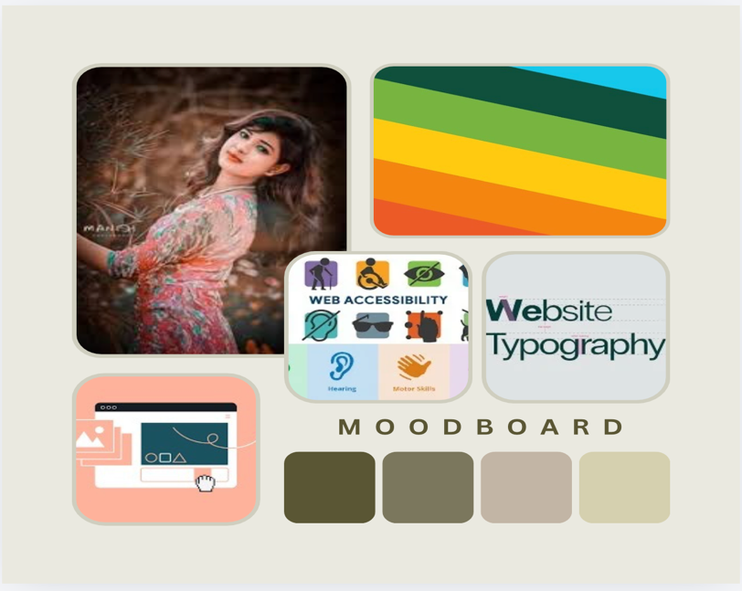

Figure 1 Mood board

Wireframe Screenshots

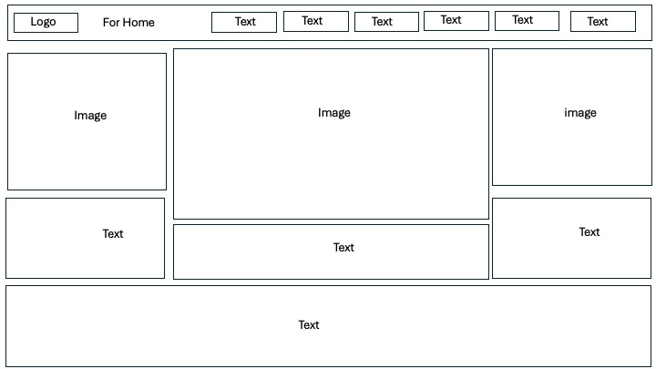

Figure 2 Wireframe Home page

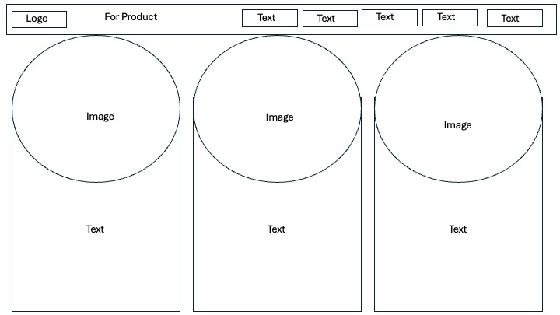

Figure 3 Wireframe Product page
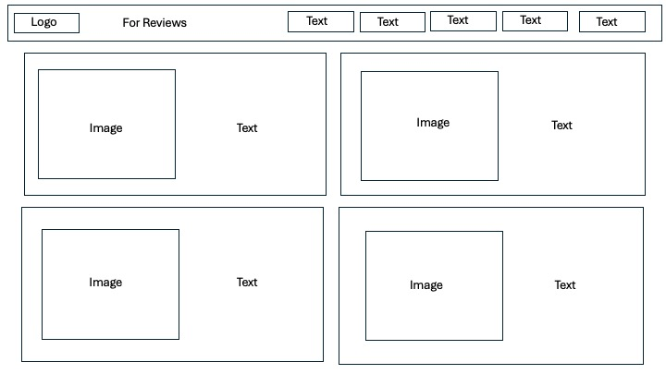

Figure 4 Wireframe Reviews page
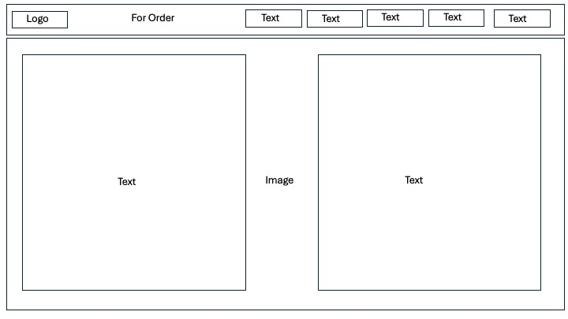

Figure 5 Wireframe Order page

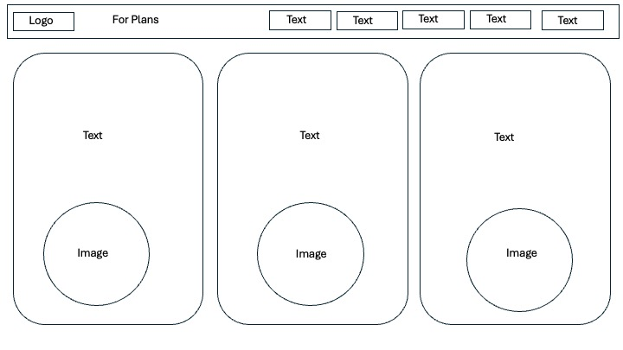

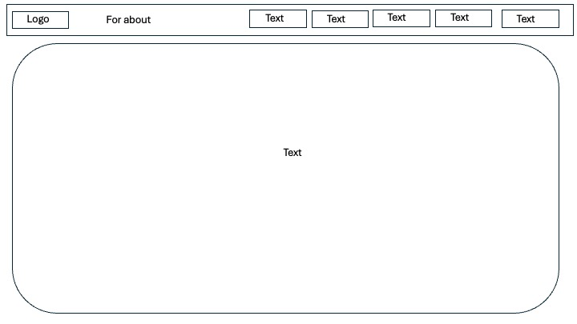
Figure 6 Wireframe Plans page

Figure 7 Wireframe About page

Web Design Screenshots
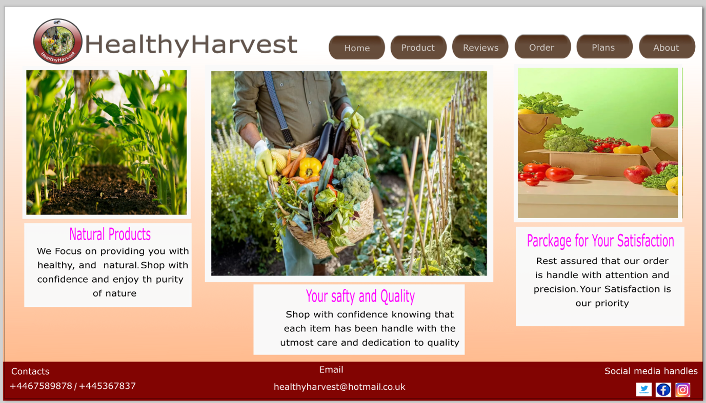

Figure 8 Home page
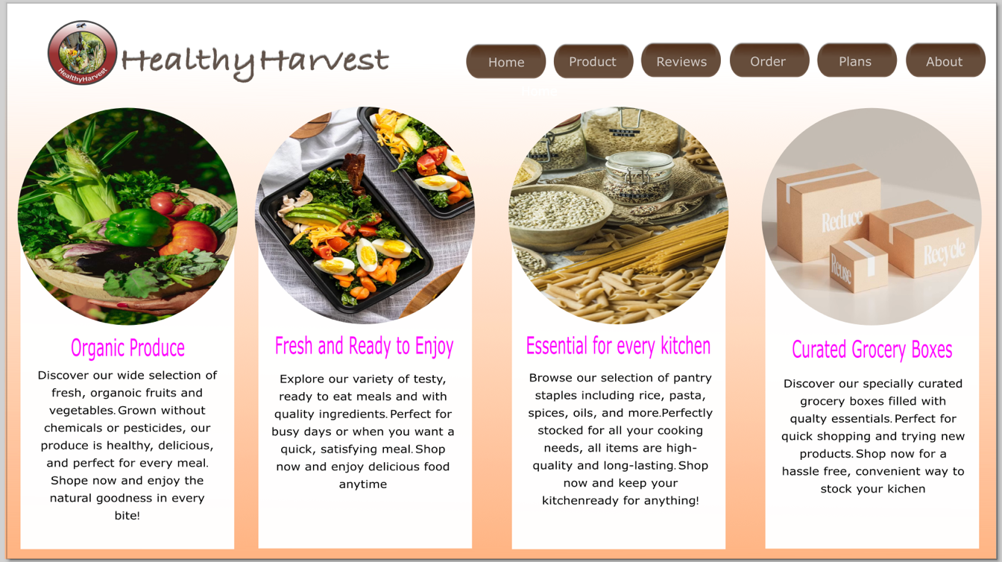

Figure 9 Product page

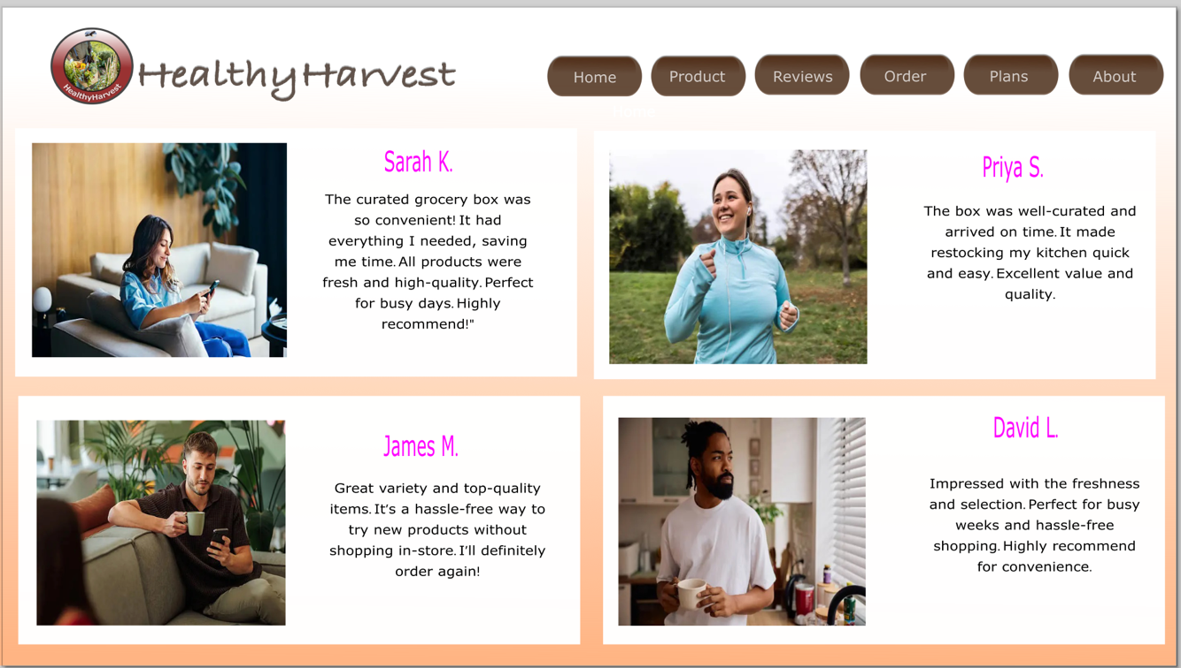

Figure 10 Reviews page
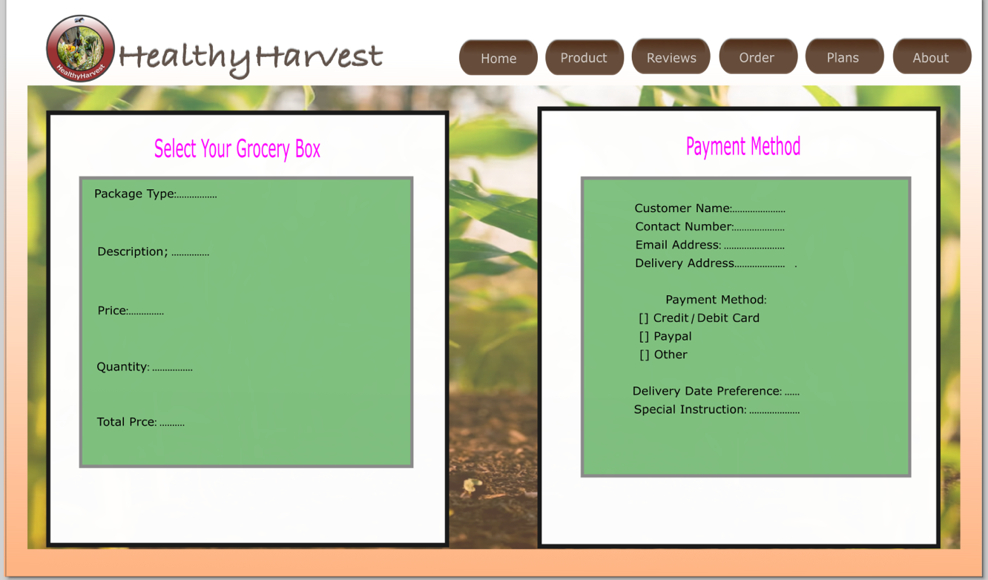

Figure 11 Order page

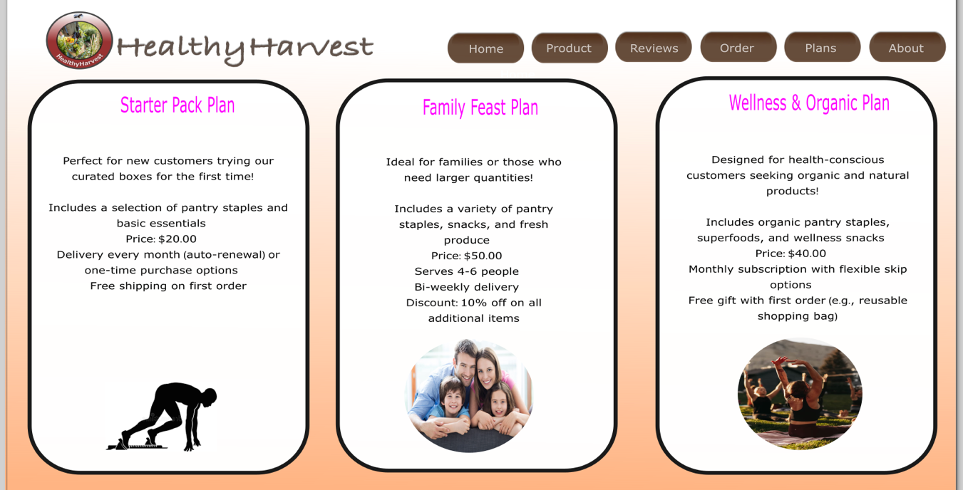

Figure 12 Plans page
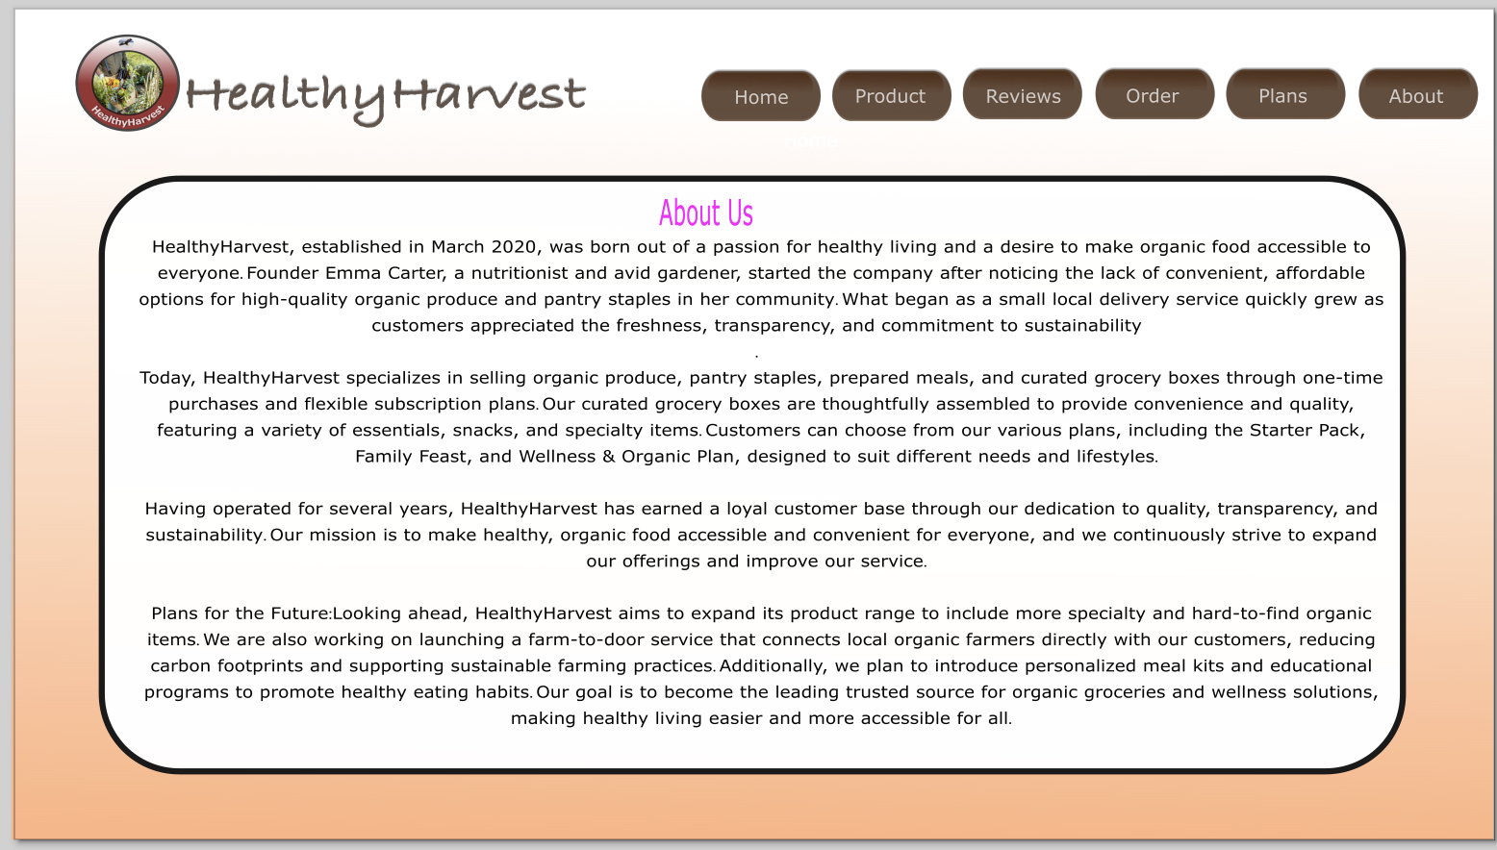
Figure 13 About page

4.1 MOODBOARD AND WIREFRAME DESIGN
A mood board in webpage design is a visual compilation of images, colours, typography, textures, and design elements that illustrates the overall look, feel, and aesthetic direction of a website project. It functions as both a reference and an inspiration tool for designers, clients, and stakeholders, helping to establish a shared understanding of the desired style and mood before progressing to detailed design and development. Mood boards are essential for maintaining consistency in visual language, evoking specific emotions or reinforcing brand identity, and guiding style decisions throughout the web design process. One common challenge for designers is effectively communicating emotions and ideas to clients during the conceptual phase. In this context, mood boards comprising a curated selection of images and words are invaluable for synthesizing a client’s perceptions and providing clear guidance on visual communication [1].
A wireframe is a fundamental schematic or visual guide that illustrates the core structure, layout, and functionality of a single webpage screen, serving as a basic blueprint that outlines the placement of essential elements such as headers, navigation menus, content sections, images, and interactive features, providing a clear overview of how the page will be organized and how users will interact with it. [2].

I find that mood boards and wireframes are indispensable tools that significantly enhance and streamline my web design process, as they provide a structured framework for both visual inspiration and functional planning. I use a mood board to define and establish the overall aesthetic, emotional tone, and mood of the website, bringing together a carefully curated collection of images, colours, typography, textures, and other visual elements that work together to create a cohesive and compelling visual identity. This not only helps me clarify my design direction but also ensures that everyone involved in the project whether clients, team members, or stakeholders shares a common understanding and agreement on the desired look and feel. Such alignment guides my decisions related to style, branding, and user experience throughout the design process, making sure that the final product resonates with the intended audience and accurately reflects the brand’s values.
At the same time, I employ wireframes as skeletal blueprints that map out the structure of the webpage, indicating where key elements such as headers, navigation menus, images, content sections, and interactive components will be positioned. Wireframes help me plan the user flow, organize content logically, and proactively identify potential usability issues or navigation bottlenecks early in the development stages. By combining the strong visual guidance derived from the mood board with the precise structural outline provided by the wireframes, I am able to create web pages that are not only visually attractive and aligned with the intended aesthetic but also highly functional, easy to navigate, and optimized for an engaging user experience that effectively communicates the brand’s message.

5.0 CONCLUSION
Reflecting on this project, I recognize that the design process played a crucial role in developing a high-quality website that effectively aligns with Healthy Harvest’s business objectives and core values. Through thorough analysis of the existing platform, I identified key usability and aesthetic deficiencies that hindered user engagement and trust. By employing user centred design principles, I was able to create a comprehensive redesign strategy that emphasizes accessibility, visual coherence, and functionality, all tailored to meet the needs of environmentally conscious consumers seeking transparency and quality. The use of mood boards and wireframes was instrumental in establishing a clear visual identity and a structured layout, ensuring consistency and ease of navigation throughout the website. This structured approach allowed me to address technical responsiveness, streamline the user journey, and incorporate strategic features such as detailed product information, personalized recommendations, and trust signals, which collectively enhance user experience and foster brand credibility. Ultimately, this project reinforced the importance of a methodical, research-driven design process in delivering a website that not only meets aesthetic standards but also supports business growth, increased conversions, and customer loyalty in a competitive organic market.

Bibliography

[1] | Qin, Zheng and Wang, Guolong and Deng, Wanqiu and Hao, Yanli, Introduction to E-commerce, Springer Nature, 2025.
[2] | Cristina Nardin Zabotto, Silva Sergio Luis, Daniel Capaldo, and other, “University of wales Trinity Saint David,” November 2019. [Online]. Available: https://www-sciencedirect-com.uwtsd.idm.oclc.org/science/article/pii/S0169814119300988. [Accessed 26 Thursday June 2026].
[3] | Yudhanto, Yudho and Pryhatyanto, Wahyu Mangantasno and Sulandari, Winita, Designing and making UI/UX designs on the official website with the design thinking method, 2022, pp. 165 - 170.

