OPERATING SYSTEMS, CLI COMMANDS AND SCRIPT AUTOMATION
Report and Practical Evidence Portfolio

Student name: Rao M A Siddique
Student number: 2531847
Course name: Computer Architecture and Operating Systems
Module name: ACCA4022
Assessment: Operating Systems / CLI and Scripting
Submission date: 12/08/2026

Table of Contents

If the table of contents is not populated automatically, right-click it in Word and select “Update Field” → “Update entire table”.

Introduction
An operating system (OS) is software that coordinates hardware, applications, users, and system resources. This report covers the core functions of a general-purpose operating system and then applies them to Windows and Linux command-line interfaces (CLI). PowerShell/Batch and Bash are practical in how to process files, networks, users, and scheduling. Small scripts are also produced in order to illustrate how command-line automation can reduce repetitive work and achieve repeatable system management. Vendor documentation and technical references guide the discussion and evidence placeholders list where the student’s own screenshots and course-activity evidence should be added.

1. Key Functions of General Operating Systems
A general-purpose operating system acts as an intermediary between applications and physical resources. It is responsible for process management, memory management, file system management, device and I/O management, networking, security/access control, resource allocation and performance monitoring [1], [2]. All these functions are very related and have similar tasks. For example, a process needs CPU time and memory, accesses files in the file system, communicates through networking services and operates under the permissions of a user or service account. Process management manages the creation, execution, scheduling and termination of processes. Windows shows this through Task Manager, which allows processes and resource usage, users and services to be assessed. Microsoft describes Task Manager as an integrated system to monitor application and process performance [3]. PowerShell provides a programmable alternative: Get-Process returns process objects and allows for filtering by name or PID [4]. Linux provides similar visibility via ps, but longer-running observation can be done with top. The Linux ps tool reports a snapshot of current processes [5]. Memory management allocates RAM and virtual memory to processes while trying to keep process performance and isolation. Windows documentation explains that working-set and virtual-allocation information can be used to understand application memory consumption [6]. In Linux, the kernel memory management subsystem does virtual memory management, which requires paging and memory allocation for kernel and user-space programs [7]. This demonstrates that memory management is more than just showing free RAM; the OS manages mappings, pages and resource pressure. File system management keeps files, directories, names, permissions and metadata organized, and is a core OS responsibility. IBM identifies file system management as essential to create and retrieve files in Windows PowerShell because the system has to ensure the permissions and the organization of the data in the files. Linux uses ls and find; ls can show hidden entries and detailed metadata, while find searches directory hierarchies using expressions [9], [10]. Device management and I/O provide common interfaces to hardware such as disks, keyboards, displays and network interfaces. Networking is also an OS service because TCP/IP communication, interfaces and routing depend on system-level configuration. Linux has the ip command which can display or manipulate network devices and routes [11], while Windows has PowerShell networking cmdlets and traditional utilities such as ipconfig. Security and access control provide authentication, account management and authorization. The Windows net user can display, create, modify and delete accounts [12], while Linux user add creates accounts with options for home directories, groups and shells [13].

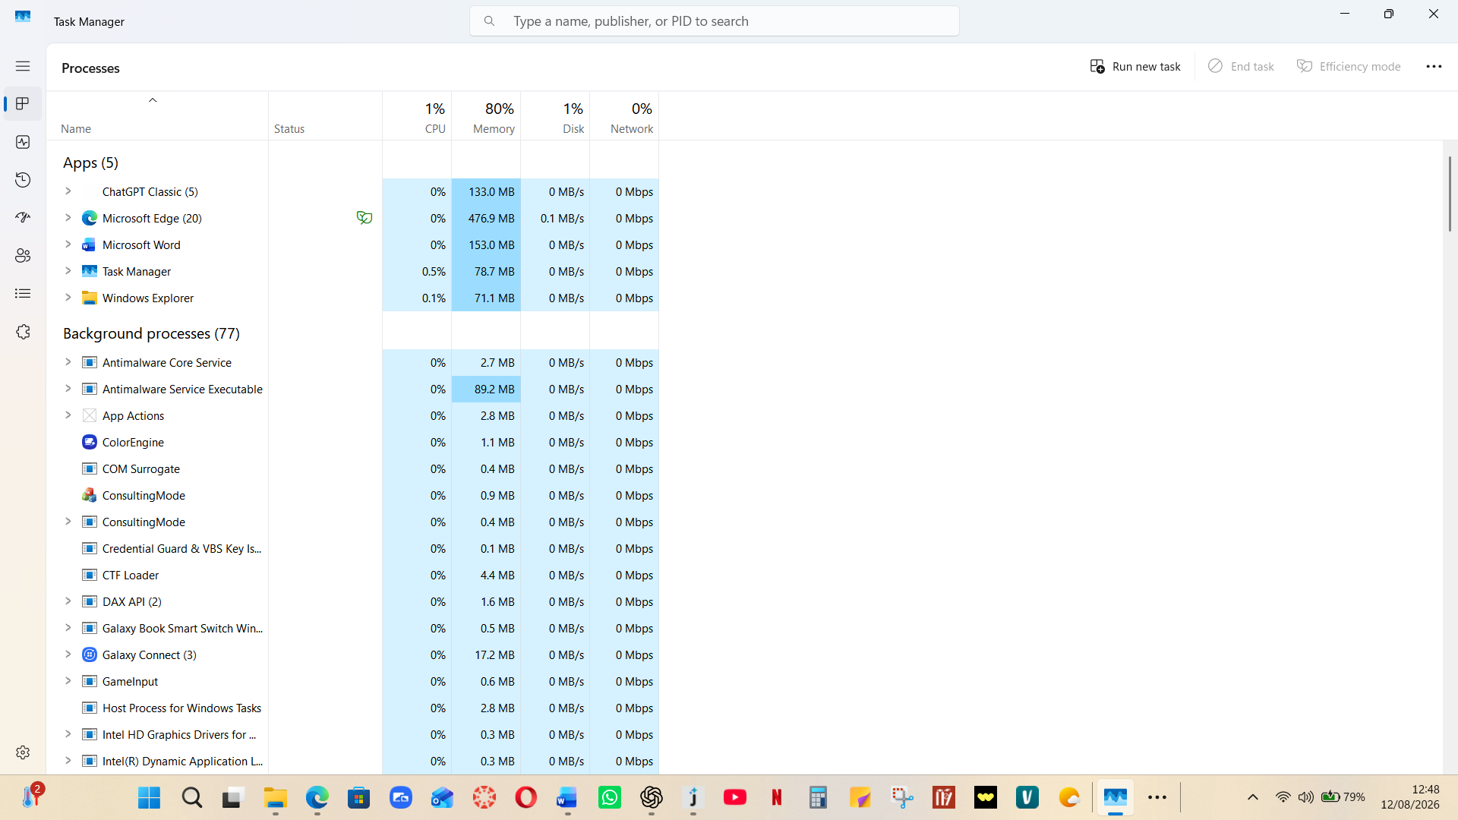
Figure 1A. Windows service management (illustrative screenshot).

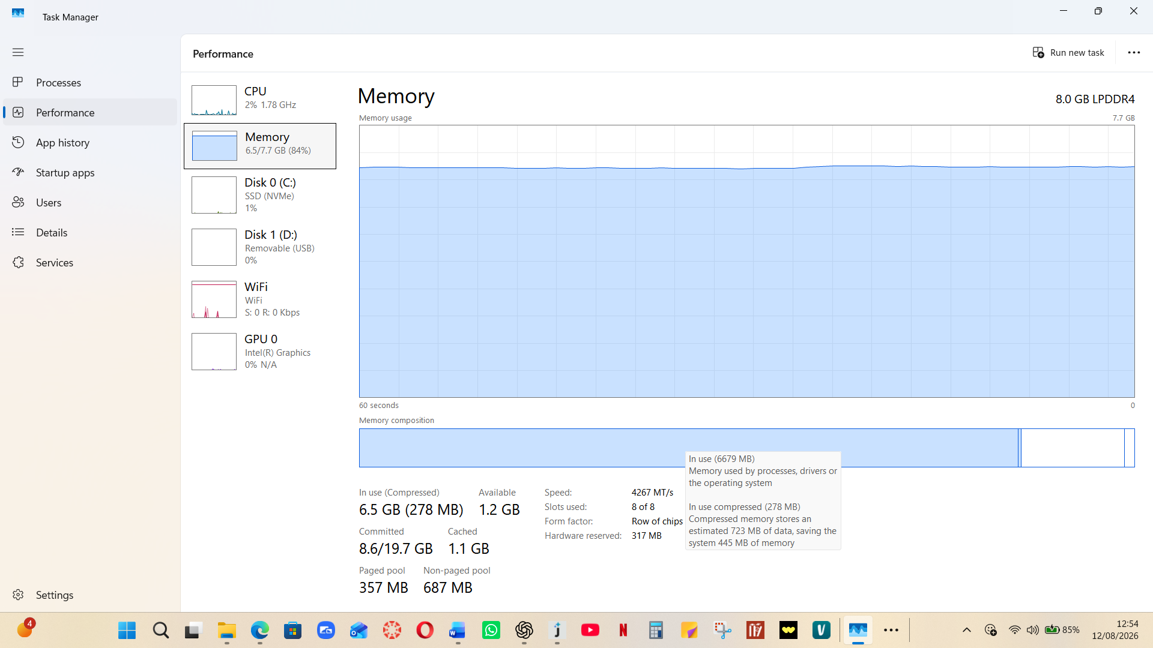

This screenshot shows Windows Task Manager → Performance → Memory. You can use the following explanation directly under the screenshot in your report:

Figure: Windows Task Manager - Memory Performance.

This screenshot shows the memory management and system monitoring function of the Windows operating system. Task Manager provides real-time information about how the computer’s physical memory (RAM) is being used by the operating system and running applications.

The system has 8.0 GB of LPDDR4 RAM, of which approximately 6.2 GB (81%) is currently in use, leaving around 1.5 GB available. The high memory consumption indicates that most of the RAM used is currently being used by Windows and active applications. Windows uses RAM to store programs and data that are actively required, allowing applications to access them much faster than they can from storage.

The Memory usage graph shows how RAM utilisation has changed during the last 60 seconds. In this screenshot, the graph is relatively static and memory usage has not changed significantly during that period. The value of In use (Compressed) of 6.2 GB contains memory actively being used, with around 493 MB compressed. Memory compression allows Windows to store more data in RAM without necessarily going to slower disk-based virtual memory.

The screenshot also shows the available memory of 1.5 GB and the cached memory of 1.4 GB. The cached memory contains the data that Windows can use if required. The committed value of 8.5/19.7 GB is the committed virtual memory, while the hardware-reserved value of 317 MB is the RAM reserved for hardware functions.

Other information includes the memory speed of 4267 MT/s, the LPDDR4 memory type, and that 8 of 8 memory slots are used. The left-hand panel also provides fast information about CPU, disk, Wi-Fi, and GPU performance.

The screenshot as a whole provides concrete evidence of OS memory management and performance monitoring functionality. It shows how Windows monitors RAM usage and provides administrators/users with information that can be used to identify high memory usage and potential performance problems.
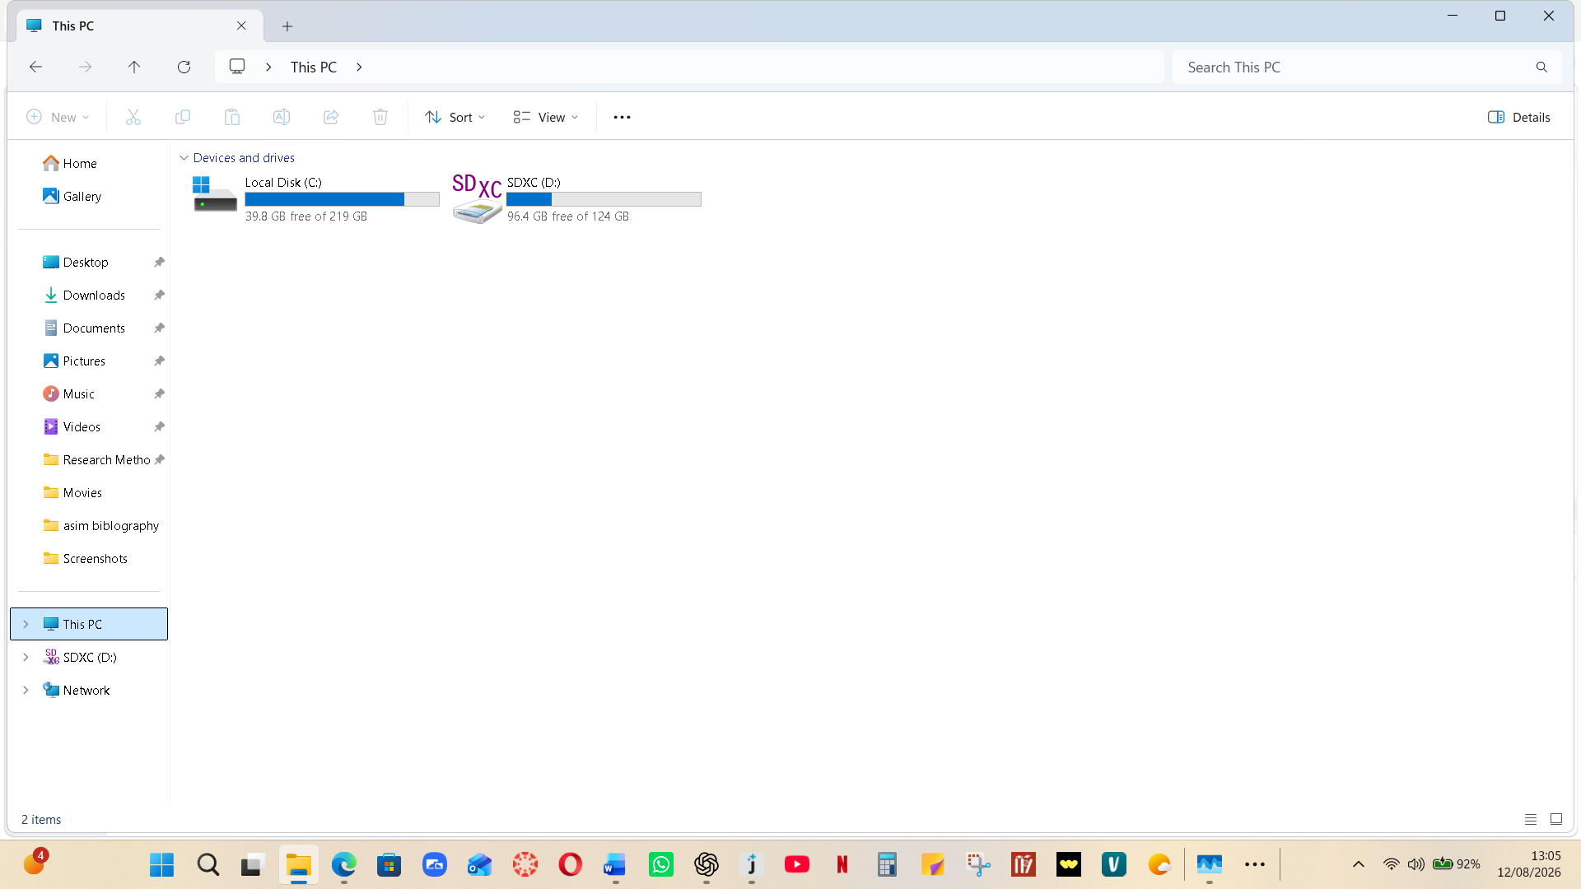
This screenshot shows Windows File Explorer - This PC showing the operating system’s file and storage management. It lists the available storage devices: a Local disk (C:) with 39.8 GB free of 219 GB and an SDXC drive (D:) with 96.4 GB free of 124 GB. Users can access, organize, copy, move, delete, and manage files and folders through this interface.

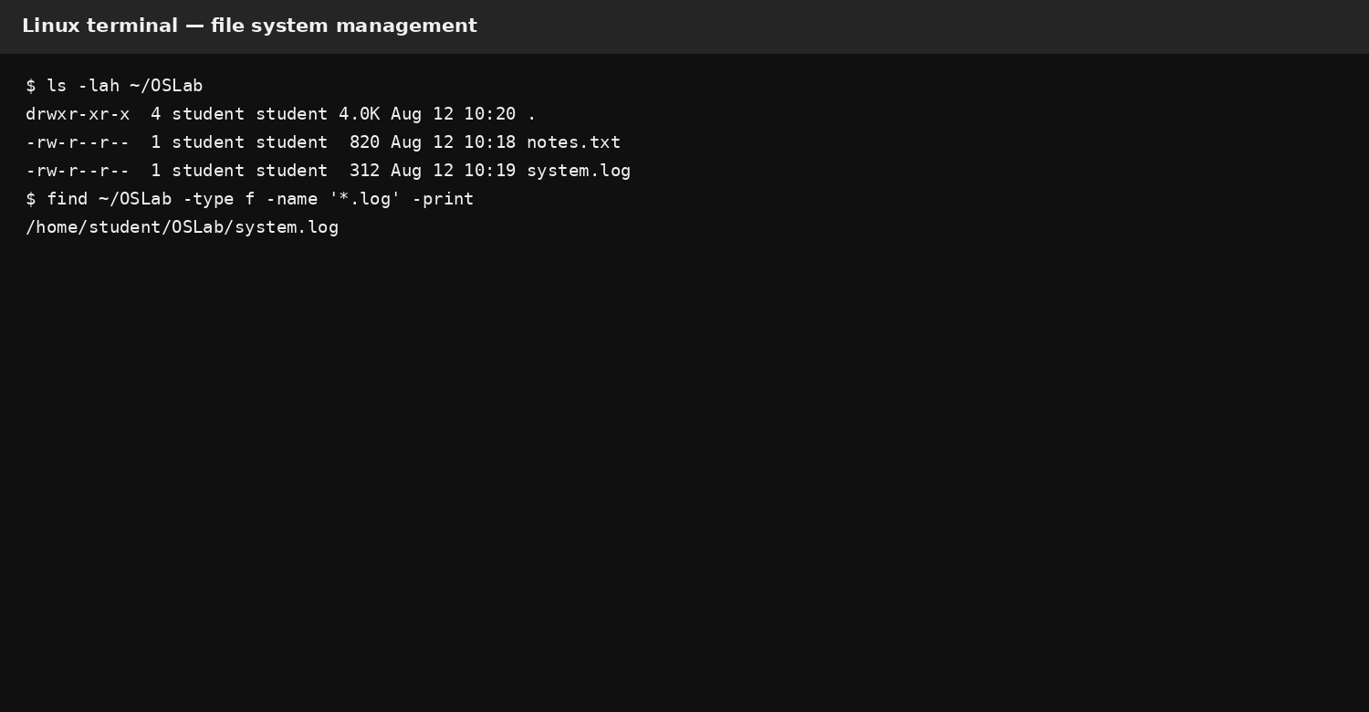
Figure 1B. Linux file-system management (illustrative screenshot).
Finally, scheduling and monitoring are reliable. Windows Task Scheduler can run programs at specific times or when events happen [14], and schtasks display these operations using the CLI [15]. Linux cron uses crontab files to set commands that run at specified times (e.g., @daily or @reboot). Together, these functions demonstrate why an OS is more than a graphical desktop: it is the control layer that allocates resources, provides interfaces and enforces system-wide policies.

2. Use of Windows OS CLI Commands
The following PowerShell and Windows command line activities provide a practical administration set. Each command should be run on the student's Windows test system and captured with the command and output visible. PowerShell is especially useful since many cmdlets return structured objects instead of plain text, and filtering and sorting can be chained together [4], [8]. The examples below are intentionally low-risk; commands that modify accounts or scheduled tasks should only be run in an approved lab environment. Get-Process | Sort-Object CPU -Descending | Select-Object -First 5 — Process management: identifies the five processes with the most CPU time. Get-Process -Name explorer | Select-Object Id, Process Name, CPU — Process management: retrieves a specific process and selected properties. Get-Child Item -Path $HOME -File -Recurse -Depth 2 — File/directory management: recursively lists files to a limited depth. New-Item -Path "$HOME\OSLab" -ItemType Directory -Force — File/directory management: creates the laboratory directory; -Force avoids failure if it already exists. Copy-Item "$HOME\OSLab\notes.txt" "$HOME\OSLab\backup.txt" -Force — File management: copies a file and overwrites an existing destination when required. Test-Connection 8.8.8.8 -Count 4 — Network testing: sends four ICMP echo requests to test reachability. Get-NetTCPConnection -State Established | Select-Object -First 10 — Network monitoring: lists established TCP connections. ipconfig /all — Network monitoring: shows detailed adapter configuration, addresses and DNS information. Get-Local User | Select-Object Name, Enabled, Last Logon — User management: reviews local user accounts and selected account properties. net user — User management: lists local user accounts; Microsoft provides options for viewing, adding, modifying and deleting accounts [12]. schtasks /query /fo LIST /v — Task scheduling: queries scheduled tasks in verbose list format [15]. schtasks /query /tn "\Microsoft\Windows\Defrag\Scheduled Defrag” Task scheduling: queries one named task; /tn selects the specific task [15].
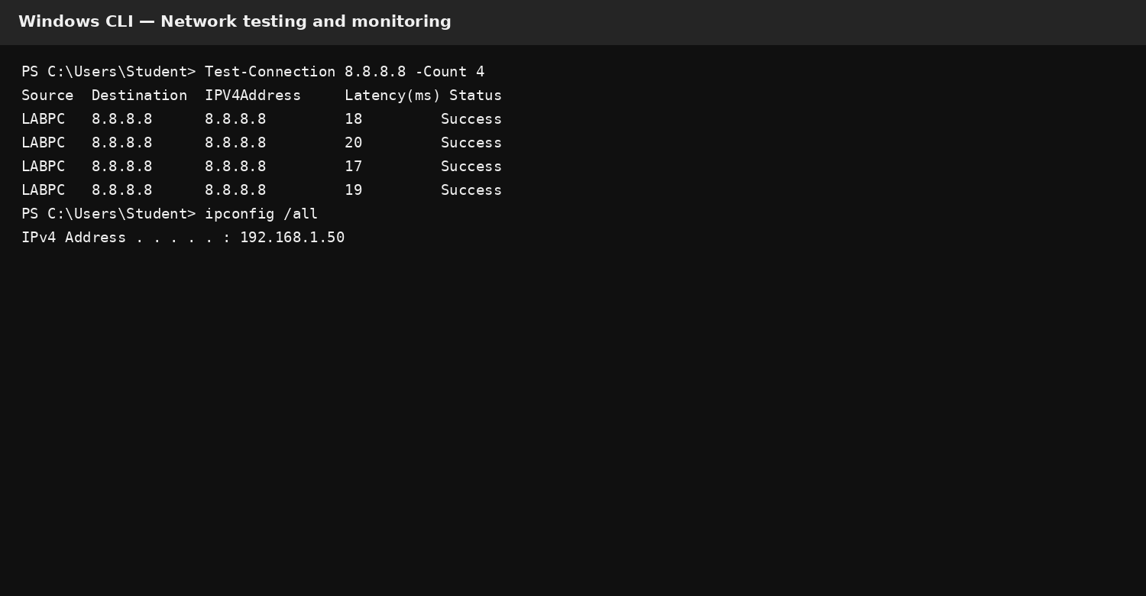
Figure 2A. Windows network testing/monitoring (illustrative screenshot).
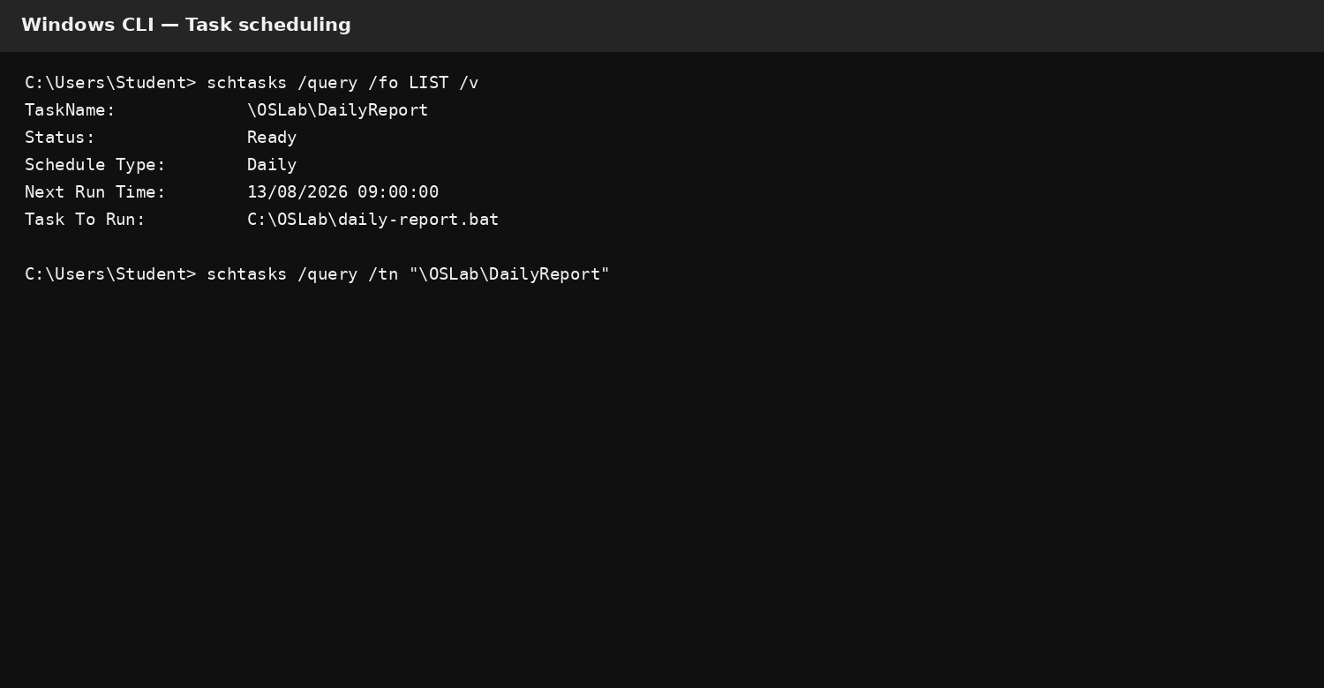
Figure 2B. Windows scheduled-task query (illustrative screenshot).
These commands show the five main areas needed without a single interface. Process commands show resource use and identity; file commands show how directories and files can be manipulated; network commands test connectivity and examine active connections; account commands provide local administration; and schtasks provide CLI access to Windows Task Scheduler. Microsoft confirms that schtasks can query, create, change, run and end scheduled tasks [15]; Task Scheduler itself is designed to execute programs at chosen times or in response to events [14].

3. Use of Linux OS CLI Commands
Bash provides a text-based interface to interact with Linux and is widely used for administration and automation. Ubuntu describes the command line as a text interface that can manipulate files and command chaining [17] and the GNU Bash manual includes shell variables, conditional constructs, loops and arithmetic [18]–[20]. The following commands cover the same administration themes as the Windows section and can be helpful for comparison. 1. ps aux --sort=-%cpu | head -n 6 — Process management: shows the processes sorted by CPU usage and keeps only the first six lines [5]. 2. pgrep -a bash — Process management: is to find Bash processes and print their command lines. 3. ls -lah ~/OSLab — File/directory management: displays long, human-readable and hidden files [9]. 4. mkdir -p ~/OSLab/{logs, backup} — File/directory management: creates nested directories and does not fail when parent directories already exist. 5. find ~/OSLab -type f -name '*.log' -print — File management: searches a directory hierarchy for regular .log files [10]. 6. cp -v ~/OSLab/notes.txt ~/OSLab/backup/ — File management: copies a file and reports the action. 7. ping -c 4 8.8.8.8 — Network testing: sends four ICMP echo requests. 8. ip -br addr — Network monitoring: provides a quick overview of the interface addresses; ip can show/manipulate interfaces and routes [11]. 9. ip route — Network monitoring: displays the routing table [11]. 10. id — User management: shows the user's UID, GID and group memberships. 11. getent passwd | cut -d: -f1 | head -n 10 — User management: displays a sample of account names in the system account database. 12. crontab -l — Task scheduling: shows the current user's cron entries and crontab is used to set scheduled commands [16].
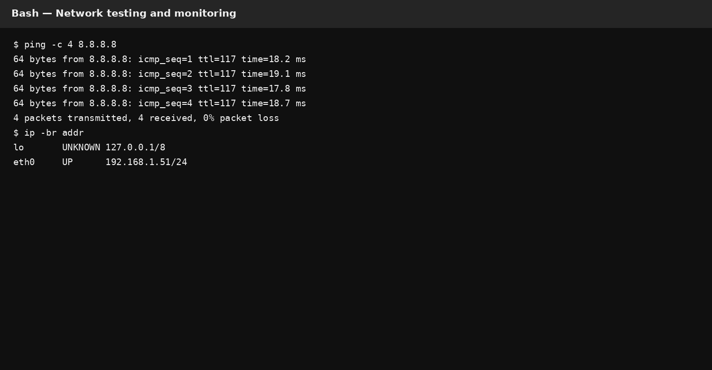
Figure 3A. Linux network testing/monitoring (illustrative screenshot).
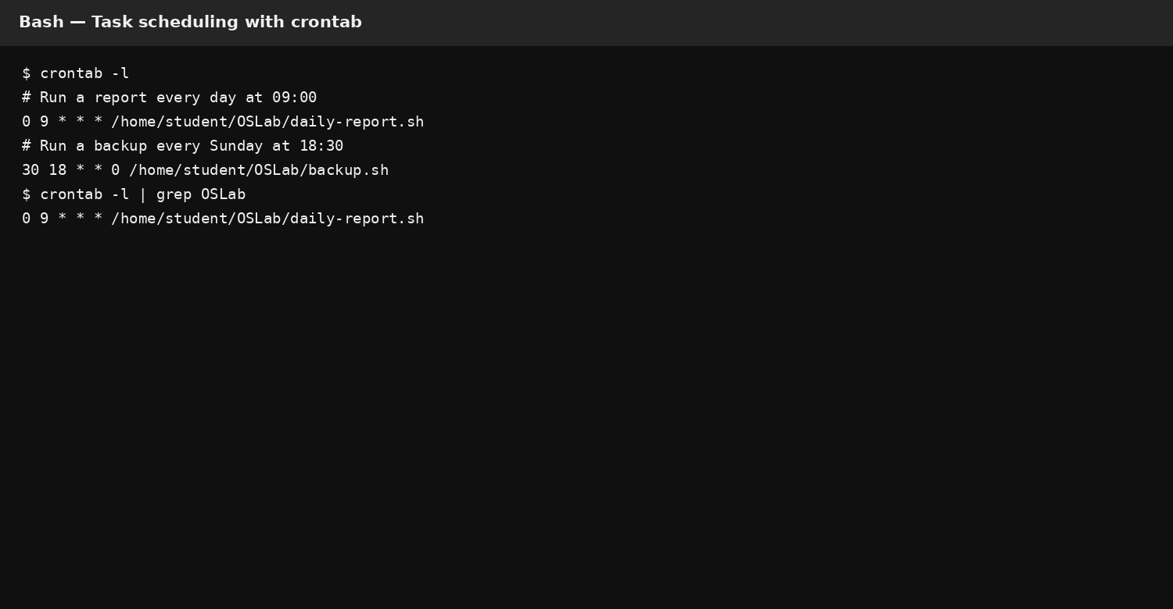
Figure 3B. Linux crontab scheduling (illustrative screenshot).

The Linux commands show how the CLI will expose core OS functions. ps provides a process snapshot [5]; ls and find support structured file discovery [9], [10]; ip exposes interfaces and routing [11]; and crontab provides per-user scheduling [16]. Account creation can also be done through user add, which supports options such as -m for a home directory and -G for supplementary groups [13]. The administrative commands should be tested carefully because Linux privileged operations can impact system-wide files, users and services [17].

4. Use of Windows OS Scripts
Batch files are a simple way to combine Windows commands into repeatable procedures. The examples in the following are variables, user input, arithmetic, a loop and conditional logic. They must be saved for a laboratory folder instead of system directories. Scripts should be saved as .bat files which the student executes and screenshots of the source and the result are made.

4.1 Batch Script A – Repeated File Test
@echo off
set /p "name=Enter your name: "
set /p "count=How many test files? "
set /a total=count*2
echo Hello %name%. Two operations per file = %total%.
if %count% LEQ 0 (
echo Enter a positive number.
exit /b 1
)
for /L %%N in (1,1,%count%) do (
echo Test %%N > "OSLab_Test_%%N.txt"
)
echo Created %count% test files.
pause
This script accepts two inputs and performs integer arithmetic using set /a. The if statement validates that the requested number is positive, while for /L repeats a file-creation action. The design demonstrates a small but realistic automation pattern: gather parameters, validate them, calculate a derived value, then perform a repeated operation.

4.2 Batch Script B – Simple Backup Loop
@echo off
set /p "source=Enter source folder: "
set "backup=%source%\backup"
if not exist "%source%" (
echo Source folder does not exist.
exit /b 1
)
if not exist "%backup%" mkdir "%backup%"
set /a copied=0
for %%F in ("%source%\*.txt") do (
copy /Y "%%F" "%backup%\" >nul
set /a copied+=1
)
echo Backup complete. Files processed: %copied%
pause
The second script accepts a folder from the user, checks that it exists, creates a backup directory when necessary and loops over text files. The copied counter is incremented with set /a. This demonstrates how Batch can automate a routine backup-style operation while still providing basic validation.

5. Use of Linux OS Scripts
Bash is particularly suitable for automation because commands can be combined with variables, command substitution, conditions and loops. The GNU documentation confirms that Bash can be programmed with arithmetic evaluation and compound structures like if, for and while [18]–[20]. In the following examples we use ordinary user space files and therefore avoid unnecessary system changes.

5.1 Bash Script A – Arithmetic and Validation
#!/usr/bin/env bash
read -rp "Enter your name: " name
read -rp "Enter a positive integer: " n
if [[ "$n" =~ ^[0-9]+$ ]] && (( n > 0 )); then
square=$((n * n))
echo "Hello $name"
echo "The square of $n is $square"
for ((i=1; i<=n; i++)); do
echo "Iteration $i"
done
else
echo "Input must be a positive integer."
fi
The script uses read for user input, a regular-expression check inside [[ ]], arithmetic expansion with $(( )), and a C-style for loop. Bash arithmetic supports operators such as multiplication and addition, while conditional expressions can evaluate numeric comparisons [18], [20]. The result is a compact example of validation followed by controlled repetition.

5.2 Bash Script B – Log File Counter
#!/usr/bin/env bash
read -rp "Enter a directory to scan: " dir
count=0
if [[ -d "$dir" ]]; then
while IFS= read -r file; do
echo "Found: $file"
((count++))
done < <(find "$dir" -type f -name "*.log" -print)
echo "Total log files: $count"
else
echo "Directory not found."
fi
This script demonstrates directory validation, a while loop, process substitution and arithmetic counting. It reuses the find utility to locate log files and counts each result. This is a practical example of composing small Linux tools into an administrative workflow. Because find searches directory trees according to expressions [10], the same structure could be adapted for backup inventories, audit reports or cleanup preparation.

Conclusion

References
1: IBM, “What is an operating system?” IBM Think, 2026. [Online]. Available: https://www.ibm.com/think/topics/operating-systems. [Accessed: Aug. 12, 2026]. [2] Microsoft, “Troubleshoot performance problems in Windows,” Microsoft Learn, 2026. [Online]. Available: https://learn.microsoft.com/en-us/troubleshoot/windows-server/performance/troubleshoot-performance-problems-in-windows. [Accessed: Aug. 12, 2026]. [3] Microsoft, “Troubleshoot processes by using Task Manager,” Microsoft Learn, 2026. [Online]. Available: https://learn.microsoft.com/en-us/troubleshoot/windows-server/support-tools/support-tools-task-manager. [Accessed: Aug. 12, 2026]. Michael Kerrisk, “ps(1) — Linux manual page,” man7.org, 2026. [Online]. Available: https://man7.org/linux/man-pages/man1/ps.1.html. [Accessed: Aug. 12, 2026]. [6] Microsoft, “Disk use, memory improvements and Windows Application Performance,” Microsoft Learn, 2026. [Online]. Available: https://learn.microsoft.com/en-us/windows/apps/develop/performance/disk-memory. [Accessed: Aug. 12, 2026]. [7] The Linux Kernel documentation, “Memory Management,” Linux Kernel, 2026. [Online]. Available: https://www.kernel.org/doc/html/latest/admin-guide/mm/index.html. [Accessed: Aug. 12, 2026]. [8] Microsoft, “Get-ChildItem,” PowerShell documentation, 2026. [Online]. Available: https://learn.microsoft.com/en-us/powershell/module/microsoft.powershell.management/get-childitem. [Accessed: Aug. 12, 2026]. [9] Michael Kerrisk, “ls(1) - Linux manual page,” man7.org, 2026. [Online]. Available: https://man7.org/linux/man-pages/man1/ls.1.html. [Accessed: Aug. 12, 2026]. [10] Michael Kerrisk, “find(1) — Linux manual page,” man7.org, 2026. [Online]. Available: https://man7.org/linux/man-pages/man1/find.1.html. [Accessed: Aug. 12, 2026]. [11] Michael Kerrisk, "ip(8) - Linux manual page", man7.org, 2026. [Online]. Available: https://www.man7.org/linux/man-pages/man8/ip.8.html. [Accessed: Aug. 12, 2026]. [12] Michael Kerrisk,"useradd(8) - Linux manual page," man7.org, 2026. [Online]. Available: https://man7.org/linux/man-pages/man8/useradd.8.html. [Accessed: Aug. 12, 2026]. [14] Microsoft, “About the Task Scheduler,” Microsoft Learn, 2026. [Online]. Available: https://learn.microsoft.com/en-us/windows/win32/taskschd/about-the-task-scheduler. [Accessed: Aug. 12, 2026]. [15] Microsoft, “schtasks commands,” Microsoft Learn, 2023. [Online]. Available: https://learn.microsoft.com/en-us/windows-server/administration/windows-commands/schtasks. [Accessed: Aug. 12, 2026]. [16] Michael Kerrisk, “crontab(5) - Linux manual page,” man7.org, 2026. [Online]. Available: https://man7.org/linux/man-pages/man5/crontab.5.html. [Accessed: Aug. 12, 2026]. Canonical, “The Linux command line for beginners,” Ubuntu, 2026. [Online]. Available: https://documentation.ubuntu.com/desktop/en/latest/tutorial/the-linux-command-line-for-beginners/. [Accessed: Aug. 12, 2026]. [18] GNU Project, “Bash Reference Manual,” GNU, 2026. [Online]. Available: https://www.gnu.org/software/bash/manual/bash.html. [Accessed: Aug. 12, 2026]. [19] GNU Project, “Shell Arithmetic,” Bash Reference Manual, 2026. [Online]. Available: https://www.gnu.org/software/bash/manual/html_node/Shell-Arithmetic.html. [Accessed: Aug. 12, 2026]. [20] GNU Project, “Conditional Constructs,” Bash Reference Manual, 2026. [Online]. Available: https://www.gnu.org/s/bash/manual/html_node/Conditional-Constructs.html. [Accessed: Aug. 12, 2026].

Appendices

Appendix A – Tutorial Activity: OS Types
INSERT YOUR COMPLETED OS Tutorial 1 activity here. Include the questions/answers required by your module and, where appropriate, a screenshot or scan of the completed activity. Do not substitute invented answers for your own tutorial work.
INSERT APPENDIX A EVIDENCE: OS Tutorial 1 activity / answers.
INSERT APPENDIX A EVIDENCE: OS Tutorial 1 activity / answers.

Appendix B – Lecture Activities / Activity Log
Insert selected lecture-activity answers or an activity log showing dates, topics, commands tested and brief outcomes. This appendix should demonstrate engagement with the teaching activities and should correspond to the report's practical work.
INSERT APPENDIX B EVIDENCE: Lecture activity answers / activity log.
INSERT APPENDIX B EVIDENCE: Lecture activity answers / activity log.

Appendix C – Evidence of Engagement with an Online Certified Course
Insert evidence from one relevant online certified course. Suitable examples from the assessment brief include Cisco Networking Academy/Skills for All OS or Linux courses, Labex Linux for Beginners, LinkedIn Learning PowerShell courses, Microsoft Learn PowerShell automation learning, Google Cloud Shell learning, or another approved OS/CLI course. Include several screenshots showing the course title, your enrolled/progress status, module completion and/or certificate evidence. The evidence must be genuine and associated with your own learner account.
INSERT APPENDIX C FIGURE 1: Course enrolment / course title evidence.
INSERT APPENDIX C FIGURE 1: Course enrolment / course title evidence.
INSERT APPENDIX C FIGURE 2: Course progress / completed modules evidence.
INSERT APPENDIX C FIGURE 2: Course progress / completed modules evidence.
INSERT APPENDIX C FIGURE 3: Certificate or completion evidence, if available.
INSERT APPENDIX C FIGURE 3: Certificate or completion evidence, if available.
Submission checklist: replace every screenshot placeholder; update the title-page details; add your authentic tutorial, lecture and online-course evidence; update the table of contents; proofread the final document; then export/submit the Word document through the institution's required Turnitin submission route.
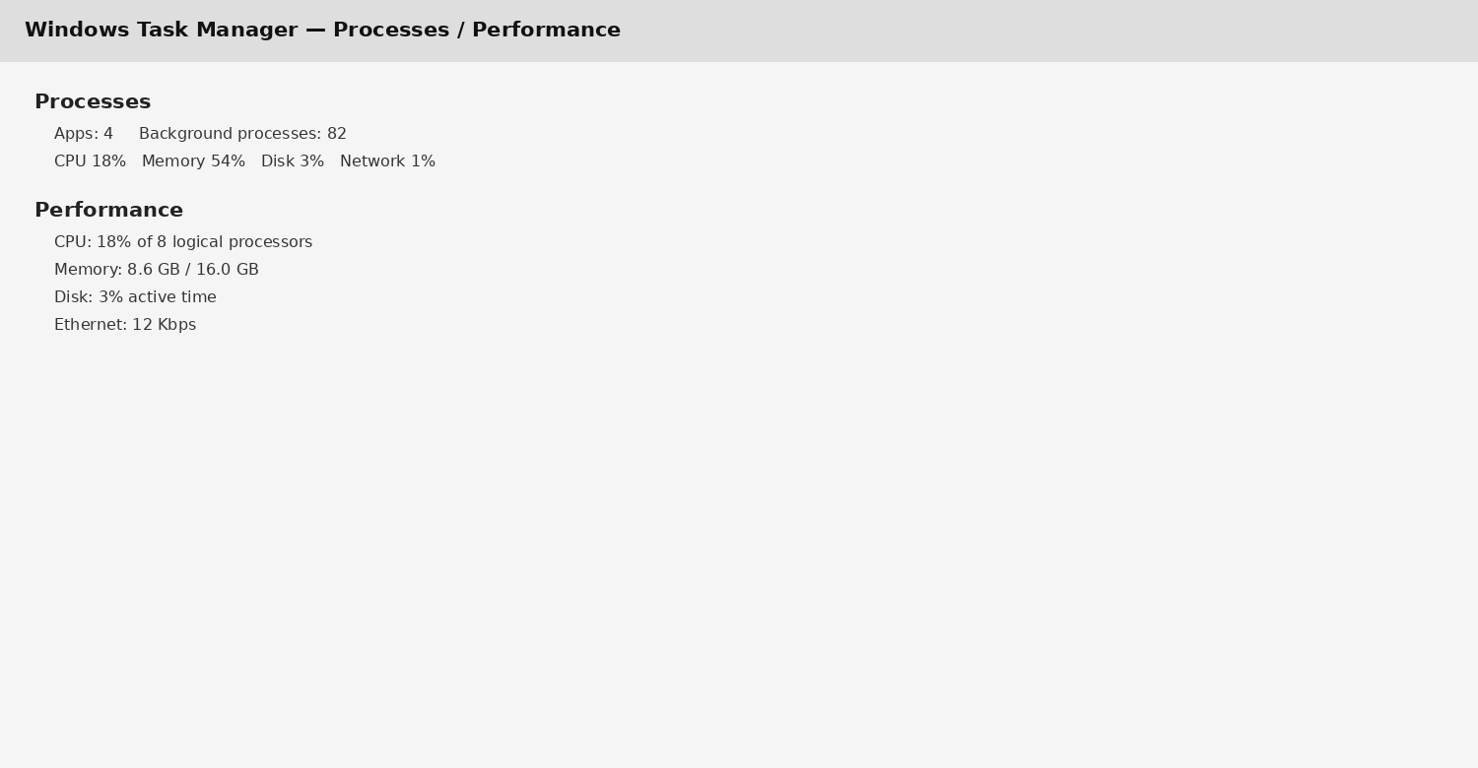
INSERT FIGURE 1: Windows Task Manager screenshot showing Processes and Performance tabs.
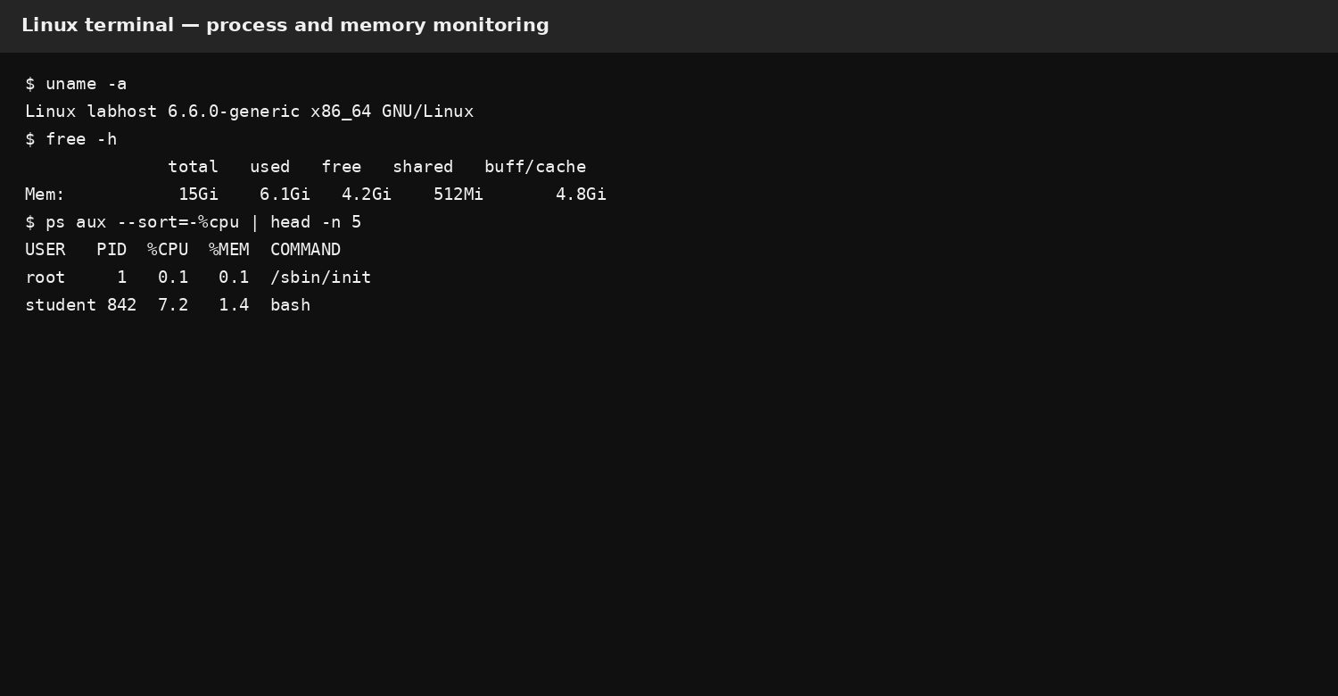
INSERT FIGURE 2: Linux terminal screenshot showing ps/top and memory or system information.
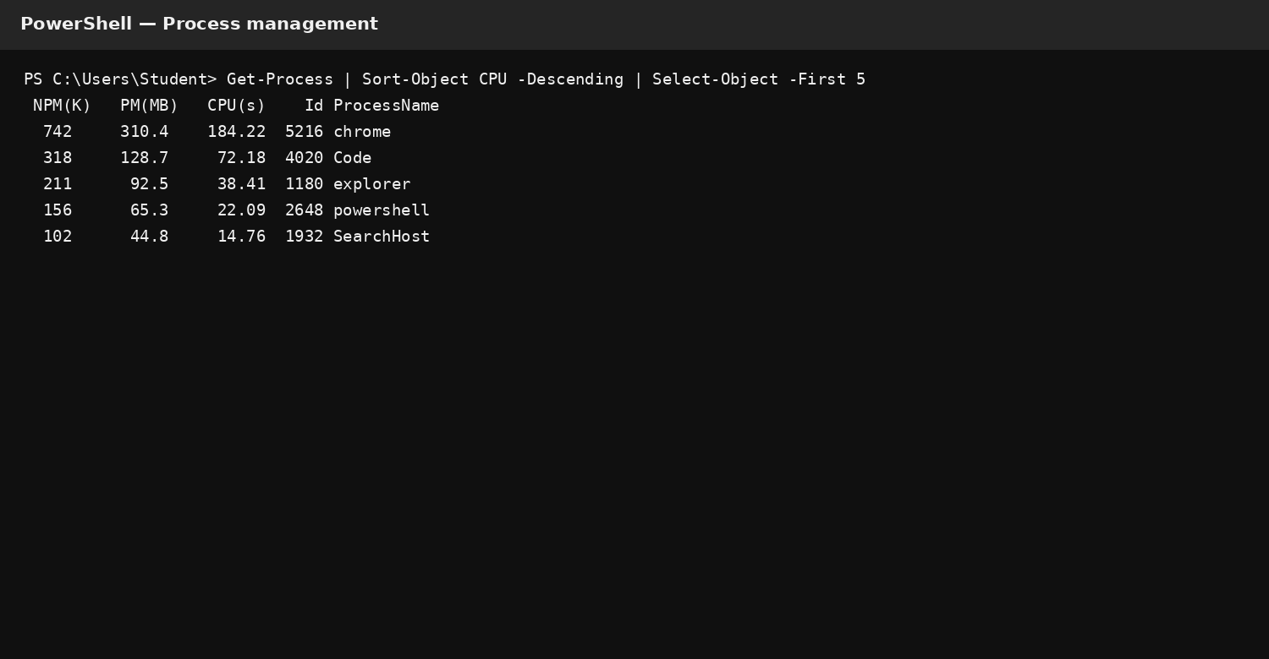
INSERT FIGURE 3: Windows CLI evidence – commands 1–4 with real output from machine.
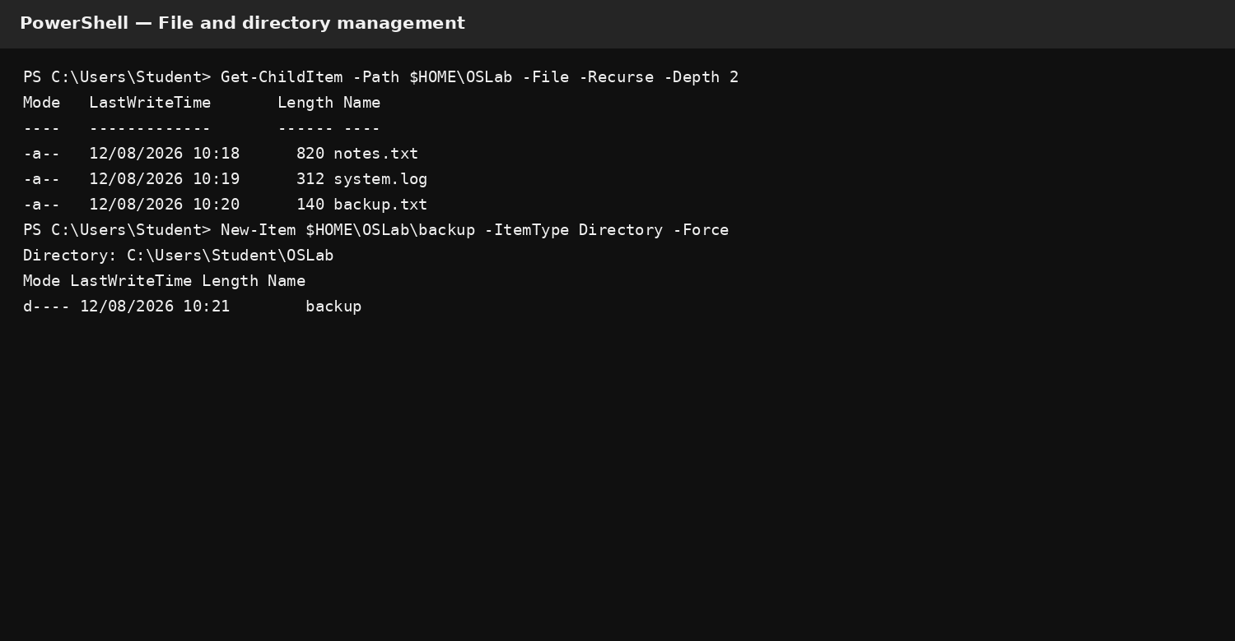
INSERT FIGURE 4: Windows CLI evidence – commands 5–8 with real output from machine.
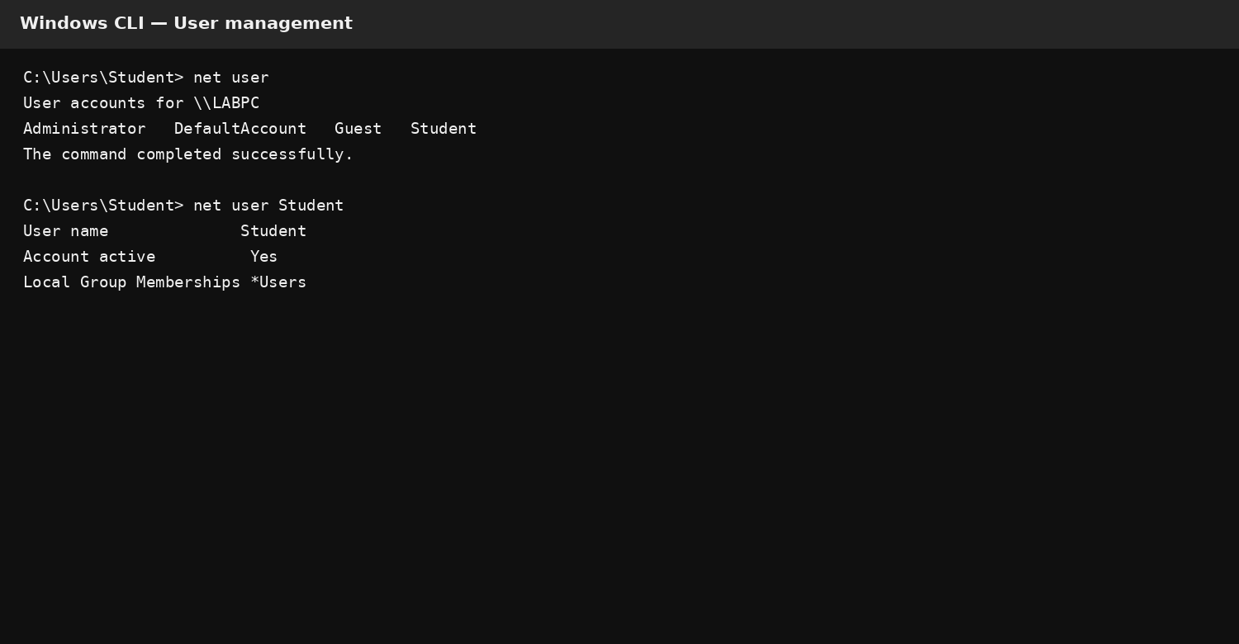
INSERT FIGURE 5: Windows CLI evidence – commands 9–12 with real output from machine.
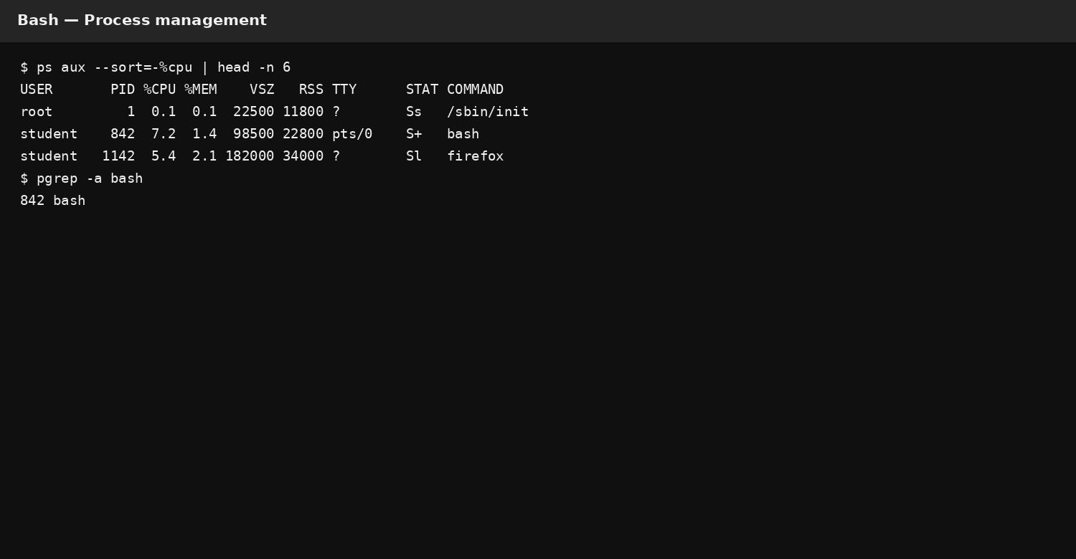
INSERT FIGURE 6: Linux CLI evidence – commands 1–4 with real output from machine.
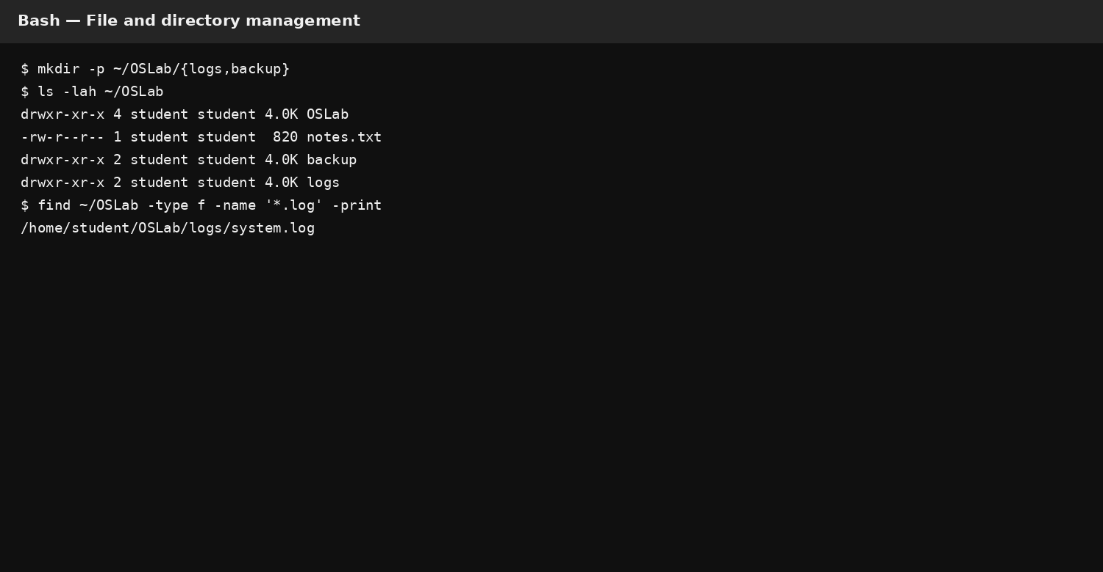
INSERT FIGURE 7: Linux CLI evidence – commands 5–8 with real output from machine.
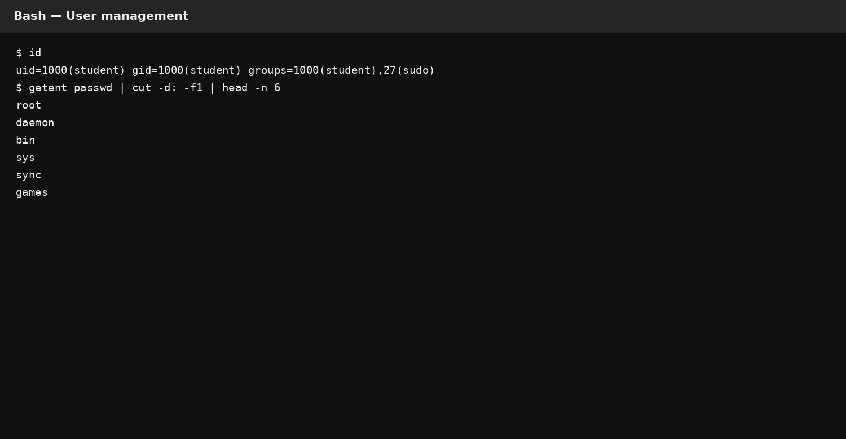
INSERT FIGURE 8: Linux CLI evidence – commands 9–12 with real output from machine.
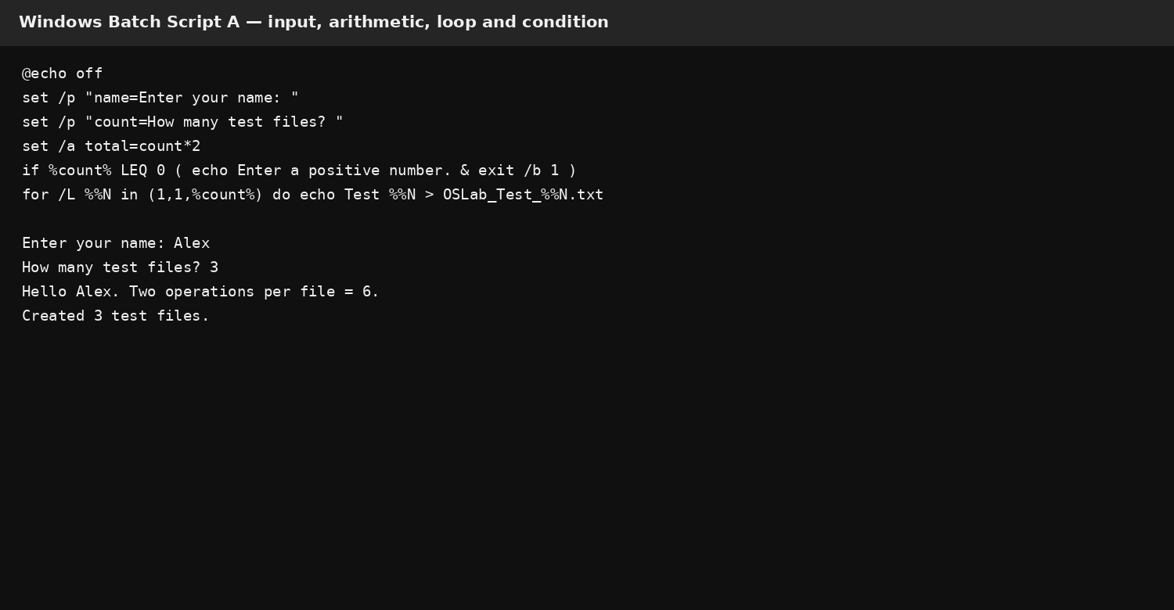
INSERT FIGURE 9: Batch Script A – code and execution output from Windows system.
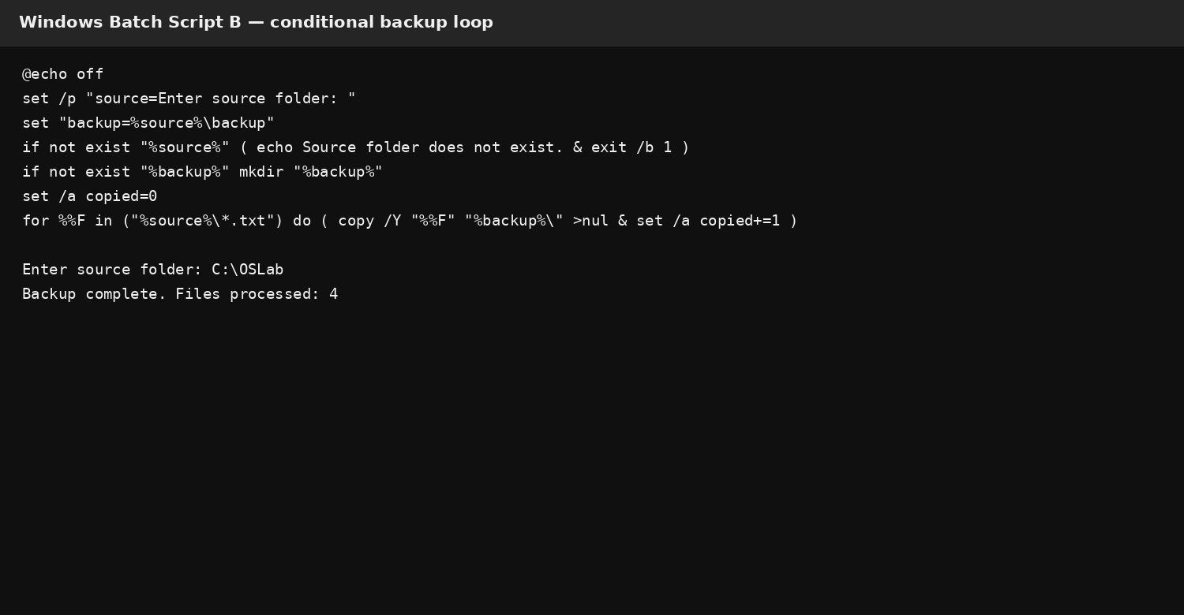
INSERT FIGURE 10: Batch Script B – code and execution output from Windows system.
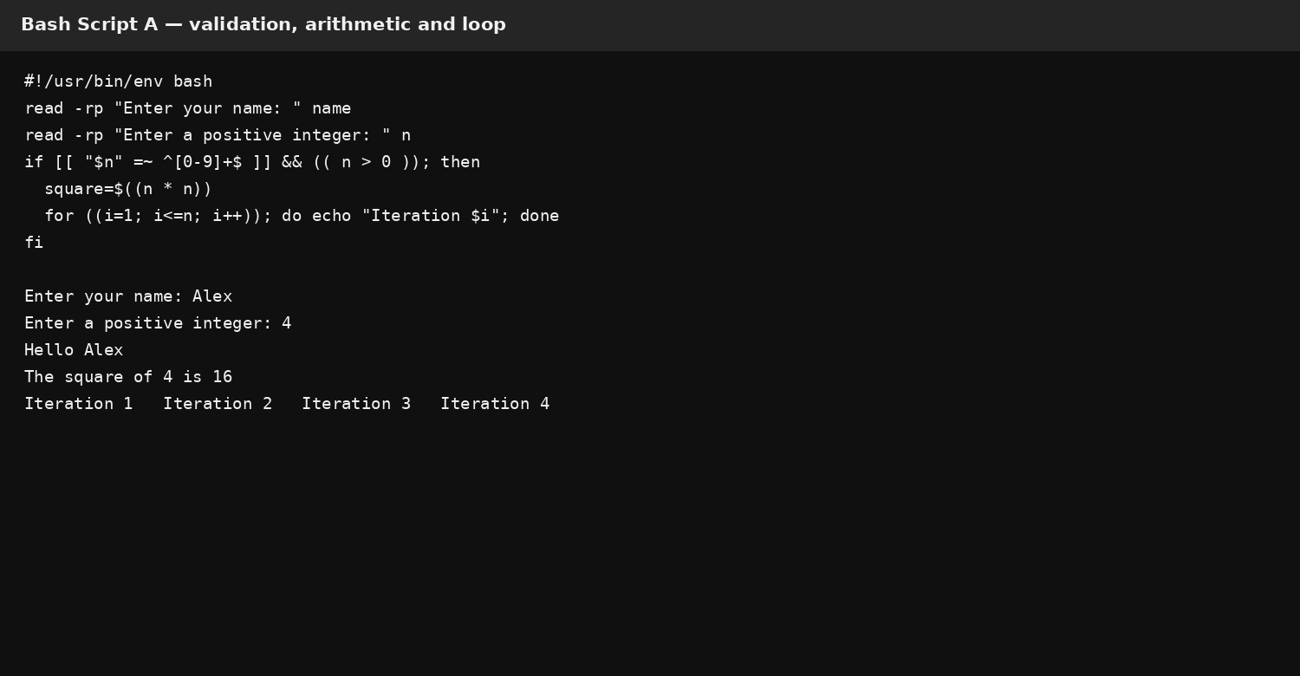
INSERT FIGURE 11: Bash Script A – code and execution output from Linux system.
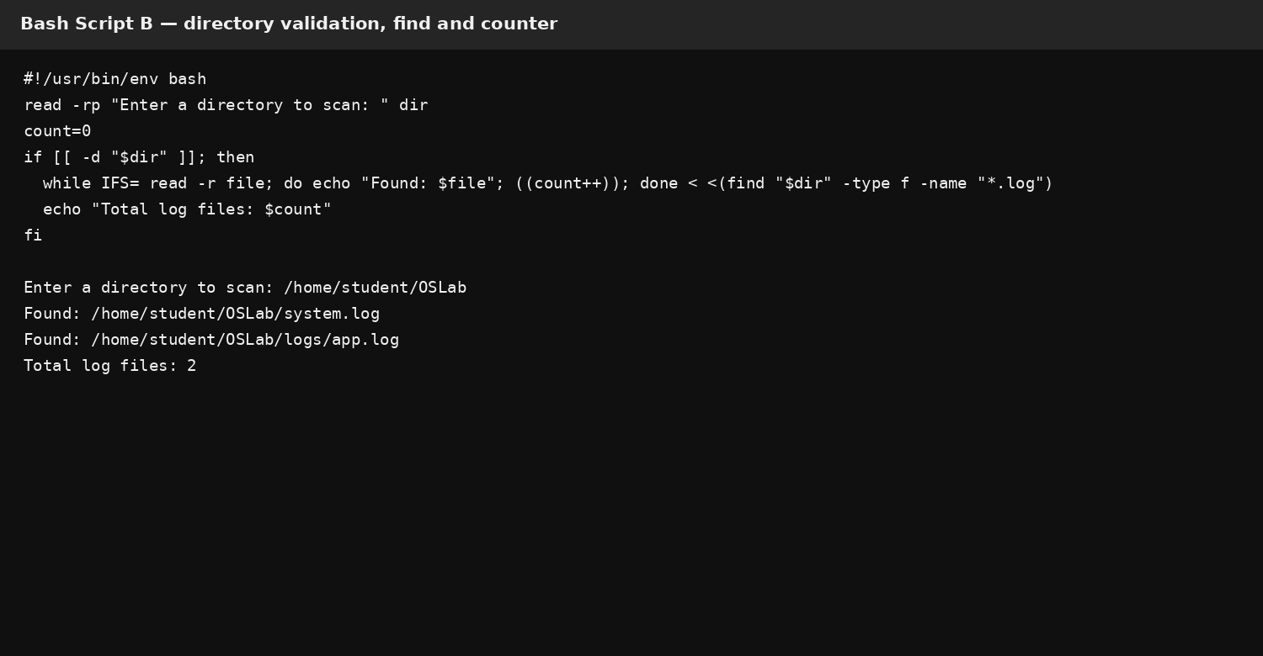
INSERT FIGURE 12: Bash Script B – code and execution output from Linux system.

