Employability skills
Task 2

Table of Contents
Task 2 3
Introduction 3
Overview of the Gibbs reflection model 3
Stage 1: Description 4
Stage 2: Feelings 5
Stage 3: Evaluation 6
Stage 4: Analysis 6
Stage 5: Conclusion 7
Stage 6: The action plan 7
Conclusion of the entire assignment 7
Reference 9

Task 2

Introduction
The report is a reflective report that is based on the feedbacks that I have received as a student from educational institution. The feedbacks have helped me in developing the various employability skills. The feedbacks that I have received from the various educational institutions that have help me in developing my employability skills are communication skill, time management skill, critical problem skill, leadership skill and different types of management skill. The different skills has not only developed my employability skill but also developed me as a human being. The feedbacks have really helped me in working on the fields of my weakness. In this reflective report, I am going to use GIBBS reflective cycle to demonstrate the different phases of my experience during the learning session in my institution that has helped me to develop my employability skill (Gibbs, 1988). The different phases of Gibbs reflective cycle are description, feelings, evaluation, analysis, and conclusion and action plan.

Overview of the Gibbs reflection model
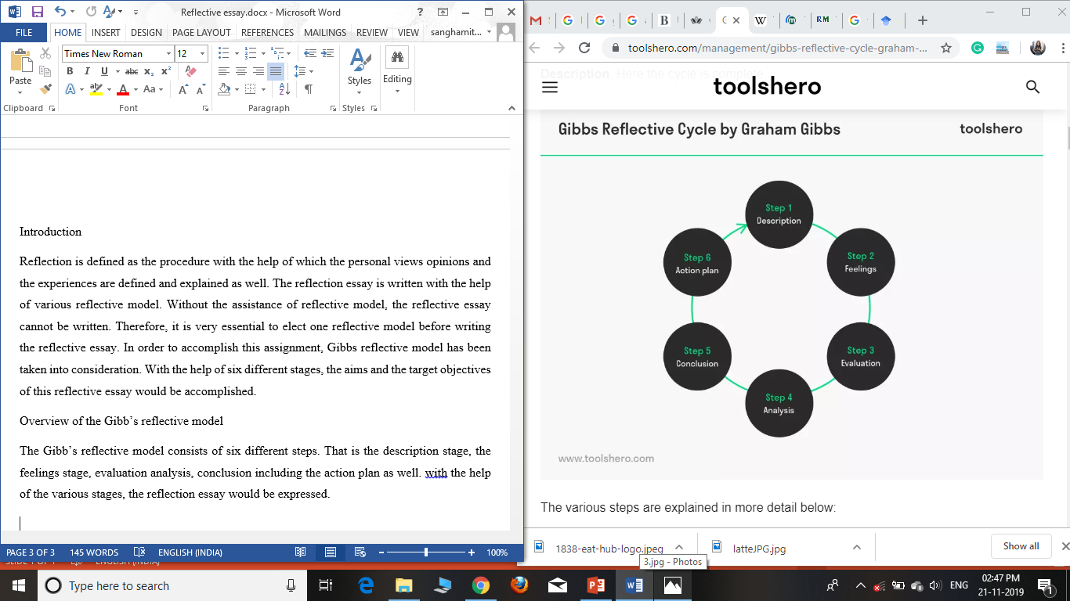
The gibbs reflective models is the type of model with the help of which reflection essay are being explained in the most accurate way. This is because of the fact it consists six varying stages. With the help of the six stages the writers are able to explain and execute the reflection in the most accurate way. Moreover, the gibbs reflection model assist the writer to analyses their overall experience and describe in their own view accordingly in order to make it easier for the readers to understand. The six varying stages of the Gibbs reflection model consist of the description stage where the overall activities that are conducted are described accurately in this section. All the faced issues and errors are also described over here. Secondly, in the feeling step, various feelings related to the works that are conducted are described over here. All the associated feeling starting from the positive and the negative ones are demonstrated clearly over here in this particular task. The third step is about the evaluation of the activities such as what type of activities have been analyzed and what are executed are described over here. All the resulted outcomes are evaluated over here in this particular section. The fourth stage is the analyzing stage where the resulted outcomes are analysed according based on which the conclusion is being drawn. The conclusion can be either positive or negative as well based on the activities that are acquired. The last stage of the Gibbs reflection model is the action plan stage where a particular plan which is effective is being formulated based on the string and the weak points. The action plan is basically used to improvise several areas that are actually need to. This is the entire structure of the Gibbs reflection model based on which the entire task would be conducted.

Stage 1: Description
My university has helped in developing the various skills that was missing inside me to gain the employment abilities. The various skills such as the communication skill, time management skill, critical problem skill, leadership skill and different types of management skill were incorporated inside me by my university. I am always an introvert person and during my initial years in my university I faced my problems in interacting with my friends and classmates due to this nature. My university has helped me in overcoming my introvert nature by starting a course of a team project, where in every team there will be 10 students. This team project helped me to communicate with each other and work as team. The professors of my university give feedbacks to every student so that they can develop themselves. The communication skills that I have learnt are both verbal and written skills. In my university, the professors used to communicate with us through email which has help me in writing formal mails and documents. This idea of writing the formal mails has helped me in developing my employability skills as now I can write formal to any business organization which was earlier not possible by me. The communication with each and every team members during my group project work has help me in easy communicating and to cope up with the other members. The communicating skill is one of the major skills of employability skill. The critical problem solving skill is another skill that I have learned from my university. The professors and the project coordinators also encouraged us in our project paper and research papers and motivated by giving me and my classmate feedbacks on how solve a critical module, which later helped me in enhancing my performance in university. I have punctuality issue during my college days but in my university under the supervision and guidance of my professor I have improved a lot in managing my time schedule. The leadership skill that I developed during my group project module helped me to frame an idea of different types of leader in an organization and their working preferences.

Stage 2: Feelings
I felt that certain key skills like communication skills including both verbal and writing skills, time management skills, skills related to ICT i.e., skills about various hardware and software and how to utilize the virtual medium like internet, skills about how to solve a critical problem in an urgent situation, and skills to work among a group by properly communicating with the group members are extremely necessary to excel both in the academic field and the professional field. I was tremendously feeling upset initially as I could not get hold of anything due to my lack or deficit of knowledge of certain skills which was utterly necessary to complete this task and I felt myself unfit to achieve my target successfully. Moreover due to the lack of these skills and qualities in myself I was lagging behind other students and my performance was quite poor compared to others and more precisely to say I ended up wasting a lot of the allotted time which was needed to execute the assignment successfully. I realized that unless and until I could make myself compatible and eligible enough by imbibing all the necessary skills that are utterly essential for the execution of the task, I could not excel in my academic career and that would make a negative influence on my overall career in the long run. Moreover it also affected me mentally as I was lagging behind my fellow classmates in the academic performances as they had sound knowledge about these various key skills.

Stage 3: Evaluation
Through the feed that I have received from my tutor based on the feedback, I have analysed the fact that the presentation skill along with the reporting skill need to be improved considerably. This is because of the fact, the way I was presenting my views and opinions even after understanding was not at all effective and productive and thus it may hamper the future professional life as well. As per the feed back I have evaluated the fact that presentation skill need to be improved vigorously by me so that none of the issues and errors I face in the upcoming future. My tutor explained me the facts of not being able in the most accurate way. This is because of the fact, my communication skills was not that effective. I was unable to make other understand what exactly I want to convey. That I why, few steps have been provided to me with the help of which I would be able to develop my presentation skills accordingly.
Taking the reporting skills into consideration, gathering of data was not attempted 100 percent in total. This is because of the fact, the technique that I was adopting was not productive and I was thus recommended to change the way of collecting the data accordingly. As per the feed back, I would work in the upcoming future.

Stage 4: Analysis
Though I came up with a series of problems and hazards at the beginning of the assignment which stood in the way of completion of my task, as I lacked certain skills and qualities but at the end I managed to imbibe within me certain key skills and took initiative in order to develop and boost up those skills, and come up with the successful completion of the assignment. Though there were challenges of individual learning, since I was a fresher in the institution, the lectures of the professors and the lecturers were enlightening and enriching enough to help me with my assignment and the class lessons rendered out helped me immensely to adopt the various strategies and techniques which I needed to reach to the most authentic and appropriate conclusion. In order to solve my problem regarding communication skills, I took the help of power point presentations to a large extent and practiced writing reports and other articles extensively, in order to draft error free and grammatically correct sentences. I also got engaged in extensive enlightening discussions both with my classmates and professors over a relevant topic of this assignment in order to boost my verbal communication skills and to get rid of any hesitation while asking about a topic to my professors. To develop my numerical skills, I practiced various statistical calculations and made use of them to prepare various PowerPoint presentations that I submitted during the conduction of the project. A tremendous and rigorous use of Microsoft Office programs made me accustomed and habituated with the necessary ICT skills which in modern days is tremendously necessary to excel in any field. Through analysis and the collection of information for the assignment, I mastered the skills of problem solving, like solving the various issues which aroused during the conduction of this assignment and how to come with a suitable solution within the allotted time .Working in efficient teams and participating in wide range of activities and discussions that were conducted among the teams, contributed to increase my key skills and to nurture them on an extensive level which not only helped in the completion of this task, but also paved the pathway for my successful future endeavors. Teamwork has imbibed within me the required and essential patience and the strategically devised tricks that are needed in order to put up any analysis or research process and to execute that assignment successfully.

Stage 5: Conclusion
From this entire section it has been understood the fact that few of the activities were not conducted effectively by me and thus need to be improvised as soon as possible so as to achieve a bright future in the upcoming future. Therefore, as per the feedbacks, all the necessary tasks need to be followed in order to improve my employability skills

Stage 6: The action plan
The various action plan that need to be conducted are as follows:
- Improving the presentation skills within the next 5 weeks
- Improving the reporting skills within the next 5 weeks
- Within this 10 weeks, the communication skills would be improved by me

Conclusion of the entire assignment
From this entire assignment, it has been understood the fact that the employability skills is the key procedure with the help of which future can be secured. Thus, the weak points need to be improved and the string point need to be practiced as lot so that every activities and qualities can be neutralized within the stipulated amount of time.

Reference
Collet, C., Hine, D. and Du Plessis, K., 2015. Employability skills: perspectives from a knowledge-intensive industry. Education+ Training, 57(5), pp.532-559.
Gibbs, G (1988). The reflective cycle. Kitchen S (1999) An appraisal of methods of reflection and clinical supervision. Br J Theatre Nurs, 9(7),313-7
Messum, D., Wilkes, L., Peters, C. and Jackson, D., 2017. Senior Managers' and Recent Graduates' Perceptions of Employability Skills for Health Services Management. Asia-Pacific Journal of Cooperative Education, 18(2), pp.115-128.
Suleman, F., 2016. Employability skills of higher education graduates: Little consensus on a much-discussed subject. Procedia-Social and Behavioral Sciences, 228, pp.169-174.
Suleman, F., 2017. Employability skills of higher education graduates: Little consensus on a much-discussed subject. Procedia-Social and Behavioral Sciences, 228, pp.169-174.
Tsitskari, E., Goudas, M., Tsalouchou, E. and Michalopoulou, M., 2017. Employers’ expectations of the employability skills needed in the sport and recreation environment. Journal of hospitality, leisure, sport & tourism education, 20, pp.1-9. Messum, D.G., Wilkes, L.M., Jackson, D. and Peters, K., 2016. Employability Skills in Health Services Management: perceptions of recent graduates. Asia-Pacific Journal of Health Management, 11(1), pp.25-34.
Tsitskari, E., Goudas, M., Tsalouchou, E. and Michalopoulou, M., 2015. Employers’ expectations of the employability skills needed in the sport and recreation environment. Journal of hospitality, leisure, sport & tourism education, 20, pp.1-9. Messum, D.G., Wilkes, L.M., Jackson, D. and Peters, K., 2016. Employability Skills in Health Services Management: perceptions of recent graduates. Asia-Pacific Journal of Health Management, 11(1), pp.25-34.

