

Skills for the Workplace
Module Assignment Submission
Student Name: | Tracey Hughes
Student Number: | 2008698
Module No: | BMSK4006
Module Title: | Part 1 Business Plan

Statement of Confirmation of Authenticity
By the act of making this submission, the student declares that this is the work of the student named above. The work has not, in whole or in part, been knowingly presented elsewhere for assessment, or where assessment has been built on a previous assessment, this has been identified. Where materials have been used from other sources it has been properly acknowledged. If this statement is untrue, the student acknowledges that an assessment offence has been committed.
Attention is drawn to the plagiarism and unfair practice policies of both the University and of ILM.

Table of Contents
Statement of Confirmation of Authenticity 2
Table of content ……………………….,……………………………………………………………………….3
Executivesummary………………………………………………………………………….5
Business/Industry Overview 8
Market Analysis and Competition 10
1. Sales and Marketing Plan 10
2. Product or Service Offerings 16
Our services and products are as follows: 16
3. Pricing Strategy 17
4. Sales and Distribution 17
Payment methods as follows: 18
5. Advertising and Promotion 18
Ownership and Management Plan 19
Operating Plan 20
Financial Plan 21
References 33

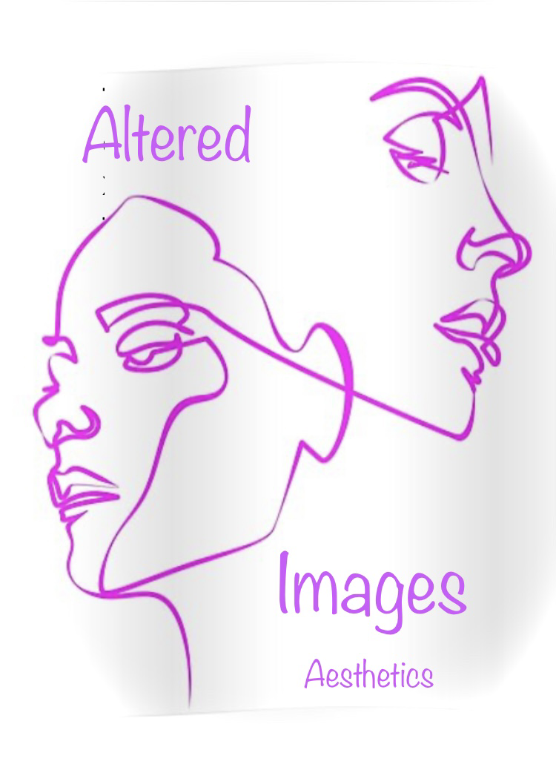

Unit 2,
Dafen industrial estate
Llanelli
Carmarthenshire
SA14 8ND
Tel :01554 788605/ 07814701291
https://www.Glamtanbeauty.com
Alteredimages.info @glamtanbeauty

Executive Summary
Altered Images is an aesthetic clinic based in Llanelli, Carmarthenshire. It specialises majorly in treatments for clients affected by facial palsy, the business offers additional services for skin rejuvenation and scar and tattoo removal. The business provides our specialised services for the entire population of west and south Wales (appendix 1)
At altered Images, the business has acquired plans and support to reach our target audience and to provide the needs of our clients are our highest priority. Altered Images use only F.D.A approved products and equipment and offer our clients a bespoke service and offer free consultations and after care.
The equipment that has been chosen such as GentleLase plus and Palamar Fractional Laser which are both F.D.A approved for used on scarring, surgical scars v, skin resurfacing stretch marks, melasma. It delivers light to the skin through rays of high precision micro-beams that penetrate the dermis, it is gentle enough for delicate areas such as face. It offers minimum downtime and can penetrate deeply enough to stimulate the collagen but not damage the skin surface generally 3-5 sessions are recommended for best results (SKIN55 Dermatology)
The products chosen by Altered Images are the world's leading brand of hyaluronic acid facial filler and are well known for their amazing results using the ‘Juvéderm’ range, it can deliver natural looking results lasting up from up to 9-24 months, depending on treatment and of course individual results may differ. These are used for cheeks and lips and upper part of the face. (Juvéderm.)
The use of Botulinum toxin in patients is highly effective in the treatment for synkinesis and eye closure and drooling, as it is a neurotoxic protein produced by the bacterium clostridium botulinum .it prevents the release of neurotransmitters acetylcholine from axon endings at the neuromuscular junction, which helps the client with movement and works well as a pain relief. (Nichols, H.)
Working closely with facial palsy Uk the business has had a great deal of experience with clients with facial palsy and synkinesis and who are in a lot of pain, and discomfort. And offer a range of treatments to help clients overcome their lack of confidence issues and the feeling of normality, it can be an incredibly stressful time for clients and at Altered Images have only the client's wellbeing which is the heart of our business.
The business plans to make sure our clients will enjoy the convenience our clinic offers for location and being a specialised clinic, which can offer all their needs, including emotional needs as we offer a counselling service for clients struggling with confidence issues and be diagnosed with B.D.D (Body Dysmorphic Disorder) (NHS.UK)
As seen in appendix 1 A range of photographs of before and after pictures using our bespoke procedures.

Business/Industry Overview

In recent years, the facial aesthetic market has grown significantly. The Aesthetic Society released its annual statistics for 2020 and it demonstrates that even amid the Covid 19 pandemic popularity rose. It shows that the market size was £8.6 billion in 2016 and is expected to rise to £19.4 billion by 2023 growing at a CAGR of 12,2% during the forecast period. The high demand has resulted from social media influencers and the quest for perfection. While the trend is now for a more natural look rather than the trout pout of a couple of years ago. The introduction of filters has made the population more obsessed with how they look than ever before.
While a lot of people were afraid to go under the knife the new advanced treatments available are non-invasive and can be administered in a brief period of time, this suits the majority of working people as there is no downtime for healing.
During intensive research being undertaken, that while there are a lot of clinics offering these procedures and many more, there are not any clinics that deal with disfigurement and uneven facial features due to brain injuries, facial palsy or traumatic accidents which have taken away their confidence and their quest being to look normal rather than keeping up with influencers and celebrities showing off a certain look.
in the whole of the country there are less than five clinics that deal with these issues and are all under the NHS , which is extremely difficult to get appointments and some people are waiting years to just be offered an appointment , during this time they are suffering with depression which can lead to a neurological condition Body Dysmorphic Condition , which is extremely debilitating as the person suffers from total body hatred and see their imperfections in a greater way , this can also lead to self-harm and suicide .(NHS. UK)
An article written after speaking to two practitioners on what trends will be big in 2022, Dr Ashley and Dr Rowland-Warmann state that after 2020 did not go as planned for the industry but it did not waver our love for procedures, one such procedure is the use of hydraulic acid injected into the face which can help in the appearance of acne scars and some skin disorders. The use of a new treatment Profhilo is a new injectable on the block and targets dull ness and skin laxity (Palmer,V. 2021)
Much will depend on the extent of the patient's paralysis to which treatments will be suitable, but such are:
- Botulinum toxin
- thread lifts
- fillers
- nerve blocks for pain relief
- electrical stimulation
- facial rehabilitation therapy.
These treatments are not specific to facial palsy patients with synkinesis's and uneven features,

Market Analysis and Competition

Sales and Marketing Plan

After thorough research and contacting’ facial palsy .org’ there are many medical treatments used in the management of facial paralysis such as Botox, eye care pain relief as well as treatments such as cognitive behavioural therapy, counselling, and facial rehabilitation therapies. Despite the negative impacts of facial palsy, there are major gaps in understanding relating to treatments and care of those affected and a recognition of the pressing need to develop an agenda with the potential to fill these gaps. Facial Palsy UK is a charity registered in England and Wales and their mission is for every affected person with facial palsy has access to the best treatments and support available. This can all be found at www.facialpalsy.org.uk
As part of an advocacy group to support and enable people to gain access to high quality appropriate and timely treatment support and services. A perception that the condition is cosmetic hinders and inhibits patients from seeking support. A lot depends on the post code lottery referring to local budgets can lead to lack of facilities (facialpalsy.org.uk)
Facial Palsy U.K commissioned an appearance research called a Delphi study. This approach attempted to obtain a consensus amongst a panel of individuals with knowledge of a particular issue. It was widely used to set research priorities for their conditions and the questionnaires were completed remotely which allowed patients to express themselves freely. (Facial palsy U.K)
In total 85 respondents took part. The majority of patients were female (85.1%) and had experienced acquired facial palsy (88.7%) and predominantly caused by Bell's palsy (40.3%) Acoustic Neuroma/vestibular schwannoma (16.1%) or Ramsay Hunt syndrome (12.9%) in total 82.3% currently had facial palsy and only 14.5% of these were receiving treatment.
Another survey was carried out by Facial Palsy .org, accessing health care for facial palsy via the NHS and the impact of living with the condition. It was developed to better understand how people access health care for facial palsy. Responses were gathered through an online survey from people who have or have had facial palsy, are aged 18 and over and all live in the Uk and are all eligible for NHS care. There were 421 respondents due to rounding percentages may not add up to exactly 100%. Charts and graphs can be found in appendix 3
All respondents were asked what would improve their quality of life with reference to facial palsy:
- Routine access to health care (84.1%)
- More psychological support (83.3%)
- More awareness of facial palsy amongst the general public (81.1%)
Of the 211 respondents who requested follow up health care the biggest problem faced by more than a third was failing the need to justify why they needed help.
- Best recovery they could hope for (27.5%)
- Told treatments are not funded as it is a cosmetic procedure (18.0%)
- Did not know where or who to go for help (41.7%)
- Needed to complete a specialist request for funding (5.7%)
- Problems not bad enough to warrant a specialist 12.3%)

The graph in appendix 3 Shows the options with the most positive feedback even though these treatments and procedures are almost impossible to gain access to.
The most positive outcomes were:
- Platinum weights in the eyelids (95%),
- face lift (95%),
- botulinum toxin injections (89.7%),
- brow lift (88%) specialist facial therapy (79.7%)
- smile surgery (76.2%).
Additionally found in appendix 4 is a copy of questions asked in the survey.
Swot analysis
At Altered Images we produced a swot analysis to show how we can achieve success in a competitive Industry.
Strengths
Our strength as a business is the knowledge and bespoke nature of our business for patients with facial palsy who are unable to get referred or seen by an NHS care giver.
The location of our business in a brand-new ultramodern business hub just of the M4 which houses other beauty industries but unlike ours, so we can all work alongside each other. (Appendix 6)
Weaknesses
According to our analysis it might take some time to be able to gain a reputable clinic from clients who have not yet been able to have these treatments before and are frightened to try.
Opportunities
We were able to see through our research that due to the limited number of resources given to clients with facial palsy we can offer them a new service, which they may never be able to obtain.
Threats
Not been able to grow as quick as demand will allow, does cause worry but plans are in place should I need more staff and offer specialised training to inexperienced staff.

Pestle analysis:
Political factors
Product safety is an especially crucial factor in this type of industry. A bill called the personal care product safety act allows the FDA to have a major approach to ensuring product safety. Companies need to be registered to follow all safety guidelines. When ordering from abroad, consideration must be taken to follow all political and legal requirements as what may be allowed to be used in some countries may not be allowed to be used in the U.K.,
Economic Factors
Unlike a lot of other businesses, the beauty industry continues to grow, pricing has become a huge factor as people find they may not have the money to spend on such extravagance, while others see It as a necessity and could not cope without it and would sacrifice a lot to have their procedures.
Social Factors
The beauty industry offers a remarkably similar product overview. It is up to the individual business to build up a reputation a brand if you like of being the best around. To help the products used should be of the best quality and containing the proper legal requirement of ingredients. Receiving complimentary reviews and offering the customer a more of a luxurious experience will set yourself apart from the competition, while keeping up to date with training and able to give the newest products and services.
Technological factors
It is extremely important to be visible on all social media platforms to be able to get the best out of your business and show potential clients what services are on offer showing before and after photos and receiving feedback such as reviews to keep yourself up to date
Payment methods are mostly by use of some technology or other and smart phones are the new debit card, so it is extremely beneficial to the business that these are all kept up to date and data protection is always adhered to
Legal factors
Ingredients in the beauty industry are regulated by the FDA some are regulated without being approved and this can be tricky to navigate without knowing the law. (FD&C act)
Whilst in the U.K and across Europe EU Cosmetic Products Regulation 1223/2009 (CPR) must be complied with these strict laws to ensure human safety and to protect customers from misleading claims.(ctpa)
Environmental factors
It is more important ever to practice being eco-friendly, the use of less plastic in packaging, products being not tested on animals, and being cruelty free this does matter a lot to a customer and more than ever before, clients are now concerned with what products contain and how this affects them physically, there have been many scare -mongering stories out there but it is imperative that the business does its research before using such products and not being entirely truth full

Market trends
We at altered Images believe in the advancements of non-surgical invasive surgery against surgical options may be far less daunting and this is adding to the growth in the market. The social stigmas are dwindling due to influencers showing what new procedures they are having done and the turn in the trends of the more natural the better.
While a lot of people were afraid to go under the knife the new advanced treatments available are non-invasive and can be administered in a brief period of time. this suits the majority of working people as there is no downtime for healing.
After speaking to two practitioners on what trends will be big in 2022 Dr Ashley and Dr Rowland-Warmann state that after 2020 did not go as planned for the industry but it did not waver our love for procedures, one such procedure is the use of hydraulic acid injected into the face which can help in the appearance of acne scars and some skin disorders.
the next grandiose thing will be the liquid nose jobs, the days of surgery being your only option has long gone especially as these procedures take minutes rather than hours. added to the usual treatments such as Botox fillers which can help take the yrs. Off.
My unique selling point is I am a trained aesthetics with several years' experience and know how important these types of procedures are to help people feel less conscious of the way they look.
As a person who has suffered with BDD and know first-hand how difficult it is to be understood instead of being labelled vain I have fought for treatment after having a blood clot in my brain which has made my face wonky, I was lucky due to the severity that I was seen and was having treatment regularly until government funding was cut. This is the reason our business can make an impact on others wellbeing.

Product or Service Offerings

Our aim at Altered Images Aesthetics Clinic is to offer specialised non-surgical cosmetic procedures at an affordable and competitive price we are highly trained and experienced in dealing with facial trauma, we offer a confidential bespoke service with a fully qualified aesthetics and councillor who can share your journey from start to finish. This sets us apart from other aesthetic clinics and as this is a noticeably big niche in the market there is no competition between other clinics and even before we open the door for business, we will have a long waiting list. we use the absolute best products, have over 25 years' experience in the beauty industry, the last 10 years specialising in facial movement and rehabilitation for facial palsy sufferers.

Our services and products are as follows:
- Botulinum toxin
- thread lifts
- fillers
- nerve blocks for pain relief
- electrical stimulation
- facial rehabilitation therapy.
- Platinum weights
Price list can be found in appendix 5

Pricing Strategy
The prices the business will charge will reflect the knowledge and experience that the staff possess in this very specialised field as there is so little competition, I acknowledge the fact we as a business could charge a lot more as there are an extortionate amount of customer's waiting for these treatment's and have been for many years. We also acknowledge these are normal people with sometimes limited budgets who have had the unfortunate trauma of losing their facial features along with their identity, so the charge would be slightly more than a cosmetic therapist as this is far more intricate and bespoke.
The business will be offering introductory offers including a free consultation on first visit. This would normally be £100., this would also be considered as a deposit for non-show, which is extremely important as the appointment diary will be full of sometimes long waiting lists and cancellations could be another client's advantage.
The business will be working very closely with’ Facial Palsy U.K’ and as a sponsored client would offer 20 % on first visit to any NHS referrals on first visit, these clients would already have consultation notes given by neurologists and consultants.
The supplier costs differ from which products can and should be used, where in some cases cheaper products may work for some, our clients are putting their whole identity and confidence in our hands so as a business we need to know that the best possible product on the market is being administered. These products have been researched and used in many non-surgical procedures at another reputable clinic and has shown impressive results as seen in appendix 1
It should also be noted that there is no direct cost of sales for services, only for products.

Sales and Distribution
All services and procedures will be given to the client on a one-to-one basis, after a lengthy consultation of what the clients wants and expects, procedures are given in a sterile environment, where the client will be made comfortable.

Payment methods as follows:
- Payment via online banking
- payment via bank transfer
- Payment via mobile money
- Payment with cash
- Payment with automatic card readers
Digital transformations have helped smaller businesses connect with customers online and are able to provide alternative payment methods which automatically connect with their banking service, and this gives the clients the opportunity to pay directly by debit card, PayPal, Klarna, Clear-pay and Apple pay.(Day,E. June 2021)

Advertising and Promotion

Satisfied clients are part of the best marketing tool, as they are showing to the world what we as a business can achieve. This gives an advantage over all other clinics and that it can be shown that what we do is bespoke and looks natural to others, The business runs its own website where clients can see for themselves the before and after shots of treatments and products used .There is also a fb page which is attached as an add on for facial palsy support groups where links are given to clients who would be interested in our services.
We also work in proximity with Dr Javaid who specialises in rehabilitation medicine who has up until now been practising alternative medicine to treat facial palsy including Botox and nerve blocks.in an NHS capacity. Her funding unfortunately has been taken away from Neath Hosp which is Swansea health board (appendix 7) which means even less professionals in the industry. Working with this Dr in a professional and personal capacity has allowed the business to gain patients trust and confidence whist training beside her. While the lack of funding has been a big issue, we will be relocating her clients to the new establishment.
The business intends to do promo nights, where potential clients can meet each other and receive a bespoke evening of talks and demonstrations on such subjects as confidence building, short self-worth talks as this clinic is able to take not only your insecurities and disfigurements away it will also give you the tools you need to repair after your trauma, CBT Training, and meditation therapies.
The business has a specialist in web design to make an interactive web page where it will contain all the information that is needed with the professional, courtesy and confidentiality that is required. We have added as an extra feature Domain Rating (DR)as it strengthens website back link profile so meaning several websites will link back to me as Search engines place more trust and credibility with this added feature., such links include, Aesthetics magazines, Aesthetics and the PMFA journal. As poor links will have a negative impact on my online presence.

Ownership and Management Plan
The legal structure of the company will be as a sole trader, this suits the business well, as a sole trader I can set up and receive payments from customers and purchase stock directly. I need to declare myself to HMRC as being self-employed with the business name, start of trading and the style of operation, and be able to set up and enter my self-assessment tax returns. As a sole trader I have the advantage of being low cost and minimal maintenance, I may seriously consider becoming a limited company at a later date as the business expands.
As I have found the perfect set up which is a new business hub which is about to open to the public as “U.K largest luxury hair, beauty, tanning and now aesthetics salon.” it is a local premises where I am very well known in the area for my beauty and aesthetic experience and is 200 yards away from my home, so familiarity will play a great deal in the business regaining a reputation. (Appendix 8)

A C.V. showing my qualifications and experience to be able to run this as a sole trader appendix 9

Operating Plan
In acquiring a business location, the business has been extremely lucky to have been offered two consulting rooms in a brand-new state of the art building which is in its final completions. The floor plan for this new building is over 3000 sq. ft and holds over 15 consulting rooms, it will come fully furnished to a high standard that will match the rest of the building and furnishings it also holds 10 toilets and has disability access which is imperative as some of the clients may have sight impairment due to their disability. Fortunately, the set of consulting rooms I have acquired are in the back part of the building which has its own exclusive access and parking areas and ramps for wheelchair access and its own set of gender-neutral facilities. This feature is extremely important to the clients as confidentiality is the key to my business, these may be patients who do not venture out as are ashamed of their appearance. (Appendix 8)
Another feature which will be of value is that the rest of the businesses in adjoining rooms are beauty therapists who can offer my clients other treatments once they have had the facial treatments done and they look and feel more like themselves, this just adds to the beauty of my clients and their self-worth, this could also be classed as a great partnership incentive where clients are referred to others and discounts are applied
To honour the client's identity and confidentiality, appointments are made through a secure booking system which all clients must complete, giving name address, and personal information relating to medical conditions, this information is only given once but all staff have access to it and is password protected and all data handling and procedures are adhered to and followed to the law.

Financial Plan

Whilst starting off a business as a sole trader, it will be less difficult to change or expand the business as needs may arise while allowing the decisions to come from One partner. As the business expands and is financially viable, I may make the decision to take on new employees which for tax purposes will be more efficient to become a limited company which additionally would allow me to protect my personal assets.
As the business grows in the first year, the business will take on apprentices to train to how we work, and the procedures given hopefully In a few yrs. when they are qualified be given their own clinics where they are able to work under the altered Image name expanding into new and different premises and into a brand name.
As the reputation of the business grows., and government budgets still being cut the business would look at also expanding Into different regions where the funding for these cosmetic procedures are non-existent , the business would consider taken a mobile clinic with trained staff , all products and services to help and serve clients nearer home with In opportunity to have the help they need , also a possibility would be hiring consultations rooms at surgeries or possible hotels In areas deprived of these services ,
The goal is To be able to live comfortably and in the next five years being able to put most of my profit margin back into the business and dedication to expand we thrive on being the best facial palsy specialists in the country.
Financial plans for sales, cash flow Are In appendix 10

Appendix 1

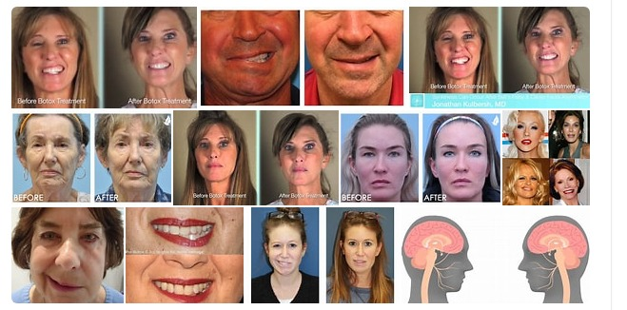

Appendix 2
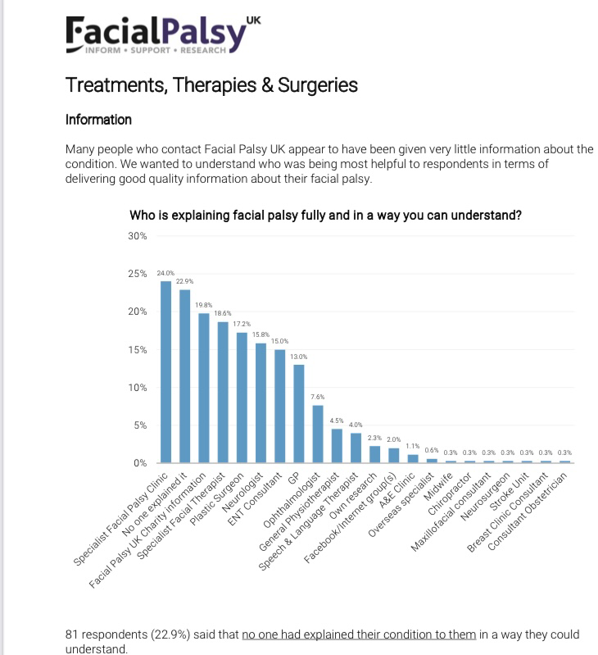

Appendix 3
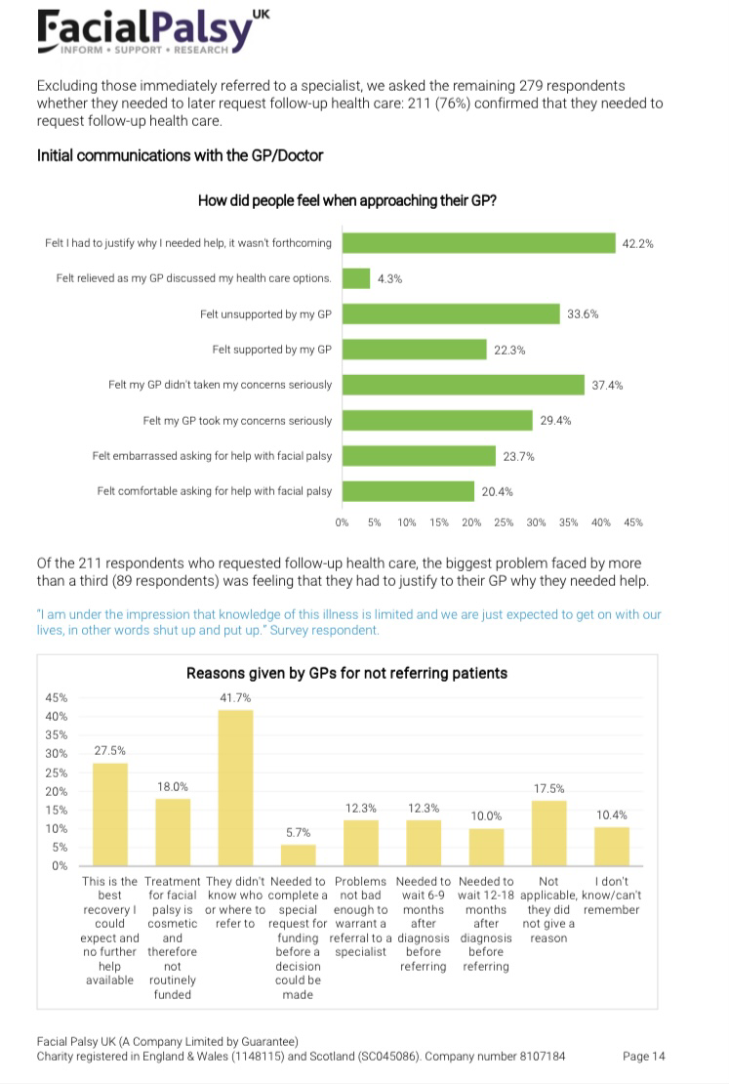

Appendix 4
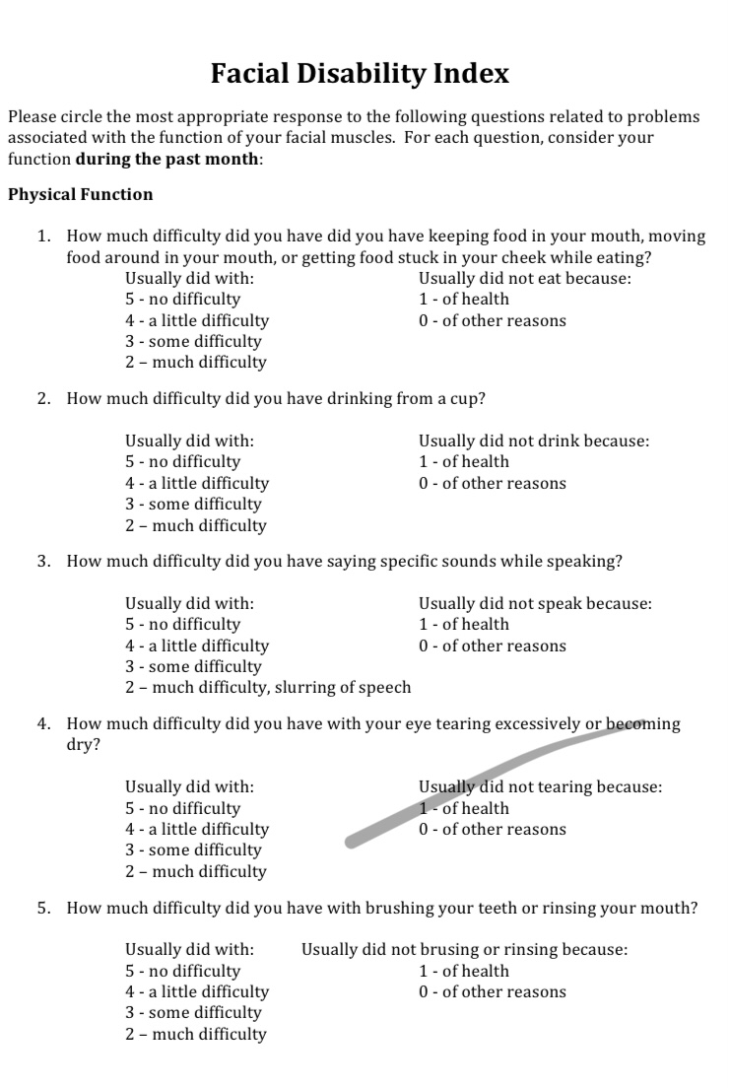

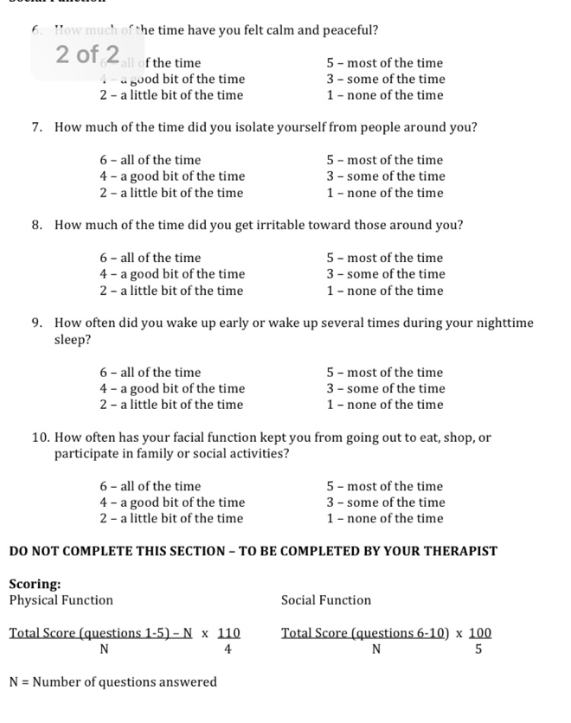
Appendix 5
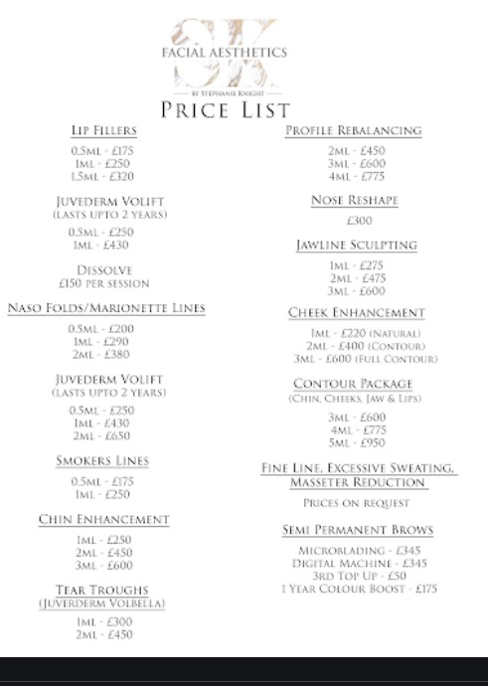

Appendix 6

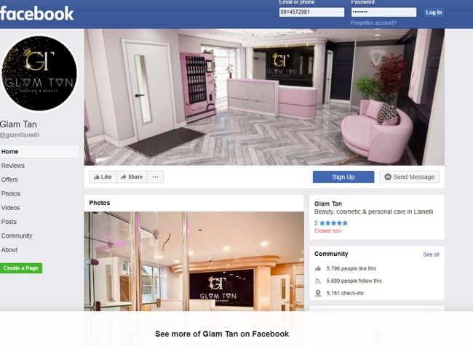

Appendix 7
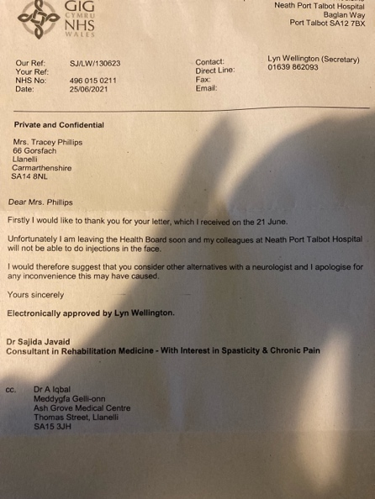

Appendix 8

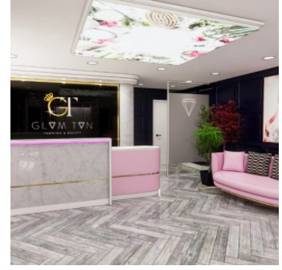

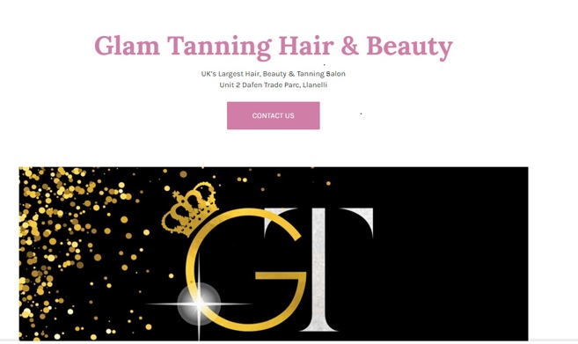

Appendix 9
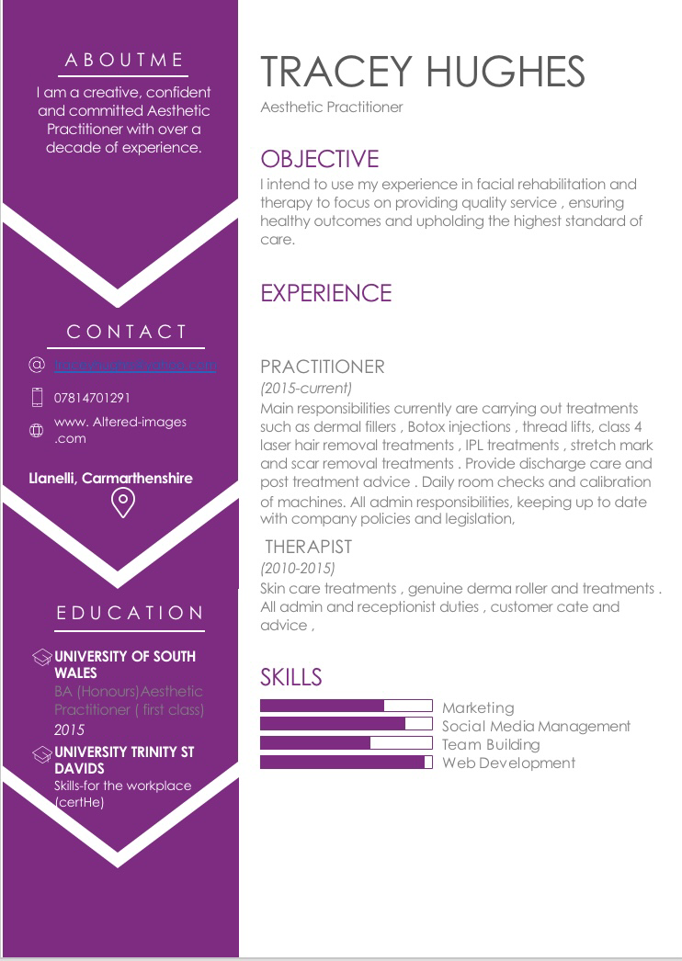

Appendix 10

Business_Plan_Financial_Tables (Web view)

References

Body Dysmorphic Disorder (BDD) [online} available at: https://www.nhs.uk/mental-health/conditions/body-dysmorphia (accessed 03 July 2021)

Botox: Cosmetic and medical uses [online] available at: https://www.medicalnewstoday.com/articles/158647 (Accessed 04 July 2021)

CTPA, The voice of British cosmetic industry[online] available at: https://www.ctpa.org.uk/faqs (Accessed 04 July 2021)

Day, E (2021) [online]How digital transformation can help smes grow online and increase revenue. Available at: https://www.embryodigital.co.uk/how-digital-transformation-can-help-smes-grow-online-and-increase-revenue/ (Accessed 11 July 2021)

Glowday.com, 2021: Aesthetic trends 2021: what treatments will be huge? [online] Available at: https://www.glowday.com/blog/aesthetic-trends-for-2021-what-tweakments-will-be-huge > (Accessed 01 July 2021)

Juvéderm Range [online] available at: https://:www.juverderm.co.uk/what-is-Juvéderm/

Palomar ICON 1540nm fractional Lazer, - what can we treat [online} available at: https://www.skin55.co.u.k/iconlazer (accessed 10 July 2021

Penfold, G..2018) So you want to be a facial therapist? [online] Available at: https: /www.csp.org.uk/frontline/article/so-you-want-to-be-facial-therapist/ (04 July 2021)

Research [online] available at: https://www.facialpalsy.org.uk/research/ (Accessed 04 July 2021)

statistic's, surveys &trends 2021 [online]Available at: https://www.surgery.org/media/news-releases/the-aesthetic-society-stats-reveal-americans-spent-over-9-billion-aesthetic-plastic-surgery-2020( Accessed 02 July 202)1

Treatments and Therapies [online} available at: https://www.facialpalsy.org.uk/support/treatments-therapies/ (Accessed 13July 2021)

What is facial palsy? [online] available at: https://www.facialpalsy.org.uk/inform/what-is-facial-palsy/ (accessed 02 July 2021)

What is advocacy? [online] available at: https://www.facialpalsy.org.uk/support/useful-info/advocacy/

Day, E (2021) [online]How digital transformation can help smes grow online and increase revenue. Available at: https://www.embryodigital.co.uk/how-digital-transformation-can-help-smes-grow-online-and-increase-revenue/ (Accessed 11 July 2021)

/

