Barriers to Global Education

Throughout this essay, there will be numerous barriers to global education critically discussed. Discussing article 26 of the Universal Declaration of Human Rights (UDHR). There will be a mention of STG’s and their impact on education. The first barrier to be discussed will be Poverty, followed by child marriage, discussing what it is, how it affects education and how it disregards article 26 of the UDHR. The second barrier will be child labour, followed by disabilities and health. The final barrier to be discussed will be was and conflict, looking into the insurgency and how families are being affected. They will follow the same pattern as child marriage on how they are discussed. Each barrier will have a section on how education has been affected and how it will continue on as the children grow.
The UDHR is the document that sets out the human rights, declared in 1948 in Paris. For the first time, human rights were set out and made universally acceptable and available after being translated into over 500 different languages. The aim of the UDHR is to give everyone equal rights, however, there was some contempt around human rights has caused vicious acts of humankind. (United Nations, N.D.)
The UDHR is just as appropriate now as it was in 1948 when it was first developed. While human rights were adopted, those abusing them did not stop, however, many people did regain autonomy and freedom. (United Nations, 2015)
Article 26 of the UDHD sets out the rights to education, that education must be free for the compulsory and important levels and be accessible to everyone. Furthermore, education should be focused of helping the development of each and every individual and solidifying the human rights, promoting friendships among nations, races and religions and finally, parents have the right to choose what their child learns. (United Nations, N.D.)
Along with the UDHR, the United Nations set out seventeen goals for sustainable development (STG), they were set out in 2015 to help end world poverty by 2030. Goal number four covers education. (United Nations, 2020)
The following barriers show just how big of an impact education has on children.
Child poverty has a big impact on education. In Africa, about 2 in every 3 children live in complete poverty. The increase in population means more children living in poverty today than in 1990. Poverty in childhood has increased impact on adulthood. Being less likely to access education, health care and have poor nutrition. Those who are unable to meet the full abilities are unable to contribute to society. (UNICEF, 2020)
Poverty has numerous roots, among the roots, education stands out. While education is one of the leading causes of poverty, it is not always the case. Individuals living below the poverty line are at a higher risk of keeping their children off of school, making the possibility of them living in poverty even higher. (Giovetti, 2020)
Education affects poverty in three ways. The first way being education developing skills; Education supports a person’s holistic development, receiving worthy education helps children in developing their skills and reaching their full potential. Using the skills earned through education, children are able to reach higher. Next is fighting inequality; In order for education to be accessed by everyone , there needs to be more equality. Those who are considered vulnerable are treated differently, not considered equals. One of the main inequalities in education is gender, girls are less likely to be welcomed into a classroom, which continues into communities. Education helps bridge the gap if inequality. The final affect education has on poverty being reducing risk and vulnerability; vulnerability has many forms, from living in natural disaster areas to conflict. These situations increase the risk of living in poverty, which will continue as the children grow up. (Giovetti, 2020)
Linking to the UDHR, there are some aspects to poverty that prevent education, which then continues to break article 26 and the right to education.
Developing countries face many barriers when it comes to education, some being obvious while others being more complicated. While growing education helps in improving many areas to a child’s life, the barriers that stand in the way are not always easy to overcome. Education in developing countries is limited by the barriers. Some of these barriers being: Child marriage, labour and soldiers. These children are vulnerable and susceptible to less education and more disadvantage, missing school due to something that is out of their control. (Rueckert, 2019)
There are many more barriers to education through poverty that will affect access to education.
Water is not actively available for roughly two billion people, this means that people, mainly girls spend millions of hours in their lifetime collecting water, carrying forty pounds of water on their backs for around thirty minutes each day. Over time, the body starts to wear down, the task of collecting water is physically challenging, causing back and spin injuries as they continue to carry out the demanding work. An addition to this being that women tend to sleep less due to the tasks they are required to accomplish for their families, collecting water cuts into their workload which means they must make up the time by sleeping less. (Myers, 2017)
Child Marriage is rife in developing countries, with more than 700 million females married before their eighteenth birthday, with roughly 250 million married before they are fifteen years old. While there is a massive number of girls being married off, there are also a number of boys who are forced into child marriages, with 77% of girls married before their eighteenth birthday and 5% of boys at the same age, showing that there is a drastically higher number of girls married off compare to boys. The gender inequality is found in even developed countries, with 15% of women married before they are eighteen where as there is 2% of men in the same age category. Child marriages are often to significantly older men, men who are more than ten years older than the children. Furthermore, child marriages are more common in South Asia and sub-Saharan Africa, these are the two regions that the most common countries for child marriage are found. (UNICEF, 2013)
(Figure 1)
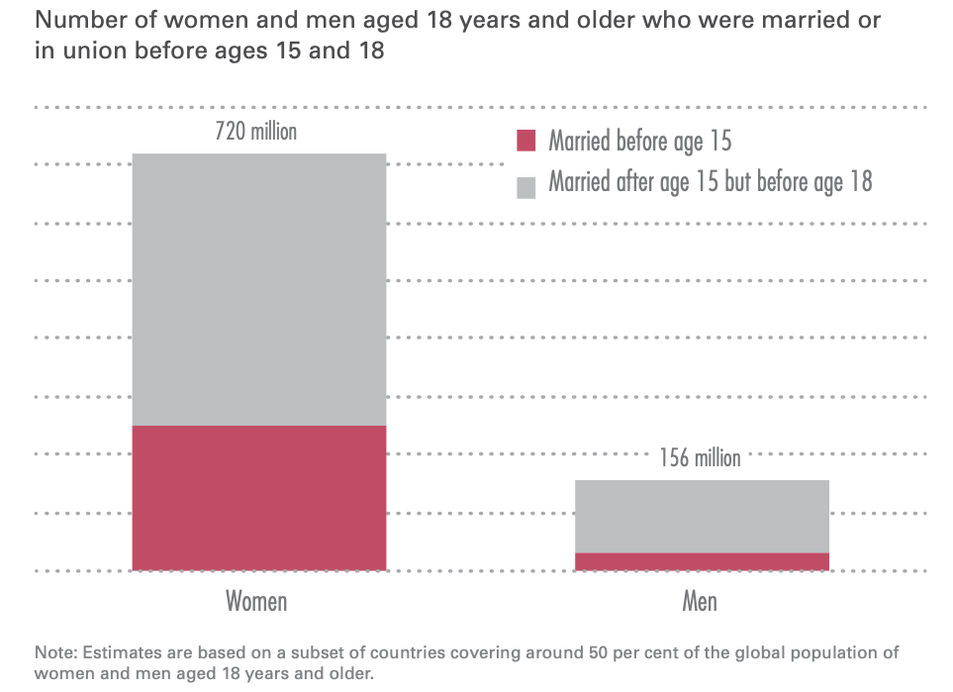
(UNICEF, 2013)

From the graph above, which is found in UNICEF (2013) shows the percentage of men and women child marriages, there is a clear gap of child marriage between the genders. The graph is split into two sections, the red being children who are married before the age of 15 and the grey being the married between 16 and 18.
Child marriages pose many risks for children, one being that they are denied a basic childhood, being cut off from friends and families, their access to education is restricted, this is due to the family holding all the power over the children, especially girls. These decisions being if they access school and when they get married. Furthermore, there is a lack of education in women who were forced into child marriage. (UNICEF, 2018)
Furthermore, there are fees that often come with schooling; therefore, girls often do not resume their education, there is also child pregnancy, which causes many children to drop out of school or be excluded. (Theirworld, 2021)
Following on, child marriages reduce the chances of young girls completing their secondary education. (Wodon, 2017)
Education is a human right, as stated in article 26 of the UDHR, however, it is also an influential factor in empowering women. Those who are educated are often healthier and happier, they participate more in communities, are less likely to have unprotected sex resulting in fewer children. Likewise, education transfers to future generations, having girls chase their educational dreams and ambitions. (Silis, Hanmer, et al, 2015)
As stated at the beginning, article 26 of the UDHR is the right to education, however, this human right is being broken when a child is forced into marriage, from the points made, it is clear that education is not a priority to families who marry their children off to wealthy older men and women.
Education is challenging for children living in poverty. There are many reasons for this, one lacking funding, developing countries require support and funding from other countries, however, only around 20% of funding for education goes towards low-income areas. Another reason being lack of training for teachers. Without quality teacher training needs to be taken into account, in order for quality education at all levels, teachers need to be trained. Furthermore, there are many areas in developing countries that do not have a standard classroom, without a proper learning environment, children are not able to learn correctly. They have little to no school supplies or necessary supplies such as water. (Rueckert, 2019)
Another barrier to global education in child labour and child slavery. Globally there is roughly 168 million children in some kind of labour. Industries such as agriculture and manufacturing being the main child labour users. One of the biggest industries in Africa that relies on child labour is Cocoa. This industry has been unable to stamp out child labour which has then caused a bad reputation for the industry, as a result of this, consumers have filed lawsuits against the companies. (Kelly, 2016)
Chocolate companies in the US have lawsuits filed against them for using a chain of child slaves in Africa. Eight of the children took legal action and are pursuing vengeance and compensation for themselves and others. The children were not given any pay and they were not given appropriate clothing to protect themselves from harmful chemicals that they were required to work with. The constant disregard for children’s human rights, has caused the continuing poverty crisis in Africa. (Balch, 2021)
Additionally, even the UK is not free of child labour, there are some companies that are unable to guarantee that their supply chain is free of child labour. (Cheshire, 2021)
Moreover, child labour blocks children from achieving possibilities in life. Taking the children’s human rights away and making them work in unsafe environments. There are some jobs that children take part in that are not considered child labour, such as working to grow skills without compromising their education and well-being, also chores for their parents in order to earn a small amount of pocket money. (Theirworld, 2021)
This is something that many children do, it is not dangerous for them, it helps them gain skills and prepares them for life.
While the above is true, there are still millions of children around the world working in fields and factories, working as a maid or servants and even down mines. There is a higher percentage of girls doing domestic work such as cleaning and serving, than there are boys. Some of the work that children are forced to do is illegal. Some children are forced into prostitution. The work they do is often unpaid, instead they are given food and somewhere to sleep. No matter what form of child labour that a child is forced into, the work prevents children from accessing education what is more the children are not able to reach the potential. The children either never attend education or they need to drop out. Additionally, education has shown to drastically reduce child labour, the lack of education keeps the cycle of poverty, and children will continue to be illiterate. Education will help in breaking the chain. Funding of $39 billion will help in providing quality education for all stages of education in developing countries by 2030. (Theirworld, 2021)
Not only is Child labour preventing education it goes against the UDHR and the STGs.
What is more, education for all (EFA) launched in 1990 in order to provide education to everyone, working with international agencies in order to roll out. The policy aimed to provide quality education, improve education, decrease the dropout rates and promote early years education. (The World Bank, 2014)
It is clear that children forced into labour work are less likely to gain an education, without education, children are going to continue being exploited and used for others gain. Child labour is fully against the UDHR article 26, breaking children’s human rights and preventing them from accessing quality education.
Highlighting on the above, there are even more barriers to global education that children suffer every day. Disabilities and health cause an enormous barrier to education.
The UK hosted the Global Disability Summit (GDS), the summit brought together numerous organisations and governments. The summit aimed to ensure that those with disabilities are not left behind. (Njeri, 2020)
Disabilities affect people in different ways. There are individuals who are denied education while their friends and family all access education.
There are roughly 650 million people living with a disability globally, that’s 10% of the world’s population, with 180 million of these being children and 80% of the children living in developing countries. Millions of these children are not in school. 25% of each population has been estimated to have some form of disability. Mobility impairments and visual impairments re two of the main disabilities found. The common cause for some of these are dangerous working environments, disease and bad health care. (Tesemma, 2011)
Linking with child labour, dangerous work environments can cause irreversible health damage, causing lifelong disabilities.
Person A from Nepal was born with visual impairments, until the age of twelve, person A was deprived of education because of their impairment. Person A’s family lacked the knowledge that those with disabilities are still able to be education, they were therefore kept from school. At the age of twelve, person A was given the chance to enter mainstream education and learn alongside their peers. However, the books and materials were not inclusive, person A had to rely on friends to continue on through their education. Person A’s experience showed them the prejudice towards disabilities and the stereotype that those without disabilities are unable to attend school. They went through education, past secondary level and went onto get a bachelor’s degree, showing that no matter what the disability may be, they are as capable as everyone else. (Lamichhane, 2015)
This is showing that disabilities remain an issue for children accessing education, not all children have the same support as person A, therefore, remain uneducated.
There are many countries in Africa that have little to no policies in place for those living with disabilities, those that are in existence, make a point of saying that disabilities are flaws within a child. However, there is one piece of legislation that supports children with disabilities in Africa. The 1996 Constitution of the Gambia, this sets out a number of articles that support children, article 28 gives those with disabilities the right to education, the articles following set out the right to not be discriminated and to be protected. (Tesemma, 2011)
The legislation sets out similar rights to the UDHR, while the UDHR article 26 sets out the right to education, the legislation mentioned above is article 28. No matter the different articles, both documents state just how important education is and how education should be protected.
Moreover, even though education is a human right, access to education is denied to millions of children with disabilities. Around 95% of children living with some form of disability in developing countries are not in school. Attendance rates are lower and the expulsion rates are higher in children with disabilities than those without. (Rueckert, 2019)
Finally, War and conflict ruin education for children, with the insurgency situation in Mozambique, children are forced to flee their homes. One mother was forced to flee after her twelve-year-old son was captured and beheaded while she hid the rest of her family, while another was forced to flee and hide her family. The US government spent months training soldiers in order to help the people. (BBC News, 2020)
This demonstrates how children are pulled from their homes, taken away from their education and given life as a refugee. This demonstrates that children are being deprived of their education and they are unable to access the support that they need.
Millions of children are in need of education in war and conflict zones, conflict had an impact that cannot be stated clearly as it is not something that can be determined by those not living in conflict zones. . (Rueckert, 2019)
To sum up everything that has been stated so far, the UDHR has various articles, setting out the number of human rights, this essay in particular looked at article 26 and the right to education, discussing in detail the barriers that affect education.
Poverty is one of the leading factors in barriers to education, having three specific causes and ways out. This actively demonstrates the ability to leave the cycle of poverty and how education is the way to go. Child marriage is still a popular concept in Africa and other developing countries. With there being millions of children being forced into arranged marriages, along the lines of poverty and the gap between genders, child marriage has a similar pattern, there is a higher percentage of child marriage in girls than in boys, which is shown in figure 1. Following this child labour and child slavery was discussed in depth, showing how children are forced into labour, their human rights stripped away and oppressing them, keeping the children from education. Furthermore, as stated above, disabilities are a big barrier when it comes to education. They link with child labour, the particular reason for this being that children are often forced to work in dangerous environments, the children can get injured, which have detrimental impacts on their health and well-being. Finally, war and conflict were discussed briefly. This essay critically discussed how education is affected by different barriers and how the UDHR has been broken through the years, along with a brief description on what the SDG’s are and how they work to support the global needs of every child.

References:

Balch, O. (2021). ‘Mars, Nestlé and Hershey to face child slavery lawsuit in US’ The Guardian. 12 February. Available at: https://www.theguardian.com/global-development/2021/feb/12/mars-nestle-and-hershey-to-face-landmark-child-slavery-lawsuit-in-us (accessed: 4 April 2021)

BBC News. (2020). ‘Mozambique insurgency: Children beheaded, aid agency reports’ 16 March. Available at: https://www.bbc.co.uk/news/world-africa-56411157 (Accessed: 2 April 2021)

Cheshire T. (2021). ‘ Uighurs: MPs 'appalled' firms can't guarantee supply chains free of forced labour in China’ Sky News. 17 March. Available at: https://news.sky.com/story/uighurs-mps-appalled-firms-cant-guarantee-supply-chains-free-of-forced-labour-in-china-12248374 (Accessed: 23 March 2021)
From Charity to Investment’ Cambridge University Press. Available at: http://assets.cambridge.org/97811070/64065/frontmatter/9781107064065_frontmatter.pdf (Accessed: 29 March 2021)
Giovetti, O. (2020). ‘How does education affect poverty? It can help end it’ Concern worldwide US. 27 August. Available at: https://www.concernusa.org/story/how-education-affects-poverty/ (Accessed: 4 April 2021)

Kelly, A. (2016). ‘Child labour is part of most of what we buy today: what can we do?’ The Guardian. 24 November. Available at: https://www.theguardian.com/sustainable-business/2016/nov/24/child-labour-what-can-we-do-africa-modern-slavery (Accessed: 24 March 2021)
Lamichhane, K. (2015). ‘Disability, Education and Employment in Developing Countries from Charity to Investment’ Cambridge University Press. Available at: http://assets.cambridge.org/97811070/64065/frontmatter/9781107064065_frontmatter.pdf (Accessed: 3 April 2021)
Myers, K. (2017). ‘Women, Water & The cycle of poverty’ Concern worldwide US. 10 August. Available at: https://www.concernusa.org/story/women-water-the-cycle-of-poverty/ (Accessed: 3 April 2021)

Njeri, M. (2020). ‘The impact of UK Aid on inclusive education’ Available at: https://www.leonardcheshire.org/our-impact/stories/impact-uk-aid-inclusive-education (Accessed: 23 March 2021)

Rueckert, P. (2019). ’10 Barriers to Education That Children Living in Poverty Face’ Global Citizen. Available at: https://www.globalcitizen.org/en/content/10-barriers-to-education-around-the-world-2/ (Accessed: 17 March 2021)

Sills, M,J. Hanmer, L. Parsons, J & Klugman, J. (2015). ‘Child Marriage: A Critical Barrier to Girls’ Schooling and Gender Equality in Education’ Taylor & Francis online. 13(3). https://doi.org/10.1080/15570274.2015.1075755.
Tesemma, T, S. (2011). ‘Educating Children with Disabilities in Africa. Towards a policy of inclusion’ Available at: https://www.eenet.org.uk/resources/docs/6519.pdf (Accessed: 30 March 2021)
The World Bank. (2014). ‘Education for All’ Available at: https://www.worldbank.org/en/topic/education/brief/education-for-all (Accessed: 29 March 2021)

Theirworld. (2021). ‘Child labour’ Available at: https://theirworld.org/explainers/child-labour (Accessed: 24 March 2021)

Theirworld. (2021). ‘Child Marriage’ Available at: https://theirworld.org/explainers/child-marriage (Accessed: 26 March 2021)

Theirworld. (2021). ‘Helping children stay in school is key to ending child labour’ 17 December. Available at: https://theirworld.org/news/children-in-school-key-to-end-child-labour (Accessed: 28 March 2021)

Unicef. (2013). ‘Ending Child Marriage, Progress and prospectus’ Available at: https://www.unicef.org/media/files/Child_Marriage_Report_7_17_LR..pdf (Accessed: 12 March 2021)
UNICEF. (2020). ‘Ending child poverty’ Available at: https://www.unicef.org/esa/ending-child-poverty (Accessed: 3 April 2021)
United Nations. (2015). ‘Universal Declaration of Human Rights’ Available at: https://www.un.org/en/udhrbook/pdf/udhr_booklet_en_web.pdf (accessed: 2 April 2021)
United Nations. (2020). ‘The Sustainable Development Goals Report 2020’ Available at: https://unstats.un.org/sdgs/report/2020/#sdg-goals (Accessed: 28 March 2021)

United Nations. (N.D.). ‘Universal Declaration of Human Rights’ Available at: https://www.un.org/en/about-us/universal-declaration-of-human-rights (Accessed: 12 March 2021)

Wodon, Q. (2017). ‘Child Marriage and Education: Impacts, Costs and Benefits’ Available at: https://www.globalpartnership.org/blog/child-marriage-and-education-impacts-costs-and-benefits (Accessed: 26 March 2021)

