

A Critical Analysis of How the Early Help System is Signposted to UK Families Through Local Authority Websites

Component 2: Written Report
Module: Protecting and Supporting Families in Health and Care
Module code: BMHP5021
Student name: Momodou Lamin Demba
Student number: 2415947
Lecturer’s name: Shaila Hussain

- Introduction
Early Help system is a family-centred preventative strategy, which aims at identifying and meeting the arising needs before they lead to statutory intervention. It is located in the broader framework of safeguarding and is indicative of a transition in the child protection practice to the proactive type (HM Government, 2023). Local authorities are a key to the operation of Early Help, especially in digital platforms, as the main access points for families.
The report critically analyses the methods of communication of Early Help services to the public by three local authorities, namely Leeds City Council, Norfolk County Council and Tower Hamlets Council, using their websites. The analysis is based on the evaluation of accessibility, clarity, structure, and inclusiveness of information. It also thinks of the degree to which these platforms comply with statutory expectations and the principles of multi-agency cooperation. The report recommends that even though the three councils offer valuable information, there is a vast difference in usability, transparency, and user engagement that has a direct impact on the accessibility of the information by families.
- Explanation of the Early Help System
Early Help is assistance that is offered to children, youths, and families when issues appear. It is targeted at avoiding the further development of more severe safeguarding issues (HM Government, 2023). The Early Help System Guide focuses on the message that successful Early Help needs to be based on timely identification, combined intervention, and comprehensive family needs (Department for Education, 2020).
One of the main characteristics of the Early Help is its voluntary and collaborative character. Contrary to the statutory intervention, families access services in agreement, and this requires effective communication and access to information. This renders the local authority websites an important engagement tool. In case of information being vague or hard to follow, the supporting system might not be requested when families are at an early stage, and this will be counterproductive to the full preventative model.
The assessment of need is another underpinning of the system, usually via schemes like Early Help Assessments (EHA). These tests help to exchange information between agencies in a structured way and to make sure that the intervention will be custom-made. The success of these frameworks, however, relies on their articulation and marketing to the families through the internet.
Of particular importance, Early Help is representative of the general theoretical provisions on child development and protection. The ecological systems theory emphasises that the multiple interactional environments define the outcomes of children (Bronfenbrenner, 1979). Early Help realises this by tackling both family, school and community issues at the same time. Thus, Internet communication has to be able to capture this complexity, and it has to be easy to use by non-professional users.
- Multi-Agency Working in Early Help
One of the principles of the Early Help and safeguarding is multi-agency working. It consists of the joint work of health, education, social care, and voluntary sector professionals to deliver coordinated assistance (HM Government, 2023). The reason is that either agency alone is not able to meet the complex needs of children and families in totality.
Successful multi-agency working is also a matter of information sharing, joint decision making and role-definition. The legal guidance emphasises that partners should collaborate in the understanding of needs at the initial stage and take corresponding actions. This involves structural coordination and effective communication channels amongst families.
Critically, multi-agency working is not devoid of challenges such as fragmentation, inconsistent thresholds and communication barriers (Munro, 2011). Such difficulties are usually observed in the presentation of information online. Without a clear description of who does what, or how the services relate, families will feel confused and detached.
Therefore, digital platforms are interfaces of the multi-agency systems. They have to simplify the complex professional structures into easy-to-use information. This encompasses obvious referral routes, contact information and descriptions of services provided. The degree to which the websites of local authorities attain this is quite diverse, as examined below.
- Evaluation of Local Authority Websites
4.1: Leeds City Council
The Early Help services are presented relatively well organised and thoroughly in Leeds City Council. It has sections specifically on children's services, Early Help and family support and the site has easy navigation routes. Data is categorised as thematic headings involving health and social care, children and families, public health, and school and education.
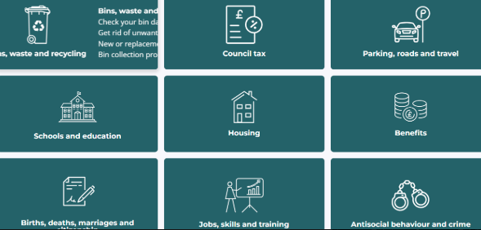
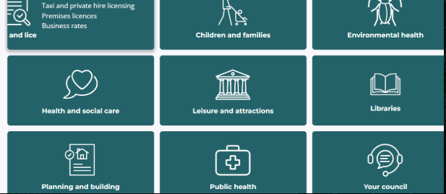
One of the most important strengths is that Early Help has been incorporated into a larger safeguarding framework. The site directly associates Early Help with multi-agency working and partnership formats, which is statutory in nature (Leeds City Council, 2024). This is conceptual clarity and policy congruence.

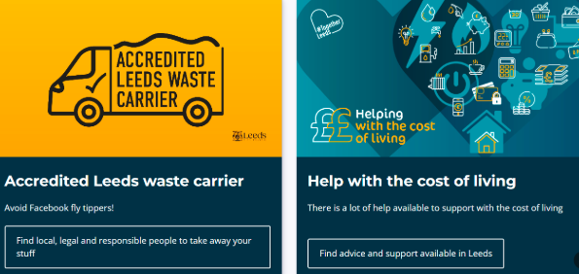
Nevertheless, the presentation is somewhat professional. Such terms as clusters and targeted services are not always well explained. This can act as a barrier to accessibility for families who are not conversant with safety systems. In addition, the level of information is wide, yet it may be overloaded with text, which decreases the usability for poorly digitally literate users.
The second weakness is that there are relatively few interactive capabilities. The visual aids, step-by-step instructions, or simplified paths to gaining support are limited. It is the opposite of best practice in the digital service delivery, which prioritises user-centred design and accessibility (NHS Digital, 2019).
4.2: Norfolk County Council
The Norfolk County Council is more approachable and friendly. The site is well-defined and has an Early Help section, which is written rather lightly and has a clear system of navigation. The organisation of information is based on the service categories, which are more accessible.
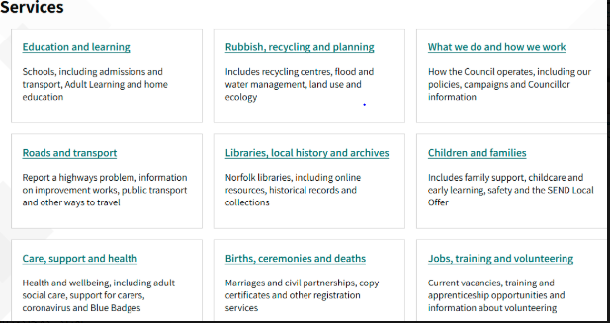
Clear referral pathways have been used, which is also a strength. The site outlines the way in which families may receive support, such as help with living costs, and a community directory. This is an application of the early intervention principle, which minimises access barriers (Norfolk County Council, 2024).
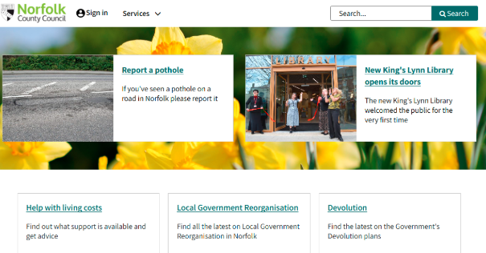
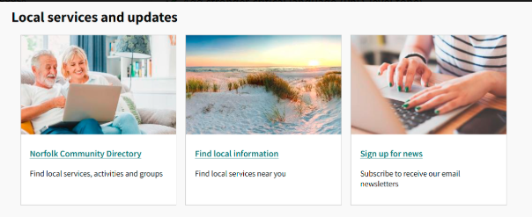
Norfolk is also more integrated in terms of digital engagement strategies. The site has useful guidelines, frequently asked questions, and detailed explanations of procedures like Early Help Assessments. This supported the role of digital technologies in service delivery to ensure communication is user-focused.
Nevertheless, these have certain limitations. Although the site is user-friendly, it is not comprehensive enough to provide information about the multi-agency structure that Early Help is based on. The emphasis is laid on service availability, but not systems knowledge. This can curtail transparency and make families less aware of how the support is arranged.
Moreover, culturally responsive content has little evidence to support it, a factor especially significant in heterogeneous communities. Some user groups may not be able to access information due to a lack of multilingual materials or a lack of customised information.
4.3: Tower Hamlets Council
Tower Hamlets Council introduces Early Help in a very well-developed safeguarding system, as it is a city council with a heterogeneous population. The site offers a “Children and Family Care” section where services are categorised clearly, such as parenting support services, youth provision services and referrals for safeguarding. One of its strengths is the clear-cut multi-agency working. The site is clear and explains how various agencies combine their efforts to ensure the safety of children in Tower Hamlets. This supported the expectations of the statute as shown in Working Together to Safeguard Children (HM Government, 2023), which manifested transparency and accountability.
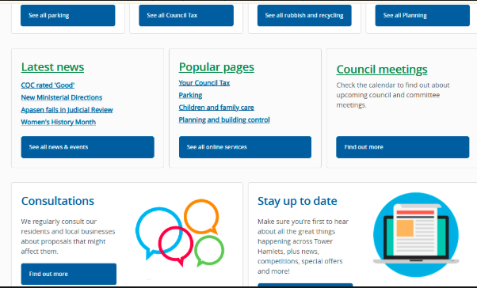
Also, Tower Hamlets is more inclined to inclusiveness and diversity. The demographic profile in the borough is mirrored in attempts to offer convenient services, including community support provision and the community right to bid. This corresponds to the theoretical approaches to social determinants of child welfare (Featherstone et al., 2018). Nevertheless, despite all these strengths, the site has major challenges with usability. Several links allowed navigation to find essential information. Significant information is frequently built into professional-centric pages, so families may not be able to find the appropriate services quickly.
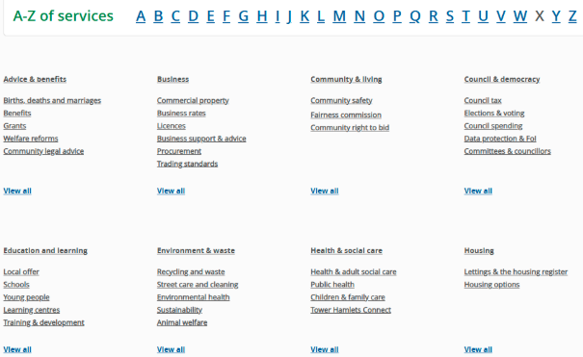
Moreover, the site is informative, but it does not have simplified user paths. The visual aids, stepwise instructions, or interactive devices are not used extensively to facilitate comprehension. This is especially a problem with the complexity of safeguarding systems and the vulnerability of users that may be associated with them. More importantly, the website seems to be more focused on institutional transparency rather than allowing users access. Although the information might be comprehensive to professionals, families might have difficulties engaging. This is indicative of a larger conflict in the field of digital public services between accountability and usability.

- Comparative Analysis of Strengths and Weaknesses
5.1: Accessibility and User Experience
The Norfolk County Council presents the most positive results in the aspect of user accessibility. Its website is written in plain language, has easy navigation and organised routes leading one to the appropriate services. This brings about user-centred design principles and conforms to the best practices of digital (NHS Digital, 2019).
Leeds and Tower Hamlets, on the contrary, have more complicated interfaces and include more text. Both of them are very informative, but they are not simplified, which lowers usability. This is especially worrisome in relation to Early Help, where the information should be provided on time.
Tower Hamlets is doing the worst in this area because of the fragmented navigation and layers of information. Entry points may not be easily identified by the users, which negates the preventative goals of Early Help.
5.2: Clarity of Early Help Communication
The most conceptually detailed account of Early Help is given by Leeds City Council. It explicitly connects services to the protection structures and multi-agency work. This is highly responsive to statutory direction, and it shows a high level of policy comprehension.
Nevertheless, this transparency is rather professional than user-friendly. Accessibility is hampered by technical language and complicated construction for the family. Norfolk, on the contrary, makes main ideas easy to understand, but even shallow at times.
In Tower Hamlets, there is a partial balance because it gives in-depth explanations, but it does not provide them in a format that can be easily used. This implies that clarity is not only content-based but also presentation-based.
5.3: Representation of Multi-Agency Working
The most vivid description of multi-agency cooperation is offered by Tower Hamlets, which defines the role of safeguarding partners. This improves transparency and is very much aligned with the statutory expectations (HM Government, 2023).
Leeds also shows a great incorporation of the principles of multi-agency, but in a more implicit way. The building demonstrates cooperation, and this fact is not always evident to the users.
Norfolk is the lowest in this category, and few descriptions have been made in terms of the mechanisms of collaboration among agencies. Although this will make the user experience easier, it can lower the knowledge of the wider support system.
This brings out a major tension between simplicity and transparency. Both are necessary in efficient communication, and none of the councils manages to reach this balance completely.
5.4: Inclusivity and Responsiveness
Tower Hamlets is the most dedicated to the concept of diversity and inclusiveness, which is indicative of the local realities. The site recognises the needs that are community-specific and offers culturally responsive services.
Norfolk and Leeds are less concerned with inclusivity, or, more precisely, multilingual resources and customised communication. This constitutes a lost chance of working with different groups of people, especially considering the fact that accessibility is crucial in protecting contexts.
Critically, inclusivity is not an added feature but a fundamental part of successful Early Help delivery. In the absence of it, some groups can end up being left out of support systems.
5.5: Digital Strategy and Engagement
The most consistent with the current digital engagement techniques (such as clear direction, user-oriented content, and feasible advice) is the Norfolk County Council. This portrays the Week 8 learning about the importance of digital technologies in improving service delivery.
Leeds and Tower Hamlets are behind in terms of this, as they do not use interactive or user-centred methods of information dissemination as extensively as they do traditional ones. This hinders interaction and can decrease the efficiency of Early Help as a prevention system.
- Conclusion and Recommendations
As can be seen in this report, all three local authorities offer very robust information about the Early Help, yet their efficiency in terms of accessibility and user-friendliness differs considerably. Norfolk County Council proves to be the best in general. Its website is more focused on clear, accessible and user-friendly navigation, thus making it easier to get assistance from the family. Nevertheless, it does not go into details on multi-agency structures. The Leeds City Council has great policy consistency and conceptual clarity, but is constrained by the professional orientation and unfriendly design. The best and most inclusive framework is offered by Tower Hamlets Council, which is impaired by the lack of usability and disjointed navigation.
The local authorities should focus on user-centred web design by reorganising the Early Help pages into logical pathways (e.g., get help now), with visual icons and simplified navigation lists to help the families to find the appropriate service within a few clicks. Moreover, councils need to strike a balance between simplicity and transparency by providing brief descriptions on multi-agency working (who does what, how referrals are made, etc.) in plain language summaries with optional detailed instructions to those users who need more information. Lastly, the government must be increasingly inclusive by making sensible online adjustments, such as providing multilingual information, simplified forms, and culturally meaningful case studies, so that non-whites and their families can receive and comprehend the services of Early Help without any obstacles.

Reference
Bronfenbrenner, U. (1979). The ecology of human development. Harvard University Press.
Department for Education (2020). Early Help System Guide. Available at: https://assets.publishing.service.gov.uk/media/628de13be90e071f5f7e1bd2/Early_Help_System_Guide.pdf
Featherstone, B., Gupta, A., Morris, K., and Warner, J. (2018). Let’s stop feeding the risk monster: Towards a social model of ‘child protection’. Families, relationships and societies, 7(1), 07-22.
HM Government (2023). Working Together to Safeguard Children 2023. Available at: https://assets.publishing.service.gov.uk/media/6849a7b67cba25f610c7db3f/Working_together_to_safeguard_children_2023_-_statutory_guidance.pdf
Leeds City Council (2024). Family Hubs and the Early Help front door team. Available at: https://www.leeds.gov.uk/one-minute-guides/family-hubs-and-early-help-front-door-team
Munro, E. (2011). The Munro Review of Child Protection. Department for Education.
NHS Digital (2019). NHS Digital service manual. Available at: https://service-manual.nhs.uk/
Norfolk County Council (2024). Early Help for children and families. Available at: https://www.norfolk.gov.uk/article/40407/Early-help-for-children-and-families
Tower Hamlets Council (2024). MAST Early Help and children’s and family services. Available at: https://www.towerhamlets.gov.uk/lgnl/health__social_care/children_and_family_care/Early_Help/Early-Help-and-Children-and-Family-Service.aspx

