

Handwritten Digit Recognition
Based on MNIST Dataset

by
Yuxuan Zhao

January 2022

1. Introduction
Artificial intelligence, a branch of computer science, is dedicated to allowing machines to make judgements about the unknown in a human-like manner after a certain amount of training. Artificial intelligence covers a wide range of areas, among which handwritten digital recognition has been used on a large scale in areas closely related to people's livelihood, such as finance, postal services and education. The study of algorithms for handwritten digit recognition is of great practical value because handwritten digits are difficult to replace completely by printed digits and because of the high recognition accuracy required [1]. In this paper, we classify handwritten digit images from the MNIST dataset using a variety of classification methods based on what I have learned in the course and analyses the effectiveness of each classification method.

2. Methods and experiments
2.1 MNIST Handwriting Dataset
The MNIST dataset (Mixed National Institute of Standards and Technology database) is a database of handwritten digits collected and collated by the National Institute of Standards and Technology from 250 different people, with 70,000 images, a training set of 60,000 examples and a test set of 10,000 examples [2]. An example of part of the MNIST handwritten dataset is shown in Figure 1.
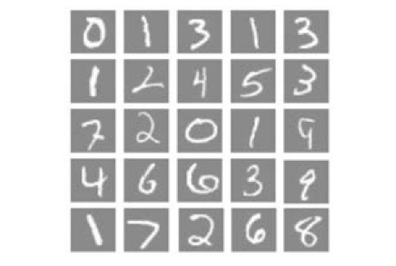
Figure 1 Examples in the MNIST handwritten dataset

2.2 Data preprocessing
Firstly, a 28*28 2D digital image from the MNIST handwriting dataset was converted to a 1D flat vector using the reshape function and converted to floating point type, with a total of 784 floating point numbers in the image. The digital image images is then digitally normalized. The simplest way to normalize the image is to divide the image by 255, as the image has values from 0 to 255. The normalization of the image will improve the classification accuracy of the training model during the training process.
2.3 Histogram of Oriented Gradient
HOG (Histogram of Oriented Gradient) is an algorithm originally proposed by Dalia et al. for pedestrian detection and has since been widely investigated in other areas of image recognition. The HOG algorithm calculates the gradient size and direction of uniformly sized and densely packed cells in an image and performs statistics.
The HOG algorithm process is as follows.
1) Grey-scale the original image,
2) normalize the original image, usually using the Gamma correction method, and
3) calculating the gradient size and gradient direction for each pixel of the image.
4) cutting the image into cells of equal size.
5) counting the gradient information for each cell to obtain a histogram of its statistical description. The gradient information is usually counted in 8 directions, and the vector represented by this gradient histogram is its descriptor
6) Combine the statistical feature vectors of adjacent cell units to obtain the feature vector of each block.
7) Combine the descriptors of all blocks within the image to obtain the HOG feature vector of the original image.
As the images in the MNIST dataset used in this paper are digital images, where the shape of local numbers can be well described by the gradient or edge direction density distribution [4], the HOG method constitutes features by calculating and counting the gradient direction histogram of local regions of the image, which is in principle more compatible with handwritten number recognition and should effectively improve the performance of subsequent recognition methods. On the other hand, HOG only counts the gradient information of the image, while ignoring other information such as mean and variance. However, since mean and variance are not highly relevant features for handwritten digit recognition, ignoring the mean and variance of the images does not have a significant negative impact.
I therefore decided to use the HOG method of pre-processing to extract image features in this recognition process. The initial image is a 28*28 two-dimensional digital image, in which the handwritten numbers have a stroke width of about 3-6 pixels. Therefore, I think it is more appropriate to use a 4*4 cell to segment the image and achieve better results. Taking one of the digital images as an example, the original and HOG-extracted feature maps are shown below.
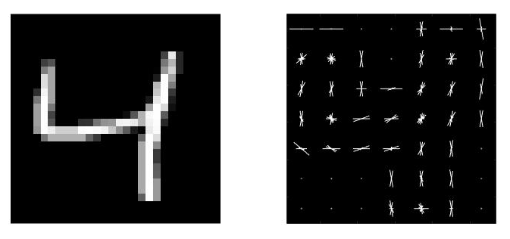
Figure 2 HOG extracted features

2.4 Naive Bayes
A Naive Bayesian classifier is a simple and efficient classifier based on Bayesian theory. The Bayesian principle is as follows: for a given item to be classified, the probability of each category occurring under the conditions in which the item occurs is solved, and whichever is greatest is considered to be the category to which the item to be classified belongs.
$$P\left(A|B\right)=\frac{P(A,B)}{P(B)}$$
If A and B are independent to each other, then
$$P\left(A | B\right)=P\left(A\right)$$
$$P\left(A,B\right)=P\left(A | B\right)P\left(B\right)=P(A)P(B)$$
The principle of the Naïve Bayesian classifier is as follows: for a given item to be classified, the probability of each category occurring under the conditions in which this item occurs is solved, and whichever is greatest is considered to be the category to which the target to be classified belongs.
The steps of the Naive Bayesian classification are as follows.
1) Calculate the prior probability. The prior probability of each sample is equal to the number of samples in the category to which it belongs as a proportion of the number of all samples.
2) Calculate the conditional probability. Based on the premise that each feature is independent of each other, calculate the joint distribution of inputs/outputs conditional on different features.
3) The output with the highest posterior probability is calculated as the prediction result using Bayes' theorem [3].
Since the fitcnb function in matlab needs to fit a normal distribution to the data, the variance of the data cannot be zero. I use the function to remove columns of similar data features that have a variance of zero.
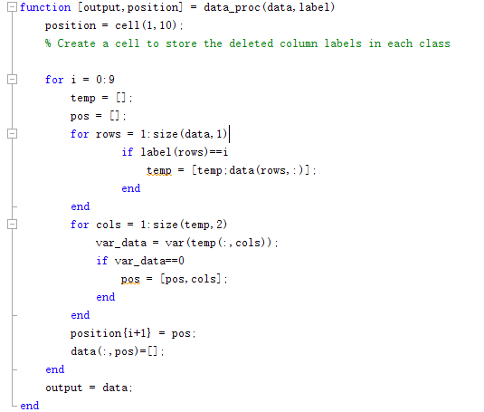
After data processing, input the training data and labels into fitcnb function to obtain Naïve Bayes model. The variation of accuracy of Naïve Bayes model with the amount of training data is as follows:
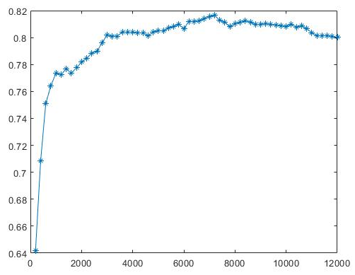
Figure 3 Accuracy variation with training data amount
When the data is directly input into the network, the accuracy of the network reaches the highest when the training set is 7200 pictures, which is 81.65%. It takes 0.524433 seconds to classify 10000 pictures in the test set. The confusion matrix is shown in the figure below:
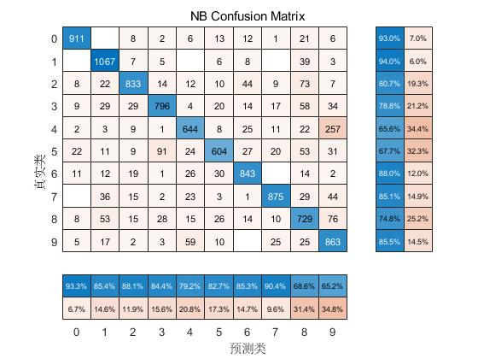
Figure 4 Confusion Matrix of NB Model
The highest Accuracy of the network was achieved at 89.70% when the data was input to the network after the HOG extracted features and the training set was 7800 images. The confusion matrix is shown below. The data was extracted with HOG features and then fed into the network for training, resulting in a significant increase of 8.05% in the network recognition accuracy. The confusion matrix is shown in the figure below:
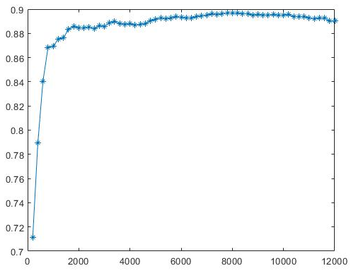
Figure 5 Accuracy variation with training data amount

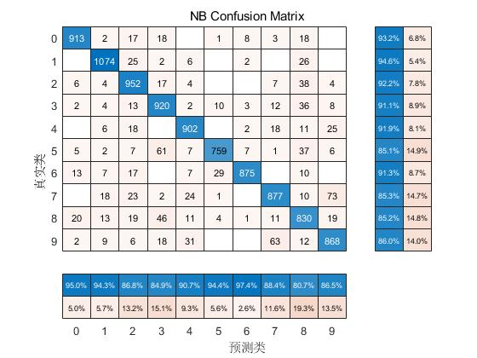
Figure 6 Confusion Matrix of NB Model
The figure above shows that the Accuracy of the Naïve Bayes model gradually increases to a peak and then decreases as the amount of data in the training set increases. Therefore, for the Naïve Bayes model, the larger the training set, not the better. It is conjectured that since the Naïve Bayes model is based on statistical principles, the variability of different human fonts cannot be ignored in the model, and therefore the prediction results will be biased by the addition of more training data when the training set becomes larger.
Comparing the two Confusion Matrixes, it can be seen that using HOG significantly reduces the number of incorrectly identified 4s as 6s, and thus the overall recognition rate is greatly improved. The gradient information of the HOG improves this.

2.5 SVMs
Support vector machines (SVMs) are linear classifiers defined in the feature space such that the classification interval is maximized [4]. The goal is to find the separating hyperplane that correctly partitions the training data set and has the largest geometric interval [5]. For a non-linear classification problem in the input space, it can be transformed into a linear classification problem in some dimensional feature space by a non-linear transformation to learn a linear support vector machine in a high-dimensional feature space. Since in the pairwise problem learned by a linear support vector machine, both the objective function and the classification decision function involve only the inner product between instances and instances, it is not necessary to explicitly specify the non-linear transformation, but to replace the inner product among them with a kernel function.
An SVM is essentially a binary classifier and can be considered as a collection of multiple binary classifiers when performing multiple classification. The fitcecoc function uses k(K-1)/2 binary support vector machine (SVM) models using the one-versus-one coding design.
The accuracy of the SVM network was 94.38% after training the image data directly into the network.
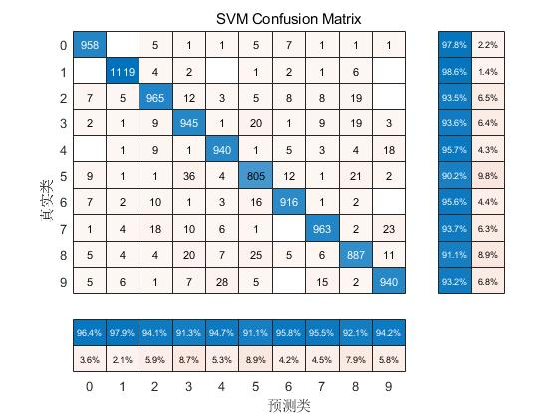
Figure 7 Confusion Matrix of SVM Model
Training the data after the HOG extracted features into the network resulted in an accuracy of 98.40% for the SVM network.
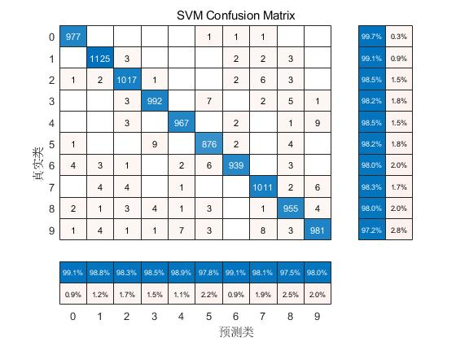
Figure 8 Confusion Matrix of SVM Model after HOG
Comparing the 2 figures above, it can be seen that after using HOG to extract features, the false recognition rate of individual digits generally decreased and the overall performance of the network was improved to a new level.

2.6 Trees
2.6.1 Decision Trees
A decision tree is a supervised learning algorithm. It is applicable to categories and continuous input and output variables. Decision tree learning is a method of approximating a discrete-valued objective function, which represents the function learned from a set of training data as a decision tree. It is robust to noisy data and can learn to derive expressions. The decision tree classifies instances by arranging them from the root node to a leaf node, which is the classification to which the instance belongs. Each node in the tree specifies a test for an attribute of the instance, and each subsequent branch of the node corresponds to a value of that attribute [6]. The decision tree uses the information entropy of different features to calculate the classification after branch selection by different features, finding the best one as the root node, and so on.
Using the fitctree function in matlab the desired classifier can be trained. The accuracy obtained by feeding the image data directly into the classifier was 87.77%.
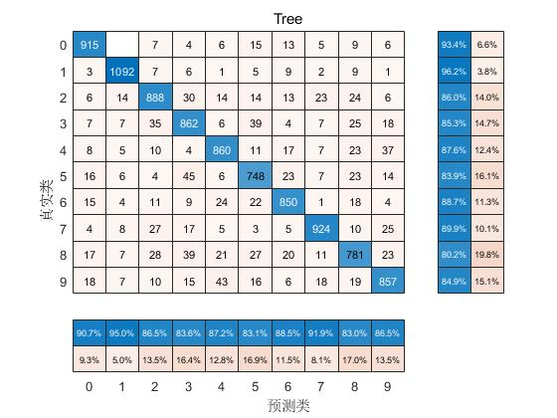
Figure 9 Confusion Matrix of Decision Trees Model
The accuracy of the network obtained after HOG feature extraction and input network training is 90.31%.
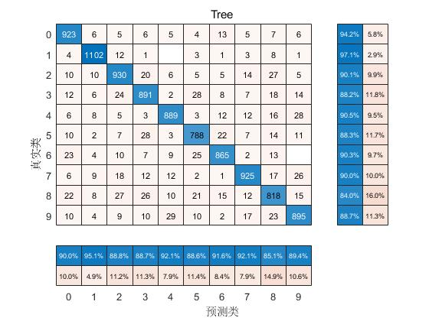
Figure 10 Confusion Matrix of Decision Trees Model
It can be seen that HOG feature extraction can improve the recognition rate of Decision Trees Model, but the improvement is far less effective than that of Naïve Bayes.

2.6.2 Bagging Trees
The basic idea of Bagging is to combine a number of weak classifiers to form a strong classifier.
For a training set, Bagging will perform several rounds of random sampling, each round of random sampling will be used to train a weak classifier, each round of training is completed to obtain a prediction function, then the training can be completed to obtain multiple prediction functions. Each weak classifier will get a corresponding prediction result, and finally the prediction result of the whole Bagging Tree will be obtained using the majority voting rule [7].
As HOG has been found to improve the effectiveness of individual Decision Trees in 2.4.1, the data is no longer fed directly into the model for training, and the feature data extracted by HOG is fed into Bagging Trees for the next experiment.
A loop was performed in Matlab using the TreeBagger function to obtain the relationship between the number of trees and the overall acc as follows.
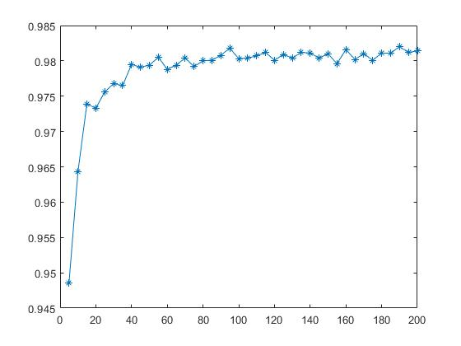
Figure 11 Accuracy variation with amount of tree
From the above figure it can be seen that when the number of decision trees is below 40, the accuracy of the classifier keeps rising. When the number of decision trees exceeds 100, the accuracy of the classifier fluctuates repeatedly, which means that the performance of the Bagging Trees Model no longer improves significantly. Finally, 95 was chosen as the number of decision trees, at which point there was better recognition performance. At this point the recognition accuracy of the network was 98.21% and the Confusion Matrix was as follows.
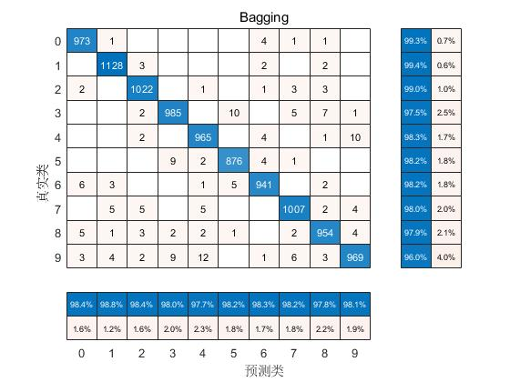
Figure 12 Confusion Matrix of Bagging Trees Model
It can be seen that the performance of the Bagging Trees Model is very much improved compared to the Decision Tree. And according to the Confusion Matrix, it can be seen that the misclassification of many numbers is only concentrated in some other classes, unlike SVM and Naïve Bayes, which are more dispersed.

2.6.3 Random Forest
RF (Random Forest) is an evolution of the Bagging algorithm, which is still based on the idea of bagging, but with unique improvements. Firstly, Random Forest uses decision trees as a weak learner. On the basis of using decision trees, Random Forest has made improvements to the building of decision trees. A normal decision tree selects the best feature among all the sample features on a node to divide the left and right subtrees of the decision tree, but Random Forest selects the best feature by randomly choosing a part of the sample features on a node to divide the left and right subtrees of the decision tree, which further enhances the generalization ability of the model.
In simple terms, Random Forest not only selects a random portion of the data for training, but the features used in the training process are also randomly selected.
The Random Forest algorithm proceeds as follows.
The input is the sample set D={(x,y₁),(x₂,y₂),...(x_{m},y_{m})}, and the number of weak classifier iterations is T.
The output is the final strong classifier f(x).
1) For t=1,2... , T:
a) Randomly sample the training set for the $t$ time, $m$ times in total, to obtain a sample set $Dt$ containing $m$ samples
b) train the $t$ decision tree model $Gt(x)$ with the sample set $Dt$, and when training the nodes of the decision tree model, select some of the sample features among all the sample features on the nodes, and select an optimal feature among these randomly selected features to make the left and right subtrees of the decision tree
2) The category or one of the categories with the most votes cast by the T weak learners is the final category.
The classifier is set up in matlab using the templateTree function and is fed into the fitcensemble function for training along with the HOG features. As the number of trees increases, the classifier performance changes as follows.
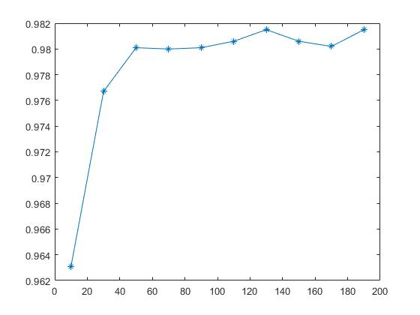
Figure 13 Accuracy variation with amount of tree
As the above figure shows, RF is able to achieve over 98% accuracy at 50 classifiers, which is similar to Bagging Trees. The Confusion Matrix of RF at this point is shown below.
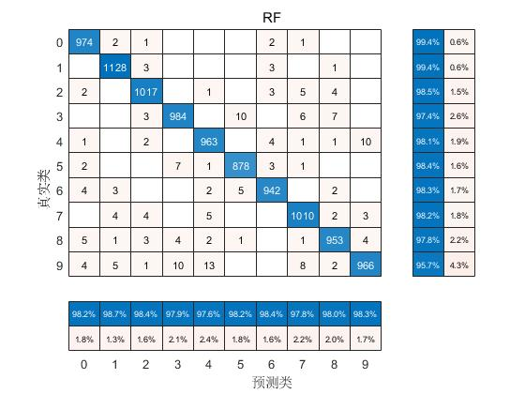
Figure 14 Confusion Matrix of RF Model
Comparing the Confusion Matrix of BT, we can see that the Confusion Matrix of the RF classifier is similar to its counterpart, basically the same. However, the RF classifier uses fewer features and is faster than the BT with the same number of trees.

3. Discussion of results
The performance parameters of each network above are shown in the following table
Table 1 Performance parameters of each network
 | Accuracy | Sensitivity | Specificity
NB | 81.65% | 92.96% | 99.28%
NB(HOG) | 89.70% | 93.16% | 99.47%
SVM | 94.38% | 97.76% | 99.60%
SVM(HOG) | 98.40% | 99.69% | 99.90%
DT | 87.77% | 93.37% | 98.96%
DT(HOG) | 90.26% | 94.18% | 98.86%
BT(HOG) | 98.15% | 99.39% | 99.81%
RF(HOG) | 98.15% | 99.39% | 99.93%
It can be seen that HOG feature extraction can generally improve the performance of each of the above methods, and by a large margin for some models, indicating that the image pre-processing and information extraction steps are crucial to the digital recognition process.
The selection of parameters can also greatly affect the classification performance of the classifier.
The Naïve Bayes classification is based on statistical principles and has a low recognition rate of 89.70%.
SVM, bagging trees and RF performed well, and the accuracy rate reached more than 98%.
It takes 1.231783 seconds for SVM to recognize 10000 test images, 1.404364 seconds for bagging trees (nTree = 50), and 0.318848 seconds for RF(nTree = 50). The recognition speed of RF is much faster than bagging trees and SVM.
Therefore, the method with the highest accuracy in this paper is HOG + SVM. The method with high accuracy and fast calculation is HOG + RF.

4. Conclusion
This paper introduces Naïve Bayes, SVM, and decision trees, and implements handwritten digit recognition based on these algorithms via matlab code for the MNIST dataset. It is experimentally verified that feature extraction by HOG in pre-processing can effectively improve the performance of each network in the paper. By experimentally adjusting some of the training parameters in each network, the network performance is gradually improved and the overall recognition rate is increased. Finally, by comparing each network in the paper, it is determined that the performance of the HOG+SVM method is superior, but there is still much room for future improvement.

References
[1] Zhou Bo-kai. Handwritten number recognition based on random forest[J]. Computer Programming Skills and Maintenance,2021(11):112-114. doi:10.16184/j.cnki.comprg.2021.11.042.
[2] Zeng Documenta,Meng Qinglin,Guo Zhaokun. Research on handwritten digit recognition based on deep convolutional self-coding neural network[J]. Computer Application Research,2020,37(04):1239-1243.DOI:10.19734/j.issn.1001-3695.2018.09.0774.
[3] Wang M,Li D-X. Handwritten digit recognition based on improved VGG-16 and Naive Bayes [J]. Modern Electronics Technology,2020,43(12):176-181+186.DOI:10.16652/j.issn.1004-373x.2020.12.041.
[4] Bo WJ, Ni ShouDong. Research on multi-bit pose target detection of electronic components by combining HOG and SVM[J]. Mechanical Design and Manufacture, 2021(10):76-80. doi:10.19356/j.cnki.1001-3997.2021.10.017.
[5] Li Hang. Statistical learning methods (2 ed.) [M]. Beijing:Tsinghua University Press,2019:111-153
[6]Huang W,Wei P. Recognition of handwritten numbers based on decision trees [J]. Information Technology and Informatization,2011(06):21-23+73.
[7] Zhao Liheng. Research on the application of handwritten digit recognition based on decision tree[J]. Software,2018,39(03):90-94.

Appendix 1: code of load data

clc;
clear;

% Load data
x_train=LoadMNISTImages('./mnist/train-images.idx3-ubyte');
x_test=LoadMNISTImages('./mnist/t10k-images.idx3-ubyte');
y_train=LoadMNISTLabels('./mnist/train-labels.idx1-ubyte');
y_test=LoadMNISTLabels('./mnist/t10k-labels.idx1-ubyte');

function images = LoadMNISTImages(filename)
imagesfile = fopen(filename,'rb');
assert(imagesfile~=-1,['Could not open',filename,'']);

magic = fread(imagesfile,1,'int32',0,'b');
assert(magic==2051,['Bad magic number in',filename,'']);

numimages = fread(imagesfile,1,'int32',0,'b');
fprintf('Number of images in the dataset: %6d ...\n',numimages);
numrows = fread(imagesfile,1,'int32',0,'b');
numcols = fread(imagesfile,1,'int32',0,'b');

images = fread(imagesfile,inf,'unsigned char');
images = reshape(images,numcols,numrows, numimages);
images = permute(images,[2 1 3]);

images = reshape(images,size(images,1)*size(images,2),size(images,3));
images = double(images/255)';

fclose(imagesfile);
end

function labels = LoadMNISTLabels(filename)
labelsfile = fopen(filename,'rb');
assert(labelsfile~=-1,['Could not open',filename,'']);

magic = fread(labelsfile,1,'int32',0,'b');
assert(magic==2049,['Bad magic number in',filename,'']);

numlabels = fread(labelsfile,1,'int32',0,'b');
fprintf('Number of labels in the dataset: %6d ...\n',numlabels);

labels = fread(labelsfile,inf,'unsigned char');
assert(size(labels,1)==numlabels,'Mismatch in label count');

fclose(labelsfile);
end

Appendix 2: code of Extracting HOG Features
% Extracting HOG Features
x_train_pre=reshape(x_train',28,28,[]);
x_test_pre=reshape(x_test',28,28,[]);

cellSize = [4 4];
[hog_4x4, ~] = extractHOGFeatures(x_train_pre(:,:,4),'CellSize',cellSize);
hogFeatureSize = length(hog_4x4);

x_train_HOG = zeros(60000,hogFeatureSize,'single');
for i = 1:60000
img = x_train_pre(:,:,i);
img = imbinarize(img);
x_train_HOG(i, :) = extractHOGFeatures(img,'CellSize',cellSize);
end

x_test_HOG = zeros(10000,hogFeatureSize,'single');
for i = 1:10000
img = x_test_pre(:,:,i);
img = imbinarize(img);
x_test_HOG(i, :) = extractHOGFeatures(img,'CellSize',cellSize);
end

clear x_train_pre x_test_pre cellSize hog_4x4 hogFeatureSize img i

Appendix 3: code of naïve bayes

% Load data
LoadMNIST
ExtractingHOG

range=120;
a=[];
maxacc = 0;

for i=2:2:range
train_num=i*100;
% train_num=7800
data_train = x_train_HOG(1:train_num,:);
[data_train,position] = data_proc(data_train,y_train(1:train_num));

data_test = x_test_HOG;
for rows = 1:10
data_test(:,position{1,rows})=[];
end

nb_model = fitcnb(data_train,y_train(1:train_num));

tic
result = predict(nb_model,data_test);
toc

cp=classperf(y_test,result);
Accuracy=cp.CorrectRate;
if Accuracy>maxacc
maxacc=Accuracy;
maxcp=cp;
maxresult=result;
end
a = [a;[train_num,Accuracy]];
end
figure('color',[1 1 1]);
plot(a(:,1),a(:,2),'-*')

Accuracy=maxcp.CorrectRate;
PositivePredictiveValue=maxcp.PositivePredictiveValue;
NegativePredictiveValue=maxcp.NegativePredictiveValue;
figure('color',[1 1 1]);
cm = confusionchart(y_test,maxresult,'Title','NB Confusion Matrix', ...
'RowSummary','row-normalized', ...
'ColumnSummary','column-normalized');

Appendix 4: code of SVM

% Load data
load('MNIST_data.mat')

% linear SVM
tic
SVM_model=fitcecoc(x_train,y_train); % Train
toc
tic
result = predict(SVM_model,x_test);
toc
cp=classperf(y_test,result);
Accuracy=cp.CorrectRate;
PositivePredictiveValue=cp.PositivePredictiveValue;
NegativePredictiveValue=cp.NegativePredictiveValue;

figure('color',[1 1 1]);
cm = confusionchart(y_test,result,'Title','SVM Confusion Matrix', ...
'RowSummary','row-normalized', ...
'ColumnSummary','column-normalized');

% linear SVM
tic
SVM_model_HOG=fitcecoc(x_train_HOG,y_train); % Train
toc

tic
result1 = predict(SVM_model_HOG,x_test_HOG);
toc

cp=classperf(y_test,result1);
Accuracy1=cp.CorrectRate;
PositivePredictiveValue1=cp.PositivePredictiveValue;
NegativePredictiveValue1=cp.NegativePredictiveValue;

figure('color',[1 1 1]);
cm1 = confusionchart(y_test,result1,'Title','SVM Confusion Matrix', ...
'RowSummary','row-normalized', ...
'ColumnSummary','column-normalized');
Appendix 5: code of Trees

%% Load data
LoadMNIST
ExtractingHOG

%% Train and Testing a Decision Tree Classifier(With HOG)
% Get labels for each image.
tree1 = fitctree(x_train_HOG,y_train);
predictedLabels1 = predict(tree1, x_test_HOG);

cp=classperf(y_test,predictedLabels1);
Accuracy1=cp.CorrectRate; %0.9031
figure('color',[1 1 1]);
cm_tree1 = confusionchart(y_test,predictedLabels1,'Title','Tree','RowSummary','row-normalized','ColumnSummary','column-normalized');

%% Train and Testing a Decision Tree Classifier(Without HOG)
tree2 = fitctree(x_train,y_train);
predictedLabels2 = predict(tree2, x_test);

cp2=classperf(y_test,predictedLabels2);
Accuracy2=cp2.CorrectRate; %0.8777
figure('color',[1 1 1]);
cm_tree2 = confusionchart(y_test,predictedLabels2,'Title','Tree','RowSummary','row-normalized','ColumnSummary','column-normalized');

%% Bagging
a=[];
maxacc = 0;
for numTrees=10:5:200
tree_Bagging = TreeBagger(numTrees,x_train_HOG,y_train,'Method','classification');
tic
predictedLabels_Bagging = predict(tree_Bagging, x_test_HOG);
toc
predictedLabels_Bagging=str2double(predictedLabels_Bagging);
cp3=classperf(y_test,predictedLabels_Bagging);
Accuracy=cp3.CorrectRate
if Accuracy>maxacc
maxacc=Accuracy;
maxcp=cp3;
maxresult=predictedLabels_Bagging;
end
a = [a;[numTrees,Accuracy]];
[numTrees,Accuracy]
end
figure('color',[1 1 1]);
plot(a(:,1),a(:,2),'-*')

Accuracy=maxcp.CorrectRate;
PositivePredictiveValue = maxcp.PositivePredictiveValue;
NegativePredictiveValue = maxcp.NegativePredictiveValue;
figure('color',[1 1 1]);
cm_Bagging = confusionchart(y_test,maxresult,'RowSummary','row-normalized','ColumnSummary','column-normalized','Title','Bagging');

% Random Forest
a=[];
maxacc = 0;
for numTrees=40:5:55
t = templateTree('Reproducible',true);
tree_RF = fitcensemble(x_train_HOG,y_train,'Method','Bag','Learners',t,'NumLearningCycles',numTrees);
tic
predictedLabels_RF = predict(tree_RF, x_test_HOG);
toc
cp4=classperf(y_test,predictedLabels_RF);
Accuracy_RF =cp4.CorrectRate; %0.9427
if Accuracy_RF>maxacc
maxacc=Accuracy_RF;
maxcp=cp4;
maxresult=predictedLabels_RF;
maxRF=tree_RF;
end
a = [a;[numTrees,Accuracy_RF]];
[numTrees,Accuracy_RF]
plot(a(:,1),a(:,2),'-*')
end
figure('color',[1 1 1]);
plot(a(:,1),a(:,2),'-*')

predictedLabels_RF = predict(maxRF, x_test_HOG);

cp4=classperf(y_test,predictedLabels_RF);

figure('color',[1 1 1]);
cm_RF = confusionchart(y_test,predictedLabels_RF,'RowSummary','row-normalized','ColumnSummary','column-normalized','Title','RF');

