Series Hybrid Vehicle (Part A)

Introduction

We have been approached by a managing director, specializing in making off road buggies for the corporate entertainment sector. He would like to better understand the typical duty cycle of one of his off road buggies. This report will take you through a theorised duty cycle of what the buggy might experience in day to day usage, as well as any results that we gather.
The track we were going to make had to be realistic whilst being interesting and entertaining enough for people to enjoy driving it. The buggy had to be able to get around the whole track, and calculations had to be done to show this. The duty cycle that we had to have a total of 20m climb to test the buggies climb ability and include any idle running time. The track also had to take a total of two minutes to get around.

The Buggy

The designed course had to take into account all of the problems brought forward by the managing director, whilst still being entertaining and drivable for the buggy. This meant that the track had to be designed with the buggy in mind so it made sense to select a buggy first.
The buggy that I have chosen to use is the Polaris RZR 170.

The specs for this buggy are as follows:
Engine size: | 4 stroke- 169 cc
Transmission: | Automatic
Drive train: | Rear wheel drive
Power: | 10 K,w /5.5 Hp
Brakes: | Disk
Weight: | 227Kg

This buggy is ideal for the corporate entertainment. As you can see it is fully roll caged and comes with 5 point safety harnesses so is incredibly safe for passengers. It has two seats, one for a driver and one for an instructor if required. The 10Kw power plant allows the buggy to accelerate at 1m/s at full throttle, which is not scarily fast but at the same time entertaining enough to excite passengers. This in combination with the exposure to the elements you get with any buggy is guaranteed to keep people interested. Another benefit to the buggy being slower is that you will not need such a long track in order for it to get around in 2 minutes.

The Designed Course

With the buggy selected an adequate course could now be designed. It had to be two minutes long with a total climb of 20 m included, whilst being entertaining enough for people to enjoy it.
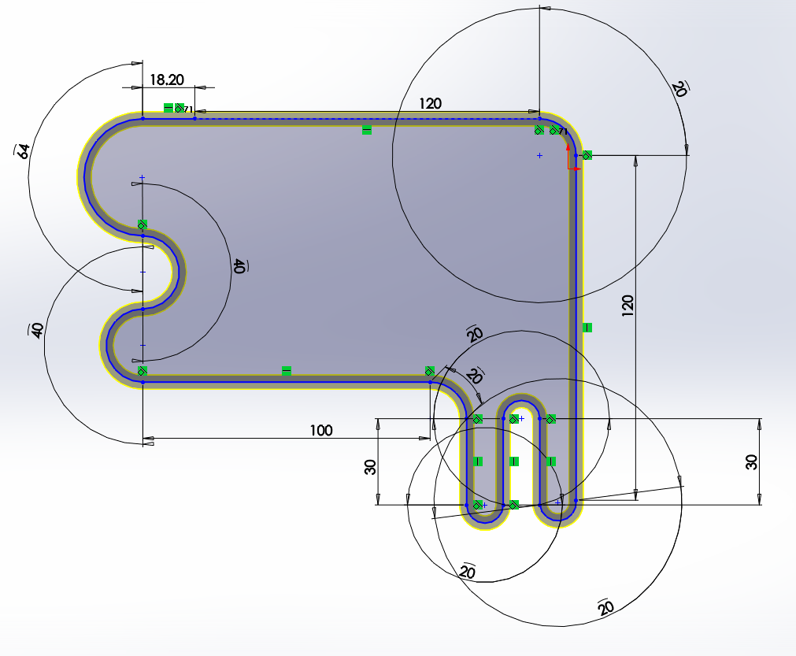
Decline
Incline
On the previous page you can see the final design of the track. The track is 5m wide to allow suitable room for driving. All the dimensions of the corners and straights for the track are shown (in meters) with the total distance covered for the whole track would be 692m. The track includes a combinations of tight, medium and longer bends for variation and to make the track more enjoyable to drive. The incline and decline sections are highlighted as you can see. To keep it simple the incline and decline sections are separate with incline being done over a 120m distance and decline being accomplished in 100m. This makes sure that it isn’t too steep for the buggy to get up and that the track has an exciting drop for people to enjoy.

Gathered Data

A full copy of the excel spread sheet will be included with this report. However, to make the data easier to understand it has been converted into graphical format. All of the data gathered and calculations made were achieved using a coefficient of friction of 0.6. This is

The first graph shown above is the speed or velocity that the buggy will be travelling for each section of the course. You can see the initial acceleration (1m/s2) in the first section of the graph on the left before breaking for the first corner. The differences in speed for the hairpin bends in the middle and the top speed (8m/s) around the course achieved during the decline can also be seen towards the middle of the graph. The buggy then comes to a controlled stop on the start/finish line. The whole lap driven in this style, as you can see, would take the buggy 121 seconds. This speed is fast enough to be exciting on a dirt off road course whilst not being too fast that it is unsafe.

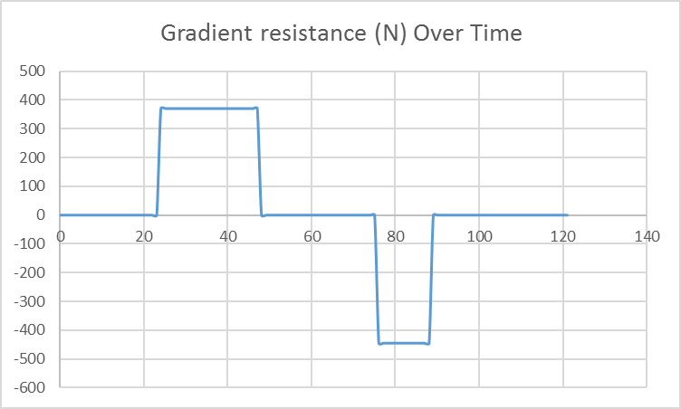
This second graph displays the resistance that is encountered at the different gradients. As you can see it matches the previous graph where the buggy is powering up the hill at lower speed and where it is dropping down at a much higher velocity. The climb that the buggy will have to endure will not take too long that it is boring to the passengers and the drop is steep enough to be exciting whilst still being safe. The buggy goes up and down the full 20m only once.

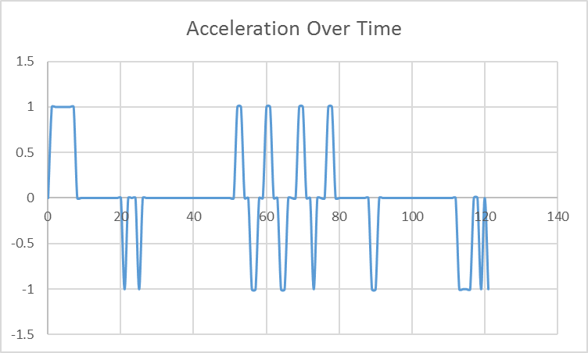
In this graph you can see the vehicle acceleration plotted against time. When we compare this to the velocity graph we can see that is matches up to where the speed of the buggy is increasing and decreasing. Where the acceleration is at 0, the buggy is coasting at the same speed, its speed is not changing. Where the acceleration is at 1, the buggies speed is increasing and if it’s at -1 then the speed is decreasing.

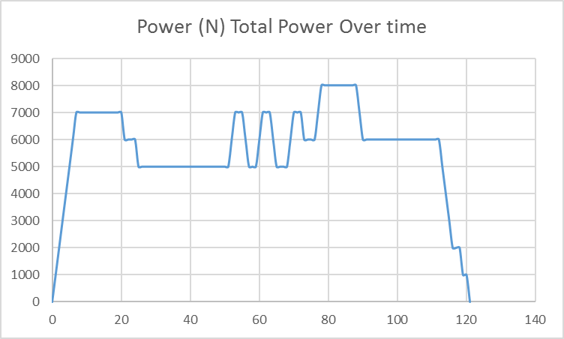
The graph above shows the total power that the buggy is required to have over each second of the lap. As you can see the buggy has more than enough power to tackle each section of the track. Where there is an anomaly however is in the decline section of the graph highlighted. Total power required of the buggy in this section should decrease as the buggy is now being assisted by gravity. Fortunately this anomaly can just be ignored as we know that the buggy will not struggle on this section of the track but it is something to consider when moving forward.
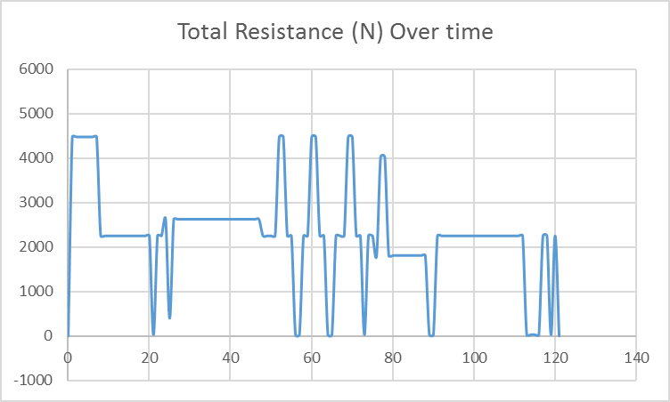
This next graph shows the total resistance that the buggy encounters for each second that it is on the track. If we compare this to the previous graph shown on total power required we can see that the anomaly is not carried forward as the total resistance for that section of the graph is below average. This means that there must be a problem with the calculations rather than with the simulated data. Going forward, this will have to be checked in the excel spreadsheet but as stated before it has no real effect on the results and so is nothing to worry about.

Conclusion

This duty cycle accurately represents the typical duty cycle of a buggy in the corporate sector. The track is complex enough to be entertaining whilst maintaining the highest level of safety and the buggy is the same. The buggy has more than enough power to get around the course which is good as this means it will not be overworked. The data has no anomalies with the exception of one that has been accounted for and talked about previously. This means that the calculations are sound. I think that this is a very accurate duty cycle.

Bibliography
Saferroadsconference.com. (2017). [online] Available at: https://saferroadsconference.com/wp-content/uploads/2016/05/Peter-Cenek-Frictional-Characteristics-Roadside-Grass-Types.pdf [Accessed 5 Dec. 2017].
Thecartech.com. (2017). Car Performance Formulas. [online] Available at: http://www.thecartech.com/subjects/auto_eng/car_performance_formulas.htm [Accessed 5 Dec. 2017].
Blitzworld.co.uk. (2017). Polaris RZR170, Kids, buggy, Go-Kart, dealer, Staffordshire. [online] Available at: http://www.blitzworld.co.uk/polaris-rzr170-i2504.html [Accessed 5 Dec. 2017].

