HOTEL ADMINISTRATION & FRONT OFFICE MANAGEMENT
Module – BIRM – M4X01920
Department: Hotel Placement – Hotel Administration & Front office
Mubaraca Mombassa -1905613

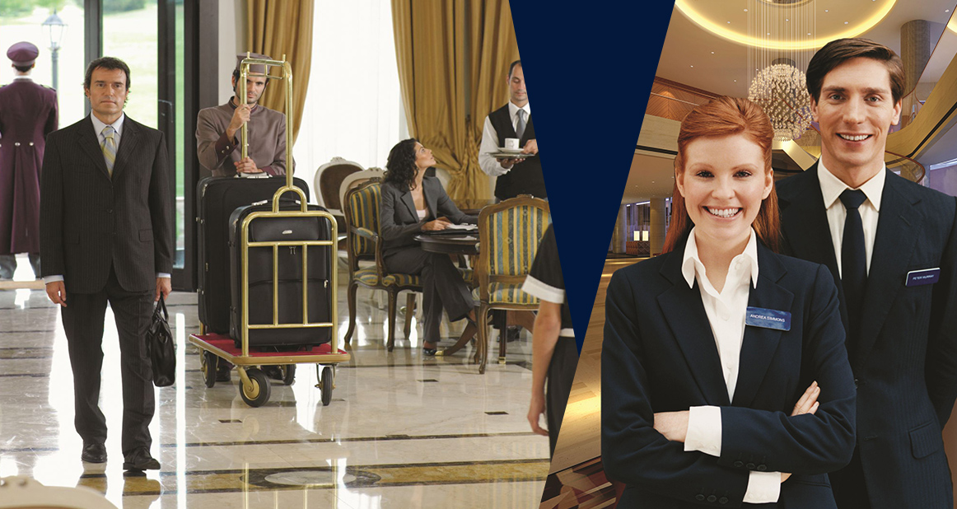
FRONT OFFICE MANAGEMTS....

Content
Introduction...............................................................................................................1
Front Office Management ..........................................................................................2
Front Office & Operations ..........................................................................................3
Interdepartmental Communication Department Information Needed from FOM................4
FOM & Duties .................................................................................................................5
Conclusion..........................................................................................................................6
References..........................................................................................................................7

Introduction
The present report intends to evaluate the role of front Office Management department, its management team, adaptations to changing consumer preferences, in order to provide excellent services. To accomplish this task, first of all, I had to establish a definition for the object of our study itself the concept of the Front Office.
The hotel’s front office referred to as the hub, the nerve centre, the brain, or some other name suggesting centrality. As H. E. Heldenbrand stated in his classic 1944 book Front Office Psychology, “To the guest, the manager is largely represented by the front office, and the unseen head will be judged favourably or otherwise by the guest treatment there”.
The perceptions, suppositions, and research introduced right now picked to outline the centrality of the front office in the cutting edge in the modern hotel. A theme that recurs throughout many of the readings in this report is that of communication. In an increasingly communication- oriented society and the world, information—its storage, retrieval, dissemination, and evaluation—can mean a competitive edge and, to certain extent, power.
Technology has given us internet, social media, cellular phones, electronic email (e-mail), telephone, and computer transmitted facsimiles (faxes), overnight delivery letters and packages, and personal data assistants (PDAs). However according to (Ducker 1999).
“"Management has to do with human beings. Its function is to make people capable of functioning together, making their strengths and weaknesses effective"

Front Office Management – FOM
It truly oversees all front office staff and ensures the suitable perfection of all front office commitments. It arranges and encourages the activities of the front work zone, reservations, guest organizations, and telephone regions. Preparing month to month reports and spending plan for the front office division.
The front office is answerable for welcome visitors, overseeing rooms, and taking care of objections. Keeps an eye on individuals from hotel, staff work in the background and every once in a while. If at any point have any close to home contact with visitors. Interestingly, the front office staffs play out their activity before people in general, similar to on-screen characters in front of an audience. Customers structure their first and, in some cases, the most enduring impression of the inn dependent on their involvement in the people of the front office.

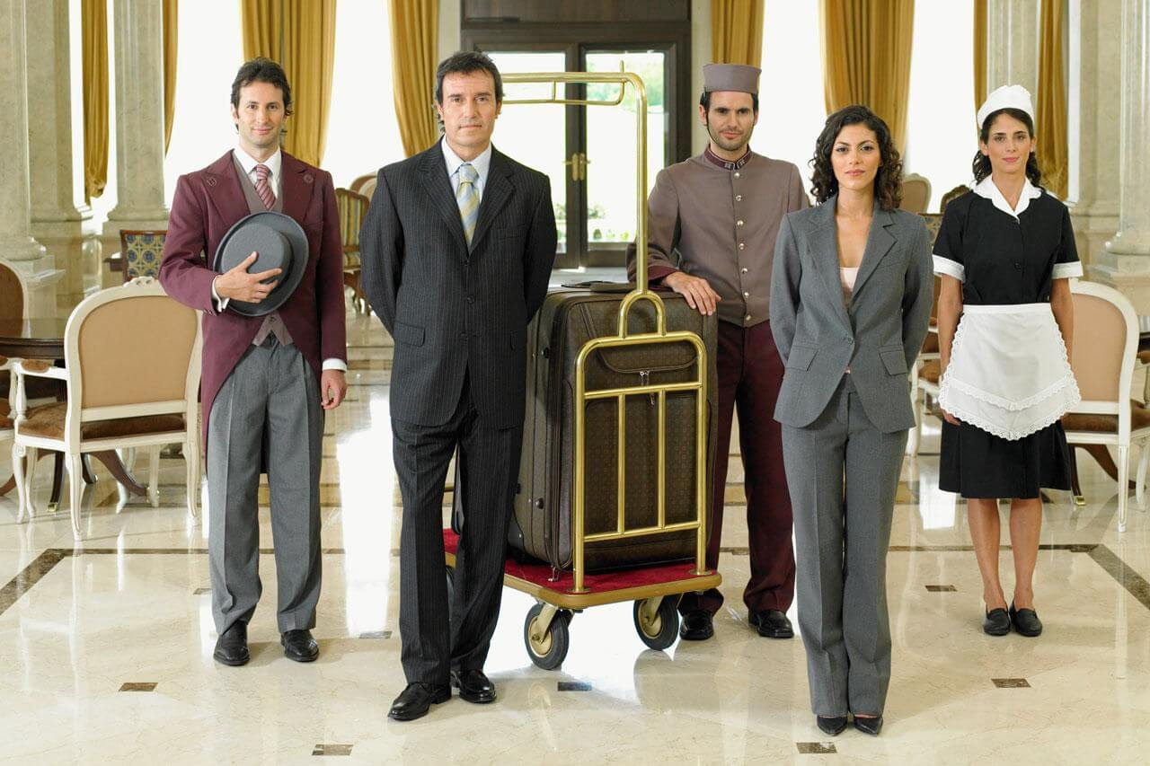
Front Office & Operation
The Important dimensions of the Front Office Management job, including communications, facilitation, and organizational interface and technical minutia. Selected job functions reported in the research findings included communications with guests and employees; facilitating medical emergencies, selling up, power failure procedures, walking guests due to overbooking, and design of computer systems for the front office; and organizational interface with the director of marketing, controller, food and beverage manager, and catering manager.
These job skills and interactions require a person to prioritize and to resolve many issues, to make quick decisions based on sound corporate management concepts, to empower employees, and to refine exemplary communication techniques. Bardi (1990, 345–349) stated,
“The front the office manager must take an active role in gathering information of interest to guests and in developing procedures for the front office to use in disbursing this information.”
This data is likewise required by different divisions to help with conveying and sorting out friendliness. This is a difficult task for the FOM to satisfy, particularly considering the all-out domain of potential data visitors may require and from what offices

Interdepartmental Communication Department Information Needed from Front Office:
Marketing and Sales - Guest history, reservations, Sales first impressions, relay messages, and guest function information.
Housekeeping - Room status, potential house count, security concerns, and requests for amenities and supplies.
Food & Beverage - Relaying messages, accurate voucher information, posting of charges to guest accounts, predicted house counts, and paid-outs.
Conference & Banquet - Information on scheduled events, process of payment of guest charges for scheduled events, preparation of daily function board and marquee, and a public communication post.
Controller - Daily summary of financial transactions, financial data for billing, and credit card ledgers
Maintenance - Room status and guest requests for maintenance service.
Security - Fire safety, emergency communication information, and investigation of guest security concerns.
Human Resources - Initial point of contact and screening for potential employees.

FOM & Duties
Along these lines, the FOM must grasp the charge of turning into a proactive communicator and facilitator. This lodging official must investigate and look for the snippets of data visitors will most likely need, and make sense of which offices must connect to satisfy these requirements. Further investigation into the job of the FOM can be cultivated by evaluating the components of an occupation examination of this position. Bardi (1990, 49–50) presents a job analysis of an FOM’s duties on a typical day.
• Review night audit report.
• Review incoming reservations for the day.
• Communicate information to employees on all shifts concerning reservations, room assignments, and room inventory.
• Communicate information to other departments—housekeeping, marketing and sales, banquets, food and beverage, plant engineering, and security.
• Resolve guest billing discrepancies and other complaints.
• Prepare budget with general manager and controller.
• Prepare forecasting sheet.
• Conduct business meetings to promote room sales.
• Assists in check-in, check-out, and reservation confirmations, updating reservation system.
• Interviews potential front office employees.
• Communicate with night auditor.
• Maintain front office equipment.
In spite of the fact that this rundown shows just a couple of the numerous obligations acted in any one typical day for a FOM, it furnishes the hopeful friendliness proficient with a thought of the scope of administrative exercises.
The FOM must remain in charge of all exercises that influence the conveyance of neighbourliness to the visitor—a significant capacity of a lodging's monetary achievement. In the event that conveying cordiality to the visitor is a significant duty of the FOM, what are the segments of this subsystem of the lodging activity? How do the front office and, hence, the FOM fit in? A response to this inquiry can be gotten from surveying the visitor administration cycle in an inn (Albrecht and Zemke, 1985). In the event that the FOM examines the different visitor departmental contacts, the individual in question can advance toward seeing how the front office fits into the productive conveyance of the lodging's cordiality administrations. The potential departmental contacts in the cycle are:
• Marketing—Preparing and administering customer surveys with concern for guest satisfaction, advertising methods, and incentive promotions.
• Reservations—Developing and monitoring a reservation system with respect to ease of access to toll-free numbers, fax, national reservation system, and telephone manner of personnel handling reservations, cancellations, accommodation availability, complimentary services and products, and general information.
• Registration—Developing and monitoring a registration system with respect to concern for managing a guest transportation shuttle system, ensuring a first contact greeting; providing assistance with luggage; organizing an efficient check-in procedure; maintaining a room status system; processing credit cards; operating a guest information system that centralizes all communication between the guest and the hotel about housekeeping, food and beverage, maintenance, and other hotel departments.
• Guest stay—Coordinating guest communications with all departments in the hotel to ensure guest satisfaction in restaurants, lounges, room service, gift shops, housekeeping services, security, wake-up calls, telephone system, and guest folio availability.
• Check-out—Developing and providing an efficient check-out system with respect to coordinating flexible check-out times, providing assistance with luggage, maintaining in-room video check-out option, monitoring guest wait-time in line, and providing folio accuracy and printout.

This list of components in a guest service cycle suggests the vast array of duties the FOM encounters in managing the delivery of hospitality services. However, one piece of “electrifying magic” is still required to make the front office hospitality relevant to modern service delivery realities: employee empowerment.
Other opportunities to provide employee empowerment can be identified through careful analysis by the FOM of the progress of the guest through the guest service cycle. The potential opportunities to serve or mist-serve the guest can be appreciated when viewed in the context of guests’ times service contacts. If 12 million guests pass through a hotel company’s entire system in a year and each has an average of 12 contacts with hotel staff—guest service staff, housekeepers, front office clerks, and others—that’s 144 million chances for the chain to give a good or bad impression (Bardi, 1990, 233). As the gatekeeper of many, if not most, of these potential contacts, the FOM is in a unique position to help his or her staff enhance the guest experience. Empowerment is another powerful tool in the FOM’s managerial arsenal. The role of the FOM demands a mastery of communication, operational details, and, increasingly, empowerment. The challenging and attractive nature of this role allows the new hospitality professional to try various ways to apply interpersonal skills that will yield a profit for the hotel. It is a challenge that will last a lifetime.

Conclusion
Overall, this assessment, explains and how to continue to oversee, examine, right, and accomplish the expected destinations and with more prominent proficiency in the hotel. Through the trading of data and correspondence between the different divisions of the inn, for example, Front work area, Housekeeping, Food and Beverage, Engineering and Maintenance, Conference and Banquet, Marketing and Sales, Leisure, Financial, and with a more prominent accentuation on Front office Management. Correspondence in the Hotel is significant between all offices and basic for what should be possible and how to design effectively, breaking down its inward and outside full-scale ecological structure, its targets, objectives, vision, promoting arranging, and activity plan. In any case, still, the business stream, where the visitor's stay decides the business moves through the property. The stream isn't steady; be that as it may, during times of high occupation, very much prepared workers are required and proficient frameworks to keep the lodging from aggregating requests and can't offer the visitor nature of administration. Although adhering to all the brand's models and estimations of the lodging. With that, I comprehend that the hotel makes sure to rely absolutely upon its workers (partners), so the visitor's stay is charming and that he can return and, what's more, promote, showing the lodging visited by others.

References

Albrecht, Carl, and Ron Zemke. 1985. Service America! New York: Dow Jones–Irwin, pp. 37–38.
Bardi, James A. 1990. Hotel Front Office Management. New York: Van Nostrand Reinhold.
Bardi (1990, 49–50), Bardi (1990, 345–349) and (Bardi, 1990, 233)
( Ducker, 1999, p231 ).
H. E. Hildebrand stated in his classic 1944 book Front Office Psychology,
Sternberg, Lawrence E. 1992. “Empowerment: Trust vs. Control.” Cornell Hotel and Restaurant Administration Quarterly 33(1):69–72.
Rutherford, Denney G. 1985. “The Front Office Manager: Key to Hotel Communications.” Florida International University Hospitality Review 3(2):38–48.

