Research Reflection Paper
Research Question: What is the impact of rebound therapy on engagement in children with severe and profound and multiple learning disabilities?
The process of researching the impact of rebound therapy on engagement in individuals with severe and profound and multiple learning disabilities gave me new insights into an intervention I deliver. I looked beyond the much-promoted physical benefits such as improved gross motor skills (Kora and Abdelazein, 2020) and saw the holistic benefits of rebound therapy. Reflecting on my research allowed me to learn from my experiences and determine my future practices (Thompson and Thompson, 2008) as a teacher and researcher. It was an invaluable opportunity to prepare for future research involving individuals with special educational needs, dauntingly described as ‘the hardest of the hardest to do science’ (Odom et al., 2005). In this paper I will break down my research process, considering what worked well and what prevented my participants from ‘having their say’ (Simmons and Watson, 2015, p51), focusing on faults in my methods rather than their cognitive delay. I will identify emancipatory methods to use in the future to give voice to my participants (Mietola, Miettinen and Vehmas, 2017) when researching their experiences with sports and physical activity.
Methodology
The decision of which approach to use was a big responsibility, as research designs that intend to be inclusive can still exclude individuals due to their cognitive and communication barriers (Gjermested et al., 2023). A behaviourist approach felt comfortable as I am accustomed to interpreting behaviours daily. However, I was very conscious that I was making decisions on behalf of my participants which would have future consequences for them. The validity assigned to the interpretations of professionals in my field is problematic (Grove et al, 1999) and I was concerned that I could unconsciously misinterpret a complex signal in favour of my hypothesis (Grove et al., 1999). Although I felt I was giving my participants faithful representation due to my knowledge and experience, I found myself seeking improved ways to consult them and minimise the possibility of their becoming ‘objects of research’ (Simmons and Watson, 2015, p56). In future, I would use co-constructed interpretations alongside behaviour observations to give participants with severe and profound and multiple learning disabilities the ability to ‘talk’ (Simmons and Watson, 2015, p63). This would limit my power to construct their voices (daHaas et al., 2022, p159), which is a danger with behaviour scoring alone.
I was initially confident in my decision to take a deductive approach and use the existing engagement model (DfE, 2020) to score behaviour. However, my literature review revealed concerns that engagement scales are too dependent on teacher interpretation (Aidonopoulou-Read, 2021) so I sought additional measures to ensure the accuracy of my scoring. I took Aidonopoulou-Read’s (2021) advice and devised a behaviour checklist after revisiting the DfE (2020) and Carpenter et al’s. (2015) descriptors of the five areas of engagement. This checklist was invaluable as I recorded small details that I may have forgotten or misremembered when I completed the engagement profiles after school. I have continued to use it in my sessions. Videos were essential as they helped me decipher subtle and unpredictable responses that may have gone unnoticed (Wilder and Granlund, 2003) e.g., slight changes to facial expression; actions I could not see on the trampoline due to positioning. The experience of scrutinising behaviour so closely helped me appreciate the ‘exciting opportunities’ (Hinchcliffe, 2022b, p78) the engagement model offers to observe children’s interest and involvement.
My use of a participatory approach improved my understanding of each child’s behaviours and the accuracy of my assessments. I was able to test emerging ideas (Simmons and Watson, 2015) rather than score based on assumptions. For example, asking a child if they were trying to move onto their tummy when they turned their head. Providing physical support to the children was also crucial to my scoring. When supporting a child to place their hand on the trampoline bed, I was able to feel their muscles working to push, although their movements were not visible to outside observers. I will use the participatory approach in future as it gives voice to marginalised young people, yet I must acknowledge its challenges (Sharpe, Coates and Mason, 2022). If my interpretation of the child’s muscle movements was incorrect and they were involuntary, my score for initiation would have been inaccurate. In future, if I am conducting research with participants I do not know, I must take time to build relationships with them and gain the ‘deep knowledge’ (deHaas et a.l, 2022, p159) necessary to limit misinterpretations, whilst accepting that misinterpretations are still possible.
Participants
I decided to increase the number of participants from 6 to 11 after receiving more permissions from parents than expected. However, this meant I only had time to observe participants in class once. I decided that a larger sample of children was the priority as many researchers working with this population struggle to detect an effect due to small numbers (Maes et al., 2019) and have limited evidence to support research and positive change. I also listened to the voices of parents, who were eager for their children to take part. One parent described their child’s participation as ‘really important’ and ‘exciting’ and I wanted every child with permission to have a voice. In future, I will request permissions prior to finalising my plans as it was stressful to reorganise at the last minute e.g., negotiating more time in the hall for rebound therapy sessions.
I had to decide whether to include a child in my study who was receiving additional rebound therapy for medical reasons. Boxall and Ralph (2010) recognised the ethical duty to protect individuals with multiple disabilities from harm but worried that being overly cautious could lead to their exclusion from research, which echoed my dilemma. I was concerned that assessing this child’s engagement would distract from my aim of reducing their congestion but wanted them to participate in research which serves their future interests (Nind, 2014). I decided that I needed to prioritise their health, which was the right decision. I also realised that it would not have been practical to collect data as my observations were focused on their breathing and their engagement was compromised by their current health. This did lead me to identify a need for research into the cardio-respiratory benefits of rebound therapy for those with breathing difficulties. My literature review had found it is limited to a study of asthmatic males (Sadeghi et al., 2012). I was excited by the idea of research that would promote rebound therapy as an intervention to relieve discomfort in children with breathing difficulties, as it is something I have experienced on a few occasions.
Data Collection and Analysis
Data collection was an exciting experience and a valuable opportunity to learn from my mistakes. I was eager to learn more about my pupils’ experiences in class but had not considered the impact my presence would have on the children I was not working with, particularly those who visit my learning support base. In one class, two children were distracted as they were trying to get my attention, and this caused a slight disruption for the teacher. It also made it challenging for me to focus on my participant. In future, I will arrive early to interact with each of the children, regardless of whether they are part of a study. The use of an iPad to take videos also proved to be an occasional distraction for one child. They were very aware of the presence of a highly desirable object as a staff member was filming most of the session. In future, I will locate a camera for data collection instead of using an iPad to make video recordings.

The process of data collection emphasised the value of collaborating with professionals and family members who know the participant intimately. I was aware of research where this approach has been used (Simmons and Watson, 2015) but I was perhaps overly confident in my own knowledge of the children and did not appreciate the full value of collaboration. During class time, I could have consulted staff more to confirm my interpretations as I am less familiar with how the children behave in this environment. It would also have been useful to collaborate with other professionals when analysing data e.g., watching my recordings alongside class teachers or therapists. White and Spencer (2018) found that a speech and language therapist’s examination of children’s responses can help identify interventions which will benefit them. This is something I would not have had time for in this small study but will keep in mind for future research.
Time was an issue when completing engagement profiles as I underestimated how much I would need when planning my research. I completed twenty-two in two weeks, which is more than a class teacher completes yearly. This was a lot of pressure and a challenge to do alongside my school paperwork. In future, I will try to calculate how much time I will need so I can plan more effectively, and request study leave if necessary.
Results
The results of a one-way t-test answered my research question and confirmed that rebound therapy has a positive impact on engagement (p=0.002). However, the results also led to more questions. Overall engagement was 42% higher in rebound therapy than curriculum time, and I wondered how it might compare to other physical interventions such as hydrotherapy. Rebound therapy and hydrotherapy share benefits e.g., independent movement (Kaur and Punia, 2016), yet pupils with multiple disabilities at my school are allocated more time in the pool than on the trampoline. A comparison of engagement in rebound therapy and hydrotherapy may lead to this being reconsidered.
My results were also able to demonstrate the impact of rebound therapy in each of the five areas of engagement:
Exploration  p=0.006  46% higher | Realisation  p=0.041  23% higher | Anticipation  p=0.027  33% higher | Persistence  p=0.001  59% higher | Initiation  p=<0.001  50% higher

Fig 1: Results of the one-way t-test
I found it useful to scrutinise the descriptors for each of the areas as I was able to improve my understanding of pupils’ current skills and what they need to develop. I was pleased to find that my rebound therapy sessions have a significant impact on persistence, described as ‘the most sophisticated level of engagement’ (Wrona and Wrona, 2021, p19). Initiation was also significantly higher in rebound therapy, allowing my pupils to show their ‘inner will’ (Wilder and Granlund, 2003, p565) and be spontaneous and independent (DfE, 2020). However, these statistics could not tell me why persistence and initiation were so much higher in rebound therapy and left me eager to investigate new hypotheses e.g., that children initiate action on the trampoline bed as they gain feedback from the smallest movements, whereas they would have to exert themselves more in class for a smaller reward. As rebound therapy has less impact on realisation and anticipation, I considered strategies to improve scores in my sessions e.g., ensuring classes give children the object of reference for rebound therapy before they arrive to increase anticipation. I believe further analysis of the qualitative data gained during my study would have helped me better understand these results and make further adjustments to my teaching.
I was unable to break down my quantitative data and ascertain whether gender and age have an impact on engagement in rebound therapy. This was partly due to small numbers. However, my data was also skewed by the presence of an outlier, as shown below:
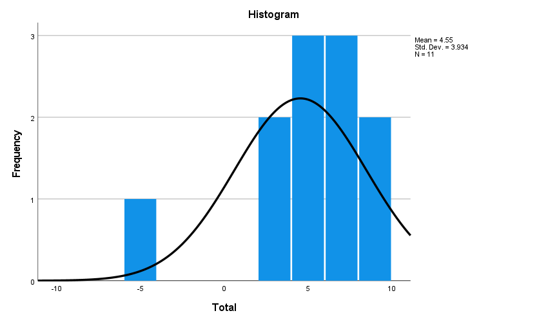
Fig 2: Normal distribution histogram

I found this disappointing but decided not to see my outlier as a problem to be fixed (Aguinis, Gottfredson, Joo, 2013). The outlier reflects positively on my ability to be a reflexive practitioner and not misinterpret signals to gain expected results (Grove et al., 1999). Upon reflection, I should not have been surprised by the presence of an outlier due to the idiosyncratic nature of children with severe and profound and multiple learning disabilities (Hostyn and Maes, 2009). Mohrman and Lawler (2012) found that interesting outliers can inform future practice and I was able to use my results to adopt new strategies to make rebound therapy sessions more engaging for this child e.g., limiting the time spent on each exercise. I also concluded that a breakdown of gender and age has limited relevance as my participants do not develop typically (Turner, 1999). My intention was to identify an effective intervention for individuals with specific learning needs, rather than age or gender, and my results achieved this goal.
Limitations
My results did not show why rebound therapy has an impact on engagement in my participants or give a clear picture of their lived experiences. It was frustrating not to use the wealth of qualitative data in my videos and engagement profiles to produce powerful accounts that would allow my pupils to share their experiences (deHaas et al. 2022) and play a more active role. For example:
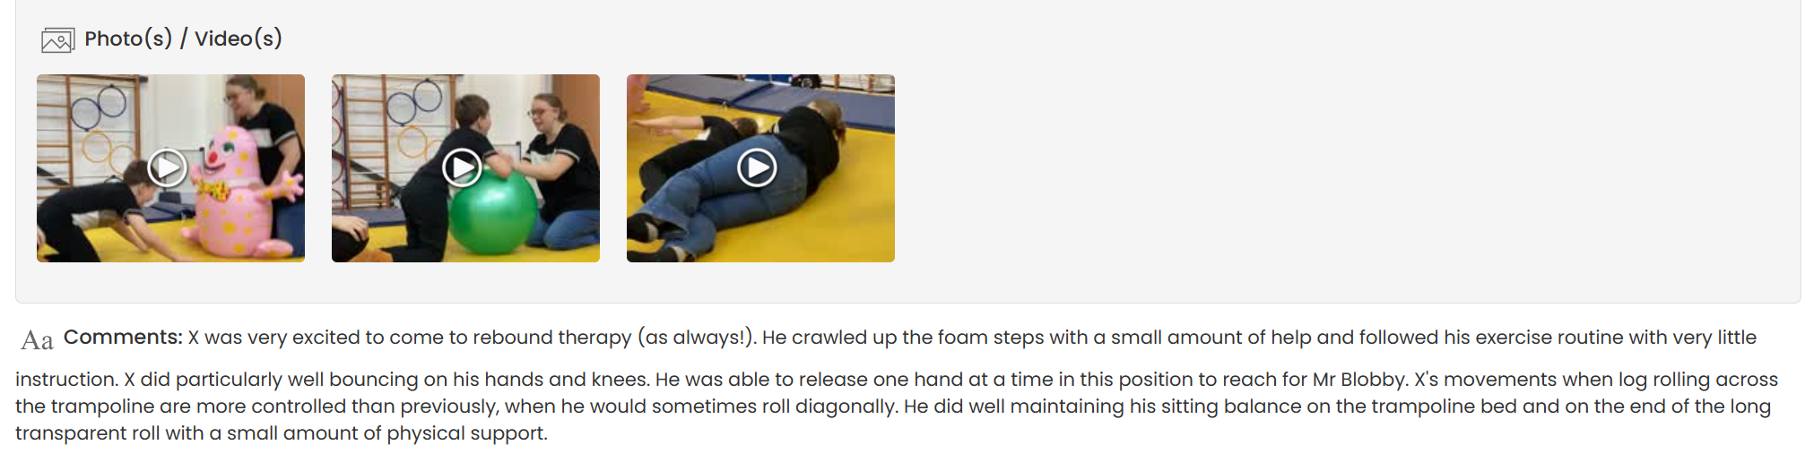
Fig 3: videos and overall comments from a rebound therapy session, as recorded on Evidence for Learning.
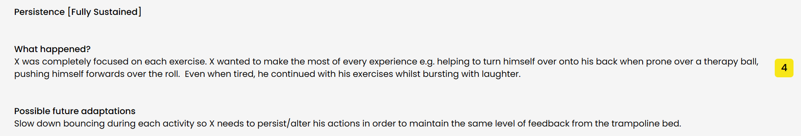
Fig 4: extract from engagement profile completed after a rebound therapy session, as recorded on Evidence for Learning.

The videos and comments in figs 3 and 4 demonstrate the joy that rebound therapy brings to one participant and the effort he made to participate e.g., helping to turn himself over. Qualitative data such as this shows that individuals with severe and profound and multiple learning disabilities have assets (deHaas et al., 2022, p159) so I will use this method in future research. The graphs produced from my quantitative data were unable to ‘embrace’ the heterogenous nature of my participants (Cluley, 2016, p45), which would have been clear had I used engagement profiles to create ‘vignettes’ (Simmons and Watson, 2015) accompanied by photographs. However, my qualitative data was not wasted as I made use of it to examine my own practice and improve delivery of rebound therapy for each of my pupils (see ‘possible future adaptations’ in fig 4).
I only observed participants once in rebound therapy and class time. Maes et al. (2019) recommend using repeated measures as fluctuating alertness levels and inconsistent health are challenges for researchers working with individuals with multiple disabilities. I did not have time for this but was fortunate that my participants were displaying usual behaviours and no health issues were reported by staff e.g., a child who frequently has seizures had not had any on the morning of their observations. However, this may not be the case in the future. Repeated measures would also have been useful to establish patterns in behaviour and confirm observations (Maes et al., 2019) e.g., that a child’s eyes widening when I stopped bouncing was an indication that they wanted to continue, and potentially improve the accuracy of my scoring.
My research only shows the impact of rebound therapy on engagement in children with severe and profound and multiple learning disabilities, yet most pupils in my school are autistic. In January 2022, autism was the most common primary need for pupils with education, health and care plans (31.3%) (DfE, 2022, p7) and engagement is a crucial first step for their learning (Aidonopoulou-Read, 2021). Current research into trampoline-based interventions for individuals with autism are focused on physical benefits such as improved muscle tone (Lourenço et al, 2015), and my research cannot be considered relevant to them as their needs are so different. Research focused on one type of need would not allow a special educational needs school to identify whether rebound therapy would be an effective intervention for all children so research should be completed for other groups.
Future Methods
This small study was an excellent opportunity to identify which research methods best serve individuals with multiple disabilities. I intend to adopt multiple methodologies in the future so I can establish not only which physical interventions and sports work for participants, but how and why they work (Klingner and Boardnnan, 2011). I also intend to try using the mosaic approach due to its emphasis on co-construction and recognition that children have their own languages (Clark and Moss, 2011). For example, I may ask one child to use symbols to express their views, another to use Makaton and use photovoice (Cluley, 2016) to gain the perspective of a child working at a pre-intentional level. The mosaic approach aligns with the participatory approach that was key to the accuracy of my assessments and encourages the reflexive practice essential to the ‘impenetrable and unfathomable’ role (Hinchcliffe, 2022a, p505) of supporting individuals with multiple disabilities.
Future Research
My current research design is easily replicable as the engagement model is a statutory requirement and intended to promote ‘consistency and a common language’ across schools (DfE, 2020, p6). The sharing of data from other schools would allow larger scale studies and make parametric analyses possible, which are challenging in inclusive research due to small sample sizes (Maes et al., 2019). A bigger sample would allow me to narrow my research and consider the impact of rebound therapy for children with specific disabilities within my population e.g., visual and hearing impairments. I could then to adapt my practices to better meet the needs of individuals. However, I recognise that the accuracy of assessment would be inconsistent if the engagement model was completed by a range of professionals, particularly inexperienced teachers, in different organisations without more specific criteria for behaviour scoring (Aidonopoulou-Read, 2021).
I would like to score children at the beginning and end of a term of rebound therapy so I can understand its impact over time. This is particularly important for children with profound and multiple learning disabilities as they need to repeat activities many more times than their non-disabled peers before they show progress (Turner, 2011). I would also like to see if a causal link could be established between changes in levels of engagement and physical development e.g., by examining engagement scores against progress recorded in the Huddersfield Index, which is used to measure achievement in rebound therapy.
I am eager to understand the benefits of different physical activities and sports for the children I teach to inform future practice. Unfortunately, research projects examining the experiences of disabled children in PE and sport are ‘conspicuous by their absence’ (Maher and Haegele, 2022, p129) and existing research gives limited attention to individuals with severe and multiple learning disabilities, despite the potential of sports to be a ‘forerunner of social change’ (Termini and Sciurca, 2017, p17). I believe that my research design, combined with qualitative methods, has the potential to show that not only do sports benefit this population, but individuals with multiple disabilities can be active participants and make valuable contributions to the sporting community.
Conclusion
Reflecting on my research was a challenging process, but I came to appreciate that reflection is purposeful and has valuable outcomes (Moon, 1999). It allowed me to see the strengths and limitations of my methods. I was satisfied with my research design as I was able to answer my question and confirm my hypothesis. However, there were important questions it could not answer, including why rebound therapy is so engaging. Reflecting on my research design left me eager to share the lived experiences of my participants, who may be the ‘most silenced’ (Mietola, Miettinen, and Vehman, 2017, p264) in research, so I identified ways to share their experiences in future using mixed methods and a mosaic approach. The reflection process led me to identify small mistakes made during data collection which I will avoid in future research. I was also able to identify opportunities for future research into physical activity and sport, where I would like to work alongside individuals with severe and profound and multiple learning disabilities. My reflection has left me more equipped to show that this population, whose capabilities are often unseen (deHaas et al., 2022) can benefit from and be included in research, sports and physical activity.
Word count: 3,299
References
Aguinis, H., Gottfredson, R.K, Joo, H (2013) ‘Best Practice Recommendations for Defining, Identifying and Handling Outliers’ Organizational research methods, 2013, Vol.16 (2), pp.270-301 DOI: 101177/1094428112470848
Aidonopoulou-Read, T. (2021) ‘Can the Engagement Model act as a replacement for the P-Scale assessment system?’ Support for Learning, Vol.36 (2) pp.258-277 DOI: 10.1111/1467-9604.12354
Boxall, K. and Ralph, S. (2010) ‘Research ethics committees and the benefits of involving people with profound and multiple learning disabilities in research’ British Journal of Learning Disabilities, 39, pp.173–180 doi:10.1111/j.1468-3156.2010.00645
Carpenter, B et al. (2015) ‘Engaging learners with complex learning difficulties and disabilities: a resource book for teachers and teaching assistances’ Routledge
Clark, A. and Moss, P. (2011) ‘Listening to young children: the mosaic approach’ Second Edition
Cluley, V. (2016) ‘Using photovoice to include people with profound and multiple learning disabilities in inclusive research’ , British Journal of Learning Disabilities, Vol (45), pp.39–46 DOI: 10.1111/bld.12174
deHass, C. et al. (2022) ‘Doing Research Inclusively: Understanding What It Means to Do Research with and Alongside People with Profound Intellectual Disabilities’ Social Sciences 11: 159. https:// doi.org/10.3390/socsci11040159
DfE (2020) ‘The engagement model: guidance for maintained schools, academies (including free schools) and local authorities’. Available at: https://www.gov.uk/government/publications/the-engagement-model (Accessed: 16th February 2023)
DfE (2022) ‘Special educational needs and disability: an analysis and summary of data sources’ (Available at: https://assets.publishing.service.gov.uk/government/uploads/system/uploads/attachment_data/file/1082518/Special_educational_needs_publication_June_2022.pdf (Accessed: 06th May 2023)
Gjermestad, A. et al. (2023) ‘Advancing inclusive research with people with profound and multiple learning disabilities through a sensory-dialogical approach’ Journal of intellectual disabilities Vol.27(1), pp.40-53 DOI: 10.1177/17446295211062390
Grove, N. et al. (1999) ‘See what I mean: Interpreting the Meaning of Communication by People with Severe and Profound Intellectual Learning Disabilities’ Journal of applied research in intellectual disabilities, Vol.12 (3) pp.190-203 DOI: 10.1111/j.1468-3148.1999.tb00076.x
Hinchcliffe, V. (2022a) ‘Developing thinking teachers: reflective practice in schools for children with severe learning disabilities and profound and multiple learning disabilities’ Support for Learning, Vol 37 (4) pp. 502-519 DOI: 10.1111/1467-9604.12424
Hinchcliffe, V. (2022b) ‘The Rochford review, pre-key stage standards and the engagement model – what does it all mean to schools and for children with SLD and PMLD?’ Support for learning, Vol.37 (1), pp. 62-79 DOI: 10.1111/1467-9604.12395
Hostyn, I. and Maes, B. (2009) ‘Interaction between persons with profound intellectual and multiple disabilities and their partners: A literature review’ Journal of Intellectual & Developmental Disability, Vol. (34) 4 pp.296–312, DOI: 10.3109/13668250903285648
Kaur, J. and Punia, S. (2016) ‘Floppy Infant Syndrome: Overview’ International Journal of Physiotherapy and Research, Vol 4(3) pp. 1554-63 DOI: 10.16965/ ijpr.2016.134
Klingner, J.K. and Boardnnan, A.G, (2011) ‘Addressing the ''Research Gap' in Special Education Through Mixed Methods’ Learning Disability Quarterly Vol 34 (3)208-218 DOI: 10,1177/07319487114I7S59
Kora, A.N. and Abdelazein, F.H. (2020) ‘The effect of rebound therapy on gross motor function in a child with spastic cerebral palsy’ BioScientific Review, Vol 2 (3) pp. 1-7 DOI: 10.32350/BSR.0203.01

Lourenço, C. et al. (2015) ‘The effect of a trampoline-based training program on the muscle strength of the inferior limbs and motor proficiency in children with autism spectrum disorders’
Journal of Physical Education and Sport Vol. 15(3), Art 89, pp.592 – 597 DOI: 10.7752/jpes.2015.03089
Maes, B. et al. (2019) ‘Looking back, looking forward: Methodological challenges and future directions in research on persons with profound intellectual and multiple disabilities’ Journal of applied research in intellectual disabilities, Vol.34 (1), pp.250-262 DOI: 10.1111/jar.12803

Maher, J. and Justin A. Haegele, J.A., (2022) ‘Disabled children and young people in sport, physical activity and physical education’ Sport, Education and Society Vol. 27 (2), pp.129–133 DOI:10.1080/13573322.2021.1967119

Mietola, R., Miettinen, S., and Vehman, S. (2017). ‘Voiceless subjects? Research ethics and persons with profound intellectual disabilities’ International Journal of Social Research Methodology, Vol 1 (3) pp.263–274 DOI: 10.1080/13645579.2017.1287872

Mohrman, S.A. and Lawler, E.E. (2012) ‘Generating Knowledge that Drives Change’ Academy of Management perspectives, 2012, Vol.26 (1), pp.41-51DOI: 10.5465/amp.2011.0141

Moon, J.A. (1999) ‘Reflection in Learning and Professional Development: Theory and Practice’ Routledge

Nind, M. (2014) ‘What is Inclusive Research?’ London, UK: A & C Black.

Odom, S.L. (2005) ‘Research in Special Education: Scientific Methods and Evidence-Based Practice’ Exceptional children, 2005, Vol.71 (2), pp.137-148 DOI: 10.1177/001440290507100201

Sadeghi, M. et al. (2012). ‘The effects of rebound therapy and aerobic training on aerobic capacity, plasma endotheline level and the quality of life in male patients with asthma’ Vesnu Publications Vol.8 (4) pp.694-703DOI:/10.22122/jrrs.v8i4.549

Sharpe, L., Coates, J. and Mason, C. (2022) ‘Participatory research with young people with special educational needs and disabilities: a reflective account’ Qualitative Research in Sport, Exercise and Health, Vol 14 (3) pp.460-473 DOI: 10.1080/2159676X.2021.1952297

Simmons, B. and Watson, D. (2015) ‘From Individualism to Co-Construction and Back Again: Rethinking Research Methodology for Children With Profound and Multiple Learning Disabilities’ Child Care in Practice, Vol 21 (1) pp. 50-66 DOI: 10.1080/13575279.2014.976179
Termini, F. and Sciurca, C. (2017) ‘Special Educational Needs and Sport. Psychological Aspects of the Interaction Between Cognitive, Affective Emotional and Motor Area’ Euromediterrean Biomedical Journal Vol 12 (5) pp.17-22 DOI: 10.3269/1970-5492.2017.12.5
Thompson, S. and Thompson, N. (2008) ‘The Critically Reflective Practitioner’ Basingstoke: Palgrave, Macmillan
Turner, C. (2011) ‘Supporting Children with Learning Difficulties: Holistic Solutions for Severe, Profound and Multiple Learning Disabilities’ Continuum International Publishing
White, S. and Spencer, S. (2018) ‘A school commissioned model of speech and language therapy’ Child language teaching and therapy Vol.34 (2), pp.141-153 DOI: 10.1177/02659018780961
Wilder, J. and Granlund, M. (2003) ‘Behaviour style and interaction between seven children with multiple disabilities and their caregivers’ Oxford, UK: Blackwell Publishing; Child: care, health & development, Vol.29 (6), p.559-567
Wrona, S. and Wrona, K. (2021) ‘Engagement of Children with Special Educational Needs in Accordance with the Routines-Based Model’ International Journal of Special Education, Vol.36(1), pp27-34 DOI: 10.52291/jse.2021.36.3

