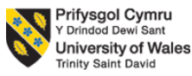

Programme: Master of Business Administration
Module : Human Capital Management component 1
Module Code: LCMB7023
Student Name: GORANIYA KHODABHAI BALUBHAI
ID: 2605881
Date of Submission: 15th October 2026

Table of Contents
1.0 TASK A: Designing Innovative Working Practices 3
1.1 Evaluation of traditional work design versus contemporary innovative working practices 3
1.2 Recommend innovative working practices suitable for NexSpace Health Systems 6
2.0 TASK B: Breeding an Environment Where Talent May Grow 7
2.1 Way organisations create environments where talent flourishes 7
2.2 Comprehensive talent growth strategy for NexSpace Health Systems 9
3.0 TASK C: Reflective Report 11
3.1 AI as a Strategic Tool 11
3.2 Reflective Analysis 11
3.3 Personal Action Plan 12
References 13

1.0 TASK A: Designing Innovative Working Practices

1.1 Evaluation of traditional work design versus contemporary innovative working practices
Traditional Hierarchical Work Design vs. High-Performance and High-Involvement Work Systems
Traditional work design is based on hierarchy, specialisation, centralisation, and top-down decision making, can offer control and accountability, but may also limit employee creativity and slow down organisational responses. For NHSX, with around 600 staff operating in a fast-evolving environment in which AI is driving changes in health care, the challenge is finding the workforce with the expertise to generate innovative ideas (Jimoh et al., 2025). The healthcare technology market will expand from $587.94 billion in 2025 to $1,467.06 billion by 2030, at a 20.0% CAGR, which further emphasizes the demand for flexible skilled and innovative workforce. This NHSX training material highlights that HR planning should be based on understanding the current skills, and skills needed in the future, and look at how to fill in any gaps in capability by recruitment, development and retention. This is further backed by broader evidence like it is revealed that just 1 in 5 employees around the world is engaged, with 62% not being engaged, continuing to highlight the need for workplaces that foster employee involvement and commitment (Alzeaideen and Qaqish, 2026). So it's time to move away from a hierarchical system of control to a more participative one with greater employee engagement, but with clarity of accountability, since the healthcare technology needs strong governance and patient protection measures (Peng and Cao, 2026).
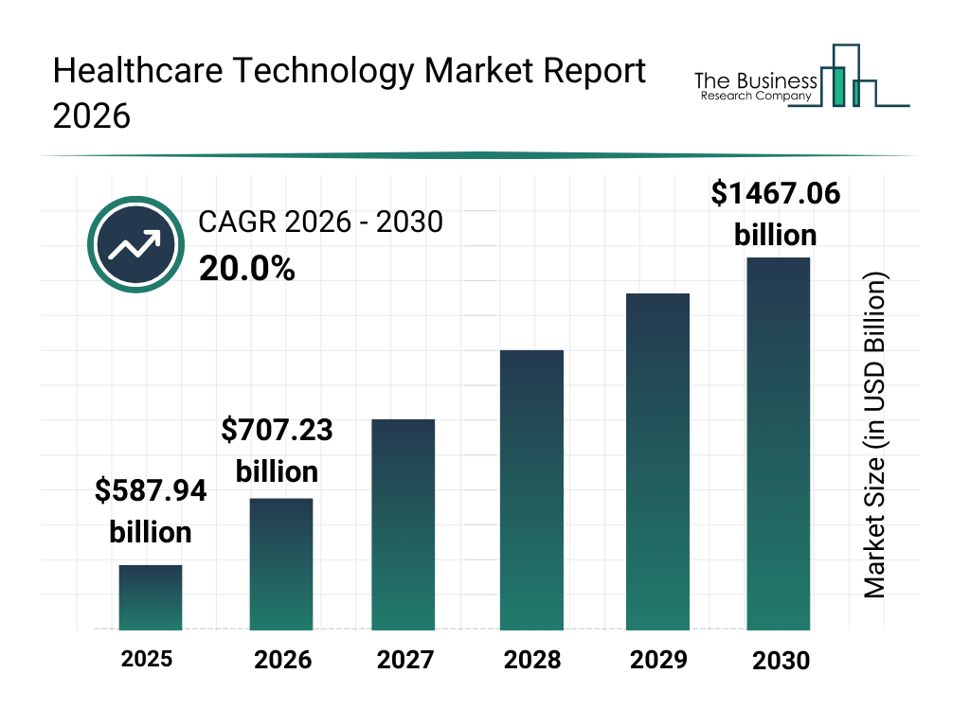
Fig 1: UK Healthcare Technology Market
Source: (The Business Research Company, 2026)
Agile, Flexible and Hybrid Working vs. Fixed Working Practices
The modern experience of being agile, flexible and hybrid can be used as a way to increase the responsiveness of an organisation in relation to being able to work from anywhere, collaborate in projects and adjust the way they work to the task at hand (Hajli et al., 2025). This is especially important in the context of NHSX's UK, India and UAE operations, where the workforce is spread out and the need for effective digital collaboration exists. It is revealed that flexible working and hybrid working are the norm for UK employers in 2025, with 91% and 74% respectively allowing for some form of flexible or hybrid working arrangements. 41% of employers said that the rise in home/hybrid working had been good for their organisation's productivity and efficiency, a higher proportion than those who said it had been bad (16%) (Lee et al., 2025). But hybrid working is not a recipe for success as it is discovered that employers also noted that there were negative impacts on managers' leadership, organisational culture and workers' relationship with the organisation's purpose. Thus, NHSX needs to embrace a structured hybrid approach whereby people work remotely as well as face-to-face,
with regular international team meetings, and shared digital spaces, rather than allowing staff to work remotely without coordination (Pacher et al., 2025).
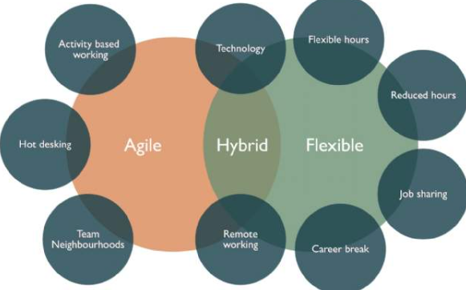
Fig 2: Agile, Flexible and Hybrid Working
Source: (Savills, 2026)
Sociotechnical Systems: Integrating People, Technology and Teamwork
In the context of NHSX, Sociotechnical Systems Theory is highly relevant, as the efficiency of the system relies not just on the use of cutting edge technology, but the interactions between the people, IT systems and procedures. The sole solution of the technologies, while improving the digital capacity, would not address the challenges of NHSX, such as poor collaboration, lack of creativity, and employee turnover (Oyeniran et al., 2025). The materials differentiate between tacit knowledge, which is learned from experience and can be hard to articulate, and explicit knowledge, which is codified and can be transmitted digitally. There is a need to create hybrid working practices that work well as teams like 52% of all U.S. workers with remote options were working hybrid, and 61% favor hybrid working, with hybrid workers also reporting 34% engagement and 54% thriving, versus 29% engagement and 49% thriving among remote-capable workers who work fully on-site (Emon and Ahmed, 2026). The message for NHSX is that AI and digital collaboration tools need to be embedded into cross-functional teams, knowledge sharing, employee autonomy, training and strong leadership, a balance between the technological and the human.
1.2 Recommend innovative working practices suitable for NexSpace Health Systems
Cross-functional Agile Teams and Employee Autonomy
NHSX should establish cross-functional agile teams involving AI specialists, software developers, data analysts, healthcare professionals, product managers and business specialists. Every team needs to have a clear goal, roles and be given the autonomy to make day-to-day decisions without having to seek further approval from senior management. This would break down functional silos and enable specialist employees to directly participate in innovation and problem solving (Shi et al., 2025). NHSX has around 600 staff members in the UK, India and UAE organisations, who can enable them to bring together international expertise and enhance knowledge transfer. Increased autonomy can also be a boost to employee ownership, creativity and growth which can help overcome the present loss of top talent. The process must continue to be managed and monitored in a way that should set measurable goals, be subjected to frequent reviews and have clear accountability, enabling NHSX to make quicker decisions without compromising on healthcare technology standards (Fu et al., 2026).
Structured Hybrid Working and Digital Collaboration
NHSX must introduce a more formal, flexible and hybrid working approach, underpinned by digital working spaces, shared cloud working spaces, an online project-management system and a centralised knowledge repository (Chilba and Kabiraj, 2026). Individual and targeted work was able to be undertaken away from the office, and focused group activities like innovation workshops, intensive problem solving and team development were able to be delivered on a scheduled collaborative basis. The latest data reveals that in 2025, 91% of employers provided some flexibility and 74% of employers had hybrid working. In addition, 41% of employers reported increased productivity or efficiency from increased home/hybrid working, while 16% said productivity was diminished (Wei et al., 2026). These are just some of the reasons why flexibility can contribute to organisational performance, but again it is the way it is managed that makes the difference. For NHSX, agreed communication procedures, shared digital documentation and coordinated collaboration periods across the three countries could help minimise communication gaps, improve knowledge sharing and help employees wellbeing. This would enable flexibility alongside accountability, which
could boost productivity, staff retention and international collaboration, helping NHSX to do more (Panya and Petchsawang, 2025).

2.0 TASK B: Breeding an Environment Where Talent May Grow

2.1 Way organisations create environments where talent flourishes
Learning Organisation: Continuous Learning and Capability Development
NHSX needs to create a learning culture where staff are always learning and applying new technical, clinical and leadership skills, not just from formal training. It is especially significant that 48% of employers in the UK enhanced their focus on developing talent in-house between 2025–26 and 91% were already doing the same or were thinking of doing so to meet skills requirements. This can be made a reality at NHSX by using digital learning platforms, micro-learning, mentoring, job rotation, secondments and cross-functional projects with colleagues from across the UK, India and UAE (Li et al., 2025). The organisation should also link learning objectives to future needs for the workforce, including in the areas of AI, data analysis and digital healthcare, as well as leadership and management. This would enable the organisation to develop its own talent pipelines, instead of relying solely on external recruitment strategies. Secondment, shadowing and job rotation also rose (from 16% to 26% respectively) and peer collaboration rose (from 30% to 36%), highlighting the increased use of development approaches that incorporate learning into daily work (Hill, 2025).
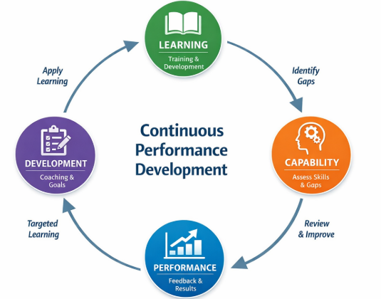
Fig 3: Continuous Learning and Capability Development
Source: (Workplan, 2026)
Psychological Safety: Creating Conditions for Innovation and Experimentation
It's also crucial for NHSX to build a culture that allows staff to ask questions about current practices, share new ideas, discuss errors and try new things without fear of repercussions. It is very applicable in this context as the organisation is currently very limited in its creativity and experimentation and has geographically dispersed teams (Özdoğan et al., 2025). In addition, managers should start to have regular talks about innovation, team retrospectives, feedback sessions and even structured times in which staff can question current practices. This should be done in a spirit of trust, respectful communication and clear accountability, not in an attempt to eliminate expectations for performance (Kumar, 2026). The business case is also associated with employee engagement: organisations with higher engagement had a median difference of 18% in sales productivity and 23% in profitability compared to those with lower engagement, and 20% of the global workforce is engaged.
Self-Determination Theory: Autonomy, Competence and Motivation
Self-Determination Theory can be applied to NHSX who have a problem with retaining high performing employees by enhancing autonomy, competence and relatedness. There should be a level of autonomy for employees to decide how to reach agreed goals and direction, resources and accountability from managers (Leander, 2025). Continuous training, coaching, mentoring, challenging tasks and career paths are in line with competence development; and international project teams and peer learning communities are in line with strengthening relatedness. This is particularly true as 44% of UK employers' said that acquiring new talent is becoming harder to keep and 45% of employers who had begun retention programs did so by increasing learning and development opportunities. NHSX should therefore supplement individual development plans with in-house project leadership and mentoring opportunities as well as career opportunities. There is also evidence that the approach could increase employee engagement: for high turnover organisations, there are median differences of 21% in turnover, along with increased productivity and profitability for the units with high levels of engagement. Autonomy and career development should therefore be considered as strategic talent and not just an added option for employees (Hammad et al., 2025).
2.2 Comprehensive talent growth strategy for NexSpace Health Systems
NHSX Continuous Talent Growth and Capability Ecosystem (CTGCE)
NexSpace Health Systems is looking to implement a Continuous Talent Growth and Capability Ecosystem (CTGCE) to align workforce planning, career development, learning management, mentoring, internal mobility, succession planning and other HR capabilities across its 600 employees across the UK, India and UAE. The strategy should start with a capability audit to understand the current and future capabilities in AI, digital health, data analytics, cybersecurity, clinical technologies and leadership and then build individual development plans based on career pathways (Riza et al., 2025). It's crucial because only a quarter (24%) of all employees worldwide say they feel they have the skills to move on to the next job level, and only 17% strongly agree that their employer is investing in skills for career advancement. There is moderate level of confidence in India as well, with 37% of its employees believing they have the skills to take their careers to the next level, and around 32% saying their employer was investing in their skills. NHSX should take steps to fill this void through structured mentoring, coaching, job rotation, secondments and practical learning projects. The focus on lifelong learning and mentoring, can thus be translated into a formal development architecture where staff members are continuously learning and applying new skills (Sangwa and Mutabazi, 2025).
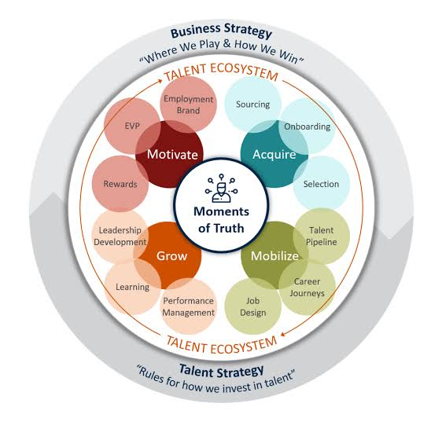
Fig 4: Talent Growth and Capability Ecosystem
Source: (Mlot. and Sorensen, 2020)
Internal mobility should be the second strand of CTGCE. NHSX can develop an internal talent marketplace so staff can apply for temporary projects, overseas posts, roles offering a potential promotion or cross-disciplinary placements around the UK, India and UAE. This would complement the lecture that has a focus on international knowledge transfer, multicultural teamwork and succession development (Huang et al., 2025). It is also revealed that 44% of career development-focused organisations have an established internal mobility programme while only 24% of other organisations do. Plus, 55% of organisations that focus on career development see internal mobility as more of a priority for the next year than do 48% of other organisations. NHSX may therefore be able to leverage internal mobility as a way to build up skills, exposure to other teams, and to prepare its employees for promotion. Managers need to look beyond full productivity for hiring; research indicates that hiring employees based on potential, rather than full productivity, resulted in a hiring rate of 1.9 times more likely to perform effectively (Huvanandana and Charoensukmongkol, 2026).
A third pillar should aim at developing capabilities through AI and access to learning for all. The NHSX staff are all engaged in the development of AI-based healthcare technologies, which means staff should have protected learning time, practical AI laboratories, digital certificates and an opportunity to use AI to real-world projects. This is relevant because only 14 percent of workers worldwide said they use generative AI every day, and 92 percent of those who use it daily said they experienced productivity benefits, while only 58 percent of those who use it infrequently said they experienced productivity benefits (Zamit and Lakhal, 2025). NHSX should also ensure that development opportunities do not become focussed into the hands of senior personnel like just one in two (51%) non-managers reported having the learning and development resources they need, whereas 72% of senior executives did.

3.0 TASK C: Reflective Report

3.1 AI as a Strategic Tool
AI can empower strategic Human Resource Management by analysing workforce data, pinpointing skill deficits, aiding in talent forecasting, and furnishing data to support recruitment, development and retention decisions. Within NHSX, AI could be used to review and evaluate employee performance and learning requirements, and workforce trends, to help managers plan ahead for capability gaps and make better informed decisions. AI should, however, not be a substitute for human judgment; it's a decision support system. To ensure that AI-generated content does not perpetuate existing biases, HR pros should critically assess the outputs. Algorithms might fail to consider individual nuances, emotions, and organisational context. Empathy is still critical during situations of performance challenges, career development, wellbeing or retention. Transparency, confidentiality and data protection are also essential to professional responsibility, as is clear accountability for decisions made through the use of AI.

3.2 Reflective Analysis

Description
I used AI to conduct research, write content and solve HR problems. It was very useful for organizing research ideas, finding themes, enhancing written communication and developing other solutions to HR issues.
Feelings
I began to think that AI will make my academic work more efficient. But, I became wary of the inaccuracies of AI-generated information, or the lack of context. I also knew that relying too much might diminish my ability to think on my own.
Evaluation
AI helped me to structure information, communicate ideas clearly and consider different solutions, in a positive way. But, the disadvantages were that it might be inaccurate and it did not give enough information about employee relationships, workplace culture and individual employee situations. Thus, AI was helpful but needed oversight of humans.
Analysis
This experience showed that AI cannot replace judgment, it's a complement. In research, I learned how to check information from AI sources with reliable information. I used AI to structure and refine my writing; my mind was the one making the decisions about my arguments. AI was used to narrow down choices and pinpoint potential dangers in HR problem-solving, while taking into account staff needs, feelings, ethics, and the context of the organisation. This enhanced my analytical and communication skills, as well as my decision making skills.
Conclusion
Overall, AI enhanced my academic and professional skills, and it reinforced the value of critical thinking, empathy and ethical responsibility.
Action Plan
Will develop skills to use AI and HR analytics; confirm key details; keep independent judgement and ethically use AI for research, communication and decision making.

3.3 Personal Action Plan
Table 1: Action Plan
Capability area | Development action | Target
AI & Digital Skills | Complete AI/HR analytics courses and practise using digital tools for HR decision-making. | Within 6 months
Analytical & Decision-Making Skills | Develop skills in data analysis, critical evaluation and evidence-based decision-making through practical projects. | Within 6 months
Leadership & Teamwork | Participate in group projects, mentoring and leadership activities to improve collaboration and leadership confidence. | Within 9 months
Communication Skills | Practise professional presentations, report writing and constructive feedback. | Within 6 months
Continuous Learning | Maintain a personal learning plan and regularly reflect on skills gained and areas requiring improvement. | Ongoing

References
Alzeaideen, K.A. and Qaqish, O.M.S., (2026). Organizational Creativity in the Digital Era: How Talent Management Can Support Innovation and Institutional Excellence. In AI-driven Sustainable Innovation and Sustained Competitive Advantage (pp. 1141-1158). Cham: Springer Nature Switzerland.
Chilba, S. and Kabiraj, S., (2026). Advancing Green Talent: A Finnish Blueprint for Sustainable Upskilling and University-Industry Integration. In University-Industry Partnerships for ESG Talent Development (pp. 57-82). IGI Global Scientific Publishing.
Emon, M.M.H. and Ahmed, M., (2026). Digital Readiness as a Catalyst for Talent Transformation in Hospitality. In Talent Management in Hotels and Hospitality (pp. 461-502). IGI Global Scientific Publishing.
Fu, J., Zheng, S., Fan, L., Zheng, X. and Qian, Q., (2026). Breeding 5.0: Artificial intelligence (AI)‐decoded germplasm for accelerated crop innovation. Journal of Integrative Plant Biology, 68(8), pp.2340-2352.
Hajli, N., Baydarova, I. and Nisar, T., (2025). Digital entrepreneurial ecosystem: the role of the sharing economy in driving innovation. Entrepreneurship & Regional Development, 37(5-6), pp.785-815.
Hammad, M., Panaousis, M., Ali, H. and Khan, W.A., (2025). Crafting a Sustainable and Innovative Future. In Smart Manufacturing Blueprint: Navigating Industry 4.0 Across Diverse Sectors (pp. 441-469). Cham: Springer Nature Switzerland.
Hill, S.W., (2025). Inspiring and Innovating: The Possibilities of Community-Led Housing for the UK’s Housing System. Planning Theory & Practice, 26(1), pp.145-152.
Huang, I.Y., Beacham, A.M., Vickers, L.H., Mu, H., Tremma, O., Maritan, E., Kaczorowska-Dolowy, M. and Monaghan, J.M., (2025). Drivers, barriers and grower perspectives of innovation adoption in the UK controlled environment agriculture sector. Smart Agricultural Technology, p.101748.
Huvanandana, G. and Charoensukmongkol, P., (2026). How digital leadership and innovative climate interact to lessen AI-related job insecurity, AI use anxiety, technostress, and emotional exhaustion. International Journal of Workplace Health Management, 19(2), pp.189-206.
Jimoh, A.L., Dunmade, E.O. and Salman, A., (2025). Green talent management and job performance: the significance of open innovation. Journal of Intellectual Capital, 26(6), pp.1190-1207.
Kumar, P., (2026). Bridging the Gap in ESG Talent Development Through Curriculum Innovation and Industry Collaboration. In Navigating ESG in Global Entrepreneurial Ecosystems (pp. 435-466). IGI Global Scientific Publishing.
Leander, K.R., (2025). Developer experience as a competitive advantage. In Developer Experience Unleashed: The Art of Creating Efficient Developer Environments (pp. 21-41). Berkeley, CA: Apress.
Lee, C.W., Liu, P.T., Thy, Y.H. and Peng, C.L., (2025). Sustainable open innovation model for cultivating global talent: the case of non-profit organizations and university alliances. Sustainability, 17(11), p.5094.
Li, A.Z., Yeo, Y.T. and Chen, W.N., (2025). Safeguarding sustenance: Singapore’s strategic commitment to enhancing food security through advancing food research and innovation. Philosophical Transactions of the Royal Society B: Biological Sciences, 380(1935), p.20240164.
Oyeniran, K.A., Oyeniran, O.H. and Oladunmoye, K.M., (2025). Artificial intelligence, innovation, and safety in biotechnology research. In Cases on AI innovations in occupational health and safety (pp. 73-98). IGI Global Scientific Publishing.
Özdoğan, B., Dirik, D. and Kahraman, A., (2025). The role of the city in the innovative software entrepreneurship ecosystem: A qualitative study. Journal of Global Entrepreneurship Research, 15(1), p.8.
Pacher, C., Glinik, M., Koch, V. and Zunk, B.M., (2025). Strategic Realignment of Accelerator Programs to Foster Deep Tech Talents: A Framework for Innovation and Growth. Procedia Computer Science, 253, pp.2720-2729.
Panya, F. and Petchsawang, P., (2025). Innovation capability as a mediator of the relation between talent management and entrepreneurial firm performance. Journal of Small Business and Enterprise Development, 32(1), pp.56-75.
Peng, M. and Cao, Z., (2026). New quality productive forces, green transformation, and climate resilience: mechanisms and evidence from China’s county-level panel data. Theoretical and Applied Climatology, 157(6), p.396.
Riza, M.F., Hutahayan, B. and Chong, H.Y., (2025). Fostering high-performing organizations in higher education: the effect of participative leadership, organizational culture, and innovation on organizational performance and commitment. Cogent Education, 12(1), p.2448884.
Sangwa, S. and Mutabazi, P., (2025). Compliance as the new competence: How obedience cultures erode innovation and leadership ethics in global workplaces. Available at SSRN 5371035.
Shi, J., Zhang, Z., Gao, R. and Chen, Z., (2025). Cultivating Talents at Tertiary Agricultural Institutions in China for Sustainable and Intelligent Development. Sustainability, 17(21), p.9754.
Wei, F., Wu, J., Xia, Q. and Yang, F., (2026). Green total factor productivity growth of China’s agricultural sector: A new metafrontier biennial Malmquist-Luenberger productivity index. Socio-Economic Planning Sciences, p.102470.
Zamit, I. and Lakhal, L., (2025). Talent identification and retention: exploratory study in international digital companies in Tunisia. Employee Relations: The International Journal, 47(8), pp.1351-1378.
Mlot, S. and Sorensen, A. (2020) What is the talent ecosystem? Talent Quarterly, 1 April. Available at: https://www.talent-quarterly.com/what-is-the-talent-ecosystem/
Workplan (2026) Performance, development and learning integration. Available at: https://workplan.com.au/performance-development-learning-integration-article/
Savills (2026) How do you successfully implement a hybrid working model? Available at: https://www.savills.com/blog/article/312234/commercial-property/how-do-you-successfully-implement-a-hybrid-working-model-.aspx
The Business Research Company (2026) Healthcare Technology Market Report 2026: Global Market Size, Share, Trends and Forecast to 2030. Available at: https://www.thebusinessresearchcompany.com/report/healthcare-technology-global-market-report

