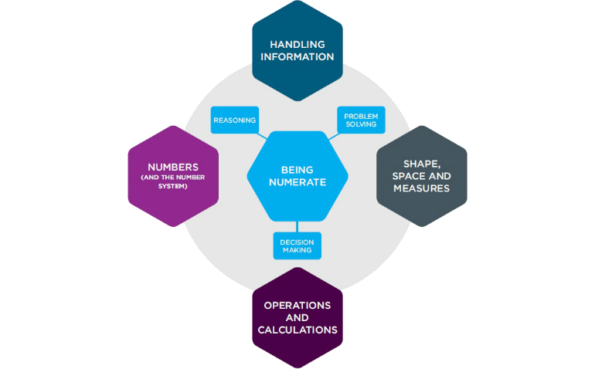
(Source: National Numeracy, 2022.)

Numbers Count
  - ECIE5001
Hannah Jones
1151203
Table of Contents
Numeracy!? Is that not just Mathematics? 2
Numeracy, in the hands of the student. 5
Place Value Slider 8
Video of place value sliders in use. 9
Evaluation of place value sliders. 10
Evaluation 13
References 15
Appendices 19

Numeracy!? Is that not just Mathematics?

When adults remember being taught mathematics, they think of topics such as geometry or algebra, or it being spilt into pure or applied mathematics
(Compton et al, 2009). Surely it hasn’t changed that much, has it? Actually, you may be surprised to learn changes in the curriculum has improved and developed to help children achieve important life skills to carry forward into the world outside of school.

Well, what is numeracy I hear you ask?

In the United Kingdom the term numeracy was identified in the Crowther Report in 1959 (Goos et al, 2019). Thompson (2010, p.33) suggests “Numeracy is the ability to process, communicate and interpret numerical information in a variety of contexts.” It is the ability to use the application of mathematics in all areas of the curriculum (Compton et al, 2009). However, to become more numerate is not to learn more mathematics but to apply it (Goos et al, 2019).

Rachel Riley, the ambassador for National Numeracy explains further what is meant by numeracy over on their YouTube channel, you will find the link here. Rachel introduces us to the idea numeracy is a basic skill that we all need to navigate through the day-to-day problems we all face in society (National Numeracy, 2017).
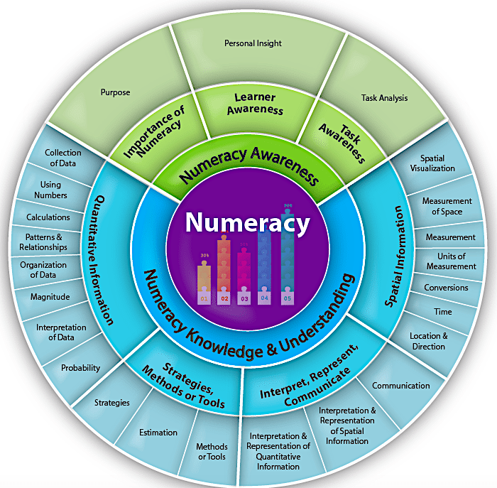
(Source: Rockyview School, n.d)

As you can see numeracy is a broad skill, it may seem complex, but it’s a skill children develop during their time in school and as adults continue developing and have the ability to use and transfer the skill appropriately.

“Why do I have to do this? It’s a waste of time! I won't use this when I'm older!”

A phrase I hear a little too often, while working as an LSA. Goos et al (2009, p.13) “…numeracy is vital for critical citizenship…” Compton (2009, p.2) goes further “Having a clear understanding of mathematics is socially empowering so we are not at the mercy of those who are more mathematically astute.”

Goos et al (2019) suggests a person’s life chances are incredibly impacted by poor numeracy skills and that it is a basic right to leave school numerate to have the ability to engage fully with any situations that my appear. Compton (2009) states “is it viewed as an essential life skill.”

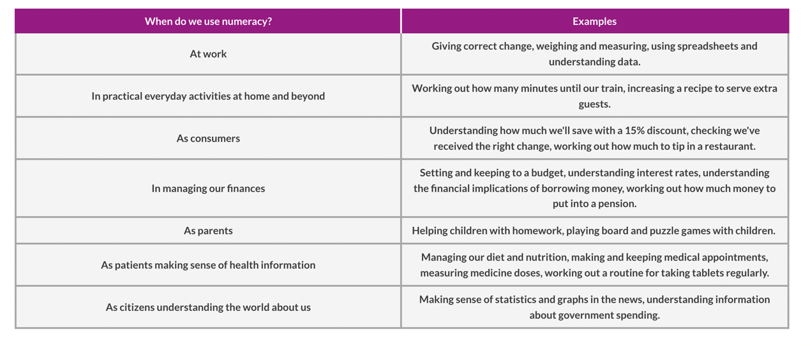
According to Sutherland (2007) students should have knowledge of mathematical tools to use both inside and out of school in a variety of situations, this was aided by the changes in The National Curriculum throughout the 1980’s and 1990’s.

(Source: National numeracy, 2022)

Numeracy is also known as numerical literacy and has been defined as an application of mathematics across the curriculum (Compton et al, 2009). A skill very similar to numeracy is literacy this is widely recognised as a transferable skill which students can recognise being used in a variety of subjects. It is important to help children see numeracy the same way.

Skills You Need (2017) State “Adults with poor numeracy skills are twice as likely to be unemployed than those who enjoy some competency in numeracy.” This statistic is unacceptable, everyone is entitled to equal opportunities. This enhances the importance of children developing the skill of numeracy in all aspects of the curriculum to allow them to have the best chance of progressing in the future.

Numeracy, in the hands of the student.

Everyone remembers learning about Victorian times, how in school they would be sat at desks listening intently and copying from the black board in fear of making a mistake and receiving a punishment. Luckily times have changed in today’s classrooms, or have they?

Without a doubt punishment for mistakes has certainly changed in fact children are encouraged to learn from any mistakes they make. Although I often experience a similar teaching style, I also recognise alternatives. A man called Paulo Freire has had a great influence with the change in teaching styles.
Paul Freire

Who was he?
- Born in Recife, Brazil in 1921
- Died in 1997
- Influential philosopher of education in the twentieth century
- Established the critical pedagogy movement
- Disliked the education system of the time and referred to it as the ‘banking’ system.
(Diaz, n.d)

The ‘banking’ system, the metaphor Paulo gave to the education system he disagreed with. He believed teachers were the problem, they contain the knowledge, which would be deposited into the empty accounts which would be the students (Drew, 2021) Martelli (2021) suggests this system relies heavily on the student memorising the information taught to later recall it when asked to do so.

To combat this Paulo came created the Critical Pedagogy where the teacher and the pupil can openly learn from each other, this removed the hierarchy of the teacher and pupil (Martelli, 2021). In this Liberationism theory, the teacher is open in discussions with the student to guide their own learning, they can say what and how they learn it (Greenwood, 2020).

Freire (n.d) himself admitted it may come across like he is undermining the teacher and demoting them however this is far from the case, the teacher has a main role, one with great responsivity. The way forward seems to be Liberationism pedagogy rather than the older style behaviour pedagogies, Liberationism allows a multiple of learning styles to be used in one classroom simultaneously (Greenwood, 2020).

The 4 main learning profiles within pedagogy:
Auditory | They learn orally, they work well and absorb information through listening.
Kinaesthetic | Hands on activities and tasks using learning aids.
Visual | Need to see information in front of them
Reading and writing | Gain information by reading texts

It is important for all children, no matter on their learning style, to have the full opportunity to access the curriculum. Teachers can create differentiated classrooms for mixed-ability groups of students utilising traditional learning practices (ResourcEd, 2021). Wales are in the process of rolling out a new curriculum, one which puts students at the heart of their education.
In light of the new curriculum happening in Wales, it is important numeracy remains as a priority for all teachers. Ensuring students experience independence in applying their numeracy skills in a range of areas and situations, their ability will be aided by specific support that they require dependant on ability to ensure they have opportunities to succeed (Welsh Government, 2022b).

What brought about these changes initially?
During the 1970s numeracy was brought to the forefront as an essential life skill which began an inquiry led by Wilfred Cockcroft into mathematics in schools in England and Wales. This resulted in The Cockcroft Report (1982), also known as Mathematics counts, in this report it was established teaching needed to improve within the field of numeracy to counteract the difficulties adults have shown in everyday solutions (Kus, 2018).
The main emphasise of the Cockcroft Report was the usefulness of mathematics, the ability for students to have understanding of solutions to problem solve. From it came a list of mathematic basics which all children, by the age of 16, should have learnt (Brown, 2014)
Donaldson (2015) asserts “Literacy and numeracy are universally acknowledged to be the essential foundations of education.” Kus (2018) would agree and states “…numeracy must permeate the curriculum. When it does, also like writing, it will enhance students’ understanding of all subjects and their capacity to lead informed lives.” With numeracy being one of the three mandatory cross-curricular skills, it is important for all staff to take responsibility to ensure progression throughout the curriculum (Welsh Government, 2022a).
In Wales they introduced a statutory National Literacy and Numeracy Framework to try to combat the difficulties in these skills. They also developed the Welsh Baccalaureate Qualification to support the improvement of skills across the curriculum (Donaldson, 2015).
Will so many changes developing and the importance shown to developing vital skills it is hopeful children will leave school more capable of everyday tasks and the ability to problem solve.

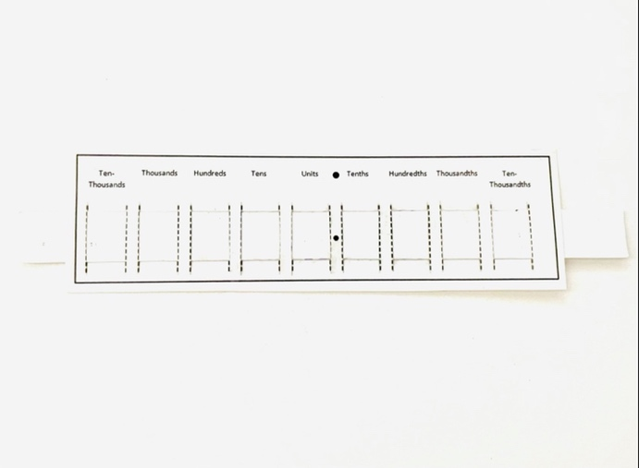

Place Value Slider
Melissa (2022) suggests “counting the zeros works great when you’re working with whole powers of ten.” However, when you are working with decimals it can be difficult and result in wrong answers.
It is important to remember it is the digits that shift either left or right rather than adding a zero and that the decimal point stays in the same place rather than cause confusion (Dabell, 2021).

Melissa (2022) suggests using hands-on models allow students to access and deeper understanding and find it easier to remember concepts.

There are two main Misconceptions when it comes to multiplying by the powers of 10.
- The first is that the decimal moves when in fact it’s the digits that move (Bhalerao, 2022).
- Another misconception is adding zeros which will provide difficulty further along.

There are two types of assessment one being summative which occurs at set times over the school year the second being formative which occurs daily within the classroom (Thompson, 2010). Summative Assessment are set tests taken at particular times of the year to assess achievement. Formative Assessment is regular, it is monitored daily usually given during feedback form teacher, peer or the student assessing themselves (Fox and Surtees, 2010).

The place value sliders may help someone who has Dyscalculia. Children that have dyscalculia, a specific learning disability which is brain- related, often struggle with mathematics (Miller, 2021).
In this case multiplication would be difficult and this would help them learn the process of multiplying by the powers of 10.

The place value slider is used for low ability children or those who struggle to understand or calculate mentally without seeing a practical or visual aid. It allows a child to physically move the numbers and this process explains the process so eventually the child will be able to progress on to using memory and give the answer using mental numeracy.

The slider is a great opportunity for children to use formative assessment and they allow the child instant feedback. A child will begin to use the slider for all multiplication by the powers of 10. When they gain confidence, they will begin to personally withdraw the slider from use for simple questions that they feel confident of working out mentally and only use it for perhaps those using decimal places. The child will continue this process until they no longer require the slider. This will allow the child to see and assess their own progression.

Video of place value sliders in use.

Evaluation of place value sliders.

Children with ALN often misunderstand questions or what has been asked of them, they rely on visual aids to understand. In numeracy often questions can be implemented into real life situations thus helping the child visualise and understand to then be able to work out the mathematical question (Compton et al, 2009). Sutherland (2007) claims the teacher’s role is to make children familiar with new tools to aid them with problem-solving in mathematics. However, Koshy and Murray (2002, p.82) assert “many problem-solving strategies develop through 'training' rather than teaching.” For the child to be able to “train” they must first understand how to problem-solve; this is where resources such as a place value slider will help to reinforce techniques to do so.

The Place Value Slider can be used as support while working out multiplication and division of the powers of 10. This is to reinforce understanding and also to help the correct process happen in order to reach the correct outcome. Some students find it difficult to understand multiplying by ten especially when decimals are involved, a place value slider, which is hands on allows students to visually see that you move the digits from one column to the next rather than moving the decimal place, this helps those students who learn through a kinaesthetic approach (Emeny, 2012). Dabell (2021) explains how learning misconceptions can be an issue when mathematical questions become harder further along for example adding a zero is often taught in regards to multiplying by ten however when you introduce a decimal place, children who have once added a zero would begin to get the answer wrong. Similarly if they move the decimal place if they do this they may become confused when they run out of numbers either side. Warwick Tutor (2022) expresses the importance of the decimal point not moving during the process of multiplying and dividing by the powers of 10 this is helpful through the means of visualising using the place value slider. An advantage of a hands-on educational aid is that they can accommodate the four different learning styles that you find within the VARK methods. They benefit those who have additional needs such as dyscalculia, dyslexia and autism. They will also help students gasp difficult concepts quicker, and make it fun and positive during the process (White, 2022) with the place value slider it is great for students who are visual and kinaesthetic learners as it is hands on allowing the student to visualise the numbers moving between the columns and physicaly move them from one column to the next. There are limitations of the place value slider and they as not versatile, they cannot be used with many numeracy problems, it is tailored to place value. This means for other tasks those who use numeracy resources would require more than one resource. This could become problematic if they rely on these resources for longer periods of time. Another point is often a child is working independently on a worksheet and the teacher or LSA can help them by assisting them in discovering the best strategy to solve a problem by asking questions. However, worksheets do not allow children the freedom to show the full extent of their knowledge and ability, they are restricting, making children conform to the worksheets structure answering often closed questions without being able to show their full understanding (Carruthers and Worthington, 2006).

Numeracy resources can range from anything like Numicon to online games, with new technology advances it is easier than ever to have access to multiple resources at a time via smart phones or iPads. A child’s exposure to these devices makes it easier for them to learn how to use technological resources also their teaching and learning becomes more enjoyable through using them. She explains the age of the passive learner has gone and they have become more engaged and involved in lessons (Swara, 2011). This is where modern technology becomes valuable having multiple resources on one device would benefit many students who rely on resource support. Sutherland (2007, p.67) states “nowadays there is a wide range of excellent computer-based environments available for learning mathematics”. With the twenty-first century came calculators, computers and mobile phones this altered the way numeracy education was approached (Kus, 2018). With calculators being widely available even on modern technology such as mobiles it is important children are taught how to use them correctly and to their full advantage. Many students and even some staff often believe that with the availability of calculators and modern technology containing a variety of calculator applications the need for a higher level of mathematics is no longer needed. This is a misconception, and it is important for all to still have basic understanding and simple ability to work out and problem solve (Compton et al, 2009). Thompson (1997, p. 98) as cited by Carruthers and Worthington (2006, p.106) asserts “all calculations in the first few years of schooling should be done mentally, using whatever aids they need.” Thompson is suggesting that children need to development mental mathematics skills to have the basic ability to move on. Mental mathematics is also used during the process of using a calculator due to understanding if they have correctly entered the numbers and if the answer is correct, It is important to remember that calculators are not infallible (Compton et al, 2009). There are a variety of apps or online programs to support students access numeracy and help them gain understanding, these are often game based which children enjoy and hardly recognising they are learning at the same time. This form of resource is being used more often in mathematics to help children try mathematical questions and the repetitive nature helps reinforce what they have learnt. If they lack understanding some of these games have the ability to share data with the teacher, this form of formative assessment allows the teacher to know what needs going over to support the child’s understanding. However, there are negatives to using these technical teaching aids such as using them incorrectly, they are there to aid teaching rather than to replace it. They can also stop teacher interactions with students, which plays a big part in the learning process and helps students feel comfortable within the subject (Swara, 2011).

Numeracy resources in general help many students but specifically those with dyscalculia. A lesser-known learning difficulty is dyscalculia which effects children learning mathematics or numeracy, they struggle with retaining information, and the ability to problem solve due to difficulty understanding (Brain balance, 2022) The Understood Team (2022) assert “an estimated 5 to 10 percent of people might have dyscalculia.” In appendix 1 you can see a dyscalculia screening report which shows below average results in a selection of criteria such as reaction time, addition and multiplication. From this the screener can do further tests and assessments to determine which areas the student has difficulty in order to inform teachers to put in the correct support. In appendix 2, again there is a dyscalculia screening report however this is for a student who unlikely has dyscalculia her resulted were mostly average however in two areas she scored below average therefore benefiting from intervention within those areas either through her teacher revisiting those areas or in a small group or possibly one to one. With dyscalculia being hard to identify with a single test alone, observation one to one will help gage the child’s difficulties (British Dyslexia Association, 2022). Students with dyscalculia may benefit from interventions, more time in tests or to complete tasks and differentiated work (Frye, 2021) In these interventions resources can be used more regularly as they allows students time to focus on any difficulties. These sessions are used to teach the child the skills they are lacking understanding and giving them help to develop strategies to be able to undertake problem-solving tasks allowing them to be able to access all parts of the curriculum and setting them up for life.

Overall, the place value slider is a great resource to reinforce prior knowledge a child has been taught. However, it is important the initial teaching is correct before students use the place value slider this discourages the habits of misconceptions and the outcome of incorrect answers. This is important with all resources, also the child often needs to be taught how to use the resource to progress correctly. Resources are not for all students and benefit certain VARK learning styles more than other however with such a variety of numeracy resources there is often something for every learning style. With the new advances in technology, numeracy is beginning to become fun to learn which helps students learn without feeling they are because it is not boring, and they are enjoying the process numeracy becomes positive and a child is more inclined to remember and use numeracy more often. Children with dyscalculia would benefit more so from resources to support reinforcing understanding due to the difficulty they have with mathematics and numeracy. To conclude the place value slider has many advantages and being hands on and visual helps many children access numeracy.

Evaluation

Initially I was excited about this module, I have always felt numeracy was a strength of mine. I enjoyed Mathematics and the skill of numeracy while at school, perhaps this was due to having dyslexia which meant I was drawn away from literacy based subjects and really flourished with mathematics. I was intrigued by this module and excited to learn more and being able to broaden my knowledge to help students who I work with.

In this module I had the greatest difficulty at beginning choosing a numeracy resource. Numeracy resources are not something I use with the student I work with. The process I took was looking at the options I had, I considered a programme which is run throughout KS3, Numeracy Ninjas. I had prior knowledge and had experienced this in action however, after careful consideration to the criteria I had to follow I decided this wasn’t the correct recourse to choose as it wasn’t something which helped children with understanding it is a timed activity which is used to assess understanding. I then contacted the numeracy coordinator who helped tremendously. To begin with help was via emails due to her being off with COVID however on her return we met and discussed place value sliders. This resource was new to our school however had already show progress with students when they had been used in interventions. I liked the tactile element to this resource and could see how it would help children with dyscalculia and those who have trouble understanding and need help to visualise. The only other issue I then had was with the video, this was because of our reduced times of the day in the school, I was unable to film the resource in action within a class due to the lack of availability I have to attend other lessons. I decided it was best for me just to film how it would be used and explain where a child could potentially go wrong.

I managed to attend two out of three lectures due to a doctor’s appointment during the second, this was arranged before I knew the dates of the lectures and it could not be avoided because of health conditions which are under investigation. This is something I would try to avoid happening in the future, although the lecture is recorded, it is not the same as being there in person and the potential of missing opportunities to ask questions is a disadvantage to me. I feel I need to use and access more support during my assignments, this will help me to plan and progress going forward, whether that is asking lectures more questions, having more input in lectures or using student services more than I do now. The latter will keep me accountable and help with time management. Participating in lectures more is a goal I wish to fulfil going forward. Hopefully face to face lectures will take place in the near future for the up and coming modules this will allow me to build confidence with others on the course as being online makes it far too easy to stay quiet and not speak in front of others, almost hiding behind a screen.

While in my role as LSA during this module I was surprised by situations I was noticing while attending a variety of lessons. One of these experiences was the teaching of the nth term which involves decimal points and the ability to understand multiplying and dividing. Interestingly we had just covered this in the maths lesson where the teacher asks questions about the numbers moving places however in physics where it was explained again the teacher proceeded to count the noughts or moving the decimal. This module has allowed me to recognise the negative impact this way has on outcomes further down the line. I have also acknowledged, more than usual, the use of numeracy across the curriculum and I have begun to recognise the importance in day-to-day life.

Most importantly this module has opened my eyes up to the various teaching methods used in schools. Especially the liberationism approach. This pedagogy is very fitted to the new curriculum where students are at the forefront of all decisions as they guide their own learning. This approach brings the student and the teacher together, learning from each other rather than being oppressed. It allows student to have a voice and say and tailor their education to their interested rather than be empty vessels ready to be filled with knowledge lectured at them (Greenwood, 2020).

References

Bhalerao, N. (2022) Multiplying by 10 and 100. Available at: https://warwicktutor.com/maths/resources/multiplying-by-10-and-100 (Accessed: 26th January 2022)

Brain balance (2022) Dyscalculia: More than a math struggle. Available at: https://www.brainbalancecenters.com/blog/dyscalculia-more-than-a-math-struggle (Accessed: 1st February 2022)

British Dyslexia Association (2022) Neurodiversity and co-occurring difficulties. Available at: https://www.bdadyslexia.org.uk/dyslexia/neurodiversity-and-co-occurring-differences/dyscalculia-and-maths-difficulties (Accessed: 1st February 2022)

Brown, M. (2014) The Cockcroft Report: Time past, time present and time future. Available at: https://www.atm.org.uk/write/mediauploads/journals/mt243/mt243-14-01.pdf (Accessed: 31st January 2022)

Carruthers, E. and Worthington, M. (2006) Children’s Mathematics, Making Marks, Making Meaning. London: Paul Chapman Publishing.

Compton, A., Fielding, H. and Scott, M. (2009) Supporting Numeracy. London: Paul Chapman Publishing.

Dabell, J. (2021) Maths Misconceptions: multiplying by 10. Available at: https://mathsnoproblem.com/blog/teaching-tips/maths-misconceptions-multiplying-ten/ (Accessed: 27th January 2022)

Diaz. K. (n.d) Paulo Friere (1921-1997). Available at: https://iep.utm.edu/freire/ (Accessed: 26th January 2021)

Donaldson, G. (2015) Futures. Available at: https://gov.wales/sites/default/files/publications/2018-03/successful-futures.pdf Accessed: 31st January 2022)

Drew, C. (2021) The “Banking” Model of Education – Pros & Cons. Available at: https://helpfulprofessor.com/banking-model/ (Accessed 26th January 2022)

Emeny, W. (2012) A Kinaesthetic resource for multiplying and dividing by 10,100 and 1000. Available at: http://www.greatmathsteachingideas.com/2012/02/16/a-kinaesthetic-resource-for-multiplying-and-dividing-by-10-100-and-1000/ (Accessed: 31st January 2022)

Fox, S. and Surtees, L. (2010) Mathematics Across the Curriculum. London: Continuum International Publishing Group.

Freire, P., D’Ambrosio, U. and Mendonça, M. (n.d) A Conversation with Paulo Freire. Availble at: https://flm-journal.org/Articles/164C34431842FA8E405A5A16BC49B9.pdf (Accessed: 26th January 2022)

Frye, D. (2021) What Is Dyscalculia? Math Learning Disability Overview. Available at: https://www.additudemag.com/what-is-dyscalculia-overview-and-symptom-breakdown/ (Accessed: 1st February 2022)

Goos, M., Geiger, V., Dole, S., Forgasz, H. and Bennison, A. (2019) Numeracy Across the Curriculum. Australia: Allen and Unwin.

Greenwood, B. (2020) What is Liberationist Pedagogy and How Can You Apply it in the Classroom? Available at: https://blog.teamsatchel.com/what-is-liberationist-pedagogy-and-how-can-you-apply-it (Accessed: 26th January 2022)

Koshy, V. and Murray, J. (2002) Unlocking Numeracy. London: David Fulton Publishers Ltd.
Kus, M. (2018) Numeracy. Available at: https://files.eric.ed.gov/fulltext/EJ1179949.pdf (Accessed: 01st Febuary 2022)

Martelli, M. (2021) Critical Pedagogy beyond Humanism. Available at: https://www.justwondering.io/critical-pedagogy-beyond-humanism/ (Accessed: 26th January 2022)

Melissa. (2022) Multiply and Divide by Powers of Ten! Available at: https://teacherthrive.com/PowersOfTen/ (Accessed: 27th January 2022)

Miller, K. (2021) What is Dyscalculia? What should I Do if My Child Has It? Available at: https://www.webmd.com/add-adhd/childhood-adhd/dyscalculia-facts (Accessed: 27th January 2022)

National Numeracy. (2017) What do we mean by numeracy? – National Numeracy. 8th November. Available at: https://www.youtube.com/watch?v=lR1t-Cn7Ui4 (Accessed: 25th January 2022).

National Numeracy. (2022) What is numeracy? Available at: https://www.nationalnumeracy.org.uk/what-numeracy (Accessed: 7th January 2022)
ResourcEd. (2021) Pedagogy: A definite guide to learning practices. Available at: https://resourced.prometheanworld.com/pedagogy-learning-practices/#chapter-9 (Accessed: 26th January 2022)

Rockyview School. (n.d) What is Numeracy? Available at: https://schoolblogs.rockyview.ab.ca/makingnumeracyvisible/what-is-numeracy/ (Accessed: 25th January 2022)

Skills You Need. (2017) Numeracy Skills. Available at: https://www.skillsyouneed.com/numeracy-skills.html (Accessed: 26th January 2022)

Sutherland, R. (2007) Teaching for Learning Mathematics. England: Open University Press.

Swara. (2011) How Modern Teaching Aids Have Benefits and Drawbacks. Available at: https://www.indiastudychannel.com/resources/146601-How-Modern-Teaching-Aids-Have-Benefits-And-Drawbacks.aspx (Accessed: 31/01/2022)

The Understood Team. (2022) What is dyscalculia? Available at: https://www.understood.org/articles/en/what-is-dyscalculia (Accessed: 1st February 2022)

Thompson, I. (2010) Issues in Teaching Numeracy in Primary Schools. England: Open University Press.

Warwick Tutor. (2022) Multiplying by 10 and 100. Available at: https://warwicktutor.com/maths/resources/multiplying-by-10-and-100 (Accessed: 31st January 2022)

Welsh Government. (2022a) Cross-curricular skills frameworks. Available at: https://hwb.gov.wales/curriculum-for-wales/cross-curricular-skills-frameworks/ (Accessed: 2nd February 2022)

Welsh Government. (2022b) Literacy and numeracy: your questions answered. Available at: https://hwb.gov.wales/curriculum-for-wales-2008/national-literacy-and-numeracy-framework-curriculum-for-wales-2008-version/literacy-and-numeracy-your-questions-answered/ (Accessed: 2nd February 2022)

White, E. (2022) Multisensory Maths: Pros and Cons of Using Hands-on Blocks. Available at: https://mathsaustralia.com.au/blog/multisensory-maths/ (Accessed: 30th January 2022)

Appendices
Appendix 1
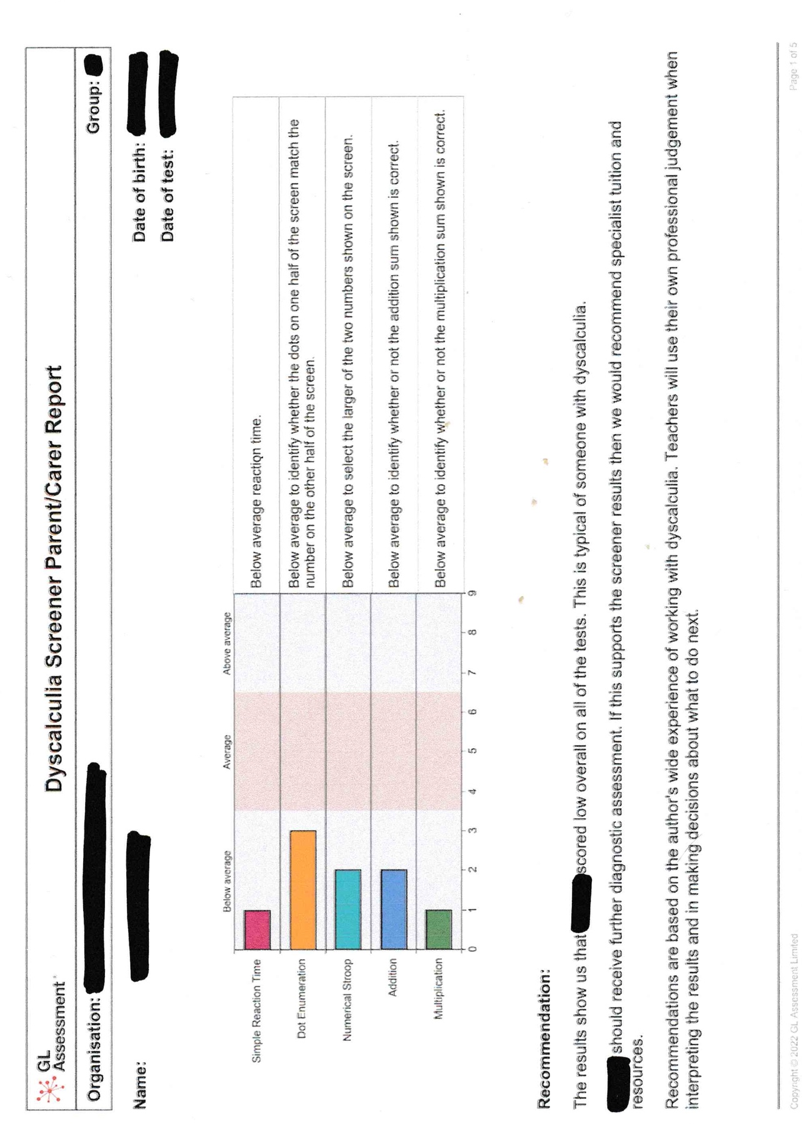
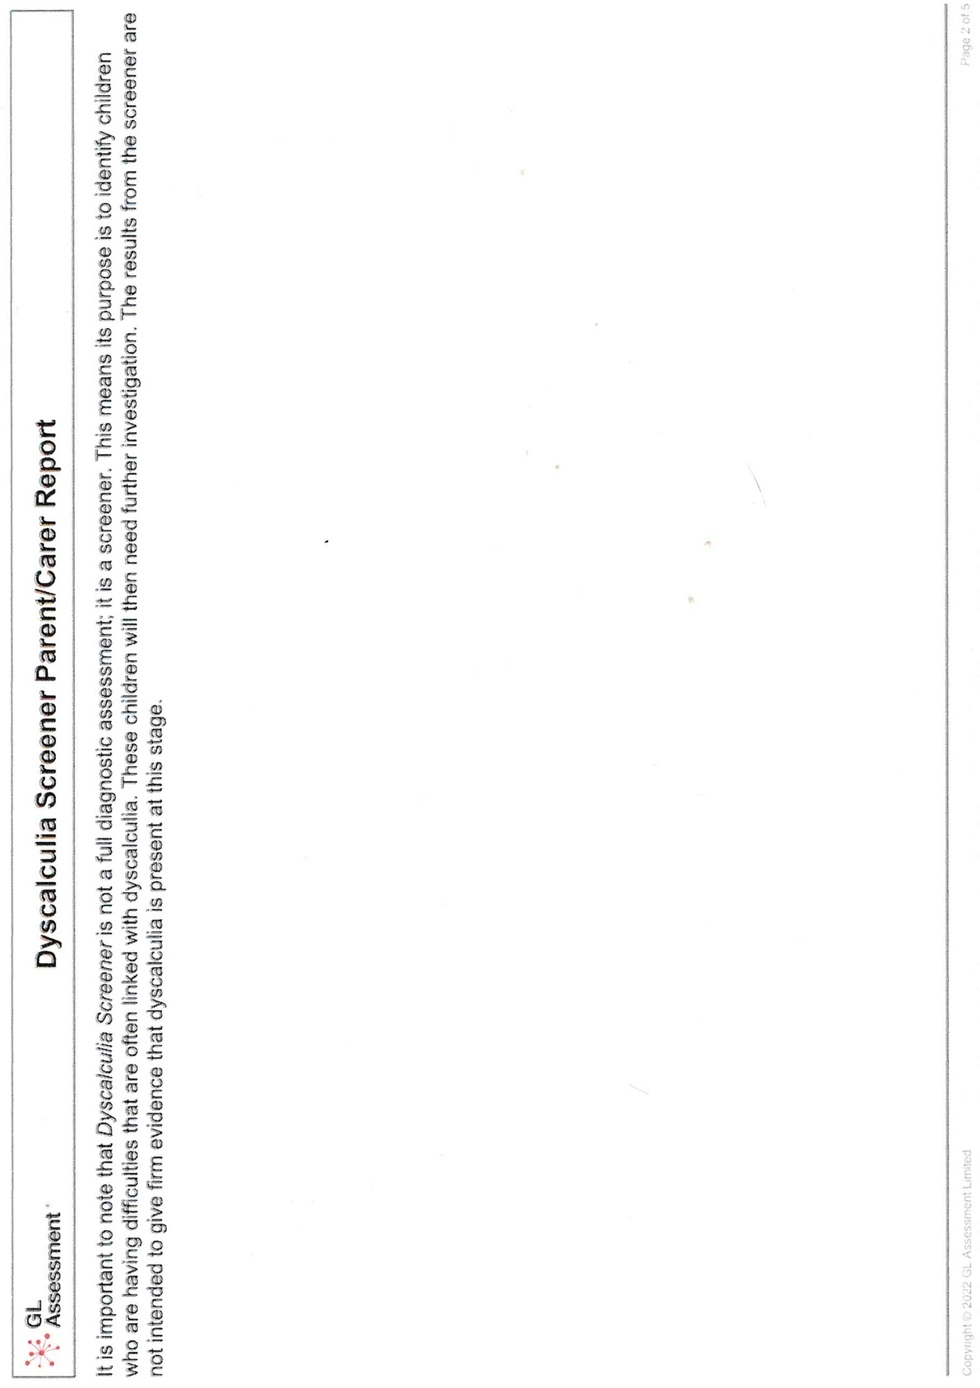
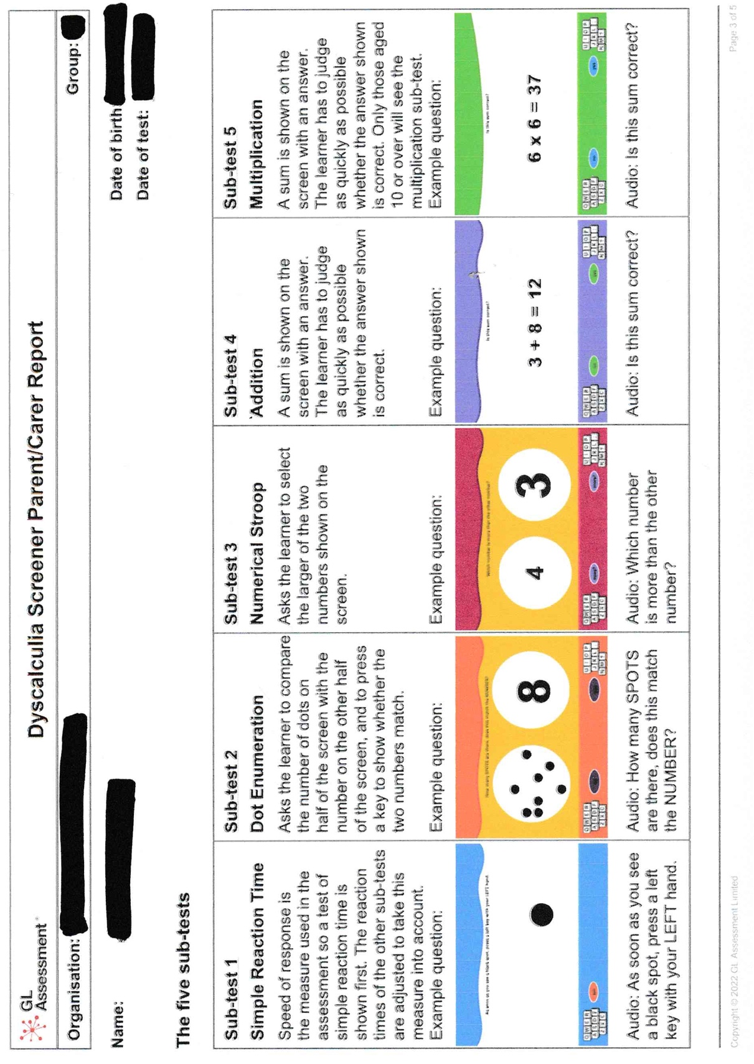

Appendix 2


