Abstract
The report mainly describes several different types of NoSQL database and the characteristics of their data storage, and by comparing NoSQL and traditional relational databases, the characteristics of their data storage support are obtained. Then, according to the given scenario, SQL and json are used to realize the data storage of relational database and document row database respectively.

NoSQL

(1) graph database
Graph database is very different from relational database in terms of data storage, query and data structure. Graph data structures directly store dependencies between nodes, whereas relational and other types of non-relational databases represent relationships between data in an indirect manner. Graph database stores the association between data as part of the data, and labels, directions and attributes can be added to the association. A typical graph database application is Neo4j. The following figure is from the official website of Neo4j, which vividly expresses the characteristics of graph database. Graph databases generally contain Nodes and vertices to represent entiies and arcs to represent relationships. The relationship of a graph database can be directed or undirected. In the graph database, nodes have attributes and types. For example, in social applications, each user can be regarded as a node, and each user has user characteristics. Multiple usersare interconnected to form a network.^{[1]}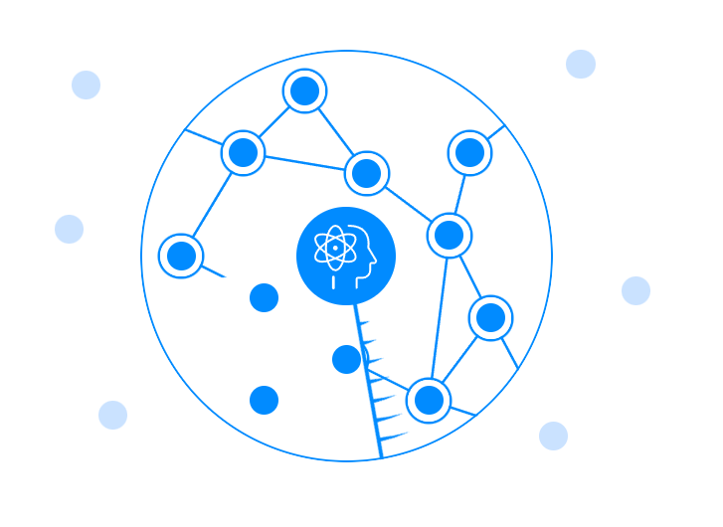（2）Column-oriented DBMS
Columnar database is a database that stores data based on columnar storage architecture, which is mainly suitable for batch data processing and real-time query. ^{[2]}The corresponding is the row database, the data in the row related storage architecture for space allocation, mainly suitable for small batch data processing, often used for online transactional data processing. A column family consists of multiple rows. Each row can contain a different number of columns to other rows. Columns do not need to match columns in other rows (that is, they can have different column names, data types, and so on). Each column contains its own rows. The following figure is a columnar database for describing user profiles.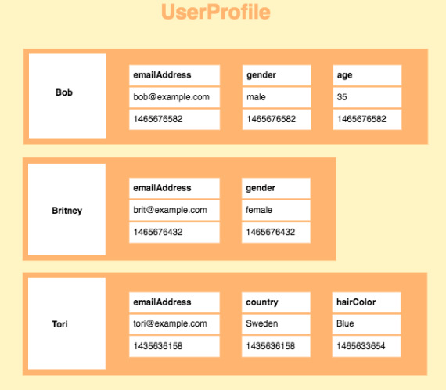

（3）document
Document data stored in an entity called a "document" manages a set of named string fields and object data values. These data stores typically store data in the form of JSON documents. Each field value can be a scalar item, such as a number, or a compound element, such as a list or a parent-child collection. Data in document fields can be encoded and even stored as plain text in a variety of ways, including XML, YAML, JSON, BSON. The fields in the document are exposed to the storage management system, so applications can use the values in these fields to query and filter data.^{[3]}
The common document database is mongodb. Here is a simple example of a json document database: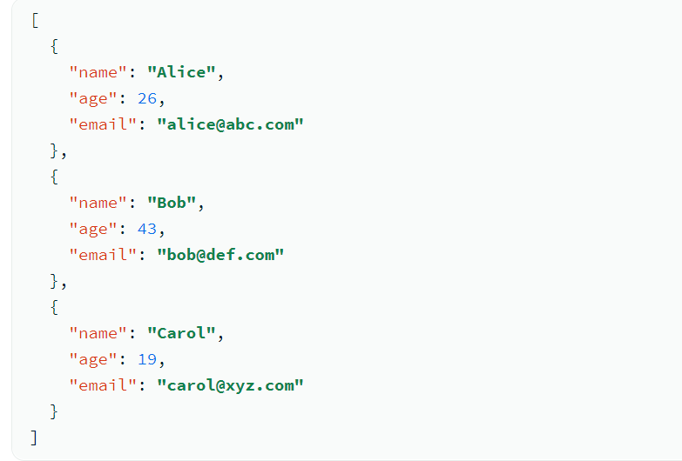

（4）key-value database
A key-value database is a simpler database where each item contains a key and a value. Typecally values can only be retrieved by reference to a key, so learning how to query for a particular key-value pair is usually simple. Key-value databases are ideal for use cases where you need to store large amounts of data but do not need to perform complex queries to retrieve the data. Common use cases include storing user preferences or caching. Redis and DynanoDB are popular key-value databases.^{[4]}

(5) Comparison of NoSQL and traditional relational database
Compared with traditional relational databases, NoSQL has the following advantages:
Flexible modeling -- Instead of relying on fixed schemas, data types, row sizes, and column names, NoSQL helps achieve a flexible data model that is better suited for working with less structured data sources.^{[5]}
Scalability - The capacity in the NoSQL database can be scaled out using a horizontal approach (adding inexpensive servers and connecting them to the database cluster). Therefore, the cost and complexity associated with scaling relationships prevents the database from becoming distributed.
Performance - By using a scale-out approach for seamless scalability, enterprises can efficiently read and write data items and store large data while processing. Companies like LinkedIn, Facebook and Google have users all over the world;
As a result, they deploy data centers around the world and partition users by routing to the nearest data so that all their users experience as little cross-center access as possible.
High Availability - For many enterprises, customer and user engagement occurs mostly or entirely online, and the availability of any application is a major concern for the enterprise. Availability is a challenge for relational databases because they are physically implemented
On a single server or on a cluster with shared storage. In contrast, NoSQL databases are typically stored in partitions that divide data into multiple database instances of any shared resource. Automatic failover means that if a node fails, the database can continue to run read and write operations on different nodes.
Compared with NoSQL, relational databases have the following advantages:
Relational databases have transactional properties (ACID) and concurrency control systems to ensure data consistency, while NoSQL databases can only comply with the AP or CP of CAP (consistency, availability, partition fault tolerance). Relational database using SQL language can complete complex business scenario query application.^{[6]}

According to the above analysis, NoSQL database is more suitable for mobile applications, real-time analysis and social media content management. In financial systems, banking systems and other trading systems, data consistency needs to be strictly guaranteed, and traditional relational databases are more suitable for use.

Relational Database Implementation

Table structure
drop table if exists purchases;
drop table if exists asset_author;
drop table if exists assets;
drop table if exists genres;
drop table if exists authors;
drop table if exists users;

create table users(
user_id serial primary key,
first_name varchar(22) not null,
last_name varchar(22),
address text,
telephone varchar(22),
join_date date not null
);

create table genres(
genre_id serial primary key,
genre_name varchar(25) not null
);

create table authors(
author_id serial primary key,
first_name varchar(22) not null,
last_name varchar(22)
);

create table assets(
asset_id serial primary key,
asset_title varchar(45) not null,
asset_genre int,
asset_publisher varchar(30),
release_date date,
asset_price numeric,
asset_stock int,
asset_blob text
);

create table asset_author(
asset_id int,
author_id int,
primary key (asset_id,author_id)
);

create table purchases(
user_id int not null,
asset_id int not null,
buy_date date,
discount numeric,
primary key (user_id, asset_id)
);

Data
alter table assets add constraint fk_asset_genre foreign key (asset_genre) references genres(genre_id);

alter table asset_author add constraint fk_asset_asset foreign key (asset_id) references assets(asset_id);
alter table asset_author add constraint fk_asset_author foreign key (author_id) references authors(author_id);

alter table purchases add constraint fk_purchase_user foreign key (user_id) references users(user_id);
alter table purchases add constraint fk_purchase_asset foreign key (asset_id) references assets(asset_id);

alter table purchases add constraint chk_discount check (discount>0 and discount<1);
alter table assets add constraint chk_asset_stock check (asset_stock>=0);

INSERT INTO "public"."users"("user_id", "first_name", "last_name", "address", "telephone", "join_date") VALUES (1, 'Lucy', 'Chan', '12 Gower Street, London WC1E 6BT', '123456789', '2023-01-04');
INSERT INTO "public"."users"("user_id", "first_name", "last_name", "address", "telephone", "join_date") VALUES (2, 'John', 'Biden', '452 Appletree Avenue, Maidenstone, Kent MA6 3TY', '7852369544', '2022-12-26');
INSERT INTO "public"."users"("user_id", "first_name", "last_name", "address", "telephone", "join_date") VALUES (3, 'Donald', 'Trump', '55 Gerrard Street, London, EC5U 2HV', '312312', '2022-12-27');
INSERT INTO "public"."users"("user_id", "first_name", "last_name", "address", "telephone", "join_date") VALUES (4, 'Luis', 'Wang', '99 Appletree Avenue, Maidenstone, Kent MA2 5TY', '131231', '2023-01-09');
INSERT INTO "public"."users"("user_id", "first_name", "last_name", "address", "telephone", "join_date") VALUES (5, 'Wayne', 'Lim', 'No.42, Zhongzhou Road, Nanyang City, Henan Province', '13552466268', '2023-01-12');
INSERT INTO "public"."users"("user_id", "first_name", "last_name", "address", "telephone", "join_date") VALUES (6, 'Chizu', 'Kelly', '11965 Venice Blvd. Suite 405, Los Angeles, CA 90066', '66583002', '2022-12-12');
INSERT INTO "public"."users"("user_id", "first_name", "last_name", "address", "telephone", "join_date") VALUES (7, 'Yosefu', 'Middn', '350 5th Avenue, New York, NY 10118-3304', '88345566', '2023-01-15');
INSERT INTO "public"."users"("user_id", "first_name", "last_name", "address", "telephone", "join_date") VALUES (8, 'Maeve', 'Fahsin', 'Room 601, No.34, Long Chang Li, Xiamen, Fujian Province', '13332036363', '2022-11-03');
INSERT INTO "public"."users"("user_id", "first_name", "last_name", "address", "telephone", "join_date") VALUES (9, 'Ryane', 'Jimn', '555 Lexington Avenue, 10th Floor, Room 202 New York', '2579153', '2023-01-13');
INSERT INTO "public"."users"("user_id", "first_name", "last_name", "address", "telephone", "join_date") VALUES (10, 'Jaqueen', 'Elya', '385-389 Oxford St, London,Suite G7-8, Davina House 137-149 Goswell Road', '12278877', '2023-01-10');

INSERT INTO "public"."genres"("genre_id", "genre_name") VALUES (1, 'Romance');
INSERT INTO "public"."genres"("genre_id", "genre_name") VALUES (2, 'Comedy');
INSERT INTO "public"."genres"("genre_id", "genre_name") VALUES (3, 'Thriller');
INSERT INTO "public"."genres"("genre_id", "genre_name") VALUES (4, 'Horror');
INSERT INTO "public"."genres"("genre_id", "genre_name") VALUES (5, 'Action');
INSERT INTO "public"."genres"("genre_id", "genre_name") VALUES (6, 'Romance');
INSERT INTO "public"."genres"("genre_id", "genre_name") VALUES (7, 'Sci-Fi');
INSERT INTO "public"."genres"("genre_id", "genre_name") VALUES (8, 'Thriller');
INSERT INTO "public"."genres"("genre_id", "genre_name") VALUES (9, 'Comedy');
INSERT INTO "public"."genres"("genre_id", "genre_name") VALUES (10, 'Trailer');

INSERT INTO "public"."authors"("author_id", "first_name", "last_name") VALUES (1, 'Nacala', 'Ryane');
INSERT INTO "public"."authors"("author_id", "first_name", "last_name") VALUES (2, 'Tapia', 'Lolek');
INSERT INTO "public"."authors"("author_id", "first_name", "last_name") VALUES (3, 'Aretha', 'Dea');
INSERT INTO "public"."authors"("author_id", "first_name", "last_name") VALUES (4, 'Shaunta', 'Jaqueen');
INSERT INTO "public"."authors"("author_id", "first_name", "last_name") VALUES (5, 'Dacre', 'Wray');
INSERT INTO "public"."authors"("author_id", "first_name", "last_name") VALUES (6, 'Dublin', 'Koda');
INSERT INTO "public"."authors"("author_id", "first_name", "last_name") VALUES (7, 'Irwin', 'Carmi');
INSERT INTO "public"."authors"("author_id", "first_name", "last_name") VALUES (8, 'Georgino', 'Adib');
INSERT INTO "public"."authors"("author_id", "first_name", "last_name") VALUES (9, 'Jorge', 'Thule');
INSERT INTO "public"."authors"("author_id", "first_name", "last_name") VALUES (10, 'Sissy', 'Lucania');

INSERT INTO "public"."assets"("asset_id", "asset_title", "asset_genre", "asset_publisher", "release_date", "asset_price", "asset_stock", "asset_blob") VALUES (1, 'Titanic', 1, 'PA', '2003-02-01', '77', 50, NULL);
INSERT INTO "public"."assets"("asset_id", "asset_title", "asset_genre", "asset_publisher", "release_date", "asset_price", "asset_stock", "asset_blob") VALUES (2, 'The Notebook', 2, 'PB', '2001-01-01', '55', 60, NULL);
INSERT INTO "public"."assets"("asset_id", "asset_title", "asset_genre", "asset_publisher", "release_date", "asset_price", "asset_stock", "asset_blob") VALUES (3, 'Flipped', 3, 'PC', '2002-01-01', '66', 70, NULL);
INSERT INTO "public"."assets"("asset_id", "asset_title", "asset_genre", "asset_publisher", "release_date", "asset_price", "asset_stock", "asset_blob") VALUES (4, 'Cairo Time', 4, 'PD', '2003-01-01', '88', 80, NULL);
INSERT INTO "public"."assets"("asset_id", "asset_title", "asset_genre", "asset_publisher", "release_date", "asset_price", "asset_stock", "asset_blob") VALUES (5, 'Pride and Prejudice', 5, 'PE', '2004-01-01', '99', 90, NULL);
INSERT INTO "public"."assets"("asset_id", "asset_title", "asset_genre", "asset_publisher", "release_date", "asset_price", "asset_stock", "asset_blob") VALUES (6, 'Bridget Jones''s Diary', 6, 'PF', '2005-01-01', '87', 40, NULL);
INSERT INTO "public"."assets"("asset_id", "asset_title", "asset_genre", "asset_publisher", "release_date", "asset_price", "asset_stock", "asset_blob") VALUES (7, 'Gone with the wind', 7, 'PG', '2006-01-01', '76', 30, NULL);
INSERT INTO "public"."assets"("asset_id", "asset_title", "asset_genre", "asset_publisher", "release_date", "asset_price", "asset_stock", "asset_blob") VALUES (8, 'If Only', 8, 'PH', '2007-01-01', '65', 50, NULL);
INSERT INTO "public"."assets"("asset_id", "asset_title", "asset_genre", "asset_publisher", "release_date", "asset_price", "asset_stock", "asset_blob") VALUES (9, 'City of Angels', 9, 'PJ', '2003-02-01', '54', 60, NULL);
INSERT INTO "public"."assets"("asset_id", "asset_title", "asset_genre", "asset_publisher", "release_date", "asset_price", "asset_stock", "asset_blob") VALUES (10, 'Jane Eyre', 10, 'PK', '2005-02-01', '43', 70, NULL);

INSERT INTO "public"."asset_author"("asset_id", "author_id") VALUES (4, 6);
INSERT INTO "public"."asset_author"("asset_id", "author_id") VALUES (7, 2);
INSERT INTO "public"."asset_author"("asset_id", "author_id") VALUES (5, 9);
INSERT INTO "public"."asset_author"("asset_id", "author_id") VALUES (3, 8);
INSERT INTO "public"."asset_author"("asset_id", "author_id") VALUES (2, 7);
INSERT INTO "public"."asset_author"("asset_id", "author_id") VALUES (9, 5);
INSERT INTO "public"."asset_author"("asset_id", "author_id") VALUES (1, 3);
INSERT INTO "public"."asset_author"("asset_id", "author_id") VALUES (8, 1);
INSERT INTO "public"."asset_author"("asset_id", "author_id") VALUES (6, 4);
INSERT INTO "public"."asset_author"("asset_id", "author_id") VALUES (7, 9);
INSERT INTO "public"."asset_author"("asset_id", "author_id") VALUES (4, 3);
INSERT INTO "public"."asset_author"("asset_id", "author_id") VALUES (5, 7);
INSERT INTO "public"."asset_author"("asset_id", "author_id") VALUES (2, 6);
INSERT INTO "public"."asset_author"("asset_id", "author_id") VALUES (3, 5);
INSERT INTO "public"."asset_author"("asset_id", "author_id") VALUES (9, 2);

INSERT INTO "public"."purchases"("user_id", "asset_id", "buy_date", "discount") VALUES (2, 3, '2022-12-28', '0.9');
INSERT INTO "public"."purchases"("user_id", "asset_id", "buy_date", "discount") VALUES (6, 1, '2022-10-31', '0.99');
INSERT INTO "public"."purchases"("user_id", "asset_id", "buy_date", "discount") VALUES (8, 6, '2022-12-13', '0.98');
INSERT INTO "public"."purchases"("user_id", "asset_id", "buy_date", "discount") VALUES (7, 4, '2022-11-17', '0.99');
INSERT INTO "public"."purchases"("user_id", "asset_id", "buy_date", "discount") VALUES (5, 7, '2022-10-22', '0.97');
INSERT INTO "public"."purchases"("user_id", "asset_id", "buy_date", "discount") VALUES (4, 5, '2022-09-09', '0.92');
INSERT INTO "public"."purchases"("user_id", "asset_id", "buy_date", "discount") VALUES (3, 8, '2022-11-08', '0.95');
INSERT INTO "public"."purchases"("user_id", "asset_id", "buy_date", "discount") VALUES (1, 5, '2022-10-24', '0.93');
INSERT INTO "public"."purchases"("user_id", "asset_id", "buy_date", "discount") VALUES (9, 2, '2022-12-12', '0.96');
INSERT INTO "public"."purchases"("user_id", "asset_id", "buy_date", "discount") VALUES (3, 9, '2022-11-27', '0.94');
INSERT INTO "public"."purchases"("user_id", "asset_id", "buy_date", "discount") VALUES (7, 2, '2022-12-22', '0.98');
INSERT INTO "public"."purchases"("user_id", "asset_id", "buy_date", "discount") VALUES (6, 8, '2022-10-09', '0.97');
INSERT INTO "public"."purchases"("user_id", "asset_id", "buy_date", "discount") VALUES (5, 2, '2022-07-21', '0.99');
INSERT INTO "public"."purchases"("user_id", "asset_id", "buy_date", "discount") VALUES (2, 7, '2022-12-02', '0.95');
INSERT INTO "public"."purchases"("user_id", "asset_id", "buy_date", "discount") VALUES (8, 1, '2022-11-28', '0.9');
INSERT INTO "public"."purchases"("user_id", "asset_id", "buy_date", "discount") VALUES (4, 6, '2022-10-27', '0.93');
INSERT INTO "public"."purchases"("user_id", "asset_id", "buy_date", "discount") VALUES (9, 5, '2022-11-04', '0.97');

Index
create index ix_release on assets(release_date);
create index ix_join on users(join_date);

Document Implementation
{
"assets": [
{
"asset_id": "1",
"asset_title": "Titanic",
"asset_genre": "1",
"asset_publisher": "PA",
"release_date": "1/2/2003",
"asset_price": "77",
"asset_stock": "50",
"asset_blob": "",
"asset_author": [
{
"author_id": "3",
"first_name": "Aretha",
"last_name": "Dea"
}
],
"asset_sold_to": [
{
"user": {
"user_id": "2",
"first_name": "John",
"last_name": "Biden",
"address": "452 Appletree Avenue, Maidenstone, Kent MA6 3TY",
"telephone": "7852369544",
"join_date": "26/12/2022"
},
"purchase_date": "2022-10-24",
"discount": 0.93
},
{
"user": {
"user_id": "3",
"first_name": "Donald",
"last_name": "Trump",
"address": "55 Gerrard Street, London, EC5U 2HV",
"telephone": "312312",
"join_date": "27/12/2022"
},
"purchase_date": "12/12/2022",
"discount": "0.96"
}
]
},
{
"asset_id": "2",
"asset_title": "The Notebook",
"asset_genre": "2",
"asset_publisher": "PB",
"release_date": "1/1/2001",
"asset_price": "55",
"asset_stock": "60",
"asset_blob": "",
"asset_author": [
{
"author_id": "6",
"first_name": "Dublin",
"last_name": "Koda"
},
{
"author_id": "7",
"first_name": "Irwin",
"last_name": "Carmi"
}
],
"asset_sold_to": [
{
"user": {
"user_id": "5",
"first_name": "Wayne",
"last_name": "Lim",
"address": "No.42, Zhongzhou Road, Nanyang City, Henan Province",
"telephone": "13552466268",
"join_date": "12/1/2023"
},
"purchase_date": "2022-10-24",
"discount": 0.93
}
]
},
{
"asset_id": "3",
"asset_title": "Flipped",
"asset_genre": "3",
"asset_publisher": "PC",
"release_date": "1/1/2002",
"asset_price": "66",
"asset_stock": "70",
"asset_blob": "",
"asset_author": [
{
"author_id": "5",
"first_name": "Dacre",
"last_name": "Wray"
},
{
"author_id": "8",
"first_name": "Georgino",
"last_name": "Adib"
}
],
"asset_sold_to": [
{
"user": {
"user_id": "4",
"first_name": "Luis",
"last_name": "Wang",
"address": "99 Appletree Avenue, Maidenstone, Kent MA2 5TY",
"telephone": "131231",
"join_date": "9/1/2023"
},
"purchase_date": "2022-10-24",
"discount": 0.93
},
{
"user": {
"user_id": "6",
"first_name": "Chizu",
"last_name": "Kelly",
"address": "11965 Venice Blvd. Suite 405, Los Angeles, CA 90066",
"telephone": "66583002",
"join_date": "12/12/2022"
},
"buy_date": "8/11/2022",
"discount": "0.95"
}
]
},
{
"asset_id": "4",
"asset_title": "Cairo Time",
"asset_genre": "4",
"asset_publisher": "PD",
"release_date": "1/1/2003",
"asset_price": "88",
"asset_stock": "80",
"asset_blob": "",
"asset_author": [
{
"author_id": "9",
"first_name": "Jorge",
"last_name": "Thule"
},
{
"author_id": "10",
"first_name": "Sissy",
"last_name": "Lucania"
}
]
},
{
"asset_id": "5",
"asset_title": "Pride and Prejudice",
"asset_genre": "5",
"asset_publisher": "PE",
"release_date": "1/1/2004",
"asset_price": "99",
"asset_stock": "90",
"asset_blob": "",
"asset_author": [
{
"author_id": "9",
"first_name": "Jorge",
"last_name": "Thule"
}
]
},
{
"asset_id": "6",
"asset_title": "Bridget Jones's Diary",
"asset_genre": "6",
"asset_publisher": "PF",
"release_date": "1/1/2005",
"asset_price": "87",
"asset_stock": "40",
"asset_blob": "",
"asset_author": [
{
"author_id": "9",
"first_name": "Jorge",
"last_name": "Thule"
}
]
},
{
"asset_id": "7",
"asset_title": "Gone with the wind",
"asset_genre": "7",
"asset_publisher": "PG",
"release_date": "1/1/2006",
"asset_price": "76",
"asset_stock": "30",
"asset_blob": "",
"asset_author": [
{
"author_id": "9",
"first_name": "Jorge",
"last_name": "Thule"
},
{
"author_id": "7",
"first_name": "Irwin",
"last_name": "Carmi"
}
]
},
{
"asset_id": "8",
"asset_title": "If Only",
"asset_genre": "8",
"asset_publisher": "PH",
"release_date": "1/1/2007",
"asset_price": "65",
"asset_stock": "50",
"asset_blob": "",
"asset_author": [
{
"author_id": "9",
"first_name": "Jorge",
"last_name": "Thule"
},
{
"author_id": "7",
"first_name": "Irwin",
"last_name": "Carmi"
}
]
},
{
"asset_id": "9",
"asset_title": "City of Angels",
"asset_genre": "9",
"asset_publisher": "PJ",
"release_date": "1/2/2003",
"asset_price": "54",
"asset_stock": "60",
"asset_blob": "",
"asset_author": [
{
"author_id": "6",
"first_name": "Dublin",
"last_name": "Koda"
}
]
},
{
"asset_id": "10",
"asset_title": "Jane Eyre",
"asset_genre": "10",
"asset_publisher": "PK",
"release_date": "1/2/2005",
"asset_price": "43",
"asset_stock": "70",
"asset_blob": "",
"asset_author": [
{
"author_id": "9",
"first_name": "Jorge",
"last_name": "Thule"
},
{
"author_id": "6",
"first_name": "Dublin",
"last_name": "Koda"
}
]
}
]
}

A demonstration of the two approaches would provide conclusive proof of the direction to follow
Through the above database implementation of Abertawe's assets and users' registration and purchase scenarios, the following conclusions can be drawn:
(1) When the types of assets are colorful and constantly changing with huge data and there is no fixed schema, nosql document database should be used for storage.
(2) When the company wants to have strict consistency requirements on the management of assets and users' registration and purchase behaviors, it should adopt the relational database.

References
[1] LIU Jun, ZHOU Su. Large database storage - from SQL to NOSQL[D]. Tsinghua University Press,2021.
[2] Lang Yunhai, Comparison between NoSQL Database and Relational Database [J]. Low-carbon world,2019.
[3] ZHANG Shasha. Convolutional Neural Network based Face recognition attendance system in coal preparation Plant [D].Xi 'an University of Science and Technology,2020.
[4] Wang Qiao-chen, WU Zhen-gang. Overview of security and privacy issues in face recognition application system[J]. New Industrialization,2019(9):47-50.
[5] Zhang Yingchun, Lu Kang, Liu Hui. Comparative Research on the Internet of Things recognition technology of Smart Library[J]. Journal of Shandong Library,2020(4):30-36.
[6] Min Zhaohao, Yang Zhuofan. Comparison of NoSQL database and relational database [J]. Electronic Technology and Software Engineering,2021(14):199-201.

