
Joseph Omar (1902433)
MSC Environmental conservation and management
GIS and Habitat Management
(ACBA7005)
WALES INSTITUTE OF SCIENCE AND ART
Habitat Management Plan

Table of Contents
2 Table of figures 3
3 Introduction 4
4 Investigation 5
4.1 Site Description- Dunant brick works 5
4.1.1 Historical Background 5
4.1.2 Site Use 7
4.1.3 Ecology at Dunant brick works 10
4.1.4 Riparian Habitats 12
4.2 The current management plans. 12
4.2.1 Invasive Species Management 12
4.2.2 Critique of management plan 14
4.3 Site Walkover & GIS Model Analysis 15
4.3.1 Generating the GIS Model 15
4.3.2 Findings From the Site Visit 22
4.3.3 Potential Flood Risks? 23
5 Recommendations/ proposed management plan 25
5.1 General Information 25
5.2 Environmental Management Plan: Policy Statement 26
5.2.1 Current Policies for Swansea Council, Wales, and the UK 26
5.2.2 Long-term Management Policy 27
5.3 Environmental Management Plan: Confirmation of Features 27
5.3.1 Evaluation for Nature Conservation 28
5.3.2 Evaluation for Public, Educational, Interpretative, and Research Use 28
5.3.3 Summary of Important Features 28
5.4 Environmental Management Plan: Factors that Influence Features and Management 29
5.4.1 Internal and Natural Factors 29
5.4.2 External and Human Factors 29
5.4.3 Legal and Operational Factors 29
5.4.4 Enhancement of Habitats for Protected Species 29
5.4.5 Summary of Factors 29
5.5 Environmental Management Plan: Objectives, Limits and Monitoring 30
5.5.1 Woodland and scrub 30
5.5.2 Semi-improved grassland 30
5.5.3 Japanese knotweed 31
5.5.4 Bullrush and Hemlock Water-dropwort swamp 32
5.5.5 Enhancement of habitats for protected species 32
5.5.6 Open water 32
5.5.7 Public access 32
5.5.8 Enhancement of Habitats for Protected Species 33
5.5.9 Interpretation 33
6 Conclusion 34
7 References 35
8 Appendices 37
8.1 Appendix 1a 37
9 Odonata 37
10 Lepidoptera 37
11 Hemiptera 37
12 Coleoptera 37
13 Fish 38
14 Amphibians 38
15 Reptiles 38
16 Birds 38
17 Breeding Bird Survey by Gwyn Roberts 1997 38
18 Botanical Survey Data - Richard Pryce 39
19 Poa pratensis sens. str. Smooth Meadow-grass 41
20 Poa subcaerulea Smooth Meadow-grass 42

Table of figures
Figure 1 Historical map of dunvant (industrialgwent, n.d.) 6
Figure 2 Survey of the area (City and County of Swansea, 1012) 9
Figure 3 Entrance to Dunvant Brickworks SS 5954 9423 (Bristow, 2022) 10
Figure 4 location on ordnance survey (geograph.org, 2023) 12
Figure 5 google satellite and point mapping to brickworks in qgis 18
Figure 6 QGIS: Orienteering map and Ordinance Survey Street View using Geo-coding and transparency over google satellite and Point data of brick works location map trimmed and geocoded over Ordinance Survey Street View using Geo-coding and transparency over google 19
Figure 7 QGIS: Orienteering map and potential flooding from using Geo-coding and transparency over google satellite and Point data of brick works location map trimmed and geocoded over Ordinance Survey Street View using Geo-coding and transparency over google satellite and Point data of brick works location with google labels visible 19
Figure 8 QGIS: Water Courses vector and geocoded orienteering raster map laid over Google Terrain and Point data of brick works location 20
Figure 9 Bing Street map point mapping to brickworks in qgis 21
Figure 10 Terrain raster map with water courses vector map (delimited point data for brick work location on map) 22
Figure 11 Terrain raster map with water courses vector map (delimited point data for brick work location on map) orienteering map of site geocoded as front layer (transparency and clipping employed) 22
Figure 12 Terrain raster map with water courses vector map (delimited point data for brick work location on map) orienteering map of site and flood potential geocoded as front 2 layers (transparency and clipping employed) 23
Figure 13 Terrain raster map with water courses vector map (delimited point data for brick work location on map) orienteering map of site and flood potential geocoded (transparency and clipping employed)- Polygons created to best fit of flood data as a scratch layer 23
Figure 14 Finally the flood polygons and point data were plotted over the satellite imagery. 24

Introduction
Effective riparian management requires knowledge of Dunvant Brickworks species. The site's terrestrial and aquatic species will be inventoried, with special emphasis made to invasive species and their possible consequences on native biodiversity (Thomas, 2008).
The Dunvant Brickworks management plan's riparian conservation and restoration goals, techniques, and results will be critically assessed. This study will highlight the plan's strengths and weaknesses, making suggestions for an updated riparian management plan that reflects the site's biological and historical settings (Rees, 2000)

Investigation

Site Description- Dunant brick works

Historical Background

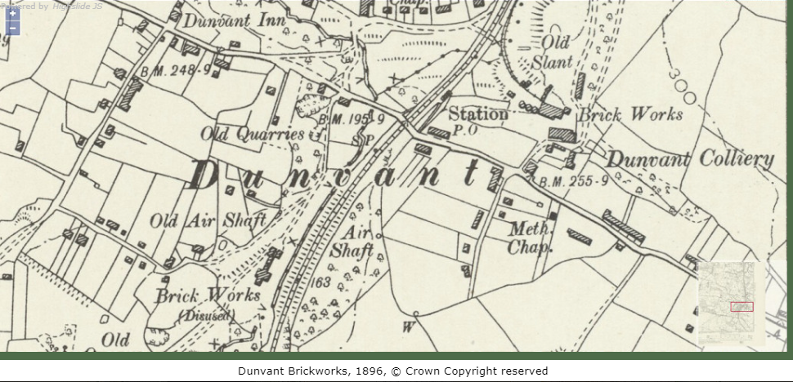
Figure 1 Historical map of dunvant (industrialgwent, n.d.)
Despite these attempts, the brickworks struggled financially and closed in the 1930s (Rees, 2000)
For decades, the Dunant Brickworks' kilns and other infrastructure deteriorated (Thomas, 2008).
The Dunant Brickworks narrative is one of ingenuity, endurance, and economic change. The Dunant Brickworks Museum preserves and educates about the company's role on Swansea's industrial history (Rees, 2000). The museum reminds us of the necessity of conserving our industrial legacy and learning from the past as we progress into the 21st century.

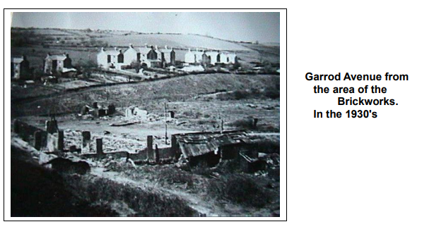
(Morgan, 1999)
These initiatives have increased cultural tourism in Swansea and diversified the local economy, decreasing dependency on conventional sectors and offering new job and investment possibilities (Thomas, 2008).
The Dunant brickworks introduced Hoffman kilns, which improved brick output nationwide (Rees, 2000).

Site Use
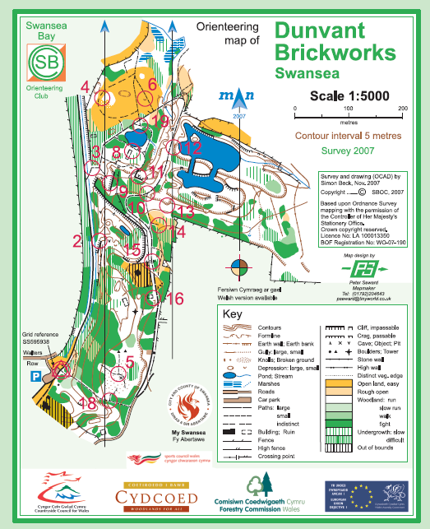
Figure 2 Survey of the area (City and County of Swansea, 1012)
The natural reserve safeguards and conserves the land. The brickworks' pond is accessible to the general public for recreational fishing purposes. Additionally, the area offers opportunities for leisurely walks, dog walking, and cycling. The prevalence of hazardous motorbike usage has increased in recent times.

The prioritisation of the welfare of the general public and the cultivation of positive relationships with community members.
Public interest and community relations: The place is well known to the general public in the region and is held in very high esteem as a resource for leisure activities like walking and horseback riding in the immediate vicinity. People from the surrounding region have shown up in droves to go on the guided walks that have been made available. Recent developments have seen the Dunvant Community Council take an interest in the growth of the brickworks. Additionally, the DCC has offered financial assistance for various access and safety measures in the past. Other prospective audiences, such as fishers and local historians, may also be interested in the topic. There is also interest from other potential audiences.
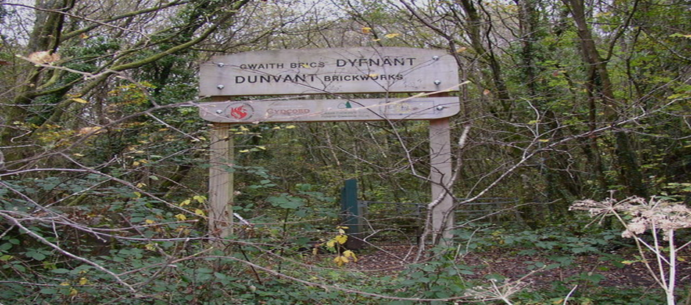
Figure 3 Entrance to Dunvant Brickworks SS 5954 9423 (Bristow, 2022)
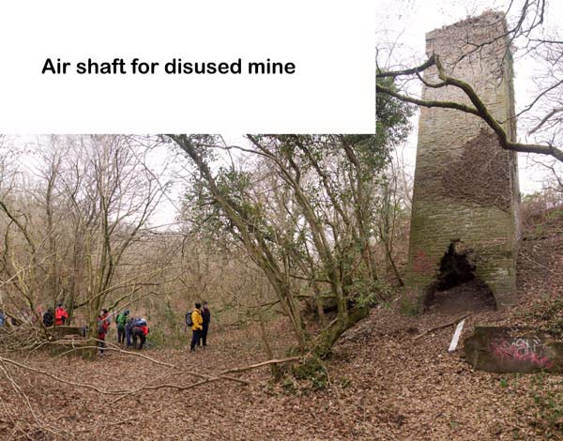
(swansearamblers, 2010)
The Visitor’s Centre is one of the uses and facilities that are targeted towards educational purposes. There is no use of the facilities for any kind of study at this moment. 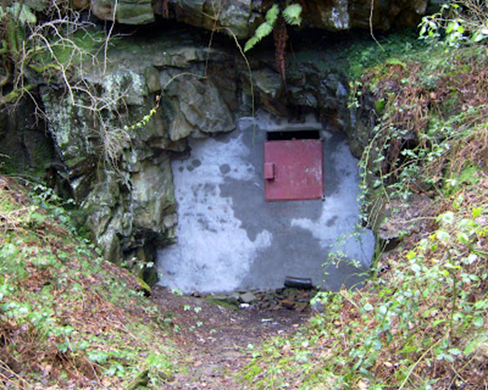
(Jones, 2008)
There are currently no facilities or uses for interpretation that are significant from an archaeological or conservation standpoint. You'll find a map that describes the bike route next to the parking lot that you can take with you. Users from the surrounding region have mentioned that the place lacks a consistent identity, such as welcome signs or information on activities that are permitted within the area, such as walking or cycling. These users have noticed that the location is lacking in these areas.
Recreational possibilities and facilities: despite the large number of people who walk on it every day, the bicycle track is in excellent condition. There is a connection between the property and Clyne Valley Country Park, which may be reached through this walk. Access to the parking lot, which is near to the bike path, may be acquired through Walter Row. The lot is not very large. The primary portion of the land has been completely encircled by a single asphalted path that is set out in a circular pattern. This walkway has a number of bridges as well as benches at various points throughout its length.
(City & County of Swansea, 2003)
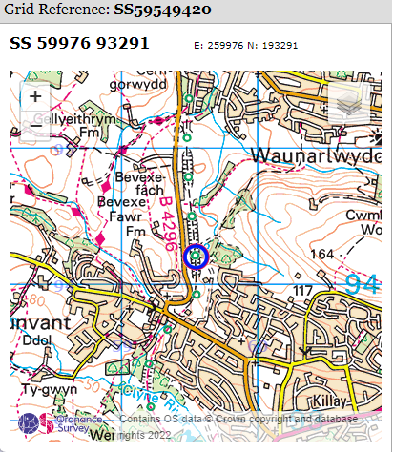
Figure 4 location on ordnance survey (geograph.org, 2023)

Ecology at Dunant brick works
For decades after the brickworks closed, nature reclaimed the land (Rees, 2000) Invertebrates, amphibians, and birds found new homes when brickwork constructions decayed Clay excavation created wetland areas and plants on the Dunant Brickworks, increasing biodiversity (Thomas, 2008).

English name | Latin name
Dragonflies | Anisoptera
damselflies | Zygoptera
newts | Pleurodelinae
frogs | Anura
Cetti's warbler | Cettia cetti
voles | Arvicolinae
shrews | Soricidae
bats | Chiroptera
European otter | Lutra lutra
common pipistrelle | Pipistrellus pipistrellus
Daubenton's bat | Myotis daubentonii
common kingfisher | Alcedo atthis
reed warbler | Acrocephalus scirpaceus
reed bunting | Emberiza schoeniclus
rare marsh fritillary butterfly | Euphydryas aurinia
southern hawker | Aeshna cyanea
signal crayfish | Pacifastacus leniusculus

(Thomas, 2008) (Rees, 2000)
English names | Latin names
Oak | Quercus
ash | Fraxinus
willow | Salix
yellow iris | Iris pseudacorus
water mint | Mentha aquatica
common reed | Phragmites australis
Japanese knotweed | Fallopia japonica
Himalayan balsam | Impatiens glandulifera

(Thomas, 2008). (Rees, 2000).
The animal variety of the Dunant Brickworks may reveal the long-term effects of industrial activity on ecosystems and the characteristics that make ecological restoration programmes successful. The site's flora and wildlife might inspire conservation plans for other industrial heritage sites, preserving cultural and ecological assets (Rees, 2000).

Riparian Habitats
The meteorological station situated at Swansea University documented the subsequent averages during the period spanning from 1961 to 1990:
The average air temperature is 10.5 degrees Celsius.
The annual precipitation in the area is 1178 millimetres.
The average daily sunlight duration is 4.14 hours.
The region exhibits a high density of forest cover, resulting in elevated levels of humidity and reduced duration of solar radiation. The steep quarry faces have led to the development of heavily shaded areas of forest and brush. These locations persistently maintain a state of darkness and moisture throughout the entirety of the annual cycle.
(City & County of Swansea, 2003)
A preliminary examination of the geological characteristics of the site was conducted in 1997. The geological formation present at the location is a sandstone that exhibits good sorting and bedding characteristics, with a northward and north-north-eastward inclination. Thin bands of shale are interspersed among the sandstone strata at the northern exit of the tunnel. The erosion process has caused the emergence of fissures in the sandstone.
The historical activities of extracting minerals from the earth have led to the formation of an essentially anthropogenic terrain, characterised by numerous excavations and elevations, alongside abrupt and uncovered rock faces. The site's most notable characteristic is the inundated dual valley, which is situated on the eastern side of the area. A high ridge that traverses the site in a north-south direction serves as a demarcation between the double valley and the quarries located in the central region of the site. The most likely explanation for the formation of this ridge is human construction, intended to facilitate access to the quarry workings from the present-day location referred to as Highland Terrace. The obstruction of water flow resulting from the collapse of a tunnel passing through the hill caused flooding in the valley.
A plethora of soil types exist, with the preponderance of them exhibiting acidic properties. Certain regions of the Earth exhibit varying degrees of moisture, while the rocks that are exposed possess minimal soil cover, if any, and contain crevices that facilitate the sustenance of select vegetation. Although no empirical investigation has been carried out on the matter, it is highly plausible that certain soils within the location have been contaminated as a result of the quarrying and brick-manufacturing activities that transpired on site.

(City & County of Swansea, 2003)

The current management plans.

Invasive Species Management
Since the mid-19th century, Swansea's Dunvant Brickworks has seen several biological changes. Invasive species have had major impacts on the site's natural flora and wildlife.
The Dunvant Brickworks had various invasive plant species throughout its existence. The invasive perennial Japanese knotweed (Fallopia japonica) was brought to the UK as an ornamental species in the 19th century. Japanese knotweed has outcompeted native flora and damaged the Dunvant Brickworks ecology (Thomas, 2008)
The Dunvant Brickworks' natural water species have suffered from the signal crayfish's ravenous appetite for invertebrates, fish, and plants (Rees, 2000)
The Dunvant Brickworks has removed Japanese knotweed and Himalayan balsam (Impatiens glandulifera) to combat invasive species (Thomas, 2008).
The site's management has reduced signal crayfish populations by trapping and habitat alteration (Rees, 2000)

Critique of management plan
The site lacks any formally demarcated compartments that are delineated by tangible features such as boundary lines. The city and county of Swansea (2003) developed an investigation management plan to enhance the execution of the plan. To achieve this, the site has been partitioned into seven distinct compartments. The determination of this phenomenon is significantly influenced by the type of habitat that exists and capitalises on the inherent features of the environment whenever possible. The cartographic representation of the compartmental divisions can be observed on the third map.
The land exhibits a "L" configuration and can be bifurcated into two sections: the western portion is oriented in an east-west direction, whereas the eastern section is aligned in a north-south direction.
The western region.
Compartment 1 comprises of communities of grassland, bracken, and scrub situated towards the western region of the cycling route.
The northern section of the site predominantly consists of grassland, forest, and scrub habitats and is partitioned into two compartments. This particular compartment exhibits smaller scale wet grassland and marsh ecosystems.
Compartment 3 is the designated area where the primary brickworks and the majority of the site are situated. The industries of quarrying and brickmaking have played a significant role in shaping the diverse topography of the region. It is mostly scrub, bracken, and forest, although there are also tiny, isolated spots with open water (the brickworks pond), bare rock, tall herb flora, and dwarf shrub heath.
The largest portion of the site's scrub and forest regions, known as Compartment 4, is situated in the southern region. Furthermore, specific locations exhibit the presence of gorse, bracken, bramble, tall vegetation, and Japanese Knotweed proliferation.
Compartment 5 is a vegetated area characterised by grass and bracken, interspersed with a limited number of dispersed trees. It is situated in close proximity to the residential dwellings situated in the eastern sector of the site.
The section located towards the east:
Compartment 6 encompasses a diminutive, steep-walled pair of valleys that have been inundated by recent floodwaters, resulting in certain areas being entirely submerged. The forest ecosystem is the dominant feature, interspersed with areas of bracken and scrub vegetation. Standing dead wood fragments can be observed within the inundated area.
Compartment 7 is situated at the furthest eastern point of the reserve and consists of areas of wet and partially improved grassland, which are encompassed by wooded, bracken, and scrubby terrain.
(City & County of Swansea, 2003)

Site Walkover & GIS Model Analysis

Generating the GIS Model
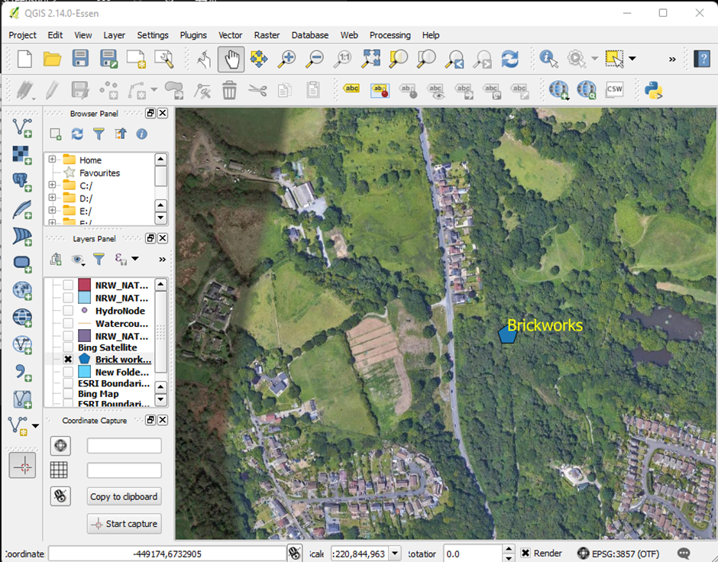
Figure 5 google satellite and point mapping to brickworks in qgis

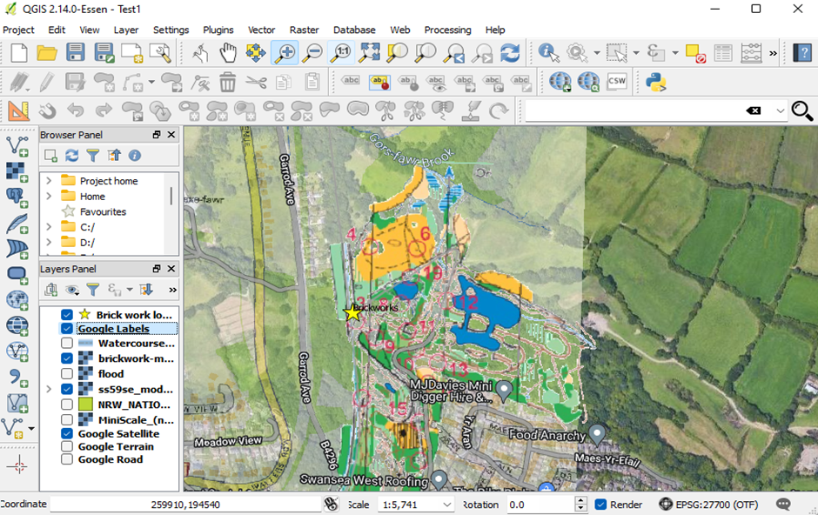
Figure 6 QGIS: Orienteering map and Ordinance Survey Street View using Geo-coding and transparency over google satellite and Point data of brick works location map trimmed and geocoded over Ordinance Survey Street View using Geo-coding and transparency over google
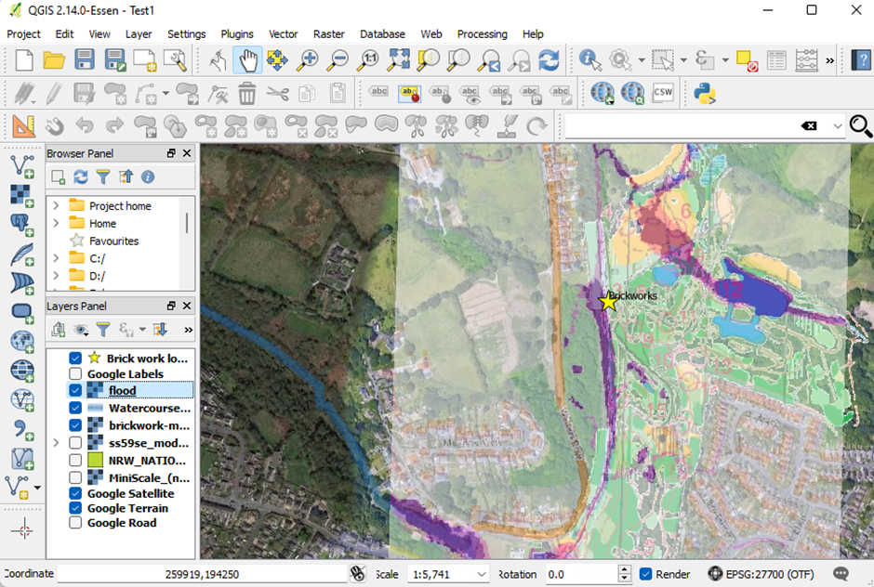
Figure 7 QGIS: Orienteering map and potential flooding from using Geo-coding and transparency over google satellite and Point data of brick works location map trimmed and geocoded over Ordinance Survey Street View using Geo-coding and transparency over google satellite and Point data of brick works location with google labels visible
(naturalresources.wales, 2022)

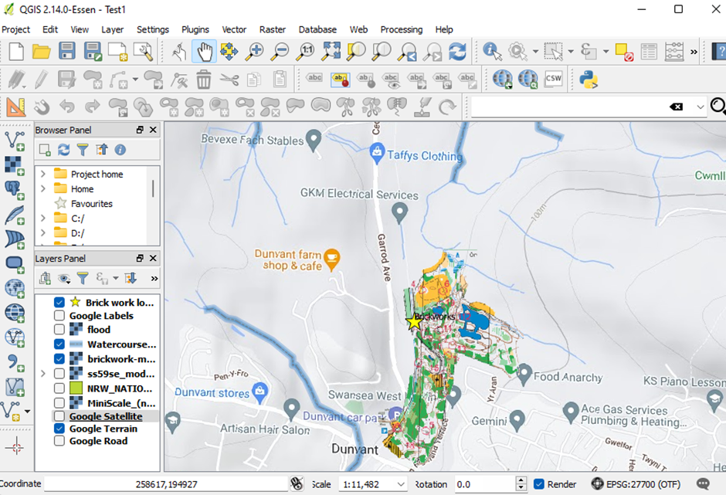
Figure 8 QGIS: Water Courses vector and geocoded orienteering raster map laid over Google Terrain and Point data of brick works location
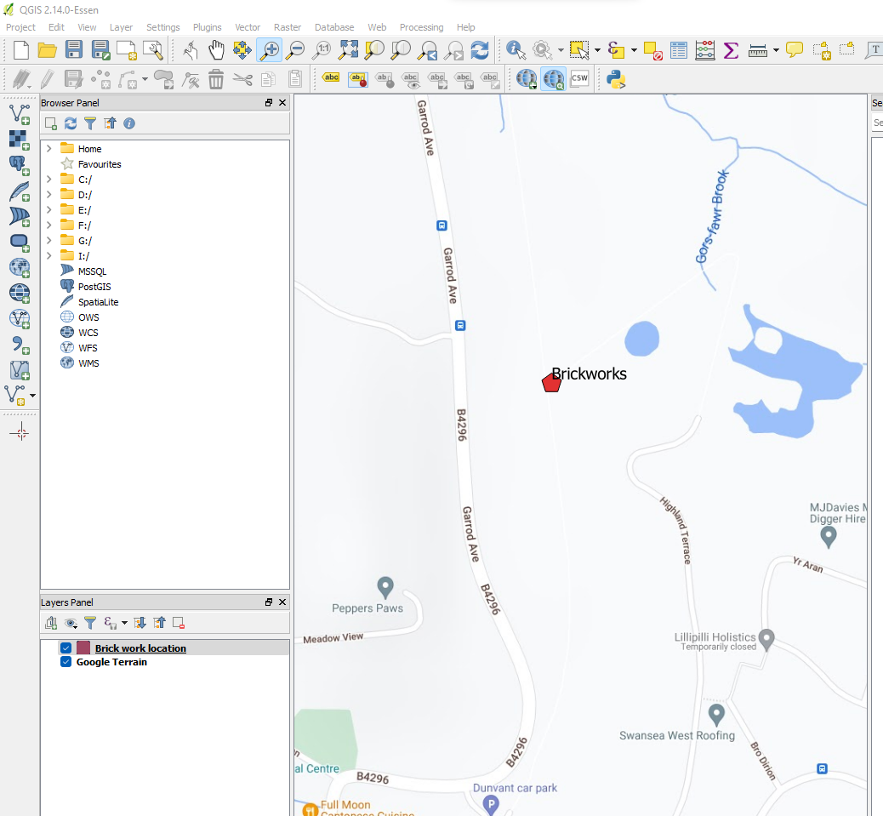
Figure 9 Bing Street map point mapping to brickworks in qgis

Creation of a riparian model using polygons based on previous layers in QGIS
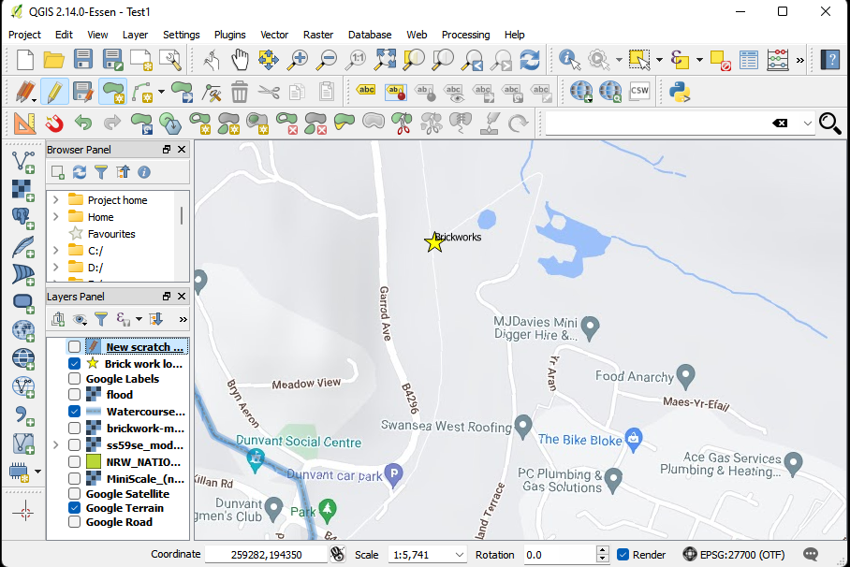
Figure 10 Terrain raster map with water courses vector map (delimited point data for brick work location on map)
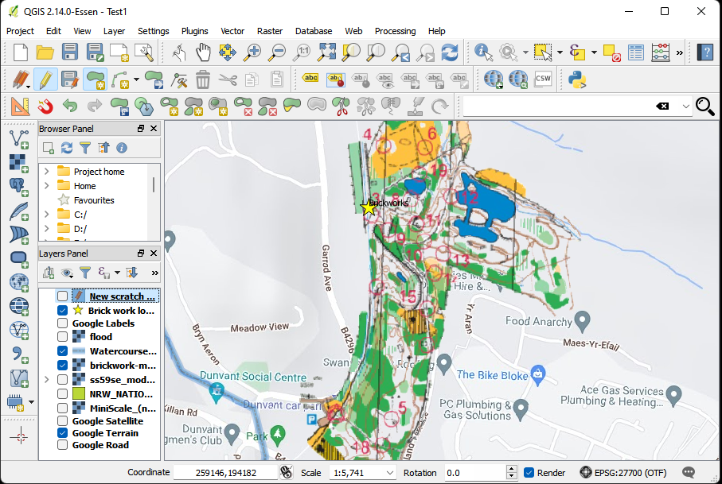
Figure 11 Terrain raster map with water courses vector map (delimited point data for brick work location on map) orienteering map of site geocoded as front layer (transparency and clipping employed)

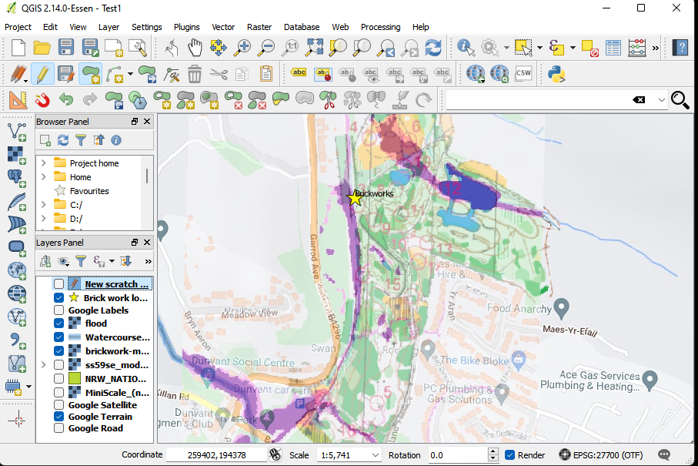
Figure 12 Terrain raster map with water courses vector map (delimited point data for brick work location on map) orienteering map of site and flood potential geocoded as front 2 layers (transparency and clipping employed)
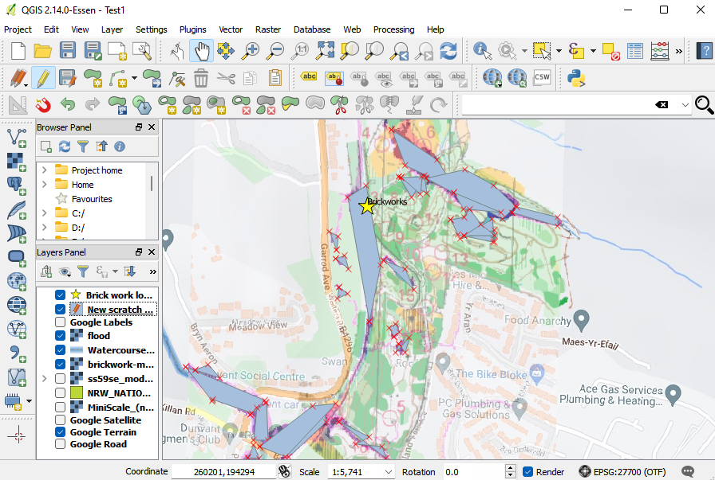
Figure 13 Terrain raster map with water courses vector map (delimited point data for brick work location on map) orienteering map of site and flood potential geocoded (transparency and clipping employed)- Polygons created to best fit of flood data as a scratch layer
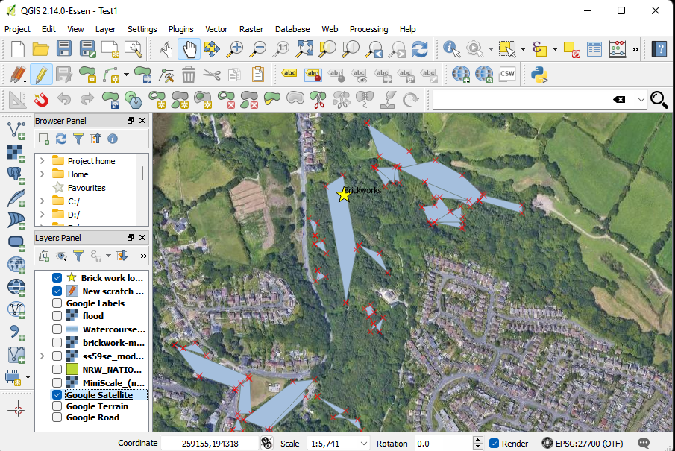
Figure 14 Finally the flood polygons and point data were plotted over the satellite imagery.

Findings From the Site Visit
Throughout the site there is evidence of a number of activities that may be detrimental to the growth and wellbeing of all plant and animal species associated with the area. Some of the key observations are as follows:
- Littering. There are multiple instances on the site where littering and fly tipping are evident both along the footpath and water ways and even deeper into the wooded areas and the abandoned buildings. numerous studies have shown the adverse effects that littering, and fly tipping have on species and their habitats. Despite this, littering and fly tipping are sometimes considered to be nothing more than a simple aesthetic problem. Because of these practises, a wide variety of environmental pollutants, such as plastics, metals, chemicals, and other types of garbage, are introduced into natural ecosystems. This has negative repercussions for the wildlife that lives in these regions. (Slavin, 2012)

- Volume of footfall. High human foot traffic may have a number of negative effects, one of the most significant of which is disruption, which can cause behavioural shifts in animals. According to, animals see people as possible predators, and as a result, they often display a "flight response" when humans approach them. This might cause animals to redirect their energy away from tasks that are more important, like as eating, mating, or caring for young. (Frid, 2002) there was evidence of biking and hiking on the site

- Pet being allowed to run free. Even if they don't hurt them directly, dogs can also cause a lot of trouble for wildlife. (Bates, 2011) found that just being around dogs can cause fear in wildlife, which can change their behaviour and possibly affect their ability to eat, reproduce, and stay alive. For example, (Lenth, 2008) did a study in a Canadian national park and found that wild animals were more likely to run away when dogs were not on leashes. This caused the animals to use more energy and could have stopped them from eating or mating.

- Vandalism. Vandalism can destroy habitats, which hurts wildlife in a direct way. Some examples of theft that causes this kind of damage are writing on rocks and trees and illegally building or destroying infrastructure in nature areas. Wildlife can lose places to live and eat because of this damage, which can cause populations to drop and species to move (Gill, 1992)

- Flooding risks. Even though flooding is a normal part of many environments, it can have big effects on wildlife, especially as climate change makes flooding more common and worse (iPCC, 2014). Flooding has many different effects on wildlife. Some species die directly because of flooding, while other species are affected indirectly by changes in habitat and food supply (Scott, 2016)

- Water pollution. Water contamination from old industrial sites, such as works buildings and mines, can have significant impacts on aquatic and terrestrial wildlife. One common contaminant associated with these sites is iron oxide, a byproduct of mining operations. Iron oxide can leach into water bodies and soil, causing acidification and other harmful changes to the environment (Johnson, 2005) there is evidence of water pollution on the site

- Dangerous or unstable buildings Abandoned buildings pose a pollution risk. Asbestos, lead, and other toxic compounds from old industrial buildings may seep into the environment and harm animals (Beyer, 1994). Lead and asbestos may damage wildlife's respiratory and neurological systems (Rattner, 2008)

Potential Flood Risks?
The Dunvant family operated the brickworks at the site, employing flood mitigation measures to mitigate commercial consequences (Thomas, 2008) .These efforts included riverside embankments and drainage systems to remove excess water (Rees, 2000) .
These efforts included restoring the old embankments and drainage systems and adding contemporary flood prevention technologies like permeable surfaces and SUDS (Rees, 2000).
In conclusion, the Dunvant Brickworks in Swansea, Wales, has been plagued by floods and related concerns since its founding. The site's operating and conservation and rebuilding phases have included flood prevention and adaptations (Thomas, 2008). Modern flood protection technology and extensive flood monitoring and response strategies have considerably decreased the danger of flooding at the site, protecting its ancient buildings and rich wetland ecosystems (Rees, 2000).
The Dunvant Brickworks in Swansea, Wales, is a good example of industrial historic site floods and dangers. The site's experiences and adaptations may help control flooding threats in comparable situations, emphasising the necessity for proactive planning and adaptive management to safeguard cultural and natural resources (Thomas, 2008).
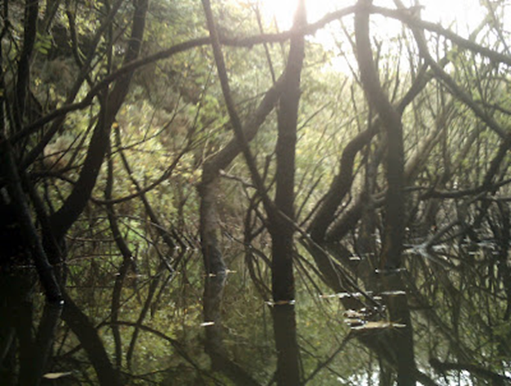
(Jones, 2008)

The velocity of water flow is a significant factor to take into account. The alteration of water movement across the area has occurred due to the disturbance caused during the operation of the brick manufacturing facility. The salient characteristic of the area under consideration is the inundated valley, accessible from the eastern direction, and fed by a rapidly flowing watercourse that is confined by a profound ravine that has been eroded. This landmark was formed as a consequence of a tunnel collapse. Subsequently, the valley floor became submerged in water. The water leakage is causing a gradual decrease in moisture levels within the valley. (City & County of Swansea, 2003)
The pond at the brickworks is primarily filled by rainwater that accumulates on the uncovered rock surfaces of historic quarry faces. The cycling track is flanked by ditches on either side, which are hypothesised to have functioned as drainage channels during the period when the track was utilised as a railway line. The occurrence of flooding in the area is attributed to the presence of a creek that traverses the northern section of the premises.
(City & County of Swansea, 2003)

Recommendations/ propose management plan

The sample plan that was investigated (City & County of Swansea, 2003) was found to be largely out of date (2003) and did not consider more recent developments on the site such as the visitors centre, voluntary involvement, or current EU, UK, Welsh legislation and incentives. As a result, this report puts forward the following strategic plan to cover current too long term, focuses for the site working forward

General Information
Land Tenure: The land is owned by Swansea Council and is managed as a wildlife habitat and public recreational area (Swansea council, 2018)
Management Infrastructure: The site is overseen by Swansea Council's Parks and Green Spaces department, with support from local volunteer groups.
Map Coverage: Maps of the site and its various habitats are available through Ordnance Survey and other public resources.
Photographic Coverage: Various photographic records of the site, including aerial and ground-level images, are held by Swansea Council and local wildlife groups.

Environmental Management Plan: Policy Statement

Current Policies for Swansea Council, Wales, and the UK
The management of Dunvant Brickworks aligns with several environmental policies at the local (Swansea Council), national (Wales), and UK-wide levels. These include the Swansea Council's Local Biodiversity Action Plan (Swansea council, 2018), which prioritises local biodiversity conservation, including at sites such as Dunvant Brickworks.
At the national level, the site's management adheres to the 'Woodlands for Wales Strategy' (Swansea council, 2018), and the Environment (Wales) Act 2016 (Welsh Goverment , 2016), which promote sustainable land management and biodiversity conservation. The site also aligns with the Well-being of Future Generations (Wales) Act 2015 (Welsh Goverment, 2015), which emphasises sustainable development and the importance of a biodiverse natural environment for well-being.
At the UK level, the Wildlife and Countryside Act 1981 (HM Goverment , 1981) and the UK Biodiversity Action Plan (Joint Nature Conservation Committee, 2007) guide the site's management, focusing on the protection of wildlife and habitats. public input on a draught, Planning Committee accepted the SPG on February 22, 2021. The webpage has the public consultation report detailing the SPG's adoption process. Step-by-step biodiversity planning Proposals should follow the SPG's Stepwise Approach. The stepwise method helps applicants consider biodiversity throughout the development management process. It shows that initiatives have reacted to a solid ecological knowledge of a site and will offer appropriate ecological mitigation, compensation, enhancement, and aftercare. Ecological Surveys and Assessments: SPG Appendix 1 gives thorough recommendations on the species, habitats, and sites likely to influence a number of kinds, sizes, and locations of Swansea development proposals, including guidance on (swansea.gov.uk, 2023).
Terrestrial Protected and Priority Species Surveys Checklist
Seasons S7 Marine/Coastal/Estuarine Species and Habitats Checklist
Legal and Policy Framework for Swansea Biodiversity Sites and Species Protection and Major, Minor, and Other Developments the SPG requires applicants to submit biodiversity and ecosystem resilience measures commensurate to the development's size.
The Council's Nature Conservation Team advises the Development Management Team on biodiversity issues in planning applications (swansea.gov.uk, 2023).
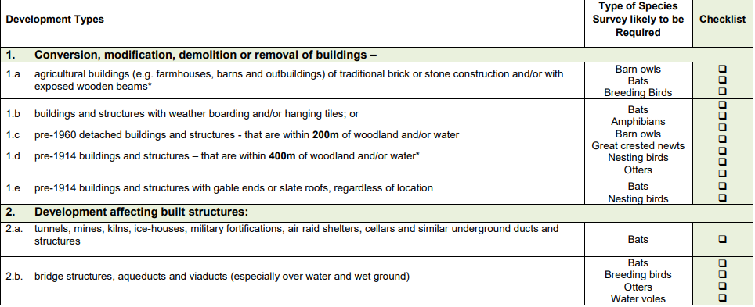
Figure 15: Checklist for Protected/Priority Species Surveys likely to be required for terrestrial development sites (swansea.gov.uk, 2023)
The Authority confirms its commitment to:
- Request authority and resources from the UK and Welsh governments to make Swansea Council net neutral by 2030.
- Publicise climate emergency and raise local knowledge of climate change to reach a countywide net zero goal by 2050.
- Review our climate change strategy with research and development professionals.
- Identify any other climate emergency policy adjustments or measures we can take within our capabilities and resources.
- Seek the aid of local partners like Swansea University and other research organisations to provide a report for the community within a year, detailing current activities and future goals.
- The Council Annual Review of Performance Report section on corporate purpose - Maintaining and developing Swansea's natural resources and biodiversity - updates this effort.
- 'Go Faster, Go Further' was the Council's March 2021 citizen survey's main takeaway.
- 2021 climate survey findings
- Climate change worried 93% of 967 respondents.
- Climate change worried 66% of 396 Twitter users.
- Restoring Nature
November 2021 marked Swansea Council's Nature Emergency. The Swansea wildlife Partnership is creating a Swansea Nature Recovery Action Plan to reverse the loss of wildlife in the City and County of Swansea and boost ecosystem resilience. By 2030, Swansea should be nature positive, meaning nature is recovering. Swansea's nature should be recovered, appreciated, repaired, sustainably maintained, and sensibly exploited by 2050 (swansea.gov.uk, 2023).

Long-term Management Policy
The long-term management policy for Dunvant Brickworks is to maintain and enhance its wildlife habitats, protect, and promote its biodiversity, and ensure its sustainable use for public enjoyment, education, interpretation, and research. This approach is consistent with the 'Making Space for Nature' report (Lawton., 2010), which advocates for more, bigger, better and joined spaces for nature.
The policy will involve adaptive management, responding to changes in ecological conditions, site use patterns, and evolving best practices in nature conservation and public engagement. This approach ensures that the site continues to deliver its multiple benefits in the long term, in accordance with relevant policies and standards.

Environmental Management Plan: Confirmation of Features

Evaluation for Nature Conservation
The Dunvant Brickworks wildlife habitat is a critical refuge for local biodiversity, supporting various habitats like woodland, semi-improved grassland, open water, and Bullrush and Hemlock Water-dropwort swamp. These habitats house numerous species, including several protected species under the UK Protected Species legislation (HM Goverment , 1981) and the Section 7 list of the Environment (Wales) Act 2016 (Welsh Goverment , 2016). The site's contribution to local biodiversity aligns with the national commitment to halt the loss of biodiversity, as articulated in the UK Biodiversity Action Plan (Joint Nature Conservation Committee, 2007).

Evaluation for Public, Educational, Interpretative, and Research Use
The Dunvant Brickworks wildlife habitat also has significant value for public enjoyment, education, interpretation, and research. The site offers opportunities for public access in line with the Countryside and Rights of Way Act 2000 (HM Goverment, 2000), and the Well-being of Future Generations (Wales) Act 2015 (Welsh Goverment, 2015). The site also provides a valuable outdoor 'classroom' for environmental education and a research platform for ecological studies, supporting the Welsh Government's aspiration for a knowledgeable and informed society as outlined in the 'Valued and Resilient' strategy (Welsh Goverment , 2017).

Summary of Important Features
The Dunvant Brickworks wildlife habitat is a valuable asset for both nature conservation and societal engagement. Its diverse habitats and species contribute significantly to local biodiversity, while the opportunities it offers for public enjoyment, education, interpretation, and research contribute to societal well-being, knowledge and understanding. The site's management plan should therefore aim to conserve and enhance these important features, in accordance with relevant UK and Welsh policies and strategies.

Environmental Management Plan: Factors that Influence Features and Management

Internal and Natural Factors
The natural features of the Dunvant Brickworks wildlife habitat, such as topography, soil type, and hydrology, significantly influence its ecological characteristics and management. The habitat types supported on the site and their associated species are directly influenced by these factors. Climate patterns also play a vital role, with changes in temperature, rainfall, and extreme weather events affecting species distribution, breeding, and survival as highlighted in the UK Climate Change Risk Assessment (HM goverment , 2017)

External and Human Factors
External influences such as surrounding land use, pollution, and human activity significantly impact the site. Noise, litter, and disturbance from visitors could impact wildlife, while agricultural runoff from nearby lands could affect water quality, as outlined in the Water Framework Directive (European Union , 2000). Invasion by non-native species such as Japanese Knotweed, often facilitated by human activity, can also alter habitats, and threaten native species (HM Goverment, 2015)

Legal and Operational Factors
The management of Dunvant Brickworks is also influenced by various legal and operational factors. These include legislation related to wildlife protection (HM Goverment , 1981), habitat conservation (Environment (Wales) Act, (Welsh Goverment , 2016) and public access (HM Goverment, 2000). Operational factors include budget constraints, staff availability, and technical expertise.

Enhancement of Habitats for Protected Species
Management practices are geared towards enhancing habitats for protected species, which are shaped by the aforementioned factors. Legal requirements under the UK Protected Species legislation (HM Goverment , 1981) and the Environment (Wales) Act 2016 (Welsh Goverment , 2016) necessitate certain management practices. Natural factors such as habitat conditions, and external factors like human disturbance, also influence the effectiveness of these habitat enhancement measures.

Summary of Factors
The management of Dunvant Brickworks is influenced by a complex interplay of internal and external factors, as well as legal and operational considerations. Understanding these factors and their interactions is crucial for effective management, ensuring that the site continues to provide high-quality habitats for wildlife and valuable recreational and educational opportunities for the public.

Environmental Management Plan: Objectives, Limits and Monitoring

The following objectives have been formulated based on observations of the site and draw from recent policies and legislation as the author believes that the previous 2003 management plan is now dated and does not consider modern political activities or funding opportunities
The Invasive Alien Species (Enforcement and Permitting) Order 2019 took effect on December 1, 2019. The text introduces provisions, offences, and penalties for complying with EU Regulation (1143/2014) on invasive alien species. The provisions apply to 66 species called 'species of Union concern'. NRW and the police can enforce criminal penalties in Wales for violating the Order. NRW can impose civil sanctions as the regulator. Licences can be issued under the Order to permit prohibited activities under the EU Regulation. The activities require a licence to be carried out. Natural Resources Wales is the licencing body in Wales. Licences will be issued in England by Natural England (walesbiodiversitypartnership, 2020).
When managing an invasive species, considering three key points is crucial. Characteristics of the chosen invasive species include its life cycle and dispersal methods. What are the characteristics of the chosen invasive species? Who lives nearby? Who would be interested in their activities? Which community stakeholders could support the user's work? Pathway Action Plans (PAPs) aim to prevent or control introduction pathways by raising public awareness, implementing border control, and minimising contamination(Jessica. F. Minett., 2023).

Woodland and scrub
Objective: Enhance the biodiversity value of woodland and scrub habitat, promoting native tree species and controlling invasive species in line with the UK Forestry Standard (Forestry Commission , 2017) and the Welsh Government's Woodlands for Wales Strategy (Welsh Goverment , 2018).
Limits: A minimum of 60% native tree cover in woodland, while ensuring invasive species don't exceed 5% of the total tree cover.
Monitoring: Conduct annual surveys to assess tree species composition, invasive species, and overall health of woodland and scrub habitat.
Rough grassland. The goal is to decrease bracken's vigour, as it can suffocate other plants if not controlled. Without management, grass growth would decline, impacting grassland species like Field Voles.
The technique is simple. Using an old broom handle, the user bruises the base of the bracken stem to fold it over. The sap exuded by the rhizome weakens the plant. The following year, bracken growth is less vigorous, allowing competition from other flora. Without bashing the bracken with broomsticks, an alternative control method would need to be adopted. Alternative methods are available. Cutting destroys all growth. Some areas require biannual cuts over multiple years for any noticeable impact. Wildlife is impacted. Non-selective topping. The stems and undergrowth remain unaffected, except for the bracken fronds which are cut, potentially impacting wildlife. Crushing is done with a heavy roller. Wildlife is impacted. Natural England recommends two herbicide treatments for bracken: asulam and glyphosate. Glyphosate is a systemic herbicide that kills other plants. Now considered carcinogenic. Asulam kills bracken and other ferns as a broad spectrum systemic selective herbicide. Some have concerns about its potential carcinogenicity.
Land bracken bashing is being managed.
Ploughing reduces bracken areas by exposing the rhizome between late June and early August. Ploughing releases carbon and depletes soil organic matter, harming wildlife. Follow-up management may be necessary using another method.
They prefer manually bashing bracken on-site as it is the least impactful method on wildlife. They don't control all the bracken everywhere because they acknowledge that bracken can be beneficial for a few species. Maximising diversity in a site can be achieved by tolerating an appropriate amount of bracken cover (The Barn Owl Trust, 2021).

Semi-improved grassland
Objective: Maintain and enhance the biodiversity value of semi-improved grassland, ensuring habitat supports diverse flora and fauna per the UK Biodiversity Action Plan (Joint Nature Conservation Committee, 2007)
Limits: A minimum of 80% native plant species cover in the grassland area, with restricted use of agrochemicals to prevent nutrient enrichment.
Monitoring: Biannual surveys to assess plant species composition, presence of indicator species, and overall grassland health.

Japanese knotweed
Objective: Prevent the spread of Japanese knotweed (Fallopia japonica) and support eradication, per the Wildlife and Countryside Act 1981 (HM Goverment , 1981)and the Environment (Wales) Act 2016 (Welsh Goverment , 2016)
Limits: No presence of Japanese knotweed within the site.
Monitoring: Regular site inspections to identify and record Japanese knotweed occurrences and implement control measures.
Japanese knotweed control.
Japanese knotweed is notoriously hard to eradicate as even small plant fragments can regrow into new plants.
Frequently asked questions about controlling Japanese knotweed for the site plan.
They provide a treatment service for landowners to control Japanese knotweed spread. After spraying the knotweed, what happens next?
The knotweed should die back around 14 days after treatment. Brown leaves and wilting are symptoms.
Can children/pets still play in the garden?
Animals and children should stay away from the treated area for 24 hours. Once the chemical dries on the plant, it is considered safe, typically within an hour as advised by the manufacturer. (swansea.gov.uk, 2023) (swansea.gov.uk, 2023)
Any treatment health risks?
The product is not dangerous.
If the treatment area is near the pond.
The product is safe around waterways. They will provide on-site advice if needed.
If knotweed isn't affected by spraying, what happens?
They will investigate, check, and re-treat if necessary.
How frequently should it be sprayed for effectiveness?
Treatment duration varies depending on the site, ranging from 1 treatment to a 5-year programme. A single spray won't eliminate the knotweed, but it will help manage it. Annual treatment over several years can help control the condition and potentially enable self-treatment (swansea.gov.uk, 2023) (swansea.gov.uk, 2023)
Cutting and digging are ineffective against established Japanese knotweed and take years to show results. Cutting and digging are ineffective for controlling Japanese knotweed and take years to show results. Japanese knotweed is controlled with herbicide. Glyphosate-based herbicides treat Japanese knotweed. Glyphosate can be eradicated with proper application and timing, but it may require two to three years of repeated treatment.

Professional glyphosate products are necessary as garden centre glyphosate products have limited effectiveness. Only qualified individuals with the required National Proficiency Test Council certificates of competence can use professional herbicide products. Local or industry body can help find qualified operators. The best way to control Japanese knotweed is by using a suitable herbicide (Natural resources Wales, 2023).

Bullrush and Hemlock Water-dropwort swamp
Objective: Maintain the biodiversity value of the Bullrush (Typha spp.) and Hemlock Water-dropwort (Oenanthe crocata) swamp habitat in accordance with the Water Framework Directive (European Union, 2000) and the River Basin Management Plans for Wales (Natural Reasource wales, 2015)
Limits: No significant alterations to the hydrological regime or water quality impacting the swamp habitat and associated species.
Monitoring: Annual surveys to assess the swamp habitat health and extent, and monitor water quality parameters such as pH, dissolved oxygen, and nutrient levels.

Enhancement of habitats for protected species
Objective: Enhance habitats to support protected species, following guidelines from the UK Protected Species legislation (HM Goverment , 1981) and the Section 7 list of the Environment (Wales) Act 2016 (Welsh Goverment , 2016)
Limits: No significant habitat alteration negatively impacting the presence and breeding success of protected species.
Monitoring: Regular surveys to monitor the presence and breeding success of protected species.

Open water
Objective: Maintain the ecological and recreational value of open water habitat, supporting aquatic species and public enjoyment, per the Water Framework Directive (European Union , 2000) and the Welsh National Parks and Access to the Countryside Act 1949 (HM Goverment , 1949)
Limits: No significant alterations to the hydrological regime or water quality impacting the open water habitat and associated species.
Monitoring: Regular water quality testing, and biannual surveys to assess the presence and abundance of aquatic species.

Public access
Objective: Provide safe, responsible, and sustainable public access, fostering wildlife habitat appreciation and understanding, per the Countryside and Rights of Way Act 2000 (HM Goverment, 2000) and the Well-being of Future Generations (Wales) Act 2015 (Welsh Goverment, 2015)
Limits: No adverse impacts on habitats, wildlife, or visitors due to public access.
Monitoring: Regular inspection and maintenance of access routes, signage, and visitor facilities, and
Monitoring: Regular inspection and maintenance of access routes, signage, and visitor facilities, and monitoring of visitor numbers and potential impacts on wildlife habitat.

Enhancement of Habitats for Protected Species
management practices are geared towards enhancing habitats for protected species, which are shaped by the aforementioned factors. Legal requirements under the UK Protected Species legislation (HM Goverment , 1981) and the Environment (Wales) Act 2016 (Welsh Goverment , 2016) necessitate certain management practices. Natural factors such as habitat conditions, and external factors like human disturbance, also influence the effectiveness of these habitat enhancement measures.

Interpretation
Objective: Provide informative, engaging, and accessible interpretation materials, enhancing visitor understanding and appreciation of the site's biodiversity and conservation significance, the Welsh Government's strategy for 'Valued and Resilient' landscapes (Welsh Goverment , 2017).
Limits: All interpretation materials must be accurate, up-to-date, and respectful of the site's wildlife and habitats.
Monitoring: Regularly review and update interpretation materials based on visitor feedback, new research findings, and changes in site conditions or management practices. Conduct visitor surveys to assess interpretation's effectiveness in enhancing understanding and appreciation of site biodiversity and conservation significance.

Conclusion

The abandoned Dunvant Brickworks wildlife habitat's environmental plan balances biodiversity conservation, flood and invasive species management, and public pleasure. (Swansea Council, 2018) (Welsh Goverment , 2016) (HM Goverment , 1981)
QGIS is essential to this method. GIS lets us map and analyse the site's physical and biological aspects in depth. Raster and vector data can visualise continuous phenomena like soil type or elevation and discrete characteristics like ecosystems or pathways (Heywood, 2011)Vector data maps individual trees, streams, and forest areas using point, line, and polygon representations.
Spatial data aids decision-making. Detailed habitat maps may help protect endangered species by identifying appropriate habitat and habitat building or connectivity possibilities. Mapping Japanese knotweed infestations and transmission patterns may help management efforts.
Map topography, soil type, rainfall patterns, infrastructure, and access routes to estimate flooding risk, which is increased by climate change (HM goverment , 2017) . This knowledge may help increase resilience by creating natural flood storage areas or adjusting access routes.
The site's human influence must be balanced. GIS can track public usage and its possible implications on animals and environments. This may influence zoning, trail and facility design, and public education.
The technique is simple. Using an old broom handle, the user bruises the base of the bracken stem to fold it over. The sap exuded by the rhizome weakens the plant. The following year, bracken growth is less vigorous, allowing competition from other flora. Without bashing the bracken with broomsticks (The Barn Owl Trust, 2021).
Site advice:
- Promote nature and biodiversity within and outside.
- Recognise the advantages of "nature-based" preventative efforts to reduce air pollution and flood risk.
- Train for the new priorities.
- Insert a biodiversity provision into land use and management service level agreements, licences, etc.
- Plant local wildflowers and trees. Non-native species help pollinators less.
- engage the council to distribute natural environment and biodiversity expenses among services
- use the techniques as stated in the management plan on how to manage invasive species such as Japanese knotweed and the control of bracken

References
Bates, A. J., 2011. Changing Bee and Hoverfly Pollinator Assemblages along an Urban-Rural Gradient. PloS one, 6(8).
Beyer, W. N. C. E. E. &. G. S., 1994. Estimates of soil ingestion by wildlife. The Journal of wildlife management,, pp. 375-382..
Bristow, J., 2022. Entrance to Dunvant Brickworks SS 5954 9423. [Art] (Geograph.org).
City & County of Swansea, 2003. Dunvant Brickworks Management Plan, Swansea: Swansea.
City and County of Swansea, 1012. Map of Dunvant Brickworks orienteering course. [Online]
Available at: https://issuu.com/swansea/docs/dunvant-brickworks
[Accessed 1 May 2023].
European Union , 2000. Water Framework Directive. EU., s.l.: European Union .
Forestry Commission , 2017. The UK Forestry Standard, s.l.: FC.
Frid, A. &. D. L., 2002. Human-caused disturbance stimuli as a form of predation risk. Conservation Ecology, 6(1).
geograph.org, 2023. Grid refrence SS 59535 94215 E: 259535 N: 194215. [Online]
Available at: https://www.geograph.org.uk/showmap.php?gridref=SS59549420
[Accessed 1 May 2023].
Gill, D. M., 1992. Ecosystem management and the conservation of natural resources. The Environmental Professional, 14(4), pp. 297-302.
Heywood, I. C. S. &. C. S., 2011. An Introduction to Geographical Information Systems. s.l.:Pearson.
HM Goverment , 1949. National parks and access to counrtyside act, s.l.: HM Goverment .
HM Goverment , 1981. Wildlife and countryside act , s.l.: HM Goverment.
HM goverment , 2017. UK Climate Change Risk Assessment, s.l.: HM goverment .
HM Goverment, 2000. Countryside and rights of way act, s.l.: HM Goverment.
HM Goverment, 2015. GB Invasive Non-native Species Strategy, s.l.: HM Goverment.
industrialgwent, n.d. The brinkworks of west glamorgan. [Online]
Available at: http://www.industrialgwent.co.uk/g41-westglam/index.htm
[Accessed 6 May 2023].
iPCC, 2014. Climate Change 2014: Synthesis Report, Geneva: IPCC.
Johnson, D. B. &. H. K. B., 2005. Acid mine drainage remediation options: a review. Science of the Total Environment, 338(1-2), pp. 3-14.
Joint Nature Conservation Committee, 2007. UK Biodiversety , s.l.: JNCC.
Jones, D., 2008. [Art].
Lawton., e. a., 2010. Making Space for Nature: A Review of England's Wildlife Sites and Ecological Network, s.l.: DEFRA.
Lenth, B. E. K. R. L. &. B. M. E., 2008. The effects of dogs on wildlife communities. Natural Areas Journal, 28(3), pp. 218-227.
Morgan, D., 1999. The Story of Dunvant A village/suburb of Swansea. Swansea: s.n.
Natural Reasource wales, 2015. River Basin Management Plans for Wales, s.l.: NRW.
naturalresources.wales, 2022. Flood map for planning. [Online]
Available at: https://flood-map-for-planning.naturalresources.wales/
[Accessed 11 May 2023].
Rattner, B. A. H. D. J. M. C. M. &. M. P. C., 2008. Injury and mortality of wildlife from the Exxon Valdez oil spill.. In Animals and oil spills, pp. 25-48.
Rees, H., 2000. The Decline of the Dunvant Brickworks: The Impact of Market Forces on a Family Business. Business History, 42(2), pp. 95-111.
Scott, D. C. E. D. M. a. L. T., 2016. Amphibian lipid levels at metamorphosis correlate to post-metamorphic terrestrial survival. Oecologia, 182(3), pp. 773-783.
Slavin, C. G. A. &. C. M. L., 2012. Linking social drivers of marine debris with actual marine debris on beaches. Marine pollution bulletin, 64(8), pp. 1580-1588.
Swansea council, 2018. Local Biodiversity, Swansea: Swansea council.
Swansea Council, 2018. Local Biodiversity Action Plan, Swansea: SC.
swansearamblers, 2010. Swansea Ramblers Walk. [Online]
Available at: http://www.swansearamblers.org.uk/Led_Walks_Pages/2010/2010_12_02/2010_12_02-hendrefoilan-SWANSEA-WALK.php
[Accessed 11 May 2023].
Thomas, A., 2008. Philanthropy and the Dunvant Family: A Legacy of Industrial Swansea. Welsh History Journal, 25(3), pp. 79-98.
Welsh Goverment , 2016. Environment , s.l.: Welsh Goverment .
Welsh Goverment , 2017. Valued and Resilient: The Welsh Government’s Priorities for Areas of Outstanding Natural Beauty and National Parks., s.l.: Welsh Goverment .
Welsh Goverment , 2018. Woodlands for Wales Strategy, s.l.: Welsh Gov.
Welsh Goverment, 2015. Well-being of future generations, s.l.: Welsh Goverment.

Appendices

Appendix 1a

- Odonata
Southern Hawker Aeshna cyanea
Common Darter Sympetrum striolatum
Broad-bodied Chaser Libellula depressa
Keeled Skimmer Orthetrum coerulescens
Emerald Damselfly Lestes sponsa
Blue-tailed Damselfly Ischnura elegans
Common Blue damselfly Enallagma cyathigrerum
Azure Damselfly Coenagrion puella
Golden-ringed Dragonfly Cordulegaster boltonii
Large Red Damselfly Pyrrhosoma nymphula

- Lepidoptera
Red Admiral Vanessa atalanta
Peacock Inachis io
Small Tortoiseshell Aglais urticae
Ringlet Aphantopus hyperantus
Speckled Wood Pararge aegeria
Gatekeeper Pyronia tithonus
Meadow Brown Maniola jurtina
Small Copper Lycaena phlaeas
Common Blue Polymatus icarus
Large Skipper Ochlodes venata
Small Skipper Thymelicus sylvestris
Green-veined White Pieris napi
Clouded Yellow Colias croceus
The Brimstone Gonepterys rhamni rhamni
Large White Pieris brassicae

Large Elephant Hawk Moth Dieleohila elpenor, caterpillar feeding on rosebay willowherb.
Common Wave Cabera exanthmata
Brown China mark Elophila nymphaeata
Silver-Y Autograpa gamma
Brown Silver-line Petrophora chlorosata – feeds on bracken

- Hemiptera
Lesser water boatman Corixa puncata
Common back swimmer Notonecta glauca

- Coleoptera
Dytiscus spp larva.

- Fish
Three-spined stickleback Gasterosteus aculeatus
A man fishing said that the following fish were caught here, with roach becoming dominant:
Perch Perca fluviatilis
Tench Tinca tinca
Roach Rutilis rutilis
Common eel

- Amphibians
Palmate newt Triturus helveticus
Common toad Bufo bufo

- Reptiles
Grass snake Natrix natrix
Slow worm Anguis fragilis

- Birds
Kingfisher Alcedo athis

- Breeding Bird Survey by Gwyn Roberts 1997
List of birds, in Voose order, 1997.
* Breeding 1997 (+ Number of terretories for each breeding species, 1997).

Ardea cinerea Grey Heron
Tadorna tadorna Shelduck
Anas platyrhynchos Mallard * (2)
Accipiter nisus Sparrowhawk
Buteo buteo Buzzard
Gallinula chloropus Moorhen * (2)
Columba palumbus Woodpigeon * (3)
Streptopelia decaocto Collard Dove
Apus apus Swift
Picus viridis Green Woodpecker * (1)
Hirundo rustica Swallow
Delichon urbica House Martin
Motacilla alba yarrellii Pied Wagtail
Troglodytes troglodytes Wren * (6)
Prunella modularis Dunnock * (3)
Locustella naevia Grasshopper Warbler
Sylvia borin Garden Warbler * (4)
Sylvia atricapilla Blackcap * (11)
Sylvia communis Whitethroat * (13)
Phylloscopus trochilus Willow Warbler * (16)
Phylloscopus collybita Chiffchaff * (10)
Regulus regulus Goldcrest
Erithacus rubecula Robin * (9)
Turdus merula Blackbird * (12)
Turdus philomelos Song Thrush * (4)
Turdus viscivorus Mistle Thrush * (1)
Parus caeruleus Blue Tit * (5)
Parus major Great Tit * (6)
Sitta europae Nuthatch * (1)
Fringilla coelebs Chaffinch * (8)
Carduelis chloris Greenfinch * (5)
Carduelis spinus Siskin
Carduelis carduelis Goldfinch
Acanthis cannbina Linnet
Pyrrhula pyrrhula Bullfinch * (2)
Passer domesticus House Sparrow
Sturnus vulgaris Starling
Garrulus glandarius Jay
Pica pica Magpie * (3)
Corvus monedula Jackdaw
Corvus corone corone Carrion Crow * (1)

- Botanical Survey Data - Richard Pryce

Acer pseudoplatanus Sycamore
Achillea millefolium Yarrow
Achillea ptarmica Sneezewort
Agrimonia eupatoria Agrimony
Agrostis capillaris Common Bent
Agrostis stolonifera Creeping Bent
Aira caryophyllea Silver Hair-grass
Aira praecox Early Hair-grass
Alliaria petiolata Garlic Mustard
Alnus glutinosa Alder
Angelica sylvestris Wild Angelica
Anthoxanthum oderatum Sweet Vernal-grass
Apium nodiflorum Fool’s Water-cress
Asplenium trichomanes Maidenhair Spleenwort
Arrhenatherum elatius False Oat-grass
Athyrium filix-femina Lady-fern
Bellis perennis Daisy
Betula pendula Silver Birch
Betula pubescens Downy Birch
Blechnum spicant Hard Fern
Bromus hordeaceus subsp. hordeaceus Soft Brome
Callitriche stagnalis Common Water-starwort
Calluna vulgaris Heather
Calystegia sepium Hedge Bindweed
Cardamine flexuosa Wavy Bitter-cress
Cardamine pratensis Cuckooflower
Carex flacca Glaucose Sedge
Carex hirta Hairy sedge
Carex laevigata Smooth-stalked Sedge
Carex nigra Common Sedge
Carex pilulifera Pill Sedge
Carex remota Remote Sedge
Carex ovalis Oval Sedge
Centaurea nigra agg. Common Knapweed
Centaurium erythraea Common Centaury
Ceratophyllum demersum Rigid Hornwort
Cerastium fontanum Common Mouse-ear
Chamaenerion angustifolium Rosebay Willowherb
Circaea lutetiana Enchanter’s-nightshade
Cirsium arvense Creeping Thistle
Cirsium palustre Marsh thistle
Coincya monensis ssp. recurvata Wallflower Cabbage
Conopodium majus Pignut
Corylus avellana Hazel
Crataegus monogyna Hawthorn
Crepis capillaris Smooth Hawk’s-beard
Cynosurus cristatus Crested Dog’s-tail
Dactylis glomerata Cock’s-foot
Dactylorhiza fuchsii Common Spotted-orchid
Dactylorhiza praetermissa Southern Marsh-orchid
Deschampsia flexuosa Wavy Hair-grass
Digitalis purpurea Foxglove
Dryopteris affinis Scaly Male-fern
Dryopteris affinis subsp. affinis Scaly Male-fern
Dryopteris dilatata Broad Buckler-fern
Dryopteris felix-mas sens.str. Common Male-fern
Eleocharis palustris Common Spike-rush
Elodea canadensis Canadian Waterweed
Epilobium hirsutum Great Willowherb
Epilobium montanum Broad-leaved Willowherb
Epilobium palustre Marsh Willowherb
Epilobium parviflorum Hoary Willowherb
Equisetum arvense Field Horsetail
Equesetum fluviatile Water Horsetail
Equesetum sylvaticum Wood Horsetail
Eupatorium cannabinum Hemp-agrimony
Fallopia japonica Japanese Knotweed
Festuca gigantea Giant Fescue
Festuca rubra agg. Red Fescue
Festuca ovina agg. Sheep’s-fescue
Fragaria vesca Wild Strawberry
Frangula alnus Alder Buckthorn
Fraxinus excelsior Ash
Galeopsis tetrahit Common Hemp-nettle
Galium aparine Cleavers
Galium palustre sens.lat. Common Marsh-bedstraw
Geranium dissectum Cut-leaved Crane’s-bill
Geranium robertianum Herb-robert
Glyceria declinata Small Sweet-grass
Glyceria fluitans Floating Sweet-grass
Glyceria maxima Reed Sweet-grass
Hedra helix Ivy
Heracleum sphondylium Hogweed
Hieracium agg. Hawkweed
Hieracium perpropinquum Hawkweed
Holcus lanatus Yorkshire-fog
Holcus mollis Creeping Soft-grass
Hyacinthoidies non-scripta Bluebell
Hypericum humifusum Trailing St. John’s-wort
Hypericum maculatum Imperforate St. John’s-wort
Hypochoeris radicata Cat’s-ear
Ilex aquifolium Holly
Juncus articulatus Jointed Rush
Juncus conglomeratus Compact Rush
Juncus effusus Soft Rush
Juncus inflexis Hard Rush
Juncus tenuis Slender Rush
Lathyrus pratensis Meadow Vetchling
Lemna minor Common Duckweed
Leucanthemum vulgare Oxeye Daisy
Leontodon hispidus Rough hawkbit
Lolium perenne subsp. perenne Perennial Rye-grass
Lonicera periclymenum Honeysuckle
Lotus corniculatus Common Bird’s-foot-trefoil
Lotus pedunculatus Greater Bird’s-foot-trefoil
Luzula campestris Field Wood-rush
Luzula multiflora Heath Wood-rush
Lychnis flos-cuculi Ragged Robin
Lysimachia nemorum Yellow Pimpernel
Lysimachia vulgaris Yellow Loosestrife
Mentha aquatica Water Mint
Mercurialis perennis Dog’s Mercury
Moehringia trinervia Three-nerved Sandwort
Molinia caerulea Purple Moor-grass
Myosotis laxa Tufted Forget-me-not
Myriophyllum alterniflorum Alternate Water-milfoil
Nuphar lutea Yellow Water-lily
Nymphaea alba White Water-lily
Odontites verna Red Bartsia
Oenanthe crocata Hemlock Water-dropwort
Osmunda regalis Royal Fern
Oxalis acetosella Wood-sorrel
Phalaris arundinacea Reed Canary-grass
Phleum pratense subsp. pratense Timothy
Phragmites australis Common reed
Plantago lanceolata Ribwort Plantain
Plantago major Greater Plantain
Phyllitis scolopendrium Hart’s-tongue
Poa annua Annual Meadow-grass
- Poa pratensis sens. str. Smooth Meadow-grass
Poa trivialis Rough Meadow-grass
- Poa subcaerulea Smooth Meadow-grass
Polygonum hydropiper Water-pepper
Polypodium interjectum Polypody
Polypodium vulgare sens. lat. Polypody
Polystichum setiferum Soft Shield-fern
Potentilla anserina Silverweed
Potentilla erecta Tormentil
Potentilla reptans Creeping Cinquefoil
Prunella vulgaris Self-heal
Pteridium aquilinum Bracken
Pulicaria dysenterica Common Fleabane
Quercus x rosacea Hybrid Oak
Quercus robur Pedunculate Oak
Ranunculus acris Meadow Buttercup
Ranunculus bulbosus Bulbous Buttercup
Ranunculus ficaria Lesser Celandine
Ranunculus flammula Lesser Spearwort
Ranunculus repens Creeping Buttercup
Rhinanthus minor subsp. minor Yellow-rattle
Rhododendron ponticum Rhododendron
Rorippa palustris Northern yellow-cress
Rosa arvensis Field Rose
Rubus fruticosus agg. Bramble
Rumex acetosa Common Sorrel
Rumex acetosella agg. Sheep’s Sorrel
Rumex conglomeratus Clustered Dock
Rumex crispus Curled Dock
Rumex obtusifolius Broad-leaved Dock
Rumex sanguineus Wood Dock
Salix caprea Goat Willow
Salix cinerea subsp. oleifolia Grey Willow
Sambucus nigra Elder
Scrophularia nodosa Common Figwort
Senecio jacobaea Common Ragwort
Senecio sylvaticus Heath Groundsel
Silene dioica Red Campion
Solanum dulcamara Bittersweet
Solidago virgaurea Goldenrod
Sorbus aucuparia Rowan
Stachys sylvatica Hedge Woundwort
Stellaria graminea Lesser Stitchwort
Stellaria holostea Greater Stitchwort
Stellaria media agg. Common Chickweed
Taraxacum agg. Dandelion
Teucrium scorodonia Wood Sage
Trifolium dubium Lesser Trefoil
Trifolium hybridum subsp. hybridum Alsike Clover
Trifolium pratense Red Clover
Trifolium repens White Clover
Typha latifolia Bulrush
Tussilago farfara Colt’s-foot
Ulex europaeus Gorse
Urtica dioica Common Nettle
Valeriana officinalis Common Valerian
Veronica beccabunga Brooklime
Viburnum opulus Guelder-rose
Vicia sativa sens. lat.
Vicia segetatis
Viola palustris Marsh Violet
Viola riviniana Common Dog-violet
Vulpia bromoides Squirreltail Fescue

(City & County of Swansea, 2003)
.

