Sunila Khan: 1813037
Lecture: Obinna Nkwocha
BMSW5103: Understanding and Engaging in the Customer Experience
Date: 29 March 2021

Table of Contents
Introduction 4
Ethics 4
Marketing Ethics Importance 4
Ethical Technology Broadband 5
Sky Broadband Ethics 5
Ethical Relationships with Suppliers and Other Business Partners 5
Responsible Products and Service 5
Safe Data Protection 5
Sky Ethics Impact to the Customers 6
Virgin Media Broadband Ethics 6
Child labour 6
Children Online Safety and Web safe 6
Helping with Home-schooling 6
Virgin Media Ethics Impact to the Customers 7
BT Broadband Ethics 7
Fibre Broadband 7
Moving Home with BT 7
BT Ethics Impact to the Customers 8
Sustainability 8
Three Pillars of Sustainability 8
Social Sustainability 8
Environmental Sustainability 9
Sky Broadband Sustainability 9
Zero Carbon 9
Provide Opportunities to Young People 9
Sky broadband Sustainability Impact to the Customers 9
Virgin Media Sustainability 10
Transforming Disabled People Life 10
Supporting Women in Stem Role 10
Better for Planet 10
Broadband Sustainability Impact to the Customers 10
BT Sustainability 10
Wider Range of Communities Programme 10
Fundraising 10
ChildLine 11
Light User Scheme 11
Broadband Sustainability Impact to the Customers 11
Customer Relationship Management (CRM) 11
Quality 12
Total Quality Management 12
Deming Theory of Quality 12
Deming Cycle 12
Deming Cycle Seven Deadly Disease 13
Deming 14 Point 15
Juran’s Theory of Quality/Quality Trilogy 17
Quality Planning 17
Quality Control 18
Quality Improvement 18
Juran's Quality Planning Road Map 18
Quality Trilogy and Quality Roadmap 19
Crosby's Cost of Quality 19
Crosby’s 14 Step 19
Recommendation 21
Conclusion 21
Reference List 23

Introduction
This report highlights three broadband companies which are Sky board, Virgin media, and BT broadband. This report is based on marketing and marketing ethics. What kind of marketing ethic broadband companies have and how it will impact on customer experience? This report also talks about sustainability and how broadband companies use them effectively to make a good impact on their customers. Quality management is discussed and how organizations use by quality management in their organization to fulfil the customer requirements, build better relationships with customer and market, and compete with competitors in the market.
Customer relationship management which is known as CRM is explored along with three types of quality theories which are Deming theory of quality, Juran’s theory of trilogy and Crosby’s cross of quality and how broadband companies adopt their policies for progression and build good relations with the customers and market. Finally report ends to give some recommendations and conclusion of how the broadband companies can improve their ethical and sustainability policies.

Ethics
Ethics explanation in simple words, doing a right thing and it is also known, what is good and what is wrong in human conduct. According to Sidgwick, (2019). “Ethics also called moral philosophy, which gives the ideas, to decide, what is right, wrong, good or bad?”
Marketing ethics is a process by companies, who promoting their stuff in the market. Their main aim is, not only providing good quality service to the customers but also, they focus how their products benefit in long term to the customer loyalty.

Marketing Ethics Importance
Marketing ethics are important to any organization and firm to develop more positive attitude between organization and customers. When the organization behave ethically, they build good image about the organization in the mind of the customers, employees, and the society.
In this role, marketers are expected to embrace the highest professional ethical norms and the ethical values implied by our responsibility toward multiple stakeholders (e.g., customers, employees, investors, peers, channel members, regulators, and the host community. (AMA, 2021).

Ethical Technology Broadband
Ethical shopping is relying on devices now days. Internet which has become an essential part of people’s lives, people use internet for work, staying in touch with family and friends, shopping, banking, and many other daily activities. In my report, I am going to discuss three big broadband Sky, BT, Virgin media, and their ethical policies.

Sky Broadband Ethics
Sky is a valued part of everyday life in over 10 million homes. They are proving high-quality television in high definition. They make technology simple and put viewers in control.

Ethical Relationships with Suppliers and Other Business Partners
Sky believe that partnerships are built on trust and mutual advantage. They interact with their customers, suppliers, and business partners with honesty. Sky believes better business create better world, that is a reason obeying laws and regulations relating to labour and employment, including human trafficking, and forced labour prevention; health and safety; the environment; privacy and information security; anti-money laundering; anti-tax evasion; and anticorruption. Their ethical business behaviour to give them opportunities to compete their competitor in the market and expand their business. (Static.skyassets.com. 2021.)

Responsible Products and Service
Sky strives to always be professional, honest, and helpful to their customers. They want their customers to enjoy Sky and stick with a company. If anything, ever goes wrong, they always make sure to provide a best service to their customers. They listen to complaints and get resolve the problem as soon as possible. If their product is faulty, they are happy to replace to keep their customers happy.

Safe Data Protection
Sky is a professional company in the market, that is one reason they always handle personal or sensitive information in a secure way, for example if customer contact them regarding any issue, they will ask username or password or memorable question to make sure that is a right person to speak and share the information.
Everyone who works for Sky, they have a responsibility to security, Sky colleagues, Sky customers to think about their privacy and data protection in any activity and to keep confidential information like this safe. To understand how to look after personal data, they have clear data protection policies and processes, and they will provide training every year for security concern.

Sky Ethics Impact to the Customers
Because Sky broadband have a good relation to their supplier and other colleague, they provide their customers quick services which is a positive impact to the customers. Customers are happy to have a quick service from Sky.
Sky broad band handle all the personal data in secure way, that procedure give good impact on customer brain. One of the very old customer said, he used the service many years but every year their price is goes up and this year they cross all the limit price goes up 63% and customer left the company due to high price. (Reviews.io. 2021).

Virgin Media Broadband Ethics
Virgin Media is one of the UK’s entertainment company. Virgin Media is a part of Liberty Global and world largest international cable company. Together, Virgin Media and Liberty Global serve 29 million customers across 30 countries, helping connect people to the digital world and providing a best service. (Virginmedia.com 2021). [Ref]

Child labour
According to Simper, (2015). “Virgin media does not support child labour in any circumstance. They believe children who are under 18 they are illegal to employ in any condition. Virgin media is strongly against to children work in night shift and hazardous places. Virgin media recommend all suppliers must work together to stop the child labour because child labour affect their mental health and personal development.

Children Online Safety and Web safe
Virgin media offer to their customer parental controls to filter out content that may be inappropriate for children. They provide advanced parental controls where access to websites can be filtered based on age category and customer can also set time for the kids which is called screen time.
They also provide virus safe, and it is free and easy to use for of Virgin media customers. Virgin media offer all the customers award winning Virgin media internet security powered which is called F-secure safe. It can be easy to install on your mobile, tablet or desktop. F-secure safe helps to keep customers safe online. It is free for 3 months then just £3 a month or £30 a year. (Internet matters)

Helping with Home-schooling
According to Clarkson, (2021). “Virgin Mobile is offering an additional 20GB of mobile data per month to make sure all the children can access internet and not left behind to their remote learning. They also provide access learning resources without using up their data. Children can use Oak National Academy, which provides online lessons and resources for free across all key stages, even if they have no data left on their plan for that month.”

Virgin Media Ethics Impact to the Customers
Children online safety is most important these days. Virgin media provide best under control safety which impact very positively to the customer, especially parents. Supporting home school children through their offers is also a good impact on the customers.
Virgin media customer services has some negative elements, especially where people have wait on the phone longer than 30 minutes. People cannot get what they expect. For example, according to one of the customers he complained four times according to his issues, but company did not resolve his issue and put him in a long queue to hold. (Trustpilot. 2021).

BT Broadband Ethics
BT broadband are one of the largest and oldest providers of telecommunication service which developed in 1846. They provide higher value of broadband and internet product and services. In UK they serve over 20 million business and residential customers. (Bt.com/plc 2021). [Ref]

Fibre Broadband
BT use fibre broadband which is a type of high-speed broadband. They use fibre optic cables, which are much better than copper cable. For example, if we transfer any kind of data in our devices, it is taking too long but if we have copper cable but if we use fibre cable to transfer data, it will be so quick. Basically, you can do all the things you love on the internet faster.

Moving Home with BT
Moving home is stressful for most people. BT provide you all the service you need when you move to a new house. You can move your BT phone, broadband and TV services all in one go. To do this you will follow just simple instruction:
- 2 weeks’ notice.
- Your BT account holder information.
- Your current telephone numbers.
- Your new address.
- Your moving date.
According to Wilkinson-Jones, (2020). “BT has provided a service that will take care of everything when you are moving home. All you need to do is phone BT with your account number, your new address, and your moving date. BT will do the rest. It is recommended you give BT at least two weeks' notice before your moving day and you can tell BT about the move up to 90 days in advance if you so wish.”

BT Ethics Impact to the Customers
BT broadband help people when moving home. They transfer their internet from their old house to new house with no extra charges which is a good impact to the customers and stress free. According to Howdle, (2021). “When BT contract is come to end, their price suddenly goes up which cause lower customer satisfaction. Signal goes drop too. They try to keep changes the deal regularly.”

Sustainability
According to Brundtland, (1987) sustainability means, “Meeting our own needs without compromising the ability of future generations to meet their own needs.”

Three Pillars of Sustainability

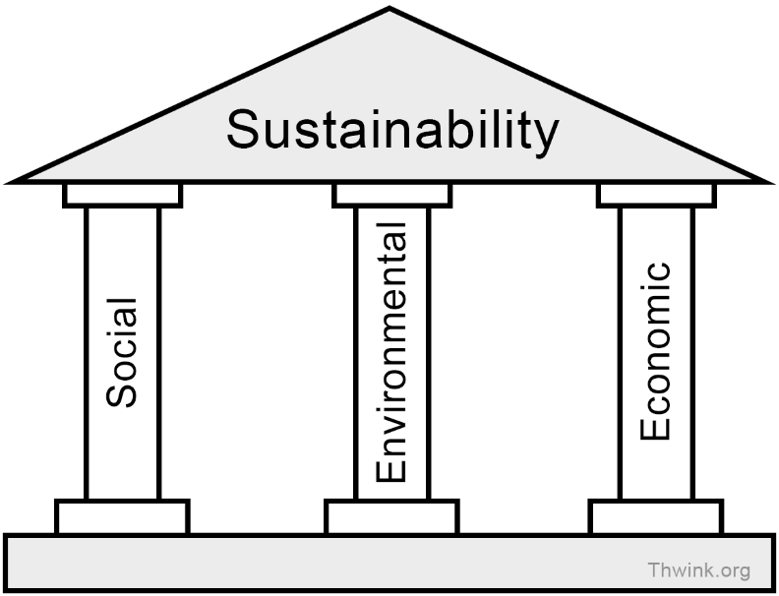
Another way we can describe people, planet, and profit.
(Thwink.org. 2014.)

Social Sustainability
Social sustainability is people and community must be trading equally and fairly. Another word by understanding what people need from the places they live and work. Social sustainability support social and cultural life, people engage well with each other.
Racisms, discrimination and equal opportunities in schools and workplaces one of the social sustainability example. According to Dillard, et al, (2008), “A social sustainability system must be based on fairness in distribution and opportunities in any cast, religion and gender.”

Environmental Sustainability
Environmental sustainability is human have a responsibility to protect the environment. Many of our decisions impact environment are not seen immediately. Climate change is one of the examples. Another example is our oceans are full of rubbish and garbage, that is the reason life of the ocean and millions of birds are extinct from the earth. According to Vezzoli, and Manzini, (2008). “Another issue each of us is personally experiencing day to day is waste, which is very harmful for human, animals and earth.”
Economic Sustainability
Economic sustainability support long-term economic growth without negatively economic impacting social, environmental, and cultural aspects of the community.

Sky Broadband Sustainability

Zero Carbon
Sky going to introduce zero carbon by 2030. They want to cut the carbon emissions created by their business, their suppliers and across the world how using their products. Sky will plant trees, mangroves, and seagrass to absorb to save energy and protect environment. They want to spread the word through their channels and shows, inspiring as many people as they can to join with sky and #GoZero. (Static.skyassets.com. 2021)

Provide Opportunities to Young People
Sky provides opportunities to young people through Sky Scholars Sky Academy Studio and Mama Youth. Young people come from every background to have the opportunity to learn themselves. Children write their news report, edit it and film it, then watch it on big screen. Children can feel their achievement. They can see their career. When they watch TV they will know, they are a part of this world.
(Skygroup.sky. 2019)

Sky broadband Sustainability Impact to the Customers

Sky zero carbon programme is not only good for the customer impact, but also it is good for whole society and environment. Air will stay fresh, good to slow climate change, build better relationship not only customers but also non-customers and society. According to Lash, and Wellington, (2007). “Reducing your exposure to climate risk and creating new opportunities for profit, it is essential we protect the environment to reduce harmful cases.”
Provide an opportunity to young people and offer to work in their organization is a good impact to the customer and communities.

Virgin Media Sustainability
In 2015 they set five years goals sustainability plan to engage the customers and communities. Purpose of five-year plan was creating positivity and change the society. Some of the plans are discussed and explained below.

Transforming Disabled People Life
Disabled people face many problems in their life. For example, staying in work, making a new friend, employer attitude, inflexible working hours and many more. In this difficult situation Virgin media bring a bright opportunity and hope for disable people. They did provide a Virgin platform to independently work and education to unlock their abilities. (Virgin Media. 2018).

Supporting Women in Stem Role
Virgin media support women in stem role. Stem is Science, Technology, Engineering and Maths skills. They ensure to have a good balance between man and woman. Virgin media provide a good career opportunity to the women to improve their self.

Better for Planet
Virgin media become a zero-waste operation by end of 2025. Purpose of the zero waste is most of the thing reuse and recycle to save the cost and environment. (Virgin Media. 2021).

Broadband Sustainability Impact to the Customers

BT Sustainability

Wider Range of Communities Programme
BT always try to make a difference in society through their communities’ programmes. BT invest in communities to improve the quality of life and wellbeing. That way they improve the communications in society and provide wider range of benefits.

Fundraising
BT organise major national charities events. They manage to enter most of the telephone network for these kinds of event and, they provide call centre to take donation over the phone. Many fundraising programmes are organised by BT employees. BT support international disasters emergency programme. An organization that supports UK charities, they are working together to support abroad disaster emergency programmes.

ChildLine
BT support many charities and fundraising programme in UK. They support children’s hospitals, education programme, hospital and many more. They run the programme which is called ChildLine. ChildLine is free r 24-hour helpline for children and young people in the UK. The main aim of this charity is to ensure every child is listened to. ChildLine has been supporting children for many years. They give young people a voice when no one else is listening. Whatever problem or danger children facing, ChildLine listen to them and try to solve the problem. (BT.com 2021).

Light User Scheme
BT provided basic telephone services to all customers, including people on in low income. They run light user scheme for those people who do not want long conversation over the phone, but they need phone for emergency purpose, but they cannot afford monthly heavy bill contracts. In that case BT run the scheme for those people who are in low income. BT provided affordable service to them. For example, joining fee is less than £10 a month or £50 a year which people can afford easily.
According to Brignall, (2008). “BT has announced a scheme called "light user". The purpose of scheme is to provide a half-price phone service specifically targeted at those on the lowest incomes. BT will offer line rental for £4.50 a month of calls which is less than half the standard price. To be eligible, customers must receive one of three benefits - income support, income-based Jobseeker's Allowance or Guaranteed Pension Credit.”

Broadband Sustainability Impact to the Customers
Transforming a disabled life is a huge thing in our society. Virgin media platform provides many opportunities to the disable people which is good impact on for everyone.

Customer Relationship Management (CRM)
Customer relationship management means good customer relationships for existing and prospective customers. It is all about understanding the customers and their expectation and needs. According to Buttle and Maklan, (2019). “CRM is to understand and improve the experience of customers as they interact with business.”
CRM could also improve the relationship between a business and customers which provide a profit to the firm current and future operations and investments. According to Knox, et al, (2007). “Wrapping a firm around the customer to ensure providing a best service according to their need and also beneficial for the firm.”

Quality
Quality is what the customer wants according to their needs. For example, some people spent £100 to buy a new pair of trainers rather than spend £25, because of the quality difference but some people happy to spend £25 because they are comfortable with a quality or maybe they have some financial issues.
Quality can be defined has having no defect as well and focus to maintain on long term. Toyota and Honda are one of the examples in the market. According to “Kotler and Armstrong, (2010). “Quality depend on customers needs and satisfaction or quality can be defined as a no defect.”

Total Quality Management
According to Hoyle, (2007). “Quality management introduced by Juran, Deming and Phill Crosby wrote about the quality management. Purpose of the quality management are to ensure the continuous improvement in customer services, customer satisfaction, employees training, materials, skills.” TQM is a strategy that focus on controlling, monitoring firms' processes and procedures and aim of the strategy is overall performance and minimize default.
To improve CRM companies, use models such as Deming, Juran’s and cosby’s which will them move in the right direction. These models are explained below.

Deming Theory of Quality
Deming introduce theory of quality management. Organization can use the theory to improve the quality and product. According to Aguayo, (1991). “Organization should produce better quality product in first time to develop loyal customer.”

Deming Cycle
Deming cycle is based on four things. Plan, do, act and check. If firm or business companies introduce new product in the market, they must plan first. Second step is executing the plan or carry out the changes if required. Third check it or observe it and make sure everything is perfect before the product is introduced in the market and lastly if everything is okay begin to produce in the market which is called act. Sky broadband can apply Deming cycle to improve the productivity and good relationship with customers.
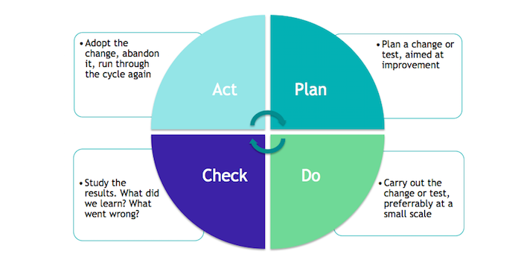
(ICT Institute. 2017)
Deming cycle come with a seven deadly disease.

Deming Cycle Seven Deadly Disease
Deming deadly disease are most serious barrier management faces in current management actions.
Lack of Constancy of Purpose | It is essential to stay in business, focus on one plan. If you keep changing plan and policies, that will make employees confused and affect quality and improvement.
Emphasis on Short-term Profits | Short term thinking is not good for the whole organization. For example, if Sky did not train their employees properly due to expenditure or they use low quality product to make easy and quick money. It gives them a short-term profit but long term it will be a loss.
Evaluation of Performance, Merit rating, or Annual Review | Work improvement is very important for the Sky broadband. That way their company can improve, and rating will be higher which is good impact in business and benefit for the company. Most of the customers nowadays read reviews and performance before they purchase anything.
Mobility of Top Management | Management did not work in one place to the long term which is affect to organization progression. Mobility of management is almost a serious problem which cause dissatisfaction with the job.
Visible Figures | Visible figures are important in the organization, for example, suppliers, taxes, and employees must be paid on time. Another example is customer complaints figure. Sky broadband must have a complaint record and date of resolution.
Excessive Medical Costs | Employee’s health care is very important to the organization. Sky must provide to their employee’s safe environment which is good for the productivity and mental health and give their employee sick pay. According to Guettler, (2012). Safe environment makes employees happy and challenged will generally lead to better mental and physical health. If employees are taking sick days, productivity can be maintained at higher levels.
Costs of Liability | A liability is something a person or company owes; it is normally sum of money. For example, many businesses take out liability insurance just in case, if customer wants warranty from organization and organization fulfil customer needs. Sky must keep in mind liability insurance for legal and urgent need.

To help any organization or Sky broadband to survive long term in the market, they need to apply Deming formulated 14 points.

Deming 14 Point
According to Anderson, (1994). “Deming management method includes a set of 14 points that can be use as guidelines for organizational behaviour and practice regarding quality management. Aim of the Deming 14 points is transforming business, improve product and services and provide organization new way of thinking.”
If Sky broadband adapt Deming 14 point, they can improve customer relationship management in their organization. They are listed below:
Constancy of purpose | If any plan is executed in the organization, Sky broadband must think the long-term vision rather than short term vision.
Adopt new philosophy | If Sky broadband adopt a new philosophy time by time that give them to opportunities to compete in the market, Deming said to avoid any mistake adapt a new method.
Do not rely on inspection | Do not rely on inspection of any production. For example, If Sky introduce new router in the market, they cannot rely just on last result inspection. They must inspect whole process of the making of router, like, how it can be made better. What kind of raw materials are required? Basically, build quality into the process start to end.
Improve constantly | Constantly improve your product, system, and service, for example, if your product rating point is 4, make sure it is going higher and higher that mean you constantly improve in the any organization and broadband firm.
Employee’s training | Provide a higher level of training to all the employees, for example employees must know technical skills. Employees know how to use the machinery and knowledge in their work field that can also help Sky broadband to improve the customer relationship.
Improve leadership and supervision method | Leadership or inspector must be responsible. They should know how they can improve their services and how they can do thing better and better. If Sky broadband inspector or leadership have these qualities, they not only improve the services, but they also compete in the market.
Long term relationship | Long term good relationship to the suppliers and buyers give organization many benefits.
Report problem and ask questions | In any organization if you report a problem or ask question keep employs and organization engaged, and it is a quick way to resolve the issues.
Teamwork | Teamwork improve productivity and provide a better idea in the organization. Working together people learn faster and get faster solution of any problem. To get a winning innovation Sky must motivate to their employees work as a team.
Target goal and set plan | Do not give your team target. For example, if Sky broadband tell their employees they must finish specific job in 4 hours’ time, that way employees can get easily demotivate and try to quickly finish their job which can cause mistakes. If Sky wants to avoid any mistakes, they set target or plan but if they want to reach the target or goals they can work as a team rather than expect just one person.
Working standard | Working standard provide improvement of activities, reduce injuries and accident in workplace. Sky can play important role of business interaction, economy, and good customer relationship to adopt working standard.
Remove the barrier management (must listen to employees) | Remove all the barrier in workplace. Listen to the employees. Give them opportunities to talk. For example, arrange some meeting twice a week or once a month, that way Sky broadband have opportunities to improve their service more.
Ongoing education/training | Provide ongoing training to Sky broadband staff and team member, that way employees improving their performance, reduce mistakes and skill gap and provide a good service to the customers.
Implement/accomplish the transformation | To reach success implement plan, procedure, and policy in good way. Sky broadband can improve customer relationship by adopting Deming theory.

Juran’s Theory of Quality/Quality Trilogy
According to Juran’s quality theory product meets customer satisfaction and product or service development processes in organizations. Juran is well known founder of quality management. His quality management theory is based on three key principles which are:
- Quality Planning.
- Quality Control.
- Quality Improvement.
Juran Trilogy is also known as an improvement cycle.
Bisgaard, (2008). “Quality management provides the framework for the industrial application of statistical quality control, design of experiments, quality improvement, and reliability methods.”

Quality Planning
Virgin media can improve their service and build good bonding to their customers by using Juran quality planning. Juran quality planning is to fulfil customer requirements in product, services, system process and maintain the quality. If Virgin media create an innovation in their business, they must make sure everything will be according to customer’s needs.
According to Juran, (1992). “Quality planning is a process which required to meet customers need.”

Quality Control
In the early stage of the process companies check performance criteria of the making, that way, they have more chances to improve the product. If Virgin media can do regular inspection of process, they can reach their target and customer needs. According to Schilling and Neubauer (2017). “Inspect quality into the product of process, start till end.”

Quality Improvement
Virgin media expand their business to apply quality improvement in their business. Quality improvement is to improve outcome and performance and provide a great result.

Juran's Quality Planning Road Map
The Quality Planning Roadmap is used for product and process development. Juran Roadmap can provide Virgin media a good structure that helps them become more competitive and provide long-term business results.

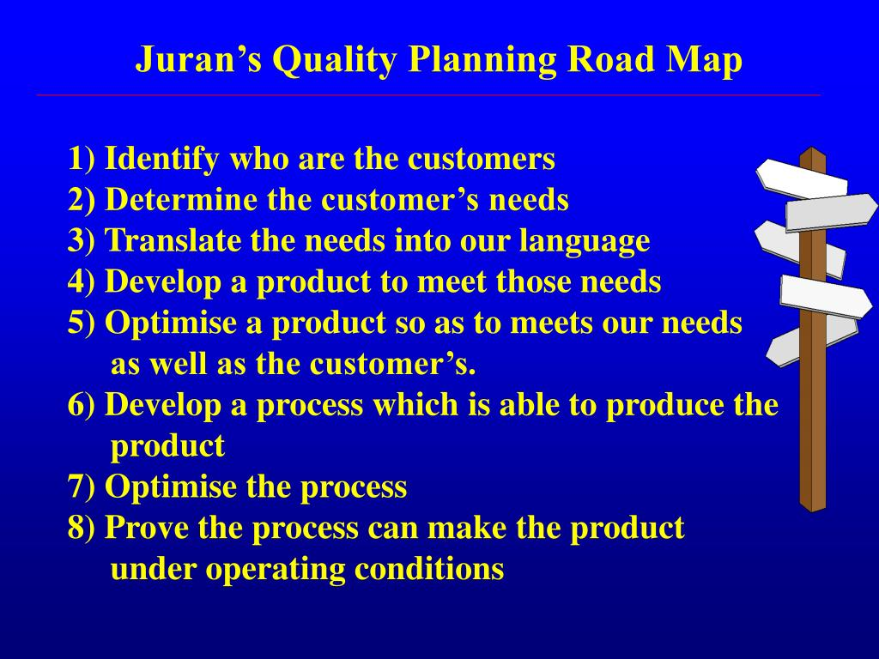

Quality Trilogy and Quality Roadmap
Virgin media should involve everyone who is working inside or outside the organization as a team member. Just quality trilogy and quality roadmap is not enough to project improvement. Everyone should work on same page to improve the productivity.

Crosby's Cost of Quality
According to Crosby’s quality cannot compromise defective product. If organizations introduce bad quality product. They will face a lot of problems. For example, lose money, lose customers, and lose trust. Crosby said check all the product and analysis all the defect items. Quality cannot compromise defect.

Crosby’s 14 Step
BT broadband can improve their organization to adapt by Crosby’s 14 step. According to Philip, (2005). “Crosby’s quality must be defined at clearly to help the organization in long term employee’s participation rather than bunch of experience or opinion.” The aim of the 14 step is companies understand, where they need improvement and put effort to get better results.
Management commitment | Quality improvement must be recognised by management. Management should be responsible for all the work commitment. They should know what the customer really needs.
Quality Improvement Team | Each department should work together as a team for improve the quality and better work.
Quality Measurement | Quality measures for each area of activity that are recorded to show where improvement is possible, and where corrective action is necessary. That way organization know people do the job and they can work out the defective items and replace quickly.
Cost of Quality Evaluation | The cost of quality is action where necessary and correct the defect item. If organization correct the item on time, they can save money and as a result they have good profit.
Quality Awareness | This is involved through training and visible evidence of quality improvement in the organization. Making your employees aware to the company of defects item.
Corrective Action | Discussion about problems will bring great solutions and elements for improvement. People need to see that problems are being resolved on a regular basis, which help to build positive atmosphere.
Zero Defect Programme | The purpose of the defect programme is that everyone should do things right first time.
Supervisor Training | All the managers should have formal training which is essential for any department or firm. Manager should be understanding each of the 14 steps and able to explain to their employees or team workers.
Zero Defect Day | It is important everyone get same message same day. Zero defect day is an opportunity to pass your message to the employees. Zero defects count as the performance standard of the company which makes a positive impact to everyone.
Goal Setting | Each company of the supervision or manager set goals for their team which is normally time bases.
Error Cause Removal | Employees should tell the organization if any error comes through in carrying out his duties. This process built up a trust in the organization and people are confident to tell the management any problem and management duties are to solve the problem in 24 hours.
Recognition | The act of recognition is what is important. For example, if employees meet the company target or goals, they have rewards.
Quality Councils | The quality professionals or team leader should organise regular meeting to improve the quality and discuss about improvements.
Do It Over Again | It is important to keep everything up to date for example employees training, zero defect day, zero defect programme, maintain the quality and if any changes happen, tell the organization people immediately.  BT broadband can more improve their organization to apply Crosby’s theory.

Recommendation
I recommend to the three broadband companies to run successfully that they can identify the problem first. For example, which area needs more attention, where the mistakes can happen? How they can improve it. They can use SWOT analysis to know internal issues in the organization. Porter 5 Forces can help them, how they can compete the business in the market.
They can adopt Juran’s, Deming’s or Crosby’s management quality to improve the quality of product and built some loyal customer relationship. Companies mission and vision should be clear in the organization and they need to be focus on core values.
Broadband companies monitor their good and bad feedback and answering the questions of customers and employees. Provide safe and happy atmosphere to the whole organization and produce better quality product to stay in a competition.
They can use last approach in their organization to provide better services to their customers. For example, listen to the customers, apologies them, solve the problem and at last thanks.

Conclusion
In this report I gathered information about three broadband companies. What kind of marketing ethics they used? First, I explain what ethic and marketing ethics is. Basically, what kind of good thing these broadbands doing for their customers and stay their position in the market.
Some broadband companies are very responsible about their product and service, some are stick with a children safety and some are provided faster broadband to their customers to for improve the communication skills. All these three companies have good and bad Impact of the customers.
I also found some evidence of sustainability. Again, how broadband companies used sustainability to protect the environment, social factors and economic factor and it is impact on customers experience.
I discuss in my report quality management and how organization can use three quality management theory in their organization to build a good relation to their customers.
I briefly described in my report Deming’s, Juran’s and Crosby’s quality management theories and finally I provide some personal recommendation.

Reference List
Anderson, J.C., Rungtusanatham, M. and Schroeder, R.G., 1994. A theory of quality management underlying the Deming management method. Academy of management Review, 19(3), pp.472-509. [Accessed 18 March 2021].
American Marketing Association. 2021. Codes of Conduct | AMA Statement of Ethics. [online] Available at: <https://www.ama.org/codes-of-conduct/> [Accessed 11 March 2021].
Aguayo, R., 1991. Dr. Deming: The American who taught the Japanese about quality. Simon and Schuster. [Accessed 27 March 2021].
Bt.com. 2021. [online] Available at: <https://www.bt.com/bt-plc/assets/documents/digital-impact-and-sustainability/our-report/report-archive/2004/social-and-environmental-report-2004.pdf> [Accessed 14 March 2021].
Bt.com. 2021. Our history - About BT | BT Plc. [online] Available at: <https://www.bt.com/about/bt/our-history> [Accessed 26 March 2021].
Bisgaard, S., 2008. Quality management and Juran's legacy. Quality Engineering, 20(4), pp.390-401. [Accessed 19 March 2021].
Brignall, M., 2008. BT gets heavy with 'light' users. [online] the Guardian. Available at: <https://www.theguardian.com/money/2008/oct/18/internetphonesbroadband-consumeraffairs> [Accessed 14 March 2021].
Brundtland, G.H., 1987. What is sustainable development. Our common future, 8(9). [Accessed 14 March 2021].
Buttle, F. and Maklan, S., 2019. Customer relationship management: concepts and technologies. Routledge. [Accessed 17 March 2021].
Clarkson, N., 2021. How Virgin Media is helping with home schooling | Virgin. [online] Virgin.com. Available at: <https://www.virgin.com/about-virgin/latest/how-virgin-media-is-helping-with-homeschooling> [Accessed 13 March 2021].
Dillard, J., Dujon, V. and King, M.C. eds., 2008. Understanding the social dimension of sustainability. Routledge. [Accessed 14 March 2021].
Guettler, T., 2012. W. Edwards Deming & the Deadly Diseases. [online] Deep Thinking. Available at: <https://thomasguettler.com/2012/05/13/w-edwards-deming-the-deadly-diseases/> [Accessed 19 March 2021].
Howdle, D., 2021. BT Broadband Review 2021 | Is BT Broadband any good? - Cable.co.uk. [online] Cable. Available at: <https://www.cable.co.uk/broadband/providers/bt-broadband/reviews/> [Accessed 21 March 2021].
Hoyle, D., 2007. Quality management essentials. Routledge. [Accessed 17 March 2021].
ICT Institute. 2017. Information security and PDCA (Plan-Do-Check-Act) - ICT Institute. [online] Available at: <https://ictinstitute.nl/pdca-plan-do-check-act/> [Accessed 17 March 2021].
Juran, J.M., 1992. Juran on quality by design: the new steps for planning quality into goods and services. Simon and Schuster. [Accessed 19 March 2021].
Knox, S., Payne, A., Ryals, L., Maklan, S. and Peppard, J., 2007. Customer relationship management. Routledge. [Accessed 17 March 2021].
Kotler, P. and Armstrong, G., 2010. Principles of marketing. Pearson education. [Accessed 25 March 2021].
Lash, J. and Wellington, F., 2007. Competitive advantage on a warming planet. [Accessed 21 March 221].
Philip B, c., 2005. [online] Agiledevelopment.org. Available at: <https://www.agiledevelopment.org/download/qp1205crosby.pdf> [Accessed 28 March 2021].
Reviews.io. 2021. SKY Reviews - Read 165 Genuine Customer Reviews | www.sky.com. [online] Available at: <https://www.reviews.io/company-reviews/store/sky> [Accessed 21 March 2021].
Sidgwick, H., 2019. The methods of ethics. Good Press. [Accessed 11 March 2021].
Static.skyassets.com. 2021. [online] Available at: <https://static.skyassets.com/contentstack/assets/bltdc2476c7b6b194dd/bltcaa5c6b68cbc75d0/5e65fedc18b328555145d642/Code-of-Conduct-English-UK.pdf> [Accessed 12 March 2021].
Skygroup.sky. 2019. Bigger Picture Impact Report 2019. [online] Available at: <https://www.skygroup.sky/biggerpictureimpactreport2019> [Accessed 14 March 2021].
Static.skyassets.com. 2021. [online] Available at: <https://static.skyassets.com/contentstack/assets/bltdc2476c7b6b194dd/bltf0b4c083467f8dea/5f357968168ec908bebea613/Ways-of-Working-07-2020-FINAL.pdf> [Accessed 13 March 2021].
Schilling, E.G. and Neubauer, D.V., 2017. Acceptance sampling in quality control. Crc Press. [Accessed 19 March 2021].
Simper, M., 2015. [online] Virginmedia.com. Available at: <https://www.virginmedia.com/content/dam/virginmedia/dotcom/documents/corporate/Supplier-Code-of-Conduct.pdf> [Accessed 13 March 2021].
Thwink.org. 2014. The Three Pillars of Sustainability. [online] Available at: <https://www.thwink.org/sustain/glossary/ThreePillarsOfSustainability.htm> [Accessed 14 March 2021].
Trustpilot. 2021. Virginmedia is rated "Bad" with 1.5 / 5 on Trustpilot. [online] Available at: <https://uk.trustpilot.com/review/www.virginmedia.com> [Accessed 21 March 2021].
us, A., partners, O. and Member, V., 2021. Virgin Media - Internet Matters Founding Member - Internet Matters. [online] Internet Matters. Available at: <https://www.internetmatters.org/about-us/our-partners/virgin-media-internet-matters-founding-member/> [Accessed 13 March 2021].
Vezzoli, C. and Manzini, E., 2008. Design for environmental sustainability (p. 4). London: Springer. [Accessed 14 March 2021].
Virgin Media. 2021. Better for the planet. [online] Available at: <https://www.virginmedia.com/corporate/sustainability/meaningful-connections-plan/better-for-the-planet> [Accessed 21 March 2021].
Virgin Media. 2018. Transforming lives. [online] Available at: <https://www.virginmedia.com/corporate/sustainability/goals-and-performance/transforming-lives#:~:text=Our%202020%20goal%3A%20Support%201,by%20the%20end%20of%202020.> [Accessed 16 March 2021].
Virginmedia.com. 2021. [online] Available at: <https://www.virginmedia.com/content/dam/virginmedia/dotcom/documents/corporate/Our-supplier-code-of-conduct-2017.pdf> [Accessed 26 March 2021].
Wilkinson-Jones, P., 2020. Moving home with BT broadband - Moving House | Cable.co.uk. [online] Cable. Available at: <https://www.cable.co.uk/providers/bt/moving-home/> [Accessed 14 March 2021].

