

Programme: BA (Hons) Leadership and Management Skills for the Workplace
Module code and name: BMSW6105_Coaching and Mentoring Skills for the Workplace
Lecturer Name: Dennis Pepple
Name of the Student: Ivaylo Georgiev
ID Number: 2128090
Task 3_Written Reflection

Table of contents:
- Introduction…………………………………………………………………………….……3
- Critical evaluation of the purpose of coaching and mentoring within a workplace..…3
- Critical analysis of the GROW coaching model…………………………………………5
- Reflection on Practical 1 – coaching session……………………………………………6
- Reflection on Practical 2 – mentoring session…………………………………………..8
- Conclusion………………………………………………………………………………….10 Reference list………………………………………………………………………….…...12

REFLECTIVE REPORT ON COACHING AND MENTORING
- Introduction
This reflective report provides an analysis of my experiences in coaching and mentoring through structured peer-to-peer exercises undertaken during my academic studies. The primary aim is to critically examine these experiences using Gibbs’ Reflective Cycle (1988), a model that facilitates structured reflection through six stages: description, feelings, evaluation, analysis, conclusion, and action plan.
The report focuses on two practical sessions. Practical 1 involved a coaching session where I applied the GROW model, specifically concentrating on the ‘Options’ phase to help a coachee explore solutions for skill development in a new role. Practical 2 consisted of a mentoring session utilizing the Johari Window model, with a particular focus on the ‘Unknown’ area to identify hidden strengths and areas for improvement. Feedback from my lecturer indicated that while I effectively facilitated the coaching session, I did not adequately predispose the coachee before beginning.
Coaching and mentoring are integral to personal and professional growth. Coaching is a structured, goal-oriented process aimed at enhancing performance and skill development (Whitmore, 2017), whereas mentoring fosters long-term career and personal growth through guidance and knowledge-sharing (Garvey et al., 2018). By comparing and analysing these methodologies, this report aims to deepen my understanding of their practical applications and effectiveness in workplace settings. The reflection will highlight lessons learned, areas for improvement, and strategies to enhance future coaching and mentoring engagements.
- Critical evaluation of the purpose of coaching and mentoring within a workplace
Coaching and mentoring are essential tools for professional and organisational development. Coaching primarily focuses on performance improvement and skill development, while mentoring aims at career guidance and personal growth (Garvey and Stokes, 2022). Both approaches contribute significantly to employee engagement, leadership development, and knowledge transfer within an organisation (Baugh,2021).
The main purpose of coaching in the workplace is to enhance an individual's performance through structured goal-setting, constructive feedback, and guided self-reflection. Coaching helps employees improve specific skills, adapt to new roles, and increase their problem-solving capabilities (Davies et al., 2020). Effective coaching fosters accountability, motivation, and professional growth, ultimately benefiting both the individual and the organisation (Grant, 2014).
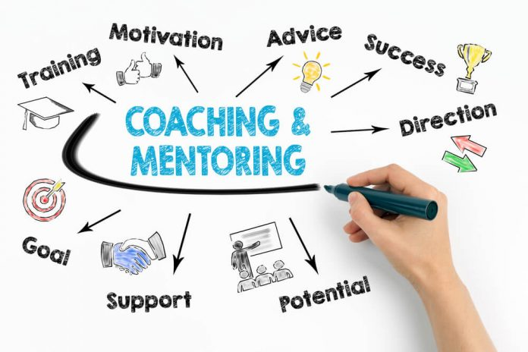
(Source: Training, 2021)
Mentoring, on the other hand, plays a crucial role in career progression, organisational learning, and leadership development. Mentors provide guidance, share experiences, and help mentees navigate workplace challenges (Allen et al., 2017). Mentoring relationships encourage continuous learning, strengthen organisational culture, and improve employee retention (Aihevba, 2022).
Although coaching and mentoring share similarities, they differ in structure and purpose. Coaching is typically short-term and focused on immediate skill acquisition, whereas mentoring is a long-term relationship emphasising career development (Scholz et al., 2023). Coaching sessions are structured, with defined objectives and measurable outcomes, whereas mentoring is more flexible and relationship-driven (Carmel and Paul, 2015).
While coaching increases workplace productivity and performance, mentoring enhances employee satisfaction and commitment. Both approaches are vital for talent management and succession planning, ensuring that employees develop the necessary skills and knowledge to contribute effectively to organisational success (Garvey and Stokes, 2022). However, challenges exist, such as unclear objectives in coaching and dependency issues in mentoring. Organisations must strategically implement both methods to maximise their impact on workforce development (Grant, 2014).

- Critical analysis of the GROW coaching model
The GROW model, developed by Whitmore (2017), is a structured coaching framework designed to help individuals set goals and develop strategies for personal and professional growth. It consists of four key stages: Goal, where the coachee defines their objective; Reality, which assesses their current situation; Options, exploring potential solutions; and Will, determining commitment to an action plan. The model is widely used in workplace coaching due to its structured yet flexible nature (Watts and Corrie, 2022).
The Goal stage clarifies the desired outcome, ensuring the coachee has a clear direction. The Reality phase helps identify obstacles and resources available to them. The Options stage, which I focused on in Practical 1, encourages brainstorming multiple approaches to achieving the goal. Lastly, the Will phase secures commitment and accountability for execution (Passmore & Fillery-Travis, 2011).


(Source: Structural learning, 2023)

Advantages of the GROW Model:
- Structured Approach: The model provides a clear, step-by-step process, making coaching sessions more effective (Whitmore, 2017).
- Empowerment: Encourages self-reflection, problem-solving, and decision-making, increasing coachee autonomy (Mejia, 2025).
- Versatility: Applicable across industries and coaching scenarios, making it a valuable tool for skill development (Rahman, 2023).
- Accountability: Helps coachees take responsibility for their progress, ensuring commitment to their goals (Asobee, 2021).
Disadvantages of the GROW Model:
- Coach Dependence: Success depends on the coach’s ability to ask insightful, open-ended questions that stimulate critical thinking (Alabdali, 2020).
- Coachee Readiness: The model assumes the coachee is motivated and self-aware, which may not always be the case (Carden et al., 2022).
The GROW model is highly effective in structured environments where clear goals and measurable outcomes are required. It is particularly beneficial in performance improvement settings, where employees need structured guidance to enhance their skills and meet key performance indicators. Career development is another area where the model excels, as it enables individuals to define career aspirations and create actionable plans for achieving them. For example, it can help employees adapt to new roles by identifying key skills they need to develop and exploring potential learning strategies (Whitmore, 2017)
Additionally, leadership coaching benefits from the GROW model, as it helps managers refine strategic thinking, decision-making (Rahman, 2023), and leadership styles. The model is also useful for structured problem-solving, allowing employees to evaluate multiple solutions when faced with workplace challenges.
However, the GROW model may be less effective in highly emotional situations where individuals require deeper psychological support rather than structured goal setting. It is also less useful for unmotivated coachees who lack self-awareness, as they may struggle to engage with the process without additional motivational strategies.
Furthermore, in unstructured learning environments that require greater flexibility and open-ended exploration, the rigid framework of the GROW model can be limiting. In such cases, a more adaptive or exploratory coaching model may be preferable to encourage creativity and deeper personal insight. In cases where open-ended exploration and flexibility are required, a more adaptive coaching model may be preferable.
- Reflection on Practical 1 – coaching session
Using Gibbs’ Reflective Cycle (1988), I will reflect on my first coaching experience, focusing on a session aimed at skill development for a new job role using the GROW model, specifically the ‘Options’ stage. The model is widely used for structured reflection and encourages individuals to reflect on their experiences by following a systematic process of description, feelings, evaluation, analysis, conclusion, and action plan to enhance learning and personal development.

Description:
The coaching session took place in a peer-to-peer learning environment, where I worked with a coachee preparing for a new job role, and I had to guide her using the GROW model, focusing on the ‘Options’ stage. We followed a structured format where the coachee shared their challenges, and I helped brainstorm potential solutions. The objective was to identify actionable steps and to set goals for skill development for the new role. I also summarised key points to ensure clarity and maintain engagement.
Feelings:
Initially, I felt confident due to my preparation and structured questions. However, as the session progressed, I realised my reliance on scripts made the questioning feel rigid. I also felt I wasn’t engaging as effectively as I had hoped. Feedback from my lecturer pointed out that I missed an opportunity to establish rapport at the beginning, which could have made the coachee feel more comfortable. While this was disappointing, it motivated me to improve my approach in future sessions by balancing structure with flexibility and engagement.
Evaluation:
The session had strengths. My use of the GROW model kept the conversation focused and productive, and my positive tone helped the coachee feel comfortable. I provided validating comments like “that sounds smart” to foster a collaborative atmosphere. My structured approach also helped stay on track with skill development options relevant to the coachee’s role.
However, some areas needed improvement. My over-reliance on scripted questions made the conversation feel rigid and less dynamic. I struggled to adapt to the coachee’s responses, limiting deeper engagement. Additionally, I didn’t build rapport at the start, which may have made the coachee feel less at ease. Lastly, although I introduced the GROW model, I failed to provide a brief explanation of it, which may have left the coachee unsure about the process.
Analysis:
The GROW model helped keep the session focused, but my reliance on scripted questions restricted adaptability and reduced engagement. I should have started with rapport-building to make the coachee feel comfortable (Van Coller-Peter and Manzini, 2020). Without this, it was harder for them to open up fully. Furthermore, not clearly explaining the GROW model may have made the coachee uncertain about the process and their role in it, which could hinder their involvement.
Conclusion:
This experience reinforced the importance of balancing structure with flexibility. While the GROW model provided clarity, I learned that building rapport and providing a brief explanation of the model would have improved the session’s effectiveness. Coaching should not only provide structure but also create a comfortable, dynamic environment where the coachee feels engaged.
Action Plan:
In future sessions, I will prioritise rapport-building at the start to ensure the coachee feels comfortable. I will also provide a concise explanation of the GROW model to clarify the coaching process. Finally, I will aim to ask questions more naturally and flexibly, avoiding excessive reliance on scripts to promote a more engaging and adaptive conversation.
- Reflection on Practical 2 – mentoring session
Description
In this mentoring session, I provided feedback using the Johari Window model, focusing on the ‘Unknown’ area. The Johari Window model, developed by Luft and Ingham (1955), is a psychological tool designed to enhance self-awareness and improve communication. It comprises four quadrants: the ‘Open’ area (known to self and others), the ‘Blind Spot’ (known to others but not self), the ‘Hidden’ area (known to self but not others), and the ‘Unknown’ area (unknown to both self and others).
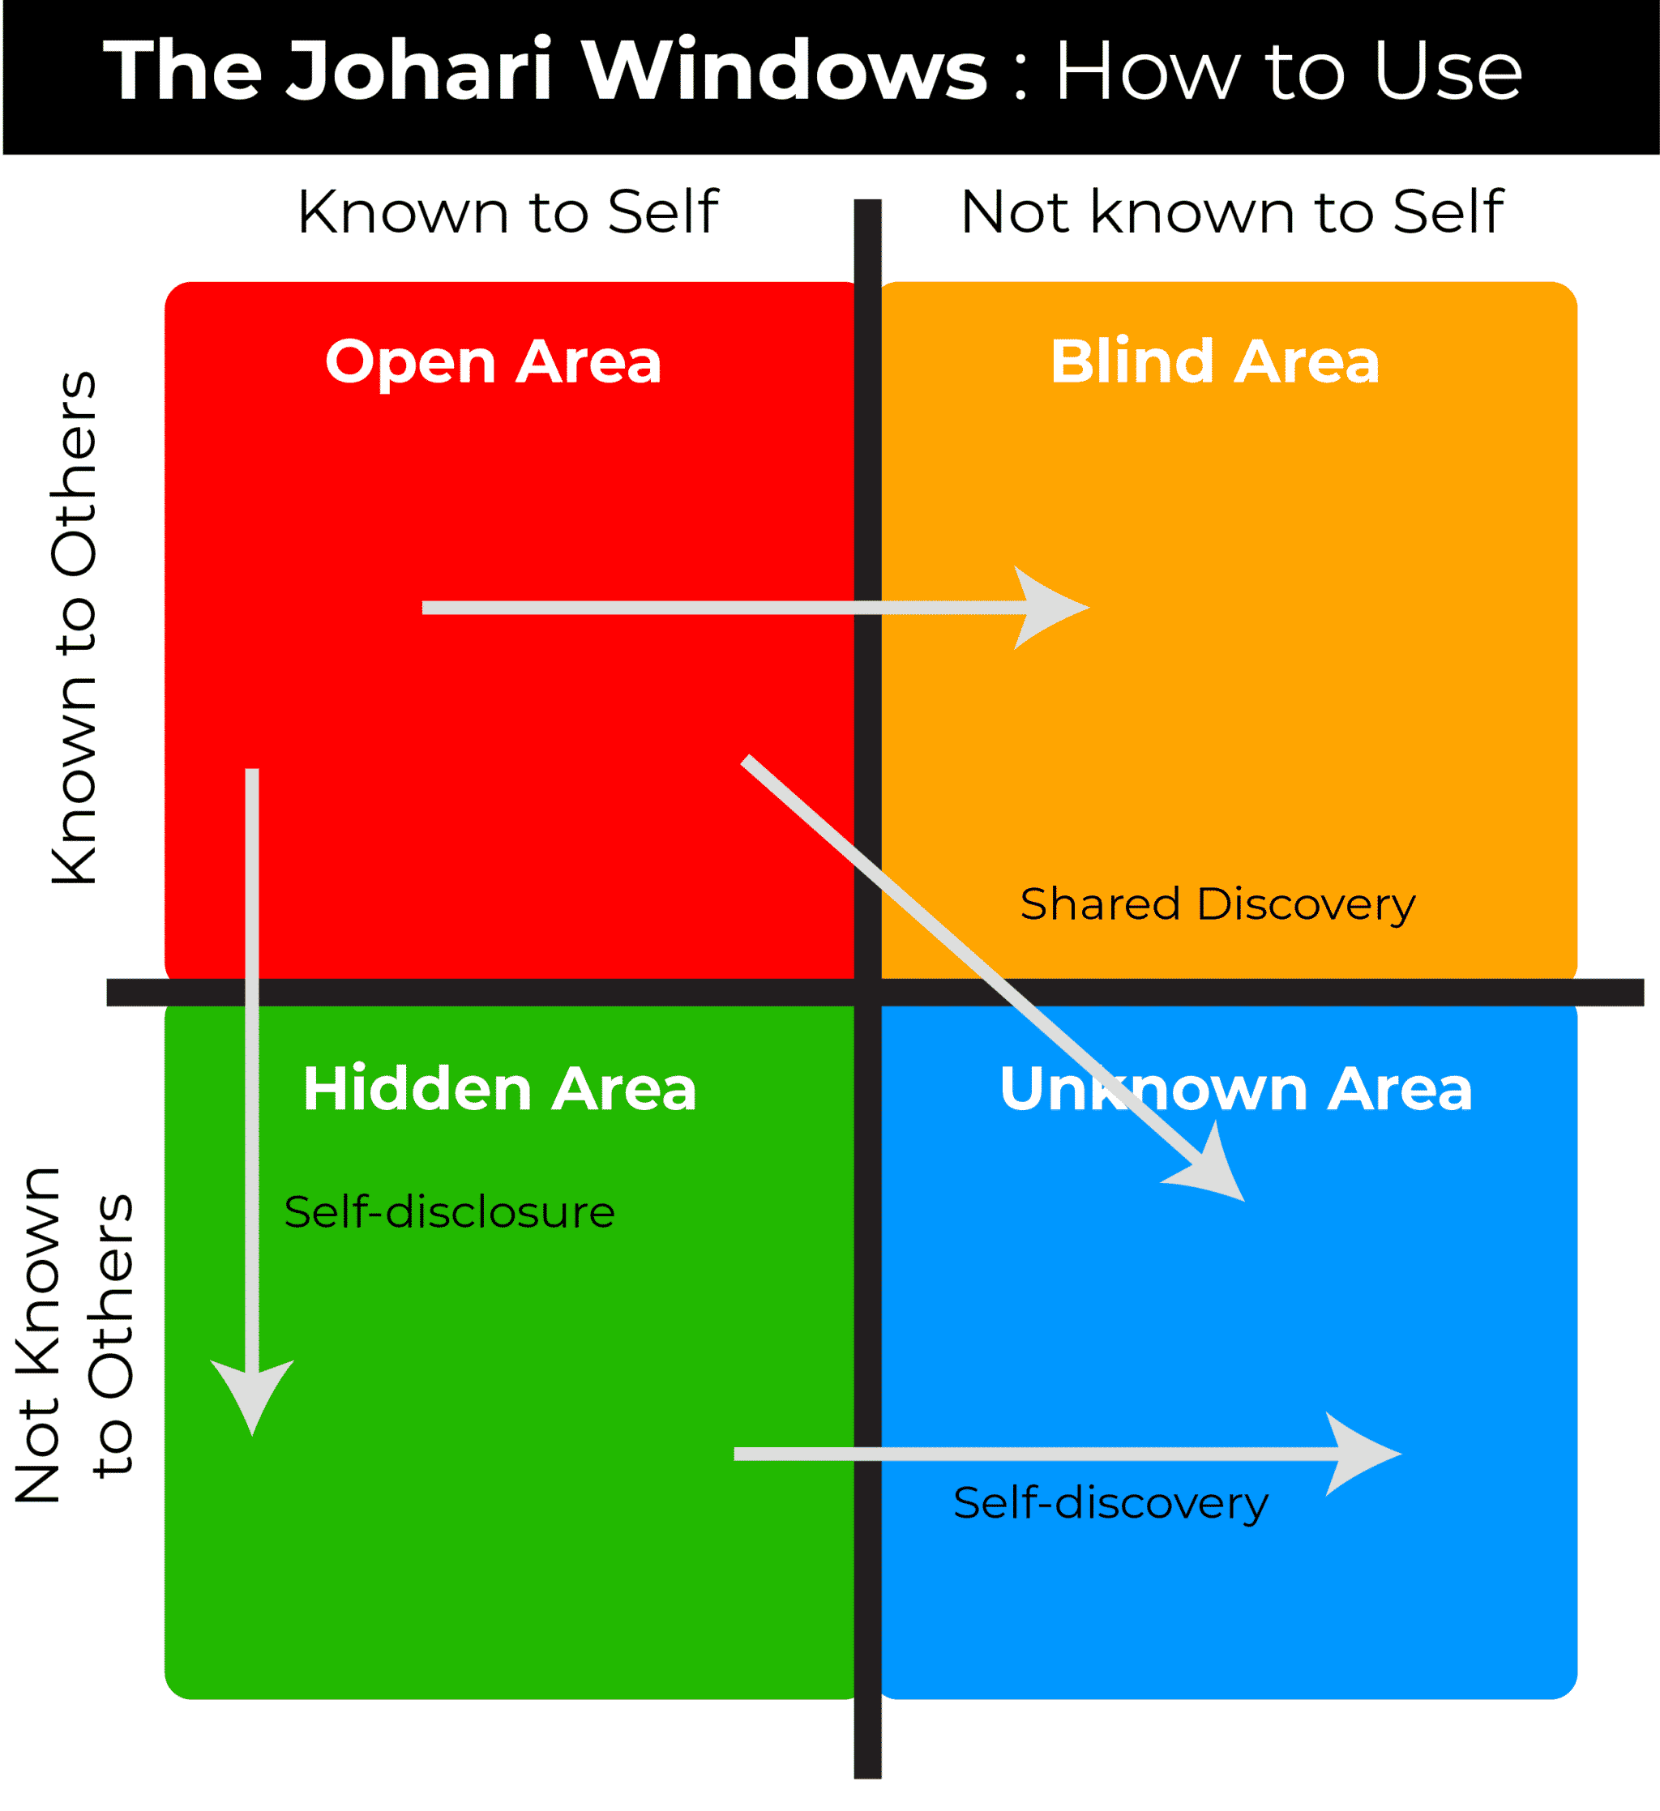
(Source: Coach foundation, 2023)

The session focused on identifying my mentee's potential strengths in leadership and public speaking. I asked open-ended questions to explore my mentee’s past experiences and observations from colleagues. I actively listened and summarised key points to support self-reflection. The session ended with my feedback that my mentee may have hidden strengths in leadership and public speaking.

Feelings
I felt confident using questioning techniques, which allowed me to guide the conversation effectively. I also felt positive about my listening skills and summarising points to maintain engagement. However, I experienced some self-doubt when I sensed my mentee was hesitant about my feedback. This made me question whether I had communicated my observations clearly enough. After the session, I felt mixed emotions — satisfied with my ability to create a reflective environment but concerned that my feedback might not have been as impactful as expected.

Evaluation
The session had several strengths. I applied the Johari Window model effectively by focusing on the ‘Unknown’ area, which encouraged my mentee to reflect on their unexplored abilities. My questioning skills were strong, and I successfully steered the conversation in a positive direction. Summarising key points helped to ensure that the mentee was reflecting deeply on the conversation.
However, I recognised that I found it challenging to balance offering guidance with allowing my mentee to reach conclusions independently. While I identified potential strengths in leadership and public speaking, I occasionally leaned too heavily on guiding the thinking rather than giving the mentee space to explore her own insights. Providing my mentee with greater ownership of the conversation may have helped her develop deeper self-awareness and confidence in their conclusions.

Analysis
The session’s positive outcomes resulted from effective questioning and listening, which encouraged self-reflection. The Johari Window model proved valuable, as its focus on uncovering unknown traits aligns well with providing constructive feedback (Luft & Ingham, 1955). My ability to ask thoughtful questions helped the mentee engage meaningfully in self-reflection.
However, my difficulty in balancing guidance with independent thinking highlights an area for improvement. Research suggests that allowing mentees to reach conclusions independently promotes deeper learning and builds confidence (Venktaramana et al., 2023). By adopting a more facilitative approach and giving my mentee greater space to express her thoughts, I could have strengthened her ability to identify strengths on her own.

Conclusion
I successfully applied the Johari Window model to explore my mentee’s unexplored abilities. However, I identified key areas for improvement, particularly improving the balance between providing guidance and encouraging independent thinking to enhance the mentee’s engagement and growth.

Action Plan
In future mentoring sessions, I will focus on creating a better balance between guiding the conversation and allowing the mentee to develop their own insights. I will achieve this by asking open-ended questions that prompt reflection and pausing to give my mentee space to process their thoughts. Additionally, I will provide feedback with greater clarity, supported by relevant examples, to ensure my observations are both meaningful and actionable.
- Conclusion
Reflecting on my coaching and mentoring experiences has provided key insights into effective professional development strategies. The GROW coaching model helped me guide my coachee in exploring options for skill development, while the Johari Window model successfully encouraged my mentee to reflect on previously unexplored strengths. Both experiences underscored the importance of effective questioning, listening, and feedback delivery.
One key learning point from my coaching experience was the importance of building rapport early to establish trust and ensure effective communication. In my mentoring session, I realised the need to balance offering guidance with encouraging independent thinking to empower my mentee. These insights have shaped my understanding of how to create impactful development sessions.
Moving forward, I will apply these lessons by focusing on rapport-building in coaching, while adopting a more facilitative approach in mentoring to promote independent reflection. By refining these skills, I aim to improve my ability to guide others effectively, fostering confidence, self-awareness, and positive growth in future workplace interactions. Ultimately, my goal is to create a supportive environment where individuals feel encouraged to explore their potential and unlock new strengths. By strengthening these skills, I hope to contribute positively to the development and success of my colleagues in the workplace.

Reference List
Aihevba, E.O., (2022). Mentoring as a tool for managing talents (Doctoral dissertation, Sheffield Hallam University (United Kingdom)). Available at: https://www.proquest.com/openview/a08daa2576c979e41d59b39adcaea0da/1?pq-origsite=gscholar&cbl=2026366&diss=y. (Accessed: 23/02/25).
Alabdali, M., (2020). Activate the learning and development agenda using coaching culture. European Journal of Human Resource Management Studies.
Allen, T.D., Eby, L.T., Poteet, M.L., Lentz, E. & Lima, L. (2017). ‘Career benefits associated with mentoring for protégés: A meta-analysis’, Journal of Applied Psychology, 89(1), pp.127-136.
Asobee, M.S., (2021). An investigation on the role of coaching in strategic leadership development in the academia. Open Journal of Leadership, 10(2), pp.47-59.
Baugh, S.G., (2021). Mentoring Research Through the Years: A Brief Review. Oxford Research Encyclopaedia of Business and Management.
Carden, J., Passmore, J. and Jones, R.J., (2022). Exploring the role of self‐awareness in coach development: A grounded theory study. International Journal of Training and Development, 26(2), pp.343-363.
Carmel, R.G. and Paul, M.W. (2015). Mentoring and Coaching in academia: Reflections on a mentoring/coaching Relationship. Policy Futures in Education, [online] 13(4), pp.479–491. doi: https://doi.org/10.1177/1478210315578562( Accessed: 21/02/25).
Davies, C., Brychan, A., Fillery-Travis, A., Palmer, S. and Crossman, J., (2020). Coaching for teachers. Available at: https://repository.uwtsd.ac.uk/id/eprint/1219 (Accessed: 23/02/25).
Garvey, B. and Stokes, P. (2022). Coaching and mentoring: theory and practice. 4th ed. Los Angeles: Sage
Gibbs, G. (1988). Learning by Doing: A Guide to Teaching and Learning Methods. Oxford: Further Education Unit.
Grant, A.M. (2014). The Efficacy of Executive Coaching in Times of Organisational Change. Journal of Change Management, 14(2), pp.258–280. Available at: https://doi.org/10.1080/14697017.2013.805159. (Accessed: 23/02/25).
Grant, R.M. and Baden-Fuller, C., (2018). How to develop strategic management competency: Reconsidering the learning goals and knowledge requirements of the core strategy course. Academy of Management Learning & Education, 17(3), pp.322-338.
Haddock-Millar, J., Stokes, P. and Dominguez, N. eds., (2023). Reciprocal Mentoring. Taylor & Francis.
Luft, J. and Ingham, H. (1961). THE JOHARI WINDOW A Graphic Model of Awareness in Interpersonal Relations. [online] Available at: https://static1.1.sqspcdn.com/static/f/1124858/28387950/1617395004320/THE+JOHARI+WINDOW.pdf. (Accessed: 13/03/25).
Mejia, C., (2025). Guiding Personal Growth: The Significant Impact of Self-Awareness Coaching Compared to Self-Directed Learning [online]. Available at: https://www.researchgate.net/profile/Carlos-Mejia-57/publication/388414533_Guiding_Personal_Growth_The_Significant_Impact_of_Self-Awareness_Coaching_Compared_to_Self-Directed_Learning_THE_IMPACT_OF_SELF-AWARENESS_COACHING/links/67978641645ef274a449c727/Guiding-Personal-Growth-The-Significant-Impact-of-Self-Awareness-Coaching-Compared-to-Self-Directed-Learning-THE-IMPACT-OF-SELF-AWARENESS-COACHING.pdf, (Accessed: 09/03/25).
Rahman, M.A., (2023). Professional development in an institution through the GROW model. Assyfa Learning Journal, 1(2), pp.112-121.
Rolls, J., (2024). The transformational leader: The wellspring of the learning organization. In Learning organizations (pp. 101-110). Productivity Press.
Scholz, A., Gehres, V., Schrimpf, A., Bleckwenn, M., Deutsch, T. and Geier, A.K., (2023). Long-term mentoring relationships in undergraduate longitudinal general practice tracks–a qualitative study on the perspective of students and general practitioners. Medical Education Online, 28(1), Available at: https://www.tandfonline.com/doi/full/10.1080/10872981.2022.2149252#d1e281( Accessed: 20/02/25).
Van Coller-Peter, S. and Manzini, L., (2020). Strategies to establish rapport during online management coaching. SA Journal of Human Resource Management, 18, p.9. Available at: file:///C:/Users/akirk/Downloads/1298-18072-1-PB.pdf, (Accessed:15/03/25).
Venktaramana, V., Ong, Y.T., Yeo, J.W., Pisupati, A. and Krishna, L.K.R., (2023). Understanding mentoring relationships between mentees, peer and senior mentors. BMC medical education, 23(1), p.76. Available at: https://link.springer.com/article/10.1186/s12909-023-04021-w , (Accessed: 15/03/25).
Watts, M. and Corrie, S., (2022). Growing the ‘I’ and the ‘We’ in transformational leadership: The LEAD, LEARN & GROW Model. Coaching Practiced, pp.139-157. Available at: https://onlinelibrary.wiley.com/doi/abs/10.1002/9781119835714.ch13 (Accessed:09/03/25).
Whitmore, J. (2017). Coaching for performance: The principles and practice of coaching and leadership. London: Nicholas Brealey

