

Analytical assessment of engine internal components

Contemporary Powertrain

ACHA6006
22/03/25
Megan Gwilym

Contents
1.0 Introduction 3
2.0 Methodology & Assumptions 4
3.0 Forces and Stresses at 6000 RPM 5
3.1 Kinematics 5
3.3 Connecting Rod Midpoint Stress 7
3.4 Gudgeon Pin Stress at Point A 7
3.5 Connecting Rod Bolt Stress 8
4.0 Fatigue Safety Factor Analysis 9
4.1 Conrod Midpoint 9
4.2 Gudgeon Pin 10
4.3 Connecting Rod Bolt 10
4.4 Critical Comparison 11
5.0 Extension to 9000 RPM 12
5.1 Critical Analysis 12
6.0 Connecting Rod Bolt Redesign 13
6.1 Material Constraint 13
6.2 Final Redesign 14
6.3 Critical Analysis 14
7.0 Torque Analysis 15
7.1 Critical Analysis 15
8.0 Conclusion 16
References 16

1.0 Introduction
The Ford 1.6 Sigma is a four-cylinder petrol engine used extensively across Ford’s passenger car range. During operation, gas pressure and inertia forces cycles the bottom end components between compression and tension thousands of times per minute. Fatigue, the failure of a material under repeated cyclic loading, is considered the most common of mechanical failure in engineering practice and can occur well below a material’s static limits. A simple comparison of peak stress to UTS is therefore insufficient as a design criterion.
(Savaripour, Hosseini, Farhani, & Akbari, 2025) confirm fatigue strength as the primary design consideration for connecting rods in SI engines, whilst (Witek & Zelek, 2019) demonstrated that stress concentrations at bolt hole regions are significant contributors to fatigue crack initiation. This report analytically assesses the conrod midpoint, gudgoen pin at point A and connecting rod bolt, extends the analysis to 9000 RPM, proposes a bolt redesign and compares torque outputs for flat-plane and cross-plane crankshaft configurations.

2.0 Methodology & Assumptions
All calculations were performed in MATLAB across the full 720° crank cycle. Kinematics equations were applied to determine piston acceleration from which gas, inertia and net forces were calculated at each crank angle. Component stresses were derived from these forces and fatigue safety factors calculated using the goodman criterion (Savaripour, Hosseini, Farhani, & Akbari, 2025).
$$FSF= \frac{σAllowable}{σRange}$$
The following assumptions were made throughout the analysis:
- Peak pressure analysis was conducted at 6000 RPM, where cylinder pressures are highest.
- Gudgeon pin loading was assumed to be symmetric, with force shared equally either side of the connecting rod.
- Bolt preload was taken as 60% of UTS, consistent with torque to yield tightening to 90% of yield strength.
- The bolt thread modelled as a U-shaped notch for Kt calculation, following Roark's Formulas for Stress and Strain.
- Endurance limit was taken as 45% of UTS for all components, as specified in the engine specification document.
- The analysis focuses on the shank region of the connecting rod for the midpoint stress calculation, as fretting at the pin ends introduces different fatigue modes not covered by this simplified approach (Xu, et al., 2024).

3.0 Forces and Stresses at 6000 RPM

3.1 Kinematics
Piston acceleration was calculated using:
Figure 1 – Piston Kinematics
$$\frac{d^{2}S}{{dt}^{2}}=Rω^{2}cosθ+ \frac{R^{2}}{L} ω^{2}cos2θ$$
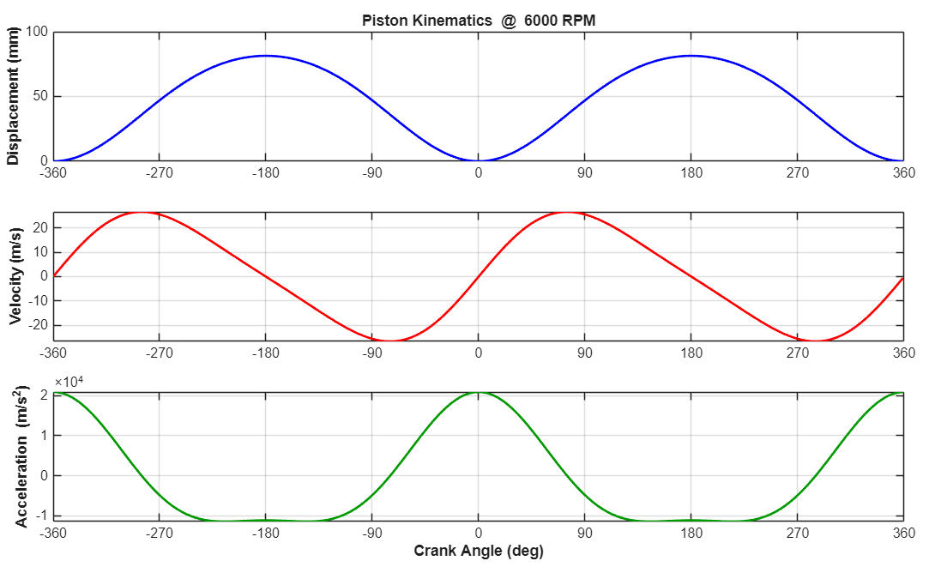
With R = 40.7 mm, L = 134 mm and λ = 0.304, peak acceleration at 6000 RPM reaches 21,000 m/s^{2.}. Figure 1 shows the full kinematic profile, the asymmetry between TDC and BDC confirms non-simple harmonic motion as the second order term alternately adds and opposes the first.

3.2 Forces
Forces were calculated at each crank angle using:
$$Fnet=Fgas-Finertia$$
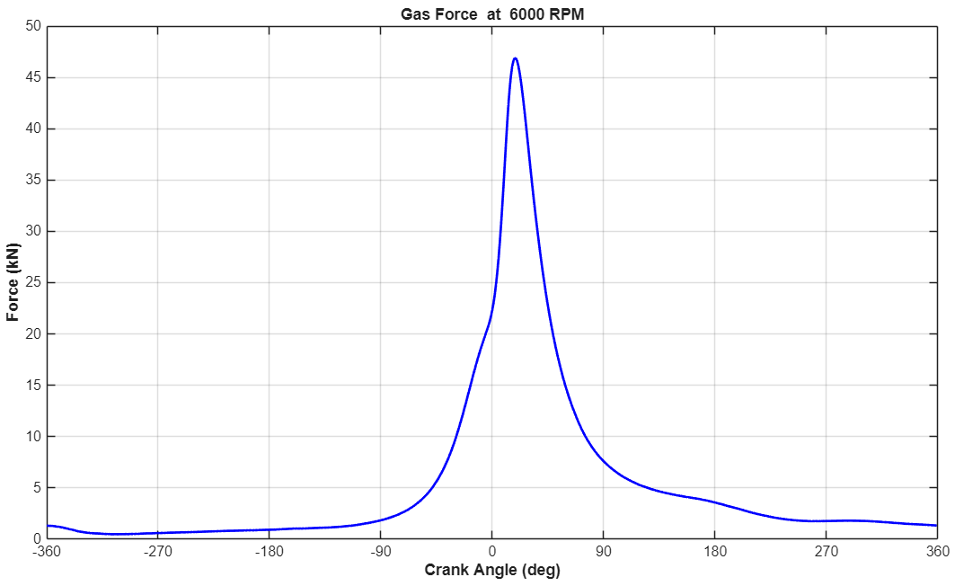
Peak gas forces reach 46.7kN approximately 18° ATDC. Figure 2 shows the gas force at 6000 RPM. The net force (figure 3) confirms inertia force grows with w² and becomes increasingly dominant at higher RPM (Xu, et al., 2024)
Figure 2 – Gas forces at 600RPM
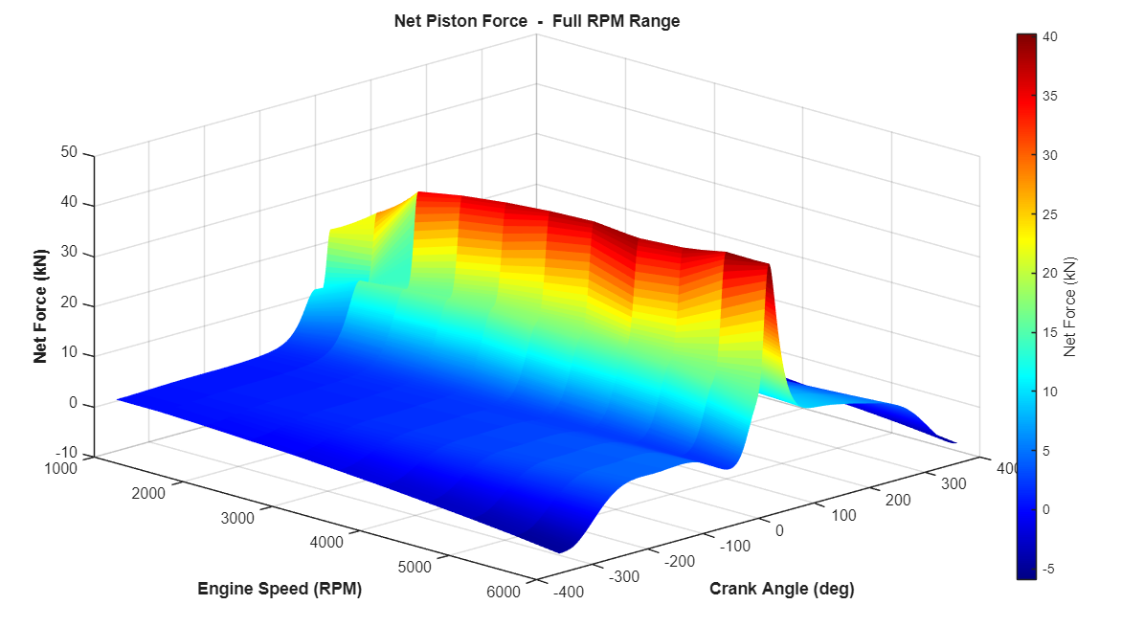
Figure 3 – Net force at full RPM range.

3.3 Connecting Rod Midpoint Stress

Axial stress at the conrod midpoint was calculated directly from the net force:
$$σ_{comp}= \frac{{-F}_{net}}{A}$$

Where A = 196.39 mm². The negative sign reflects compression during combustion. During inertia phase the stress reverses to tension, this cyclic reversal governs fatigue life at this location (Witek & Zelek, 2019).

3.4 Gudgeon Pin Stress at Point A

The inertia force acting on the pin assembly was calculated using:

$$F_{net}=F_{gas}-F_{pininertia}$$
$$F_{pininertia}=MRω^{2}\left(cosθ+\frac{R}{L}cos2θ\right)$$

Where M includes piston, rings, circlips and exposed pin mass. The bending moment at Point A was found from:
$$M_{max bending}=\left(\frac{F_{net max}}{2}×L2\right)$$

Where L2 = 7.75 mm. The second moment of area for the hollow pin section was determined using:
$$I= \frac{π}{64}×\left({D2}^{4}-{D1}^{4}\right)=8423{mm}^{4}$$

Bending stress was then calculated from:
$$σb=\frac{My}{I}$$
Where y = 10.5 mm. The pin cycles between downward bending during combustion, placing the upper face in compression, and upward bending during the inertia phase as the piston assembly pulls away. This cyclic reversal combined with direct shear across the pin cross-section defines the fatigue loading at Point A (GmbH, 2010).

3.5 Connecting Rod Bolt Stress
Preload stress = 0.60 X UTS = 660 MPa. When the engine is running, the inertia tensile force causes additional bolt loading above the preload. Bolt and cap stiffnesses were calculated using:
$$K=ε\frac{A}{L}$$
The extra force carried by the bolt was determined from:
$$F_{extra bolt}= \frac{F_{inertia bolt} K_{bolt}}{\left(K_{bolt}+ K_{cap}\right)}$$
Only the inertia tensile force acts to separate the cap from the rod, during combustion the cap is pressed onto the rod and bolt load remains at preload. Thread stress concentration Kt = 2.31 was applied to the alternating stress amplitude only using Roark’s U-notch formula (Li, Zhou, & Zhang, 2025):
$$K_{t}=C_{1}+C_{2}\left(\frac{2h}{D}\right)+C_{3}{\left(\frac{2h}{D}\right)}^{2}+C_{4}{\left(\frac{2h}{D}\right)}^{3}$$
Increasing the ratio Kcap/Kbolt reduces the extra force carried by the bolt above preload, directly reducing stress amplitude and improving the fatigue safety factor.
Component | Max stress  (MPa) | Min stress  (MPa) | Mean stress  (MPa) | Actual range  (MPa) | FSF | Allowable range (MPa)
Conrod Midpoint | 30.292 | -205.977 | -87.843 | 236.268 | 2.854 | 674.353
Gudgeon Pin (point A) | 55.111 | -149.108 | -46.998 | 204.219 | 3.651 | 745.575
Connecting Rod Bolt | 693.126 | 646.874 | 670 | 46.252 | 1.525 | 70.526
Table 1 – Fatigue Stress Results Summary at 6000 RPM.

4.0 Fatigue Safety Factor Analysis
The goodman criterion was applied to each component using:
$$σallowable=2σ end-lim×\left(1-\frac{σmean}{UTS}\right)$$
$$FSF= \frac{σAllowable}{σRange}$$

4.1 Conrod Midpoint
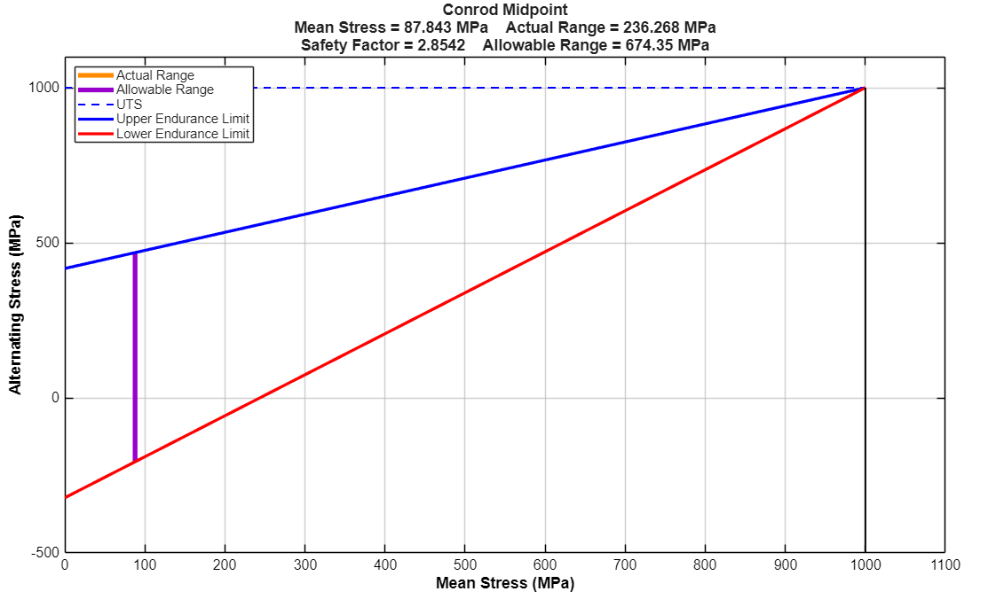
An FSF of 2.85 confirms the conrod midpoint is safe for infinite life, though the substantial margin suggests over engineering relative to applied loading. The actual stress range of 236.3MPa is considerably lower than the allowable range of 674.4MPa, with the operating point sitting close to the Y-axis at a mean stress of 87.8 MPa. The true mean stress is -87.8 MPa, confirming the rod spends most of the cycle under compression with tension occurring only briefly during the inertia phase. (Gao, et al., 2022) noted that large safety margins indicate design redundancy reducible through geometry optimization without compromising reliability.
Figure 4 – Goodman Diagram, Conrod Midpoint.

4.2 Gudgeon Pin
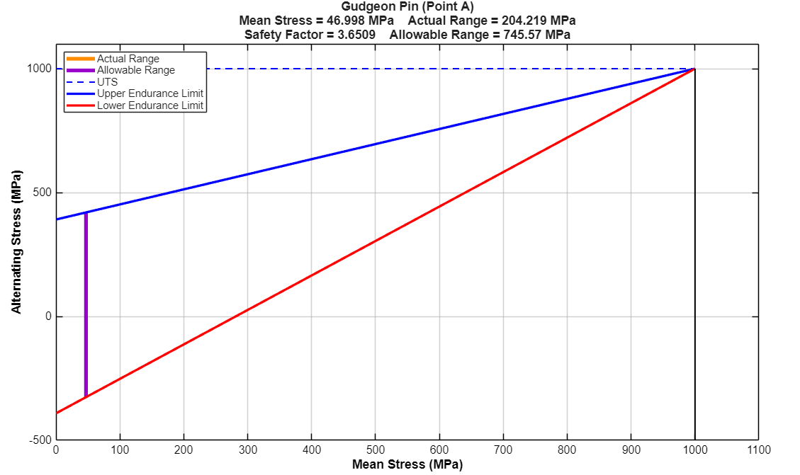
The pin returns the highest FSF of 3.65, the actual range of 204.2 MPa against an allowable range of 745.6 MPa places the operating point very close to the Y-axis at a mean stress of 47 MPa, reflecting a predominantly alternating load cycle with minimal mean stress contribution. (Savaripour, Hosseini, Farhani, & Akbari, 2025) identified the piston pin interface as a critical stress concentration region, justifying the conservative design margin. The elevated FSF also accounts for side loading and thermal effects not captured in this analysis.
Figure 5 – Goodman Diagram, Gudgeon Pin

4.3 Connecting Rod Bolt
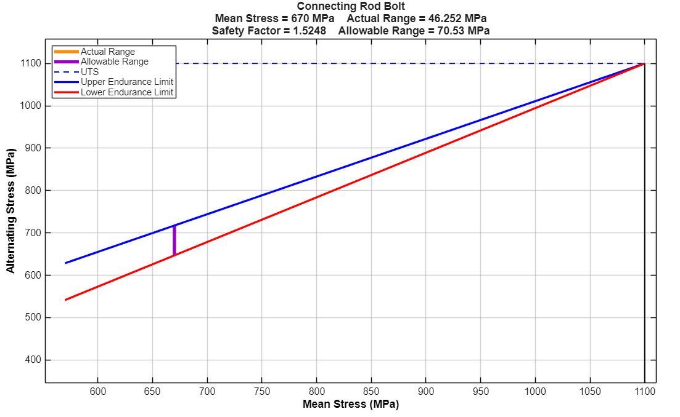
The bolt is the critical component with only 52% margin above the fatigue threshold. Unlike the conrod and pin, the bolt operates with a high positive mean stress of 670 MPa, driven almost entirely by the 660 MPa preload, places the operating point far to the right of the Goodman diagram at 61% of UTS, reducing the allowable alternating range to just 70.5 MPa against an actual range of 46.3 MPa. The narrow gap between UEL and LEL lines at this position on the diagram graphically illustrates why the bolt is critical. The thread stress concentration Kt = 2.31 further amplifies the alternating amplitude, without Kt the FSF would be noticeably higher. (Li, Zhou, & Zhang, 2025) demonstrated that preload has a significant influence on bolt FSF, and this is clearly reflected here. Whilst safe at 6000 RPM, the narrow margin makes the bolt the component most vulnerable to any increase in engine speed.
Figure 6 – Goodman Diagram, Connecting Rod Bolt.

4.4 Critical Comparison
All three FSF values exceed 1.0 confirming safe infinite life at 6000 RPM, however, the disparity between the bolt FSF of 1.52 and the pin FSF of 3.65 highlights a design imbalance. (Mohamed Faisal & Athisayam, 2026) note that components with high FSF values represent opportunities for mass reduction, while those approaching 1.0 require redesign or material upgrades.

5.0 Extension to 9000 RPM
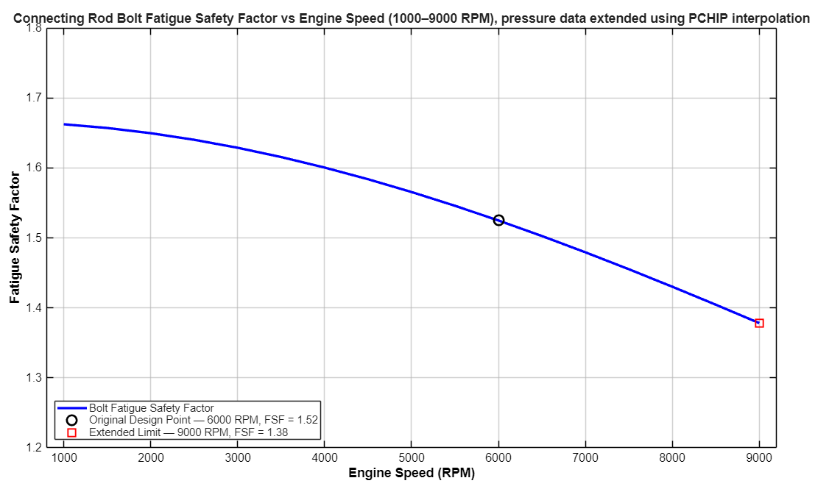
Cylinder pressure data was supplied up to 6000 RPM. To extend the analysis to 9000 RPM, PCHIP interpolation was applied across the full pressure data set at each crank angle. PCHIP was selected as it is shape-preserving, guarantees monotonicity between data points and prevents oscillation that would produce physically unrealistic pressure values.
Figure 7 – Connecting Rod Bolt Fatigue Safety Factor vs Engine Speed (1000-9000 RPM), pressure data extended using PCHIP interpolation.
RPM | Mean Stress (MPa) | Stress Range (MPa) | FSF
1000 | 660.00 | 8.226 | 1.658
2000 | 660.06 | 8.980 | 1.644
3000 | 660.21 | 16.422 | 1.624
4000 | 660.70 | 27.610 | 1.589
5000 | 663.11 | 40.967 | 1.558
6000 | 671.74 | 54.282 | 1.525
7000 | 673.61 | 62.954 | 1.479
7500 | 675.63 | 72.269 | 1.455
8000 | 677.78 | 82.226 | 1.430
8500 | 680.07 | 92.825 | 1.405
9000 | 682.50 | 104.067 | 1.378
Table 2 – FSF vs RPM Results Table

5.1 Critical Analysis
The FSF declines smoothly from 1.66 at 1000 RPM to 1.38 at 9000 RPM. Between 6000 and 9000 RPM alone the stress range increases by 91.6%, from 54.3 MPa to 104.1 MPa, whilst mean stress increases only marginally from 660 to 682.5 MPa. This confirms alternating amplitude is the dominant fatigue drive at high RPM, driven by ω² relationship between inertia force and engine speed. (Xu, et al., 2024) demonstrated that stress amplitude increases consistently with engine speed, clearly evidenced here. Whilst the FSF remains above 1.0 across all full range, the declining trend and narrow margin of 1.38 at 9000 RPM provides a clear motivation for redesign.

6.0 Connecting Rod Bolt Redesign
The redesign objective was to recover the FSF at 9000 RPM to the original 6000 RPM baseline of 1.52. Two design changes were investigated, wasted shank geometry and material upgrade, consistent with the design improvement approaches outlines by (Witek & Zelek, 2019) and (Gao, et al., 2022).
Wasted Shank Concept
The bolt shank was split into three sections:
- Section 1 – full diameter under head.
- Section 2 – reduced wasted shank diameter.
- Section 3 – thread engagement section.
Reducing the wasted shank diameter reduces total bolt stiffness K bolt, which reduces the load sharing factor:
$$F_{extra bolt}=\frac{F_{inertia bolt}K_{bolt}}{\left(K_{bolt}+K_{cap}\right)}$$
A smaller K bolt mean less of the external separating force is carried by the bolt above preload, reducing the stress amplitude and improving the FSF.

6.1 Material Constraint
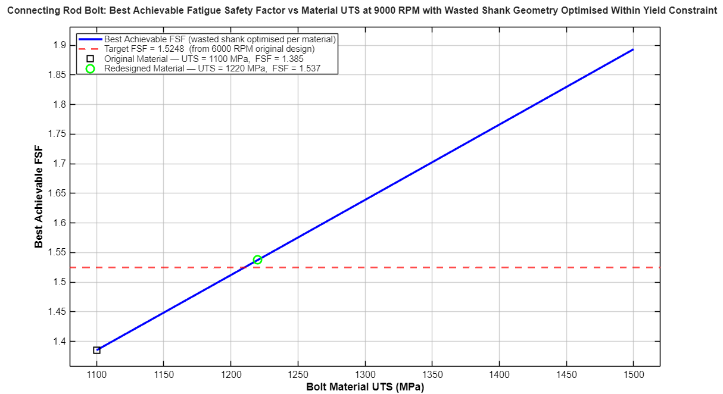
The minimum wasted diameter is constrained by yield; the section must carry the full preload without yielding. With the original material (UTS = 1100MPa, Sy = 990 MPa) the minimum diameter is 6.001mm, leaving less than 1mm of design freedom. The best achievable FSF within the range is only 1.385, insufficient to meet the target of 1.52. A material upgrade is therefore necessary.
Figure 8 - Connecting Rod Bolt: Best Achievable Fatigue Safety Factor vs Material UTS at 9000 RPM with Wasted Shank Geometry Optimised Within Yield Constraint

6.2 Final Redesign
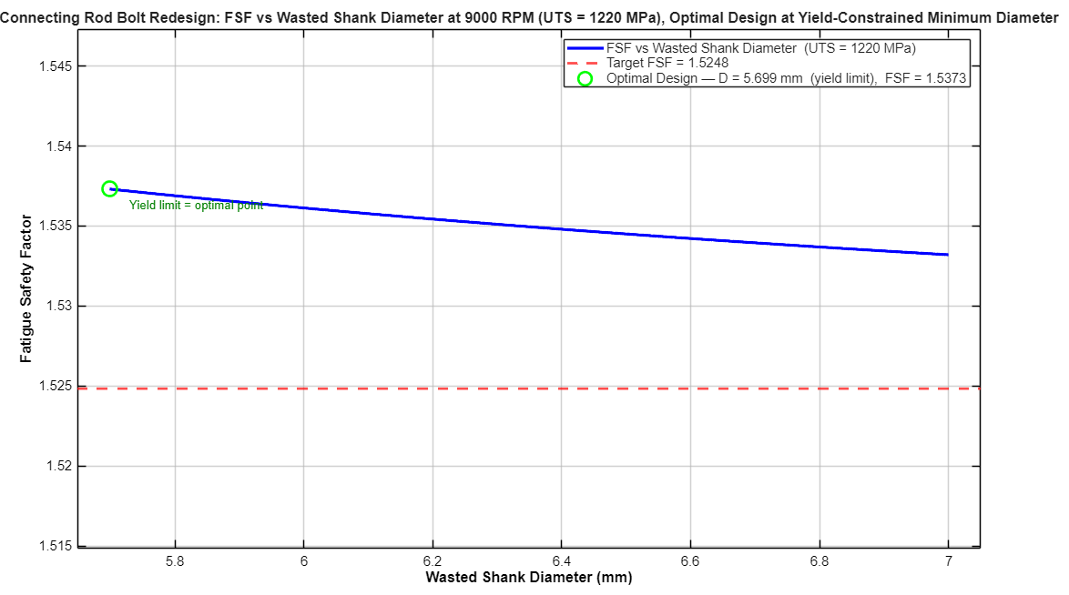
A minimum UTS of 1220 MPa (grade 12.9) was identified as the threshold to achieve the target FSF. At this UTS the minimum wasted diameter reduces to 5.699 mm, opening sufficient geometric design space.
Figure 9 - Wasted Shank Bolt Redesign @ 9000 RPM — FSF vs Wasted Section Diameter (UTS = 1220 MPa)
Parameter | Original | Redesigned
Material UTS (MPa) | 1100 | 1220
Yield strength (MPa) | 990 | 1098
Endurance limit (MPa) | 495 | 549
Shank diameter (mm) | 7.00 | 5.699
Load sharing factor | 0.2128 | 0.2058
Mean stress (MPa) | 670 | 681.8
Actual range (MPa) | 46.3 | 100.6
FSF at 9000 RPM | 1.3782 | 1.5373
(Table 3 – Redesign Comparison Table)

6.3 Critical Analysis
The achieved FSF at 9000 RPM is 1.5373, exceeding the target of 1.52. Neither change alone is sufficient, the material upgrade is required to open the geomatic design space, and the wasted shank is required to reduce the load sharding factor. The wasted diameter of 5.699 mm represents 81.4% of the full bolt diameter. It should be noted that kt = 2.31 is assumed unchanged throughout. In practice Grade 12.9 bolts typically use rolled threads which produce a smoother root radius, reducing Kt and providing additional FSF margin not captured here (Gao, et al., 2022).

7.0 Torque Analysis
Instantaneous crank torque was calculated at each angle using by summing gas and inertia torque contributions:
$${Torque}_{Gas}=\left(Gas Force×tan∅×Rcosθ\right)+\left(Gas Force×Rsinθ\right)$$
$$Torque Inertia=Inertia Force×tan∅×Rcosθ-Inertia Force×Rsinθ$$
$$Crank Torque=Torque Gas+Torque Inertia$$
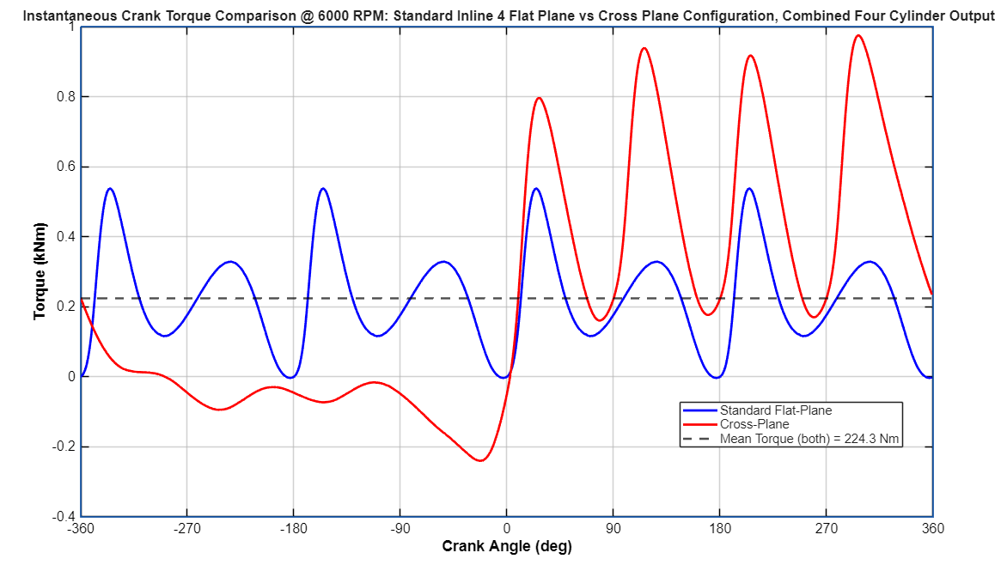
Summed across all four cylinders with firing offsets of 0°, 180°, 360°, 540° for flat plane and 0°, 270°,180°,90° for cross plane. Results are presented in Figure 10 and Table 4.
Figure 10 - Instantaneous Crank Torque: Flat-Plane vs Cross-Plane Inline-4 @ 6000 RPM
Metric | Flat plane | Cross plane
Firing offsets (deg) | 0, 180, 360, 540 | 0, 270, 180, 90
Mean torque (Nm) | 224.3 | 224.3
Max torque (Nm) | 537.7 | 975.0
Min torque (Nm) | -3.1 | -239.8
Peak to peak (Nm) | 540.8 | 1214.8
P-P ratio | 1.0x | 2.25x
(Table 4 – Torque results)

7.1 Critical Analysis
Mean torque is identical at 224.3 Nm for both configurations, independent of firing order. The flat plane produces a peak-to-peak variation of 540.8 Nm whilst the cross plane reaches 1214.8 Nm, 2.25 time higher with a minimum of -239.8 Nm as the crank actively decelerates during the 270° firing gap. The flat plane is clearly the correct choice for this application, producing smooth torque delivery and low NVH. The cross plane’s higher variation would require a heavier flywheel and increases crankshaft bearing fatigue loading.

8.0 Conclusion
At 6000 RPM all three components are safe for infinite fatigue life. The bolt is the critical component at FSF = 1.52, whilst the conrod (2.85) and gudgeon pin (3.65) both show significant design margin suggesting over engineering at standard operating conditions.
Extending to 9000 RPM confirms the bolt as the limiting component as the FSF decline to 1.38. The redesign successfully recovers the target FSF through a wasted shank geometry combined with a Grade 12.9 material upgrade, neither change alone was sufficient doe to the yield constrained design space.
The flat plane crankshaft produces less than half the torque variation of the cross-plane alternative, confirming its suitability for this passenger car application.

References
Carjova, K., Priednieks, V., Klaucans, R., Irbe, I., & Urbahs, A. (2021). Fractographic study of marine diesel engine connecting rod stud bolt crack. Latvian Journal of Physics and Technical Sciences, 28-42.
Gao, W., Wang, G., Zhu, J., Fan, Z., Li, X., & Wu, W. (2022). Structural Optimization Design and Strength Test Research of Connecting Rod Assembly of High-Power Low-Speed Diesel Engine. Machines, 815.
GmbH, M. (2010). Cylinder Components Properties Applications Materials. Vieweg and Teubner.
Ismail, I., Abdelrazek, E., Ismail, M., & Emara, A. (2021). Enhancing the Durability of Connecting Rod of a Heavy-Duty Diesel Engine. International Journal of Automotive and Mechanical Engineering, 8728–8737.
Li, J., Zhou, F., & Zhang, A. (2025). Analysis of the influence of geometric accuracy on the preload and stress of engine connecting rod bolts. Scientific Reports, 1-15.
Mohamed Faisal, M., & Athisayam, A. (2026). Structural Optimization and Fatigue Life Assessment of Connecting Rod Using Topology Optimization and Finite Element Analysis. EPJ Web of Conferences.
Savaripour, H., Hosseini, S. A., Farhani, F., & Akbari, M. (2025). Finite element analysis of fatigue in the connecting rod of a spark ignition engine based on results of combustion tests. Proceedings of the Institution of Mechanical Engineers Part D Journal of Automobile Engineering, 1-12.
Witek, L., & Zelek, P. (2019). Stress and failure analysis of the connecting rod of diesel engine. Engineering Failure Analysis, 374–382.
Xu, W., Le Roux de Bretagne, O., Grasso, M., Harrison, M. F., Carless, O., & StLeger-Harris, C. (2024). On a numerical methodology to assess the fatigue life of connecting rods. Proceedings of the Institution of Mechanical Engineers Part D Journal of Automobile Engineering, 3232–3241.

