how does a leader engage in the change process?
Leadership and Change BMSW6010

ALLISON CULLEN (2218746)
Submission Date: Friday 29th November 2024

Contents

1.0 Introduction 1
1.1 Report Remit 1
1.2 Context 1
2.0 Task One 2
2.1 Leadership Style 2
2.2 Chosen Leadership Style 3
2.2.1 Positive Impacts 3
2.2.2 Negative Impacts 4
3.0 Task Two 4
3.1 Change Model 4
3.2 Chosen Change Model 5
3.2.1 Comparison 6
3.3 Change Process 6
4.0 Task Three 7
4.1 Leadership and Change 7
4.1.1 Successes 7
4.1.2 Failures 7
5.0 Conclusion 8
6.0 References 9

List of Figures
Fig 2.1.1 Lewin’s Leadership Triangle
Fig 3.11 Lewin’s Three-Step Model

1.0 Introduction

1.1 Report Remit
The University of Wales Trinity Saint David requested this report it was asked for on the 25th of September, 2024. To give an insight and evaluate a change management process that has taken place over the last three years. This report was compiled from various academic books, articles, and journals to study the challenges and the outcomes. This report will examine Mark Zuckerberg's leadership styles and organisational behaviours and how he has influenced employees and organisational culture. This report will clarify the difficulties of the change management process.

1.2 Context
Mark Zuckerberg, born on May 14, 1984, in White Plains, New York, is a U.S. entrepreneur and co-founder of Facebook (now Meta Platforms). He was interested in computers and learned to program as a teenager. While at Harvard University, he launched Facebook in 2004 with co-founders Eduardo Saverin, Andrew McCollum, Dustin Moskovitz, and Chris Hughes to help students connect. The platform quickly expanded to other universities and was eventually opened to the public. (Howell and Wanasika, 2019).
Zuckerberg left Harvard to create Facebook, the largest social network by 2012, connecting 1.86 billion users. Over the years, the company has developed other platforms like Instagram, Threads, and WhatsApp.(Haupt, 2021).
In October 2021, Facebook rebranded as Meta to emphasise its focus on the metaverse, moving toward immersive experiences like augmented and virtual reality. Zuckerberg expressed that the metaverse would succeed the mobile internet, enabling genuine presence and new forms of self-expression. Reality Labs (2021) In January 2024, Meta announced it was training Llama 3, its latest generative AI model, aiming for artificial general intelligence (AGI). Zuckerberg stated, “Our long-term vision is to build general intelligence, open source it responsibly, and make it widely available.” (Law, 2024, N.P).

2.0 Task One

2.1 Leadership Style
As stated by Bradfield Learning and Development (2023). A leader's style is demonstrated in their engagement when working with the team, which helps significantly with the team's dynamics. This impacts how well team members collaborate and communicate, therefore influencing the organisation’s overall effectiveness and success. Modifying the leadership is important for cultivating an encouraging atmosphere for every team associate.
According to Lewin (1999), autocratic, democratic, and laissez-faire leadership styles are viewed as a triangle. How autocratic and democratic styles share similarities in structure and discipline. Democratic and laissez-faire styles offer individual flexibility, allowing associates to follow their objectives and how to make decisions based on personal motives rather than solely following authority.
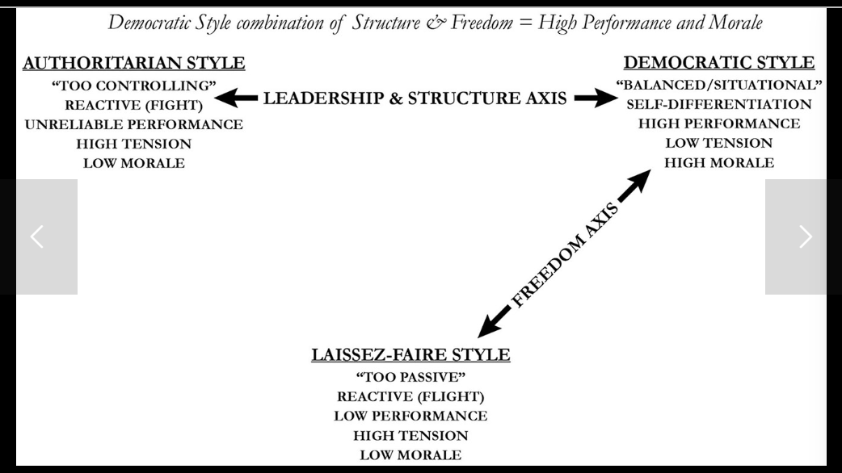
Figure 2.1.1 Lewin Leadership Style Triangle (Lewin, 1999).
His leadership and transformation ideas are required for Organisational Development to help implement change, encourage positive cultures, and boost employee engagement. OD professionals implement assessments, coaching, and workshops led by theories such as Lewin’s field theory and the leadership triangle. (Crosby, 2021)
Burns (1978) published his pivotal book, Leadership, which called for a new focus on leadership. He drew attention to the reliance on transactions. He introduced the concept of transforming leadership, aiming for an extreme change in the social system and a switch in attitudes, norms, and behaviours that shape daily life (Bruce and Mckee, 2020). Transformational Leaders are forward-thinking and aim to convey substantial change. This leads to improved performance but demands a leader capable of developing trust and dedication (Alqatawenh, 2018).

2.2 Chosen Leadership Style
Mark Zuckerberg's approach to leadership incorporates aspects of both visionary and transformational styles combined with a decisive and, at times, risk-taking manner that is typically linked to autocratic characteristics (Eaton et al., 2023).
Crawford (2023) describes that the founder and CEO, Zuckerberg, demonstrates visionary leadership by maintaining a precise determination, a positive mindset, and a pursuit of innovative solutions while visualising the company’s future direction. His vision concentrates on using technology to connect individuals and foster meaningful experiences. A vital element of this approach is establishing ambitious goals and motivating employees to strive toward a shared vision.
Luqman et al. (2020) Explained that Zuckerberg’s attitude to transformational leadership is seen in his talent for inspiring, motivating, and empowering staff to perform at their best in the organisation’s achievements. He promotes innovation, questions established norms and nurtures an environment of ongoing learning and development. A vital element of this leadership style is inspiring and influencing employees to exceed their existing limits and accomplish outstanding outcomes.
Zuckerberg frequently opts for a top-down approach in decision-making, demonstrated by the abrupt rebranding to Meta and significant investments in metaverse technology. This autocratic leadership style has sometimes resulted in a varied response within the company, as certain employees felt excluded from the decision-making process (Carter and Egliston, (2024) was a good source of information.
Zuckerberg demonstrates adaptability as a leader, recognising the need to adjust to changing circumstances in a fast-paced industry, addressing challenges, welcoming new trends, and directing the company toward different paths. A vital element of this approach is being adaptable and reactive to technological progress and changes in the market (Demir, 2022).

2.2.1 Positive Impacts
Mark Zuckerberg's vision has positioned Meta as a virtual and augmented reality leader. Emphasising metaverse technology allows Meta to stay competitive by creating an immersive digital experience. Zuckerberg’s ability to make quick decisions enables expert resource allocation, accelerating innovation associated with Zuckerberg's vision for future social interactions. Meta's responsibility to new technologies sets it apart from rivals, providing opportunities to change online interactions and establish a distinct market position. (Deloitte Digital, 2024).

2.2.2 Negative Impacts
Financial tension in Metaverse investments due to uncertain advertising revenue has led to investor dissatisfaction and harmed staff morale at Meta. This decline in workplace culture has resulted in layoffs and a disconnection from the company's mission. Investor doubts have negatively impacted Meta's stock performance, with shares dropping 19% in April 2024, prompting stakeholders to reassess future strategies and investments in metaverse technology.
Zuckerberg’s leadership has made Meta a pioneer in immersive technology, but more consideration of incorporating employee and stakeholder input could enhance trust and morale. While visionary leadership can drive innovation, it holds risks when significant decisions are made without consultation (Taylor, 2021).

3.0 Task Two

3.1 Change Model
Change models are essential contexts that help organisations plan, implement, and sustain changes to achieve specific outcomes. These models provide structured procedures that address the challenges of organisational transformation. Leaders who use these models are better equipped to manage and reduce resistance. Gaining acceptance of the vision from all employees and stakeholders is crucial for the change's success. Leaders need to create a clear and accepted vision to make effective changes. They should set measurable aims and develop a strategy to help the organisation's goals (Errida and Lotfi 2021).
Other change models, like Kotter’s Eight Steps and ADKAR, offer different views and practices in a changing context. While these frameworks share common principles—such as the importance of communication and stakeholder commitment they vary in difficulty, flexibility, and importance. Acknowledging their limitations, such as oversimplification or a linear approach, organisations often integrate elements from multiple models to suit their needs and situations better. However, Lewin’s change model will be used for this essay (Haas et al., 2019).

The Kurt Lewin change theory model consists of a three-step process (Unfreeze-Change-Freeze) that provides a framework for implementing change. It helps managers to implement significant changes, minimise operational disruption, and ensure lasting adoption of the change. This model emphasises the importance of gaining acceptance from individuals for successful change, as it involves introducing new processes and reassigning tasks (Memon, 2021).
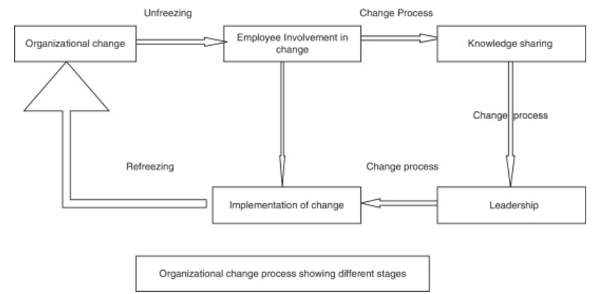
Fig 3.1.1. The three-step model: The arrows indicate stages of Kurt Lewin's model, not the relationships between employee behaviour, culture, resistance, leadership, communication, and performance outcomes. Sage, (2004).

3.2 Chosen Change Model
Kurt Lewin's three-step change model serves as a plan for change management, breaking down the change process into a structured approach to comprehending and executing change while meeting the psychological and behavioural adjustments required for lasting transformation (Burnes. 2020).
The first phase involves preparing the organisation for change by looking at the current situation. This includes creating a convincing plan that shows why existing practices are inadequate, and this will often be supported by evidence like declining sales or low customer satisfaction. This stage is usually the hardest, as challenging established practices can create instability, resistance and a fear of change (Bell, 2024).
Preet (2021). Changing the existing situation means that the change process can begin. Organisational change is complex and often requires a problem-solving approach to explore options. It is necessary that companies effectively communicate the change to employees, deal with misunderstandings, and explain the benefits. Employee engagement and support are essential, as small successes can build momentum for further achievements.
During organisational change, employees transition to a final stage of 'refreezing,' stabilisation. For this change to be effective, leaders must insert it into the organisational culture; otherwise, employees may revert to old behaviours. To ensure sustainable change, organisations can know early adopters, gather employee feedback, and provide on-demand training and support (Malik, 2022).

3.2.1 Comparison
ResearchGate (2019) The Lewin’s model provides an understanding of change but lacks the necessary feedback on procedures and cultural issues that are current for organisations today. The Kotter model covers problems such as emphasising stakeholder engagement and continuous improvement. However, it is resource-intensive, making it unsuitable for small-scale changes. Combining Lewin’s simplicity in planning with Kotter’s focus on communication and culture can create a practical approach to organisational change.

3.3 Change Process
Zuckerberg's leadership style has strengths and weaknesses when compared to Lewin’s framework.
Unfreeze Stage
Zuckerberg effectively challenges established norms, as seen in his rebranding of Facebook to Meta in 2021, which started the shift towards The Metaverse. This aligns with Lewin's unfreeze stage; he was unsatisfied with the current state and encouraged investors to be open to change. However, his abrupt introduction of these changes has led to resistance from stakeholders and employees, indicating that a more gradual approach could improve engagement (Anjum et al., 2024).
Changing Stage
During this transition, Zuckerberg had to consider new processes regarding his focus on Metaverse Virtual Reality and Augmentative reality technology. He thinks creatively and does things outside the confines of bureaucracy compared to other organisations. He sometimes engages productively with his employees on projects and provides direct feedback. This can motivate employees. However, successful change depends on clear and inclusive communication, which can be sometimes overlooked in Zuckerberg's top-down approach, leading to misunderstandings. (Eaton et al., 2024).

Refreezing Stage
Hussain. et al.(2018); this source was helpful in the refreezing phase. Zuckerberg's record is mixed. He strives to maintain stability, but many employees left Metaverse during the change process. This phase suggests that he needs more sustainable inclusion methods for lasting success. While his innovative approach allows rapid adaptation, more structured unfreezing and refreezing strategies could help reduce disruption and improve stakeholder engagement.

4.0 Task Three

4.1 Leadership and Change
Mark Zuckerberg's leadership has influenced the transformation of Meta over the past three years, especially regarding the company's rebranding from Facebook to Meta. Zuckerberg’s progressive, transformative leadership style has served well as a promoter of innovation.

4.1.1 Successes
Zuckerberg has driven Meta's transformation from a social media company to one focused on the Metaverse, a virtual world combining augmented reality (AR) and virtual reality (VR). In 2021, he stated, "The Metaverse is the next significant chapter of the technology industry" (Poore, 2023). Over the next decade, the Metaverse will introduce 3D holograms and touch sensations to digital interactions. Currently, users are reaping the benefits of virtual travel while still enjoying video games and exploring fictional worlds (ibid). Meta has invested heavily in this vision by acquiring VR companies and developing Oculus headsets. Despite some scepticism, this investment positions Meta as a leader in VR and AR innovation (ibid).
Meta’s core platforms, Facebook, Instagram, and WhatsApp, have surpassed 3 billion daily active users in 2024, reflecting a robust business model, particularly in developing regions. AI investments have enhanced ad-targeting, increasing user engagement and retention by 8% on Facebook and 6% on Instagram. Meta AI assists in customising content to user preferences, while Instagram’s Reels and short videos have driven engagement and ad revenue, showcasing Zuckerberg’s responsiveness to market trends. (Zourmpanos, 2024)

4.1.2 Failures
The decline in Trust and Regulatory Study Meta has faced significant challenges regarding privacy and user trust. The company has dealt with issues related to data privacy, misinformation, and harmful content, leading to lawsuits in the U.S. and Europe over the past three years (Goodchild, 2024). Its management of privacy rules during the pandemic and the 2020 U.S. election damaged its reputation, and concerns from the Cambridge Analytica scandal further harmed public opinion about Zuckerberg's leadership (ibid).
Meta experienced its first quarterly revenue decline due to a slowing advertising market, increased competition from TikTok, and Apple's iOS changes. The company struggled to maintain profitability, resulting in 11,000 layoffs (13% of its workforce). Following poor results, Meta's share price dropped by 25%, erasing $80 billion in value, while Reality Labs reported over $58 billion in operating losses since 2020 (Vanian, 2024).
In 2020, Instagram launched a short-form video feature seen as a response to TikTok, which CEO Mark Zuckerberg acknowledged as a significant competitor (Milmo, 2024). Data from Sensor Tower shows that Instagram has around 1.5 billion active users monthly, while TikTok has nearly 1.1 billion. However, TikTok users are more engaged, averaging 95 minutes daily on the app than Instagram's 62 minutes (ibid).

5.0 Conclusion
Leadership involves influencing people to work toward a common goal and connecting employees with an organisation's future. Mark Zuckerberg exemplifies this as he navigates the tech industry with his vision for the metaverse, a virtual reality user interaction space. His innovative leadership has positioned Meta (formerly Facebook) as a key player despite criticisms about his approach's lack of balance and inclusivity. While his vision enables adaptation and growth, it raises concerns about data privacy and misinformation. Ultimately, Zuckerberg's ability to tackle complex challenges fosters important discussions about effective leadership in challenging times.

6.0 References

Alqatawenh, A.S. (2018) ‘Transformational leadership style and its relationship with change management’. Verslas: teorija ir praktika, 19(1), pp.17-24.
Anjum, N., Rahaman, M.S., Salemzadeh, A., Rahman, M.M. and DANA, L.P., (2024) ‘Adapting & mitigating employee resistance to change: Contrasting Adkar and Kurt Lewin’s three steps change model’. Journal of Entrepreneurship and Business Resilience, 7(1), pp.63-91.
BBC News, (2022) Facebook owner Meta in the first ever sales fall. Available at: https://www.bbc.co.uk/news/business-62322862/ (Accessed: 22nd November 2024).
Bell, M. (2024) Lewin’s Change Management Model. Available at: https://www.mindtools.com/ajm9l1e/lewins-change-management-model/ (Accessed: 15th November 2024).
Bradfield Learning and Development (2023) ‘What is the difference between leadership and management’. According to CIPD? Available at: https://bradfield.co.uk/difference-between-leadership-and-management-according-to-cipd/. (Accessed: 9th November 2024).
Bruce, J.A. and Mckee, K.E. (2020) Transformative leadership in action : allyship, advocacy & activism. Bingley, England: Emerald Publishing.
Burnes, B. (2020). The Origins of Lewin’s Three-Step Model of Change. The Journal of Applied Behavioral Science, 56(1), 32-59. https://doi.org/10.1177/0021886319892685/ (accessed: 20th November 2024).
Carter, M. and Egliston, B., (2024) Fantasies of virtual reality: Untangling fiction, fact, and threat. London. MIT Press.
Crawford, J. (2023) Leadership advancing great leaders and leadership. London: IntechOpen. Doi 10.5772/intechopen.104266.
Crosby, G. (2021) ‘Lewin’s Democratic Style of Situational Leadership: A Fresh Look at a Powerful OD Model’, The Journal of Applied Behavioural Science, 57(3), pp. 398–401. Available at: https://doi.org/10.1177/0021886320979810/
Deloitte Digital (2024) The future of Business and Workplace. Metaverse.Available at: https://www.deloittedigital.com/mt/en/insights/perspective/The-Future-Of-Business-And-Workplace.html/ (Accessed: 14th November 2024).

Demir, C. (2022) Career Management via Metaverse. Available at: https://www.researchgate.net/profile/Cagla-Demir-2/publication/369553362/ (Accessed: 14th November 2024),
Eaton, L., Bridgman, T. and Cummings, S., (2024) ‘Advancing the democratisation of work: A new intellectual history of transformational leadership theory’. Leadership, 20(3), pp.125-143.
Eaton, L., Bridgman, T., & Cummings, S. (2024). Advancing the democratisation of work: A new intellectual history of transformational leadership theory. Leadership, 20(3), pp.125-143. https://doi.org/10.1177/17427150241232705/ (Accessed: 16th November 2024).
Errida A, Lotfi B.(2021) The determinants of organisational change management success: Literature review and case study. International Journal of Engineering Business Management. 13. doi:10.1177/18479790211016273.
Goodchild, J.(2024) Facebook at 20: contemplating the cost of privacy. Available at: https://www.darkreading.com/data-privacy/facebook-at-20-contemplating-the-cost-of-privacy/ (Accessed: 22nd November 2024).
Hass, M.R.C. et al. (2019) ‘DidacticsRevolution: Applying Kotter’s 8-Step Change Management Model to Residency Didactics’, The Western Journal of Emergency Medicine, 21(1), pp. 65–70. Available at: https://doi.org/10.5811/westjem.2019.11.44510/ (Accessed: 15th November 2024).
Haupt, J. (2021) ‘Facebook futures’, Mark Zuckerberg’s discursive construction of a better world’. New Media & Society, 23(2), pp.237-257. https://doi-org.ezproxy.uwtsd.ac.uk/10.1177/1461444820929315/.
Howell, J.P., & Wanasika, I. (2019). Snapshots of Great Leadership (2nd ed.) Routledge. Taylor & Francis Group. https://doi.org/10.4324/9781315110066/.
Hussain, S. T. et al. (2018) ‘Kurt Lewin’s change model: A critical review of the role of leadership and employee involvement in organisational change’. Journal of innovation and knowledge, 3(3). pp.123-127. https://doi.org/10.1016/j.jik.2016.07.002/.
Kraus, S., Kanbach, D.K., Krysta, P.M., Steinhoff, M.M. and Tomini, N., (2022) ‘Facebook and the creation of the metaverse: radical business model innovation or incremental transformation’? International Journal of Entrepreneurial Behavior & Research, 28(9), pp.52-77.
Law, M. (2024) ‘Lifetime of Achievement: Mark Zuckerberg’. Available at: https://technologymagazine.com/articles/lifetime-of-achievement-mark-zuckerberg/ (Accessed: 1st November 2024).
Lewin, K. (1999). The Complete Social Scientist. Figure 2.1.1. Washington DC. American Psychological Association.
Luqman, R., Fatima, S., Ahmed, S., Khalid, I. and Bhatti, A. (2020). ‘The Impact of autocratic leadership style on counterproductive work behaviour’. The mediating role of employee commitment and the moderating role of emotional exhaustion. Pollster Journal of Academic Research, 6(01), pp.22-47.
Malik, P. (2022) Lewin Three Stage Model of Change: Overview. Available at: https://whatfix.com/blog/lewins-change-model/ (Accessed: 15th November 2024).
Memon, F.A., (2021). Improving employee’s engagement in change: Reassessing Kurt Lewin’s model. City University Research Journal, 11(1) Available at: https://www.cusitjournals.com/index.php/CURJ/article/view/282/ (Accessed: 15th November 2024).
Milmo, D. (2024) Instagram overtakes TikTok as the world's most downloaded app. Available at: https://www.theguardian.com/technology/2024/mar/08/instagram-tiktok-app-reels-video-meta/ (Accessed: 22nd November 2024).
Northouse, (2004) Leadership: Theory and practice. 3rd ed., Sage. DOI: 10.1016/j.jik.2016.07.002/.
Poore, C. (2023) Leadership in the Metaverse. 1st Ed. New York. Fast Company Press. Available at: https://www.google.co.uk/books/edition/Leadership_in_the_Metaverse/5lcteaaaqbaj?hl=en&gbpv=1/ (Accessed: 17th November 2024).
Preet, S. (2021) Lewin's three-stage Change Model. Available at: https://www.linkedin.com/pulse/lewins-3-stage-change-model-sonal-preet/ (Accessed: 15th November 2024).
Reality Labs (2021) Connect 2021: Our vision for the metaverse. Available at: https://tech.facebook.com/reality-labs/2021/10/connect-2021-our-vision-for-the-metaverse/ (Accessed: 20th November 2024).
ResearchGate (2019) Change Management in Information System Development and Implementation Projects. Available at: https://www.researchgate.net/publication/334736458_Change_Management_in_Information_System_Development_and_Implementation_Projects/ (Accessed 15th November 2024).
Taylor, D (2021) Meta: the good, the bad and the ugly of Facebook’s name change. Available at: https://thebrandgym.com/meta-the-good-the-bad-and-the-ugly-of-facebooks-name-change/ (Accessed: 14th November 2024).
Vanian, J. (2024) Meta’s Reality Labs Post 4.4 Billion Loss in Third Quarter. Available at: https://www.cnbc.com/2024/10/30/metas-reality-labs-posts-4point4-billion-loss-in-third-quarter.html/ (Accessed: 22nd November 2024).
Zourmpanos, Y. (2024) AI Powers Meta’s Strong Growth: Profts. Available at: https://www.forbes.com/sites/gurufocus/2024/11/14/ai-powers-metas-strong-q3-growth-profits-soar/ (Accessed: 16th November 2024).

