3/24/2025
University of Wales Trinity Saint David
London campus
E-Portfolio Link: Do not forget to share your e-portfolio (Wix) link here
Module Name: Learning In the Digital Era
Module Code: ACCA 4025

Student Name: Mohamed Osman
Student ID:2607605
Group: 1

Lecturer’s Name: Koushik Modak

LDE Assignment 1
E-Portfolio
Table of Contents
Introduction 2
Main Body 2
Task 1: Essential Academic and Employment Skills for the future career Path 2
Task 1 (a): Report on Essential Academic and Employment Skills 2
Task 1 (b): AI Assistant Tools 2
Task 1 (c): Evaluation of Task 1 (a) based on Similarity report 3
Task 2: Collaborative Mind Map and Individual Poster 3
Mind Map (Collaborative) 3
Poster (Individual) 3
Task 3: Virtual Collaboration and RefWorks 3
Report on Virtual Collaboration 3
Step-by-step process of using RefWorks with visuals 3
Task 4: E-Portfolio Creation and Evaluation 3
Task 4 (a): E-Portfolio Creation 3
Task 4 (b): Illustrative Review of E-Portfolio tool Selection 4
Conclusion 4
References 4
Task 1 References: 4
Task 3 References: 4

Introduction
The digital world is changing the way people study and work. Digital technology and artificial intelligence (AI) are becoming important in education and many careers. This e portfolio will discuss the academic and employment skills needed for my future career as a Cyber Security Education Specialist. It will also explore different AI assistant tools and explain how they can support learning and work. In addition, I will discuss the importance of developing digital skills and using technology responsibly. Completing this assignment will help me understand the skills I need to improve during my studies and prepare for my future career.

Main Body

Task 1: Essential Academic and Employment Skills for the future career Path

Task 1 (a): Report on Essential Academic and Employment Skills
Studying at university requires different skills to complete assignments and understand new information. I think time management, research, critical thinking and academic writing are some of the most important skills. Time management helps students organise their work and finish assignments before deadlines. Research skills are also important because students need to find reliable information instead of using any website they find online. The University of Oxford [1] provides guidance on study skills, including reading, note-taking and referencing. University College Birmingham [2] also provides advice on academic skills and writing. These skills help students organise their ideas and explain them clearly. Personally, I sometimes find it difficult to manage my time when I have several tasks to complete. I also want to improve my research and referencing skills so that I can use sources correctly in my assignments. I believe that developing these skills will help me become more confident at university and prepare me for my future career.
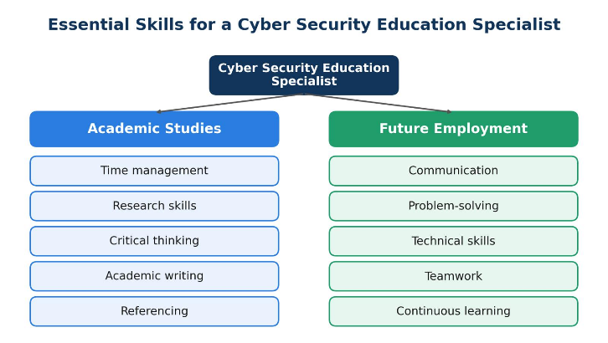
For my future career as a Cyber Security Education Specialist, I will need good communication, problem-solving and technical skills. This career involves explaining online safety to people who may not have much technical knowledge. For example, I may need to teach students or school staff how to recognise phishing emails, use strong passwords and protect their personal information. Zaheri’s cyber security awareness training course [3] covers topics such as phishing, social engineering and password protection. These topics are useful because they show the types of online risks that people need to understand. Calder’s The Cyber Security Handbook [4] explains cyber security threats and how organisations can prepare for and respond to cyber attacks. This knowledge can help me give people useful advice about staying safe online. I will also need patience and teamwork because people learn in different ways. As technology changes, I must continue learning and updating my knowledge. I believe these skills will help me explain cyber security clearly and support others in protecting themselves online.

Task 1 (b): AI Assistant Tools
AI tools are becoming useful in education and everyday life. They help students understand difficult topics, find information and complete tasks. Three popular tools are ChatGPT, Microsoft Copilot and Google Gemini.
ChatGPT is useful for explaining difficult topics and helping with writing. Its answers are easy to understand, especially when I ask for simpler words. For my future career as a Cyber Security Education Specialist, this tool can help me explain online safety to students, such as how to recognise phishing emails.
Microsoft Copilot is helpful for finding information, summarising text and preparing presentations. It also provides links that can help users check information. This makes it useful when preparing learning materials about cyber security.
Google Gemini is good for generating ideas and creating quiz questions. For example, it can help me make a short quiz about phishing and online safety for students.
However, these tools do not always provide correct or detailed answers. Sometimes, I need to ask more questions to get the information I want. I would always check the answers before using them in my assignments or teaching, and I would never share private information with AI tools. I think AI tools can make learning easier, but students still need to think for themselves and check the information they receive.

Criteria | ChatGPT | Copilot | Gemini
Generating answers | Explains phishing in simple English. | Summarises online safety rules. | Explains online safety topics.
Creative work, code/diagram generation | Helps create simple learning materials. | Helps prepare presentations about online safety. | Creates quiz questions for students.
Data analysis | Helps organise information and explain results. | Helps organise and summarise information. | Helps organise information into questions and answers.
Problem-solving | Gives tips to help students recognise phishing emails. | Suggests ways to stay safe online. | Suggests answers to quiz questions.

Figure 1: ChatGPT Explaining Phishing and Online Safety
This screenshot shows how ChatGPT explains phishing in simple English and gives tips to help school students recognise phishing emails and stay safe online. This tool could help me prepare educational materials for my future career as a Cyber Security Education Specialist.
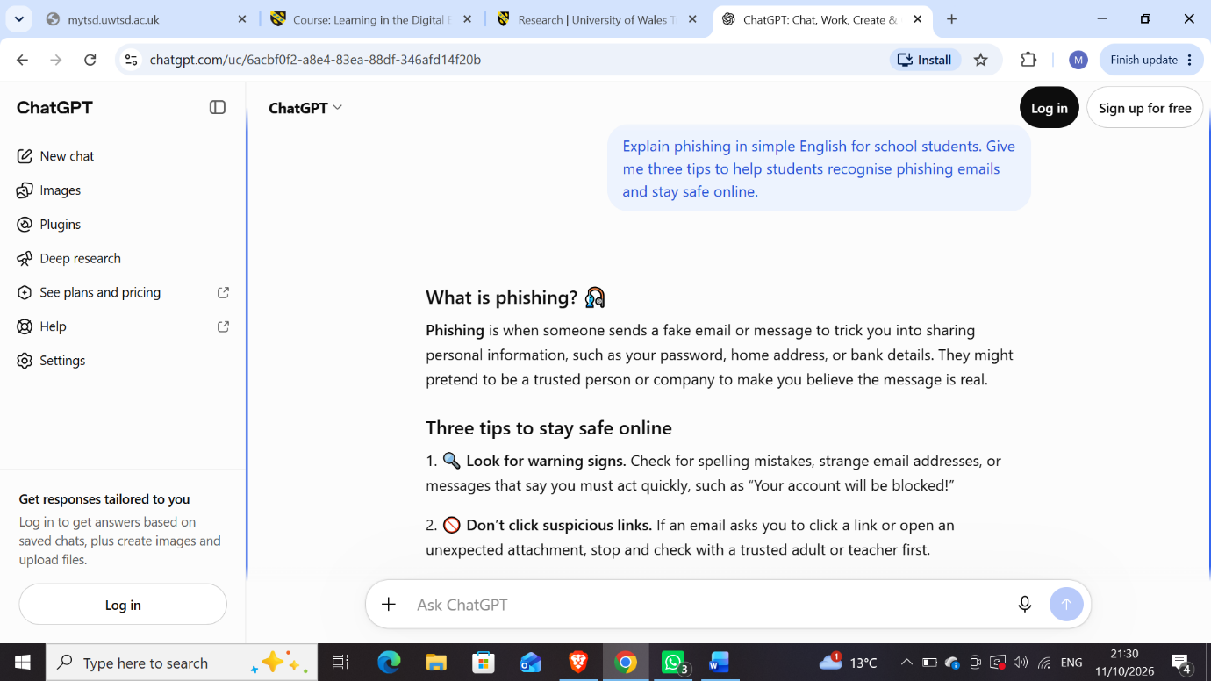
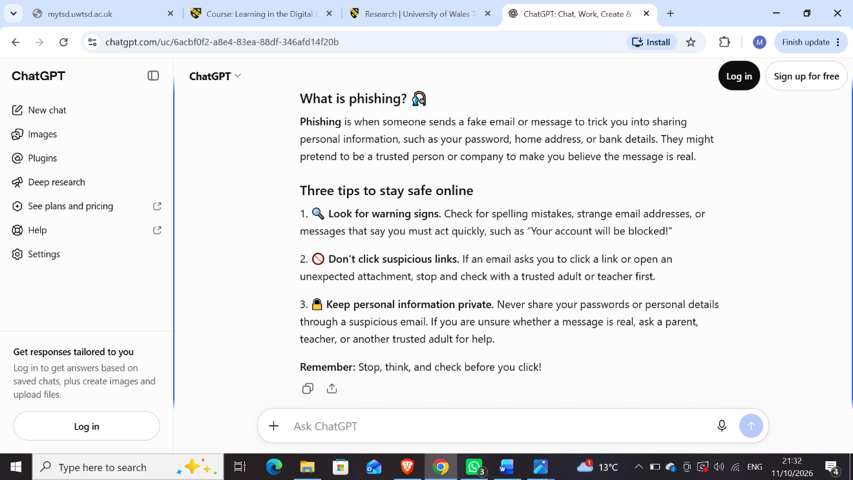

Figure 2: Microsoft Copilot Summarising Online Safety Rules
This screenshot shows how Microsoft Copilot summarises online safety rules for school students using simple English. It explains how to protect personal information, use strong passwords and avoid suspicious links. This tool could help me prepare presentations and educational materials about online safety for my future career as a Cyber Security Education Specialist.
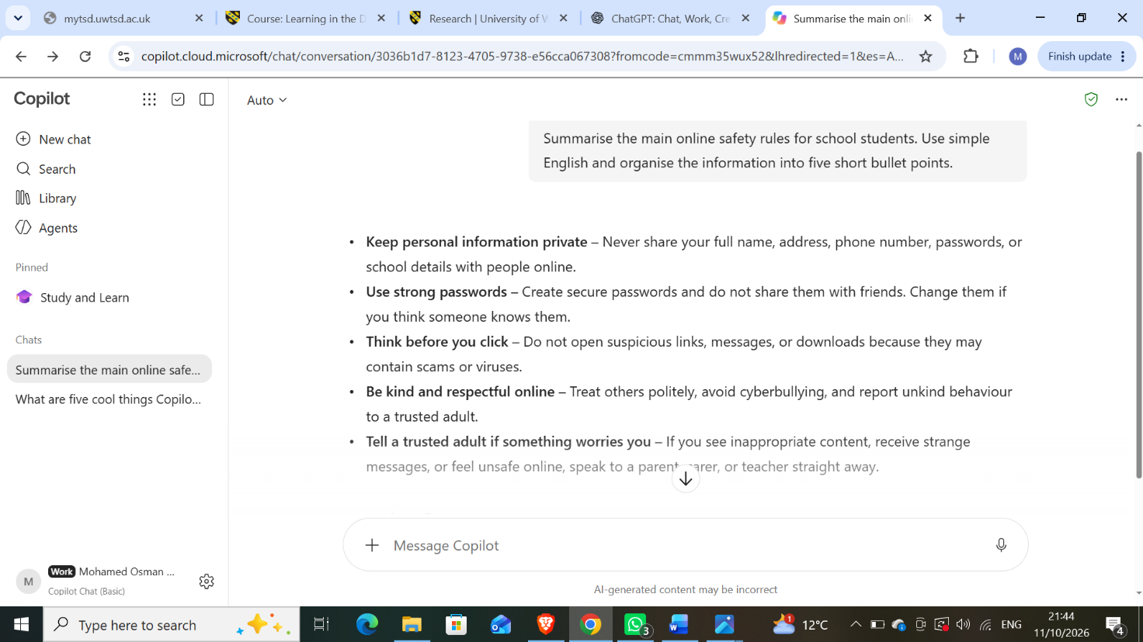

Figure 3: Google Gemini Creating a Phishing Quiz
This screenshot shows how Google Gemini creates a quiz about phishing emails for school students. The quiz includes multiple-choice questions to help students understand phishing and recognise online threats. This tool could help me create interactive learning activities about cyber security for my future career as a Cyber Security Education Specialist.
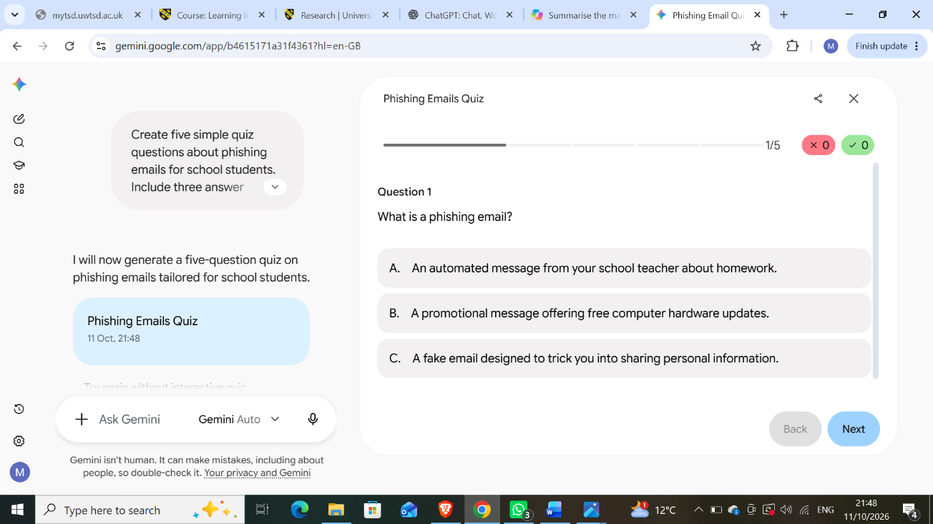

LinkedIn Learning Course
I selected the course Google Gemini: Get Started with Google’s AI Assistant on LinkedIn Learning. The course is presented by Nicholas Brazzi and lasts approximately 42 minutes. It explains how Google Gemini can answer questions, help with writing, summarise information and analyse documents. I think this course will help me understand how AI assistants can support learning and education. In my future career as a Cyber Security Education Specialist, I could use AI tools to prepare learning materials, create quizzes and explain online safety to students.

Figure 4: LinkedIn Learning Course – Google Gemini: Get Started with Google’s AI Assistant
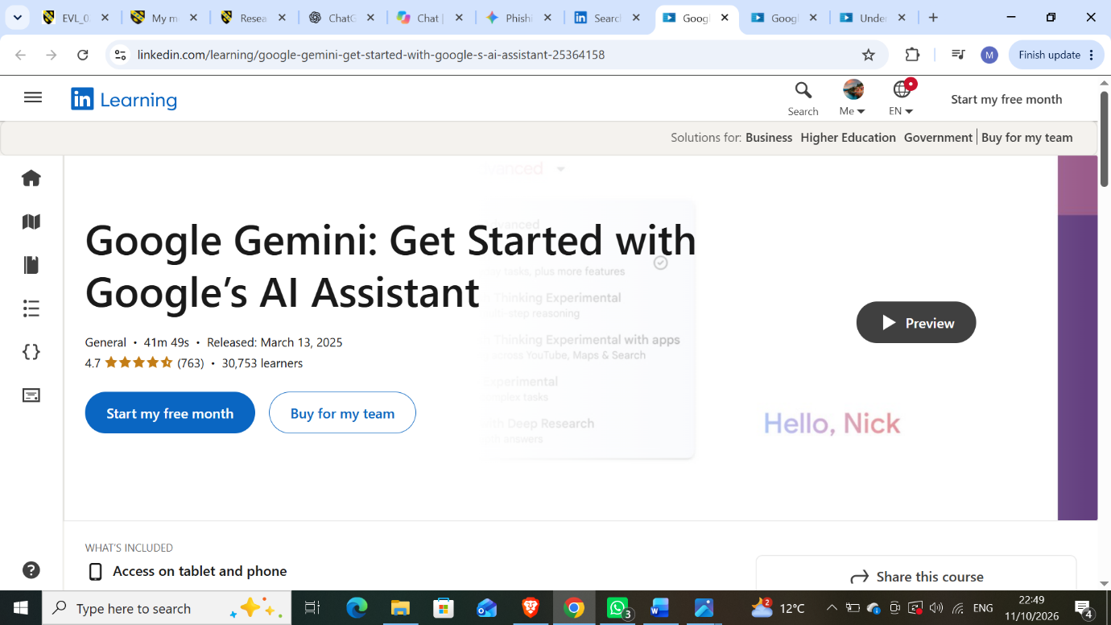

Task 1 (c): Evaluation of Task 1 (a) based on Similarity report
Submit the document prepared in Task 1 (a) to Turnitin and generate the similarity report and take a screenshot of your similarity report and paste it here. Please evaluate your similarity percentage. (200 words) – self-evaluation (approx. 200 words and 2 paragraphs where the first paragraph is about your similarity index and your areas of improvement. Then the second paragraph is about how much mark you deserve on your work with an appropriate justification-Remove this part after completing).

Task 2: Collaborative Mind Map and Individual Poster

Mind Map (Collaborative)
(approx. 450 words where 3 persons in one group and the contribution from each person should be 150 words approx..).

Poster (Individual)
No word limit. Mind Map must be inserted in the Poster

Task 3: Virtual Collaboration and RefWorks

Report on Virtual Collaboration
(approx. 350 words and 4-5 sources-Remove this part after completing).
Put your Chosen topic here and write a summary of that topic with IEEE referencing using RefWorks-Remove this part after completing.

Step-by-step process of using RefWorks with visuals
Put screenshots with appropriate discussion explaining what has been demonstrated in that screenshot-Remove this part after completing (100-150 words)

Task 4: E-Portfolio Creation and Evaluation

Task 4 (a): E-Portfolio Creation
Explain how you have created your e-portfolio with screenshots as evidence-Remove this part after completing.

Task 4 (b): Illustrative Review of E-Portfolio tool Selection
(approx. 100-150 words and 1-2 sources (if used)-Remove this part after completing).

Conclusion
(approx. 100 words -Remove this part after completing).

References

Task 1 References:
[1] University of Oxford, “Study Skills.” [Online]. Available: https://www.ox.ac.uk/students/academic/guidance/skills

[2] University College Birmingham, “Academic Skills.” [Online]. Available: https://www.ucb.ac.uk/university/student-support/learning-support/learning-hub/academic-skills/

[3] R. Zaheri, The Beginners 2024 Cyber Security Awareness Training Course [Video course]. Packt Publishing, 2020.

[4] A. Calder, The Cyber Security Handbook: Prepare for, Respond to and Recover from Cyber Attacks with the IT Governance Cyber Resilience Framework (CRF). IT Governance Publishing, 2020.
[5] LinkedIn Learning, “Google Gemini: Get Started with Google’s AI Assistant,” N. Brazzi, Mar. 13, 2025. [Online]. Available: LinkedIn Learning Course⁠￼

Task 3 References:

