HTML & CSS Web Development
Nicholas Gelstharp (2211042)
L4 – Introduction to Web and Database Concepts
5/15/23

Contents

Introduction 2
Requirements 2
Implementation 3
Evaluation 10
a) 10
b) 12
References 15
Appendices 16

Introduction

This report details the creation of a website for the ficitonal organisation Coeliac Cymru. A website was hand coded in HTML and CSS that would aim to provide information and links to support for suffers of Coeliac disease that primarily live in Wales. This report details the requirements of the website and provides evidence of validation of both the index and css file using online tools. Further to this there is research in three key areas of web development, namely usability, SEO and accessibility. In this section these terms are defined and research, and then using this information the completed Coeliac Cymru website is evaluated against many different criteria with both positives and areas for future development highlighted.

Requirements

The website created is for a fictional organisation named Coeliac Cymru. The purpose of this website is to provide information and links to support around the topic of Coeliac disease, for people living in Wales. The website will describe what Coeliac disease is, what the symptoms are, what help and other information is available and what treatments are. The website will also have a funciton that will allow its visitors to get in touch with Coeliac Cymru and to distinguish which type of allergy they have in the process.
The intended audience for the website would be people living in Wales that suspect or have Coeliac disease and are looking to understand more about it. The links provided are UK wide and so the information and advice would be relevant to anyone in the UK with the disease and so anyone outside of Wales may also find value in using the website.

Implementation

Index.html
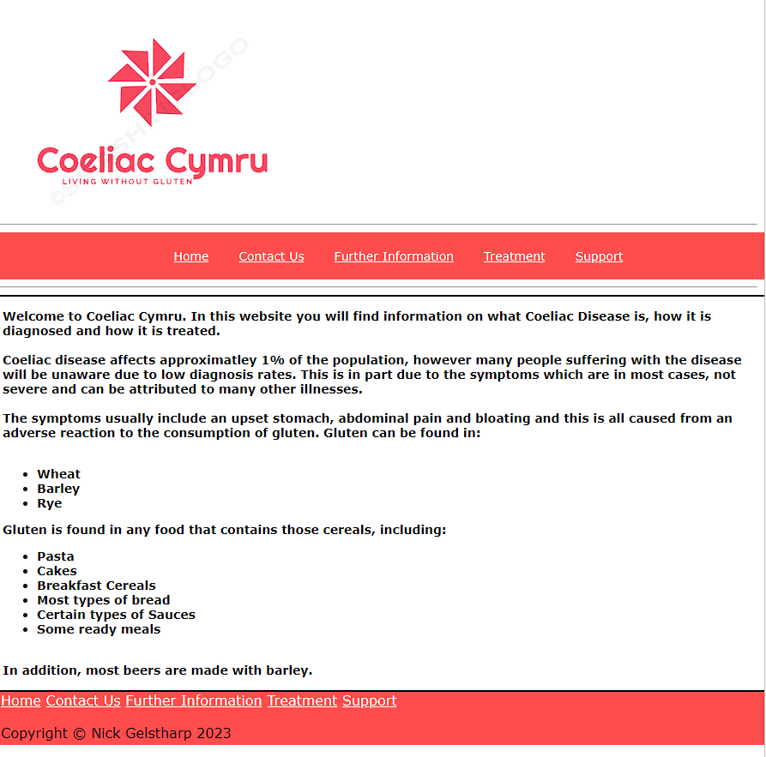

Contactus.html
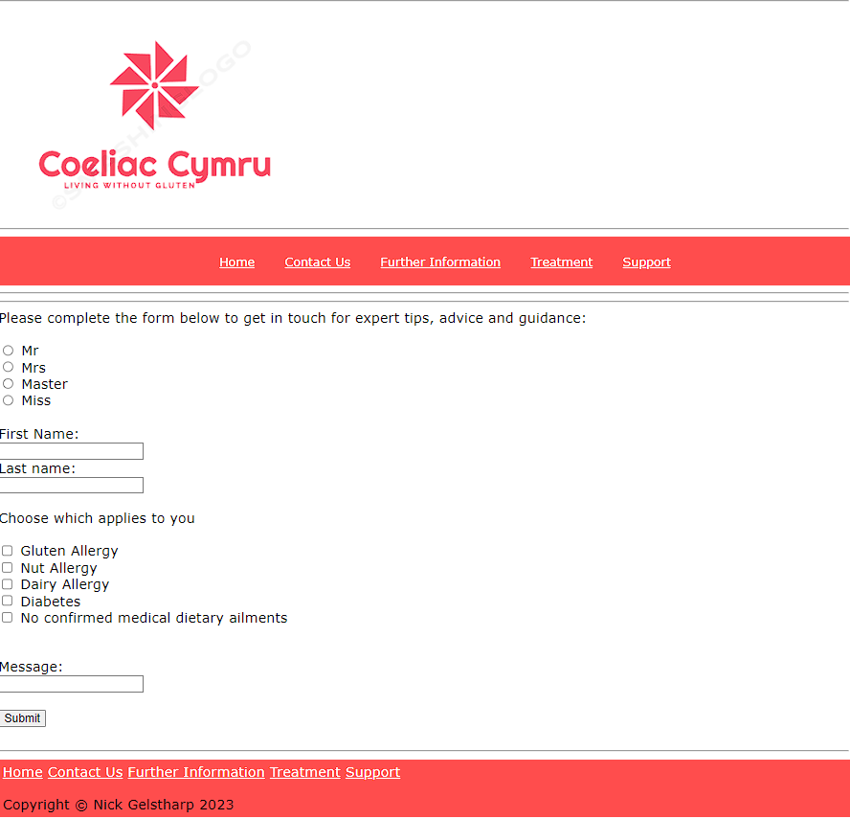

Further.html
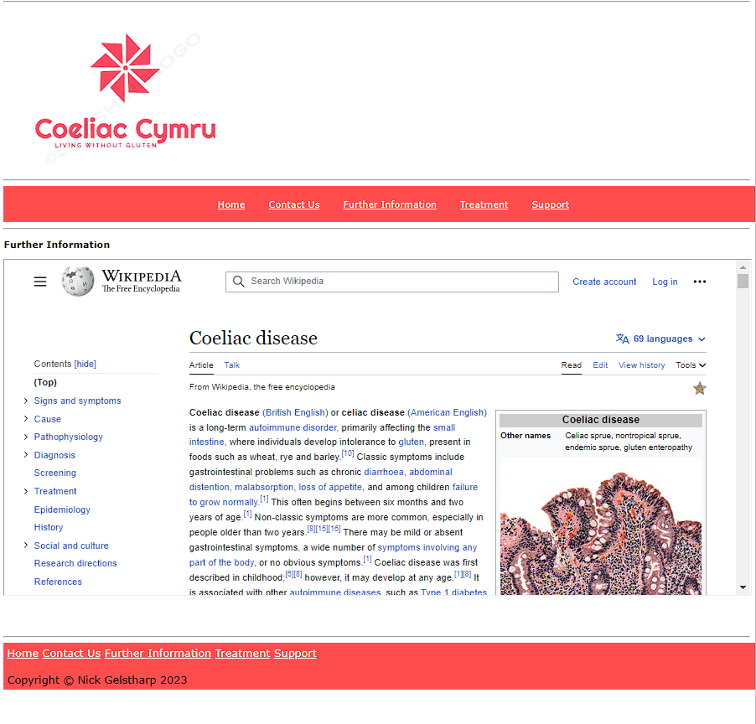

Treatment.html
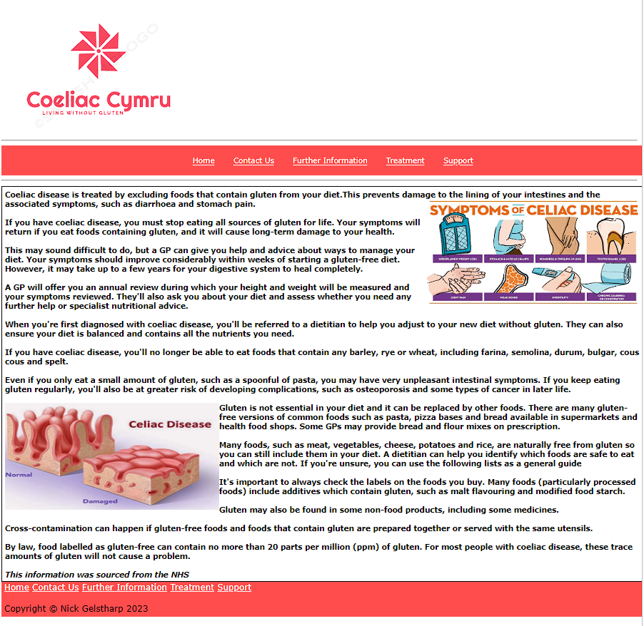

Support.html
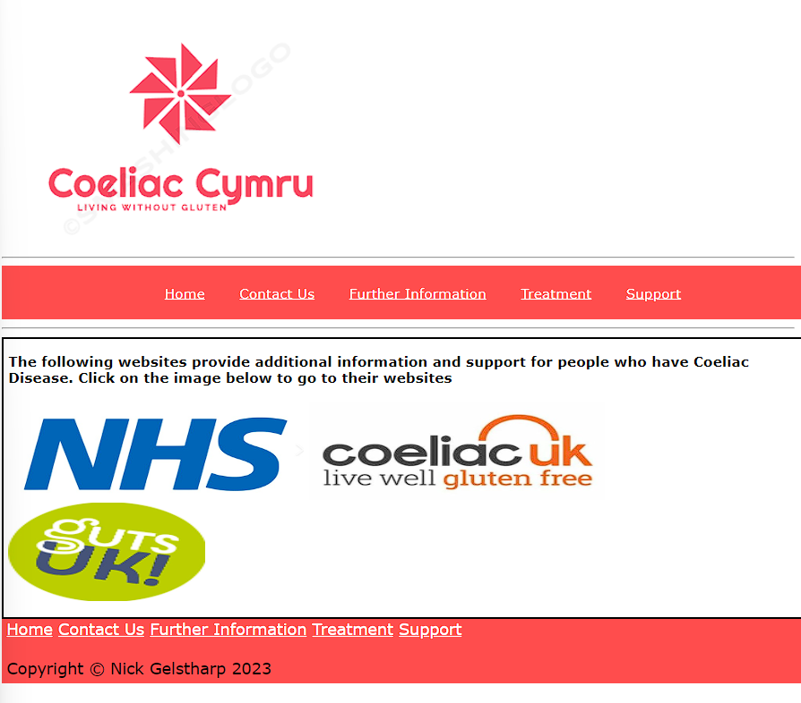

Validation of index.html
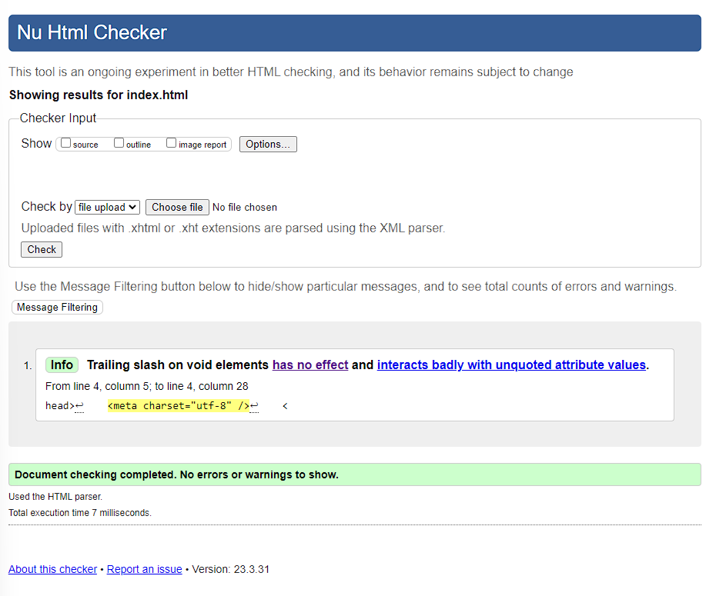
The above is a validation performed using https://validator.w3.org/nu/#file. When this test was first run there were errors where <ul> was within <h1> , this was resolved by moving the list to outside of <h1>. There was a further error that was in place where a tag had not been closed, upon searching I had to close the final div tag in order to remove the error. The information that remains on the HTML checker is an issue that I have not been able to resolve.

Validation of css file
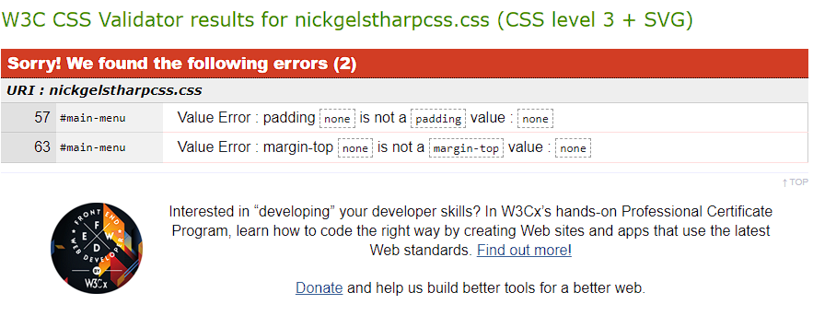
The CSS validator found the following 2 errors within my original file. The first issue was stating that the value I had entered for padding was invalid. To rectify this, as I did not need any padding within this section I removed that line.
The second error is referring to the margin at the top of the main menu section, which again I have entered a value that is not recognised. I removed this line and then repeated the upload of my CSS file which resulted in no error’s being found.
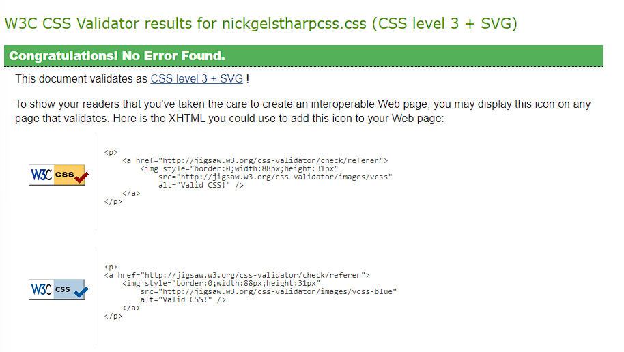

Evaluation

a)

Website usability and utility is of critical importance for any web developer hoping to gain consistent traffic to through their site. One of the main reasons for this is that over the last 10 years the amount of websites in existence has exploded with an estimate from 2019 stating that 1.72b websites existed at that time.
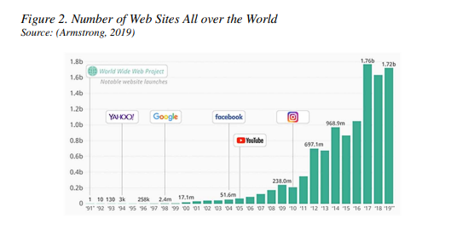
[1]
With all of this competition users’ expectations are high and is a websites usability is not at least as good as other websites, users will be unlikely to return and poor web presence could also damage the legitimacy of a brand such is the ubiquity of websites in the modern era.
Website usability could be categorised in the following 5 ways
- Ease of understanding
- Simplicity of use
- How quickly a user can find the information they require
- How easy the perception of navigation is on the website
- The ability of the user to control what they are doing whilst on the website
[2]
In the role of web development, each of the above should be a key consideration from the very beginning and the structure and content of the website should all be determined with these things in mind from the conceptual stage, to ensure that the end product meets the needs of the clients. It is equally important to note that the purpose and target audience for a website will drastically alter the meaning of each of the categories above. For example, ease of understanding for a website that provides math tuition for primary school children will be significantly different from a website that is selling clothes.
Another key consideration during web development is web accessibility. The leading authority on web accessibility would be W3C and their most up to date guidance for accessible web development is broken down into the following four categories.
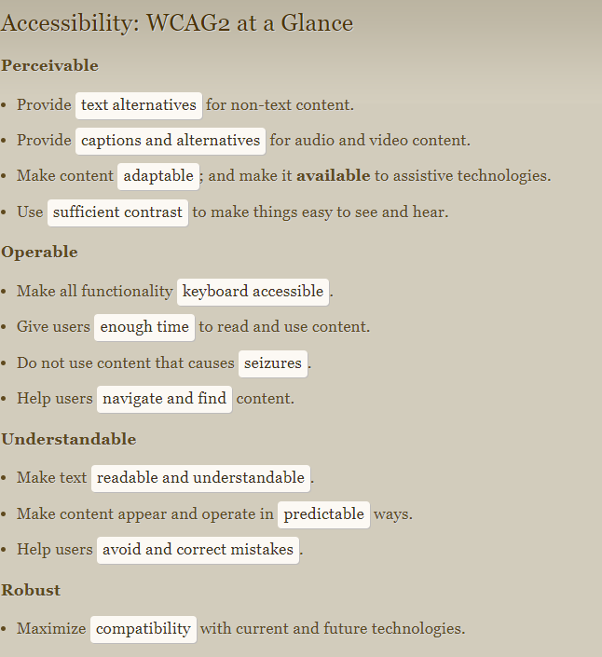
[3]
This cheat sheet produced by W3C gives a clear indication of all of the features required from a modern-day website and is about to be superseded by WCAG3 which will aim to simplify this guidance. The evaluation of website accessibility has been automated in many instances with tools such as AChecker, aXe Tool and Wave Tool allowing open source access that provides web developers with indications of how compliant their websites are with WCAG 2.1 and valuable metrics which can enable web developer to continually strive for better accessibility. This will ensure that the potential audience for a website is as wide and inclusive as possible.
Search engine optimisation (SEO) is vital for web developers as by far one of the most common ways that users will discover websites is through search engines such as Google or Bing. SEO can be described as the efforts a web developer makes to improve the ranking in the search results for given keywords [4].
Search engines, whilst they often do not sell anything directly to the majority of its visitors, generate billions of pounds every year from advertising from marketing initiatives and website owners. This is achieved through providing effective search results to its users and as such it is within their interest to ensure that the results served up to an individual using their engine is as appropriate as possible. Failure to do this will likely mean that the user will switch to an alternative search engine and potentially never return. [5]
A study of Greek internet traffic sought to discover the correlation between the most popular websites in the country and SEO usage. They looked for the presence of the following SEO techniques
Meta description and keyword tags
Image optimisation (alt tags)
URL (meaningful and having keywords within them)
Linking sites.
Website speed/load time
PageRank (an algorithm used by Google to rang a web page from 0-10, the higher the better)
Bounce Rate (how many users left after visiting just one page)
Social Media (active links to Social Media accounts)
The result of this study found that of the top 50 websites 74.49% of the features listed above were optimised for SEO with 100% of those websites having Meta description and keyword tag optimisation [6]. This clearly shows the importance to a web developer of SEO and without correct implementation it would be unlikely that a website would be successful, unless there is already a significant brand presence.

b)

Evaluating the Coeliac Cymru website for usefulness I would consider the same five factors discovered during research
- Ease of understanding – the website has been designed with simplicity in mind. Each of the pages is clean and only contains the information that the user is likely to be looking for at that time. The website is extremely simple and therefore easy to understand. However, an improvement in this area could have come in the form of more description on the index page that would allow user to better understand what was within each page. Each page could also perhaps have had a description at the top to describe its purpose.
- Simplicity of use – The website has dynamically sized text, images and navigation bars to ensure it is very simple to use. The navigation bars are dynamically coloured so that hovering over them shows he user that they can be clicked. Having two navigation bars and the logo hyperlink consistently means that the user will be able to navigate to any part of the website at any time. To improve in this area I could have created a vertical navigation bar, which is perhaps more common and also maybe changed the titles of the links on the navigation bar to be more meaningful.
- How quickly a user can find the information they require – the website has been designed in a way that ensures that all of the pages are available within a single click at all times from either the top or bottom navigation bar. This makes the information very easy and quick to find.
- How easy the perception of navigation is on the website – as above the website is simple and consists of 5 pages which can be accessed at all times from multiple hyperlinks which makes the perception of the navigation of the website very simple.
- The ability of the user to control what they are doing whilst on the website – The user has full control over this element, which again is due to the navigation bars. Within all of the pages everything is explained clearly and the user is never out of control as there are no automated process which assume control from them.
Overall I think the design of the website is simple enough that anyone should be able to find the information within very quickly and easily. The utility is also good, as the form created is very simple and doesn’t ask for any information not needed and the information almost all of the pages will fit nicely on to most screens thanks to dynamic scaling. The utility could have been improved through better descriptions and the support section being renamed to better reflect its purpose of linking to further support. The look and feel of the website is consistent and minimalist, the red is there to represent the Welsh element and in these two areas it is successful. However, the website is quite cold and clinical in its simplicity and would not be very welcoming for potential visitors. This could be improved with animation, background images and perhaps a redesigned header to be more accommodating. The content is largely generated from NHS sources to ensure its accuracy [7]. Further improvements to the content would be to make it richer with further images on each of the pages, more informative text and again to make the design more welcoming and less clinical.
The SEO techniques that have been applied to the website are in that any images that have been included have alt tags which can be picked up by SEO. The proposed URL Coeliac Cymru is meaningful and has the Keyword Coeliac within it which will help with SEO. However, Cymru would only be a keyword for Welsh speakers which, could limit the traffic. The links within Coeliac Cymru are to respected authorities within the Coeliac community which will also assist with SEO. An improvement in this area would have been to employ Meta tags and descriptions which are the main way that a search engine would discover the website through its automation processes.
In order to a check accessibility the website was evaluated against the 4 principles of WCAG2.1.
Perceivability – the website does have text alternatives for non-text content. There is no audio or video content and so captioning was not required. The website is designed to be reactive to size and mouse hovering and so it is adaptable by device. However, no specific assistive technologies were considered during its design. The contract of the website was checked using www.contrastchecker.com with the main body being black texts on white background this contrast is correct on all metrics
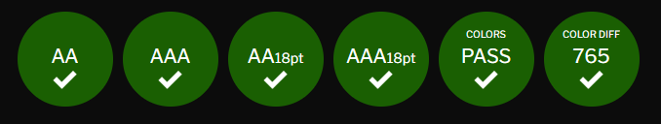
However, the main logo that is used throughout was less successful in the contrast test
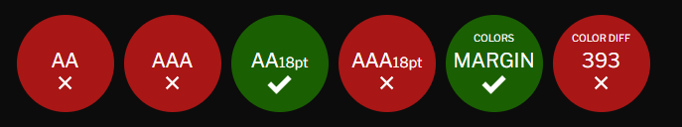
To improve this black outlines on the text itself would have made the contrast better and choosing a deeper colour red may also have improved this element of accessibility.
Operable – The website has no automation which means that users can take their time to read the static text and elements and they will not be pressured here. The consistent application of navigation bars will also help users to easily navigate and find content. There is no animation within the website and as such no elements will cause seizures or physical reactions. The majority of the webpages can be navigated using a keyboard, the only exception to this is the iframe which once entered using tab on the keyboard cannot be exited without the use of a mouse.
Understandable – The text is readable and understandable. Content is presented in a consistent manner throughout which means that users can accurately predict the likely structure of the website at any given point. There are no elements specifically designed to help users avoid and correct mistakes.
Robust - The website is designed to dynamically scale depending on the size of the window it is being presented through and in this way it is quite robust.
Overall, the website is accessible and meets the majority of the points required. However, some tweaks to the colour scheme and some additional attention a few other minor elements would have increased this accessibility further.

References

[1] | Y. Akgul, in App and Website Accessibility Developments and Compliance Strategies, Pennsylvania, Engineering Science, 2022, p. 7.
[2] | D. Belanch, L. V. Casalo and M. Guinaliu, “Website usability, consumer satisfaction and the intention to use a website: The moderating effect of perceived task,” Journal of Retailing and Consumer Services, vol. 19, no. 1, pp. 124-132, 2011.
[3] | W3C, “Accessibility: WCAG2 at a glance,” W3C, [Online]. Available: https://www.w3.org/2009/cheatsheet/#wcag2. [Accessed 15 May 2023].
[4] | L. Cheng-Jye, Y. Sheng-An and H. T.-L. Dean, Estimating Google's search engine ranking function from a serch engine optimization perspective, vol. 40, no. 2, pp. 239-255, 2016.
[5] | N. Tonellotto, C. Macdonald and I. Ounis, Efficient query processing for scalable web search, Boston: Now Publishing, 2018.
[6] | D. Giomelakis and A. Veglis, Investigating Search Engine Optimization Factors in Media Websites, vol. 4, no. 3, pp. 379-400, 2016.
[7] | NHS, “Coeliac disease,” NHS, 31 March 2023. [Online]. Available: https://www.nhs.uk/conditions/coeliac-disease/. [Accessed 15 May 2023].

Appendices

Index.html
<!DOCTYPE html>
<html lang="en">
<head>
<meta charset="utf-8" />
<title>Coeliac Cymru</title>
<link rel="stylesheet" type="text/css" href="nickgelstharpcss.css">
</head>
<body>
<hr>
<a href="index.html">
<img src="coeliacCymruLogo.png" alt="Coeliac Cymryu Logo"></a>
<hr>
<div class="top-menu">
<ul id="main-menu">
<li><a href="index.html">Home</a></li>
<li><a href="contactus.html">Contact Us</a></li>
<li><a href="further.html">Further Information</a></li>
<li><a href="treatment.html">Treatment</a></li>
<li><a href="support.html">Support</a></li>
</ul>
</div>
<hr>
<div class="container">
<div class="white-paraleft">
<h1>Welcome to Coeliac Cymru. In this website you will find information on what Coeliac Disease is, how it is diagnosed and how it is treated. <br><br>
Coeliac disease affects approximatley 1% of the population, however many people suffering with the disease will be unaware due to low diagnosis rates. This is in part due to the symptoms which are in most cases, not severe and can be attributed to many other illnesses. <br><br>
The symptoms usually include an upset stomach, abdominal pain and bloating and this is all caused from an adverse reaction to the consumption of gluten. Gluten can be found in: <br><br>
</h1>
<ul>
<li><b>Wheat</b></li>
<li><b>Barley</b></li>
<li><b>Rye</b></li>
</ul>
<h1>Gluten is found in any food that contains those cereals, including:<br></h1>
<ul>
<li><b>Pasta</b></li>
<li><b>Cakes</b></li>
<li><b>Breakfast Cereals</b></li>
<li><b>Most types of bread</b></li>
<li><b>Certain types of Sauces</b></li>
<li><b>Some ready meals</b></li>
</ul>
<h1><br>In addition, most beers are made with barley.<br><br></h1>
</div>
</div>
<div class="bottom-menu">
<a href="index.html">Home</a>
<a href="contactus.html">Contact Us</a>
<a href="further.html">Further Information</a>
<a href="treatment.html">Treatment</a>
<a href="support.html">Support</a>
<br><br>
Copyright &copy; Nick Gelstharp 2023
</div>
</body>
</html>

Contactus.html
<!DOCTYPE html>
<html>
<head>
<html lang="en">
<meta charset="utf-8" />
<title>Contact Coeliac Cymru</title>
<link rel="stylesheet" type="text/css" href="nickgelstharpcss.css">
</head>
<body>
<hr>
<a href="index.html">
<img src="coeliacCymruLogo.png" alt="Coeliac Cymryu Logo"/></a>
<hr>
<div class="top-menu">
<ul id="main-menu">
<li><a href="index.html">Home</a></li>
<li><a href="contactus.html">Contact Us</a></li>
<li><a href="further.html">Further Information</a></li>
<li><a href="treatment.html">Treatment</a></li>
<li><a href="support.html">Support</a></li>
</ul>
</div>
<hr>
<hr>Please complete the form below to get in touch for expert tips, advice and guidance: <br><br>
<div class="container">
<div class="white-para">
<form>
<input type="radio" id="mr" name="mr" value="Mr">
<label for="mr">Mr</label><br>
<input type="radio" id="css" name="mrs" value="mrs">
<label for="mrs">Mrs</label><br>
<input type="radio" id="master" name="master" value="Master">
<label for="master">Master</label><br>
<input type="radio" id="miss" name="miss" value="miss">
<label for="miss">Miss</label>
<br><br>
<label for="firstname">First Name:</label><br>
<input type="text" id="fname" name="fname"><br>
<label for="lname">Last name:</label><br>
<input type="text" id="lname" name="lname">
<br><br>
Choose which applies to you
<br><br>
<input type="checkbox" id="gluten" name="gluten" value="gluten">
<label for="gluten">Gluten Allergy</label><br>
<input type="checkbox" id="nut" name="nut" value="nut">
<label for="nut">Nut Allergy</label><br>
<input type="checkbox" id="dairy" name="dairy" value="dairy">
<label for="dairy">Dairy Allergy</label><br>
<input type="checkbox" id="diabetes" name="diabetes" value="diabetes">
<label for="diabetes">Diabetes</label><br>
<input type="checkbox" id="NA" name="NA" value="NA">
<label for="Na">No confirmed medical dietary ailments</label><br>
<br><br>
<label for="message">Message:</label><br>
<input type="text" id="msg" name="msg"><br><br>
<input type="submit" value="Submit">
<br><br>
</div>
</body>
<hr>
<body>
<div class="bottom-menu">
<a href="index.html">Home</a>
<a href="contactus.html">Contact Us</a>
<a href="further.html">Further Information</a>
<a href="treatment.html">Treatment</a>
<a href="support.html">Support</a>
<br><br>
Copyright &copy; Nick Gelstharp 2023
</body>
</html>

Further.html
<!DOCTYPE html>
<html>
<head>
<html lang="en">
<meta charset="utf-8" />
<title>Further Information</title>
<link rel="stylesheet" type="text/css" href="nickgelstharpcss.css">
</head>
<body>
<hr>
<a href="index.html">
<img src="coeliacCymruLogo.png" alt="Coeliac Cymryu Logo"/></a>
<hr>
<div class="top-menu">
<ul id="main-menu">
<li><a href="index.html">Home</a></li>
<li><a href="contactus.html">Contact Us</a></li>
<li><a href="further.html">Further Information</a></li>
<li><a href="treatment.html">Treatment</a></li>
<li><a href="support.html">Support</a></li>
</ul>
</div>
<hr>
<div class="container">
<div class="gray-para">
<h1>
<p>Further Information</p>
<iframe src="https://en.wikipedia.org/wiki/Coeliac_disease" name="iframe1" width="100%" height="500"></iframe>
</div>
<br>
<a href="https://en.wikipedia.org/wiki/ United_Kingdom" target="iframe1">Go to wikipedias UK page</a>
</div>
</body>
<hr>
<body>
<div class="bottom-menu">
<a href="index.html">Home</a>
<a href="contactus.html">Contact Us</a>
<a href="further.html">Further Information</a>
<a href="treatment.html">Treatment</a>
<a href="support.html">Support</a>
<br><br>
Copyright &copy; Nick Gelstharp 2023
</body>
</html>

Treatment.html
<!DOCTYPE html>
<html>
<head>
<html lang="en">
<meta charset="utf-8" />
<title>Treatment</title>
<link rel="stylesheet" type="text/css" href="nickgelstharpcss.css">
</head>
<body>
<hr>
<a href="index.html">
<img src="coeliacCymruLogo.png" alt="Coeliac Cymryu Logo"/></a>
<hr>
<div class="top-menu">
<ul id="main-menu">
<li><a href="index.html">Home</a></li>
<li><a href="contactus.html">Contact Us</a></li>
<li><a href="further.html">Further Information</a></li>
<li><a href="treatment.html">Treatment</a></li>
<li><a href="support.html">Support</a></li>
</ul>
</div>
<hr>
<h1>
<div class="container">
<div class="white-paraleft">
Coeliac disease is treated by excluding foods that contain gluten from your diet.This prevents damage to the lining of your intestines and the associated symptoms, such as diarrhoea and stomach pain.
<img src="symptom.jpg" alt="Coeliac Symptoms" style="float:right;width:400px;height:200px;">
<br><br>
If you have coeliac disease, you must stop eating all sources of gluten for life. Your symptoms will return if you eat foods containing gluten, and it will cause long-term damage to your health.
<br><br>
This may sound difficult to do, but a GP can give you help and advice about ways to manage your diet. Your symptoms should improve considerably within weeks of starting a gluten-free diet. However, it may take up to a few years for your digestive system to heal completely.
<br><br>
A GP will offer you an annual review during which your height and weight will be measured and your symptoms reviewed. They'll also ask you about your diet and assess whether you need any further help or specialist nutritional advice.
<br><br>
When you're first diagnosed with coeliac disease, you'll be referred to a dietitian to help you adjust to your new diet without gluten. They can also ensure your diet is balanced and contains all the nutrients you need.
<br><br>
If you have coeliac disease, you'll no longer be able to eat foods that contain any barley, rye or wheat, including farina, semolina, durum, bulgar, cous cous and spelt.
<br><br>
Even if you only eat a small amount of gluten, such as a spoonful of pasta, you may have very unpleasant intestinal symptoms. If you keep eating gluten regularly, you'll also be at greater risk of developing complications, such as osteoporosis and some types of cancer in later life.
<br><br>
<img src="anatomy.jpg" alt="Stomamch Anatomy of Normal person Vs Damaged" style="float:left;width:400px;height:200px;">
Gluten is not essential in your diet and it can be replaced by other foods. There are many gluten-free versions of common foods such as pasta, pizza bases and bread available in supermarkets and health food shops. Some GPs may provide bread and flour mixes on prescription.
<br><br>
Many foods, such as meat, vegetables, cheese, potatoes and rice, are naturally free from gluten so you can still include them in your diet. A dietitian can help you identify which foods are safe to eat and which are not. If you're unsure, you can use the following lists as a general guide
<br><br>
It's important to always check the labels on the foods you buy. Many foods (particularly processed foods) include additives which contain gluten, such as malt flavouring and modified food starch.
<br><br>
Gluten may also be found in some non-food products, including some medicines.
<br><br>
Cross-contamination can happen if gluten-free foods and foods that contain gluten are prepared together or served with the same utensils.
<br><br>
By law, food labelled as gluten-free can contain no more than 20 parts per million (ppm) of gluten. For most people with coeliac disease, these trace amounts of gluten will not cause a problem.
<br><br>
<i>
This information was sourced from the NHS
</i>
</h1>
</div>
</a>
</div>
</body>
<div class="bottom-menu">
<a href="index.html">Home</a>
<a href="contactus.html">Contact Us</a>
<a href="further.html">Further Information</a>
<a href="treatment.html">Treatment</a>
<a href="support.html">Support</a>
<br><br>
Copyright &copy; Nick Gelstharp 2023
</body>
</html>

Support.html
<!DOCTYPE html>
<html>
<head>
<html lang="en">
<meta charset="utf-8" />
<title>Support</title>
<link rel="stylesheet" type="text/css" href="nickgelstharpcss.css">
</head>
<body>
<hr>
<a href="index.html">
<img src="coeliacCymruLogo.png" alt="Coeliac Cymryu Logo"/></a>
<hr>
<div class="top-menu">
<ul id="main-menu">
<li><a href="index.html">Home</a></li>
<li><a href="contactus.html">Contact Us</a></li>
<li><a href="further.html">Further Information</a></li>
<li><a href="treatment.html">Treatment</a></li>
<li><a href="support.html">Support</a></li>
</ul>
</div>
<hr>
<div class="container">
<div class="white-paraleft">
<h1>The following websites provide additional information and support for people who have Coeliac Disease. Click on the image below to go to their websites<br><br>
<a href="https://www.nhs.uk/conditions/coeliac-disease/"><img src="nhslogo.jpg" alt="NHS Logo"style="width:300px;height:100px;"/></a>
<a href="https://www.coeliac.org.uk/information-and-support/coeliac-disease/about-coeliac-disease/"><img src="coeliacuklogo.jpg" alt="Coeliac UK Logo"style="width:300px;height:100px;"/></a>
<a href="https://gutscharity.org.uk/advice-and-information/conditions/coeliac-disease/"><img src="gutslogo.jpg" alt="Guts uk Logo"style="width:200px;height:100px;"/></a>
</h1>
</div>
</a>
</div>
</body>
<div class="bottom-menu">
<a href="index.html">Home</a>
<a href="contactus.html">Contact Us</a>
<a href="further.html">Further Information</a>
<a href="treatment.html">Treatment</a>
<a href="support.html">Support</a>
<br><br>
Copyright &copy; Nick Gelstharp 2023
</body>
</html>

CSS file
h2 {
color:red;
}
h1 {
color:black;
font-size:14px;
}
body{
background-color:white;
font-family: "Verdana";

}
.container {
width:auto;
margin:auto;
}
.white-paraleft{
background-color:white;
color:black;
border:2px solid black;
padding:5px;
float:left;
width:100%;
}
.top-menu{
background-color:#ff4d4d;
color:black;
padding:5px;
width:100%;
}
.bottom-menu{
background-color:#ff4d4d;
color:black;
padding:5px;
width:100%;
}
.gray-pararight{
background-color:white;
color:black;
border:2px solid black;
padding:5px;
float:right;
width:40%;
}
.bot-para{
background-color:gray;
color:white;
border:1px solid black;
}
a{
color:white;
}
a:hover{
color:gray;
}
#main-menu{
list-style:none;
text-align:center;
border: none;
font-size:14px;
}
#main-menu > li {
display:inline;
padding:15px;
}
@media(max-width:600px){
#main{
width:100%;
float:none;
}

#gray-paraleft{
width:100%;
float:left;
}
#gray-pararight{
width:100%;
float:right;
}

#navbar li{
display:block;
}

}

