aGallwch ychwanegu’ch targedau o’ch aseiniad diwethaf (Ond yn berthnasol os yr ydych wedi cwblhau aseiniad) / Please add your targets from the previous assignment (Only relevant if you have completed an assignment)
Targed/Target 1 | Remember to give page numbers for direct quotations
Targed/Target 2 | Try to avoid asserting points.
Targed/Target 3 | Punctuation needs a little more attention in places -check apostrophe use, for example.
Targed/Target 4
Targed/Target 5

Choose an intervention that supports the learning and development of a pupil / group of pupils. Reflect critically on its potential for ensuring pupil progression and the possible challenges that may arise.

The aim of this essay is to recognise how Key Stage 2 (KS2) pupils’ learning and development can be supported through the use of an intervention. To do this, a set of pupils and an intervention will be chosen as a key focus. There will be a discussion of what is meant by pupil progression and a critical reflection of the intervention. This critical reflection will evaluate the intervention’s potential for ensuring pupil progression and the challenges that may arise with both the intervention itself and the implementation of the intervention.

For this assignment, two pupils in a school from a Professional Teaching Experience (PTE) in Swansea in Wales have been chosen. This was chosen specifically so that a reflection of what was viewed in PTE of the pupils and intervention can be discussed along with various reliable literature sources in order to gain a full view of the strengths and limitations of the intervention and its potential to progress pupils’ learning. To keep an ethical practice, the school and the pupils will remain anonymous throughout this essay and will be referred to as ‘Pupil A’ and ‘Pupil B’. These pupils are female twins in a year 4 class who moved to Wales from Syria and joined the school when they started year 3. The pupils’ both speak fluent Arabic at home and to each other in school and have some, but not a lot of, knowledge of the English language which they have learnt in the one year that they have been in the school through immersion of the English language. As these pupils have English as an Additional Language (EAL) there will be a focus on the development of their English language and literacy skills. It was clear from PTE that the pupils struggled to understand tasks mainly due to the language barrier. This aspect and these pupils have been chosen for this assignment because the number of children over 5 years old who have a first language other than English and Welsh is increasing from 1,853 in 2011/12 to 3,140 in 2018/19 in Swansea (Welsh Government, 2019). This presents an increase of 1,287 EAL pupils in the past seven years. Therefore, this suggests that there will be more EAL pupils joining schools in the future who may need support in their learning so evaluating an intervention that may work for some EAL pupils will help to improve future professional teaching practice. The intervention that will be evaluated is one-to-one support for these pupils. This member of support staff will be able to translate the class teacher’s instructions, use picture cards with the pupils and will be able to use mini whiteboards to help the pupils’ English spelling skills.

Before discussing how the intervention progresses pupils’ learning, it is vital to discuss what is meant by pupil progression and how EAL pupils learn and develop. The Welsh Government (2020b) state, “learner progression along a continuum of learning from ages 3 to 16 is central to Curriculum for Wales” which firstly suggests the importance of pupil progression within the school environment and secondly suggests that pupil progression takes place from nursery until the end of secondary school. This presents a constant need to support all children and help their skills progress and develop at an early age. This also implies that ensuring pupils’ progression is the main aspect of the Curriculum for Wales, showing how important pupil progression is within the primary and secondary school sectors. However, it could be shown that EAL pupils will require further support as Gross (2013, p. 4) believes, ‘learning language is complex, so much so that no one has yet been able to programme a computer to do what we as human beings seem to do ‘by magic’. Therefore, this may show that the pupils chosen will require further assistance to help them progress in all aspects of their learning as they will be trying to learn a language at the same time as learning the other skills within the curriculum. Furthermore, presenting the struggles and barriers that EAL pupils face within the school environment. In addition to this, Murphy (2014, cited in Murphy and Unthiah, 2015) argues EAL pupils are likely to have less English language and literacy development than pupils who speak and learn in English. Therefore, agreeing with Gross (2013) in suggesting that EAL pupils may have slower development in all subjects / Areas of Learning Experiences (AoLEs) than pupils who are fluent in English, due to the lack of understanding of the communication between the teacher and the pupils. To support this, it is suggested that the new Curriculum for Wales will require practitioners to design the learning to suit the pupils’ needs (Welsh Government, 2020a). This suggests that teachers will be able to manipulate the curriculum to suit all learners as they know the pupils’ learning needs better than anyone. This could suggest that EAL pupils may have more equal opportunities to learn within the new Curriculum for Wales as their teachers will be able to plan their learning in the way that best supports the individual. For instance, regarding the chosen intervention, there is the opportunity to allow the one-to-one staff member to translate the work for the children, if that would be the most effective way for the pupils to progress. Baker (2011, p. 193) refers to the 1974 amendments to the American Bilingual Education Act in which he suggests that grants are given to schools to allow them to use pupils’ home languages and cultures within their teaching to “allow the child to progress effectively through the education system”. Although the American education system is vastly different to the Welsh educational system, this amendment from Congress suggests the importance of giving EAL pupils the same opportunity to learn effectively whilst also suggesting that EAL pupils learn more effectively when their home language and culture is used within their learning. The Welsh Government (2015) also suggest that pupils being competent in their home language can speed up the process of learning a new language. However, it was also suggested that “the study found that it had taken between 6-8 years for pupils to acquire academic proficiency in English” (Welsh Government, 2015, p. 8). As the pupils chosen have only been learning the English language for one year, it could be suggested that they are at the beginning of an eight-year learning process. Contrasting this, Piaget (1936, cited in McLeod, 2018) suggests there are certain ages in which children encounter major characteristics and developmental changes. As Pupil A and B are 8 years old, according to Piaget’s (1936, cited in McLeod, 2018) theory of cognitive development, this would place the pupils in the ‘Concrete Operational Stage’ which is between the ages of seven to eleven. As shown in Appendix 1, this stage suggests that children should start to think more logically. However, from looking at ‘The Preoperational Stage’ in Appendix 1, which suggests that in this second stage children should be improving their language and thinking skills but “still tend to think about things in very concrete terms” it could suggest that the pupils chosen are more suited to this stage, instead of the stage that Piaget’s theory suggests they should be in due to their age. If Piaget’s theory is correct then it would suggest that the pupils’ development is perhaps of a lower standard than that of an English Language Learner (ELL) because the pupils, at this stage of the intervention, still require picture cards to assist their learning which is an aspect of ‘The Preoperational Stage’.

With this understanding of how EAL pupils learn and develop, the intervention chosen is a one-to-one support who can provide translations for the pupils whilst using picture cards and mini whiteboards to support their English language and literacy skills as well as encourage their independence skills to develop. Throughout PTE I witnessed the use of a one-to-one support staff and the use of mini whiteboards to help the pupils learn which seemed to support their learning. However, Grigg (2010) suggests using picture cards are a very useful aid for EAL pupils to help develop their language skills. This is also supported by the Bell Foundation (2019) who also believe using visuals are a very effective way to support and progress EAL pupils’ learning and development. Therefore, I have chosen to adapt the strategy that I witnessed within PTE by adding bilingual picture cards to this intervention to help progress the pupils’ learning as I believe the pupils relied a lot on the translations and mini whiteboards so this strategy would help them gain more independence in their learning. These picture cards will be implemented to support the children when the one-to-one support may not be available and once the one-to-one starts to be withdrawn, which will help with their independence skills. Regarding the implementation of the intervention, at the time of writing this, the one-to-one support has been with the pupils for the year that they have been studying. This one-to-one support staff was with the pupils every lesson when they joined the school and throughout the year has been slowly reducing the amount of time that the pupils receive with her. It was clear when I was teaching these pupils that they still required a lot of assistance in all lessons and used the mini whiteboards with almost every word that they wrote as they would prefer a teacher to write it so they do not spell it wrong. This could perhaps present that the children were in their ‘comfort zones’ and did not like going into their ‘stretch zones’ which was used throughout the school as Dweck (2000, cited in David, 2015) believes children find encouragement to grow their learning and suggests this theory helps children who may feel like they are failing if they get something wrong. This theory suggests pupils should be in the ‘stretch zones’ in order to learn and progress their learning in the most effective way. Although this theory was used in the school, the EAL pupils chosen did not understand this concept when they were asked and therefore it did not help their learning. From experience, the pupils presented to be in their ‘comfort zones’ for the majority of the time I was in the class. It appeared that the pupils were not being challenged in their lessons as the mini whiteboard strategy was being overused. This meant it was difficult to determine how the pupils’ literacy skills were developing as they were spelling everything correctly and using the correct grammar due to the support, so it was difficult to see if their skills were progressing. Therefore, for this intervention, the one-to-one would be with the pupils in every lesson when they joined the school and would be introduced to the picture cards immediately, ensuring the one-to-one staff member understood that the picture cards should be used as much as possible and translation should assist them. As Grigg (2010) suggests that using picture cards and having the EAL pupils with someone who could translate helps their progression, it could be portrayed that having the one-to-one use the picture cards with the pupils will assist their understanding of the lessons and perhaps help them develop and progress at a faster rate. This is supported by Crolla and Treffers-Daller (2017) who suggest that strategies such as translating and using picture cards are scaffolding methods that should be learnt by the pupils to encourage them to become more independent. This theory, paired with Vygotsky (1978, cited in McLeod, 2019) who believes that scaffolding pupils’ learning will help a child progress through the zone of proximal development, suggests translation and picture cards are effective in the progression of pupils’ learning. It is suggested that slowly withdrawing these scaffolds will eventually allow the child to complete tasks independently (McLeod, 2019). Therefore, portraying that through withdrawing the support of the one-to-one and then slowly withdrawing the picture cards and use of mini whiteboards will allow the pupils learning to develop at a faster rate and will allow for them to become more independent.

There will be a focus on the different aspects of the intervention and how effective these strategies can be, according to various literary sources. To begin, one of the aspects of this intervention is giving the pupils access to translations of their lessons. Grigg (2010) encourages the use of bilingualism in the classroom. Therefore, suggesting a translator as an effective strategy for this intervention to progress the pupils’ learning. However, arguing this, Baker (2011) suggests there is some debate in whether teaching in the pupils’ home language is more effective than teaching in English. As there is a debate portrayed, it could imply researchers believe that using the home language to assist the EAL pupils will not develop their English language skills. In addition to this, it is also suggested that using home languages within learning could be a waste of time as that time could be spent on their English language learning (Arnot et al. 2014). However, to eliminate this limitation of the intervention, the picture cards and mini whiteboards will be a constant reminder to the pupils that, although the work can be translated for them, they are constantly progressing their English language skills. However, Arnot et al. (2014, p.48) also suggests that when teaching EAL pupils with little English, like the pupils chosen, “the teachers agreed that translation and interpreting was the most effective and commonly used strategy”. Although this contrasts what has previously been stated by Arnot et al. (2014), this statement could be seen as more reliable as it was from various teachers who have personal experiences to reflect upon, whereas the previous comment is suggested to have come from a singular source. Therefore, suggesting that having a one-to-one support, whilst ensuring that picture cards and the mini whiteboards are used, is an effective way to progress the pupils’ learning of their English language and literacy skills. In addition to this, the one-to-one will also be able to communicate with the pupils’ parents. From PTE, it was clear that parent and teacher communication was vital to help the parents know how their children were progressing and it was clearly shown that parents and pupils felt better when the teacher would feedback something good that the pupil had done that day. This was noticed to be a big barrier when speaking to the EAL pupils’ parents as their mum (who would pick up the pupils everyday) spoke extremely basic English. With the pupils also having little English, it was difficult for them to translate to their mum what the teacher was saying. Therefore, the pupils’ parents were very little involved in their learning. However, this must change as the Welsh Government (2020b) suggests that parents will be encouraged to engage more in their children’s learning and development. Therefore, the one-to-one staff member will also be essential to translate the communication of the teacher to the parent to ensure that the pupils’ parents are fully engaged in their children’s learning in the same way an English-speaking parent would be.

Secondly, according to the Bell Foundation (2019) the use of visuals can be used in various ways to help EAL pupils progress their English language skills. In addition to this, the Bell Foundation (2019) also present that a limitation of using visuals to progress EAL pupils is that the picture cards must be “clear and current” which may not always happen in schools. This limitation can be ensured by updating the picture cards regularly, which would happen with this intervention as the picture cards would be created according to the lesson that the teacher plans as well as having general picture cards that the pupils would use in everyday situations to support their understanding of the English language. Mistry and Sood (2015) suggest using as many visual resources, that are related to the context of the learning, as possible with EAL pupils to ensure they can make links to the English language. This can be supported by my personal experiences when teaching the EAL pupils that are being discussed. From this experience, I would suggest it is vital to encourage the use of bilingual picture cards with the pupils as I once gave the class a matching task (see Appendix 2) which had both Arabic and English as well as the pictures of the shape. When given this task, both pupils were excited to see their home language being used and completed the activity fairly independently. This helped the pupils feel included and it was clear to see that the pupils enjoyed their learning more in this lesson. This presented a huge contrast to when the pupils were given tasks that were only English. In the plenary of this lesson, I would show a shape and the pupils would need to tell me the name and properties of that shape. I allowed a few other pupils to answer first, to ensure the EAL pupils understood the task and then Pupil A volunteered to answer and got the answer correct and gave the answers in English. Although her pronunciation was not completely clear, this was expected, and I was pleased to see her volunteer to answer a question and try to speak the English as she would rarely offer to answer questions. This showed the benefits of using a bilingual matching task and suggests that bilingual picture cards can be used in a very similar way to progress the pupils’ English language development.

The last strategy that will be used within this intervention is the mini whiteboards. To begin, I will reflect on my personal experiences with using mini whiteboards with the EAL pupils whilst on PTE. It was shown throughout PTE that the mini whiteboard strategy had both strengths and limitations when working with the EAL pupils chosen. One strength shown was that if the pupils could not think of the English word they needed they could describe what word they wanted and the teacher could write it down for them. This would improve their English language skills as well as their spelling and handwriting as they could see it written in a modelled way. However, this method poses a limitation as the pupils tended to rely on a teacher giving them the correct words or sentences and they could just copy them. This is a limitation as, when marking their work, it was difficult to determine how well their literacy skills were progressing because I would be unsure if it was their work or just what they have been told to copy. Therefore, when using this strategy within this intervention, it will be ensured that the teachers in the classroom and the pupils will be aware that the mini whiteboards will only be used for singular words that the pupils do not know. The teachers will not be able to write sentences on the mini whiteboards but will be able to scaffold the pupils’ learning orally so that the pupils are being challenged but are not feeling like they are constantly failing. Copping (2016) believes that too much feedback on a pupils’ work can make the pupil feel like they have failed. This is important for these pupils in particular as I witnessed on PTE that they did not like getting their spellings wrong and they expressed that they sometimes felt sad that they could not understand the tasks. Therefore, to avoid enhancing this feeling, the mini whiteboards when paired with the picture cards and the one-to-one can support the children’s learning.

A limitation that is mentioned repeatedly when evaluating these strategies has been that the pupils tend to rely on the constant use of the strategies, which can result in the lack of progression. Therefore, to eliminate this and ensure the pupils’ English language and literacy skills are being constantly developed, this intervention will need to involve all members of staff within the classroom as well as the pupils. This is to ensure that none of the staff overuse any of the strategies when working with the pupils as this would not reflect the true progression of the pupils’ English language and literacy skills if the pupils are in their ‘comfort zones’. If the staff are aware of this, then this will prevent the pupils from trying to use the strategies too much as they were shown to do in PTE. If pupils are involved in their learning, this can help them enjoy their learning which can progress their development at a faster rate (ESTYN, 2019). Furthermore, the one-to-one staff member, class teacher and the pupils will all be involved in evaluating the effectiveness of each strategy. It will be ensured that the pupils’ voices are heard when discussing the effectiveness of the strategies as it is suggested pupil voice is vital to help them progress (ESTYN, 2019). At the start of the intervention process, when the one-to-one support is present in every lesson, the one-to-one will be able to evaluate the effectiveness of the strategy through evaluating the pupils’ progression. As the one-to-one slowly gets withdrawn, the class teacher will gradually take on the ‘evaluator’ role and will be the main assessor of the pupils’ progress. The one-to-one will then become a secondary assessor, supporting the class teacher in the evaluation of the pupils’ progress by giving a first-hand perspective of various aspects of how the pupils are progressing when they are with the pupils. For example it will be reported back to the teacher how the pupils have progressed from previous lessons, how independently they have completed the task, if there is anything they struggled with, if there was anything they did well and any other relevant notes from that lesson that would help the teacher determine how their English language and literacy skills are progressing and how it affects their learning in other subjects / AoLEs.

On reflection it can be suggested that each of the strategies within the intervention have various strengths and limitations. Furthermore, when the strategies work together and are monitored in the correct way, it can be shown that the intervention could be effective for the EAL pupils chosen. It has been portrayed that when there is too much or too little of these strategies, then this intervention may not work properly as the pupils may not show progression of their English language and literacy skills. Therefore, one of the most vital part of this intervention is the implementation. It must be ensured that the one-to-one works with the class teacher and the pupils to monitor the pupils’ progress and to discuss when to begin removing each of the strategies at the right moment within their learning that will help their English language and literacy skills progress in the most effective way. As this intervention has been based on PTE but has been adapted by adding picture cards to the pupils’ learning, the next steps for this intervention would be to have a constant one-to-one support with the pupils to introduce them to the picture cards. As previously shown, the one-to-one support can help EAL pupils progress quicker. Therefore, the constant support could help them learn how to effectively use the picture cards. Once the pupils have learnt how to use the picture cards effectively, the one-to-one support can begin to be withdrawn once again. The next steps for the class teacher would be to begin thinking about what picture cards may be needed in each of the lessons and create more discussions with the one-to-one staff, perhaps creating a table of development to ensure they can monitor the pupils’ progression effectively. Although there will not be need for further training for the staff, there will need to be a discussion between the staff members about the specifics of the intervention to enable the pupils to progress their English language and literacy skills effectively and independently.

References

Arnot et al. (2014) School approaches to the education of EAL students: Language development, social integration and achievement. Cambridge: The Bell Educational Trust Limited.
Baker, C. (2011) Foundations of Bilingual Education and Bilingualism. 5th edn. Unknown: Multilingual Matters.
Bell Foundation (2019) Great Idea: Visuals. Available at: https://ealresources.bell-foundation.org.uk/teachers/great-ideas-visuals (Accessed 11th April 2020)
Copping, D. (2016) Eliminating unnecessary workload around marking Report of the Independent Teacher Workload Review Group. Available at: https://assets.publishing.service.gov.uk/government/uploads/system/uploads/attachment_data/file/511256/Eliminating-unnecessary-workload-around-marking.pdf (Accessed 13th April 2020)
Crolla, C. and Treffers-Daller, J. (2017) A Guide to Supporting EAL Learners. Available at:https://cdn.oxfordowl.co.uk/2017/08/10/09/32/48/468/bp_eal_guide.pdf (Accessed 11th April 2020)
David L. (2015) Mindset Theory – Fixed vs. Growth Mindset (Dweck). Available at: https://www.learning-theories.com/mindset-theory-fixed-vs-growth-mindset-dweck.html (Accessed 11th April 2020)
ESTYN (2019) Designing a pupil-led curriculum. Available at: https://www.estyn.gov.wales/effective-practice/designing-pupil-led-curriculum (Accessed 13th April 2020)
Grigg, R. (2010) Becoming an outstanding primary school teacher. Essex: Pearson.
Gross, J. (2013) Time to Talk: Implementing Outstanding Practice in Speech, Language and Communication. Oxon: Routledge.
Mistry, M. and Sood, K. (2015) English as an Additional Language in the Early Years. Oxon: Routledge.
McLeod, S. (2018) Jean Piaget’s Theory of Cognitive Development. Available at: https://www.simplypsychology.org/piaget.html (Accessed 9th April 2020)
Welsh Government (2019) Stats Wales: Pupils ages 5 and over with a first language other than Welsh or English by local authority, region and year. Available at: https://statswales.gov.wales/Catalogue/Education-and-Skills/Schools-and-Teachers/Schools-Census/Pupil-Level-Annual-School-Census/Ethnicity-National-Identity-and-Language/pupilsaged5andoverfirstlanguageotherthanenglishwelsh-by-localauthorityregion-year (Accessed 1st April 2020)
Welsh Government (2015) Evaluation report on capacity building approaches to support the delivery of English as an additional language in Wales. Available at: https://gov.wales/sites/default/files/publications/2018-11/evaluation-report-on-capacity-building-approaches-to-support-the-delivery-of-english-as-an-additional-language-in-wales.pdf (Accessed 9th April 2020)
Welsh Government (2020a) Curriculum for Wales: Introduction to Curriculum for Wales guidance. Available at: https://hwb.gov.wales/curriculum-for-wales/introduction (Accessed 8th April 2020)
Welsh Government (2020b) Curriculum for Wales: Supporting learner progression: assessment guidance. Available at: https://hwb.gov.wales/curriculum-for-wales/supporting-learner-progression-assessment-guidance/ (Accessed 2nd April 2020)

Appendix 1
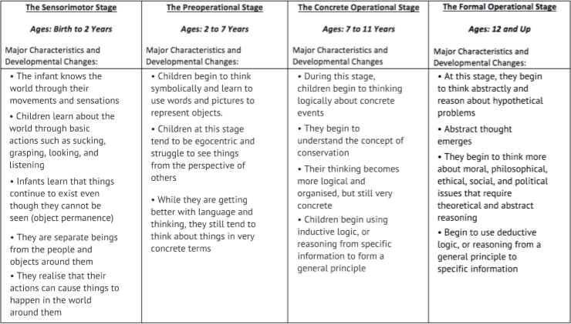
Cox, T. (2020) Presentation in lecture, 5th March.

Appendix 2
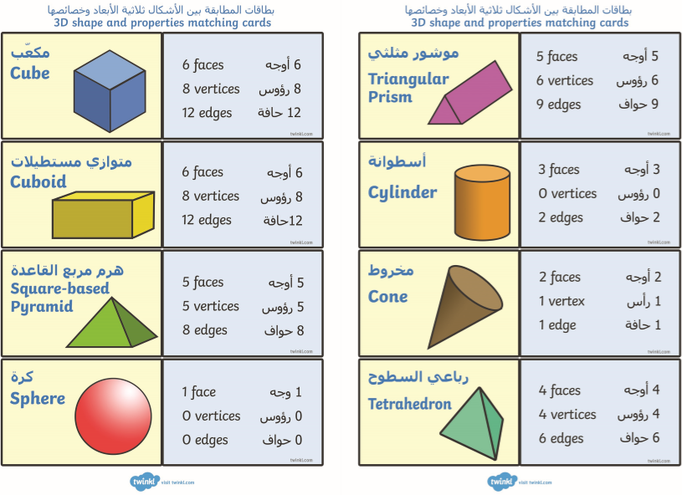

Twinkl (no date) 3D Shape and Properties Matching Cards Arabic/English. Available at: https://www.twinkl.co.uk/resource/ar-t2-m-063-3d-shape-and-properties-matching-cards-arabic-english (Accessed 16th April 2020)

