H

NHS Problem Solving and Decision Making
(BMSK4004 _ SWAN)
Jasminara Ahmed
Student 1704947

Executive Summary
The purpose of this report is to investigate the ongoing situation in NHS healthcare using PESTEL analysis to identify the problems and by decision making process. Alongside the history and background of the NHS healthcare service and the impact that is having on the stakeholders. By using the interest power tool to find out who the internal and the external stakeholders are in the NHS healthcare are and prioritise the importance of them and how they are effected within the organisation.
Contents
Introduction 3
Main Body 4
PROBLEMS IN THE NHS 8
Pestle analysis 9
Swot Analysis 9
Political 10
Economic 10
Social 10
Technological 10
Legal 10
Environment 10
Political factors in detail 11
Staffing 11
Accessing treatment here and abroad 11
Regulation 11
Cross border cooperation 12
Funding and finance 12
Economic factors in detail 12
NHS require qualified staff 12
Social factors in detail 12
The NHS healthcare services and hospitals 13
Social environment 13
The Five Whys Model 13
Fishbone theory 14
Brainstorming and Mind Mapping 16
PMI 17
Grid Analysis 18
Edward de bono six thinking Hats 19
Conclusion 20
Recommendation 21
Reference list 22

Introduction

The National Health Services in England, NHS Scotland, NHS Wales and health care and social care in Northern Ireland was established on 1948 as one major social reforms following the Second World War. The name National health services also known by NHS are used for each of the public health services in United Kingdom. NHS healthcare was introduced by the labour health Secretary Aneurin Bevan to the British public at Park Hospital in Manchester (today known as Trafford General Hospital). NHS was born out of a long awaited ambitious plan that was held for some time due to complication and timing. One of the NHS core principle was good healthcare should be available to all, the founding principle were that services should be free at the point of delivery regardless of wealth with exception of some changes, such as prescriptions, optical services and dental services.
For the first time, hospitals, doctors, nurses, pharmacists, opticians, and dentists are brought together under one umbrella organisation to give this unique service. The central principle are clear the health service will be available to all and financed entirely from taxation. The health Secretary Aneurin Bevan was said to be the face behind NHS healthcare. NHS healthcare was not only his achievement about the greatest political achievement in British history right from the beginning NHS work force was from all over the world. NHS has grown to become the World’s largest public funded health service. In the 70 years of NHS healthcare facing the biggest challenges in its existence since the lunch of it in 1948. (Healthcare London, NHS, 2018). By using the Pestle analysis to investigate the situation in NHS will give an insight of the situation and to find solutions to the problems, and finding out who the stakeholders are and the role they play using the stakeholder map. The cause and effect diagram and other tools and problem solving framework will help to resolve the problem that arises within an organisation.

Main Body
The impact NHS healthcare is having on stakeholders is big problem on its own, as this will affect the NHS healthcare in a massive way according to who they are and what role they play within the healthcare circle. Whether you work, or not in the organisation, stakeholder is someone who has something to gain or to lose through the decision making of planning process in the company. Stakeholders can be divided in three categories internal e. g employees, external are community and connected are suppliers. (Dialogue by design, 2008).
By using a stakeholder analysis process will help to identify who the stakeholders are and the roles they have whether they are internal or external stakeholders. Stakeholder mapping identifies the expectations, power, and influence they have, this helps to understanding political priorities alongside the key facilitator of the organisations, the level of interest they hold as stakeholders. This is done by using a power interest grid. First you need to understand who your stakeholders are and their input towards the organisation and then you will know who the important stakeholders are. And by making the list of the internal and external stakeholders and then using the power grid to identify them by their power and interest in the organisation.

- Commentators: those whose opinions of the organisation are heard by customers and others
- Consumers: those who are served by our customers: ie patients, families, users
- Champions: those who believe in and will actively promote the project
- Competitors: those working in the same area who offer similar or alternative services

Four sector table
High power | Satisfy  Opinion formers. Keep them satisfied with what is happening and review your analysis of their position regularly. | Manage  Key stakeholders who should be fully engaged through full communication and consultation.
Low power | Monitor  This group may be ignored if time and resources are stretched. | Inform  Patients often fall into this category. It may be helpful to take steps to increase their influence by organising them into groups or taking active consultative work.
 | Low impact/stake holding | High impact/stake holding

Internal stakeholder are dedicated to provide service and inputs to the companies and are highly effected by the decision process of the company. If there were no internal stakeholders the organisation will not be able to survive in the long run. (Healthknowledge.org.uk NHS, 2018).

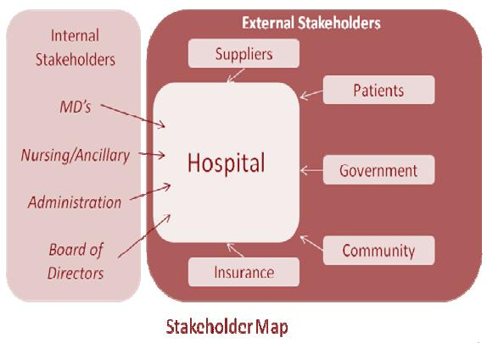

Stakeholders as follows:
Authority, hierarchy senior position
Leadership, health intelligence
Procurement
Director of nursing
Public health manager
Trustees, board, committee, members
Director of programmes and research scientist
Staff

External stakeholders are any person, group or organisation that has an interest in activities and affairs of the company this is not a financial or formal arrangement.

External stakeholders as follows:
Local authority
Providers
Acute trusts
Patients
Service users
Customer
Suppliers
Funders
Special interest groups/health visitors
Wider public health workforce
Media
(Small business.chron.com, 2018)
Friedman and Miles (2006). Have developed a model that can be used to identify the style of the stakeholder required based upon Arnsteins ladder of participation. The model is made out of twelve district levels. The model can be used to identify the style of the stakeholder Management, lower levels merely inform the stakeholder about the decision that has already taken place. At the middle level the stakeholders give their input by explaining, consulting and negotiating and voice their concern prior to the decision made but there is no assurance that it will make any impact to the result of the decision process outcome. The highest level of stakeholders input is by involvement, collaboration and partnership alongside control in corporate decision making. As shown in the table below. (Dialogue by Design, 2018). (Friedman, L. and Miles, s, 2008).

PROBLEMS IN THE NHS
On a day to day basis, most parts of the service is running perfectly but seeing some signs of pressure on the hospitals of A&E services and the GP services. There are many reasons behind the current situation that the NHS is facing today. Here are a couple of the main reasons to why this is happening.
An ageing population where people are living longer this brings age related illnesses as well as complex conditions that requires treatments and specialists care. Shortage of Doctors and not being able to see the patient on time to dismiss them has caused shortage of beds in the Hospital. Medication and technological equipment to care for the needs of the patient.
Lifestyle factors are a key issue at this point of crisis, this is having the most impact on our health due to people and the way of living. Drinking problems, smoking, poor diets and not exercising. There is an increasing number of children being overweight and this problem is currently set to continue.
Accidents and Emergency departments, ambulance service and minor injury units have an increasing level of people and this is putting pressure on the department and staff. Insufficient medical information available and unavailability to get a GP appointment. Winter sees the biggest rise in visitor numbers with cold related illnesses.
Rising costs is causing financial crisis on the service. Energy supplies, innovations and technological breakthrough that require more investments with higher number of people to cater for. These all require more financial funding and are causing an economical disaster. This is leading NHS to face financial pressure and debts.
Increasing numbers of migrants coming in to the UK for a wide variety of reasons including work, study, holiday, to seek asylum and even to join family members. And they have access to the free NHS service depending on each person circumstances and immigration status and the service they require, as some services are free to use for anybody regardless of how long they have been in the UK such as GP services and treatment in A&E department. All this is also putting pressure on the NHS health care service. Medical staff are finding it hard to cope and making the whole system slow as this is putting strain on them, as well as patients facing long waiting hours for hospital treatments often most needed patients with serious conditions with demands to this services continuing to rise and unlikely that meeting waiting time targets will become achievable, cancelation of appointments, long waiting lists for patients waiting for treatments. (Kingsfund.org.uk, NHS, 2018).

Pestle analysis
PESTLE Analysis is strategic framework to understand external forces facing a businesses or organisations. By doing a Pestle analysis of NHS will give a clear idea regarding all the key factors that are harming the organisation from the outside as well as an insight to what will be beneficial to the to the organisation. The pestle analysis is a form that is much more comprehensive version of the SWOT analysis. But plays a similar role as it is there to identify the external factors and the impact it will have on the company. And both work hand in hand with each other to help identify problems within the organisation.
(Pestleanalysis.com, NHS, 2018).
“According to studymode.com” Pestle analysis is a set of tools used to analysis and evaluate various factors which determines and affects the environment of an organization. Which should be identified in order to aid company so they can achieve optimum performance. Pestle analysis also helps in decision making process as it will give an intake to the company about their business and how it will affect them. Pestle is divided in 6 main categories, the letters stand for Political, Economic, Social, Technological, Legal and Environmental. (Processpolicy.com, NHS, 2018).

Swot Analysis
Swot analysis is an acronym for strengths, weaknesses, opportunities, and threats this is structured planning technic in order to help you identify your strength, weaknesses you have alongside what opportunities there are and the threats you are going to face. By doing the swot analysing will help you understand and make your strength stronger and better yourself as well as giving you a chance to eliminate the weaknesses and make you aware of all the threats you will be facing. This framework works well with the pestle analysis and helps identify all the internal factors as well as the external factors. (mindtools.com)
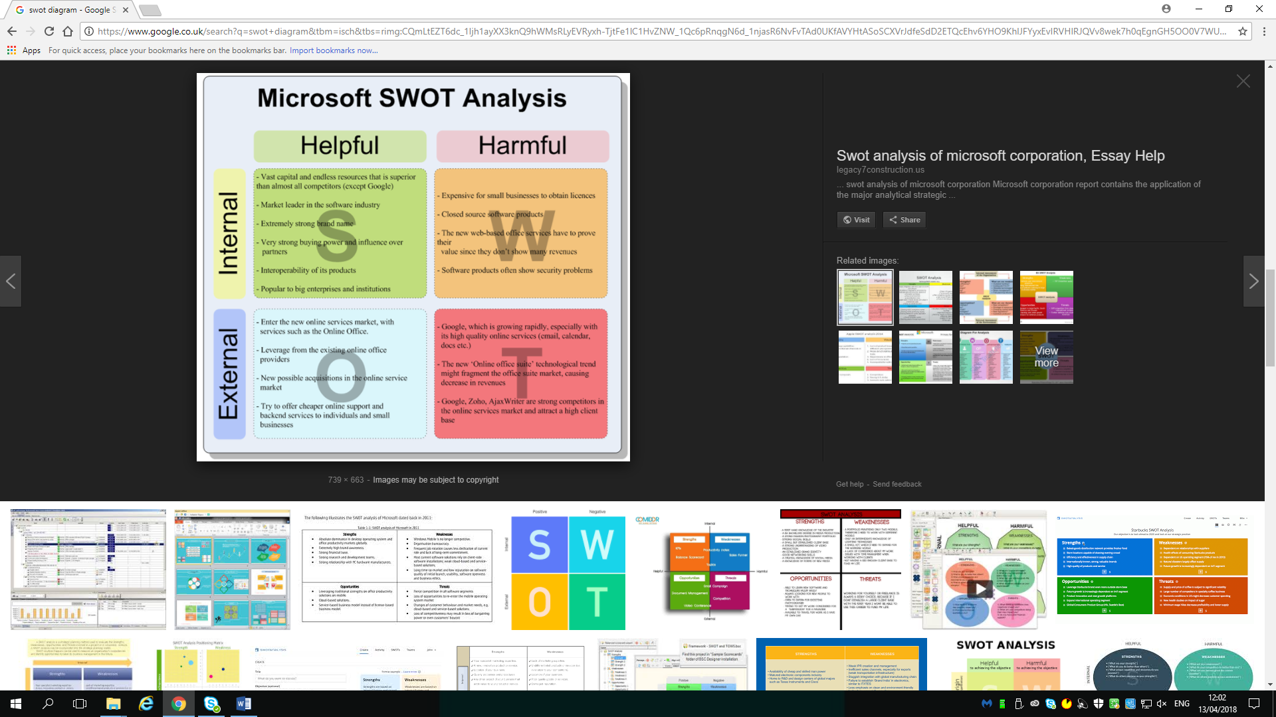

Political
Political factors relates to the pressures and opportunities brought by the political institutions and to what impact they put on the business. You must take into account the country government policy and political stability and other factors include taxations implication and industry regulations, global trade agreements and restrictions. It is also important to keep good intercountry relationships.

Economic
The economic factors relates to economic policies and what impact it has on the business, the international exchange rates, economy growth or decline, globalisation, inflation, interest rates and costs of living. Labour costs and consumer spending alongside import, export ratios.

Social
These factors relates to the cultural aspects, attitudes, belief which will determine the demand of the organisations product and how it operates. It is also important to have life style choices, trends, cultural norms, and expectations, career expectation and work life balance, as well as consumer taste and buying habits, and ethical issues.

Technological
This factors are growing rapidly and the Technological innovation products and services as well as data service. Barriers and incentives are also something to consider alongside the security levels and other technological such as mobile, social networking, automation and artificial intelligence to what degree these impact on the business.

Legal
Legal factors relates directly to the laws, regulation and legislation that will affect the way the business operates. These factors constantly changes in the UK employment, law and employment tribal decision. It has an impact to the working practises continuously and is also important to keep up to date with all changes such as the Current legislation, future legislation and international legislation alongside health and safety regulations, money laundering regulations, tax regulations consumer protection.

Environment
Environmental factors relates to the ecological and environmental aspects that effect the companies demand for products and how they operate. When a business has direct impact on in the environment and political sanctions now governs carbon resource such as wind turbines and recycling CSR. Cooperate, social responsibility and ethical sources of goods and services in which in turn has direct impact on the business chain management. (Processpolicy.com, NHS, 2018).

Political factors in detail
At the current moment Jeremy Hunt from the conservative party is serving the NHS healthcare services and social care since 2010. The political environment in the country is affecting the operations at NHS. These are the few of the things that are affecting the political side to NHS.
The rules and regulations of the NHS and the Government don’t go hand in hand this is noticed after each election happens. The funding that is given by the Government for certain treatments does not meet the required fund with the actual rates of the hospital and healthcare services. (My assignment help. Info, NHS, 2018). The Government of the country influences NHS to a large extent, the politicians are not aware about the NHS management and hence, the managers are really stressed with the continuous change. (Kings fund NHS, 2018). The UK vote to leave the EU will have a great impact and implications for health care services as well as social care. Due to economic and political uncertainty at the moment of crisis and financial pressure on NHS health and social care services, while the impact will be very strong and impossible to forecast. There are a number of important issues that will need to be resolved as follows below:

Staffing
Right from the start of NHS healthcare services in 1948 the staff force was from all over the world due to manage staff availability and to be able to maintain the funding. By leaving the EU would almost certainly create a short term crisis within the NHS service delivery.

Accessing treatment here and abroad
At the moment people from the EU country who live in the UK and people who are British residents but leave the UK to stay in the EU countries have access to the free NHS healthcare service on the same basis as the British nationals of that country. Due to voting out of the EU There is a concern that the results mean that the pensioners currently living in the EU and other countries will have to return to UK and this will put more pressure on the UK NHS healthcare service and social care services.

Regulation
If government changes the regulation of working time this will put an impact on NHS employment contracts and change pay framework. This all means what sort of decision process for their future trading relationship they come out with the EU. Even with medicines that are supplied from out the UK coming from the EU countries. EU will have to come up with a decision and decide where to keep up with the deal they have with the UK or make changes to the agreement.

Cross border cooperation
This will bring major impact to the members of the academic and medical communities as they will not be able to do research and work with other bodies from the EU with successful backgrounds to bring success to medical achievement that gave great success in the past, so they need to negotiate and come up with a solution.

Funding and finance
This will have a knock on effect on the NHS and the medicals, drugs and other goods leading to rise of prices and cuts on public spending as well as implications for service already struggling to cope within its existing budget. NHS would also have an impact by other consequences such as economic instability. (Kingsfund.com, NHS, 2018).

Economic factors in detail
The economical factor has direct impact on the economy and the performance it provides in an organisation and its profitability. This includes interest rates, employment or unemployment rates, raw material costs as well as foreign exchange rates. This can change over the years it may give your organisational product a boast or it can put you through a loss. Also not enough funding to the NHS healthcare services. These are a few of the changes that have caused in the NHS due to the economic environment.

NHS require qualified staff
The NHS requires qualified staff and hence, the cost of labour has increased drastically making it harder for the service to spend more at this point of time when there is not enough funding to be used for this to happen. As the NHS can’t work without qualified staff so they are having to cut down other expenses so that they can use the fund for staffing.

Social factors in detail
Social environment of the country in which NHS is present will decide on the changes that are needed to make. Here are few of the changes that have been caused in the NHS due to social environment. The NHS should take into consideration the number of ageing people who are present in the country as the ageing population require more healthcare services and should increase the capacity of the hospital. The main concerns are the inability to discharge the older patients in order to free up the beds, due to long term illnesses of patient needing on going treatments and having to stay in the hospital for a long period of time, this is the main cause of shortage of beds.

The NHS healthcare services and hospitals
This should be located nearby locality so people can get to the hospital easily when needed or in emergency care situation.

Social environment
This affects the staff in the NHS organisation as well as employees they believe in work life balance and the NHS should take care of this so that they can work and spend quality time with family and friends. Social environment can increase or decrease the number of patient and staff associated with the NHS. (NHS east of England, 2011).

The Five Whys Model
The five whys diagram a tool that is used for team brainstorming, and helps categorize potential source of defects or root causes. The five whys is an iterative interrogative technique that is used to find the particular problem and to determine the root causes of a problem by repeating the question to why it has happened. Each answer forms a basis of the next question and after getting an answer to keep on asking why until you get to the root of the cause and you are satisfied with the result of the answer. You can use the five whys for quality improvement and problem solving but is most effective to resolve simple or moderate difficult problems and it combines well with other methods and techniques such as root cause analysis. (Mindtools.com).

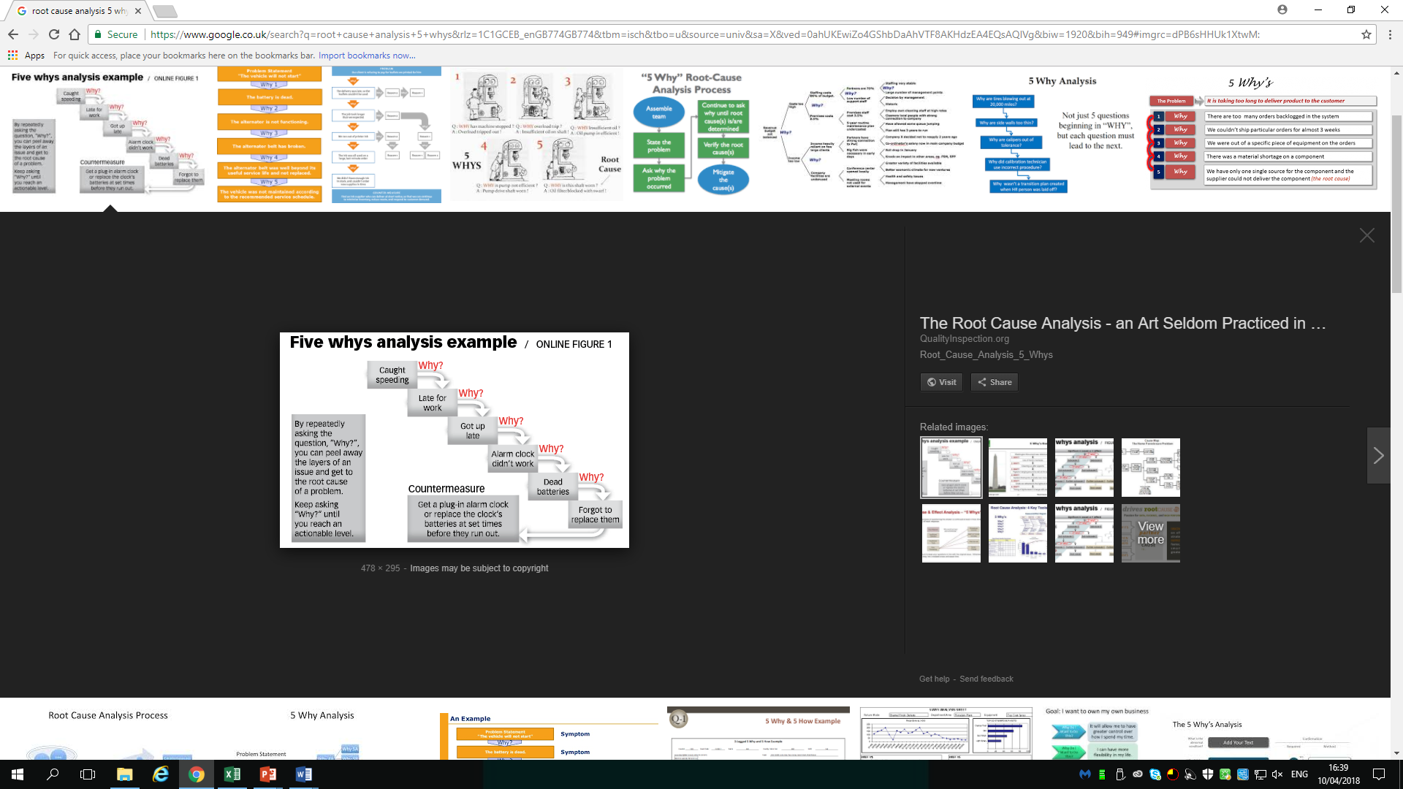

Fishbone theory
When you have a problem it is very important to explore all the aspects of the things that can cause it before you start to think about a solution. By doing so will give you a chance to understand the problems and give you an insight to how to deal with the issue. This way you can solve the problem completely. (mindtools.com). When there is a more complicated problem all organisation big or small use Cause and Effect analysis, by combining with brainstorming and Mind map this pushes you to consider all possible causes of the problem. It gives you the ability to go to the root of the problem and get a permanent solution. Analysing the possible causes of a problem by using a Cause and Effect Diagram which is also known as an Fishbone Diagram this was invented by a professor called Kaoru Ishikawa of Tokyo University in 1968 and then later adopted by Dr Edwards Deming and taught total quality management and found this as a helpful tool for improving quality. The technique uses the diagram based approach for thinking through all the possible causes of the problem and helps to analyse the situation. (Ishikawa, K, (1968) Guide to control, JUSE, Tokyo.
There are four steps to using the tool.
- Identifying.
- Work out the major factors involved.
- Identify possible causes.
- Analyse your diagram.
Fishbone diagram
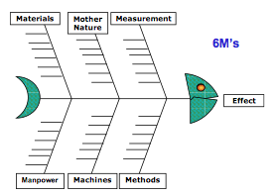

In the NHS healthcare they also use fishbone tool for problem solving methods.
Here is an E.G of the fishbone diagram used in the NHS healthcare service.

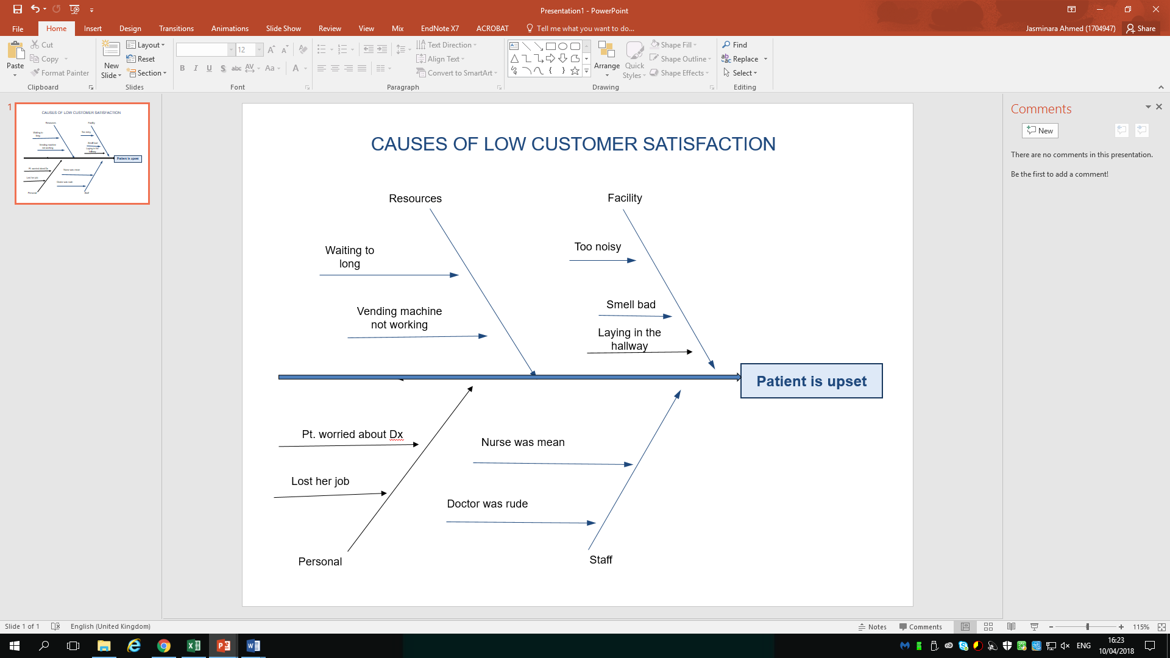

Brainstorming and Mind Mapping
Brainstorming technique for problem solving is a great and powerful method, and creates new ideas as well as motivates and develops individuals or in a team of people working together. In order to resolve an issue within an organisation brainstorming is not just a simple random activity but this needs to be structured and follows brainstorming rules. It is also said to be a tool for thinking outside the box. Once you have come up with ideas then you need to use the funnel process or other tools can be used to help you decide to which useful ideas that you will be using to solve the problem. (Businessball.com)
By making a brainstorm map gives you the potential to work your idea and provide structure to all the ideas and visualise them on paper and you can insert more ideas and build on them as well as reflecting back on previous inputs. (Mindmeister.com)

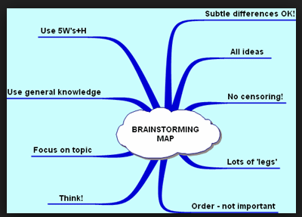

PMI
PMI is an ethical decision making framework, which helps weighing up the pros and cons of a decision this is a quick way to process a problem. PMI stands for plus, minus, interesting. This is done by a scoring method by writing the decision you have to make on paper then dividing the positive consequences of the decision in to the pros column and the cons column and then giving each individual column points based on all the decisions you have come up with once this is done add up the scores in each column then subtract the total cons from the total pros. The overall score indicates that you should go ahead with the decision and you should scrap the negative one.
(mindtools.com)

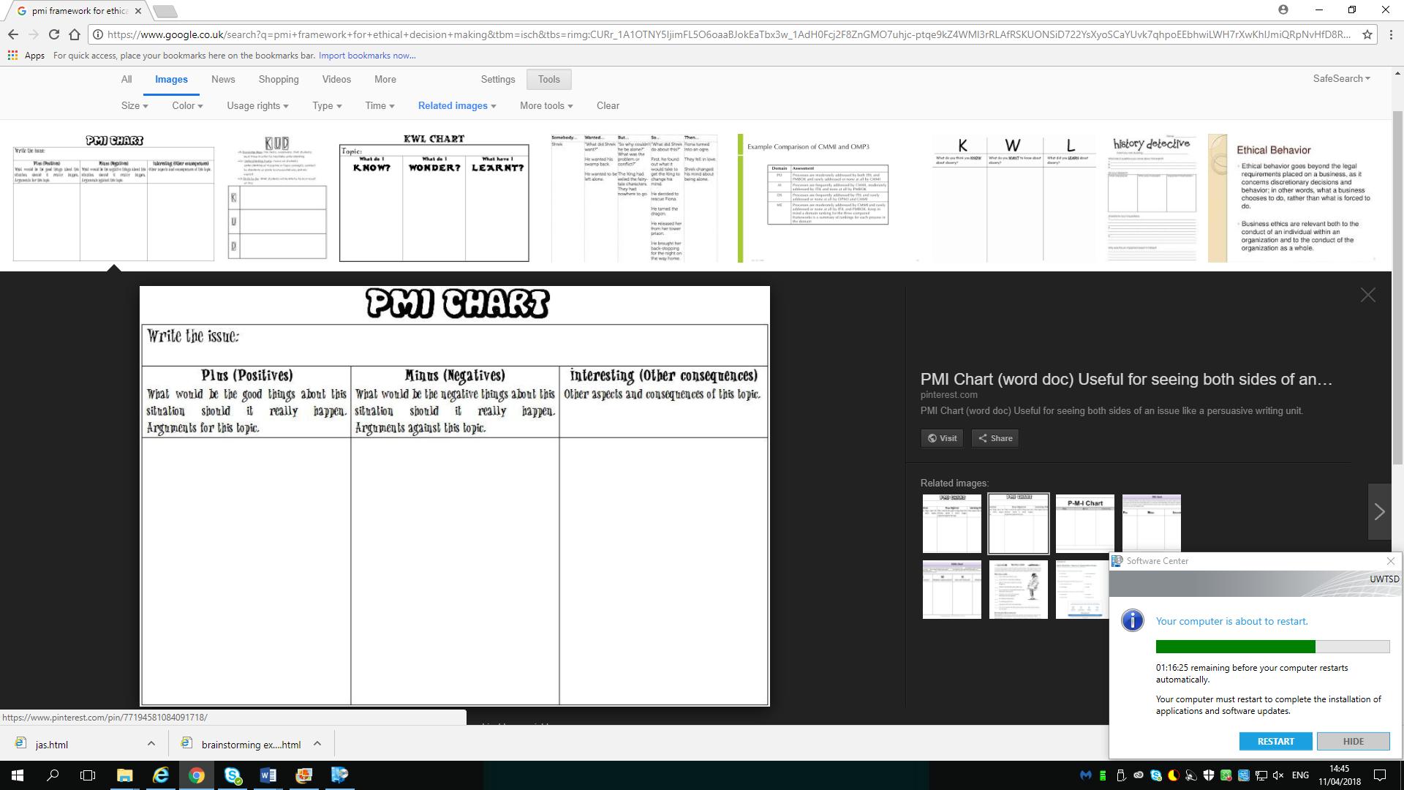

Grid Analysis
Grid analysis is a useful technique to use when in a decision making process, and to weigh up different factors. It is more effective when there is a number of good alternatives and many factors to take into account and balanced before making a decision. Firstly to make list of all the factors that are important to the decision making process. Then by using a decision making grid and imputing all the factors along one side and options on the other. Each option then is scored from 0 to 3 against each factor. Then each factors are given the score to the importance, then each option is totalled and the highest wins.

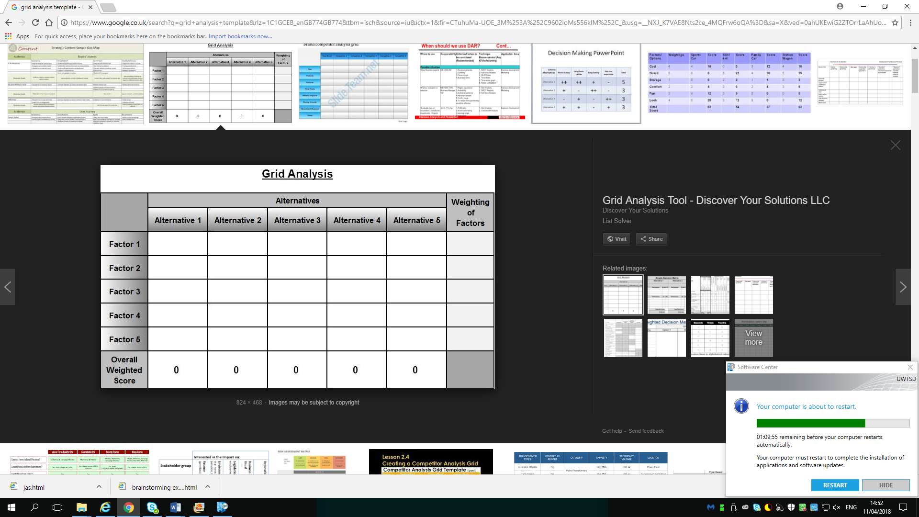

Edward de bono six thinking Hats
Six thinking hats can help you look at problems in a different angle and view point to go in to detailed inspection. It allows you to have a powerful decision checking technique in group situations from each perspective at the same time. Six hat was created by Dr Edward de bono, and published in his 1985 book of the same name. The six hat thinking technique is a frame work designed to promote thinking and decision making and process alone or in a group. The six hats are available to use and are identified by the different colours that symbolic the different style of thinking. Each hat dictates a unique way of thinking.
White hat: Information.
Red hat: Emotions.
Black hat: Negatives.
Yellow hat: Positives.
Green hat: Creativity.
Blue hat: Overview
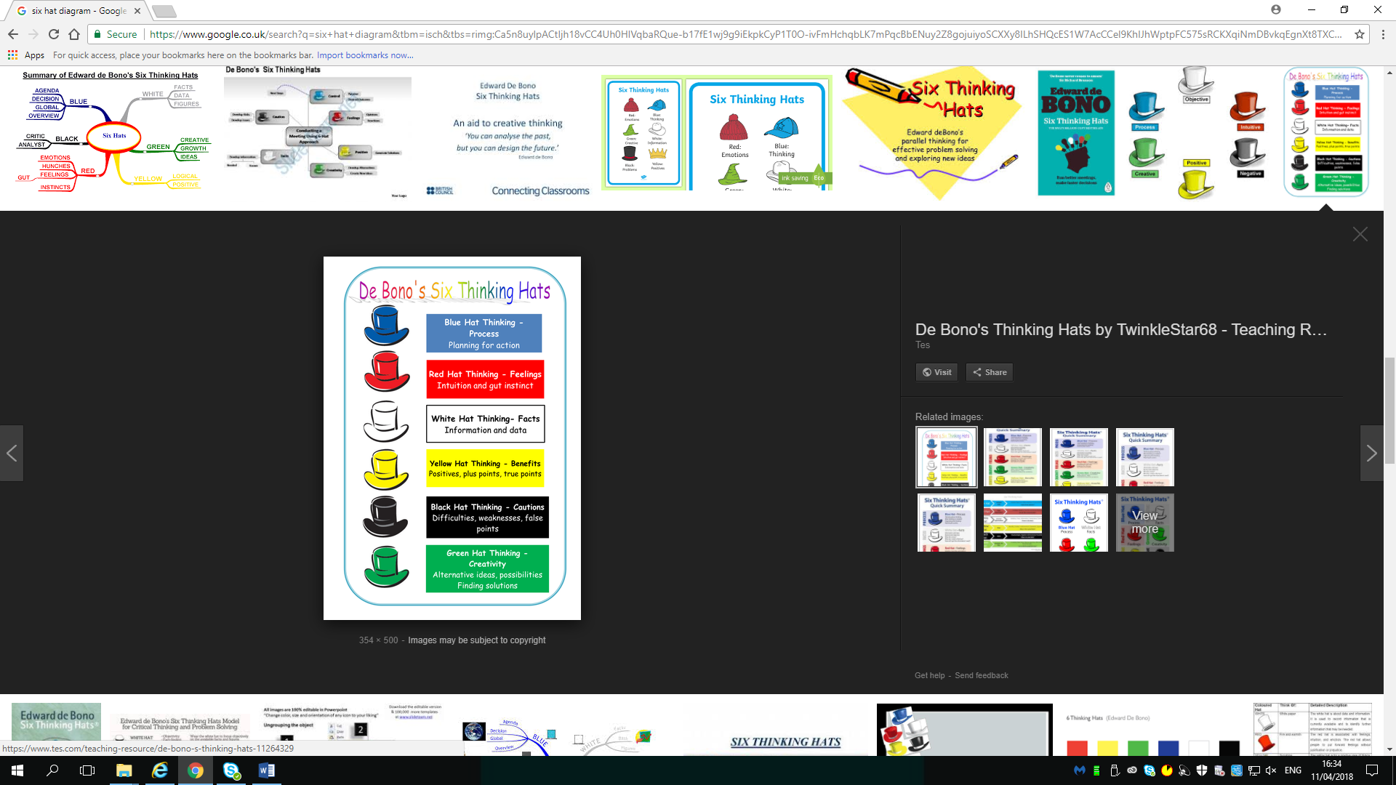

Conclusion
The current problems in the NHS is getting worse on a daily basis and needs to come up with a solution and needs to be dealt with as soon as possible. As this is putting a huge impact on the internal stakeholders as well as the external stakeholders. By understanding all aspects of the problem and coming together as a whole E.G Politicians and Government should be working towards a solution, rather than going against each other and working in different sectors, this is making the situation worse as time is a limit. Majority of the British voters would support tax rises to fund the NHS healthcare. This will be a beneficial to all people as NHS is a very important service for all no matter which field you are in. As the population and the growing age is at a high there will be more funding needed to run the NHS smoothly and more cooperation and keeping good terms with the E.U as they play a large part in the NHS circle. By introducing more health advice over the phone and by having more appointments available and managed by the GP services, lots of non-urgent visits will be avoided. As the NHS phone service is not widely available and efficient this is pushing patients to go to the G.P and A.E with less complex illnesses which could have been dealt by advice over the phone.

Recommendation
In the modern times as technology used on every day basis where ever we go, we should be introducing more mobile services to be checked by doctors on the go on our mobiles this would eliminate the overcrowding of patients and the long waiting times. We also need more social care services for the elderly patients so they can be shifted there by doing so will free up more hospital beds. Modern medicine means huge success in improving life expectancy but comes with a big price tag. NHS needs to improve their procurement and the service they provide so the efficiency can be used in a proper manner and a pacific process needs to be set up for the procurement, and service delivery will allow more patients to be treated in less time and in appropriate manner. The process for procurement will reduce wastage. Economic environment can increase the profits or the losses of the NHS so this needs to be analysed regularly and changes should be implemented. By using all the problem solving tools and analysing the problems in depth and will give a chance get to the root cause of problems and come up with a permanent solution. The biggest challenge will be to come up with a plan to pay for a long term settlement to cover for the NHS healthcare and social care to do that the government must cut costs on less important issues and focus on the more needed projects such as the NHS and make firm decisions about the future and how to sustain it.

Reference list
Websites
Mckenna, H, 2016 Five big issues for health and social care after the Brexit vote.
https://www.Kingsfund.org.uk/publications/articles/brexit-and-nhs
Robertson, R, 2016. Six ways in which NHS financial pressures can affect patient care.
https://wwwKingsfund.org.uk/publications/six-ways
Healthcare London 2018
Https://www.myhealth.london.nhs.uk/help/nhs-today.
Dialogue by design 2018
www.dialoguebydesign.co.uk/project/nhs-england-consultation.
Small business.chron.com/external-stakeholders-company-html
Dialogue by design
www.dialoguebydesign.co.uk
Kingsfund NHS
https://www.Kingsfund.org.uk
http://www.NHSdirect.nhs/checksymptoms.
https://cipd.co.uk/Knowledge/strategy/organisational-development/pestle-analysis-factsheets
Pestle analysis.com.NHS, 2018.
Https://www.processpolicy.com/pestle-analysis.htm
Https://www.mindtools.com/pages/article/newtmc-05.htm
Myassignmenthelp.info/assignments/marketing-assignment-pestle-analysis-nhs
https://england.nhs.uk/mids-east/clinical-networks/east-/clinical-networks/east-of-england-clinical-network/contract-us
Businessball.com
https//www.mindmeister.com
https://www.theguardian.com/healthcare-network/2011/jun/29/england-nhs-teaching-hospitals-london-capital.
https:www.eastamb.nhs.uk
htttps://improve.nhs.uk
https://www.independent.co.uk/topic/nhs.
https://www.supplychain.nhs.uk
https://www.telegraph.co.uk/nhs.
https://improvements.nhs.uk/resurces/six-thinking-hats
https://www.the guardian.com/society/2016/jan/18nye-bevan-history-of-nhs-national-health-service.
Decision making19.04.18
http://mbatools.co.uk/toolbox/decisionMaking/gridanalysis.htm
Accessed 22.04.18
NHS England. NHS overcoming the challenges facing problems
www.England.NHS
Accessed 20.03.18
http://nhsinvolvement.co.uk/Internal stakeholders and External stakeholders
Accessed 19.02.2018

