Assessment 1

Human Resource Management - 50% Mark

INDEX

S. NO. | PARTICULARS |  |  |  | PAGE NO.
PART-A | The current state of the labour market in the United Kingdom
 | 1. | What is Labour Market? |  |  | 4
 | 2. | Importance of Labour Market? |  |  | 4
 | 3. | State of Labour Market in the United Kingdom |  |  | 5
 |  | * |  | Net Employment Balance | 6
 |  | * |  | Recruitment, Retention, and Up-skilling | 6
 | 4. | How To Move Forward? |  |  | 7
PART-B | The emerging changes in Human Resourcing Strategies in the post-Covid, post-Brexit external environment.
 | 1. | Human Resourcing Strategies |  |  | 8
 | 2. | Factors Affecting Human Resourcing Strategies |  |  | 9
 | 3. | Brexit And Covid |  |  | 9
 |  | * | Brexit |  | 9
 |  | * | Covid |  | 10
 |  | * | Impact Of Brexit and Covid |  | 10
 | 4. | Human Resourcing Strategies Post-Brexit and Covid |  |  | 10
 |  | * | The Way Forward |  | 11
 | References |  |  |  | 12

PART-A: THE CURRENT STATE OF THE LABOR MARKET IN THE UNITED KINGDOM

WHAT IS LABOUR MARKET?

Labour Market can be essentially defined as a place, where people seeking work i.e., “workers” and people seeking workers i.e., “employers” interact with each other, in the quest to seize the best work and workers, respectively (Heylen, 1993).

As per the Merriam-Webster Dictionary, Labour Market is defined as “the number of workers who are available to be hired.”
(Merriam-Webster, 2022)

It will not be wrong to say that, Labour Market, mostly, is not an actual place, but a phenomenon of supply and demand, whereby, the employers create demand for labour, and the employee provides for the demand.

As there is a constant supply-demand chain of labour in the labour market, it can get extremely competitive, where employers compete to hire the finest, and workers securing the most rewarding and satisfying job turns out to be a common scenario (Zhang and Han, 2013). In crux, it can be said that the Labour Market is a place where the supply of jobs meets its demand.

IMPORTANCE OF LABOR MARKET?

It has been already observed that the Labour market plays a crucial role in any economy by meeting the demand for jobs through its supply. Even in a technologically driven era, the importance of labour and workforce cannot be ruled out. If anything, the boom of technology has only hiked the demand for skilled labour in recent times (Graetz, Restrepo and Skans, 2022).

Though the intendment of the Labour market does not limit to fulfilling the supply-demand chain of the labour. Organizations, as good practice, analyse and understand the various trends of the labour market as a crucial part of their recruitment process. Further, it not only helps in recruiting the perfect candidate but also helps to evaluate the required workforce, and formulate a procedure to ensure lucid onboarding. Similarly, monitoring the swings of the market bestows the labour with various job opportunities promising lucrative packages and satisfactory work-life experience.

Thus, studying the ups and downs of the labour market enables an organization to retain its competent workers and further, improve its productivity, and motivate the workers to work at their full potential.

STATE OF LABOR MARKET IN THE UNITED KINGDOM

The latest Labour Force Survey (LFS) estimates for February to April 2022, have indicated a decrease in the rates of economic inactivates and unemployment in the United Kingdom, resulting in an increase in the economic activity and employment rate over the quarter.

The LFS report elaborated on the trends of the market, grouping them into various categories, encapsulating the essence of the State of Labour Market in the United Kingdom in the current times. Below the same are mentioned and explained for better understanding:

(i) Number of Employees:
As per the LFS report, there has been a record high increase in the numbers of full-time employees, and the same is the major contributor to the increase in the total employment as a decline has been noticed in the number of part-time employees. Further, the number of self-employed workers witnessed a slight increase but the change is not significant.

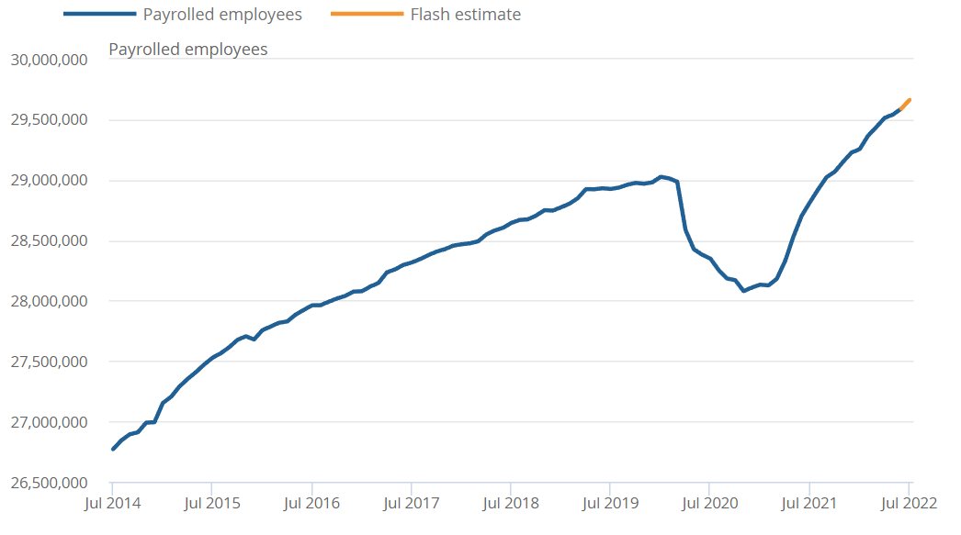
Figure 1.0: Number of Payroll Employees in the UK (Office of National Statistics)

(ii) Weekly Hours Worked:
In a quarter-wise comparison of hours worked weekly, an increase can be noticed in the total actual hours worked weekly as compared to the previous quarter (Leaker, 2022). Statistically, average actual hours worked weekly along with average hours worked by part-time workers are also now returning to levels. Further, the shortfall in total hours is caused by the reduced numbers in employment (figure 2.0).
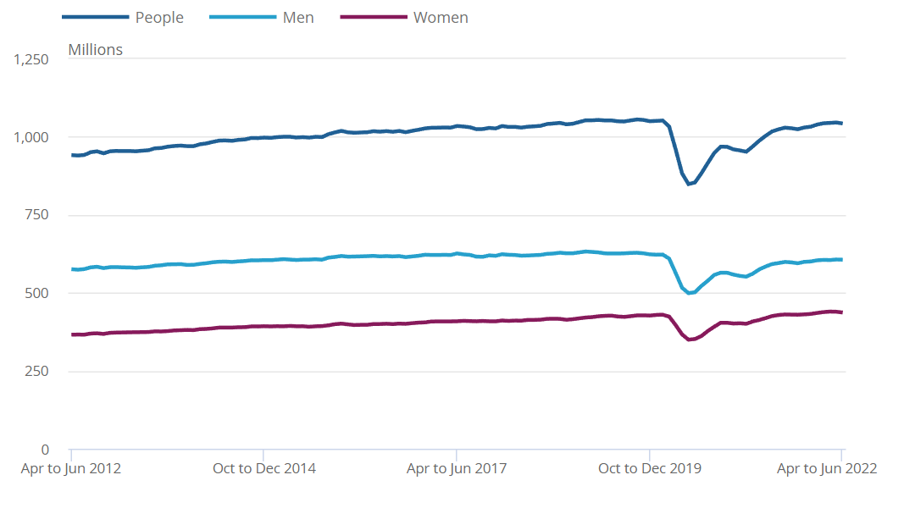
Figure 2.0: Hours Worked in the UK (Office of National Statistics)

(iii) Unemployment Rates:
Although there has been a significant decrease in the unemployment rate during the quarter, there has been an all-time high in those unemployed for up to 6 months since late 2020. On the brighter side, numbers of those unemployed for between 6 and 12 months have decreased, offsetting the increase in those unemployed for up to six 6 (Leaker, 2022). Also, the number of those unemployed for more than 12 months has continued to decrease steadily.

(iv) Economic Inactivity Rate:
The economic inactivity rate witnessed a decrease, students being the root cause for setting in motion the decrease in economic inactivity compared with the previous quarter.

(v) Number of Job Vacancies:
The number of job vacancies in the quarter, despite its slow growth, was record high creating numerous job vacancies.
(vi) Employees' Average Total Pay:
The quarter witnessed an increase in the average total pay of employees with and without bonuses. Though it has been observed that the hefty bonuses have been the major contributor to the positive growth. Further, upon adjusting the numbers as per the inflation, the results are not very promising as the growth is neither steady nor positive.

Net Employment Balance
Net employment balance represents the difference between the employers who are expecting and or willing to increase their workforce and the employers who are planning a reduction or layoff of the already recruited workforce, over a certain period of time. The Labour Market in the United Kingdom has substantiated a positive net employment balance indicating more jobs than layovers.

Recruitment, Retention, and Up-skilling
The Chartered Institute of Personnel and Development (CIPD) admitting that the Bank of England has forecasted a recession, in its quarterly Labour Market Outlook, August 2022 edition, depicted strong recruitment and retention intentions (CIPD, 2022). Further, they also stated that, upskilling existing staff along with, promotions, increments, and new recruitments have been the tools used by the employers to sustain the recruitment and retention difficulties.

In the current scenario, recruitment and retention have become extremely challenging, and the same has been forecasted for the near future. The hiring process is still not in its full bloom, and increments, bonuses, and skill development of the already employed have been the most reckoned-upon solution to the problem at hand.

This is also a momentous step toward developing a skilled workforce, as in recent history, the investment made by the employers in training and up-skilling their workforce has experienced a steep decline. Training and up-skilling of the already recruited workforce help the employers in aligning incentives with the job.

Recruitment has been challenging in certain sectors as compared to others. As per the CIPD quarterly Labour Market Outlook, August 2022 edition, 56% of employers in the educational sector have faced difficulties in filling the vacancies, followed by transport and storage at 55%, and the voluntary sector at 53%. On a more constructive tone, employment intentions on the part of the labour have stayed positive across the sectors, with information and communication, construction, business services, and admin and support services at the top exhibiting a hike of 53%, 48%, and 47% respectively (CIPD, 2022).

How To Move Forward?

Greg Thwaites, research director at the Resolution Foundation stated “The labour market could now be at a turning point,” disporting positive hope for the future of the labour market of the United Kingdom (Cominetti, Handscomb, Slaughter and Thwaites, 2022).

Despite the forecast of recession by the Bank of England, the ongoing trends, and the recent statics of the labour market of the United Kingdom are promising a positive future. To ensure, that the market trends will glide on the positive side of the slope it’s also crucial to address the critical trends of recruitment and retention difficulties. The predicament of recruitment and retention difficulties can be dealt with, with a three-step procedure as cited below:

Step 1- Focus on the existing workforce
Employers, instead of fully depending upon recruiting new people, should train to upskill or reskill their current staff. It is not only cost and time effective on the part of the employer, it also motivates the employees and boosts job satisfaction.

Step 2: Review of the Employee
To ensure that value propositions for the employees and the organization are well defined and properly communicated, employers shall conduct a timely review of the current and prospective employees.

Step 3: Flexible Reward Packages
In developing or revising the reward package, flexible options should be selected, keeping in mind the position of the organization, the needs of the employees, and the work associated. Same packages consisting of different benefits can be worked as per the individual need of the different employees. For instance, benefits such as health and wellbeing support should be made part of the reward packages to alleviate living costs (Cominetti, Handscomb, Slaughter and Thwaites, 2022).

PART-B: THE EMERGING CHANGES IN HUMAN RESOURCING STRATEGIES IN THE POST-COVID, POST-BREXIT EXTERNAL ENVIRONMENT.

HUMAN RESOURCING STRATEGIES:

To make the concept of “Human Resourcing Strategies” more striking and easily understandable let’s breakdown the term into shorter ones:

Human resource  Human resources embody the set of people who make up the workforce of an organization, business sector, industry, or economy (Lee and Stead, 1998).  Human resources, having the skills, intelligence, and knowledge, are said to be the most important resource of any organization.  Humans, metamorphosing natural resources into usable and valuable things themselves become a resource. |  |  | Human Resourcing  The procedure of identifying the need for human resources, and ensuring recruitment of the best-suited one can be defined as Human Resourcing.  Though the responsibilities of the HR Department surpass the traditional roles of finding, screening, recruiting, and training job applicants.  In today’s time, they are in charge of the employees and employee-related operations, making sure that everything required to perform the day-to-day task has been provided for and a healthy work environment is established throughout the organization (Storey, Wright and Ulrich, 2019).  It's safe to say that the HR department not only attracts but also retains qualified people.
Strategies

As per the Merriam-Webster Dictionary, Strategy is defined as “an adaptation or complex of adaptations (as of behaviour, metabolism, or structure) that serves or appears to serve an important function in achieving evolutionary success.”
With a goal to achieve a certain result, a strategy is a carefully developed plan or method ensuring the desired outcome. It is crucial to understand, that strategy does not limit at the development of a plan but also ensues undertaking such a plan or method.

We now understand that the term Human Resourcing Strategies consists of two vital parts i.e., “Human Resourcing” and “Strategies” and upon bringing both the terms together, we understand that Human Resourcing Strategies means:
“Organization’s strategies to manage its Human resourcing.”

Human Resourcing Strategies can be further elaborated as an organization’s overall plan to establish that the human resources are in perfect alignment with the business activities and overall vision and mission of the organization. The main intent of a Human Resource Strategy is to maximize the potential of the employees so that they conform to the organizational objective.

FACTORS AFFECTING HUMAN RESOURCING STRATEGIES

It has already been established that Human Resources Strategies are built upon numerous varying factors, humans, organizational objectives, and their proper alignment being the most vital deciding factors (Vinichenko, 2020). It should not come as a surprise that the economy is never static, and keeps on changing constantly. The change in the business environment of an organization can be a result of both external and internal factors.

The internal factors mainly consist of the Vision & Mission of the Organization, The Size of the Organization & Quantum of Workload, Organizational Structure, whether centralized or decentralized, expectations from the employees, and their rewarding strategy, etc.

On the other end, are the external factors, which are not under the control of an organization to meld and readjust as per its amenity. External factors are difficult to tame, and more often than not, the organization has to make room to accommodate such changes.

The factors deciding the ultimate Human Resources Strategies are very dynamic. To ensure that the Human Resources Strategies developed by the organization are capable enough to evolve with the ever-changing circumstances, it has to be kept in mind the strategies, at any given point of time should be flexible enough to adapt to the changes.

BREXIT AND COVID

BREXIT
The term “Brexit” is derived from two different terms “Britain” and “Exit”
The United Kingdom, since 1 January 1973, has been a part of the European Union (EU), and of its predecessor the European Communities (EC), but on 31 January 2020, it withdrew from the European Union (EU), BREXIT signifying the departure.

The proposal was made during the referendum held in June 2016, the agenda for voters being “Should the United Kingdom remain a member of the European Union or leave the European Union?” The votes in favour of leaving the EU counted to be 51.89%, resulting in the exit.

COVID
The largest category of a RAN Virus, Coronavirus disease (COVID-19), is an infectious disease caused by the RAN Virus type SARS-CoV-2. The first cluster of patients with Covid was identified on 21st December 2019, in China. The deadly infectious virus soon travelled out of China and gripped the entire world causing a pandemic of respiratory illness.

On January 29^{th,} 2020, the first two patients tested positive for coronavirus in the United Kingdom. Within a span of 2 months, by March 20th, 2020 the spread of the virus caused the United Kingdom to shut down schools, universities, pubs, restaurants, gyms, and other social venues in an attempt to control the spread of the virus and enforce social distancing.

IMPACT OF BREXIT AND COVID
The exit of the United Kingdom from the European Union was so closely followed by the Covid-19 pandemic hit, that it is very difficult to point out the individual impact of each on the economy of the United Kingdom (Wadsworth, 2018). Both Brexit and Covid-19 influenced the various sectors of the economy of the United Kingdom.

The Labour Market and human resources were significantly influenced by the hit of the pandemic and the separation of the UK from the EU. Such sudden external factors shift has caused various organizations to revisit and re-evaluate their Organizational Strategies across the departments to accommodate the changes and ensure a competitive edge by developing such strategies which fall in line with the post-Covid and post-Brexit era.

HUMAN RESOURCING STRATEGIES POST-BREXIT AND COVID

Initially, there has been a threat in regards to the shortfall of skilled labour supply for the United Kingdom post-Brexit. To avow tariff- and quota-free trade in goods, and establish the supply of labour, the United Kingdom and European Union provisional agreement was approved by the U.K. parliament on Jan. 1, 2021, and the same was approved by the European Parliament on April 28, 2021.

This resulted in the workforce being able to practice and provide services to clients in the UK. To further ease the transition and help the employees adapt to the new dynamics, many organizations have been encouraging and supporting their employees through the process of applying for the Settlement Scheme and attaining the settled status. Meanwhile, the spread of the pandemic had mixed impacts as the layoff raised the numbers of unemployed looking for jobs, whereas an ample number of employees resigned increasing the demand for labour, mostly balancing each other off.

In the current times, the economy has shown favourable results, whereby the number of people employed, the quantum of wages, total working hours, and other such factors have depicted positive growth, most of them being steady, making the future looks promising.

THE WAY FORWARD AND CONCLUSION

Despite, the encouraging performance of the economy, the problem of difficulties in recruitment and retention has remained. To curtail the problem, organizations are remodelling and redefining their Human Resources Strategies. Unlike recent history, organizations are now focusing on the workforce already engaged instead of hiring new employees. The budgets are now shifting from hiring expenses to training expenses. Organizations are introducing various in-house programs to train and up-skill their current workforce and to ensure their alignment with the organization’s objectives.

Such has not only reduced the annual spending of the organizations which was earlier used in the process of hunting and recruiting but also resulted in a workforce that is already familiar with the objective of the organization. Such internal growth programs have also resulted in a very satisfied and motivated workforce, which in return stays loyal to the organization and its objectives.

Although such a shift does not conclude a completely restrained from appointing a new workforce, given the advantages of internal growth of the already recruited, training and up-skilling are now seen as viable alternative to recruitment. In light of the above-mentioned, it is safe to say that there has been a shift in the way organizations now approach their Human Resources Strategies Post-Brexit and Post-Covid.

References
Cominetti, N., Handscomb, K., Slaughter, H. and Thwaites, G., 2022. Labour Market Outlook Q1 2022 • Resolution Foundation. [online] Resolutionfoundation.org. Available at: <https://www.resolutionfoundation.org/publications/labour-market-outlook-q1-2022/> [Accessed 1 September 2022].
GOV.UK. 2022. Coronavirus (COVID-19): guidance and support. [online] Available at: <https://www.gov.uk/coronavirus#:~:text=The%20government%20has%20removed%20remaining,meeting%20indoors%2C%20or%20meet%20outside> [Accessed 1 September 2022].
2022. Definition of labor market. [online] Available at: <https://www.merriam-webster.com/dictionary/labor%20market#:~:text=Definition%20of%20labor%20market,are%20available%20to%20be%20hired> [Accessed 1 September 2022].
Evans, T., 2022. UK Labour Market: February 2022 - Office for National Statistics. [online] Ons.gov.uk. Available at: <https://www.ons.gov.uk/releases/uklabourmarketfebruary2022> [Accessed 1 September 2022].
Graetz, G., Restrepo, P. and Skans, O., 2022. Technology and the labor market. Labour Economics, 76, p.102177.
Heylen, F., 1993. Labour Market Structures, Labour Market Policy and Wage Formation in the OECD. Labour, 7(2), pp.25-51.
CIPD. 2022. Labour Market Outlook | Surveys | CIPD. [online] Available at: <https://www.cipd.co.uk/knowledge/work/trends/labour-market-outlook#gref> [Accessed 1 September 2022].
Lee, M. and Stead, V., 1998. Human resource development in the united kingdom. Human Resource Development Quarterly, 9(3), pp.297-308.
Lussier, R. and Hendon, J., 2019. Fundamentals of human resource management. London: SAGE Publications.
Storey, J., Wright, P. and Ulrich, D., 2019. Strategic Human Resource Management.
CIPD. 2022. UK’s hiring boom set to continue but labour market will soon reach its peak, suggests the CIPD’s latest quarterly Labour Market Outlook | CIPD. [online] Available at: <https://www.cipd.co.uk/about/media/press/150822-labour-market-outlook-summer-2022> [Accessed 1 September 2022].
Vinichenko, V., 2020. Impact of critically relevant factors on human resourcing in the transportation industry. SHS Web of Conferences, 80, p.01017.
Wadsworth, J., 2018. Off EU Go? Brexit, the UK Labour Market and Immigration. Fiscal Studies, 39(4), pp.625-649.
Zhang, W. and Han, G., 2013. How Have Labour Market Developments Affected Labour Costs in China?. SSRN Electronic Journal,.

