Component 2 - Research Report
Student Name: Kayleigh Slater
Student Number: 2213836
Lecturer Name: Cheun Leung
LCHS4002_BIRM
Digital Skills and Research Methods.

Contents
1. Introduction 3
2. Research design 3
2.1. Research Question 3
2.2. Method 3
2.3. Ethical Considerations 3
3. Results 3
4. Discussion 3
5. Conclusion 3
6. Reference List 3
7. Appendix A – A blank copy questionnaire. 3

Introduction
We are a group of UWTSD students undertaking the module; Digital skills and research methods as part of our Health and social care course. We are conducting a survey/research study relating to the use of digital skills. This survey aims to explore any difficulty experienced by students when using digital skills for learning. By identifying areas where students may have lower levels of confidence and exploring the factors that contribute to these differences, we hope to provide insights and recommendations that can inform the development of effective strategies for promoting digital literacy and supporting students' success. Ultimately, our research aims to contribute to a better understanding of the role of digital skills in education and to support efforts to empower students with the skills and competencies needed for success in the digital skills sector. It is crucial to understand students' confidence in using their digital skills for their studies. The results of this study will be beneficial for educators and institutions in developing strategies and support systems to heighten students' digital literacy skills and ensure that they are better equipped to succeed in their academic pursuits. "Are students confident using their digital skills for study?" by using a quantitative research approach this research report aims to examine the level of confidence that students have in using digital tools for their coursework, the challenges they face in using these skills, and the support they require to enhance their digital literacy.

Research design

This research study will be to define if students are confident using their digital skills, a quantitative research design with data collection methods such as an online survey will be used. The survey includes a harmonised questionnaire that measures students' expertise in using digital tools for their studies. The survey will be given using a suitable online platform to reach a wide-ranging and diverse audience. The data collected will be analysed using appropriate statistical techniques, such as descriptive statistics diagrams, and graphs, to determine the level of students' confidence in using their digital skills for their studies. The study will also consider ethical considerations, such as obtaining informed consent, ensuring the confidentiality of the participants, and minimizing any potential risks to the participants. The findings could conceivably be used to inform the development of targeted interventions or support strategies to enhance students' digital skills and confidence.

Research Question

The research question “Are students are confident using their digital skills for study?” is an dynamic one, as digital tools have become integral to modern education. This research question seeks to explore the level of confidence that students have in using digital tools for their studies. The question requires a comprehensive understanding of the range of digital skills that students use, how frequently they use these skills, and how self-assured they are in applying these skills to their academic work. Examined using a quantitative research design, such as an online survey that assesses students' ability, and confidence in using digital tools for their studies. The outcome from the findings of the study could help identify any misunderstandings when using digital skills as part of a student’s study. Focusing on this could potential help students of UWTSD as we will be able to address the lack of confidence and help improve our usage of digital skills , which is crucial for students’ academic success and future career prospects in a the digital age we live in today.

Method
This research report on students' confidence in using their digital skills will employ a quantitative research method, by completing a standardized questionnaire designed to gather data on the level of students' confidence in using digital tools and technologies for their studies, the challenges they face in using digital skills, and the support they require to enhance their digital literacy skills. The survey questions could include a range of open questions, closed questions and ranked questions related to digital skills, such Partakers will then be asked to rate their level of agreement or disagreement with these statements using a Likert scale. Quantitative techniques that will be used to gather information for research on whether students are confident using their digital skills for study, and Participants will be recruited via an invitation to a short survey sent by email. with the survey allocated online through university or college email lists. In order to ensure the sample is representative of the target participants based on key variables such as gender, age, and confidence using diverse applications and tools.

2.3 Ethical Considerations
When conducting ethical research, is it of utmost importance to ensure that the participants are treated with respect, their rights are protected, and the integrity of the research is maintained. “Ethics helps us decide what we should do and why”, Barrett et al. (2016, p7) Informed consent should be obtained from all participants, confidentiality should be maintained throughout the survey process to protect participants' privacy. The data collected will be solely for the purpose it was intended and will not be shared with third parties. By adhering to these ethical considerations, I can ensure that this research is conducted in a responsible and respectful manner. Accurate analysis and reporting of data are essential in any research project. Without precise analysis, the results transpire inaccurate. The right to decline participation in a research project cannot be questioned. This is accompanied by the right not to be harassed to participate, as well as the right to decline. “Ethics helps us decide what we should do and why”, Barrett et al. (2016, p7). Saunders et al (2019) outlines a series of key ethical principles that any researcher needs to be aware of, the first six principles apply to working with the participants.
- Integrity, fairness and open-mindedness.
- Privacy of those taking part
- Voluntary nature of participation and right to withdraw
- Respect for others
- Avoidance of harm
- Informed consent of those taking part

As UWTSD students in our Research study it was important that we included a consent option. For example we asked the participants if they consented voluntarily to take part In our questionnaire as The principle of informed consent involves researchers providing sufficient information and assurances about taking part to allow individuals to understand the implications of participation and to reach a fully informed, considered and freely given decision about whether or not to do so, without the exercise of any pressure or coercion. This leads to the right of those taking part to expect the researcher to abide by the extent of the consent given and not to find that the researcher wishes to prolong the duration of an interview or observation, or to widen the scope of the research without first seeking and obtaining permission, or to commit any subsequent breach of the consent given. We respect any data given by the participant and it is important that we do not share the data with anyone in the organisation.
Overall, the results of the study validate the need for educational organisations to prioritize digital literacy and provide students with the essential training and support to develop their digital skills.

- Results
The results of our research indicate that students have varying levels of confidence in using digital skills for their studies. Majority of students reported feeling confident in using basic digital tools such as email, internet browsing, and word processing software. However, their level of confidence decreased when it came to more complex digital skills, such as Forms, Excel and using advanced data analysis software. Interestingly, the study found that students face several challenges in using digital skills for their studies, with a lack of access to digital tools and a lack of training and support being the most common challenges reported. These findings highlight the need for educational institutions to invest in digital infrastructure and provide adequate support to students to enhance their digital literacy skills. Overall, the results of the study demonstrate the need for educational institutions to prioritize digital literacy and provide students with the necessary training and support to develop their digital skills.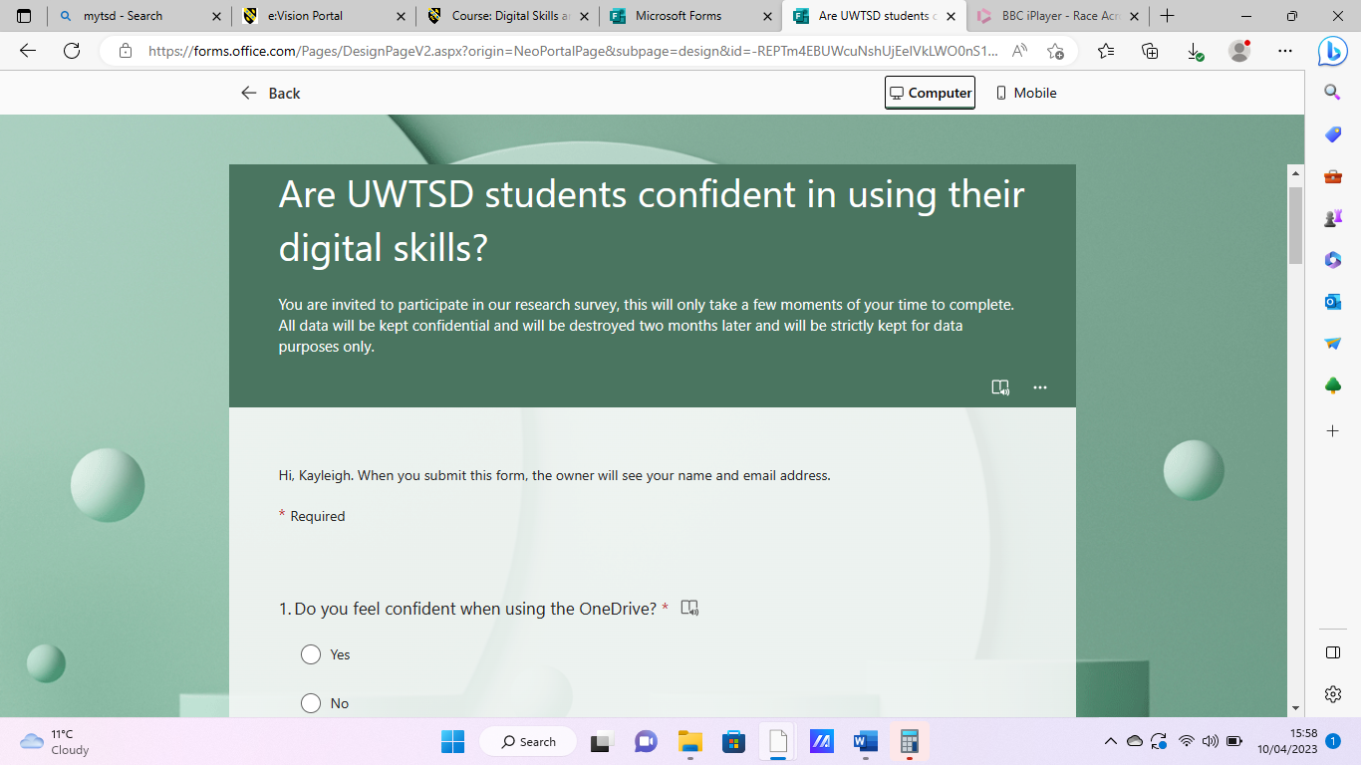 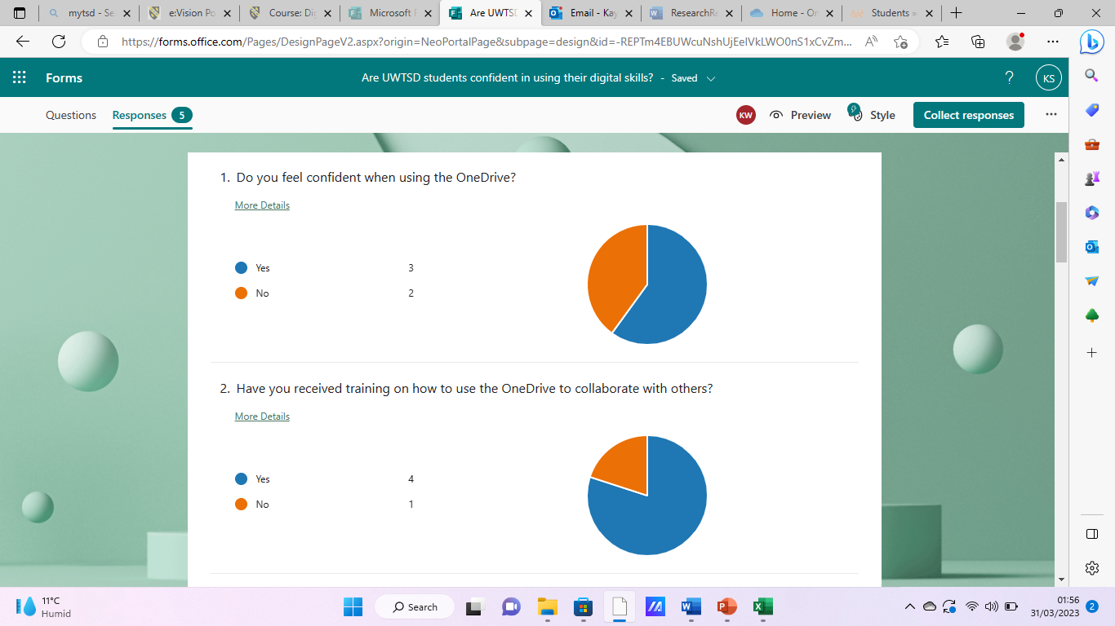
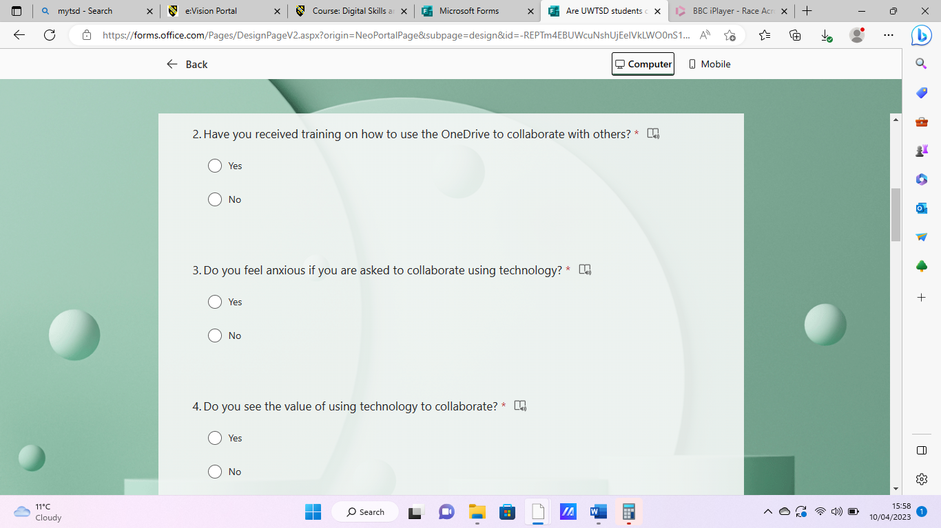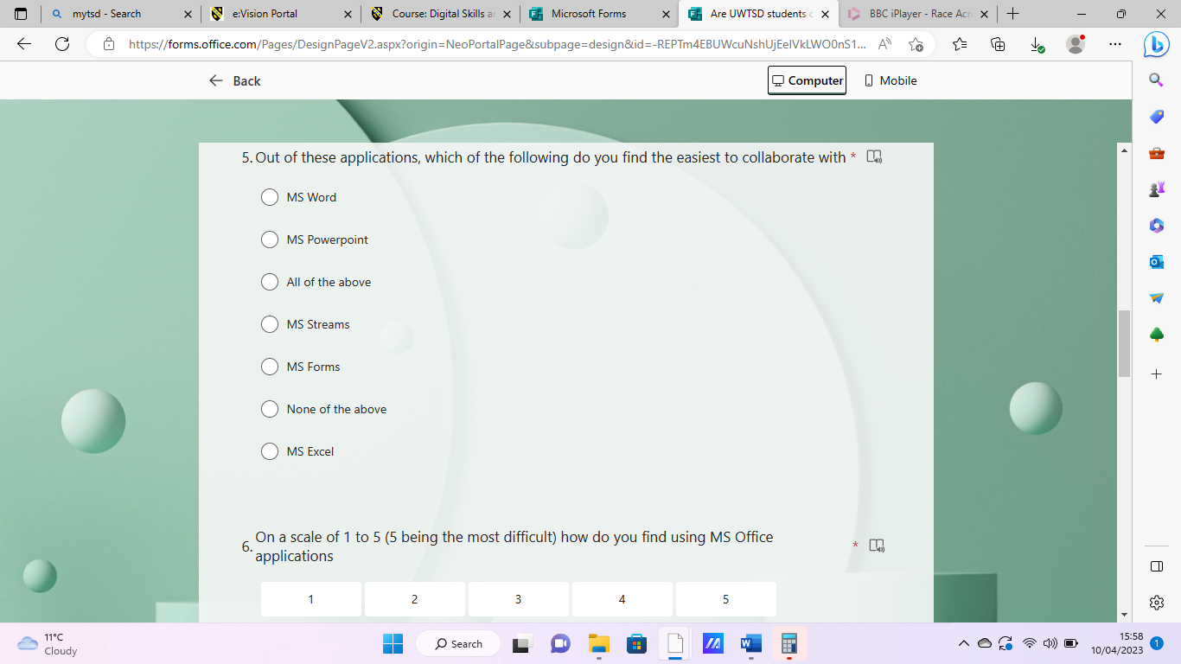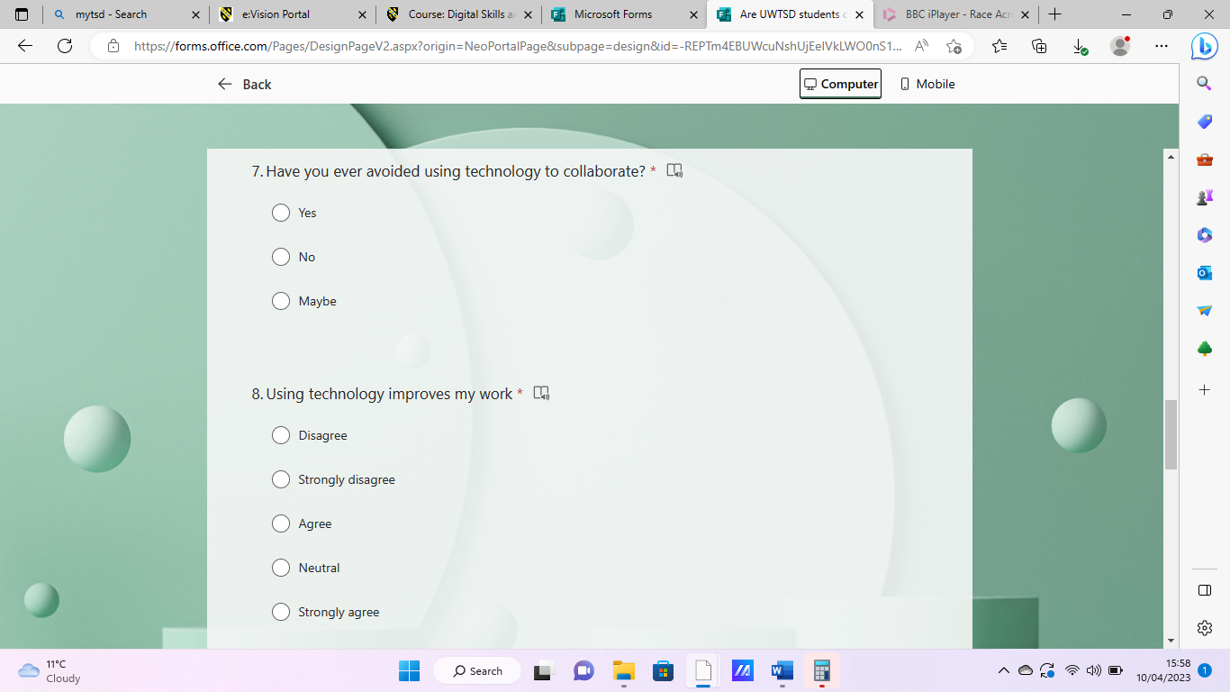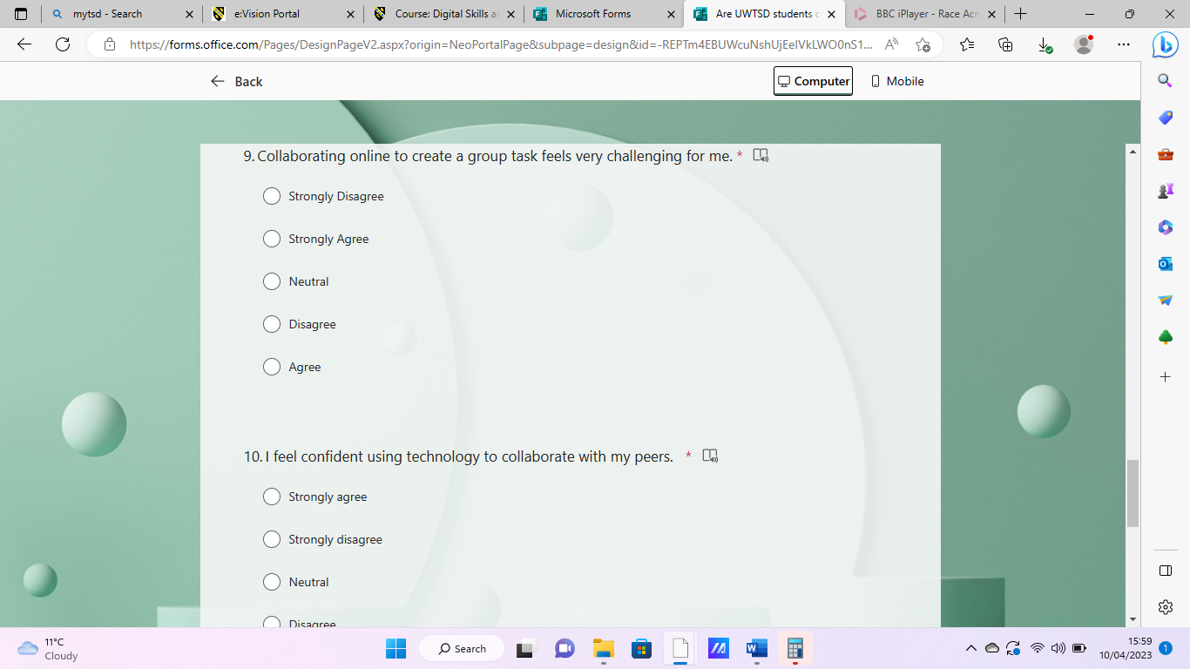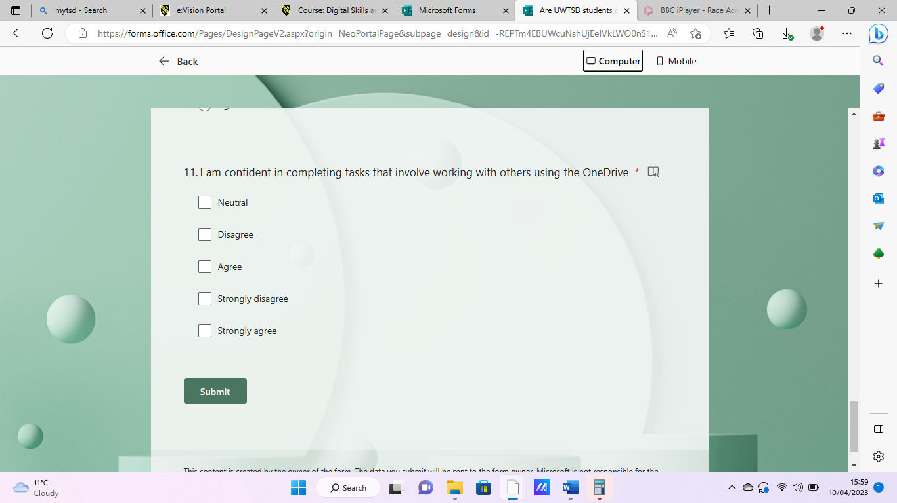

Conclusion
The results of our study suggest that there is a range of confidence levels among students in utilizing their digital skills. While some students report high levels of confidence and frequently use digital tools for their studies, others express lower confidence and may benefit from additional support and training. These findings highlight the need for continued efforts to promote digital literacy and provide resources that can help students develop and enhance their digital skills. As digital technology continues to play an important role in education and the workplace, it is crucial to ensure that students have the skills and confidence they need to succeed. Our findings suggest that there is work to be done in this area, but also that there are concrete steps that educators and institutions can take to help students develop the digital skills and confidence they need for the future as in today's world, digital literacy has become an essential skillset for academic success, career advancement, and daily life. With the increasing reliance on technology, it is crucial for students to develop confidence and competence in using digital tools and applications to support their academic and professional pursuits. Further collection and analysis of the data is needed to identify factors that may impact confidence levels and to develop strategies that can enhance students' digital skills. Regardless of individual differences, our students unanimously agree on the value of using technology to collaborate. Our survey indicates that 100% percentage of students who took part value the use of technology for collaboration. In conclusion, out of the participants surveyed, the majority expressed positive attitudes towards the role of technology in facilitating collaborative activities. However, it is important to note that some students also identified potential challenges associated with technology use in collaborative settings. Further research is needed to fully understand the nuances of students' attitudes towards technology-supported collaboration and to identify strategies that can optimize its benefits while relieving potential drawbacks.

Discussion

The results of our study on students' confidence in using digital skills, we found that a major percentage of students expressed varying degrees of confidence in using digital tools and technologies for their studies. While a large proportion of students reported feeling confident in using digital skills, a considerable number also indicated that they faced challenges and lacked confidence in certain areas of digital literacy. Results also indicate that while many students are proficient in using digital tools and technologies, there are still significant challenges that they face in applying these skills to their academic work. Many students reported that they feel comfortable using common digital tools such as email, word processing software, and online search engines. However, when it comes to more specialized digital tools such as Excel, Teams and Forms, left students feeling overwhelmed and uncertain. This variability in students' confidence levels may be attributed to a range of factors such as previous exposure to digital tools, individual learning styles, and the availability of resources and support. The study also revealed that students faced various challenges in using digital skills, such as technical difficulties and difficulty navigating digital platforms. Additionally, some younger students expressed lower levels of confidence in using certain tools, while some older students demonstrated high levels of proficiency. This suggests that individual factors, such as personality traits or prior knowledge, may play a role in determining students' confidence levels in using digital tools. Also, findings show a significant number of students reported experiencing technical issues when using digital tools, which can lead to frustration and decreased confidence in using these tools. The data collected highlights the importance of supporting students in developing their digital literacy skills. Educational institutions need to provide more training and support to ensure that all students have the skills and confidence necessary to succeed in their academic and professional pursuits in the digital age. “By equipping people to participate fully in a digital world, they are able to develop the confidence, resilience and skills to take their place as engaged digital citizens.” (Reedy, K. et, al. 2018) Overall, these findings highlight the need for tailored support and training for students to help them develop the necessary skills and confidence to effectively use digital tools and applications in their academic pursuits. By providing targeted training and resources, educators can help students overcome any barriers they may face in utilizing digital tools and applications to their full potential
Overall, these findings highlight the need for tailored support and training for students to help them develop the necessary skills and confidence to effectively use digital tools and applications in their academic pursuits. By providing targeted training and resources, educators can help students overcome any barriers they may face in utilizing digital tools and applications to their full potential.

- Conclusion
As digital technology continues to play an important role in education and the workplace, it is crucial to ensure that students have the skills and confidence they need to succeed. Our findings suggest that there is work to be done in this area, but also that there are concrete steps that educators and institutions can take to help students develop the digital skills and confidence they need for the future as in today's world, digital literacy has become an essential skillset for academic success, career advancement, and daily life. With the increasing reliance on technology, it is crucial for students to develop confidence and competence in using digital tools and applications to support their academic and professional pursuits. Further collection and analysis of the data is needed to identify factors that may impact confidence levels and to develop strategies that can enhance students' digital skills.
Regardless of individual differences, our students unanimously agree on the value of using technology to collaborate. Our survey indicates that 100% percentage of students who took part value the use of technology for collaboration.
In conclusion, out of the participants surveyed, the majority expressed positive attitudes towards the role of technology in facilitating collaborative activities.

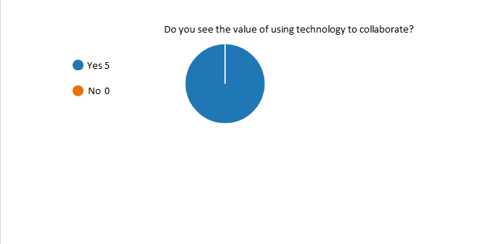

- Reference List
Barrett, D. et al. (2016) Public Health Ethics: Cases Spanning the Globe. 1st ed. Cham: Springer International Publishing. doi:10.1007/978-3-319-23847-0.
Hemingway, C., Adams, C. and Stuhlsatz, M. (2015). Digital collaborative learning: identifying what students value. F1000Research, 4, p.74. doi: https://doi.org/10.12688/f1000research.6223.1.
Reedy, K. and Parker, J. (2018). Digital literacy unpacked. London: Facet Publishing. [ebook]https://ebookcentral.proquest.com/lib/trinity/detail.action?docID=5490897

- Appendix A – A blank copy questionnaire.
Image of Survey produced by Kayleigh Slater and Kirstan Wilkes

