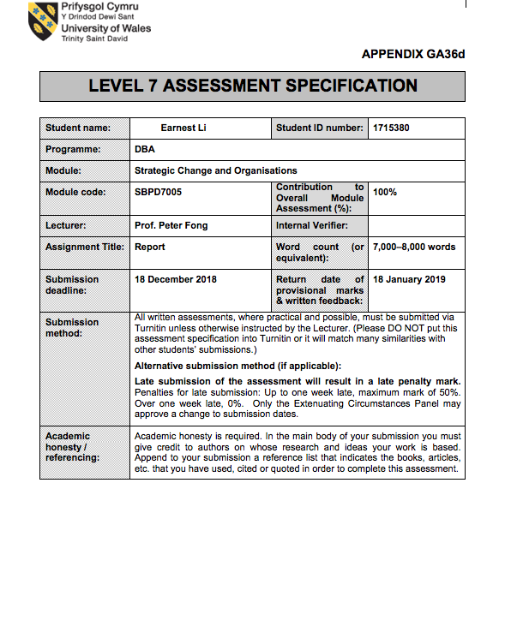
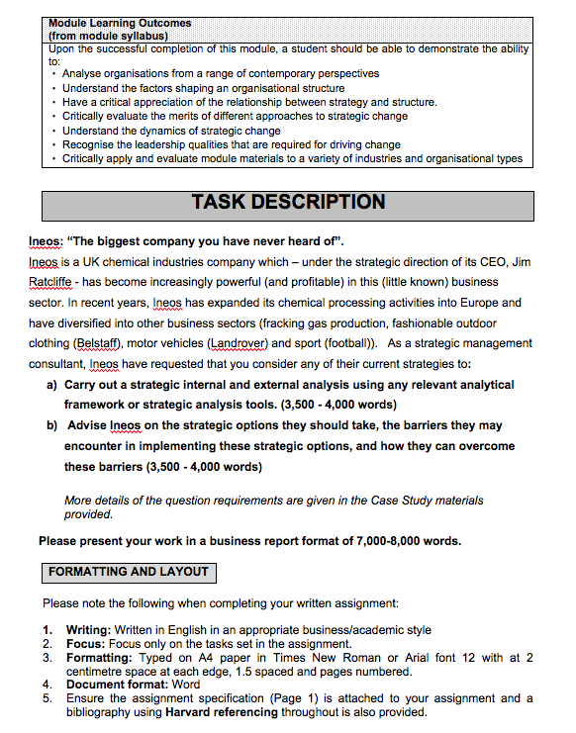

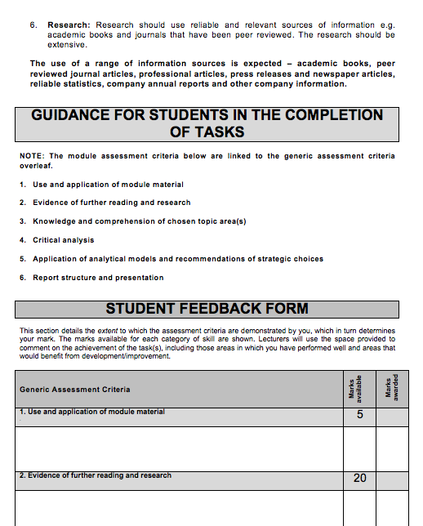

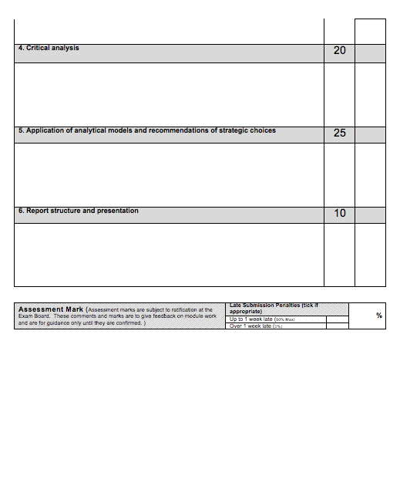

Table of Contents

Introduction P.6

Vision and Value P.6

Internal Analysis P.8

External Analysis P.13

Strategic Option P.18

Action Plan in Balanced Scorecard P.21

Barriers P.24

Strategy Map P.25

Conclusion P.26

List of references P.27

Appendices P.29

INEOS Group - 2018

Introduction
Under the strategic direction of Jim Ratcliffe, Chairman of INEOS Group, the UK chemical industries company is a global manufacturer of chemicals and oil products with sales of USD $60m, employing 19,000 people. The privately owned company was founded in 1998. Regarding the chemical sales in 2017, INEOS has grown to be the top five petrochemical companies after BASF (US), DowDuPont (US), Sinopec (China), and SABIC (Saudi Arabia). According to the official website of INEOS, the company has developed diversified products to serve a wide range of markets including adhesives, agriculture, automotive, bio fuel, chemicals, coatings, construction, cosmetics, film & sheet, home & electronics, manufacture, medical & pharma, packaging, paint & ink, pipes, pulp & paper, rubber & tyre, textiles, wire & cable.

Recently, INEOS is implementing a strategy to diversify its product by developing new business to create and produce the 4x4 vehicle in 2016 and the new product to be launched in 2020. As a strategic management consultant, this paper will carry out a strategic internal and external analysis. Moreover, it will advise INEOS on the strategic options they should take, the barriers they may encounter in implementing the strategic option, and how they can overcome these barriers.

Vision and Value
To analyse the internal strengths and weaknesses of INEOS, attributes relating to strategic management will be identified from the statement of the Chairman, and information on the website. Jim describes INEOS is a young company and believes the company is prepared to use new approaches to business (5). He says the first priority of the company is safety (7, 8), and the company is highly focused on growth and EBITDA (5), and see the “customer as king” (1, 6).

The selling points of INEOS products include making a significant contribution to saving life, improving health, and enhancing standards of living for people (6) around the world (3).
Regarding the vision and value mentioned on the website, INEOS is a customer-focused company, and its business mission is to be the supplier of choice (2) to its customers. The company aims to achieve five core values:

- excellence in safety, health, and environmental performance (7, 9)
- focus on customer satisfaction, total quality, and reliability (2)
- continuous improvement to become a cost effective producer of high-quality products (2)
- encouragement of innovation (4), entrepreneurship (6), and reward for achievement (9)
- empowerment of employees (9) to create real value for our customers (1) and ourselves (5, 7)

- Customers
- Products or services
- Markets
- Technology
- Concern for survival, growth, and profitability
- Philosophy
- Self-concept
- Concern for public image
- Concern for employees

Internal Analysis

Strengths

- Culture of safety and sustainability
Vision and value statements are clear and set the direction to run a customer-oriented business concerning for growth and profitability. Moreover, the company concerns the public image of “safety” and “sustainability” with the following activities and policy.

- More than 175,000 children participated in Go Run for Fun in 3 years; (the logo is put on the top-right side of the website.

- More than 2,500 schools participate Daily Mile supported by INEOS. Daily Mile is one of the campaigns supported by INEOS Health & Wellbeing Foundations.

- Collaborate with neighbouring companies in Belgium, Lavéra (France), Grangemouth (UK) and Norway to organise community events in 2011 to promote the International Year of Chemistry.

- The company set the “SHE” policy that is a commitment to protect the health and safety of employees, the communities in which we operate, and the users of INEOS products.

Furthermore, the company concerns talent investment. In the video talking about the INEOS difference, Jim says people of INEOS enjoying independence, and working in a degree of autonomy. The company would like to support and help young people and believe they will get real responsibility, real accountability, real exposure to the business world. Jim describes the ideal graduate with the attributes including energetic, communicate well, having a degree of competitive nature.

- Experienced management
Top management of INEOS is a team with a high degree of market familiarity and technology familiarity. It helps the company to spend the lesser time to commercialize products or services and obtain a higher percentage of IRR. Jim, Chairman of INEOS began his career with Exxon Chemicals. After he completed his MBA at London Business School, he moved to fabric and chemical producer Courtaulds. Then he joined Advent International to learn the art of deal in the world of private equity. The core teammates of Jim include Andy Currie and John Reece. Andy, Director of INEOS, has spent 15 years with BP Chemicals in technical and business management functions before working with Jim. John, Finance Director, was previously a partner with PWC where he advised the companies in the chemical industry.

Apart from the management team, Jim is a charismatic leader displaying the following behavior factors that may attract the young generation to join.

- Strategic visioning and communication behavior
Vision statement and business direction are clearly written and displayed on the website. INEOS pays effort to produce video contents with the interview of the Chairman to communicate the culture of safety and sustainability. Besides, the top management uses the approach of open communication and allow a degree of autonomy in daily operation. Therefore, top management hosts a conference call with each of the division heads giving a short report. It may help quicker decision making.

- Sensitivity to the environment
As above-mentioned, the company set safety as the key value and define it as a company culture. INEOS is aware of the regulation and policy of environmental protection may affect the business, operation, and growth of the company. It explains why INEOS promoting SHE (safety, health, and environment) policy.

- Unconventional behavior and personal risk
Jim is a risk taker. In 1992, he and his partner decided to buy BP’s chemical division in Hythe, Kent for GBP 40m. Two years later, it was valued at GBP 100m. Jim admitted it was a high-risk move.

- Private equity
INEOS uses the approach of private equity to obtain resources (cash) to purchase undervalued businesses. Top management can have greater flexibility to make the decision for seeking the source of finance, or being “first-mover”.

- Investment and financing decisions
INEOS has bought the undervalued business from global oil and chemical giants such as ICI, Dow Chemicals, and BASF. The purchases were financed by debt and enhanced INEOS’ value. In 2006, the company bought BP’s petrochemical arm Innovence for GBP 5.1 billion. It made INEOS stepping into the world rankings of the petrochemical industry. Under the strategic management, the company can leverage the existing assets to maintain strong cash flow. Some investment decisions help the company strengthening the capacity and productivity. INEOS Oil and Gas UK has completed a project (USD $80m investment) to re-route production from its Clipper South field via the Shell operated Clipper field into the Bacton processing terminal.

- Integration strategy
INEOS took acquisition strategy with backward and horizontal integrations by purchasing BP’s German ethylene oxide business, and Norsk Hydro’s polymers business in 2007. The company formed a joint venture with Lanxess and created INEOS ABS. It helps product development and market penetration in a short period of time. The company can take advantage of synergies with existing operations. Moreover, the joint venture with PetroChina in July 2011, PetroChina has completed its purchase of UK chemical group INEOS assets for USD $1 billion. The benefit of the deal is obtaining roughly 210,000 barrels of crude oil per day, supplying Scotland, Northern Ireland and the north of England.

- Leading market positions
INEOS obtained well located, well invested, large plants that help to produe high-quality and affordable products. The company plays the role as a supplier of choice for many large customers. Production of INEOS reaches 60m tonnes a year at 171 sites in 24 countries. It helps in minimizing the cost of distribution and maintain better customer services. Besides, the company can lower the cost of production by using its shale gas which is a cheaper energy.

- Operating diversity in products and services
INEOS businesses produce raw materials that meet the needs of different customers and markets. They include the manufacturing of paint, plastic, textiles, medicines, and mobile phones.

- SHE production and operations
In 2017, INEOS recordable injury rate of employees and contractors was 0.23 that was better than the average rate (0.35) of chemical industry and nearly reached the best in the class (0.21). It helps to maintain a stable productivity by concerning the safety and health issues of employees as well as contractors.

- Technology leadership
INEOS gets the top non-captive technology licensor for its polyethylene, polypropylene, polystyrene, chlor-alkali and vinyl businesses. INEOS scientists and engineers are focused to provide state of the art technologies. The company has eight R&D centers around the world in the US, Belgium, France, Germany, India, and Korea. It shows that the company embracing technology and invest in R&D to create sustainable competitive advantage (SCA).

Weaknesses

- Employee relation
In 2008, Jim experienced a major industrial relation dispute with the Unite union because of his decision to close the final salary pension scheme at Grangemouth refinery. The 2013 strike cost the business GBP 10m in a month, and the company committed to a GBP 300m survival plan. Though the issue happened five years ago, workers may “copy” the action to fight for their benefits if the top management fails to create reasonable job satisfaction and reward system.

- Pension expense
INEOS manage the operations of 171 sites with 19,000 employees. It means the company should pay attention to the pension expense. According to the 2017 annual report of INEOS Group, the pension expense increased 70.7% from GBP 9.9m (2016) to GBP 16.9m (2017). It will affect the OPEX and cash flow of the company.

IFE Matrix

 | Strengths | Weight | Rating | Score
1 | Culture of “safety” and “sustainability” | 0.12 | 4 | 0.48
2 | Experienced management | 0.12 | 3 | 0.36
3 | Private equity | 0.06 | 3 | 0.18
4 | Investment and financial decisions | 0.09 | 4 | 0.36
5 | Integration strategy | 0.06 | 3 | 0.18
6 | Leading market positions | 0.09 | 3 | 0.27
7 | Operating diversity in products and services | 0.12 | 3 | 0.36
8 | SHE productions and operations | 0.12 | 4 | 0.48
9 | Technology leadership | 0.15 | 4 | 0.6

 | Weaknesses | Weight | Rating | Score
1 | Employee relation | 0.05 | 2 | 0.1
2 | Pension expense | 0.02 | 2 | 0.04
 | TOTALS | 1.00 |  | 3.41

External Analysis

Opportunities

- Economies of scale
INEOS has completed the acquisition of WL Plastics, Noretyl, and Axiall assets from 2015 to 2016 to support the US and Europe markets and businesses. WL Plastics has over 500 million pounds of annual production capacity and provides HDPE pipe for use in oil, gas, industrial, mining, conduit, and municipal water and sewer applications. The acquisition of Axiall assets includes a cumene plant, based in Pasadena, Texas, producing 900,000 tonnes of product. Apart from the US market, INEOS acquired Noretyl to serve the Europe market. The Noretyl cracker provides 570,000 tonnes per annum of ethylene, as well as propylene to the INEOS system.

According to the 2017 Annual Report, the revenue growth of US customers is 20.6%, and the revenue growth of the Europe market is 10.4%. The revenue growth of the rest of the world is 123.4% which is a significant performance. Regarding the EBITA, the top contributor is chemical intermediates (39.3%), the second is Q&P Europe (31%), and the third is Q&P North America (29.7%). The chemical sales of INEOS in 2017 is USD $60m, and the growth is 46.2%. It shows the company achieved record profitability with acquired facilities, technology, talents, and customers. Besides, the company has sufficient cash flow and resources to expand its businesses.

- Barriers to market entry
The CAPEX and OPEX of the chemical industry are “big” numbers. In 2017, the total cost of sales of INEOS is GBP 12524.2m. It shows the entry barrier of the chemical industry is high. New comers have to prepare huge investment and time to purchase hardware and develop software to build the business. INEOS spent 20 years to be one of the petrochemical giants.

- Product differentiation
As above-mentioned, INEOS has developed a wide range of products with its leading technologies. It provides a certain degree of product differentiation. For example, the company provides modern plastics to package, protect and preserve food & drink. INEOS also provide materials to insulate houses, offices, electrical and telecommunication cables. It shows the company produces both consumer and commercial products to serve the needs of global markets.

- The economy
According to the market outlook of 2017 Global Chemical Industry published by Deloitte, it showed a continuous growth with the merging activity to stimulate innovation. The companies made use of innovation and synergies to increase sales volumes. Regarding the “Belt and Road” (B&R) plan initiated by China, it attracts investment to develop opportunities along the land-based “Silk Road Economic Belt”, and the seafaring “21st Century Maritime Silk Road”. The routes include the countries across Asia, Europe, and Africa. In the near future, many B&R projects will be launched, they need chemical materials and green energy to support. It gives INEOS the opportunity to expand its businesses.

- Level of competitiveness
Among the top five petrochemical companies in the world, the number of employees of INEOS is 19,000 that is smaller than its competitors. Being the top one petrochemical company, BASF has employed 115,490 people. Sinopec, the competitor from China, has employed 249,142 people. It means the operation costs of the competitors are higher, and the sizes are bigger that may have negative impacts on the flexibility and decision making. INEOS may take advantage of flexibility through the value chain, and fast decision making.

Threats

- Political and economic forces
Under the uncertainty created by the US-China Trade War in 2018, it may affect the global economy in 2019 and even 2020. The economic growth of the US, Europe, and Asia markets may be slowed down. It may decrease the needs of INEOS products. Moreover, the company should be aware of the issue of tax charge. In 2017, the tax charge is decreased from GBP 340.2m (2016) to GBP 301.5m (2017). It is because of the substantial reduction in the US corporate tax rate from 35% to 21%. Nonetheless, if the US government changes the policy, the tax rate will be increased to add the cost of the tax charge.

- Weak dollar
If the US-China Trade War will last a long period of time, and the US and China may adopt a “weak dollar” policy to protect their economy. Therefore, the drop of demand and the weak dollar may have a negative impact on the income of INEOS businesses.

- Social and natural environmental forces
Obviously, there is a trend to concern the issue of global warming, and it leads to the demand for green economy. Governments will set environmental policy and regulation to control pollution and protect the environment. It will have a negative impact on the development of the chemical industry. INEOS may invest more to improve the facilities to be “eco-friendly” and train the employees to operate businesses in a “greener” mindset and approaches. Young generation concerns the issue of global warming and will choose to buy “green” products or stop to use plastic products. It will affect the marketing strategy of INEOS to produce petrochemical products in a “greener” way.

- Technical forces
According to the 2017 Annual Report, the cost of spending on research and development (R&D) has a continuous drop in 2016 (8.1%) and 2017 (8.2%). It may because the company has acquired facilities and technologies from other corporations, and lowering the cost of R&D. However, the top management of INEOS should pay attention to the development of technologies. For example, Microsoft in promoting different industries to use artificial intelligence (A.I.) to transform and improve their products and services. Under this circumstance, if the company does not embrace information technology (but the competitors do), it may have a negative impact on the SCA of INEOS.

- Competitive forces
During the first 18 years, Jim was a low-profile British businessman. Nonetheless, his company being one of the giants of the chemical industry, INEOS becomes a “star”. Many news or feature stories report the history of INEOS and the critical success factors of the company as well as the management style of Jim. Not only the public know the strategy of INEOS, but also its competitors. Regarding the strategy of merging and acquisition, DowDuPont (US) was born in 2017 August. Two innovative and science-based companies that hold leadership positions in the Agriculture, Materials Science and Specialty Products industries. The new company also invests in market-driven research and development. It may be an external threat to INEOS businesses.

Besides, BASF (US) invested a $10 billion integrated chemical complex in Guangdong, China, that would start coming on-line in 2026. Sinopec (China) completed a Nanjing-based joint venture with BASF plans to double capacity for neopentyl glycol. SABIC (Saudi Arabia) collaborated with Swiss specialty chemical maker Clariant and signed the agreement with ExxonMobil to build a massive petrochemical complex near Corpus Christi, Texas. Regarding the mindset to embrace innovation, the approach of SABIC and INEOS are similar. SABIC aims to build long-term customer value through innovation and collaborate with the universities in China, Germany, UK, Italy, US, Korea to develop new products. The actions of the competitors show the threat of competition on the US and Europe markets.

EFE Matrix

 | Opportunities | Weight | Rating | Score
1 | Economies of scale | 0.12 | 3 | 0.36
2 | Barriers to market entry | 0.05 | 2 | 0.1
3 | Product differentiation | 0.15 | 4 | 0.6
4 | The economy | 0.08 | 3 | 0.24
5 | Level of competitiveness | 0.05 | 1 | 0.05

 | Threats | Weight | Rating | Score
1 | Political and economic forces | 0.1 | 3 | 0.3
2 | Weak dollar | 0.05 | 2 | 0.1
3 | Social and natural environmental forces | 0.15 | 4 | 0.6
4 | Technical forces | 0.15 | 4 | 0.6
5 | Competitor forces | 0.1 | 2 | 0.2
 | TOTALS | 1.00 |  | 3.15

With regards to Porter’s Five Forces, the petrochemical industry is still an “attractive” business to INEOS.

- Threat of new entry of the chemical industry is low. INEOS took 20 years to be one of the industry giants in the world. It is not easy to “copy” the critical success factors unless Russian company makes a huge investment to enter the market and being one of the giants.

- Level of competitive rivalry is medium. Although the resources and value chain of the competitors such as BASF, DowDuPont, and SABIC are strong and powerful, the management model of INEOS has the advantage of “flexibility” and cost effectiveness that help the company to have a strong leading market position.

- Level of supplier power is high. Having acquired qualified facilities and took the resources of good talents and technologies around the world, INEOS is a “big” suppliers of raw materials to a wide range of commercial and consumer products.

- Level of buyer power is medium. Although INEOS provides different kinds of products and services for global markets, buyers can purchase materials and services from the competitors of INEOS. The company can “keep” its customers because of the quality, pricing, and servicing of the products.

- Threat of substitution is medium. INEOS has the technology leadership in many products. Even though its competitors also invest in R&D to develop quality and low-price products, INEOS takes the SCA with the real values of safety and sustainability.

Porter’s Five Forces Analysis

Strategic option
Having experienced the 2008 Financial Crisis, Jim rebuilds INEOS group with the strategy to purchase undervalued assets from the giants of chemical industry and leverage them for obtaining resources including cash to develop the “power” of the company. Ten years later, the company is one of the top five global petrochemical companies. Although the business of INEOS can be defined as an attractive business, it is time for the company to develop new strategy to create SCA:

- differentiation
- low costs
- niche marketing
- high-performance technology
- superior quality
- superior service
- vertical integration
- synergy
- culture, leadership, and style of organization

In this part of paper, we will suggest INEOS to adopt “green strategy” and intensive strategies to produce 4x4 SUV (Projekt Grenaider) as the strategic option with the selling points of “German engine, British design” to take advantage of synergies, and create value-added product and service to win the global markets. According to the interview conducted by Quartz, LMC Automotive predicts SUVs will be crossed the 50% mark by 2020. New York Times quoted McKinsey, the global consulting firm, predicts that by 2022, one in every two cars sold in China will be an SUV. The articles show that a future demand for SUVs and INEOS will have less than two years to develop new products to penetrate the markets. Why do we say the company has sufficient resources and core competencies to develop the intensive strategies with its startup to produce 4x4 vehicle?

- Differentiation

Wallenius Wilhelmsen, providing innovative and sustainable global shipping and logistics solutions for manufacturers of cars and trucks, says SUVs have to go “green” to sustain sales. Therefore, the market needs an SUV performing less harm to the global environment and air pollution. INEOS has a culture of “safety” and “sustainability”. It is believed that the company can develop and produce SUV with the MBtech that was founded in 1995 as Mercedes-Benz technologies. MBtech also works with a wide range of other automotive clients include Porsche and BMW. It helps the company developing a unique 4x4 vehicle with the heritage of Defender, the famous British off-roader.

- Low costs
From our observation, Asian customers will buy premium-price and high-value SUV. In Hong Kong, car buyers will pay HK$300,00 to HK$700,000 to purchase an SUV. If INEOS can produce an eco-friendly SUV with low costs. It may be a profitable consumer product. It is believed the company can lower the costs by the advantage of synergies.

- Niche marketing
“British design” may be a selling point of INEOS SUV. The company has launched a marketing campaign to ask the public to give a name for the vehicle. Besides, the startup of Projekt Grenadier is building an image of “uncompromising” 4x4 to go adventure. It will attract not only male car buyers but also female customers

- High-performance technology
The objective of INEOS Automotive is to create the best 4x4 vehicle in the world. To achieve the goal, the company appointed Dr. Oliver Friller as the Director of Procurement and Supply Chain Management in Aug 2018. He has the background of Daimler and SMART to help the startup of INEOS to build a reliable and affordable car. How to get the high-performance technology? The company employed 200 German engineers work for the project in Stuttgart to execute the concept of “German engineering, British design, and entrepreneurship” to build the vehicle.

- Superior quality
INEOS claims the company produces the products that make the difference. Carbon fibre is an example showing the technologies that will allow carbon fibre to be used on a large scale to produce more lightweight and fuel-efficient cars. Apart from carbon fibre, INEOS produces recyclable plastic that will help the company implementing a “green” strategy.

- Superior service
INEOS has to produce products and provide service for all countries including Belgium, Canada, China, Denmark, France, Germany, India, Italy, Mexico, Norway, Singapore, South Korea, Spain, and Sweden. The company can make use the experience of serving the global markets and conduct training for the sales and customer relation teams of the INEOS Automotive.

- Vertical integration
INEOS can use the strategy of the joint venture to collaborate the manufacturers of glasses and aluminum to minimize the cost of raw materials in order to build an affordable 4x4 vehicle. The top management is experienced to handle the deal of joint venture. It will help the startup controlling the procurement of materials, production processes, and costs to meet the objectives.

- Synergy
INEOS Automotive can enjoy the synergy of the products, services, and technologies from the group including carbon fibre, and recyclable plastic to support building the high-quality 4x4 vehicle.

- Culture, leadership, and style of organization
Jim led the team to build a company culture to treat “customer as king”, safety as the first priority, and sustainability as the fundamental of doing business during the past few years. INEOS Automotive can adopt the company culture to write its vision statement, and coach the new jointed talents.

Action Plan in Balanced Scorecard
Strategy is about knowing where INEOS Automotive is now, where the startup is going, and how to get there. The management can use the balanced scorecard (Robert Kaplan, 2001) to achieve breakthrough performances. It combines the advantages of different incentive pay plans and helps employees understand the company’s goals. By communication the balanced scorecard to employees, the company shows employees information about what its goals are and what it expects employees to accomplish. It includes four perspectives: financial, customer, internal processes, learning & growth.

If we manage to translate mission into desired outcomes to have satisfied stakeholders, delighted customers, effective processes, motivated and prepared workforce, we need to ask and answer the following questions.

Q1. Whey we exist (mission)?
Q2. What we believe in (core values)?
Q3. What we want to be (vision)?
Q4. Our game plan (strategy)?
Q5. Implementation and focus (balanced scorecard)?
Q6. What we need to do (strategic initiatives)?
Q7. What I need to do (personal objectives)?

Statement of vision/mission

Why INEOS Automotive exists? The reason is not only a preference of Jim to own a brand of 4x4 vehicle for “fun”. Jim is an entrepreneur capable of purchasing undervalued assets and leverage for developing a profitable business. Under this assumption, the chairman decided to develop a startup of producing the 4x4 vehicle to contribute economic return for the group. What INEOS Automotive wants to be? With regards to the vision of the startup, it is building an uncompromising 4x4 vehicle to go anywhere and adventure. It is suggested the startup produces an eco-friendly, high-performance, fun to drive, and affordable SUV to serve the global markets. What INEOS believes in the core values of “customer as king”, “safety”, and “sustainability”.

Balanced scorecard of INEOS Automotive

If the vision of INEOS Automotive succeeds, how will the objectives of the startup to its stakeholders, customers, internal management process, and the ability to innovate & grow? Using the balanced scorecard to achieve the mission, we will define financial focus, customer focus, process focus, and learning focus.

- Financial focus:
- Profit
- Cash flow
- Contribution per 4x4 vehicle / SUV

- Customer focus
  - Number of vehicles sold
  - Customer satisfaction with driving experience
  - Brand index
- Process focus
  - Cost effectiveness
  - Time to produce a vehicle
  - Safety, health, and eco-friendly production (CO2 saving)
  - Car sales and after sales

- Learning focus
  - Employee skills in assemble a vehicle
  - Superior services for car sales and after sales
  - Culture of safety and sustainability

INEOS Automotive Balanced Scorecard: Table View
Scorecard | Strategic Success Factor  (S.S.F) | Performance Measure (KPIs) | Target  FY19/20/21
Financial | - Profit  - Cash flow  - Contribution per 4x4 vehicle / SUV | - EBITA  - Down payment (10%)  - Profit margin
Customer | - Number of vehicles sold  - Customer satisfaction with driving experience  - Brand index | - % of sales per month  - % of complaints/customer feedback  - Survey: rank position on services and branding
Process | - Cost effectiveness  - Time to produce a vehicle  - Safety, health, and eco-friendly production (CO2 saving)  - Car sales and after sales | - % of synergy  - Material lost 0%  - 60 days after confirming order  - Injury 0%  - % of CO2 saving  - Lead time of transaction and response per customer request
Learning  &  Innovation | - Employee skills in assemble a vehicle  - Superior services for car sales and after sales  - Culture of safety and sustainability | - Hours and levels of training  - Evaluation of total quality management  - Number of achievable new idea and action
Intensive strategies

What is the game plan or strategy to develop the business of this startup? It is suggested the company uses intensive strategies in product development, market penetration, and market development. Regarding the automotive business, it is a related diversification strategy. It is suggested INEOS implements intensive strategies to develop a new product of 4x4 vehicle or SUV with German engine and technology as well as British design to penetrate both consumer and commercial markets around the world. Having considered the resources of INEOS Group, the company can allow a high degree of synergy to implement a 3-year plan to be the phase one of developing “Projekt Grenadier” as a high value-added product.

The top management of INEOS plans to spend two years to develop the 4x4 vehicle and launch the product in 2020. If the startup can produce high-performance and “green” 4x4 vehicle or SUV, it is suggested the startup to make effort to penetrate the markets of China, US, and Europe to win a certain percentage of market share in the first year of product launch. Then, INEOS Automotive can develop the market of the “Belt and Road” countries including Mongolia, Russia, Indonesia, Thailand, Malaysia, Vietnam, Singapore, Philippines, Myanmar, Cambodia, Laos, Brunei, and East Timor.

Barriers
Although we suggest using intensive strategies to develop high value-added automotive as the alternative strategy to strengthen the sustainable competitive advantage of INEOS Group, the company has to overcome different kinds of barriers. Regarding the case of Tesla, the US manufacturer of the electric car, the productivity of the firm could not meet the purchasing orders. Moreover, the quality of Tesla’s product could not meet the standard of reliability and premium car in the first year of the product launch. Furthermore, the electric vehicle charging stations and service centers were not sufficient to support customers in the beginning in Asia market including Hong Kong. Actually, the production cost of Tesla’s electric car is higher than selling price. It means the product is not profitable. To learn from the lesson of Tesla, it is suggested INEOS Automotive has to implement the corporate strategy options from all levels including corporate, division, functional, and operational to overcome barriers.

Strategy Map of INEOS Automotive
- Deliver stakeholder value
(
Financial
Focus

1.3 Manage investment
1.2 Maximize profit

Ppro pr
1.1 Grow sales

Customer
Focus
2.3 Build strong relationships with top customers
2.1 Improve brand awareness in China, US, Europe
2.2 Enter 4x4 & SUV markets in Asia, US, Europe

Internal Processes
Focus
3.3 Innovate and integrate products
3.2 Optimize production processes
3.1 Gather market intelligence

4.3 Improve internal communication
4.2 Roll out leadership training
4.1 Implement IT training
Learning & Growth
Focus

With regards to the strategy map, it is suggested the senior management to deliver stakeholder value including ensure reasonable profit aligning with the company’s vision statement and mission. To achieve the goal, INEOS Automotive needs to focus to grow sales of 4x4 vehicle or SUV in 2020, and maximize profit in 2021 or 2022. Besides, the top management will make investment decision to purchase undervalued assets or financial decision to make the deal of joint venture. It is suggested the startup has to manage both investment and financial decisions.

Regarding the customer focus, it is recommended that the startup builds the branding in China, US, and Europe via social media and offline campaigns to improve the awareness of the brand of INEOS Automotive. The actions will help the products enter the market in phase one. Therefore, the startup has to build strong relationships with customers with superior services and high-performance product.

To strengthen customer satisfaction, the startup has to use internal control and risk management to maintain the quality of product and services. For example, the R&D and marketing teams have to gather updated market intelligence. The management has to make use the information and data to optimize the production processes. One of the key areas is procurement that includes inbound and outbound logistics, operations, sales and marketing, customer and supplier services. Each part of the service will help the teams develop innovate and integrate products that will directly affect the level of customer satisfaction.

Facing the challenge of technology such as artificial intelligence (AI), the startup cannot ignore it. What does the company need to do? It can implement related training to strength teammates with the knowledge of AI, and learn how AI can be applied to improve the product and services. Besides, it needs to implement leadership training to inspire teammates with related knowledge and transform it to have a positive impact on enhancing customer experience, production capacity, and productivity. To grow with sustainable competitive advantage, one of the key points is to embrace technology. Using the strength of INEOS, the startup can buy in technology from outside or learn the best technology by the joint venture.

Conclusion

INEO Group has been developed for 20 years, and the company is one of the top five petrochemical companies in the world. Jim, the Chairman is a charismatic leader and entrepreneur to implement the strategy of purchasing undervalued assets from the giants of the industry and leverage the assets to obtain strong cash flow to develop the businesses. Although the company has a certain degree of strength to maintain competitive advantages to make the profit, it needs to implement a new strategy such as product diversification. Regarding the competitors, they also strive for the best innovation and sustainability that are the core values of INEOS.

Therefore, the company needs to consider the strategy option, it is suggested to use intensive strategies to develop 4x4 vehicle or SUV to penetrate Asia, US, and Europe markets. INEOS Automotive can make use the related businesses to take the benefit of synergy to produce a high-performance, “green”, and affordable car to meet the needs of customers. To achieve the objectives and overcome barriers, INEOS can use the balanced scorecard and strategy map to implement value-added strategies. Moreover, automotive can be a “hot spot” of the group to create energy, excitement, and productive capacity (Gratton, 2007).

List of references
c&en (2018) C&EN’s Global Top 50 chemical companies. Available at: https://cen.acs.org/business/finance/CENs-Global-Top-50-chemical/96/i31

Deloitte (2017) Global Chemical Industry Market Outlook.

DowDuPont (2018-2019) About DowDuPont. Avaliable at:
http://www.dow-dupont.com/about-dow-dupont/default.aspx

Erik Solum (2018) SUVs go green to sustain sales. Available at:
https://www.2wglobal.com/news-and-insights/articles/features/suvs-goes-green-to-sustain-sales/

Gratton, L. (2007). Hot Spots: Why some teams, workplaces, and organizations buzz with energy-and others don't. Berrett-Koehler Publishers.

Hickson, D. J., & Pugh, D. S. (2007). Writers on organizations. Penguin UK.

Hiroko Tabuchi (2018) “The World Is Embracing S.U.V.s. That’s Bad News for the Climate. The New York Times, 3rd March. Available at: https://www.nytimes.com/2018/03/03/climate/suv-sales-global-climate.html

INEOS Automotive (2018) INEOS Automotive to build an uncompromising 4x4. Available at: https://www.ineos.com/businesses/ineos-automotive/

INEOS (2018) INEOS The word for chemicals. Available at: https://www.ineos.com/company/

Jill Petzinger (2018) “By 2020, SUVs could make up 50% of US car sales”, QUARTZ, 1st August. Available at: https://qz.com/1344537/by-2020-suvs-could-make-up-50-of-us-car-sales/
Kaplan, R. S., Robert, N. P. D. K. S., Davenport, T. H., Kaplan, R. S., & Norton, D. P. (2001). The strategy-focused organization: How balanced scorecard companies thrive in the new business environment. Harvard Business Press.

London Business School (2015) Roll with the punches. Available at:
https://www.london.edu/experience/alumni/news-and-stories/news-and-stories-listing/roll-with-the-punches-1451

Porter, M. E. (2008). The five competitive forces that shape strategy. Harvard business review, 86(1), pp. 78-93.

SABIC (2018) Automotive Driving innovation forward. Available at: https://www.sabic.com/en/industries/automotive

Sinopec (2018) Products & services. Available at: http://www.sinopecgroup.com/group/en/products/

Supantha, M. and Sinead, C. (2018) “Tesla’s all-nighter to hit production goal fails to convince Wall Street”, Reuters, 2nd July. Available at:
https://www.reuters.com/article/us-tesla-production/tesla-shares-fall-despite-hitting-model-3-production-target-idUSKBN1JS1IE

Appendices

