Name: Molly Thomas
Student Number: 2502132
WORKSHEET 5 – TESTING (Hunting for Treasure)

Test: Out of range inputs -3/20 (Treasure is at position 2)
Screenshot(s) of output:
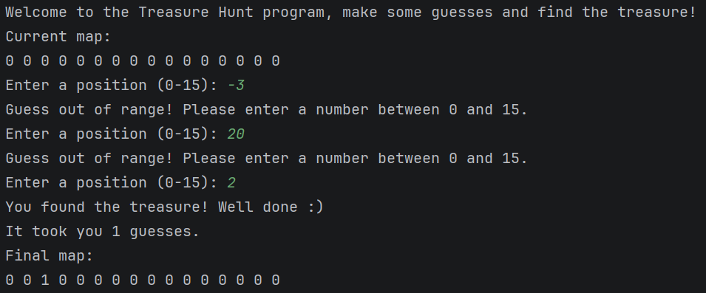
Result: Did the programme behave as expected ie syntactically and logically correct?
YES. The programme recognised that -3 and 20 were not in range so advised the user to enter a number between 0-15. The final map displayed the correct output.

Test: In range inputs 0/15/9

Screenshot(s) of output:
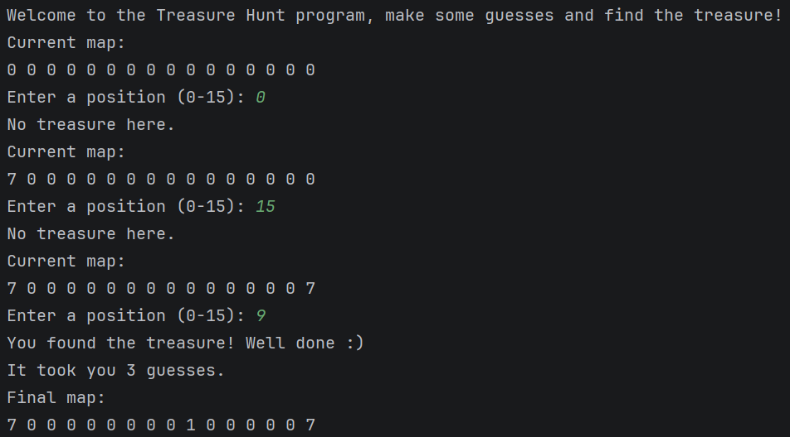
Result: Did the programme behave as expected ie syntactically and logically correct?
YES. The programme recognised the in-range numbers and marked them off the treasure map to keep track of which numbers the user has guessed. It counted each guess and displayed a final map correctly.

Test: Enter a word into the input

Screenshot(s) of output:
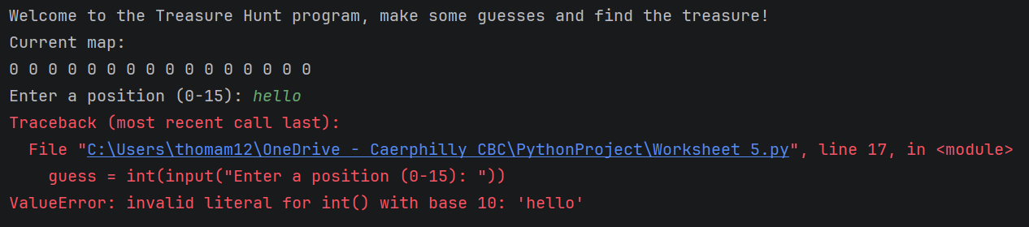
Result: Did the programme behave as expected ie syntactically and logically correct?
The programme crashed with a value error as ‘hello’ is a string not an integer. Validation needs to be added to the code to handle when this happens instead of it just crashing.

Test: Treasure at position 9
Screenshot(s) of output:
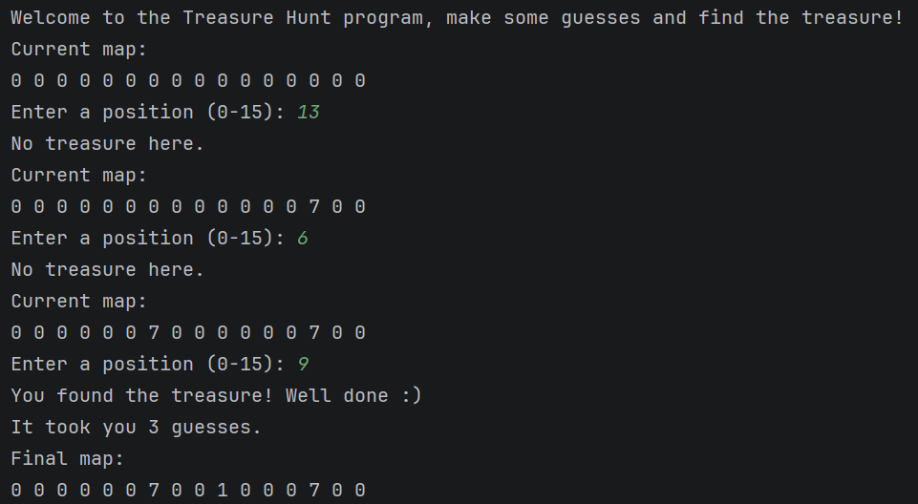
Result: Did the programme behave as expected ie syntactically and logically correct?
The programme works when the treasure is manually moved in the treasure map, this shows that it works regardless of the position it is in. The final map displayed the correct output.

Test: Repeated guesses
Screenshot(s) of output:
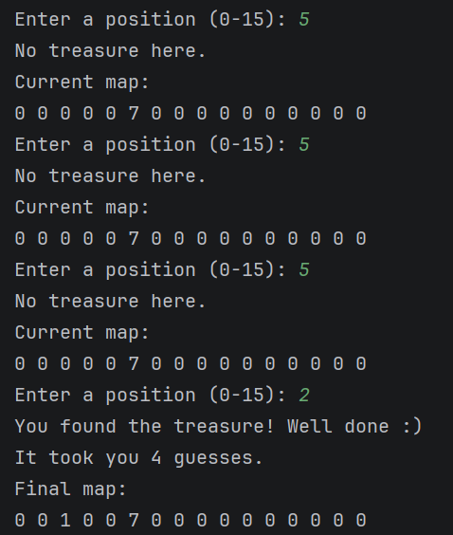
Result: Did the programme behave as expected ie syntactically and logically correct?
The programme accepts each repeated input as a guess in the final number of guesses. A prompt should be added if the user has already guessed that position and they should be asked to guess again. The final map displayed the correct output.

Final code:
treasureMap = [0, 0, 0, 0, 0, 0, 0, 0, 0, 1, 0, 0, 0, 0, 0, 0]
displayMap = [0, 0, 0, 0, 0, 0, 0, 0, 0, 0, 0, 0, 0, 0, 0, 0]
print("Welcome to the Treasure Hunt program, make some guesses and find the treasure!")
found = 0
guesses = 0
while found == 0:
print("Current map:")
for counter in displayMap:
print(counter, end=" ")
print()
guess = -1
while guess < 0 or guess > 15 or displayMap[guess] != 0:
try:
user_input = input("Enter a position (0-15): ")
guess = int(user_input)
if guess < 0 or guess > 15:
print("Guess out of range! Please enter a number between 0 and 15.")
elif displayMap[guess] != 0:
print("You've already guessed that position! Try a different number.")
except ValueError:
print("Invalid input! Please enter a NUMBER between 0 and 15.")
guesses = guesses + 1
if treasureMap[guess] == 1:
print("You found the treasure! Well done :)")
print("It took you", guesses, "guesses.")
displayMap[guess] = 1
found = 1
else:
print("No treasure here.")
displayMap[guess] = 7
for counter in range(len(treasureMap)):
if treasureMap[counter] == 1:
displayMap[counter] = 1
print("Final map:")
for counter in displayMap:
print(counter, end=" ")

