

Design and Analysis of Electromagnetic Systems
Daniel Frankland (2308433)

Title Page


2. Table of Contents
B. Eng. In Embedded Electronic Systems Electromagnetic Radiation (ACDC5009)
[7]
[7]

1. Title Page 1
2. Table of Contents 1
3. Table of Figures 3
4. Task 1 and 2 4
4.1. Abstract 4
4.2. Introduction 5
4.2.1. Dimensions 5
4.3. Methodology 5
4.3.1. Description of Halfwave Dipole 5
4.3.2. Description of Waveguide 5
4.4. Results 6
4.4.1. Calculations for Halfwave Dipole 6
4.4.2. Calculations for Task 1A Waveguide with PEC Walls Filled with Vacuum 7
4.4.3. Calculations for Task 1B Waveguide with PEC Walls Filled with Teflon 8
4.4.2. Results for Task 2 Halfwave Dipole 9
4.4.3. Results for Task1A Waveguide with PEC Walls Filled with Vacuum 10
4.4.4. Results for Task1B Waveguide with PEC Walls Filled with Teflon 15
4.5. Discussion 20
4.6. Conclusion 21
5. Task 3 22
5.1. Introduction 22
5.2. Literature review 22
5.3. Discussion 22
5.3.1. How Does Radar Work? 22
5.3.2. History of Radar in Britain. 22
5.3.3. Recent Advancement of Radar 23
5.3.4. Societal and Environmental Impacts 24
5.4. Conclusion 24
6. References 25

Table of Figures
Figure 1 3D Farfield View for Halfwave Dipole 9
Figure 2 S-Parameters for Halfwave Dipole 9
Figure 3 Azimuth Plot for Halfwave Dipole 9
Figure 4 Elevation Plot for Halfwave Dipole 10
Figure 7 Rectangular Plot of Cut-off Frequencies for all Modes in a Vacuum 10
Figure 5 Task1A Port 2 Mode 1 Port Field Display 10
Figure 6 Task1A Port 1 Mode 1 Port Field Display 10
Figure 8 Task1A Port 2 Mode 2 Port Field Display 10
Figure 9 Task1A Port 1 Mode 2 Port Field Display 10
Figure 10 Task1A Port 2 Mode 3 Port Field Display 10
Figure 11 Task1A Port 1 Mode 3 Port Field Display 10
Figure 12 Task1A Waveguide Mode 1 E Field Mag 11
Figure 13 Task1A Waveguide Mode 1 H Field Mag 11
Figure 14 Task1A Waveguide Model 1 E Field Vector 11
Figure 15 Task1A Waveguide Model 1 H Field Vector 12
Figure 16 Task1A Waveguide Mode 2 E Field Mag 12
Figure 17 Task1A Waveguide Mode 2 H Field Mag 12
Figure 18 Task1A Waveguide Model 2 E Field Vector 13
Figure 19 Task1A Waveguide Model 2 H Field Vector 13
Figure 20 Task1A Waveguide Mode 3 E Field Mag 13
Figure 21 Task1A Waveguide Mode 3 H Field Mag 14
Figure 22 Task1A Waveguide Model 3 E Field Vector 14
Figure 23 Task1A Waveguide Model 3 H Field Vector 14
Figure 24 Cut-off Frequencies for all Modes Walls Filled with Teflon 15
Figure 25 Task1B Port 1 Mode 1 Port Field Display 15
Figure 26 Task1B Port 2 Mode 1 Port Field Display 15
Figure 27 Task1B Port 1 Mode 2 Port Field Display 15
Figure 28 Task1B Port 2 Mode 2 Port Field Display 15
Figure 29 Task1B Port 1 Mode 3 Port Field Display 15
Figure 30 Task1B Port 2 Mode 3 Port Field Display 15
Figure 31 Task1B Waveguide Mode 1 E Field Mag 16
Figure 32 Task1B Waveguide Mode 1 H Field Mag 16
Figure 33 Task1B Waveguide Model 1 E Field Vector 16
Figure 34 Task1B Waveguide Model 1 H Field Vector 17
Figure 35 Task1B Waveguide Mode 2 E Field Mag 17
Figure 36 Task1B Waveguide Mode 2 H Field Mag 18
Figure 37 Task1B Waveguide Model 2 E Field Vector 18
Figure 38 Task1B Waveguide Model 2 H Field Vector 18
Figure 39 Task1B Waveguide Mode 3 E Field Mag 19
Figure 40 Task1B Waveguide Mode 3 H Field Mag 19
Figure 41 Task1B Waveguide Model 3 E Field Vector 19
Figure 42 Task1B Waveguide Model 3 H Field Vector 20
Figure 43 Leonardo ECRS Radar 23

Task 1 and 2

Abstract
This section of the report shows the design simulation and analysis of both a halfwave dipole and a rectangular waveguide using simulation software. The dipole was modelled based on dimensions derived from a student ID number, but this required adjustments to match the desired operational frequency. With this a frequency shift was calculated to achieve the target frequency and simulation results for this confirmed it.

Additionally, for the second part of this section of the report. Two waveguides were designed with one filled with a vacuum and the other filled with Teflon. Simulations and mathematical calculations were also performed to determine the cut off frequencies for the 3 desired modes. This section of the report shows the correlation between material properties and waveguide behaviour.

Introduction
For this assignment I was tasked to design both halfwave dipole and a waveguide. For the halfwave dipole I simulated this in CST. During simulation I was able to note that the given dimensions using the student number didn’t match the given frequency so I calculated a frequency shift to align this.
For the waveguide task I used Ansys as my simulation software. With this I noted no differences between simulation and the theoretical maths.

Dimensions
Part of Antenna | Name on Model | Value (mm)
Dipole radius | dip_orad | 1
Gap for port | gap | 0.5
Dipole length | dip_length | 101.95
N/A | shift | 0.89
Table 1 Parameter List for Halfwave Dipole
Part of Antenna | Name on Model | Material | Outer Radius (mm) | Zmin (mm) | Zmax (mm)
Half of dipole | dip1 | PEC | 1 | 0.25 | 51.22
Half of dipole | dip1_1 | PEC | 1 | 0.25 | 51.22
Table 2 Dimensions for Halfwave Dipole
Part of Antenna | Name on Model | Material | X-Plane Size (mm) | Y-Plane Size (mm) | Z-Plane Size (mm)
Waveguide | WG_Fill | Vacuum | 23 | 50 | 4
Table 3 Dimensions for Waveguide for Task 1 A
Part of Antenna | Name on Model | Material | X-Plane Size (mm) | Y-Plane Size (mm) | Z-Plane Size (mm)
Waveguide | WG_Fill | Teflon | 23 | 50 | 4
Table 4 Dimensions for Waveguide for Task 1 B

Methodology

Description of Halfwave Dipole
The halfwave dipole was designed using CST. I created it by making a cylinder, I then mirrored it below with an equal excitation gap between the two cylinders.

Description of Waveguide
The waveguides were designed and simulated in Ansys. Both of the waveguides were created the same way but the internal fill was changed from a vacuum to Teflon. These were created by making a rectangle at set sizes. Then both ends were given waveguide ports for excitations.

Results

Calculations for Halfwave Dipole

Dipole Length Calculation
$$λ=wavelength \left(mm\right)$$
$$L=Length of dipole \left(mm\right)$$
$$L=\frac{λ}{2}$$
$$λ=230mm$$
$$L=\frac{230}{2}$$
$$L=115mm$$

Dipole Frequency Calculation
$$f=Frequency \left(MHz\right)$$
$$λ=Wavelength \left(mm\right)$$
$$300,000=speed of light (mm/s)$$
$$λ=230mm$$
$$f=\frac{300,000}{λ}$$
$$f=\frac{300,000}{230}$$
$$f=1304.35(MHz)(2.d.p)$$

Calculations for Task 1A Waveguide with PEC Walls Filled with Vacuum
Calculation of the cut off frequency for the 3 modes.
$$f_{c}=cutoff frequency (Hz)$$
$$c=speed of light (m/s) in a vacuum$$
$$m,n=mode indices$$
$$a=width of waveguide (m)$$
$$b=height of waveguide (m)$$
$$f_{c}=\frac{c}{2}\sqrt{{(\frac{m}{a})}^{2}+{(\frac{n}{b})}^{2}}$$
$$c=3.0×{10}^{8}m/s$$
$$a=23mm=0.023m$$
$$b=4mm=0.004m$$
$${TE}_{10} mode (m=1,n=0)$$
$${TE}_{20} mode \left(m=2,n=0\right)$$
$${TE}_{01} mode (m=3,n=0)$$
$$f_{c,10}=\frac{3.0×{10}^{8}}{2}\sqrt{{(\frac{1}{0.023})}^{2}+{(\frac{0}{0.004})}^{2}}$$
$$=6.52 GHz (2.d.p)$$
$$f_{c,20}=\frac{3.0×{10}^{8}}{2}\sqrt{{(\frac{2}{0.023})}^{2}+{(\frac{0}{0.004})}^{2}}$$
$$=13.04 GHz (2.d.p)$$
$$f_{c,30}=\frac{3.0×{10}^{8}}{2}\sqrt{{(\frac{3}{0.023})}^{2}+{(\frac{0}{0.004})}^{2}}$$
$$=19.57 GHz$$

Calculations for Task 1B Waveguide with PEC Walls Filled with Teflon
New calculation for speed of light with permeability and permittivity for Teflon
$$c=3.0×10^{8}m/s(speed of light in a vacum)$$
$$μ_{r}=1 (relative permability of Teflon)$$
$$ϵ_{r}=2.1 (relative permitivity of Teflon)$$
$$C=\frac{3.0×{10}^{8}}{\sqrt{1×2.1}}$$
$$=2.07×{10}^{8}m/s$$
$$f_{c}=cutoff frequency (Hz)$$
$$m,n=mode indices$$
$$a=width of waveguide (m)$$
$$b=height of waveguide (m)$$
$$f_{c}=\frac{c}{2}\sqrt{{(\frac{m}{a})}^{2}+{(\frac{n}{b})}^{2}}$$
$$a=23mm=0.023m$$
$$b=4mm=0.004m$$
$${TE}_{10} mode (m=1,n=0)$$
$${TE}_{20} mode \left(m=2,n=0\right)$$
$${TE}_{30} mode (m=3,n=0)$$
$$f_{c,10}=\frac{2.07×{10}^{8}}{2}\sqrt{{(\frac{1}{0.023})}^{2}+{(\frac{0}{0.004})}^{2}}$$
$$=4.5 GHz$$
$$f_{c,20}=\frac{2.07×{10}^{8}}{2}\sqrt{{(\frac{2}{0.023})}^{2}+{(\frac{0}{0.004})}^{2}}$$
$$=9 GHz$$
$$f_{c,30}=\frac{2.07×{10}^{8}}{2}\sqrt{{(\frac{3}{0.023})}^{2}+{(\frac{0}{0.004})}^{2}}$$
$$=13.5 GHz (2.d.p)$$

Results for Task 2 Halfwave Dipole
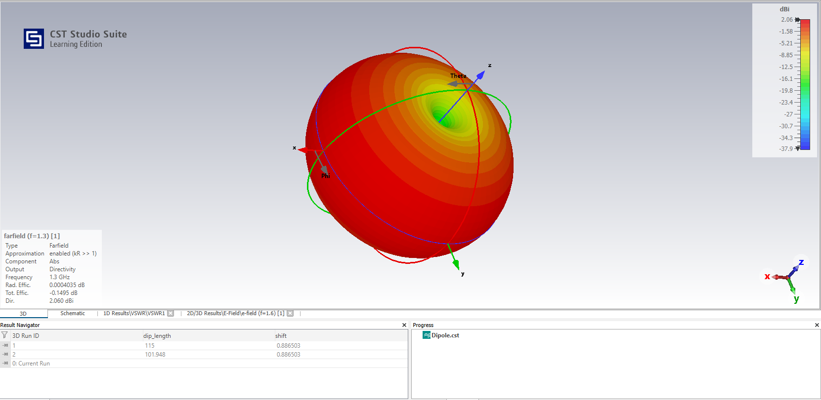
Figure 1 3D Farfield View for Halfwave Dipole
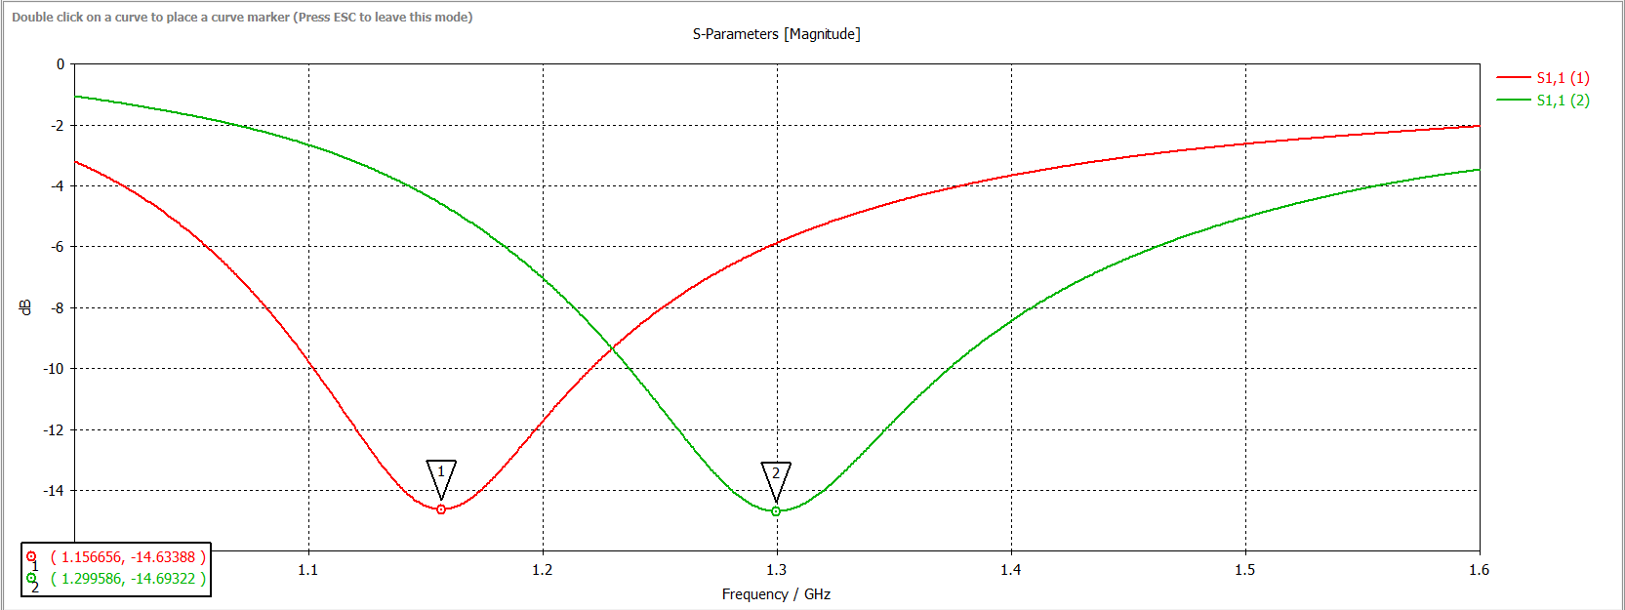
Figure 2 S-Parameters for Halfwave Dipole
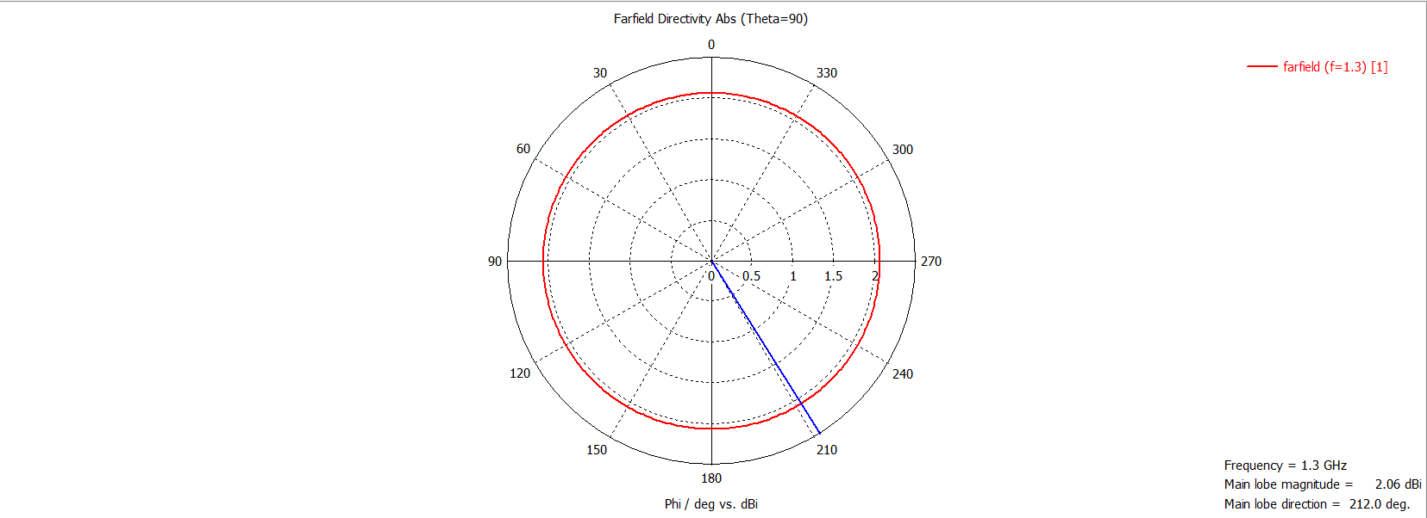
Figure 3 Azimuth Plot for Halfwave Dipole

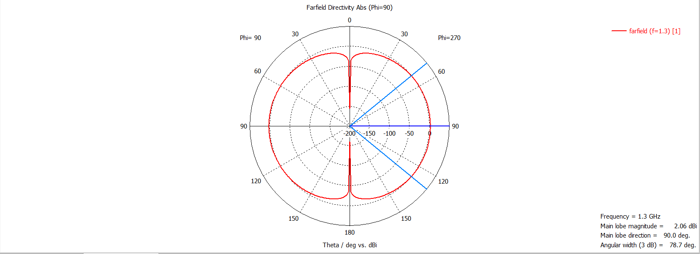
Figure 4 Elevation Plot for Halfwave Dipole

Results for Task1A Waveguide with PEC Walls Filled with Vacuum
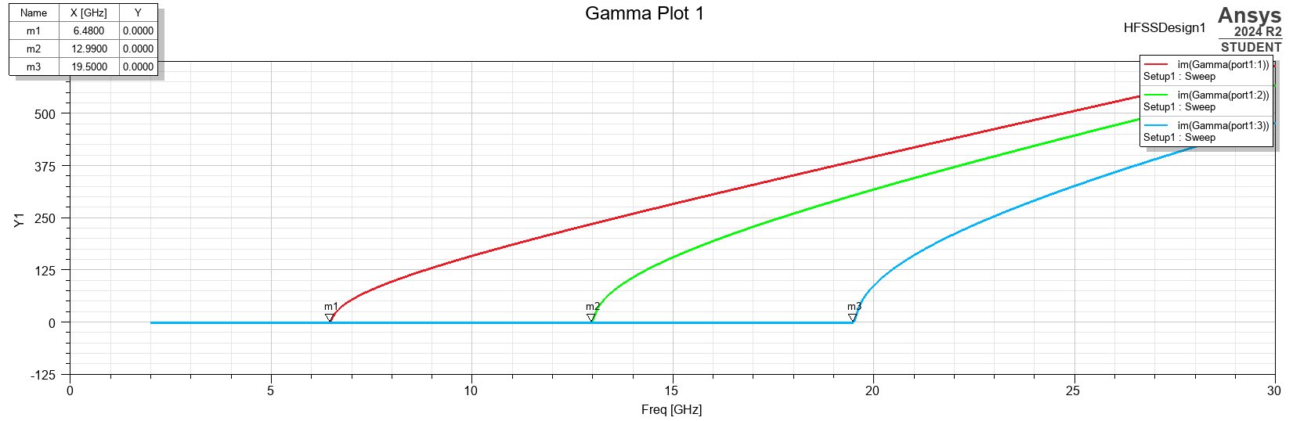
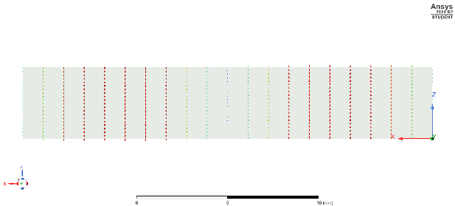
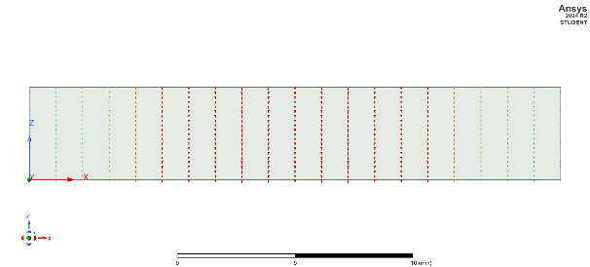
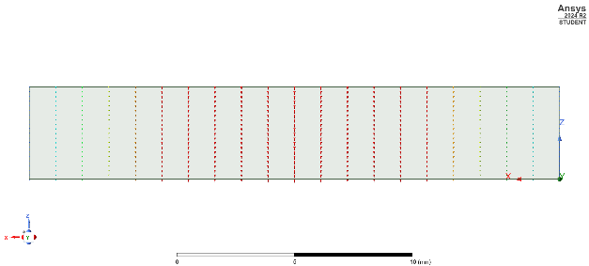
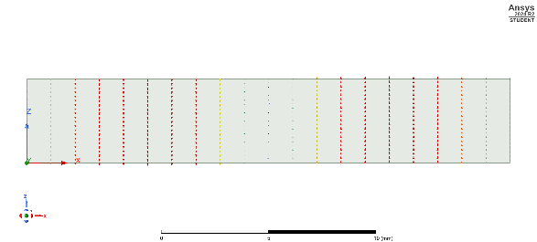
Figure 7 Rectangular Plot of Cut-off Frequencies for all Modes in a Vacuum
Figure 5 Task1A Port 2 Mode 1 Port Field Display
Figure 6 Task1A Port 1 Mode 1 Port Field Display

Figure 8 Task1A Port 2 Mode 2 Port Field Display
Figure 9 Task1A Port 1 Mode 2 Port Field Display
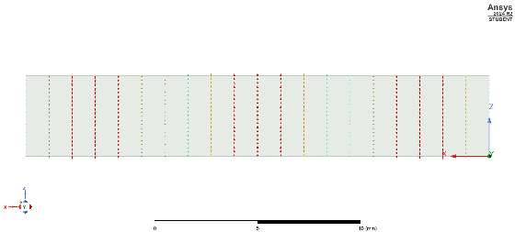
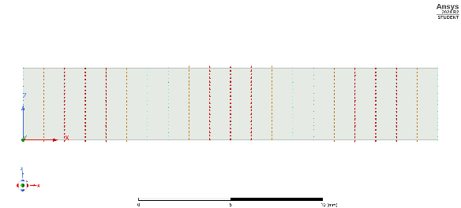
Figure 10 Task1A Port 2 Mode 3 Port Field Display
Figure 11 Task1A Port 1 Mode 3 Port Field Display

Mode 1
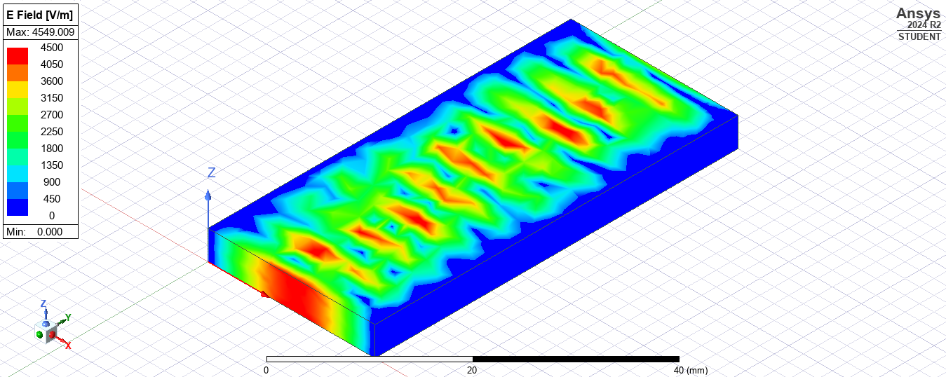
Figure 12 Task1A Waveguide Mode 1 E Field Mag

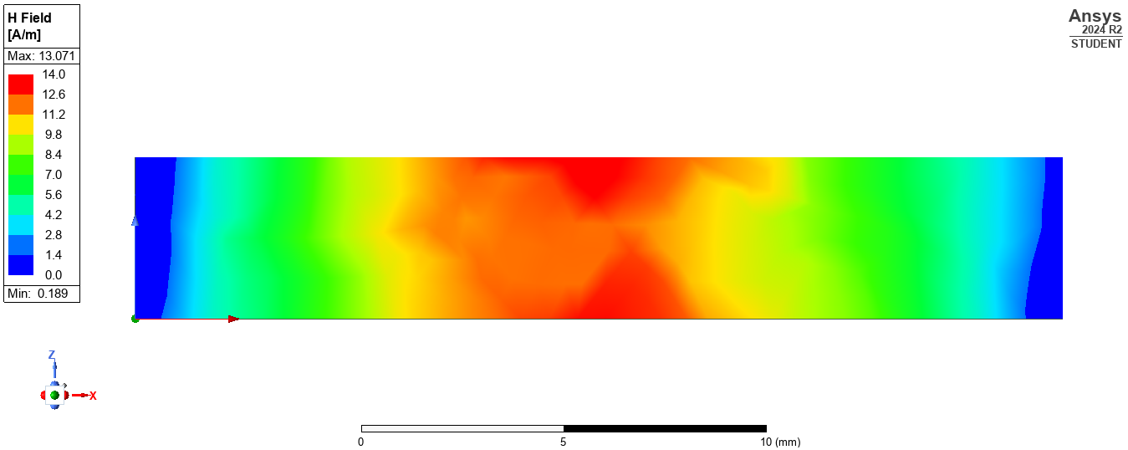
Figure 13 Task1A Waveguide Mode 1 H Field Mag
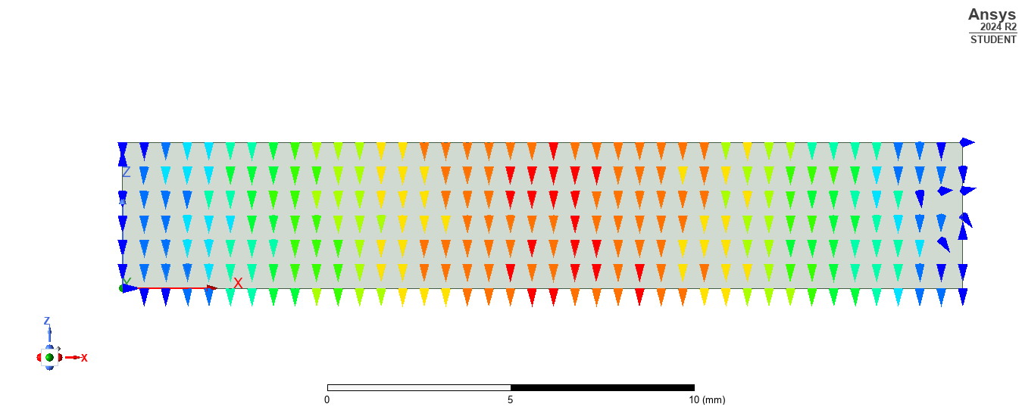
Figure 14 Task1A Waveguide Model 1 E Field Vector
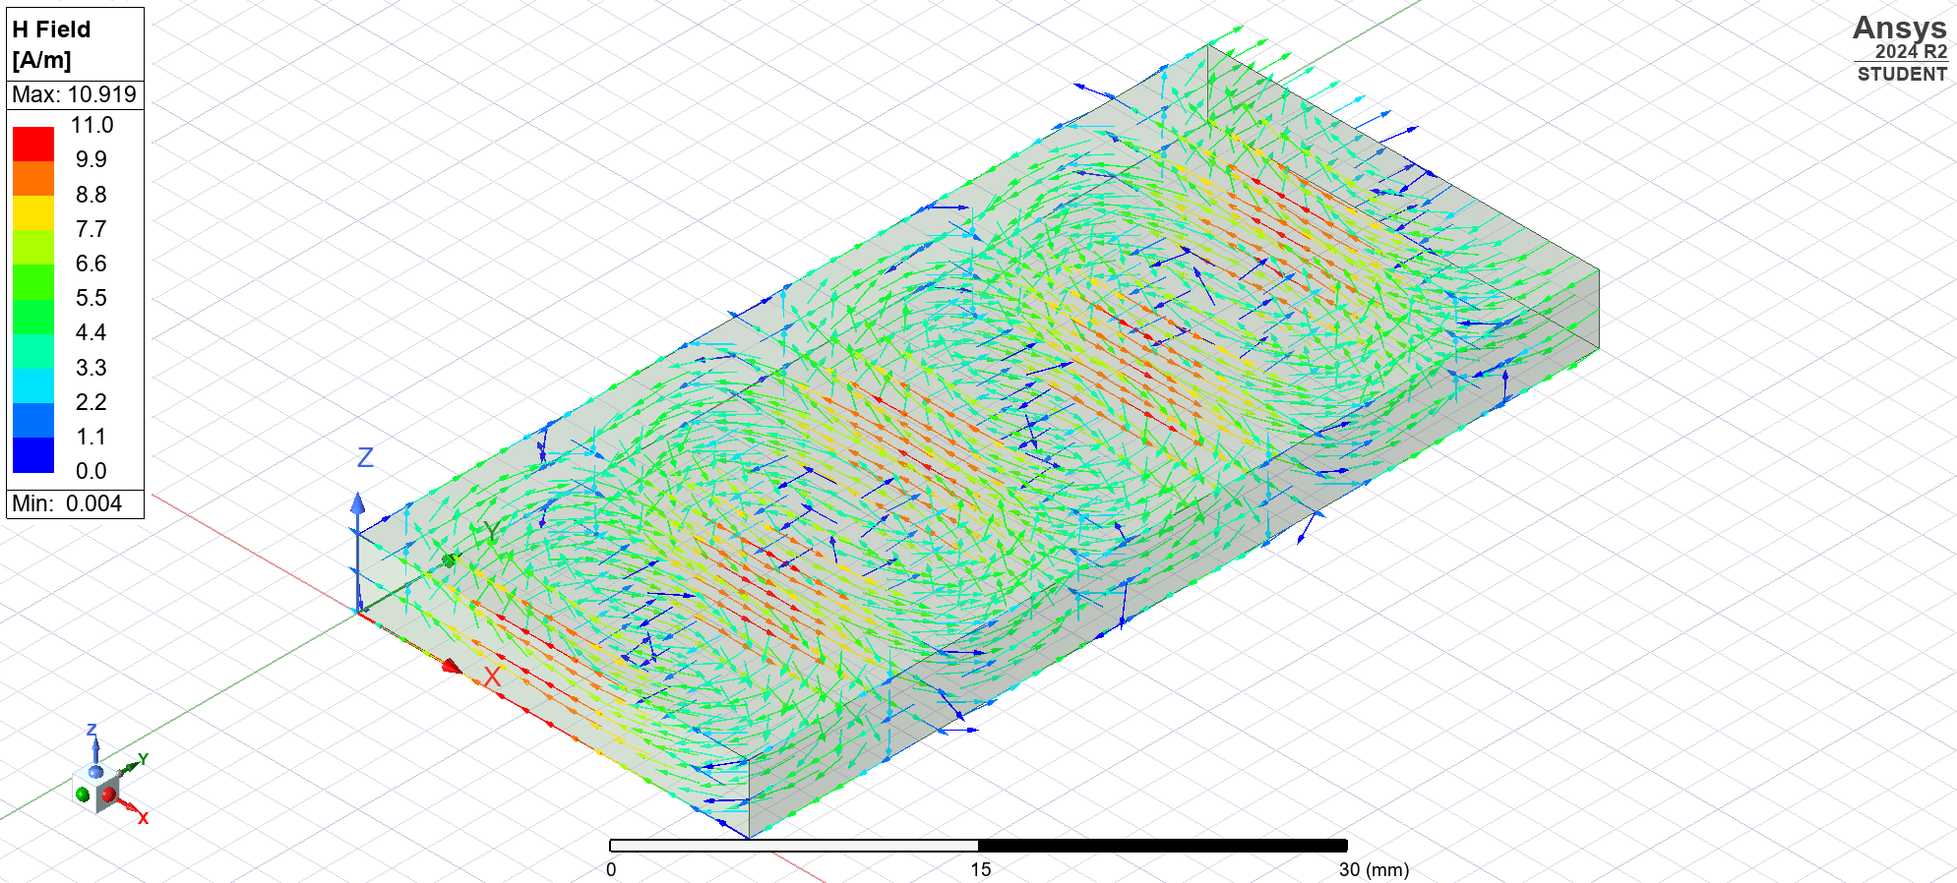
Figure 15 Task1A Waveguide Model 1 H Field Vector

Mode 2
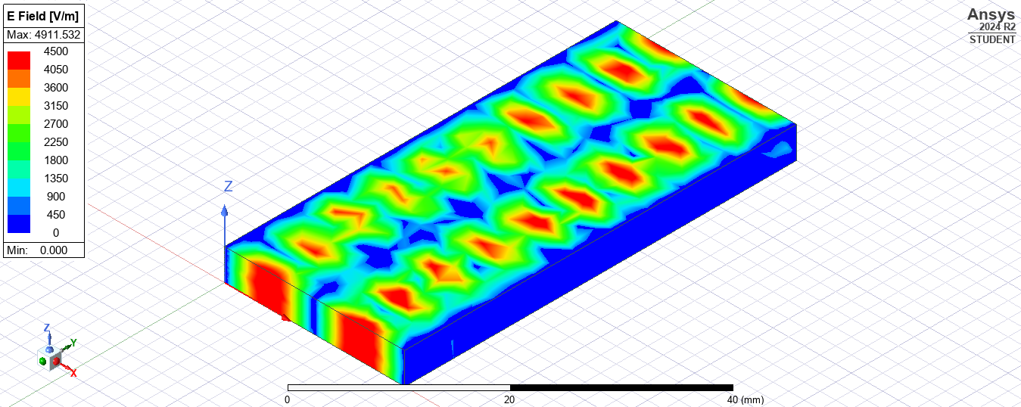
Figure 16 Task1A Waveguide Mode 2 E Field Mag
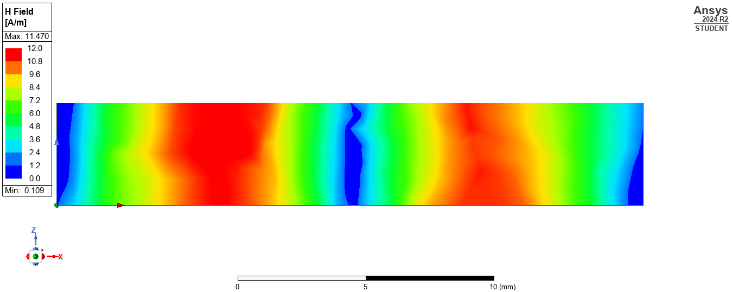
Figure 17 Task1A Waveguide Mode 2 H Field Mag
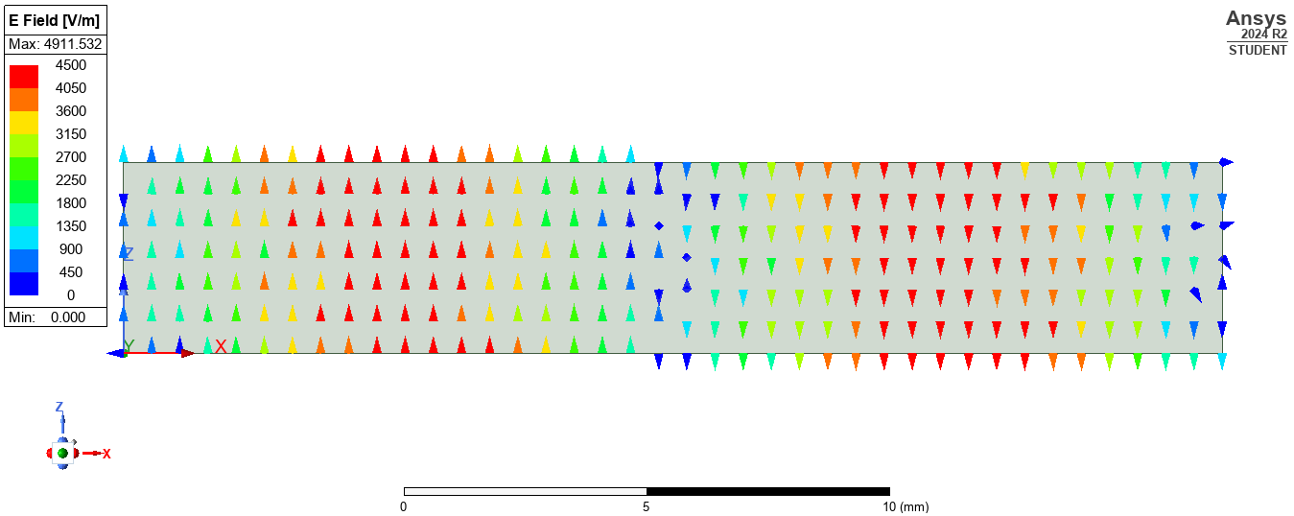
Figure 18 Task1A Waveguide Model 2 E Field Vector
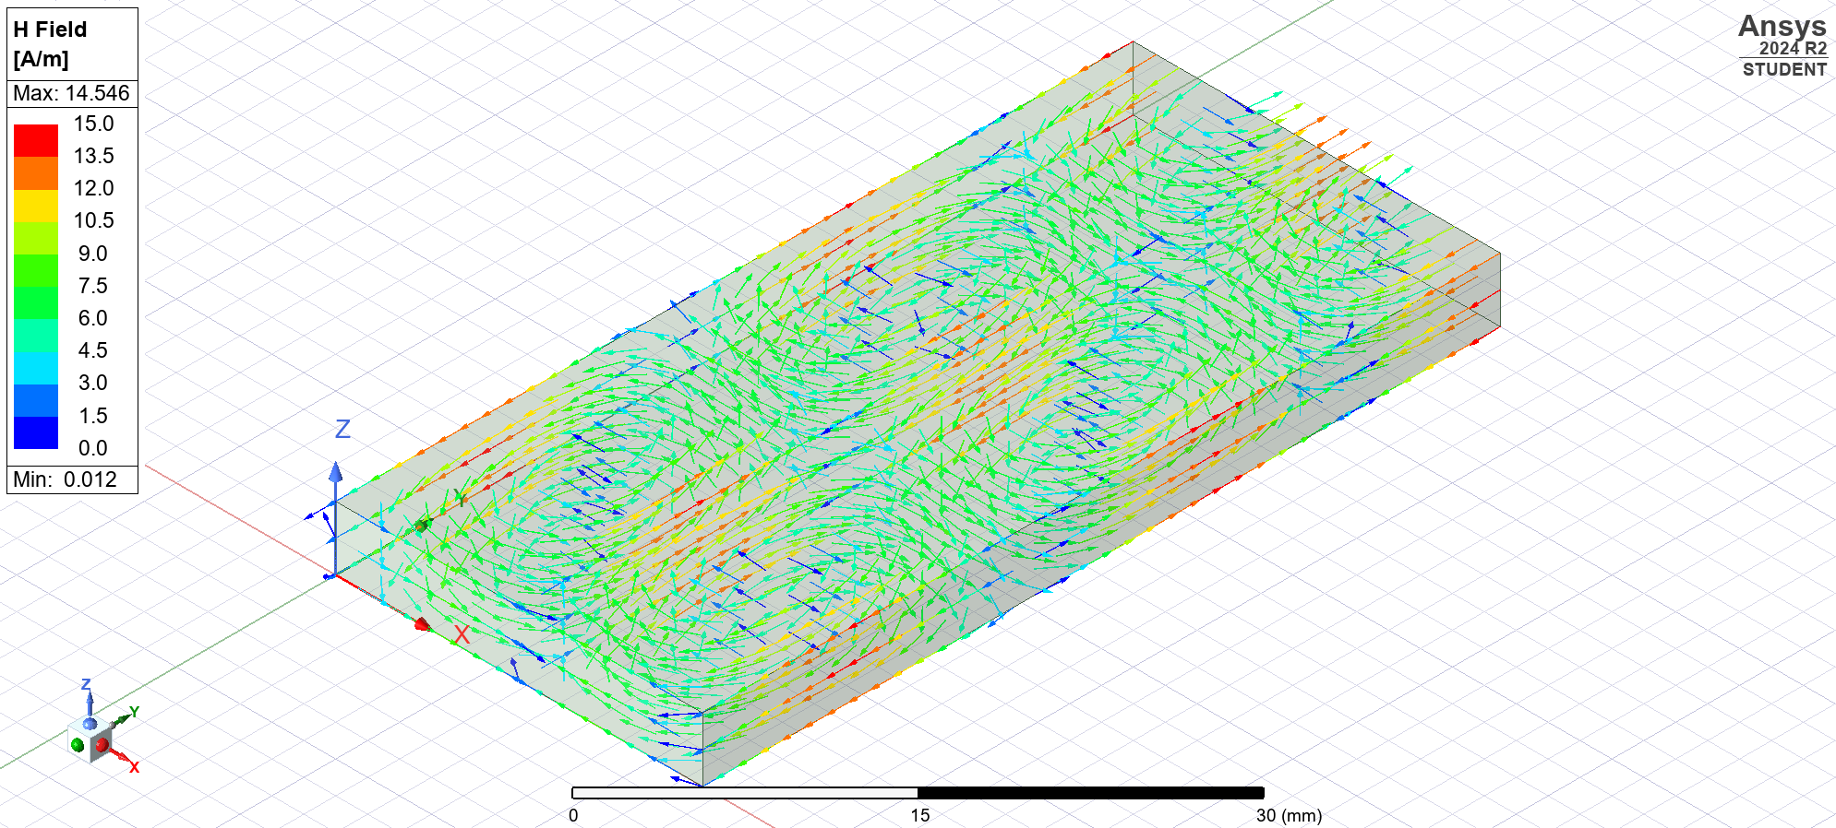
Figure 19 Task1A Waveguide Model 2 H Field Vector

Mode 3
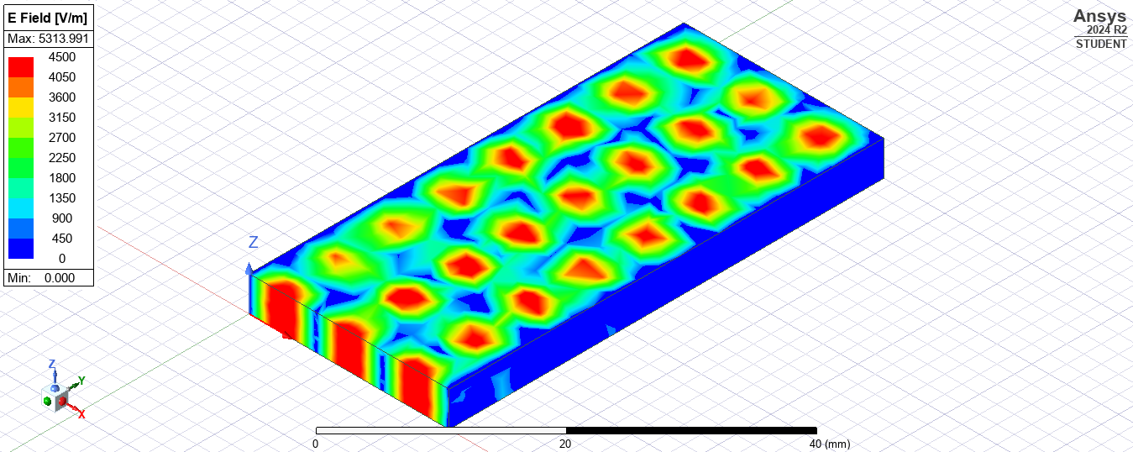
Figure 20 Task1A Waveguide Mode 3 E Field Mag
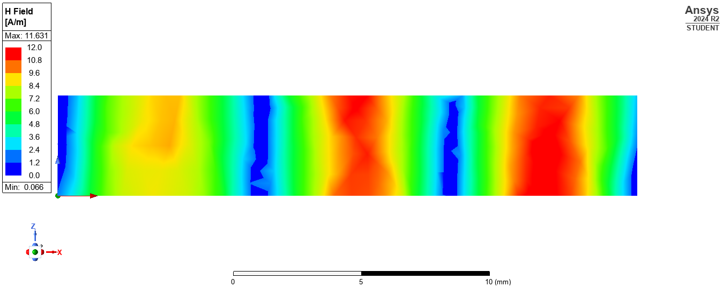
Figure 21 Task1A Waveguide Mode 3 H Field Mag
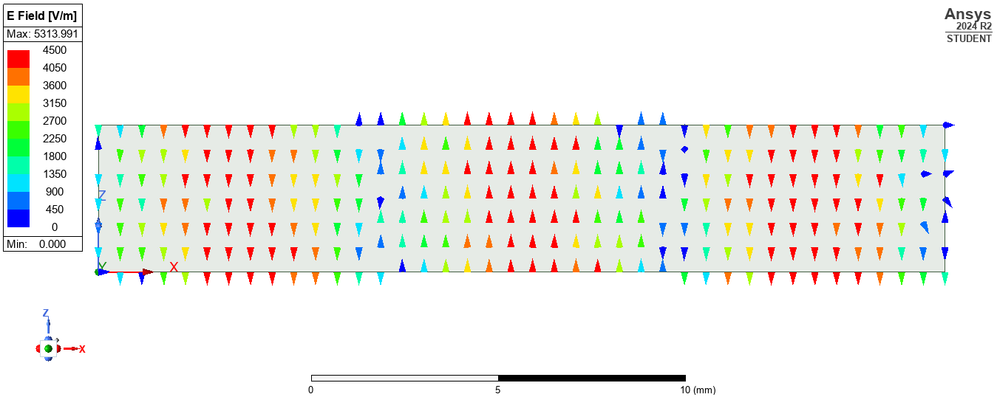
Figure 22 Task1A Waveguide Model 3 E Field Vector
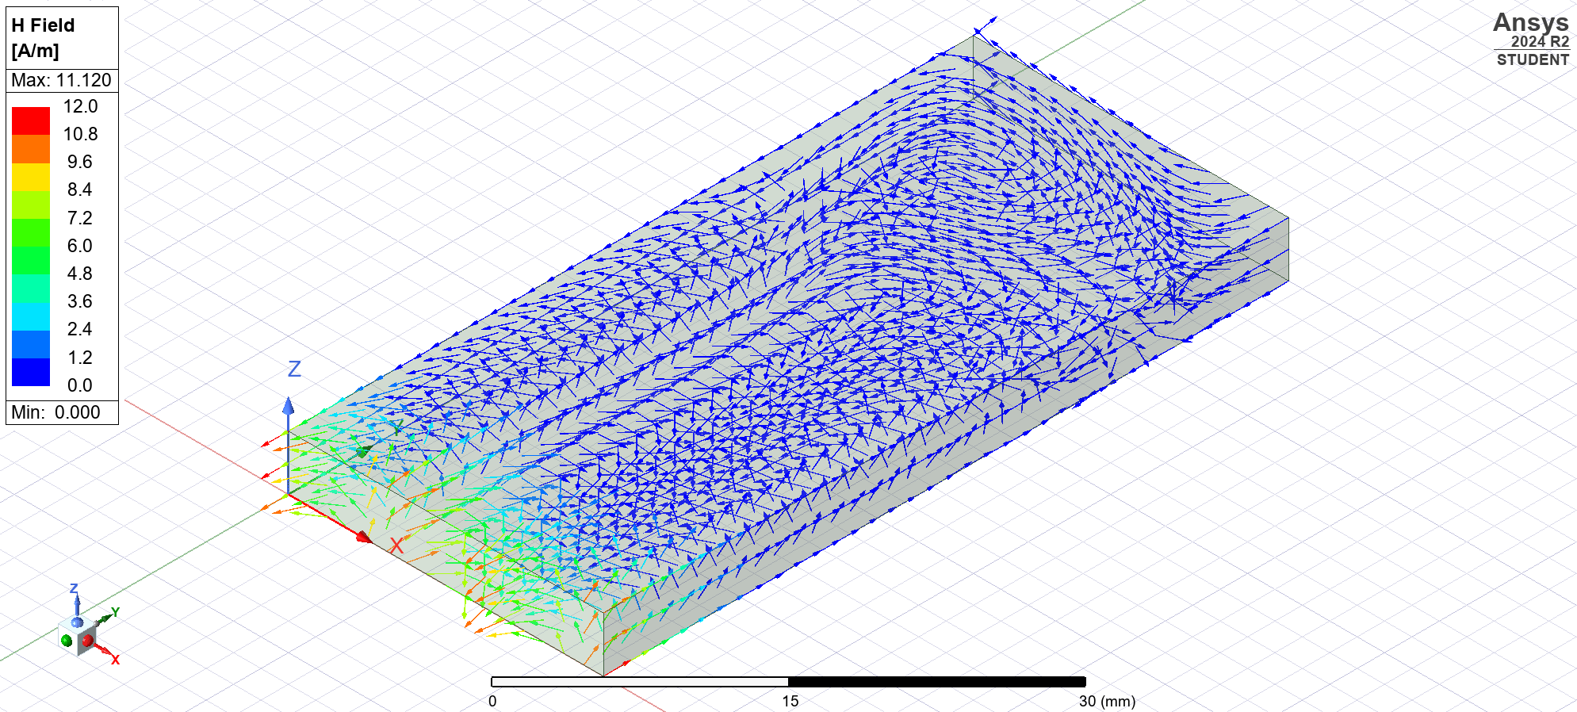
Figure 23 Task1A Waveguide Model 3 H Field Vector

Results for Task1B Waveguide with PEC Walls Filled with Teflon
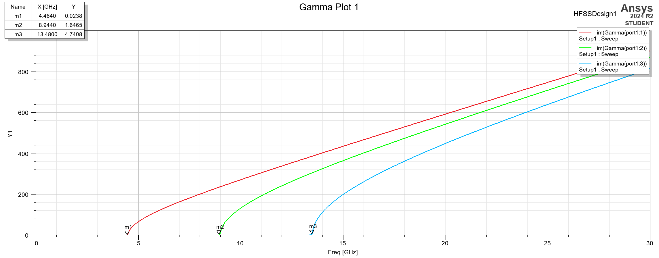
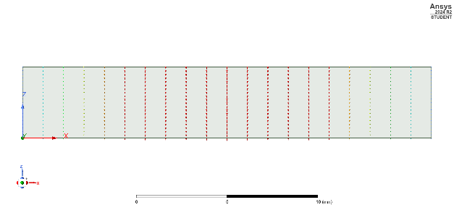
Figure 24 Cut-off Frequencies for all Modes Walls Filled with Teflon
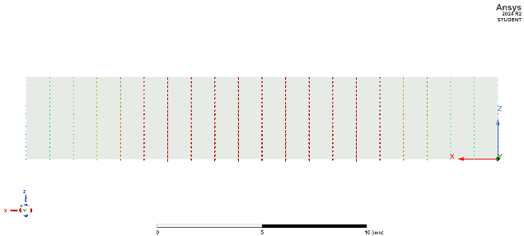

Figure 25 Task1B Port 1 Mode 1 Port Field Display
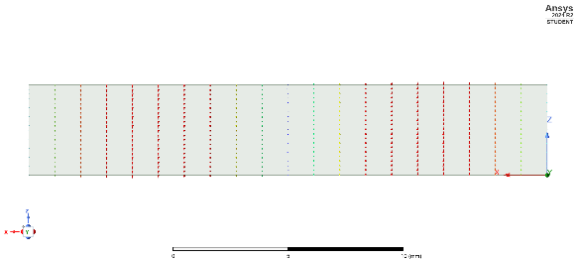
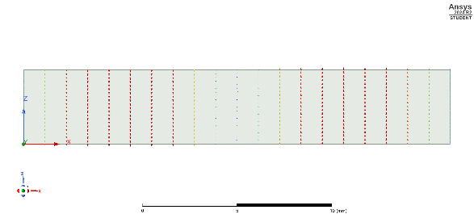
Figure 26 Task1B Port 2 Mode 1 Port Field Display
Figure 27 Task1B Port 1 Mode 2 Port Field Display

Figure 28 Task1B Port 2 Mode 2 Port Field Display
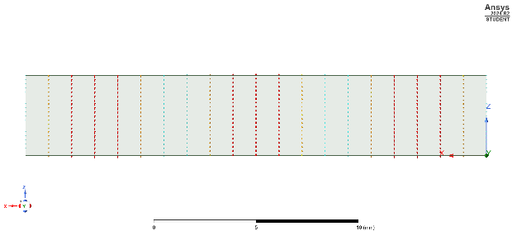
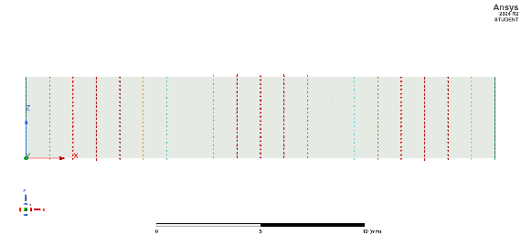
Figure 29 Task1B Port 1 Mode 3 Port Field Display
Figure 30 Task1B Port 2 Mode 3 Port Field Display

Mode 1
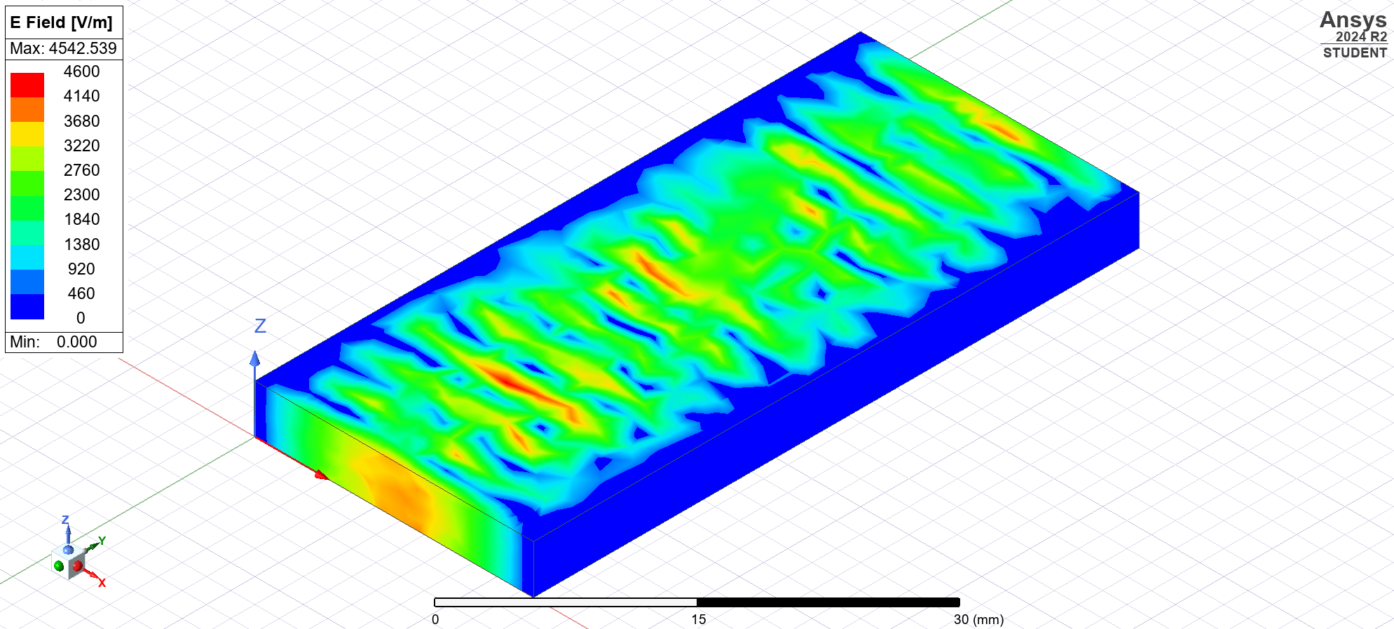
Figure 31 Task1B Waveguide Mode 1 E Field Mag
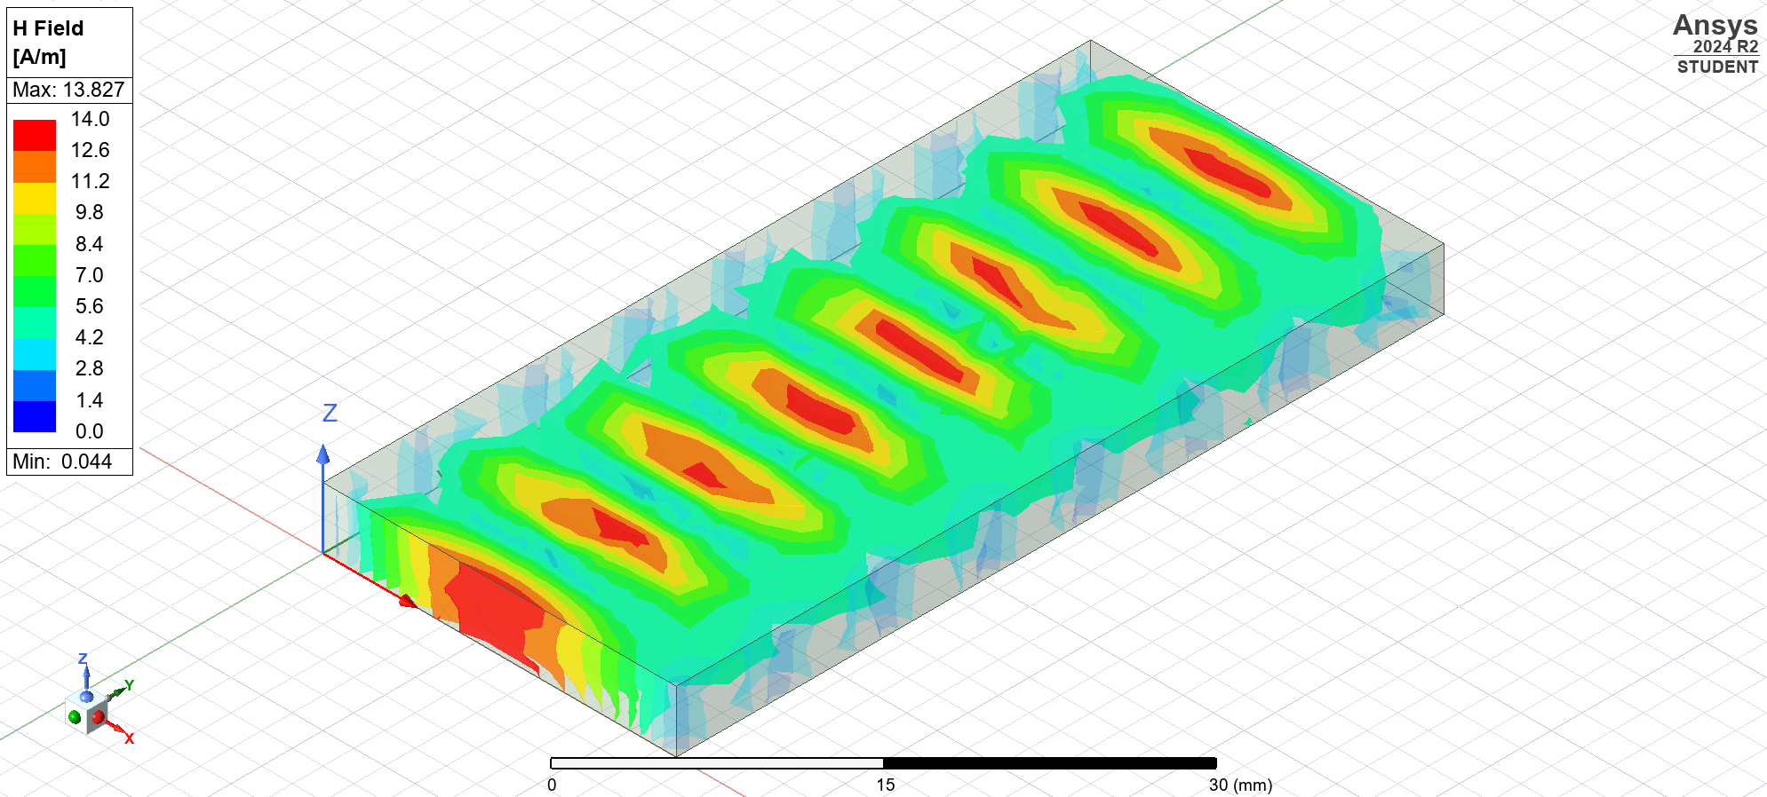
Figure 32 Task1B Waveguide Mode 1 H Field Mag
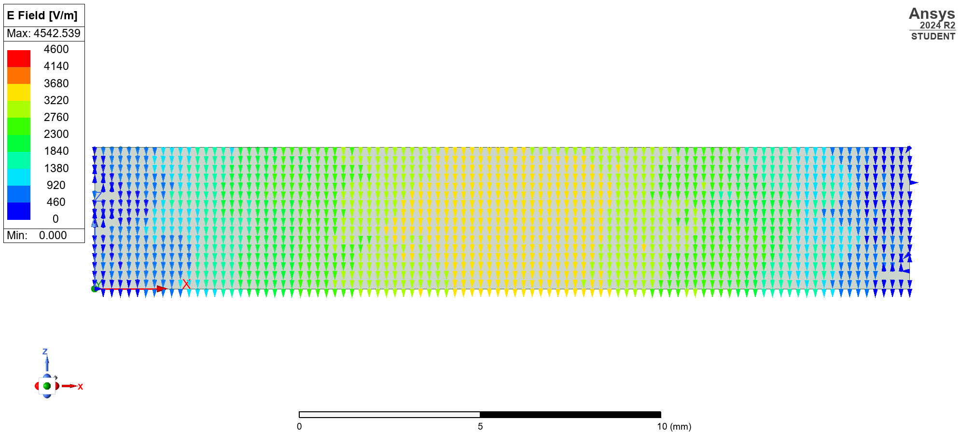
Figure 33 Task1B Waveguide Model 1 E Field Vector
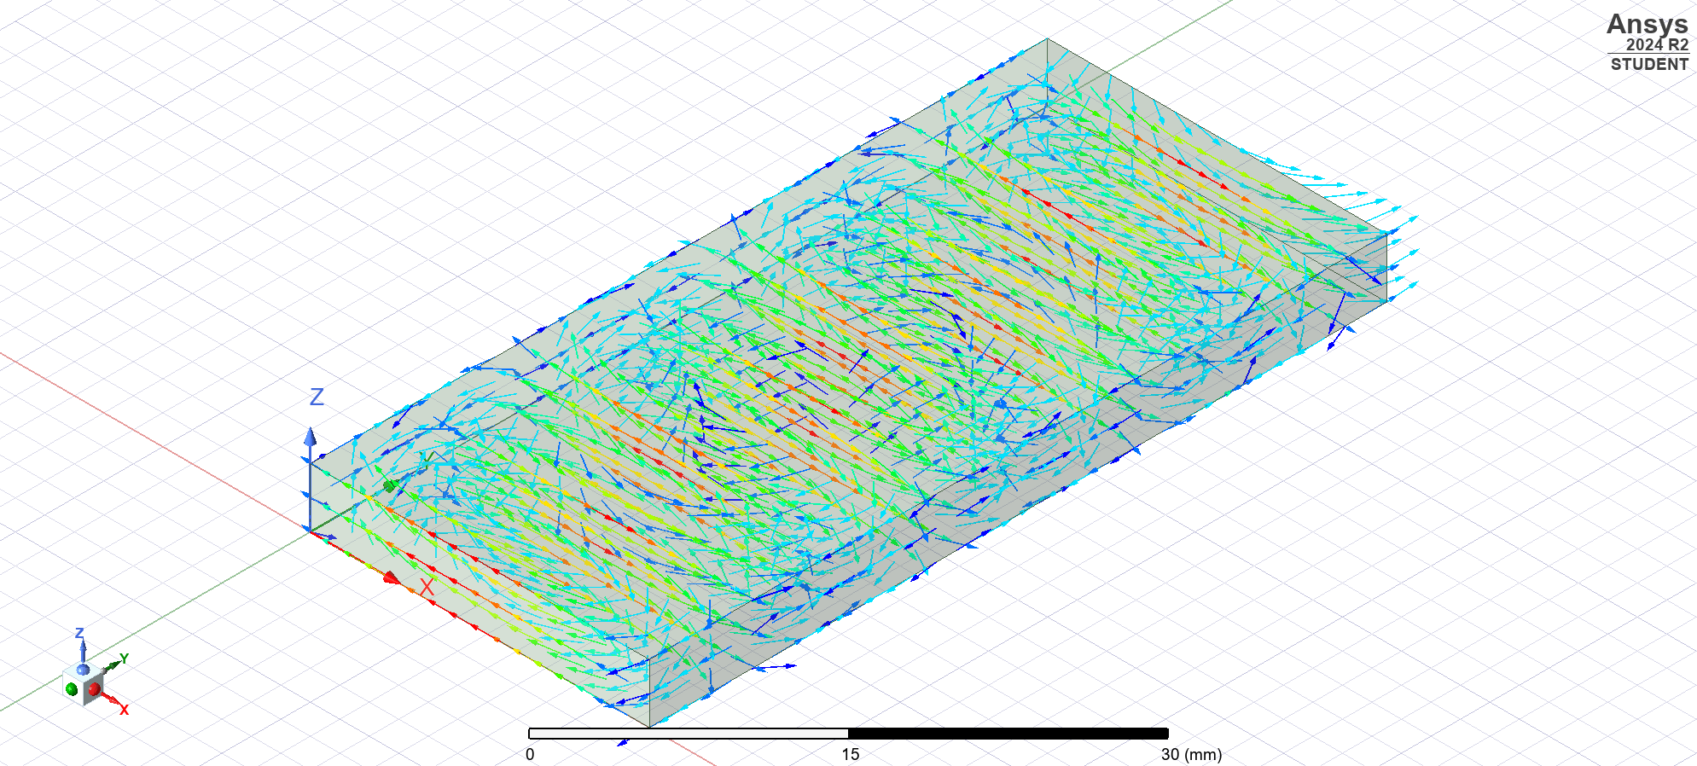
Figure 34 Task1B Waveguide Model 1 H Field Vector

Mode 2
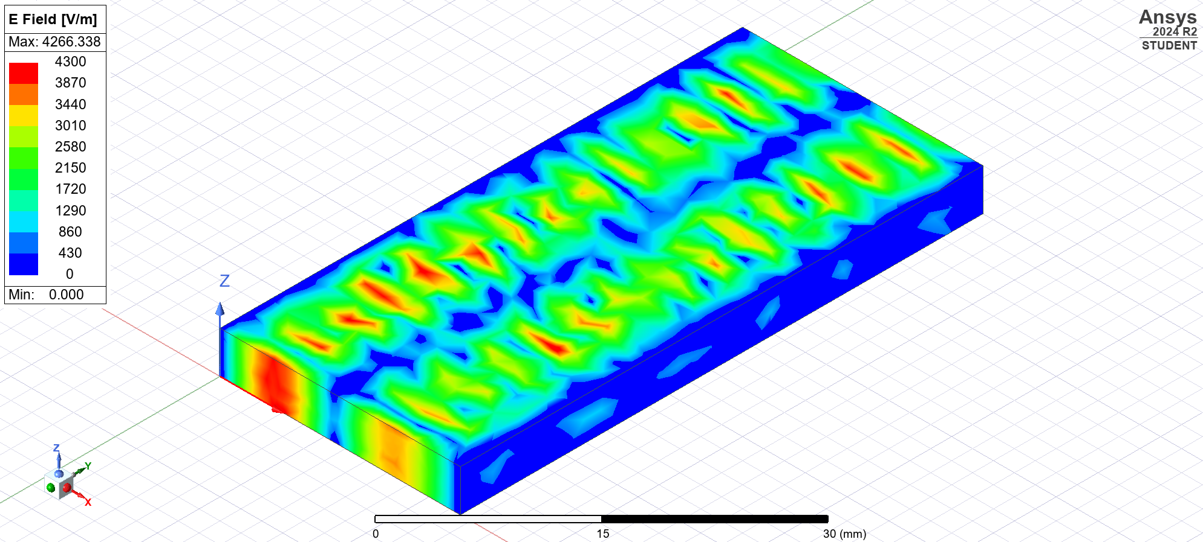
Figure 35 Task1B Waveguide Mode 2 E Field Mag
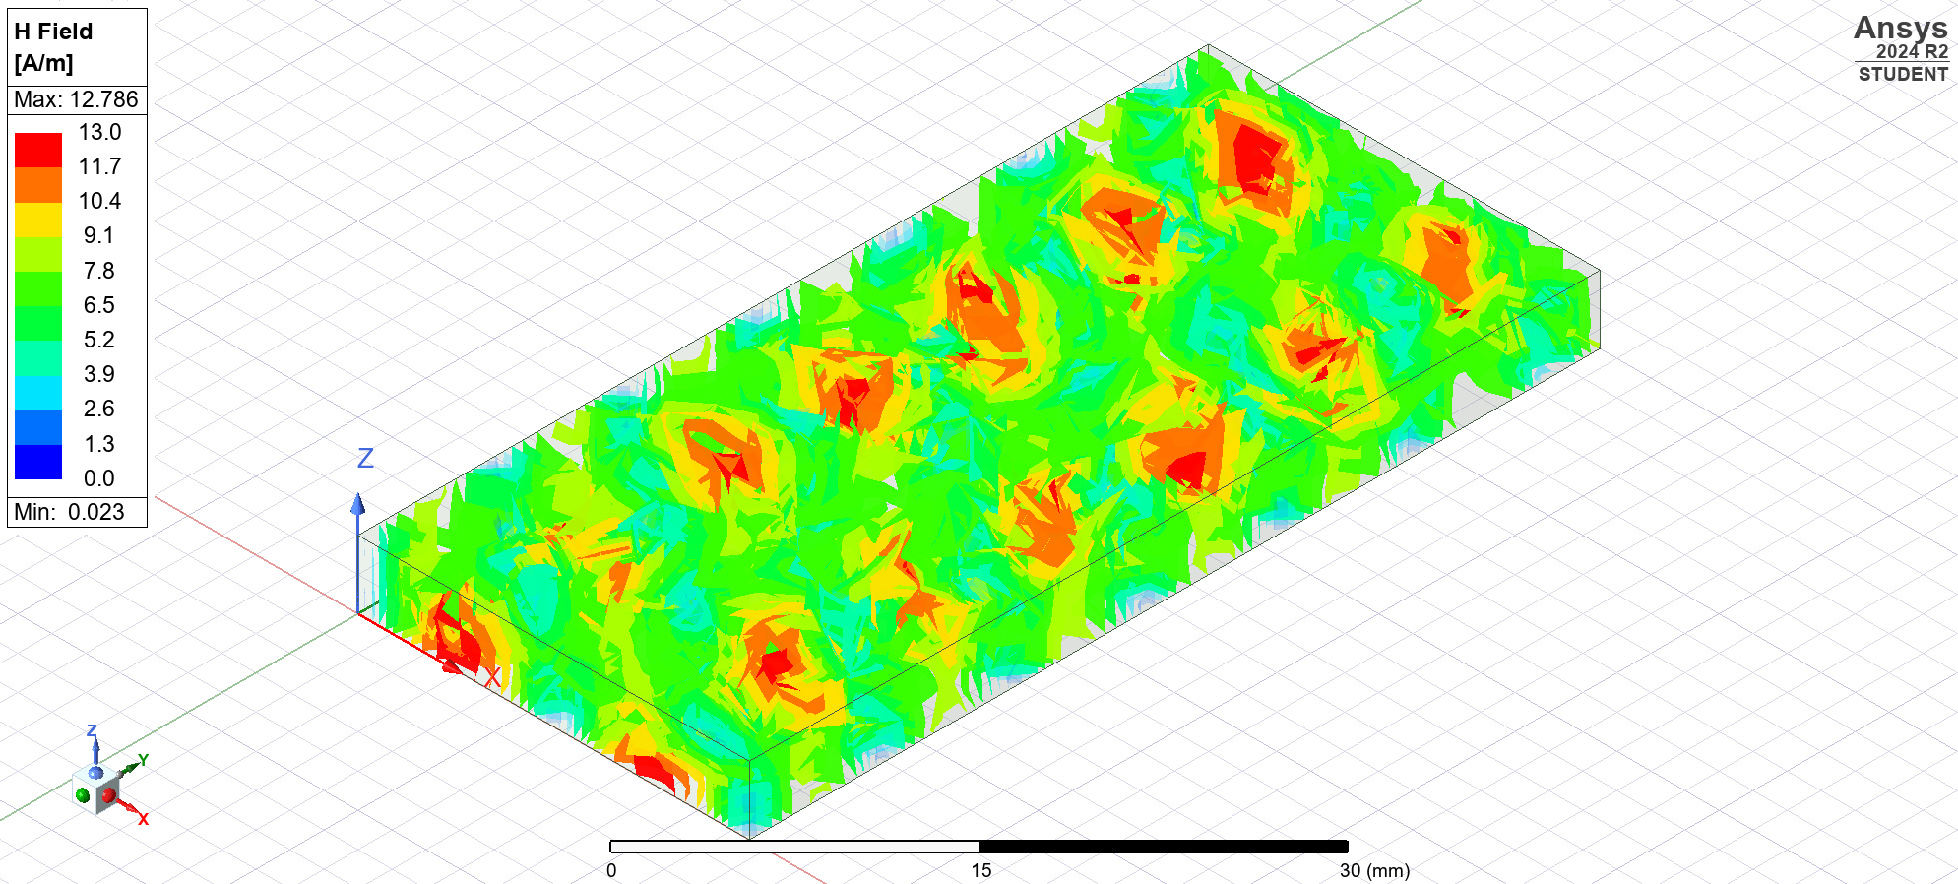
Figure 36 Task1B Waveguide Mode 2 H Field Mag
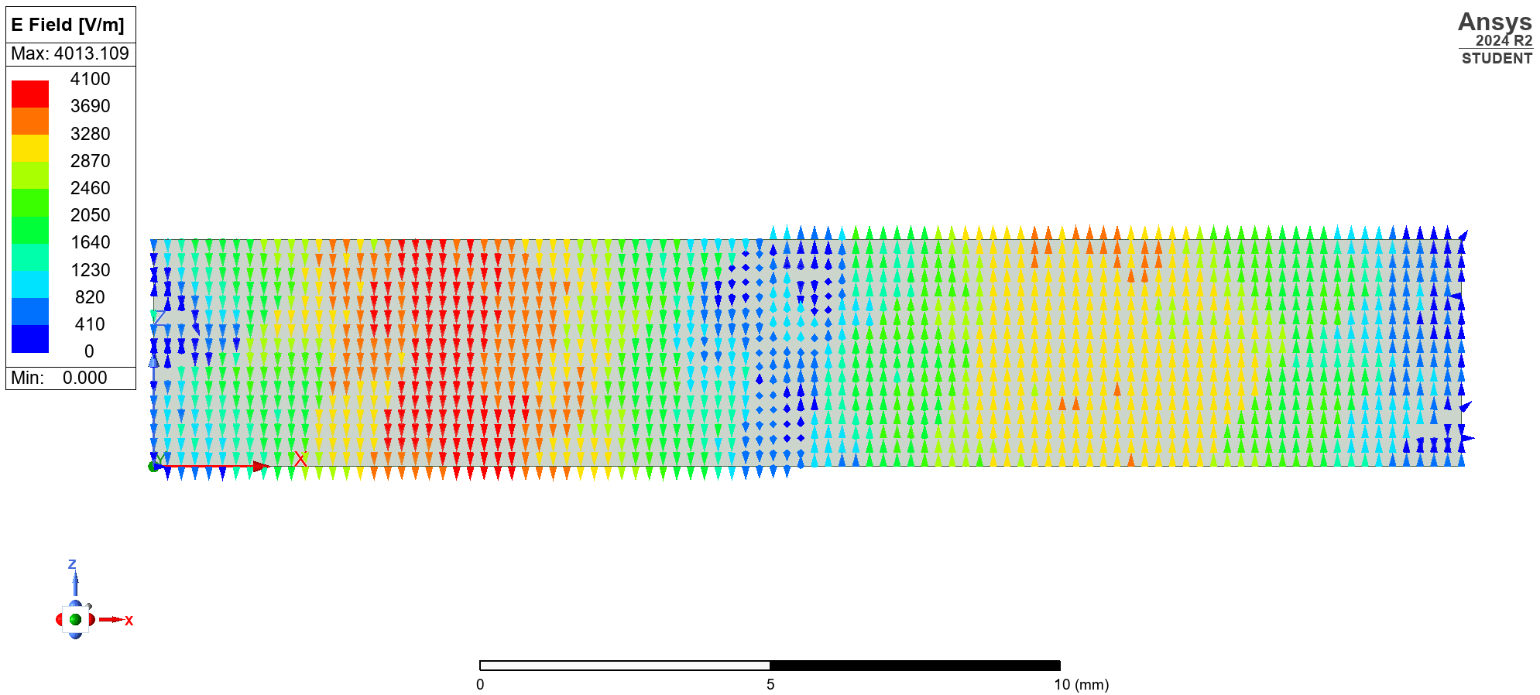
Figure 37 Task1B Waveguide Model 2 E Field Vector
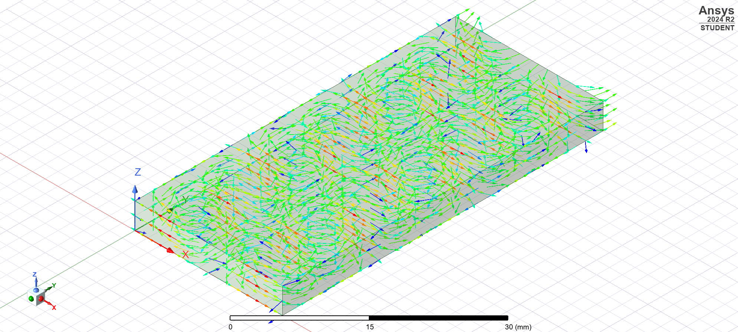
Figure 38 Task1B Waveguide Model 2 H Field Vector

Mode 3
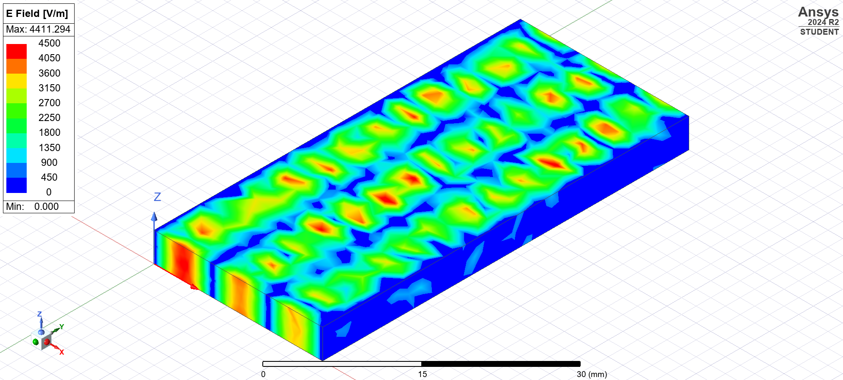
Figure 39 Task1B Waveguide Mode 3 E Field Mag
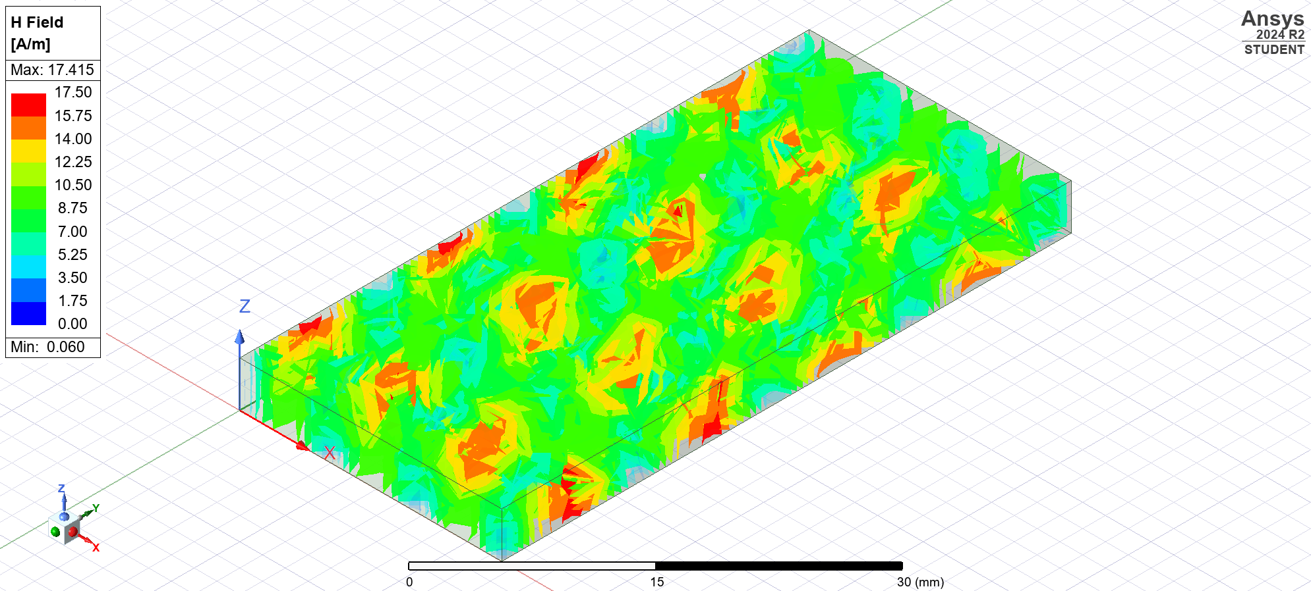
Figure 40 Task1B Waveguide Mode 3 H Field Mag
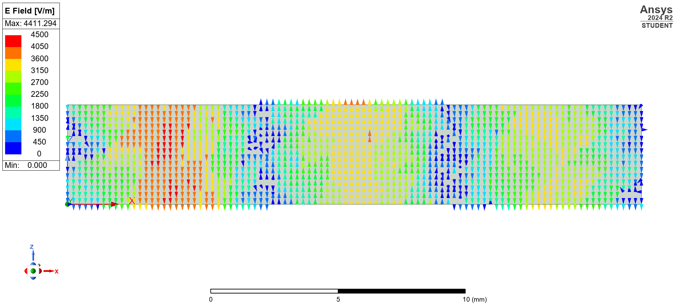
Figure 41 Task1B Waveguide Model 3 E Field Vector
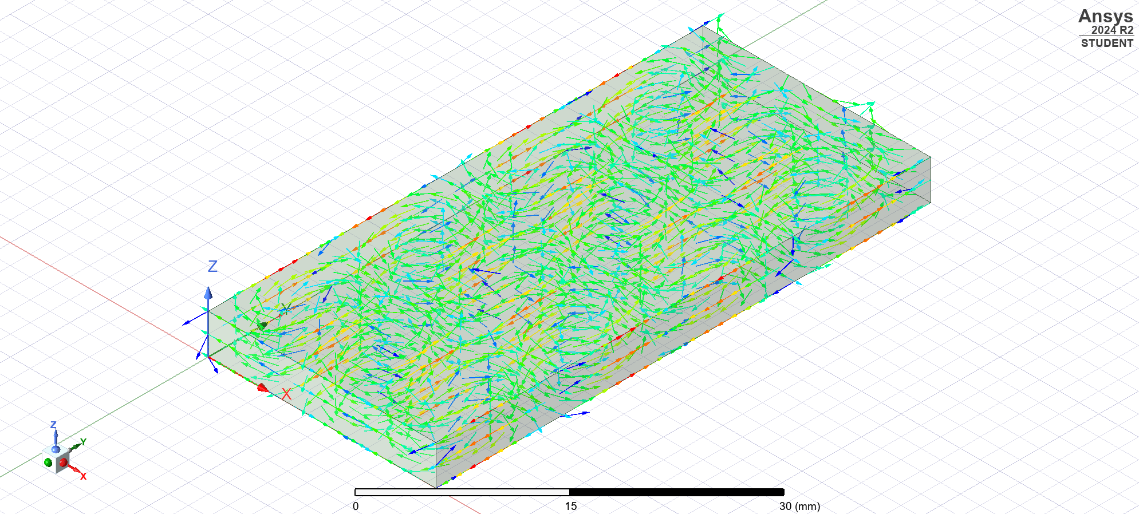
Figure 42 Task1B Waveguide Model 3 H Field Vector

Discussion
With the halfwave dipole I first simulated the results for the given requirements where the halfwave dipole was simulated to have a frequency of 1.156 GHz. This can be seen on Figure 2 as the red line. I calculated $\frac{1.156}{1.304}=0.887$ which is the required amount I needed to shift the frequency. I multiplied the shift amount with the dipole length. This then shifted the frequency of the dipole to the calculated frequency of 1.304 GHz. Which can be seen on the green line on Figure 2. Also, as can be seen in Figure 1 the halfwave dipole looks the expected apple shape. With this frequency shifted the calculated dipole length would have been changed to map to the frequency.

With the waveguides the results match the mathematically calculated results. There is a noticeable difference in the waveguides performance between the waveguide filled with a vacuum and the one filled with Teflon as can been seen comparing Figure 23 and Figure 42. Also, the difference between the Teflon filled waveguide and the Vacuum filled one is that the cut off frequency for the modes are higher in the vacuum filled compared to the Teflon filled.

Conclusion
In conclusion the design and simulation of the halfwave dipole and the waveguide showed a clear correspondence between the mathematical theory and the practical results. For the dipole a frequency shift was conducted to achieve the correct operational frequency. Corresponding adjustments to the dipole’s length were made to achieve this frequency shift. For the waveguides the simulation for both Teflon filled and vacuum filled confirmed the accuracy of the mathematical calculations for the cut off frequencies.
The material was shown to significantly affect the cut off frequencies with the vacuum filled waveguide thus allowing higher frequency propagation compared to the Teflon filled.
Overall these findings reinforced the need for precise modelling to help demonstrate and validate electromagnetic component behaviours.

Task 3

Introduction
Radar technology has been a crucial tool for detecting and tracking aircraft since the 1930’s. Initially developed during the second world war, radar systems have undergone significant technological enhancements which has helped the accuracy and reduction of false indications. However, the increasing usage of Unmanned Aerial Vehicles (UAVs) has presented significant challenges for traditional radar systems. UAVs are difficult to detect due to their small size, material and low altitudes. Traditional radar systems are primarily designed for detection of larger aircraft.

Literature review
Traditionally radar systems have struggled to detect UAVs due to their minimal radar cross section (RCS), high manoeuvrability and slow speeds. These limitations have led to development of advanced radar technology to improve UAV detection, especially within military applications due to the ongoing Russia Ukraine war.
One advancement is the Active Electronically Scanned Array (AESA) radar. AESA radars use multiple solid-state transmit/receive modules. Which allows for independent control of the phase and amplitude. This enables the generation and control of high power, agile radar beams, that can precisely scan airspace, and thus supporting several air to air and air to ground operating modes [1]. AESA technology is beneficial for UAV detection due to its ability to track multiple targets simultaneously, mitigating the traditional challenges of older radar systems.
Another development is Automatic Target Recognition (ATR) technology, which allow radar systems to differentiate drones from other objects even in busy environments. For instance, the SAAB Giraffe radar system uses advance signal processing and 3D mapping techniques to identify UAVs amongst the background noise [2].
In an article from Demire V he discusses the challenges of drone detection in urban environments. He mentions that radar systems can provide good capabilities especially at long ranges and poor visibility but conventional radars are not optimised to sense the platforms as they are smaller and slower than traditional aircraft [3]. The article highlights the need for further enhancements such as Artificial Intelligence and improved signal process techniques to enhance UAV detection capabilities.

Discussion

How Does Radar Work?
Radar works by transmitting an electromagnetic wave which reflects off objects and return to the receiver. The time delay between transmission and reception allows for the calculation of an objects distance [4].

History of Radar in Britain.
Before radar was discovered acoustic mirrors were built on the coasts of England between 1916 and the 1930’s to detect incoming enemy aircraft. These ‘listening ears were used to reflect sound waves, providing early warnings of approaching aircraft. [5]
In February 1935 Watson-Watt and Arnold Wilkins successfully demonstrated their system and manged to pick up a bomber as a test target. In May 1935 Watson-Watt, Wilkins set up experiment with a team which lead to the first working radar system laying the foundation for modern radar technology. [5]

Recent Advancement of Radar
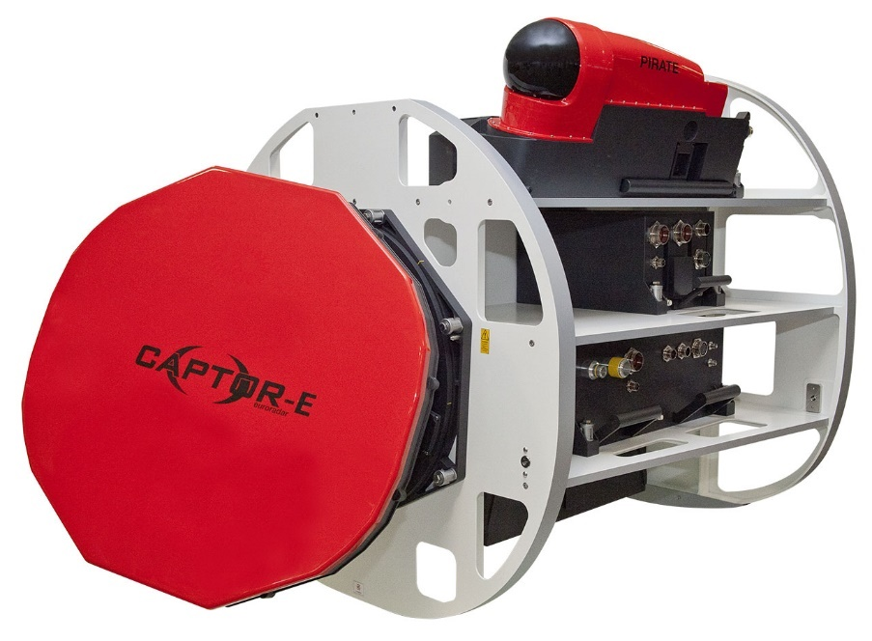
[1]
Figure 43 Leonardo ECRS Radar
Active Electronically Scanned Array (AESA) is now at the peak of radar technological advancements. It uses multiple solid-state transmit/Receive modules. Which allows for independent control giving the ability to generate and control high power radar beams [1].
AESA is also used for tracking multiple targets with high accuracy and power. Older generations only allowed for single tracking capability. Because of AESA’s ability to shape the radar beam it has the benefit of improved clutter migration. (clutter migration is any return from the ground that can mask out targets) [1]. Because of this improvement targets such as drones which could have been masked are now visible targets.
Also, AESA’s ability to adapt waveforms and frequencies makes it difficult for adversaries to jam or deceive the radar using electronic warfare techniques [1].
Artificial intelligence (AI) and machine learning (ML) are playing an increasing role in UAV detection. AI driven radar systems can analyse mass amounts of data to detect anomalies that could be the presence of a UAV. Machine learning patterns trained on UAV flight patterns can enhance detection accuracy and reduce false detections.
These AI/ML are driving development of next generation radar perception however these models require enough data to learn patterns and relationships to make accurate predictions on unseen data and scenarios [6].

Societal and Environmental Impacts
Deploying advanced radar systems has both positive and negative societal and environmental implications. Whilst improved UAV detection will enhance security the construction of these land-based radar sites can have negative environmental impacts. These infrastructures could lead to destruction of ecosystems and habitats. Additionally, with radar installations near coastlines can increase local flood risks posing and increasing amount of challenges for nearby communities.
Despite these concerns, advanced radar technologies are an essential technology for enhancing airspace security and mitigating the ongoing threat of unauthorised UAVs. Ongoing future research should focus on improving radar efficiency and integration with other detection technologies whilst minimising environmental impacts.
Some ethical and privacy concerns could be viewed with using AI based radar systems in civilian areas. These systems could be viewed as intrusive and concerns of using RF near civilians could also raise concerns of medical problems by living near such systems.

Conclusion
Radar technology has evolved significantly since its initial use in the war, with modern advancements enabling more accurate detection of UAV’s. The implementation of different radar types such as AESA, ATR and AI have and will address multiple challenges associated with traditional radar such as small radar cross section and slow-moving targets. These new innovations have strengthened detection capabilities making radar an ever more crucial component in both military and civilian applications.
However, despite these advancements there are still limitations with using AI and machine learning. These require extensive datasets for training to enhance the detection accuracy, whilst at the same time modern radar needs to stay resilient against electronic warfare attacks. Additionally, there are environmental and societal impacts that come with using radar systems and these must be managed and mitigated carefully. With continuous technological innovation, radar will remain as an essential tool in addressing emerging aerial threats and ensuring the safety of our airspace.

References

[1] | Leonardo, “An introduction to digital Active Electronically Scanned Array (AESA) radars,” 2024 April 16. [Online]. Available: https://uk.leonardo.com/en/news-and-stories-detail/-/detail/an-introduction-to-digital-aesa-radars. [Accessed 26 Febuary 2025].
[2] | Editorial, “Evolution of Radar Techonolgy in Drone Detection - Challenges and Solutions,” roboticsbiz, 12 Febuary 2024. [Online]. Available: https://roboticsbiz.com/evolution-of-radar-technology-in-drone-detection-challenges-and-solutions/. [Accessed 26 Febuary 2025].
[3] | D. V, “Drone Detection in Urban Environment,” International Scientific Journal Security and Future, no. 3, pp. 114-116, 2017.
[4] | C. Wolff, “Physical fundamentals of the radar principle,” radartutorial.eu, [Online]. Available: https://www.radartutorial.eu/01.basics/Physical%20fundamentals%20of%20the%20radar%20principle.en.html . [Accessed 2025 March 21].
[5] | RAF Air Defence Radar Museum, “The birth of radar and the second world war,” [Online]. Available: https://www.radarmuseum.co.uk/history/world-war-two/. [Accessed 25 Febuary 2025].
[6] | Ansys, “Simulating Reality: The importance of sythetic data in AI/ML systems for radar applications,” Ansys, 08 Febuary 2023. [Online]. Available: https://www.ansys.com/en-gb/blog/synthetic-data-in-ai-ml-radar-systems. [Accessed 14 March 2025].
[7] | “TemplateLab,” [Online]. Available: https://templatelab.com/cover-page-templates/. [Accessed 01 November 2023].

