Dawid Lagwa

Lab Book

Student Number: 1703488
Course: HND Electronics Engineering
Module: Workshop skills
Module Code: ACDA4001

Table of Content

1. Amplifier Circuit Build
2. How was the breadboard tested
3. Build and PCB Test
4. Screengrabs

1. Amplifier Circuit Build
Breadboard is a solderless device, commonly used to build and test prototype electronics circuits, because the components can be inserted or removed at will. This is allowed by series of terminals (holes) which are interconnected in horizontal lines at middle section of the board and vertical connections on outer portion of the board. Populating the board is simple task as it requires no soldering and several wire connections were applicable.

Amplifier is a integrated circuit but it still requires to be connected to the circuit it’s being used in to function. To put simply is a electronic device used to amplify amplitude of electronic signals, this device most commonly in sound systems such as: loud speakers.

Recently I have designed a Operational Amplifier on a Proteus Software before prototyping it on a breadboard. Reason for this was to check if the circuit works as it should outside of a electronic environment. Function of the Operational Amplifier is to amplify a weak electronic signal and output a stronger signal. When tested on the breadboard the circuit worked correctly. Allowing me to move the diagram to Easy-PC software which is used to design Printed Circuit Board (PCB) schematics which are in turn used to build a physical PCB.

2. How was the breadboard tested
While the circuit was designed on Proteus it underwent two tests to ensure it worked correctly before being prototyped on a breadboard. First test was simple simulation to see if the circuit as a whole functioned second test it underwent was with electronic oscilloscope to see if it amplified a weak signal into a strong one. The circuit once again underwent testing in prototype stage of the development. The breadboard was connected to a virtual oscilloscope to see if the signal was being amplified in a physical world.

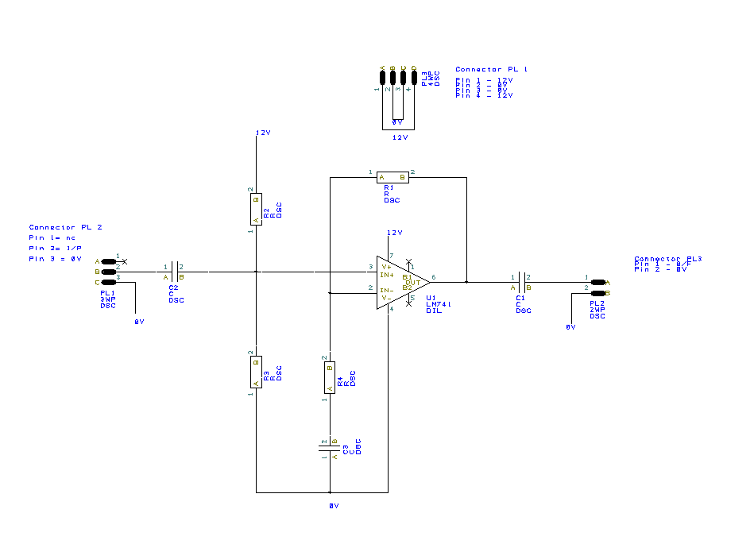
On this image you can see a circuit diagram created in Easy-PC. As seen on the diagram each component is connected to each other. First set of components that I am going to talk about is: Connector 2, C2, R2, R3, 12V power line and 741 OpAmp chip.

Connector 2 serves as two things in the circuit one is a ground and second one is a input.
Other components in this set will prevent or make overloading of the chip less likely.

Second set consists of R1, R4, C3 and 0v line which serves as an additional grounding for the circuit. Purpose of R1, R4 and C3 is to create something known as feedback loop which has task of controlling the output of this electronic device.

Last set of components its C1 and Connector 3 which form the output of this circuit.

3. Build and PCB Test
After creating the artwork for Bottom and Top layers of the PCB it was sent away to be created. When it arrived I have populated the board with necessary components and tested it to see if it worked. My testing shown that I was working but not correctly as I have installed capacitors wrong way on the board. I also have worked out Bandwidth gain created by this circuit and the result was 9.06 MHz

4. Screen grabs

