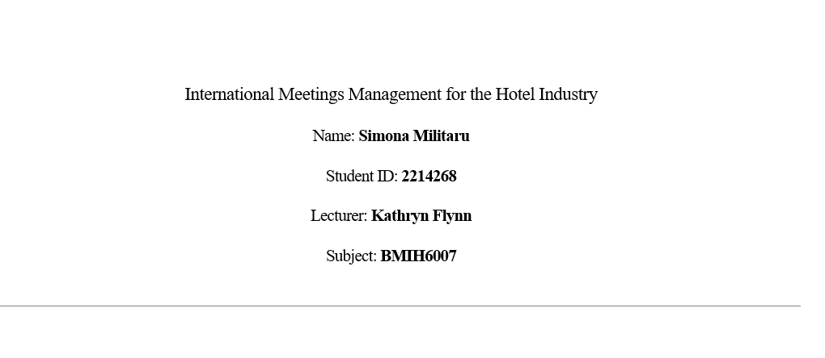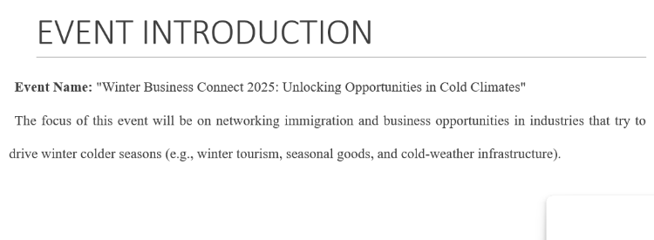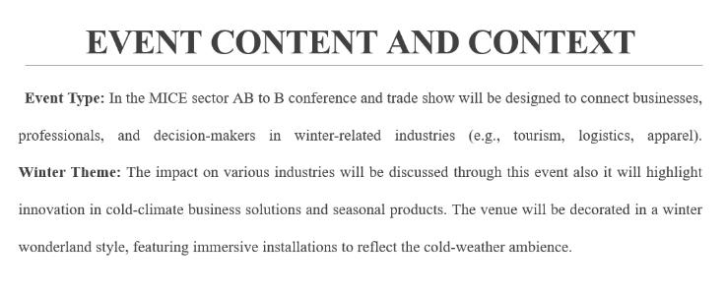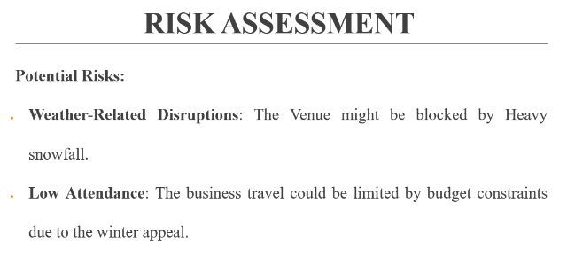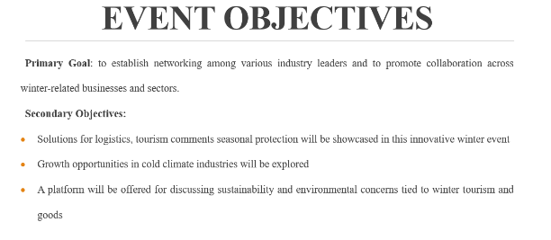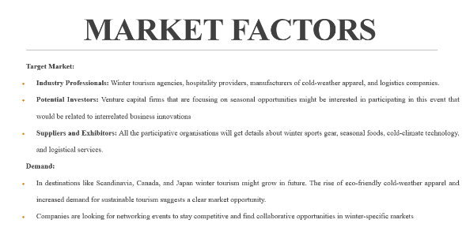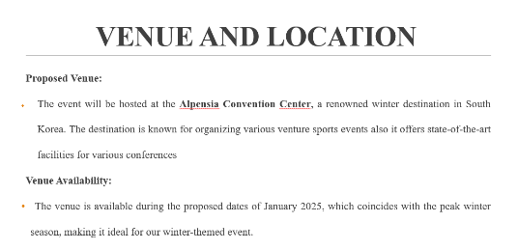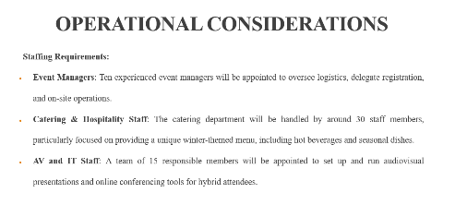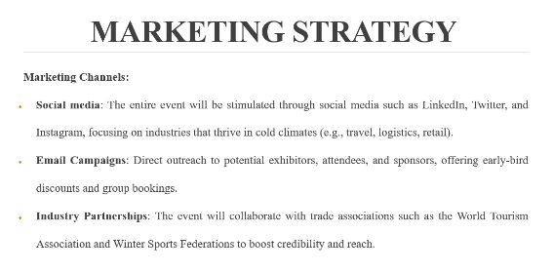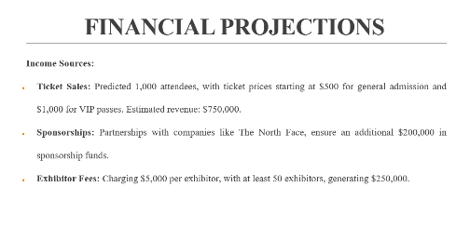

References
Allen, J., O'Toole, W., McDonnell, I., & Harris, R. (2017). Festival and special event management (6th ed.). Wiley.
Anand, A., Centobelli, P., & Cerchione, R. (2020). Why should I share knowledge with others? A review-based framework on events leading to knowledge hiding. Journal of Organizational Change Management, 33(2), 379-399.
Anufrieva, N. I., Tsarev, D. V., Gribkova, G. I., Medved, E. I., & Kiseleva, O. I. (2021). Increasing university students' organizational skills during practical application of event management technologies in organizing events. Revista Tempos e Espaços em Educação, 14(33), 1-12.
Bladen, C., Kennell, J., Abson, E., & Wilde, N. (2018). Events management: An introduction (2nd ed.). Routledge.
Bladen, C., Kennell, J., Abson, E., & Wilde, N. (2018). Events management: An introduction (2nd ed.). Routledge.
Bowdin, G. A. J., Allen, J., O'Toole, W., Harris, R., & McDonnell, I. (2022). Events management (5th ed.). Routledge.
Bowdin, G. A. J., Allen, J., O'Toole, W., Harris, R., & McDonnell, I. (2022). Events management (5th ed.). Routledge.
Getz, D., & Page, S. J. (2020). Event studies: Theory, research, and policy for planned events (4th ed.). Routledge.
Getz, D., & Page, S. J. (2020). Event studies: Theory, research, and policy for planned events (4th ed.). Routledge.
Hickman, E., Kharouf, H., Biscaia, R., & Garcia-Perez, A. (2020). Understanding online event experience: The importance of communication, engagement, and interaction. Journal of Convention & Event Tourism, 21(3), 202-222.
Lee, S., & Goldblatt, J. (2020). Special events: The brave new world for bolder and better live events (8th ed.). John Wiley & Sons.
Lee, S., & Goldblatt, J. (2020). Special events: The brave new world for bolder and better live events (8th ed.). John Wiley & Sons.
Nolan, E. (2020). The supply and design of different types of venues for business events. International Journal of Tourism Cities, 6(4), 691-710.
Nolan, E. (2020). The supply and design of different types of venues for business events. International Journal of Tourism Cities, 6(4), 691-710.
Rogers, T. (2021). Conferences and conventions: A global industry (4th ed.). Routledge.
Shone, A., & Parry, B. (2019). Successful event management: A practical handbook (5th ed.). Cengage Learning.
Shone, A., & Parry, B. (2019). Successful event management: A practical handbook (5th ed.). Cengage Learning.
Silvers, J. R. (2020). Risk management for meetings and events (2nd ed.). Routledge.
Silvers, J. R. (2020). Risk management for meetings and events (2nd ed.). Routledge
Talib, M. H. B. A., Zamzuri, N. H., & Nasir, H. M. (2024). A conceptual discussion related to festival events in Malaysia. Information Management and Business Review, 16(3), 7-12.
Thomas, K., & Stephens, S. (2022). Understanding the management theory in event management: A conceptual framework. SSRN. https://doi.org/10.2139/ssrn.4051469
Yeoman, I., Robertson, M., & McMahon-Beattie, U. (2019). Festival and events management: An international arts and culture perspective (2nd ed.). Routledge.



