UWTSD: Remote Sensing and Imaging
Name: Andrew R Hurley Jnr
Student No. 1906810
Date: 15/12/2023
Module: M6X00945
Lecturer: Dr. Nik Whitehead
Assignment Title: Part 2a – Imaging and Sensing Notes

Contents
1 Contents 2
2 Introduction 3
2.1 Location 3
2.2 Ground and Soil 3
3 Equipment 3
3.1 Spot the dog 3
3.2 DJI Mavic 2 3
3.3 Google Pixel 7a 3
4 Task 3
4.1 Minesweeper 3
5 The area 4
5.1 Google maps 4
5.2 Pixel 7a Photos 5
6 Locating the mines 8
6.1 Mavic 2 8
6.2 Pixel 7a 13
7 Discussion 18
7.1 Mavic Drone 18
7.2 Spot the Dog 18
8 Conclusion 18

Introduction

Location

Located approximately 51°36'58.1"N 3°55'38.6"W, an unkept, unmanaged privately owned section of land adjoins the UWTSD Swansea IQ campus. This land is coastal, protected by a sea wall [1] and rock armour [2] sea defences positioned predominantly southward toward an estury.

Ground and Soil

Due to the derelict nature of this land, the ground has varied conditions, including patches of bare earth, compacted soil, scattered debris, and abandoned materials. Common soil types within the coastal Swansea areas are loamy and clay-based soils which retain moisture and nutrients better than the equally local sandy soils nearer to the shores.

During the scouting and imaging of the area multiple locations of standing water were noted visually along with long grass, short grass, common weeds, and small shrubs.

Equipment

Spot the dog

Spot the Dog, a Quad-pedal operator-controlled robot (Boston Dynamics – MK IV), demonstrates the capability of self-correcting transit. It is equipped with a forward-mounted top arm and an Aft-mounted thermal IR camera fitted onto the top rail. Additionally, standard visual cameras are positioned both at the forward and aft of the robot, accessible through the operator's handset screen.

DJI Mavic 2

The DJI Mavic 2 functions as a compact drone operated via a controller and phone screen plugin for real-time visual output. It boasts an IR and 4K camera, both mounted on a gimbal for remote operation in tandem with the drone's movement. Its operational range extends to long distances, up to 5 miles away from the operator, facilitated by an integrated auto-homing feature.

Google Pixel 7a

The Google Pixel 7a smartphone hosts three accessible cameras: a 64MP Quad Bayer Wide camera, a 13MP Ultrawide camera, and a 13MP fixed focus camera. Images captured using the Pixel 7a leverage GPS, GLONASS, Galileo, QZSS, and BeiDou satellite systems to embed coordinate data, date, and time information within each photo for precise location tagging.

Task

Minesweeper

Mines planted in prior conflicts whether on land or in sea, pose a significant risk to civilian populations, military personnel and wildlife. With a potential to explode when disturbed, causing injury, death and damage to infrastructure; de-mining activities are vital to the continued safety for many all over the world.

Current methods for mine marking and mine clearance involves the use of manned expeditions to carefully find locations of minefields and mark up mines found via the use of metal detectors and animals trained on scent. These options involve risking harm on living beings and increased risk to exposing the environment to harmful chemicals.

To mitigate this risk, utilising the Mavic 2, Spot the dog and Pixel 7a, there is potential to image the area and mark potential hazard sites accurately without increased risk to human life and environment.

The area

Google maps

Figure 1 - Screenshot of aerial imaging over "minefield"
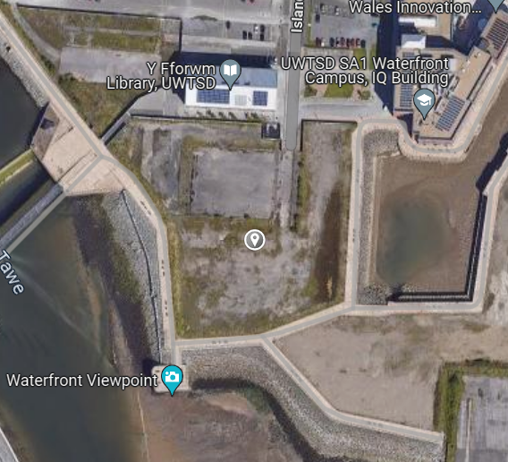
N

Pixel 7a Photos

Figure 2 – Panorama from ground platform
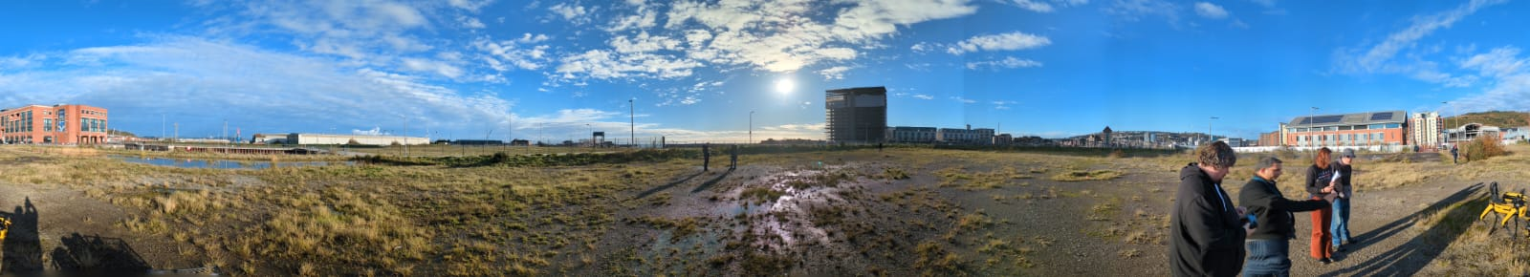

Figure 3 – Southwest corner, looking east
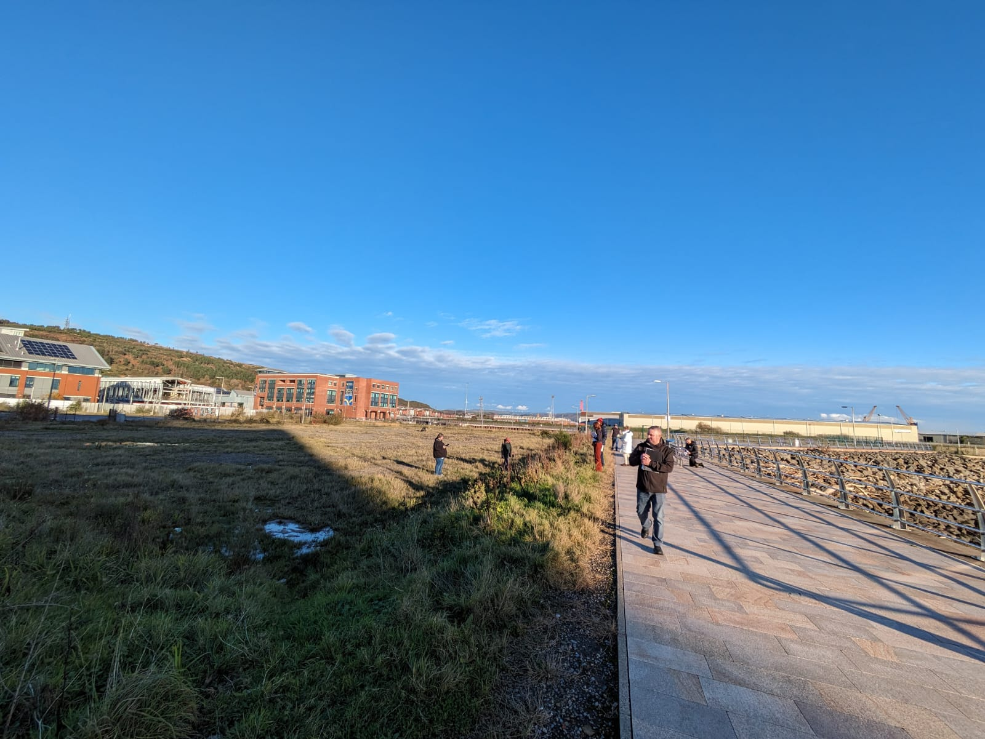

Figure 4 – Southwest corner, looking north
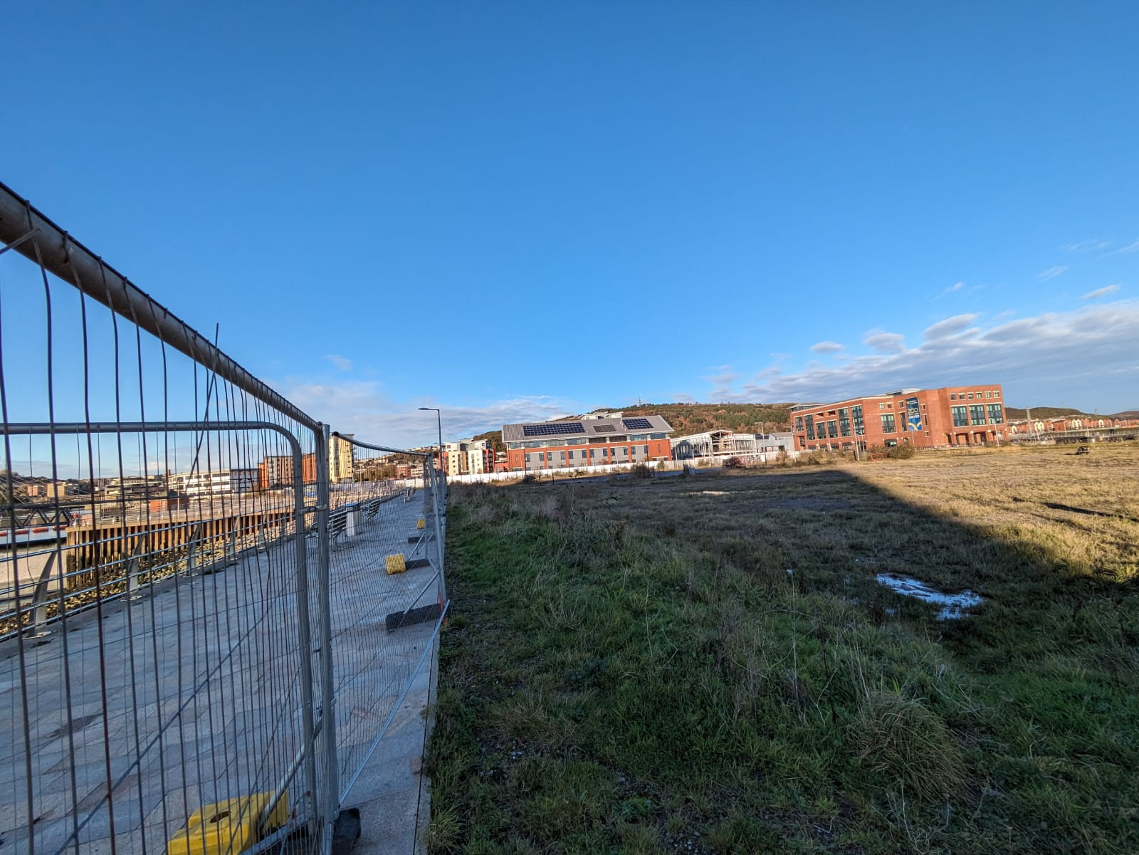

Figure 5 – Southeast corner, looking west
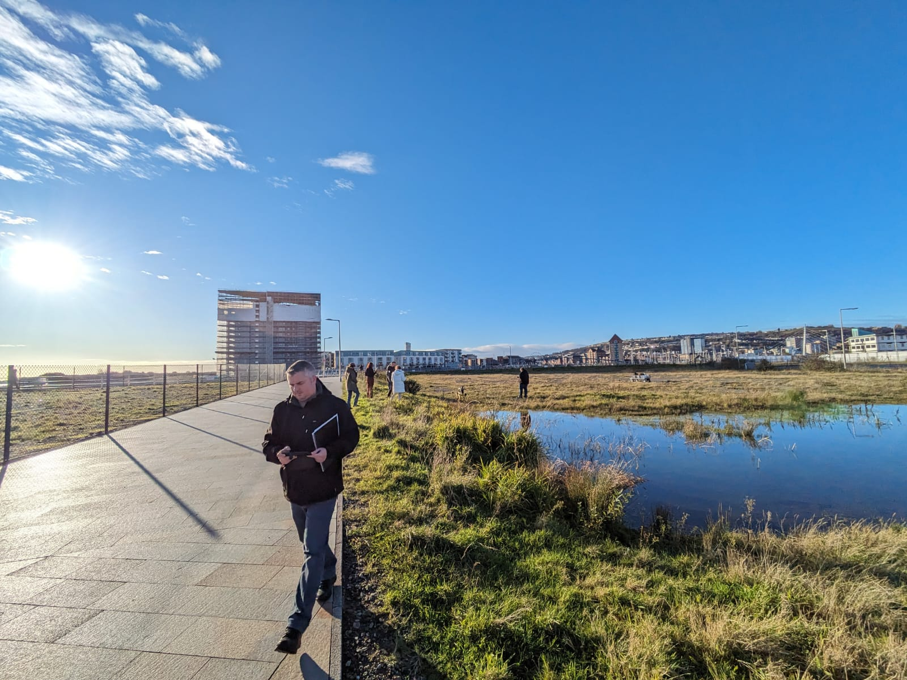

Figure 5 – Southeast corner, looking north
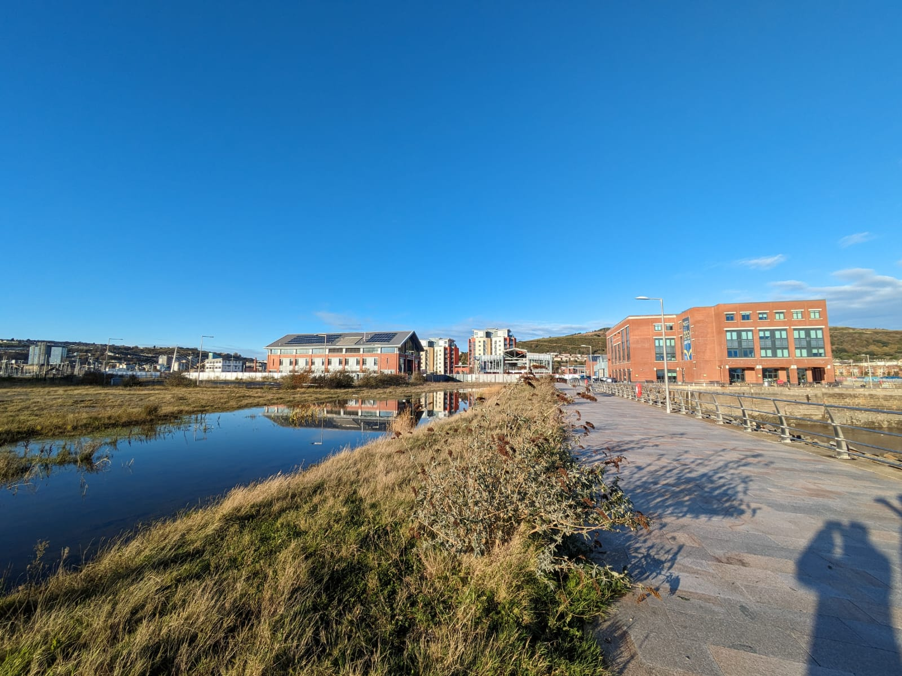

Figure 6 – Northeast corner, looking southwest
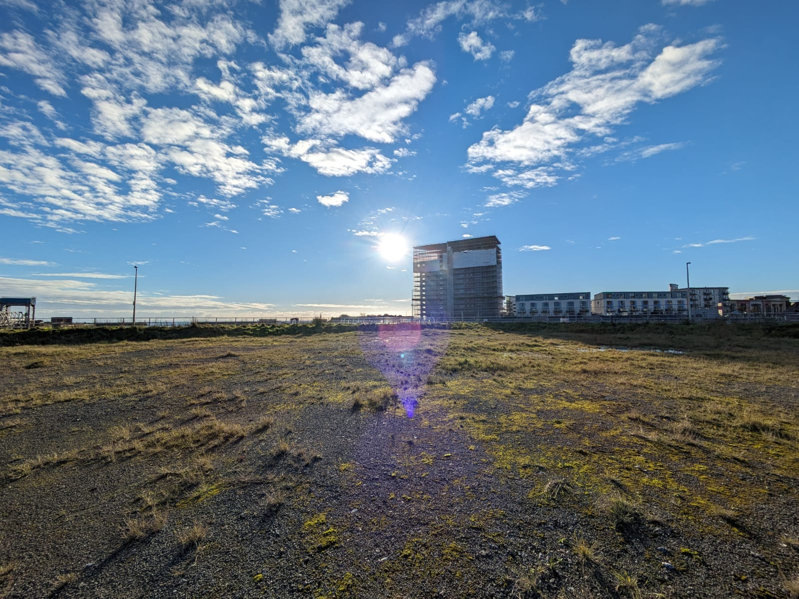

Figure 7 – Northwest corner, looking southeast
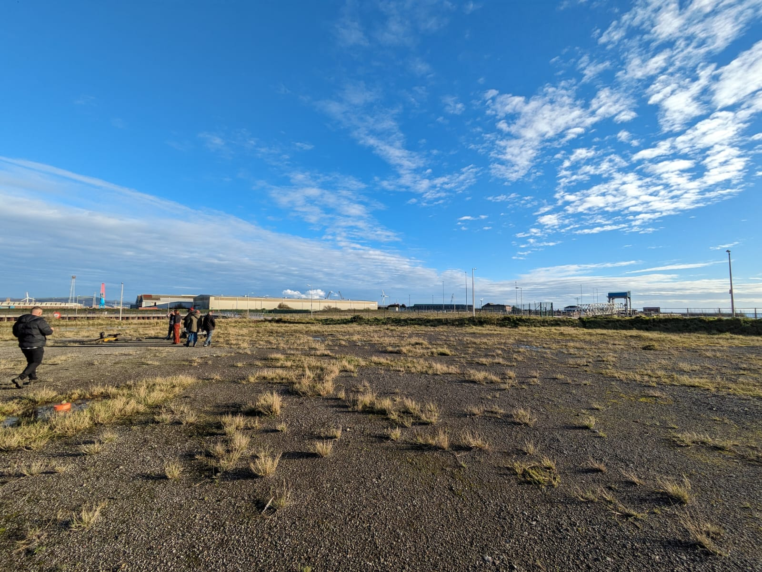

Locating the mines

Mavic 2

The Mavic 2, equipped with thermal and visual cameras began with a perimeter path of the area taking 20meter resolution shots before then taking a grid-line path across the internal area. The visual camera should be able to be used to locate the orange landmines whilst the thermal should be able to be used to locate the could external diameter of the mine with the warmer internal pocket of the mine.

Figure 8 – Perimeter shot, Southwest corner (top is due east)
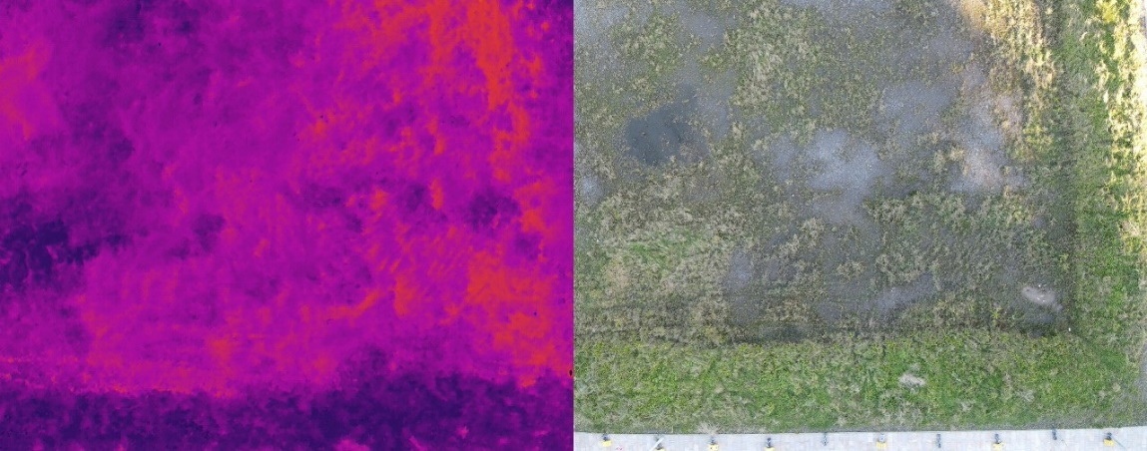

Figure 9 – Perimeter shot, South perimeter (top is due east)
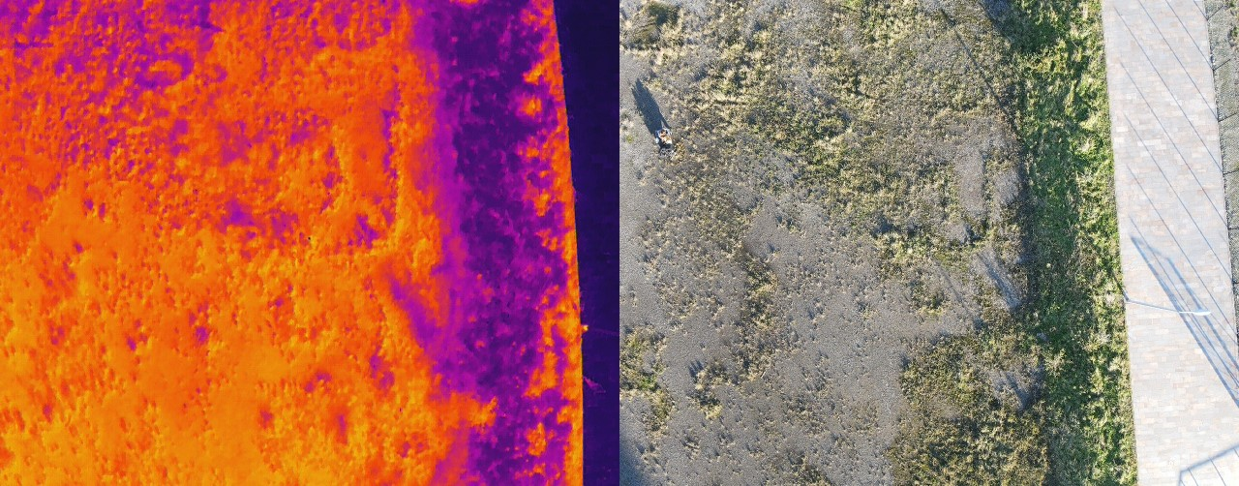

Figure 10 – Perimeter shot, Southeast corner, (top is due east)
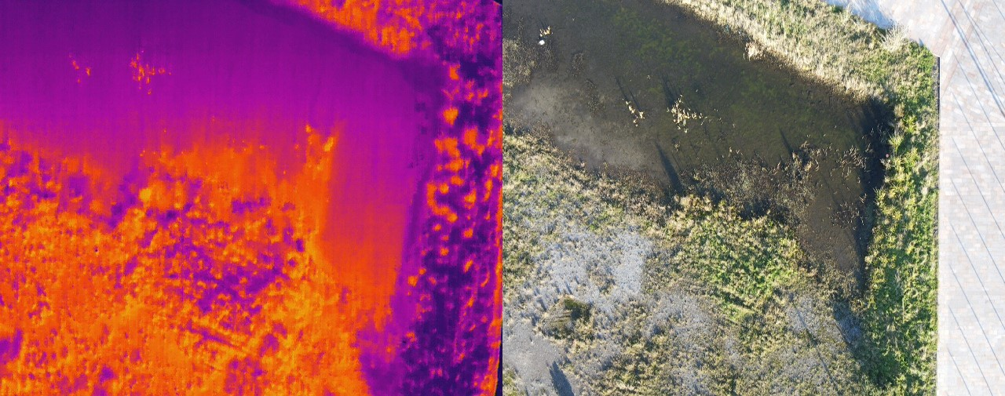

Figure 11 – Perimeter shot, East perimeter (top is due west)
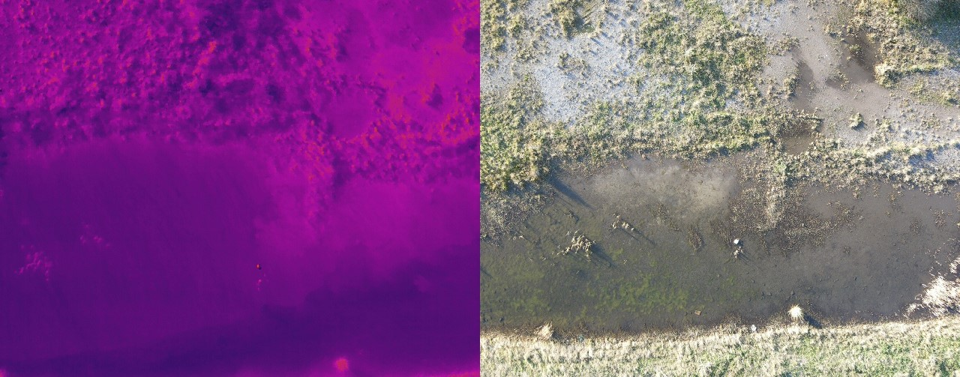

Figure 12 – Perimeter shot, Northeast corner (top is due west)
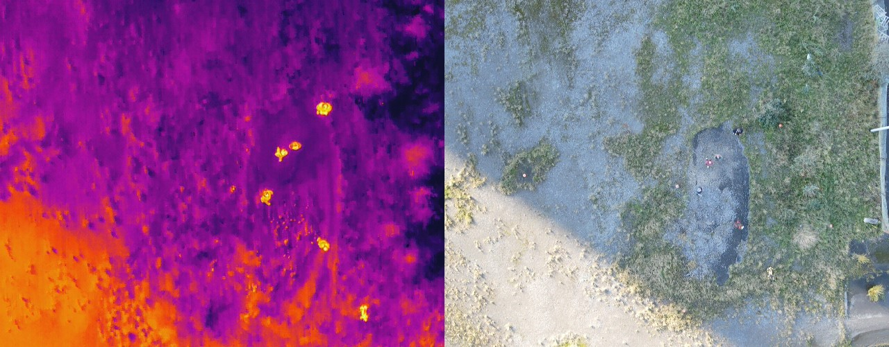

Figure 13 – Perimeter shot, North perimeter (top is due west)
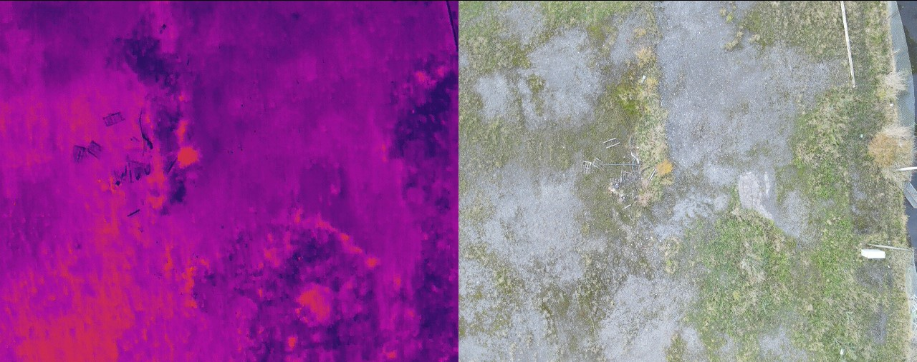

Figure 14 – Perimeter shot, Northwest corner (top is due west)
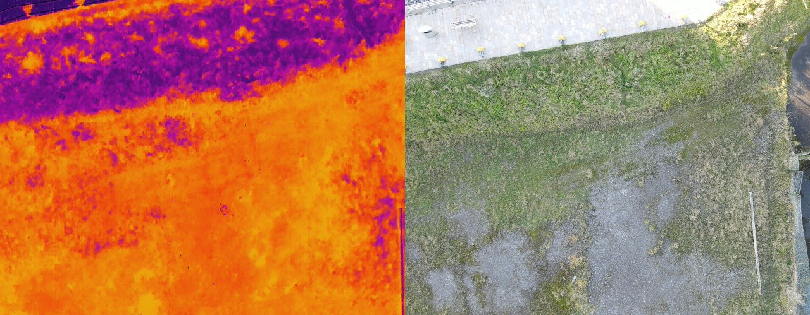

Figure 15 – Visual and Thermal mine spot image (1)
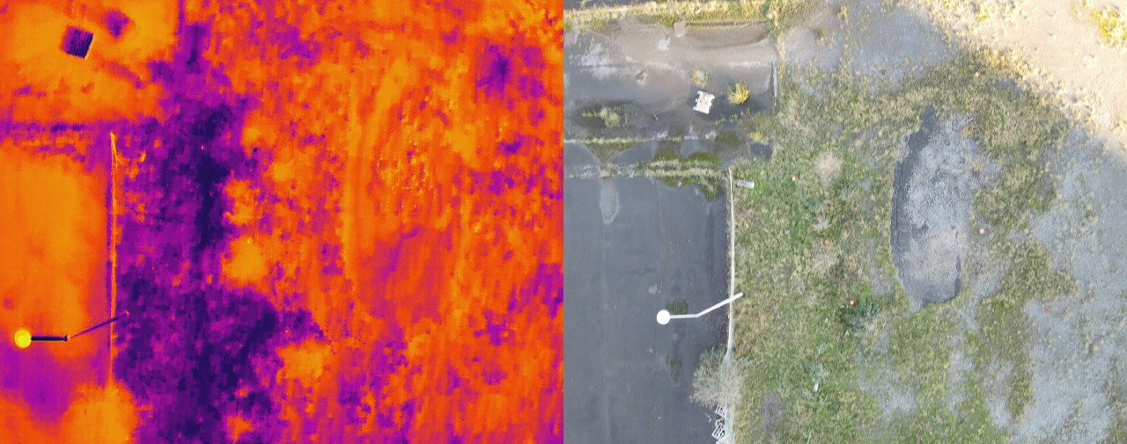

Figure 16 – Visual and Thermal mine spot image (2)
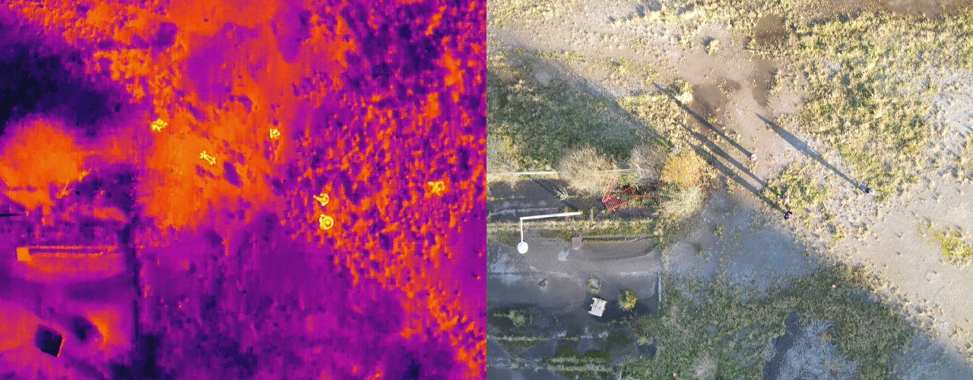

Figure 17 – Visual and Thermal mine spot image (3)
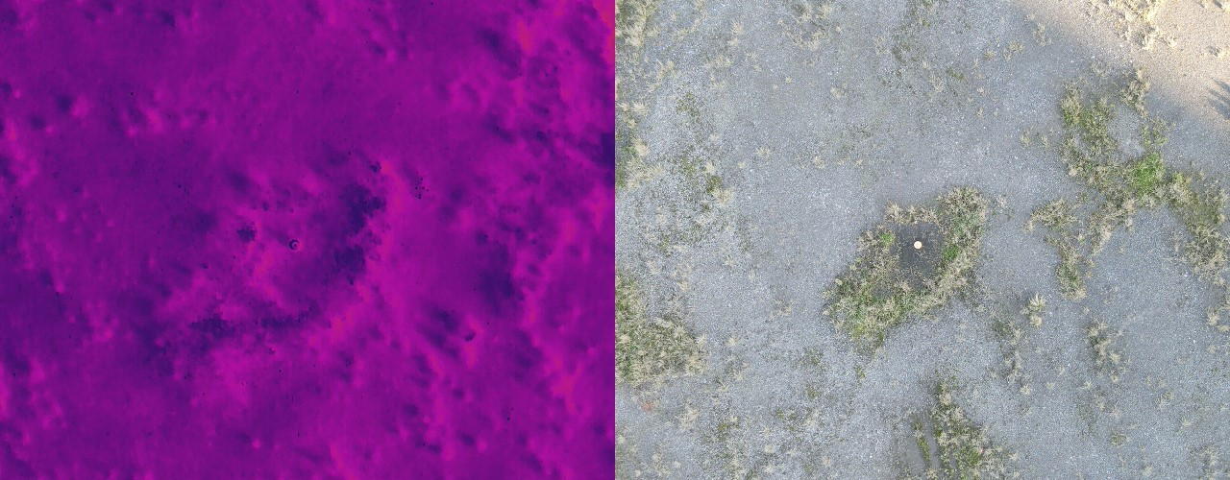

Figure 18 – Visual and Thermal mine spot image (4)
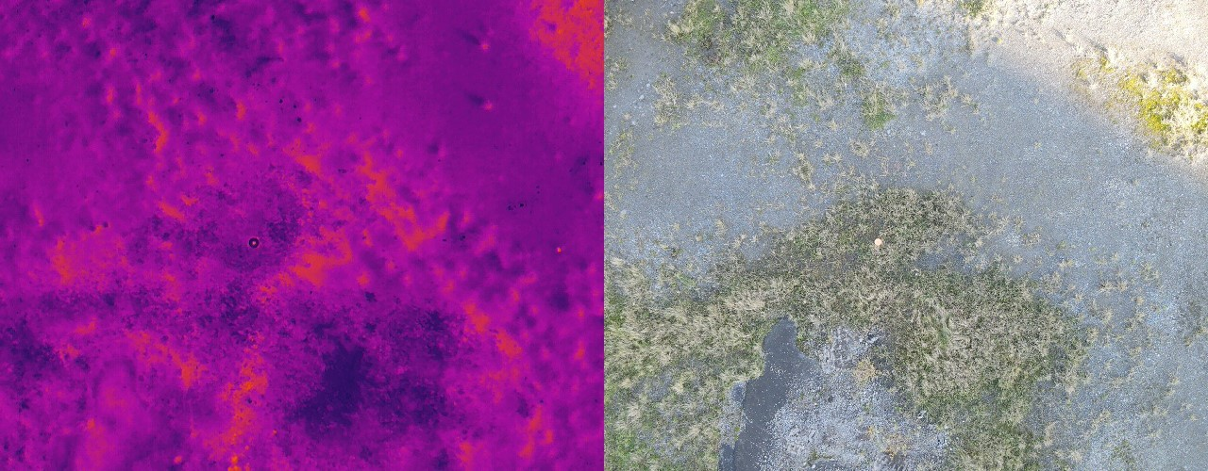

Figure 19 – Visual and Thermal mine spot image (5)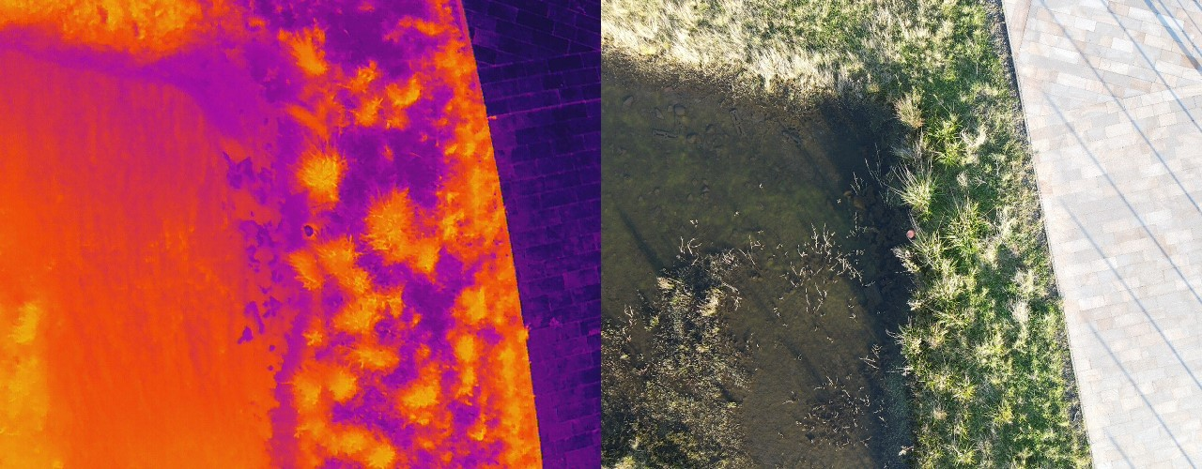

Figure 20 – Visual and Thermal mine spot image (6)
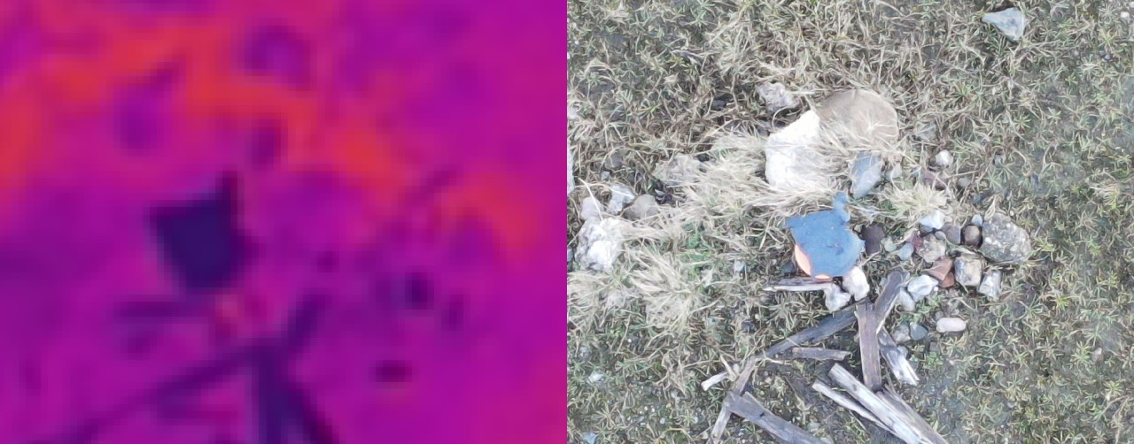

Pixel 7a

Using the current method of searching for mines, taking the area, and splitting into 5m wide lanes to walk down carefully, many mines were located purely visually and recorded via photograph with coordinates electronically attached to the image.

Figure 21 – Photograph of landmine (1) 51.616989, -3.927567
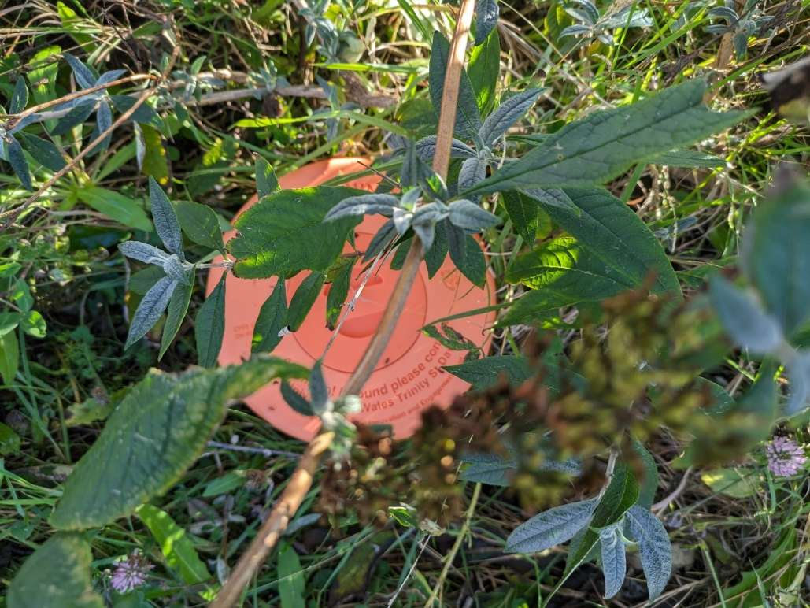

Figure 22 – Photograph of landmine (2) 51.616989, -3.927567
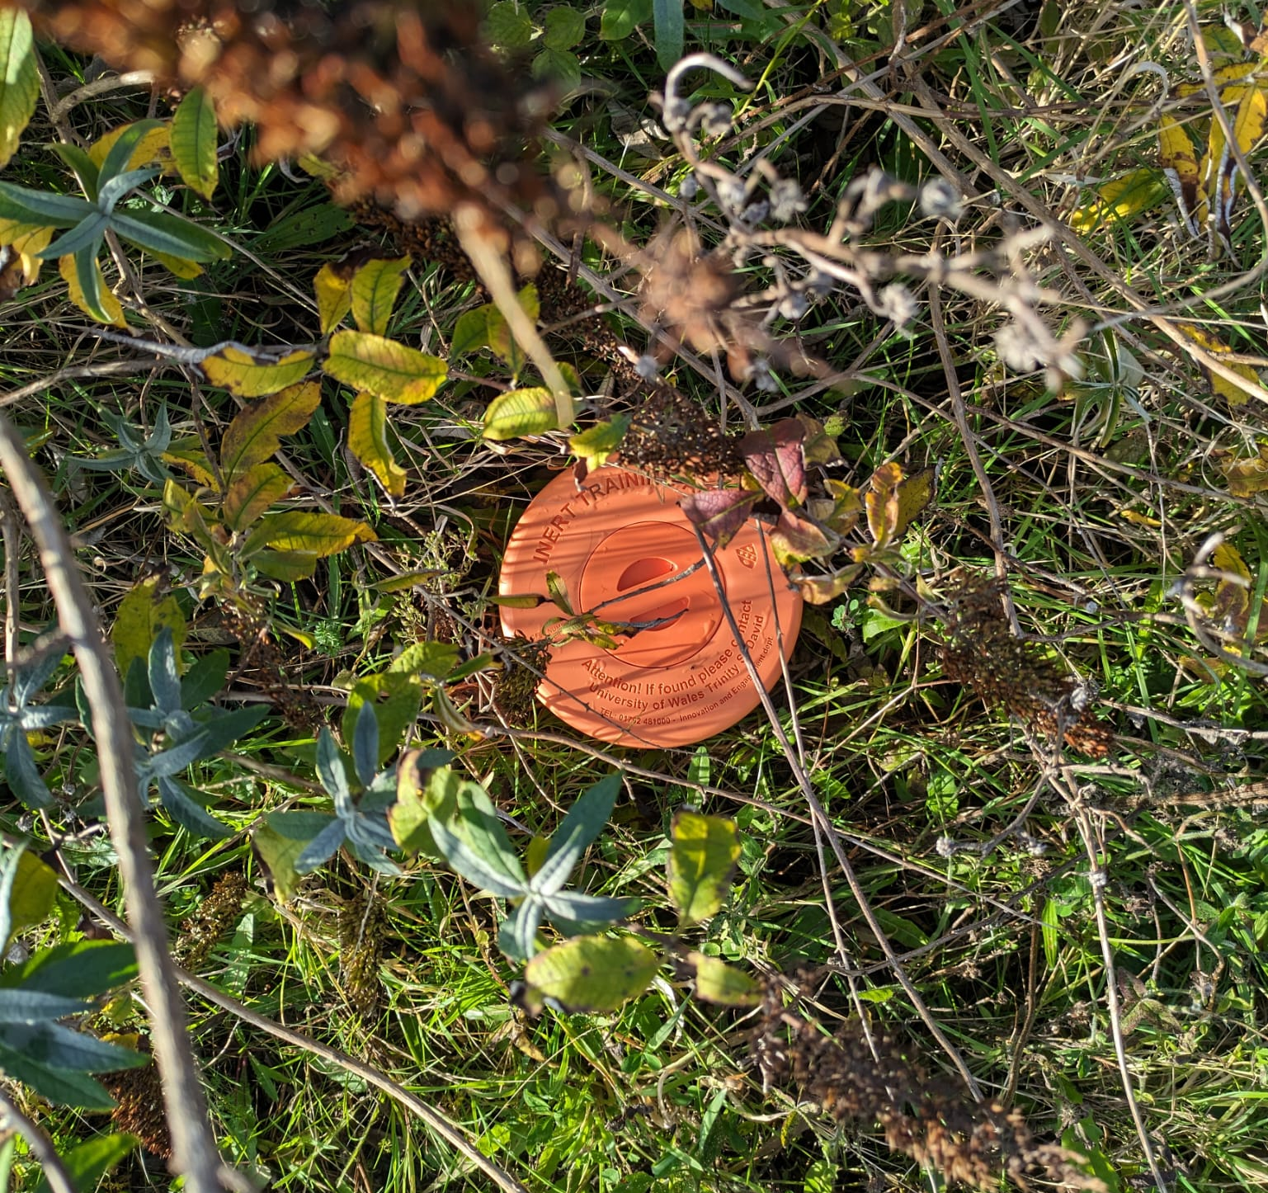

Figure 23 – Photograph of landmine (3) 51.616989, -3.927567
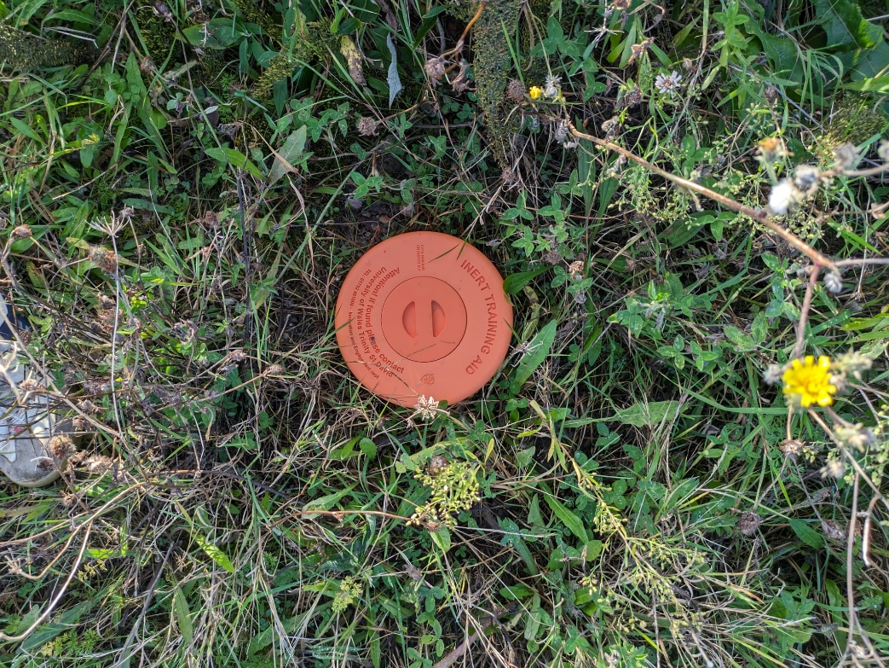

Figure 24 – Photograph of landmine (4) 51.616944, -3.927131
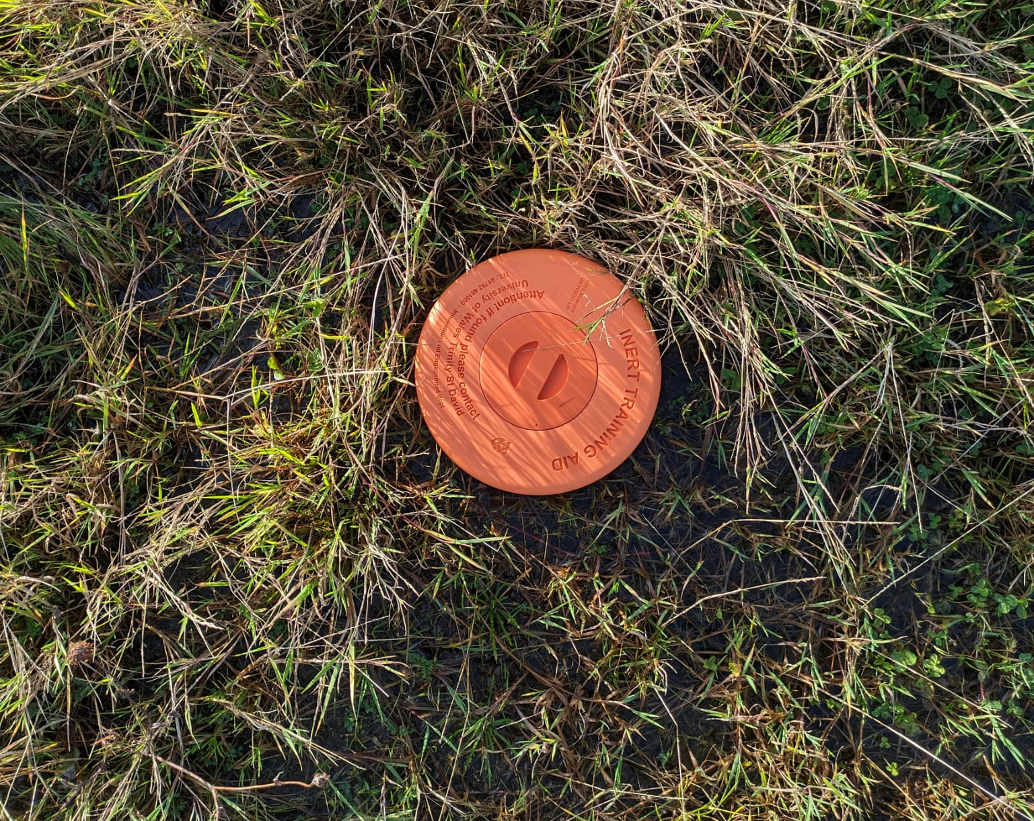

Figure 25 – Photograph of landmine (5) 51.616944, -3.927131
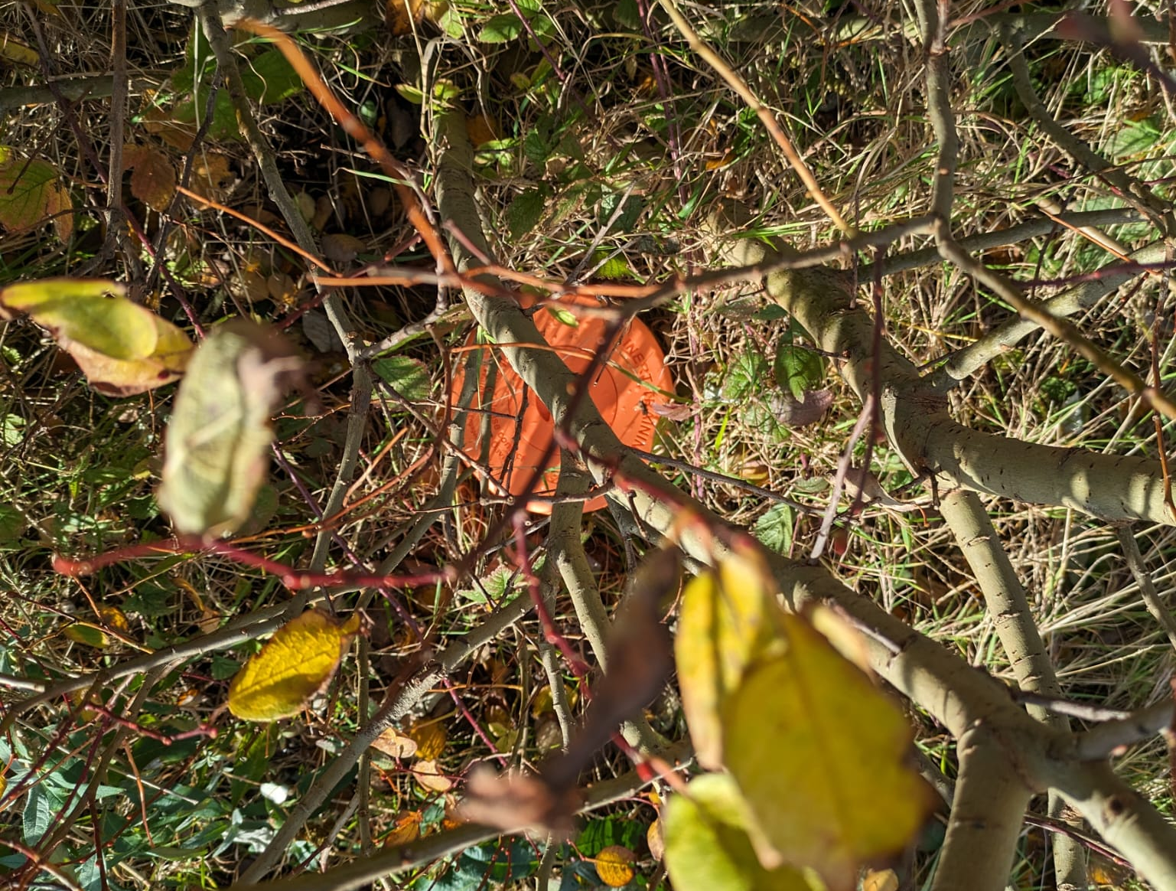

Figure 26 – Photograph of landmine (6) 51.616158, -3.927503
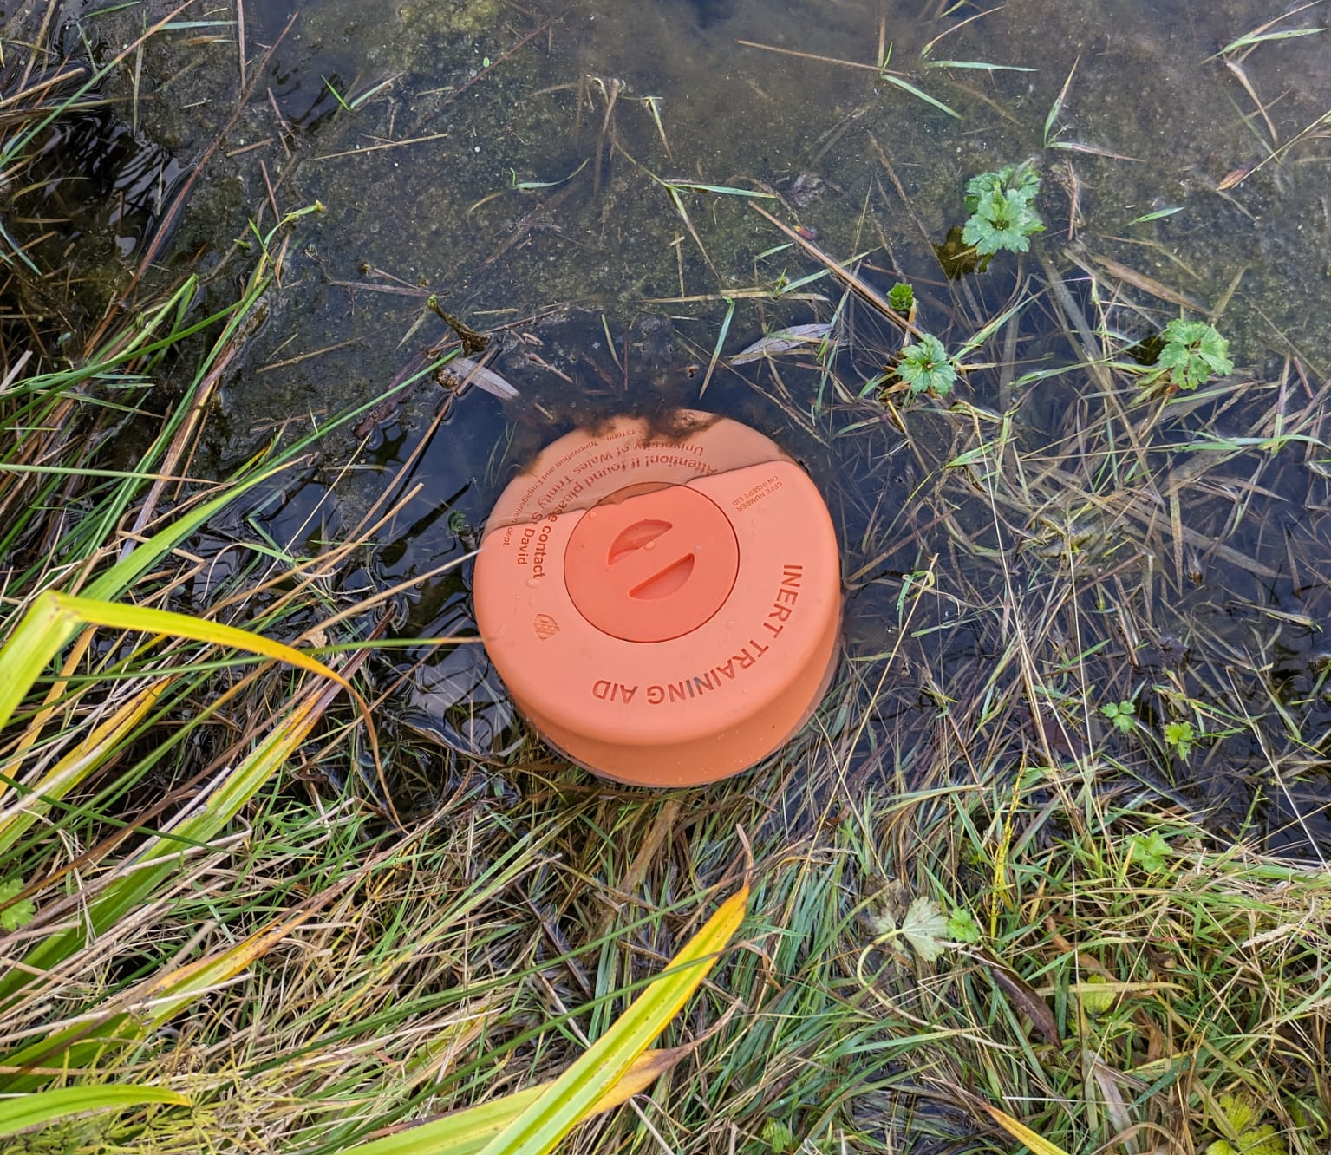

Figure 27 – Photograph of landmine (7) 51.616158, -3.927503
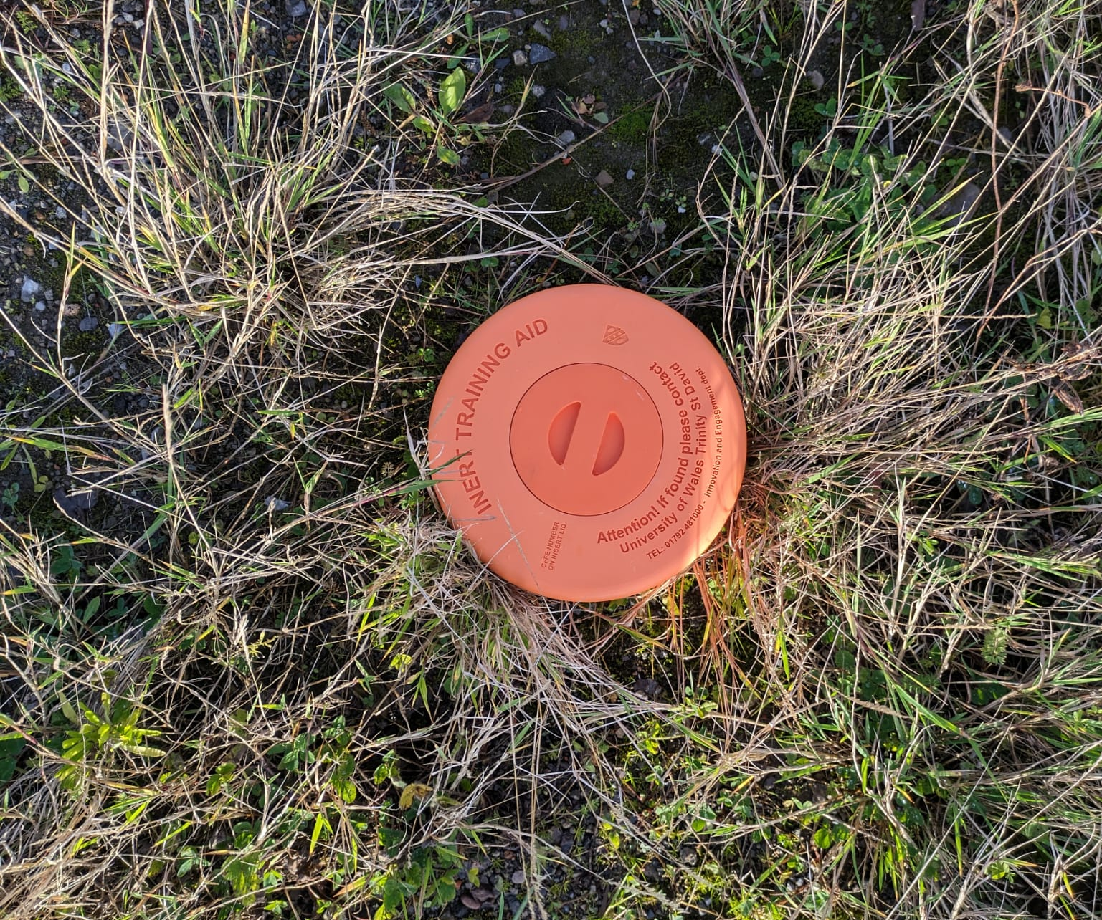

Figure 28 – Photograph of landmine (8) 51.616158, -3.927503
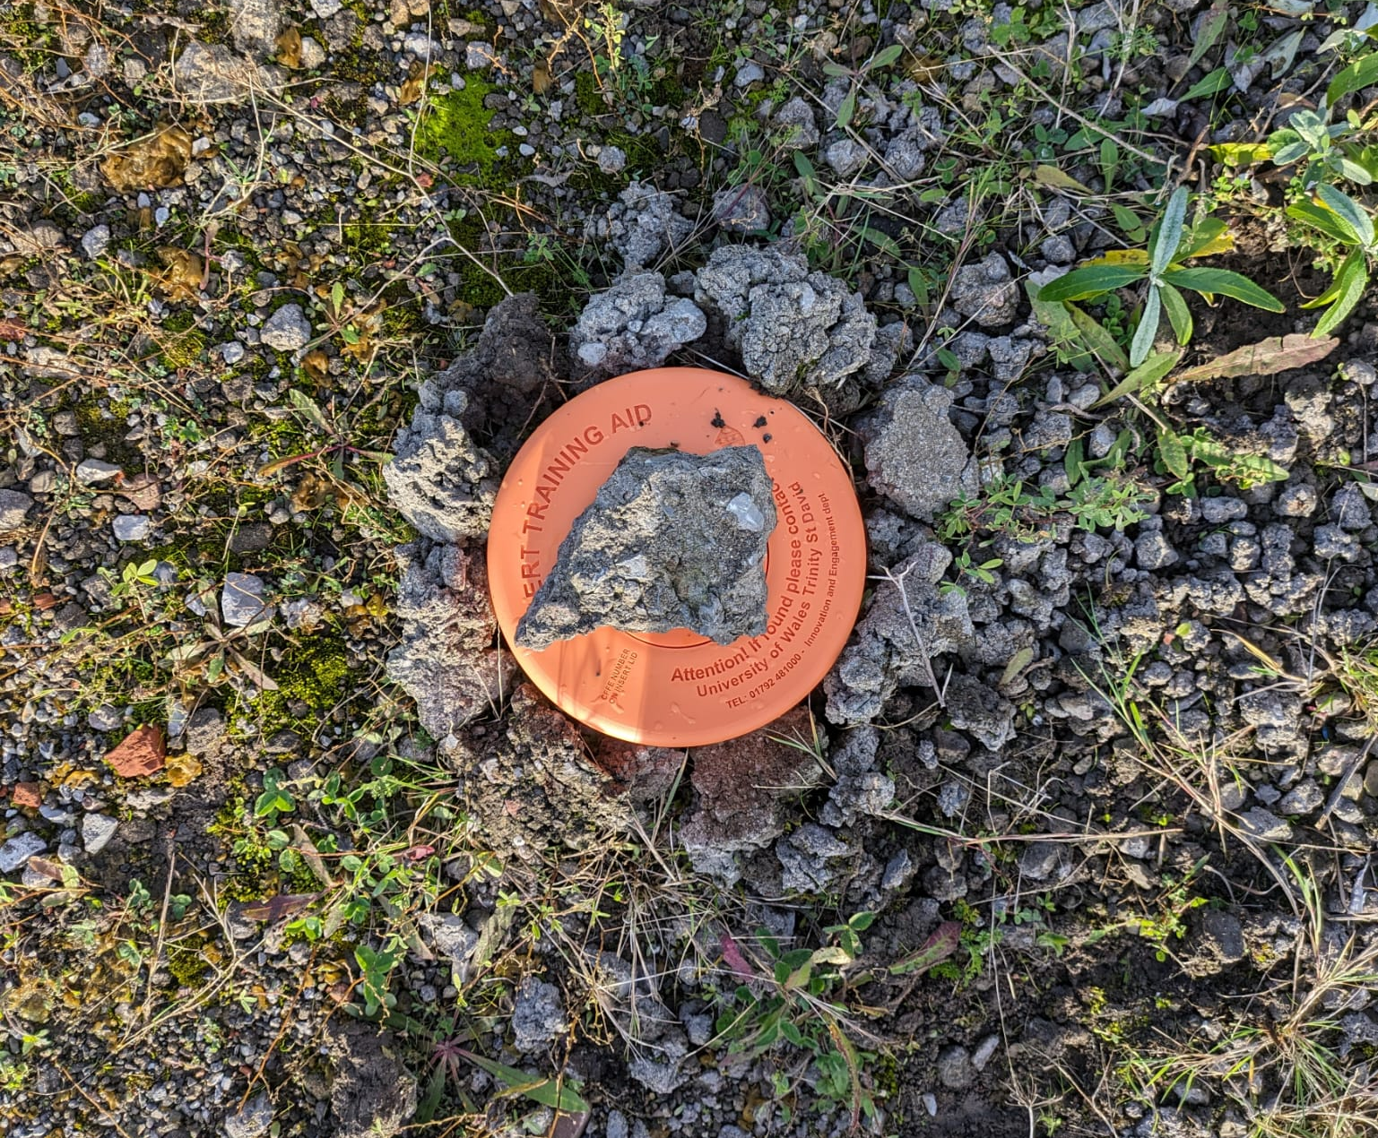

Figure 29 – Photograph of landmine (9) 51.616789, -3.927633
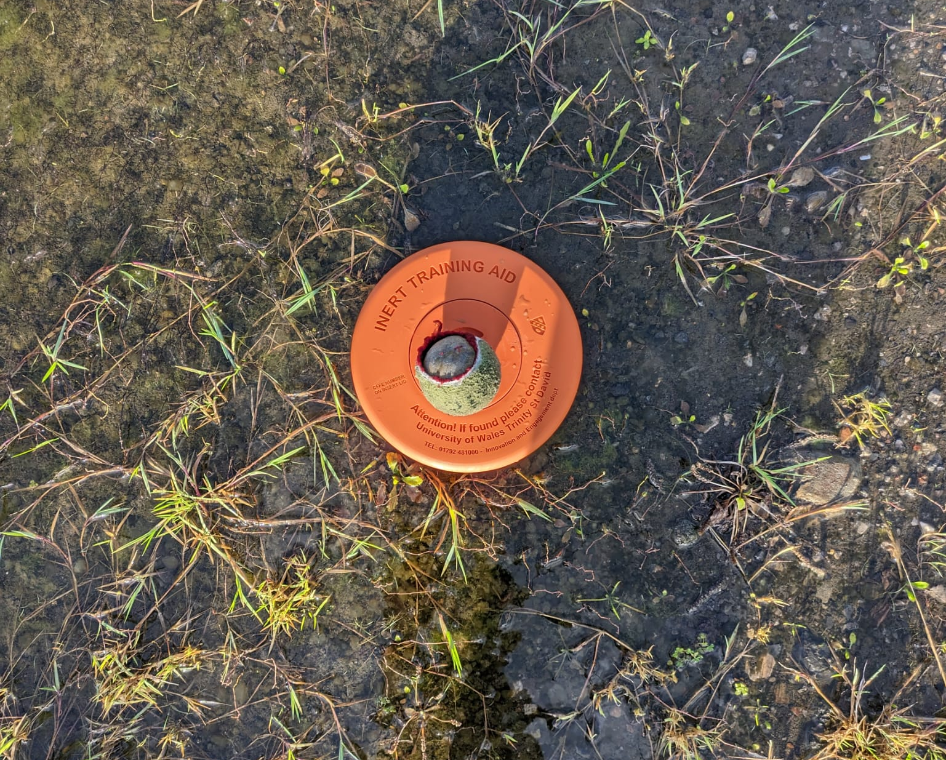

Figure 30 – Photograph of landmine (10) 51.616961, -3.927767
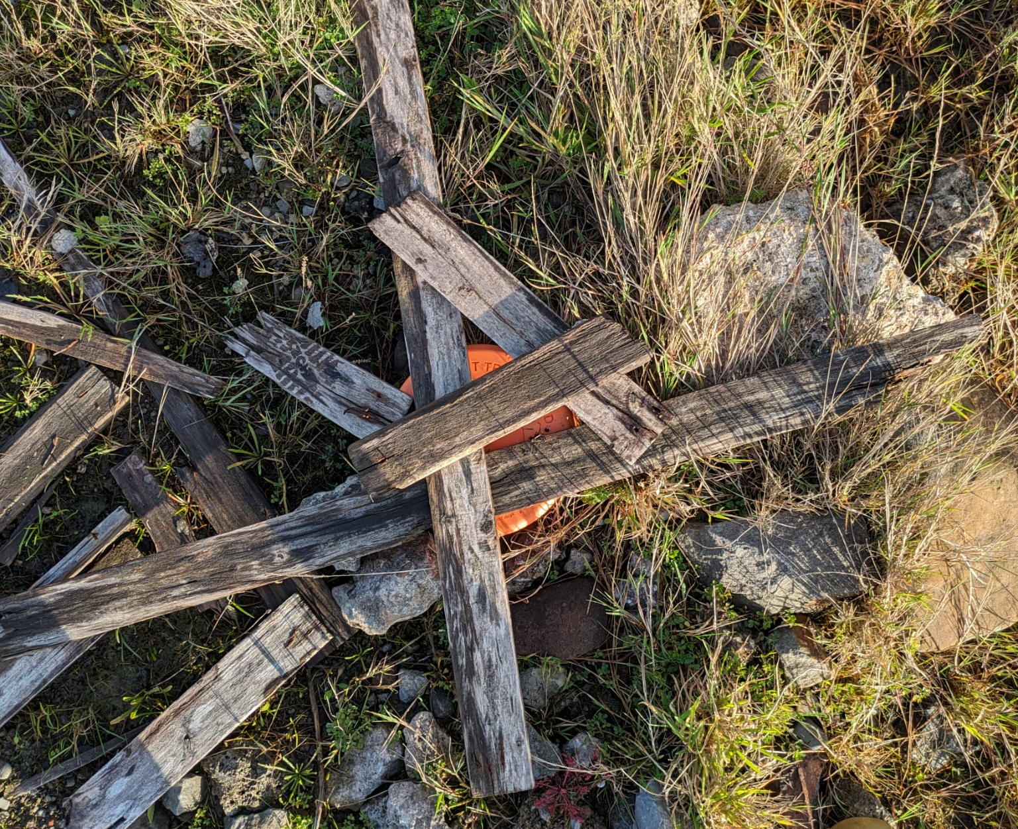

Discussion

Mavic Drone

Using both Visual and Thermal camera it was expected to easily spot the heat signatures of the hot core within the Landmine and the ambient exterior, however as seen within most figures in 6.1, the items are easier to spot on visual due to their being out in the open and bright in colour. This led to them often being spotted first on visual then later thermal imaging.

Of special note, figure 20 shows the importance of using more than one system as when covered with debris, there is zero imaging to show for the mine hidden beneath, this is where utilising the more specific search of spot the dog would be useful to unearth the mine or look for a better image angle.

In total there were 12 landmines to find, using all three systems only 10 were found on the first run, most through visual identification. However, figure 15 is representative to what would be the desired outcome as the thermal and visual cameras together provide locations for 4 landmines without the need to human intervention.

Spot the Dog

While having to data from Spot the Dog to place into the results at this time, there are some major issues that must be overcome before efficient use of Spot is possible.

The range of the dog from controller is only 20m this would require the handler to be in a hazardous environment to communicate with Spot.

Spot while autonomous in self-corrected motion, still required human intervention to right itself after falling, getting stuck and getting lost on more than one occasion. Spot would only be ideal in flat un-obstructed terrain such as the central area of the minefield as this did not have water, long grass, shrubs and hills to contest with.

Spots thermal imaging camera mounted to the rear, has a roll cage that completely obscures the camera when looking directly behind (180º line)

Conclusion

Not all 12 mines were located proving that the equipment provided was not perfected yet to acquire the location of thermal objects especially when hidden or left to cool.

There is promise with the use of the Mavic drone especially when in use with previous data to compare and look for changes to the environment.

Spot the dog is not yet ideal for mine locating or disposal. Greater controller range, improved roll-cage design and terrain control are needed at minimum to be a potential contender in the industry.

