Elfen 2 Log adfyfyriol – Element 2 Reflective log
Disgrifiad byr o’r gweithgaredd (dim mwy na 50 o eiriau
Brief description of the activity (no more than 50 words)
A group activity of 12 children taking part in an assault course, which involves throwing bean bags into hoops, balancing on beams, jumping two feet together onto big dots, balancing bean bag on head while walking.
To develop their gross and fine motor skills they promote balance and co-ordination skills through the movements of the activity.(Gov,Wales 2018), (Drew 2006).
Nod/Amcan y gweithgaredd Aim/Objective of the activity
Improve coordination and learn how to control their movement when taking part in the activity. Learn balancing skills in an upright manoeuvre, while moving steadily and safely (Gov.Wales 2018).
Jump keeping their two feet together (Drew 2006).
Children need to be made aware and to be encouraged to develop caring and sharing skills within the activities by being mindful and supportive of others.(Gov.Wales2018), (Drew 2006).
Eich rôl chi Your role
To lead a planned activity (Dewey 1933) believes that planned activities is beneficial to children’s educational development (Allen and Gordon 2017).
My role is to give the children the opportunity to develop gross and fine motor skills through the areas of learning, to allow the children to challenge themselves and get motivated.
(Gov.Wales 2018).
Rules were set out for children and the elements of the activity, and how to keep themselves safe throughout this was followed by (Gov.Wales 2018).
Build on confidence before the activity by allowing time for practice skills before-hand (Brunner 1960) suggests that children learn from first hand experiences to help them to develop their learning (Allen and Gordon 2017).
I followed the Foundation Phase Physical Development Outcomes (Gov.Wales 2018) when understanding the needs and abilities of the children.
To observe and keep a checklist on any development delays and follow the outcomes of the Foundation Phase Framework.(Gov.Wales 2015).
Allow the children at the end of the activity to give feedback and to express to me if they enjoyed or disliked the activity and voice to voice their opinions. (Gov.Wales2018).
Agweddau cadarnhaol – pam? Positive aspects – why?
The activity was suitable and appropriate for year 2 as this age should be reaching the outcomes, according to the Foundation Phase Framework (Gov.Wales 2015).
The activity is laid out for all abilities; however, it can be differentiated for the more physically developed child as they can adjust their speed and have the choice of using the bench or the rope for their balance skills, the children can support each other for inspiration, its benefit is to promote their gross motor skills, physical control, and their awareness of their space (Welsh Government 2015.).
At the beginning of the activity, I demonstrated doing the activity for them to visualise what they had to do as (Brunner 1960) emphasises (Allen and Gordon).
The activity was positive as the children demonstrated their talents, personalities and their abilities to their fullness this links in with the rights of the children. (Children’s Rights, Wales, 2011).
There was excitement shown throughout by cheering and clapping. It is important that children enjoy and express them-selves through play and physical activities, it also plays a big part in their personal and social development, by enhancing confidence and self-esteem. (Welsh Government 2018).
Agweddau heriol – pam? Challenging aspects – why?
To keep focussed as some children were distracting the others while children were taking part. I was distracted by the children that were waiting their turn, and there were demands to go to the toilet.
Pa wybodaeth arddangoswyd? What knowledge was demonstrated?
Knowing that positive risk taking is important to children I allowed them to overcome any fear they may have through practicing before the activity (Steams, Schmieder and Miller, 2011). Knowing that fun through play is an important part of a child’s development, and physical education this allowed me to be confident in leading the activity (Welsh Government 2015). A risk assessment was carried out before the activity took place to make sure there were no hazards that could bring harm to the children. To reduce the level of risk I made sure the yard was clear of stones and rubbish and any other slip hazards. During the activity the equipment was checked to make sure that it didn’t move during it being used.
Shoelaces and appropriate clothing was also checked to avoid any hazards of tripping during the activity.
Pa sgiliau arddangoswyd? What skills were demonstrated?
I felt in control of the whole activity and observed skills throughout.
From my clear and concise instructions and demonstration skills the children were aware of the understanding of the activity.
I demonstrated the skills before-hand and got the children to practice a few skills before-hand until the child feel confident.
Demonstrated the techniques of under arm throwing and over arm throwing, balancing with arms outstretched and jumping using both feet together.
On observing I developed good skills to be able to plan and adjust the activity accordingly (Welsh Government 2015), (Drew2006), (Welsh Government 2018).
Pa werthoedd arddangoswyd? Which values were demonstrated?
I used a soft expressional language throughout the activity, I used a lot of encouragement, praise and enthusiasm to bring out confidence. By showing a caring approach to a child, who comes across as being nervous, or not very confident, this help’s the child to feel at ease and try their best. Some of the children didn’t understand the instruction’s, but by talking them through gently and demonstrating to them it gave them more understanding and more confidence, I also held their hand when on the balance beam as some of them had never tried the beam before and was a bit anxious, by holding their hand they felt confident to try again without my support. I showed empathy towards the children throughout the activity, they all tried so hard and they all done their best to complete so a high five and a huge cheer was given to every child at the end of the activity. By listening to the children’s concern’s, I was always ready to reassure them by giving them some words of support, and by reassuring them that they will come to no harm, and that I will be by their side to support them when needed,
Beth allai cael ei wneud yn wahanol? Pam?
What could have been done differently? Why?
Next time if I have 12 children I will take another member of staff with me for support, or reduce the number of children.
I will make sure all the children take drinks with them as some of them forgot theirs.
Toilet before the activity.

Reflection
Gibb’s
Gibb’s (1998 developed his reflective cycle on 6 stages, his stages were Description, Feelings, Evaluation, Analysis, Conclusion, and Action Plan. Gibb’s allows for practitioners to describe their feelings in great detail; What happened? Where? and Why? How did you feel before and after? How do you feel now? He also allows for you to analyse the situation and for you to be able to conclude on what happened, you can then plan on how you would change things, how can you help yourself? Gibb’s puts a lot of compassion into his stages with feelings, meaning and thoughts (University of Edinburgh (2019).

What is reflective practice ?
Ask yourself when was the last time you had a situation? How did you respond? Did you respond in a positive way? Was it a good or bad response? How did it make you feel? Would you respond differently next time? Open up to yourself and explore and learn from it and maybe next time respond in an effective way (Johns 2013).
Reflective practice is an important process that all practitioners need to develop as it is a skill that will be needed throughout their professional career. It helps to have an understanding of yourself to be able to reflect successfully, it will make you aware of the actions you might make (Venninen et al, 2012).
(Tarrant 2012) suggests that being a professional practitioner is more about what you do, it is about how you do it that’s important, how did we say it? what did we say? was it right was it fair, was it appropriate.

Slideplayer.com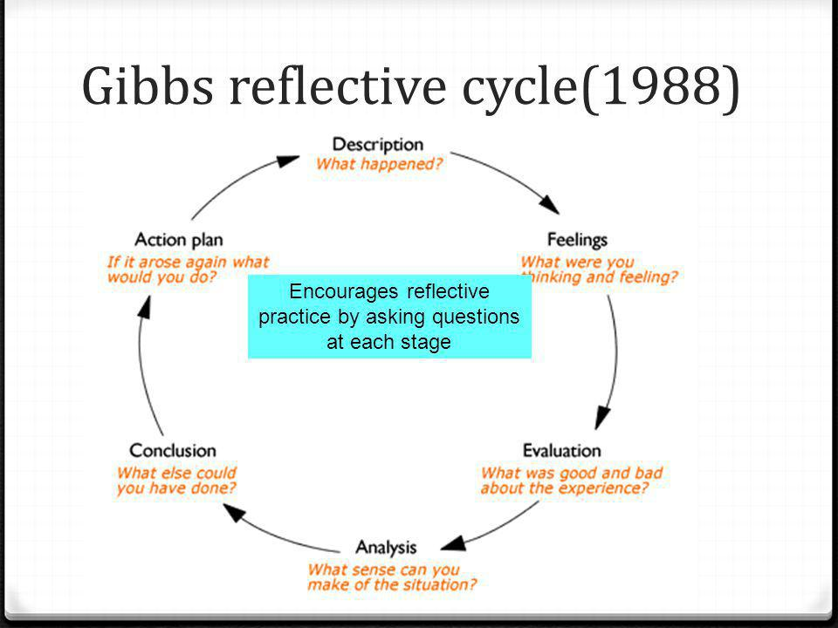

How can reflection improve practice ?
Practitioners can support each other through reflection, they can share their opinions and experiences to help others define their own perspectives. In group discussions not all may share the same experiences, but people’s perspectives can change, strengths and weaknesses can be discussed whereas plans can be put in place to improve the development of the children (Vinnenen et al, 2012). New methods can be merged to develop positive experience and learning where practitioners can improve on the positive outcomes and deliver continuous professional development (Vinnenen et al, 2012).

Estyn
Estyn inspects the quality and standards of education and training in Wales. They have four joint organisations working towards what is best for our practices. They collaborate with the care and Social Services Inspectorate for Wales (CSSIW), Wales Audit Office (WAO), the Healthcare inspector Wales (HIW) and inspection, audit and regulatory (IAR). The inspection reports on how well all the schools in Wales support the health and wellbeing of pupils. . Also they provide guidance on a quality standards of education in wales, this could include reflecting on their own practice to look at how they should improve or how the setting should improve (Estyn.gov.wales, 2019).

Reflecting on practice
Reflecting on practice supports practitioners in the work of an Early Years Setting , by the practitioners reflecting on their experiences they are able to deliver their skills to meet the demands of the Early Years Curriculum. Through improving their knowledge, skills and responding to change, practitioners are showing that they are capable and competent at engaging with children and families (Reed and Canning 2011).

CIW Care Inspectorate for Wales register, inspect and take action to improve the quality and safety of services for the well-being of the children in Wales. CIW investigate any concern’s that may arise within the practice and they take action that ensure services meet legislative and regulatory requirements. (Careinspectorate.wales, 2019)
Kolb
Kolb (1981) he has based his reflective methods on an experiential learning theory, he has based his methods around the work of Piaget and Dewey (Potter 2015).Kolby emphasises that experience plays an important part in reflecting by doing and experiencing and not from listening to other’s or just reading about things (Quin 1998). Kolb (1984) believed that for children to learn and develop they must take part and get involved in doing things. Kolb’s reflective cycle is in four parts, concrete experience, Reflective observation, abstract conceptualisation and active experience, they all consist of a circular process(Park and Sons 2011).
Desparkes.co.uk

Element 4 Personal Development Plan

Area for further development (provide further details) | Why? | How? | Who/Where? | When?
- Knowledge  To become a Family Support Worker, working towards working within residential care for children. | Helping children to be able to deal with certain experiences and to be able to provide young people with great opportunities to grow into confident successful young adults | Look for organisations that will support me in my experience and knowledge.  Researching on how to understand certain behaviours.  Becoming aware of all the children’s rights (Children’s Rights, Wales.2011) | Training.  Level 3 residential childcare qualification. https://www.gcs.ac.uk/level-3-diploma-health-social-care-children-young-people-wales-ni  (Jobs.priorygroup.com, 2019) This organisation will put you through training | 2019  2020  2019
- Knowledge  To be able to become confident in talking in meeting and holding discussions. | During working with young children and having the experience of understanding their different difficulties it is very rewarding when you can make a difference and reach out to those and to be able to help and encourage them to be able to excel in whatever it is they choose to do. | Build on confidence while representing the child effectively at meetings.  Develop skills and confidence during lectures in being able to answer questions during lectures.  Having the opportunities to speak during assemblies when praising children for star of the week. | The support off the Senco and the headteacher will enable me to increase my knowledge and experience and they can direct me to apply for the relevant courses that will enable me to have better understanding. | 2019  2020
- Skills  Develop skills on interacting and listening to children | To be able to interact with the children and be able to communicate effectively.  To be able to understand the children’s individual needs. | To be able to attend training programmes for intervention.  To obtain further knowledge through researching practical strategies for supporting children. using the library resources or researching online. | To observe and reflect on different practitioners during lessons and meetings in school.  Practice presentation skills in front of family to build on confidence. | 2019/
- Skills  To be able to understand children’s differences. | To play and important part in the child’s life and upbringing to its best potential.  To promote well-being, important values, and have excellent listening skills and work effectively with responding to children. | Form a trusting relationship with the child to make them feel secure. | To observe practitioners and they way they interact with children and reflect .  Read up on the Children’s Individual Development Plans,  and their 1 pg profiles.  Read the schools policy’s and information.  Take part in a Nurture programme called Buster | 2019/
- Values  Compassion/Caring | Because the needs and values of the children is very important to me. To be able to communicate with the children effectively, taking in children’s differences and abilities. | Understand their differences by looking at their 1 pg profile.  Research and read up on communicating effectively. | Within the school setting.  Start a nurturing group to build trust in the children. | 2019
- Values  Inclusion | Inclusion is very important as no child should be felt left out and different | Set suitable learning strategies.  Respond to their needs.  Help them overcome barriers to  support their independence.  Encourage their activity skills to build on their development. | Differentiate.  Communication.  Send them on little errands with another peer. Follow the Smart Moves intervention programme (Drew 2006). | 2019
- Other?

Reference list
Allen, S. and Gordon, P. (2017). Thinking on special educational needs and inclusion.
Boud, D., Keogh, R. and Walker, D. (1985). Reflection, turning experience into learning. London: Kogan.
Bolton, G. (2014) Reflective Practice: Writing and professional Development (3rd Ed) London: Sage.
Careinspectorate.wales. (2019). About us | Care Inspectorate Wales. [online] Available at: https://careinspectorate.wales/about-us [Accessed 16 Jun. 2019]
Childrensrights.wales. (2011). [online] Available at: http://www.childrensrights.wales [Accessed 12 Jun. 2019].
Drew, s. (2006). smart moves.
Enfield, M. and Stasz, B. (2011) ‘Presence without being present: Reflection and action in a community of practice’, Journal of the Scholarship of Teaching & Learning, 11(1), pp. 108–118. Available at: https://search-ebscohost-com.ezproxy.uwtsd.ac.uk/ [Accessed 6th June 2019].
Estyn.gov.wales. (2019). [online] Available at: https://www.estyn.gov.wales/sites/www.estyn.gov.wales [Accessed 16 Jun. 2019].
E Venninen, T., Leinonen, J., Ojala, M. and Lipponen, L. (2012). Creating Conditions for Reflective Practice in early Childhood Education. International Journal of Child Care and Education Policy, volume 6 No1, pp.1-15.[on-line]. Available at: https;//ijccep.springeropen.com /articles/10.1007/2288-6729-6-1-1 [Accessed 2nd June 2019].
Gcs.ac.uk. (2019). Level 3 Diploma in Health & Social Care (Children & Young People) Wales & NI | Gower College Swansea. [online] Available at: https://www.gcs.ac.uk/level-3-diploma-health-social-care-children-young-people-wales-ni [Accessed 3 Jun. 2019].
Google Books. (2019). Quin, F. (1998). Continuing Professional Development in Nursing. [online] Available at:https://books.google.com/books/about/Continuing_Professional_Development_in_N.html?id=Wgk1ncslpDsC [Accessed 6 Jun. 2019].

Johns, C. (2013). Becoming a reflective practitioner
Jobs.priorygroup.com. (2019). Priory Group: Residential Support Worker. [online] Available at: https://jobs.priorygroup.com [Accessed 12 Jun. 2019].
Leeds Beckett University. (2015) ‘Skills for learning: Models for structuring reflection’ https://skillsforlearning.leedsbeckett.ac.uk /preview/content/models/02.shtml [Accessed 6th June 2019].
Lindon, J. (2012) Reflective practice and Early Years Professionalism. (2Nd Ed). Hodder Education: Great Britain.
Paige-Smith, A & Craft, A (2008) Developing Reflective Practice in the Early Years Maidenhead: Open University Press.
Park, J. Y. and Son, J. B. (2011) Expression and connection: The integration of the Reflection Process and the Public Writing Process into Social Network Sites. http://jolt.merlot.org/vol7no1/park_0311.htm [Accessed 6th June 2019].
Potter, C. (2015). Leadership development: an applied comparison of Gibbs’ Reflective Cycle and Scharmer’s Theory U. Industrial and Commercial Training, 47(6), pp.336-342.
Reed, M. & Canning, N. (Eds) (2011) Reflective Practice in the Early Years (2nd Ed) London: Sage.
Tarrant,P. (2012) Reflective practice and professional Development. London: Sage.
The University of Edinburgh. (2019). Gibbs' reflective cycle. [online] Available at: https://www.ed.ac.uk [Accessed 2nd June, 2019].
Welsh Government (2015) ‘ Foundation Phase Framework’. Cardiff: Welsh Government.
Welsh Government (2018) Physical Development. Cardiff: Welsh Government.
www.npted.org/schools/primary/tairgwaith/Pages/Policies%20and%20Prospectus/School-Policies.aspx [Accessed 3rd June 2019].
University of Edinburgh https://www.ed.ac.uk/reflection/reflectors-toolkit/reflecting-on-experience/gibbs-reflective-cycle [ Accessed 4th June 2019].
University of Leicester GB https://www2.le.ac.uk/departments/doctoralcollege/training/eresources/teaching/theories/kolb
[Accessed 4th June 2019].

