
Karl Hughes (2213740)
Student, UWTSD Swansea
L4 – Learning in the Digital Era (ACCA4025)
Final Submission Document
Karl Hughes (2213740)

Table of Contents
E-Portfolio page 2
Introduction – Welcome page 2
Here is the link to my E-Portfolio 2
A screenshot of my E-portfolio homepage 2
Task 1 - IEEE Referencing and written summary on essential academic and employment skills 3
Task 1(a) – Written summary on essential academic skills 3
Task 1(b1) Turnitin score and similarity check 5
Task 1 (b2) Self-assessment using generic assessment guidelines 5
Task 2 – Academic A3 Poster ‘Life is a team sport’ and Collaborative Teamwork (Mindmap and Tuckman’s stages of team development summary) 5
Task 2(a) Public link to my academic poster ‘Life is a team sport’ 5
Task 2(b) Image of my completed academic poster 6
Task 2(c) Public link to Mindmap (Collaborative teamwork) 6
Task 2(d) Image of the completed mindmap 7
Task 2(e) Moodle Unit 3 – Virtual collaboration – Tuckman’s stages of team development (summary) 8
Task 3 – Automatic referencing tool (RefWorks) 10
Summary of Moodle unit 3 – Topic 2: Riding the storm (Including citations) 10
Task 4 – E-Portfolio creation and review 11
Task 4(a) Public link to download my E-Portfolio 11
Task 4(b) Illustrative review and screenshots of my completed E-Portfolio 11
Home 11
Welcome 12
1(a) Essential skills for study and employment 12
1(b) Similarity score and assessment 13
2(a) A3 Academic poster “Life is a team sport” 14
2(b) Collaborative teamwork – Mindmap 14
3(a) Virtual collaboration – Tuckman’s stages of team development 15
3(b) Automatic referencing – RefWorks – Storming 16
4 Why I used Google sites 16

E-Portfolio page

Introduction – Welcome page

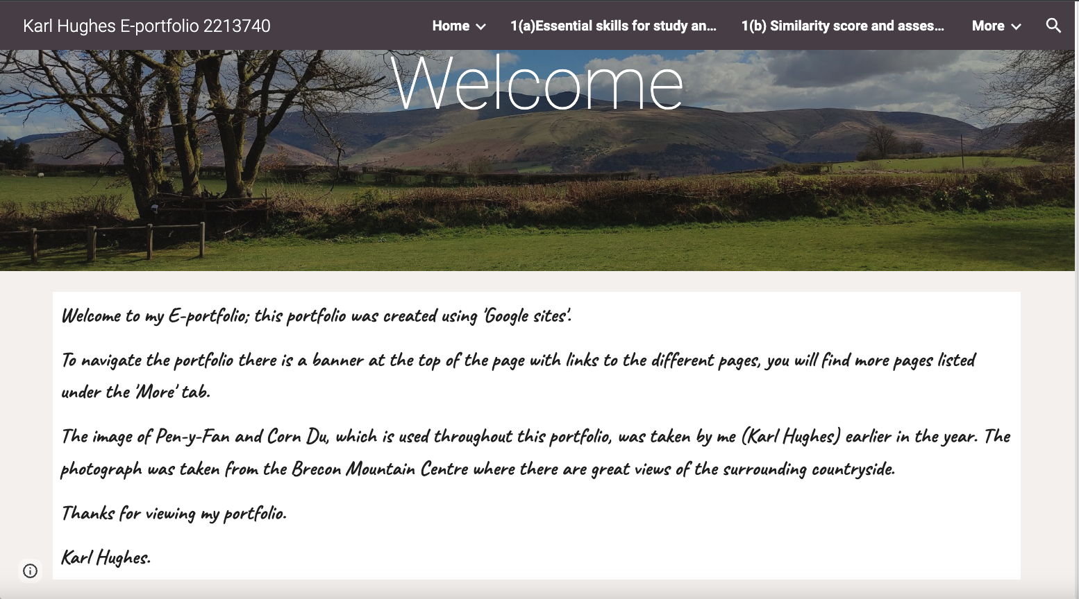

Here is the link to my E-Portfolio

https://sites.google.com/view/karlhughese-portfolio2213740

A screenshot of my E-portfolio homepage

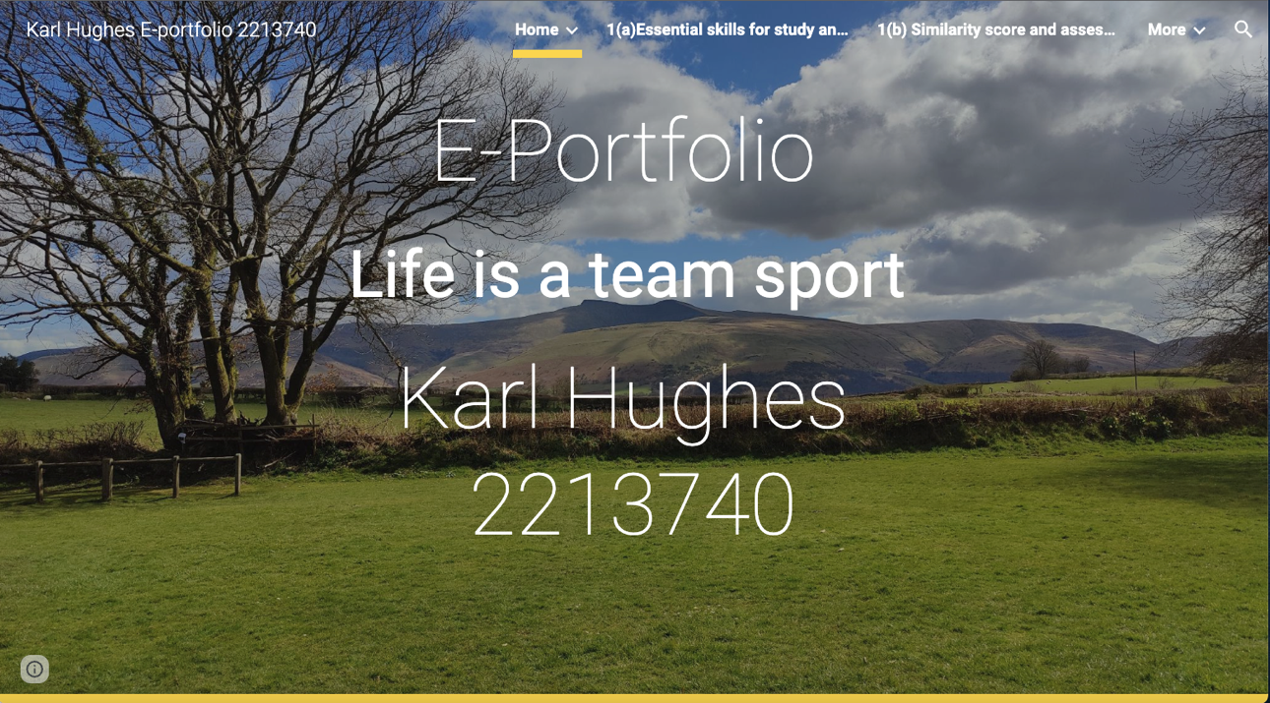

Task 1 - IEEE Referencing and written summary on essential academic and employment skills

Task 1(a) – Written summary on essential academic skills

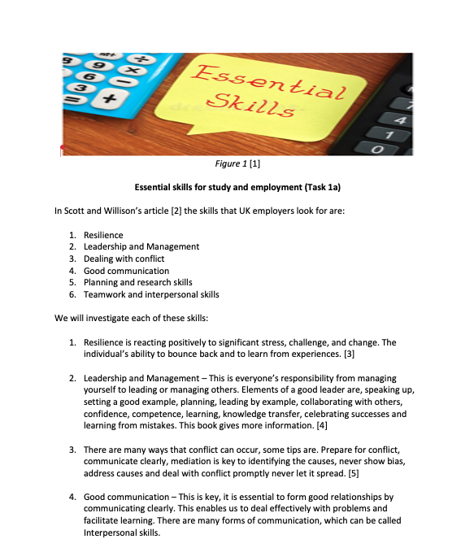

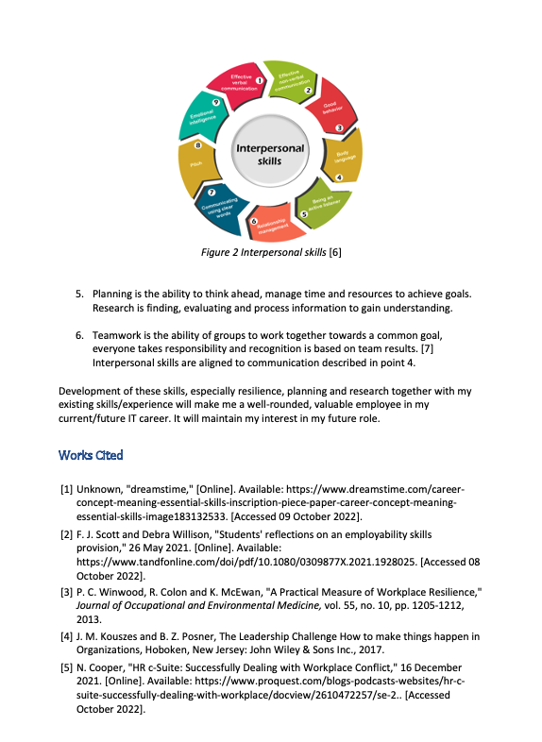


Task 1(b1) Turnitin score and similarity check

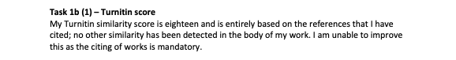

Task 1 (b2) Self-assessment using generic assessment guidelines

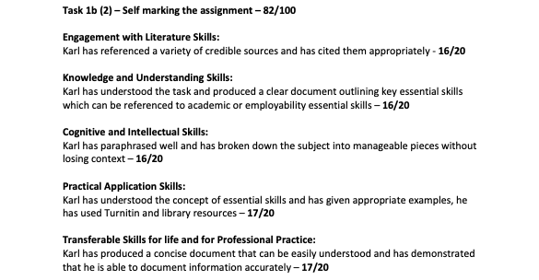

Task 2 – Academic A3 Poster ‘Life is a team sport’ and Collaborative Teamwork (Mindmap and Tuckman’s stages of team development summary)

Task 2(a) Public link to my academic poster ‘Life is a team sport’

https://uowtsd-my.sharepoint.com/:p:/g/personal/2213740_student_uwtsd_ac_uk/EfyiyeMOjlNJriRiwSnCyHoBuFIPUYwNpdZt2cTc2vkf8Q?e=cnpNcA

Task 2(b) Image of my completed academic poster

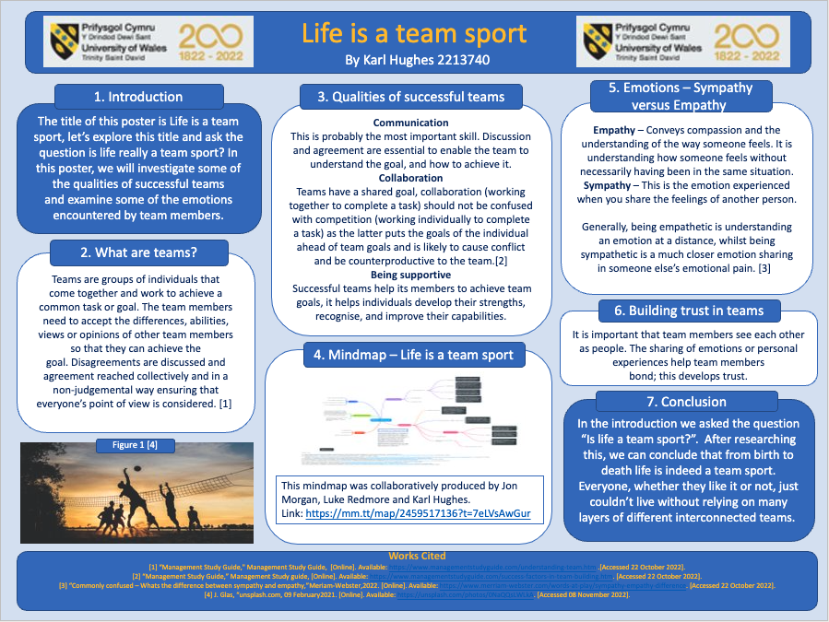

Task 2(c) Public link to Mindmap (Collaborative teamwork)

https://www.mindmeister.com/map/2459517136?t=7eLVsAwGur

Task 2(d) Image of the completed mindmap

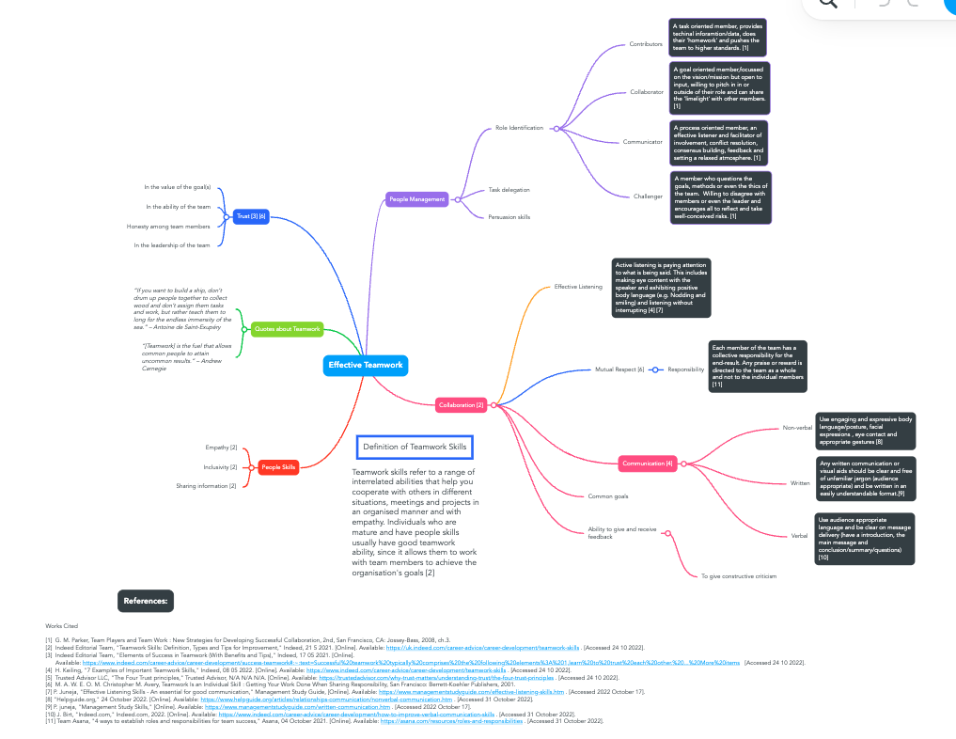

Task 2(e) Moodle Unit 3 – Virtual collaboration – Tuckman’s stages of team development (summary)

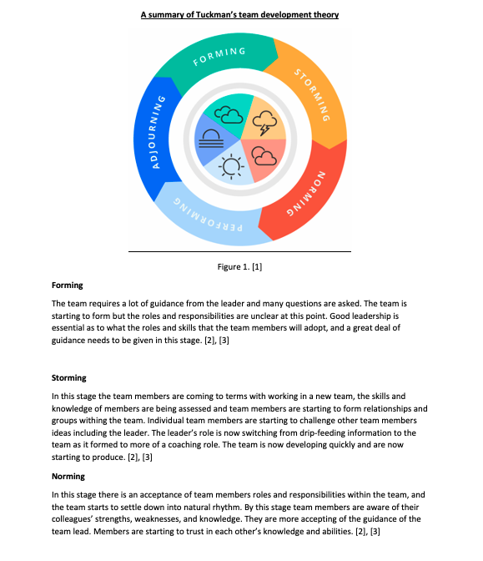

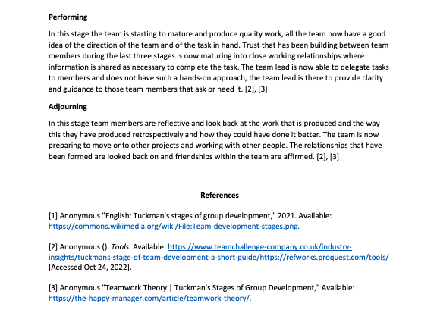

Task 3 – Automatic referencing tool (RefWorks)

Summary of Moodle unit 3 – Topic 2: Riding the storm (Including citations)

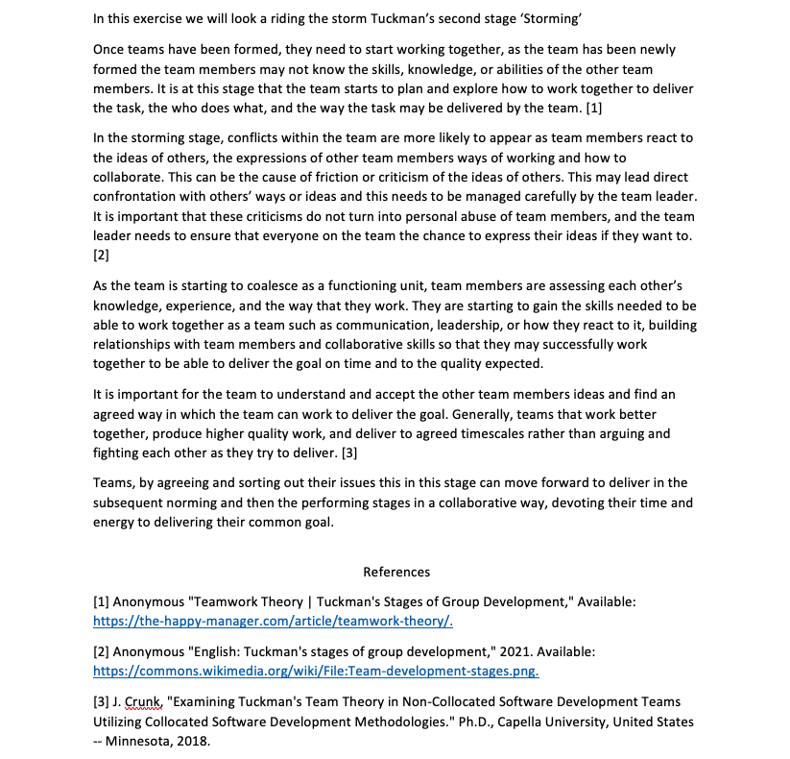

Task 4 – E-Portfolio creation and review

Task 4(a) Public link to download my E-Portfolio

https://sites.google.com/view/karlhughese-portfolio2213740

Task 4(b) Illustrative review and screenshots of my completed E-Portfolio

My e-portfolio was created on ‘Google sites’, I chose this because I hadn’t used it before and after looking at other sites it seemed to be able to provide a good user experience.

It was simple to create pages, add text and images with clearly defined tools that were accessible on a side menu that was easy to navigate.

It was also easy to publish the completed portfolio; Google provides several options that can be used to restrict who can view the published site. If the unrestricted publish option is used then the site can be viewed by anyone who finds it on the internet, but if the restricted option is selected it will only give access to certain individuals chosen by the publisher. I chose the anyone with a link can view setting when publishing my e-portfolio. Google also gives an unpublish option which gives the creator the ability to remove a site from the internet once it has been published.

Here are the pages from my e-portfolio:

Home

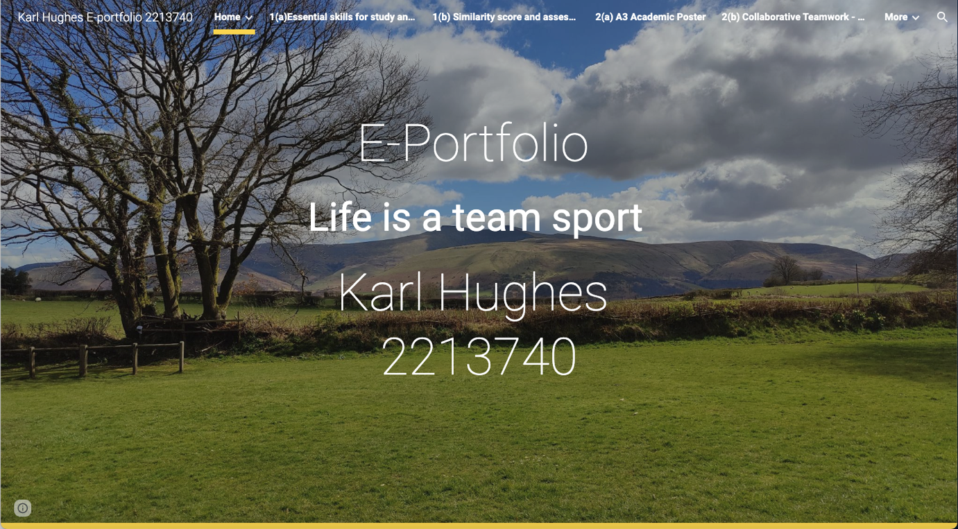

Welcome

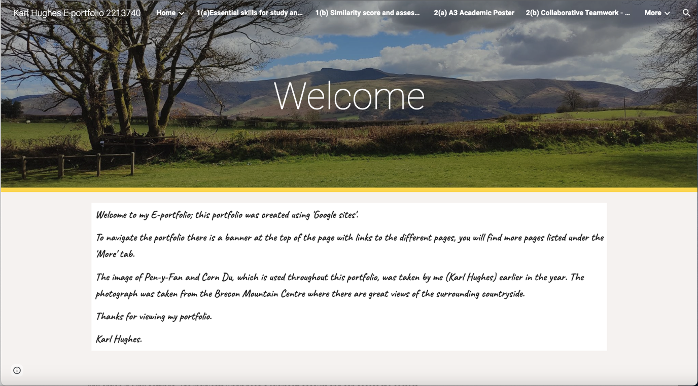

1(a) Essential skills for study and employment

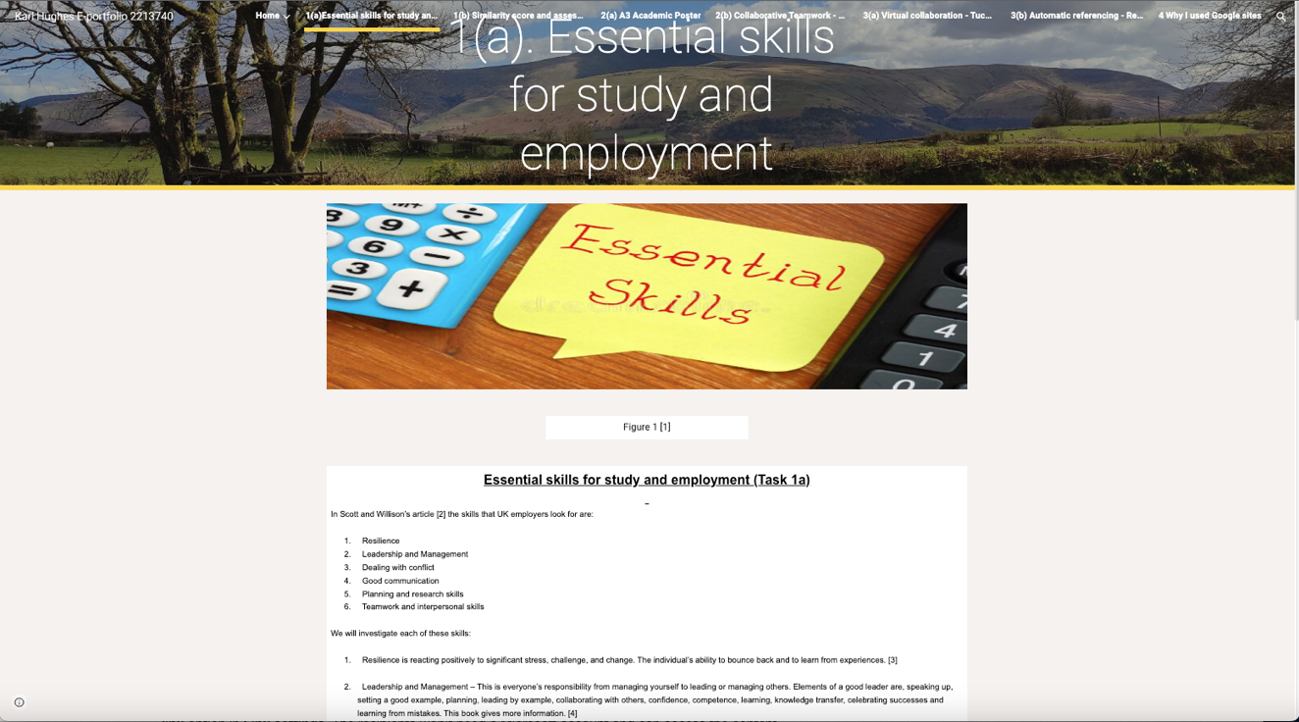
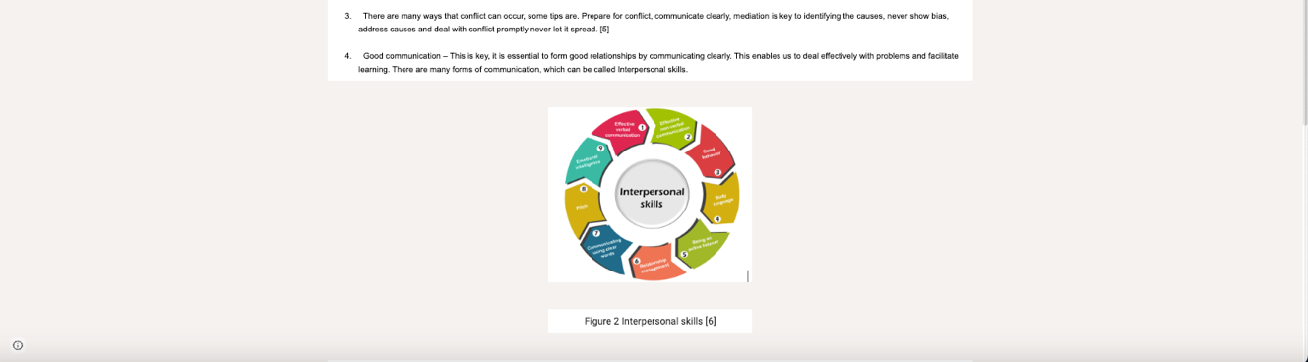
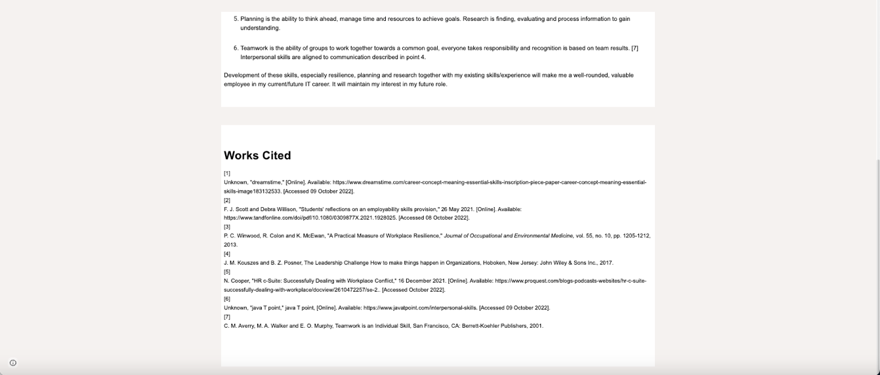

1(b) Similarity score and assessment

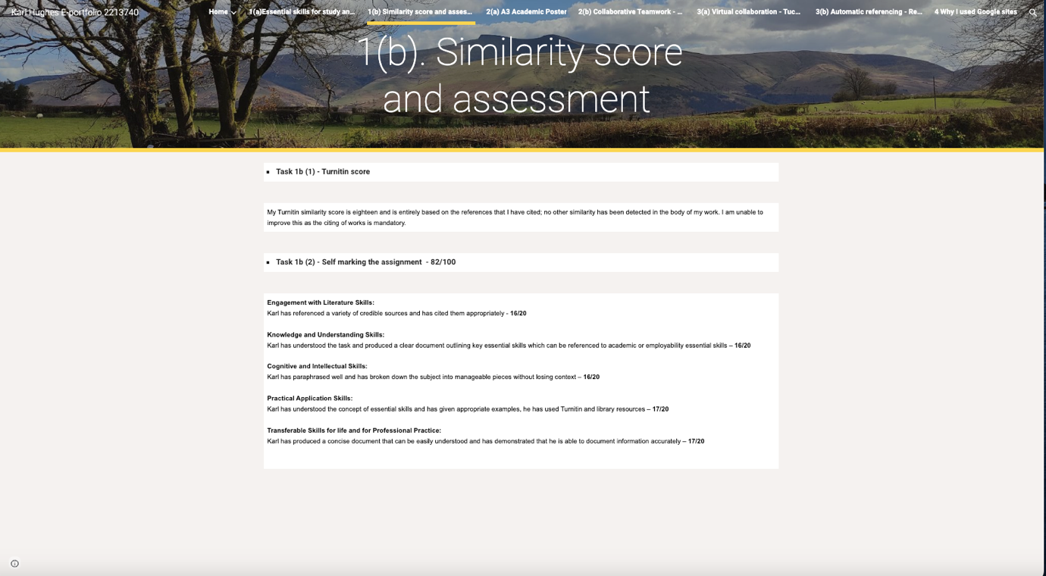

2(a) A3 Academic poster “Life is a team sport”

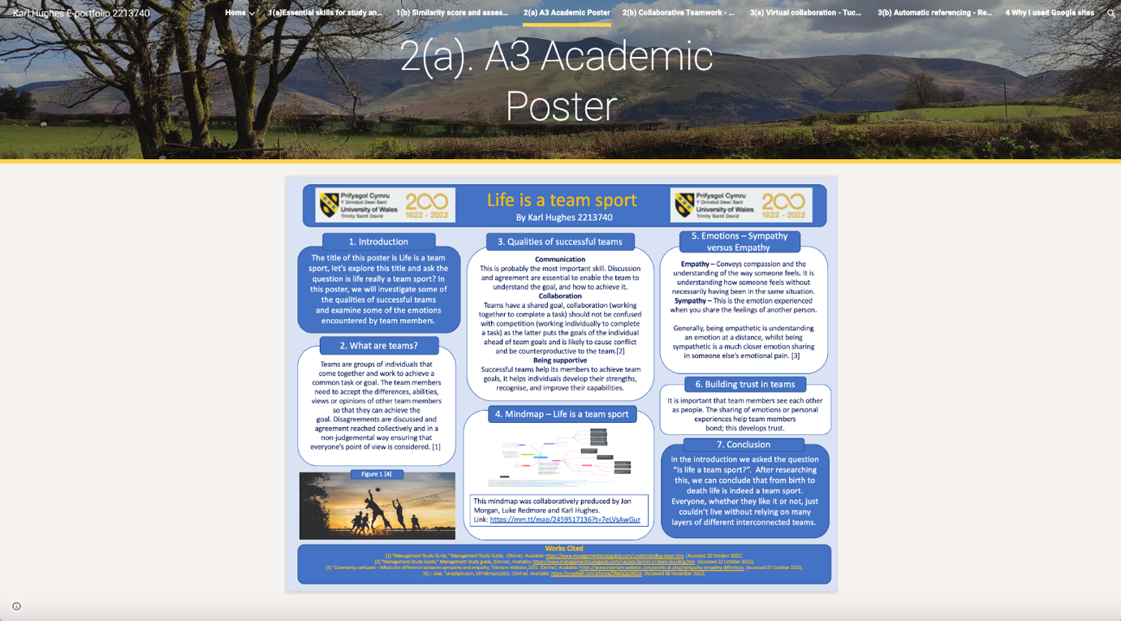

2(b) Collaborative teamwork – Mindmap

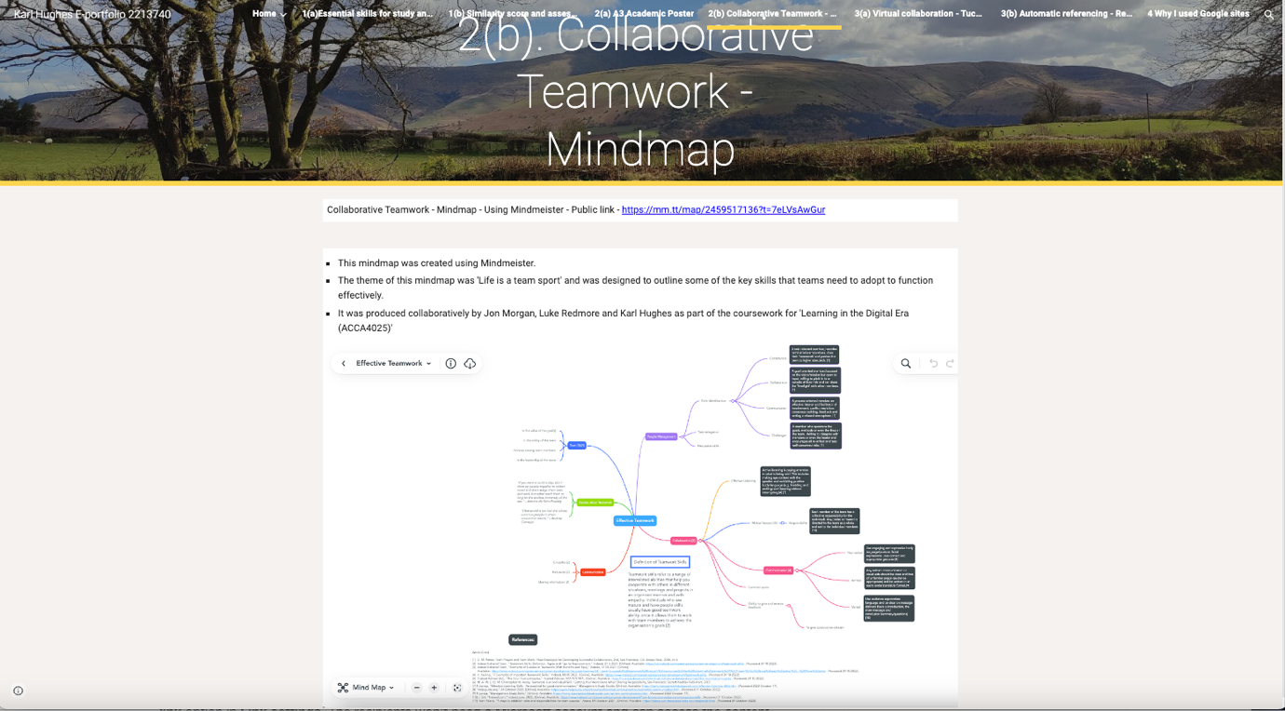

3(a) Virtual collaboration – Tuckman’s stages of team development

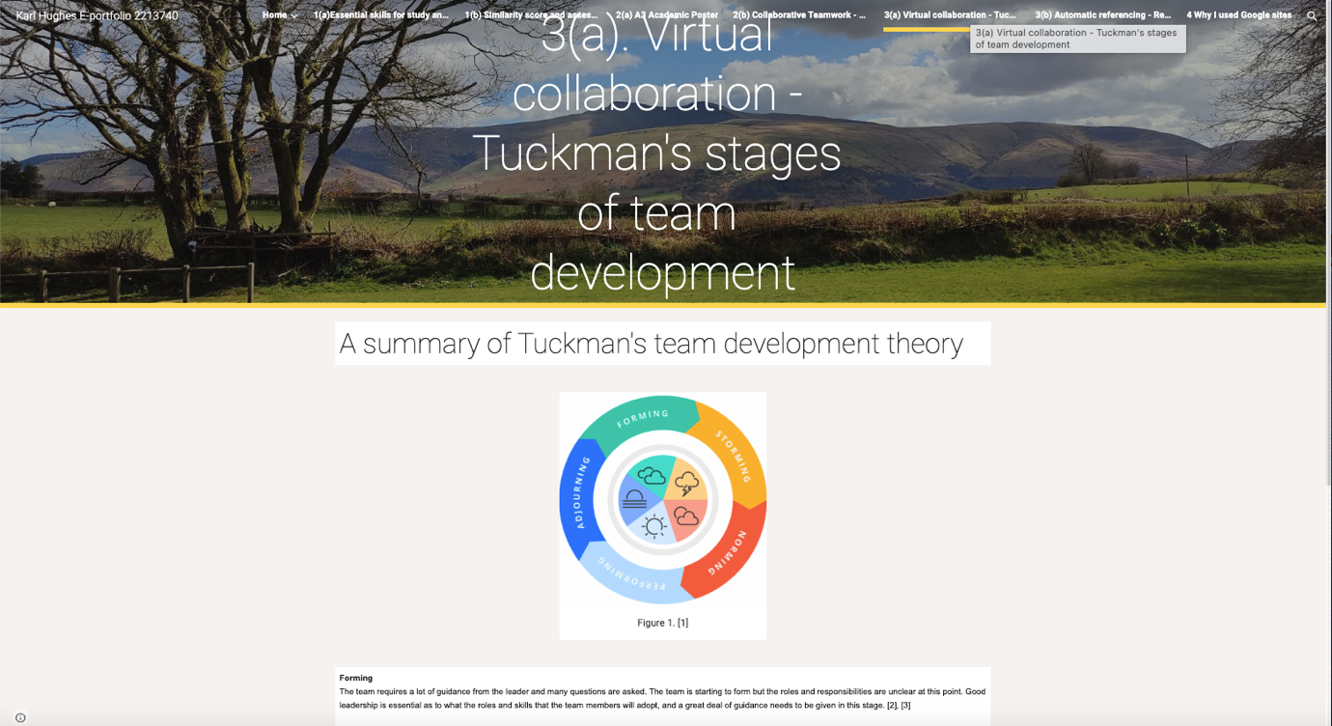
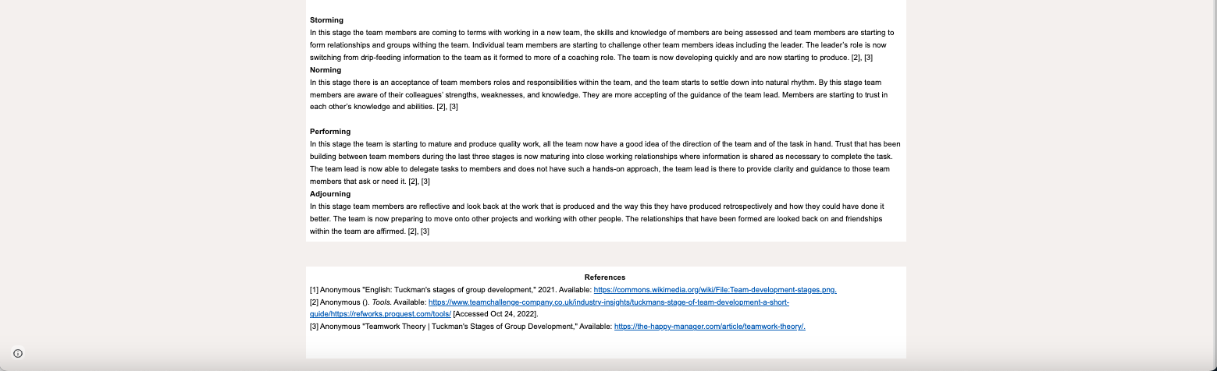

3(b) Automatic referencing – RefWorks – Storming

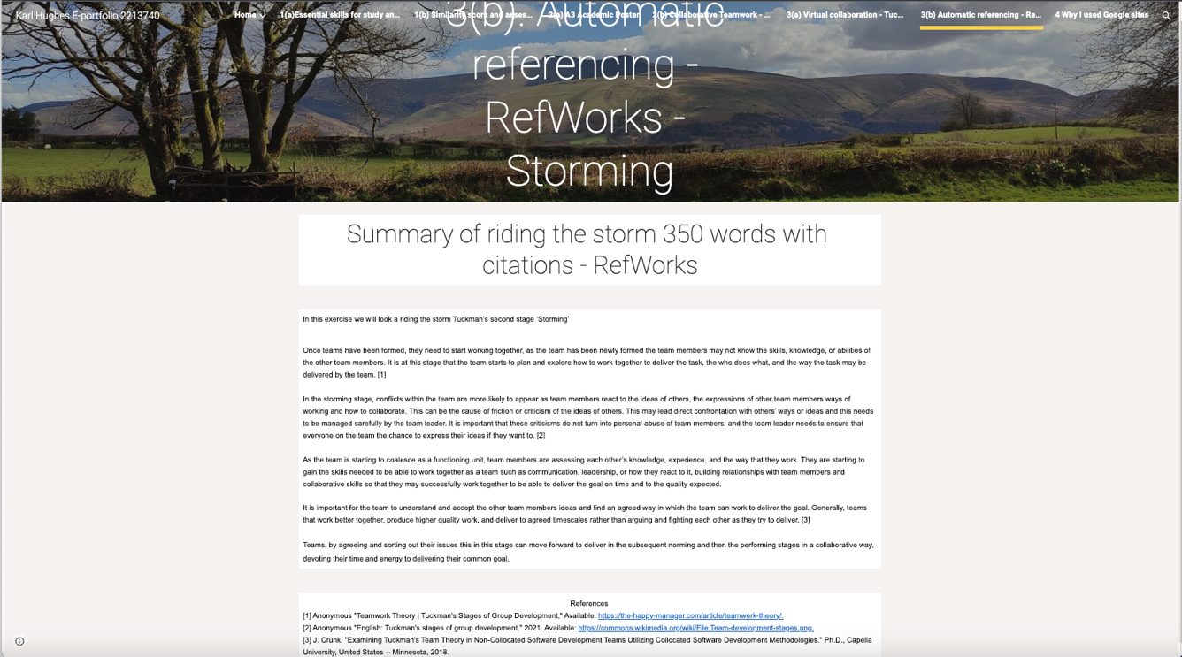

4 Why I used Google sites



