Problem Solving and Innovation (BMSW4014)

Greenwashing in the Automobile Industry
A Root Cause Analysis (RCA) – Summary
Alexandru-Mihai Mihalcea 2434299

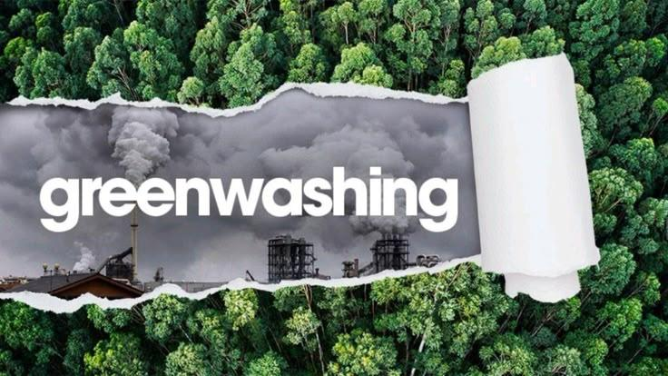

Introduction
Greenwashing is a rising issue fueled by increased sustainability marketing within multiple corporations and consumer demand. Companies are trying to capitalize on the demand for eco-friendly products, although their environmental claims often exceed their actions. Automobile companies are promoting sustainability initiatives while hiding their actual environmental performances. Even though legislation is becoming stricter and technology advances, greenwashing persists.

Summary of Impact of the current situation
The Environmental Protection Agency in the USA discovered that Volkswagen had installed software designed to cheat emissions tests which set a chain-reaction. The company faced fallout across financial, environmental, and regulatory domains. The scandal raised questions about regulatory frameworks, real-driving emissions tests and exposing the greenwashing practices that extended beyond the German automobile maker. Volkswagen was forced to pivot toward electric cars, raising the question if its transformation reflected genuine reform or just image repair.

A root cause analysis (RCA)
The RCA identifies six interconnected root causes of greenwashing in the automobile industry reflected through the Dieselgate scandal.
The first is competitive pressure and strategic incentives. The automotive industry is facing financial and technological challenges as it transitions to sustainable alternatives.
The second cause is surrounding fragmented regulations within the industry. Emissions tests are conducted in a laboratory, under conditions that do not reflect real-world driving. This allows companies to show vehicles that seem to be performing well, but are emitting far more pollutants in the real-world.
A third root cause is corporate culture. The Volkswagen scandal revealed an in-house culture where manipulation became normalized and justified in order to meet certain metrics and maintain the competitive upper hand within the industry.
During the analysis, consumer mentality was identified as another factor. Consumers tend to respond well to companies with a green branding, but often lack the knowledge to evaluate the environmental claims. As the demand for eco-friendly products grows, companies engage in greenwashing for profit.
A fifth factor is symbolic sustainability. Companies can inflate their image of environmental performance via selective disclosure. The absence of standardized frameworks has allowed for companies to highlight the good while hiding the negative outcomes.
Finally, the media plays a significant role. The internet is quick to forget a scandal and shift its attention towards sustainable promises and washes over the scrutiny of past misconduct.

Conclusion
Greenwashing is not an isolated corporate misconduct within the industry, but a deeply rooted and multifaceted issue. The Volkswagen Dieselgate issue illustrates how the company culture, regulatory inconsistencies and PR combine to allow greenwashing to thrive.
Through the root cause analysis, we intended to show that greenwashing is driven by multiple key factors that favor a perceived image over actual change.
To achieve authentic sustainability, corporations need to shift from short-term image preservation to long-term environmental responsibility. If the automobile industry does not address and shift the root causes, they risk perpetuating the symbolic environmentalism activism and delay the transition to actual ecological accountability.
On the other side there are the consumers. It is also our responsibility to demand sustainability, but to also understand what it is and how to spot false claims.

References
Boiral, O., Brotherton, M-C., Yuriev, A. and Talbot, D. (2022) ‘Through the smokescreen of the Dieselgate disclosure: Neutralizing the impacts of a major sustainability scandal’, Organization & Environment, 35(2), pp. 175–201. https://journals.sagepub.com/doi/10.1177/10860266211043561
Kell, G. (2022) From emissions cheater to climate leader: VW’s journey from Dieselgate to embracing e-mobility. Forbes, 5 December. Available at: https://www.forbes.com/sites/georgkell/2022/12/05/from-emissions-cheater-to-climate-leader-vws-journey-from-dieselgate-to-embracing-e-mobility/
Koch, C. and Denner, M. (2021) ‘The impact of greenwashing on consumer trust: A study of the automotive sector’, Journal of Business Ethics, 174(2), pp. 223–245.
Transport & Environment (2020) Carmakers’ dirty secret: How they mislead consumers on emissions and fuel efficiency. Brussels: Transport & Environment.
Vaughan, Adam (29 October 2015). "VW emissions cheat estimated to cause 59 premature US deaths"
The Wall Street Journal: Greenwashing: When Companies aren’t as sustainable as they claim Greenwashing: When Companies Aren’t as Sustainable as They Claim | WSJ

