Marketing Fundamentals: Walmart Analysis

Student name: Yordan Kostov
Student ID: 1921545

Module Title: Marketing Fundamentals
Assignment Title: Marketing Fundamentals Analysis and Evaluation- Assessment 2

Lecturer Name: Rula Alousi

Table of Contents
Processes and Stages of Marketing including the role of the marketing mix 3
Marketing Objectives 3
Current Situation 3
PEST Analysis 4
SWOT Analysis 5
Target Market 6
Market Segmentation 7
Marketing Mix 8
Stakeholder engagement and their impact on marketing activities 9
Investors 10
Employees 10
Customers 10
Suppliers 11
Impact of Stakeholder engagement 11
References 13

Processes and Stages of Marketing including the role of the marketing mix
In 1962, the Wal-Mart public chain, the owner of which was Sam Walton was founded. The organization has its headquarters in Bentonville, Arkansas, USA. Wal-Mart must be remembered as the world's second company. The business is wholly funded and run by the Walton family of President and Chief executive officer Mike Duke. It contains neighbourhood marketplaces, shops for discounts, membership warehouse storage club, Sam club, etc., and resources and processes all over the world. Wal-Mart is named to be the varied shops at a low price. They offer very low delivery time and delivery charges to their products. At various times, the organization uses various technologies to improve its offerings and consumers find themselves drawn by less use (Porter & Ramirez-Vallejo, 2017).

Marketing Objectives
Wal-Mart Organization’s principles and priorities are regarded as the basic duties of its staff, and as indicated;
• Adequate assistance is given to monitoring organizational work
• Selling discount bundles.
• Precise worker instructions
• Employee appraisal at each point only because development is steady

Current Situation
At the start of 2018, the reports of retail outages in the major retail chains (Wal-Mart, Best Buy, Home Depot, Costco, etc.) intensified not because supermarket in U.S. markets is at risk, but because some retailers make it challenging to survive in a rapidly flowing international retail setting, which is highly competitive. In 2014, the number of stores that closed or failed contrasted with the old ones is limited. In the modern market dominated by Internet consumers and smartphone transactions, it is evident that the physical retail shops run by the largest US retail chains are saturated. An emerging effect of the industrial revolution is to relocate the size and number of retailers. In the coming years, this pattern is anticipated to remain. The customer informs retail stores what interests they have in shopping and how much they value-buying in physical stores for their online sales. The market would have to adapt to changes concerning these expectations (Fadel, 2019).

PEST Analysis
A PEST analysis is carried out in an attempt to analyse in which atmosphere Wal-Mart functions. The success of the business is determined by political, economic, social and technical influences, and so deeper insights are needed. Besides, other factors are more or less appealing to the consumer in terms of overall performance in the sector (Leuprecht & Sokolsky, 2015).
Political Factors
The United States is a democratic representative republic in which the leader of the country and nation is the President. The National Government has powers between Parliament and the Judicial and the Federal Republic has jurisdiction with its state Legislature. The political structure of the United States and other industrialized economies are very different. Some of them are that the current parliament of legislature has better control in Countries, the Supreme Court has a bigger range of control and only two major parties have the supremacy. In the United States, third parties have much less control than most other existing nations. Because of the scale of the U.S., the government are responsible for the local military, and the police have wider resources. The case law applied is the legal system and the court decisions are the ones holding the most court hearings.
Environmental Factors
Public understanding of ecosystems as a whole was not universal, but people start to be worried about these issues. The customer's profile recently changed and now the consumer becomes a person who decides on his lifestyle wants and his ability to take part in the impact on the environment obligation. Thus, businesses with their goods and services are supposed to do the same. Customers are becoming increasingly aware of problems such as recycling, pollution, energy type utilized, deforestation, the use of toxins and water, air and marine pollution.
Social Factors
The bulk of the race is whites (72.4%) with a glance at the statistics of the United States, preceded by an African American (12.6%), Asian (4.8%) and many others. Approximately 1.7 percent of the people, Judaism 2%, and some Buddhism, Indianist and Muslims make up 78,2 percent of the population and no religion. The commonest religion is Christian, the U.S. customer has a strong and demanding character. Customers' increasing power and advocacy turn the retail stores into an ongoing touch. In way to involve with the customer, goods released need to be trendy and consumer products (Leuprecht & Sokolsky, 2015).
Technological Factors
Walmart has introduced automation and robotics to improve the productivity behind the scenes. The technology will meet orders, boost manufacturing and help keep the shop tidy.
Mechanization is a type of digital innovation that allows more productive business operations by using automated technology. Automation is an expected move for the company to take with a brand as large as Walmart. By enabling robots to perform simple chores the workers can concentrate without disturbance on the sale of goods.

SWOT Analysis
The SWOT review from WALMART Inc. (formerly Wal-Mart Stores, Inc.) indicates that the leadership role of the business is focused on the use of organizational capabilities and associated strategic benefits in the international retail industry.
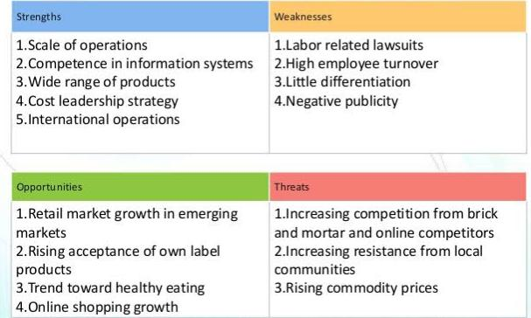

Strengths
The strengths of Walmart are all connected to their company size. These competitive forces allow the company, while a reduced retailer is small, to face threats. Walmart strengths for more global growth are: to leverage global expansion opportunities:
- The scale of the global sector
- Global distribution chain
- strong supply chain productivity
The global size of Walmart offers bottomless pockets to the corporation for success and growth. The global supply chain also offers business flexibility against market-specific danger, such as local supply chain disruptions (Chang & Hu, 2020). In addition, due to advanced technology for tracking and controlling the flow of goods from manufacturers to their shops the Walmart distribution chain is of high quality.
Weaknesses
The weaknesses of Walmart cause problems for the organization to deal with the risks found in this SWOT review as well. The weaknesses are connected directly to the general strategy of the organization and its impact on business growth, capacity, capital and profit margins. Walmart uses the generic approach for cost control, leading to the following weaknesses:
- Slim margins of benefit
- Reproduced business model easily
- Competitive drawback against speciality sellers of high-end
Opportunities
The chances of Walmart are mainly to broaden and develop business practices. The global economic condition is related to these occasions. The human resources situation in the organization, in fact, poses challenges that can be improved by the business. Walmart's prospects are described in this section of the SWOT analysis:
- Advanced nations Extension
- Improved human resources practices to develop labour market productivity
- Improving levels of quality
Threats
The challenges to the business of Walmart relate to the conditions of the retail industry and to shifts in customer expectations of the goods they purchase. These variables should push the organization to make some competitive advantage adjustments. The threats to Walmart are:
- The good trend of lifestyle
- Aggression contest
- Varying scale online retailers

Target Market
Due to the wide variety of goods offered by the company, a product sold by Wal-Mart will in any way be desired by all publics. Films and books; household equipment and veranda, baby and children's goods; exercise, athletics, fitness products; car-homemade items; photos and donations; party facilities; drugstores, health and beauty products; pet products and several other speciality products. Food, cosmetics provides for children; and the furnishings and furniture for children (Chang & Hu, 2020).
The strategy of the company "saving money on the one hand. The description of the target consumer is one with the smallest budget and can purchase its goods at the lowest possible cost, live a better life" (the prior one has always been "Always low prices"). Thus, Wal-Mart is the most likely buyer for a low-price consumer, with a family of 4. In the other hand, Wal-Mart is able to sell its products in a particular way. The firm pursues an Intimacy Approach which means that markets are precisely segmented and targeted and offers tailored to meet the needs of those segments.
Wal-Mart targets those clients based on their earnings but also population-based markets. Based on this, the company has established four shop formats and is a key determinant of which shops to use.

Market Segmentation
Market divisions can be described as 'dividing the market into separate groups of customers with different needs, features and behaviours who may need separate goods or mixtures of markets.'

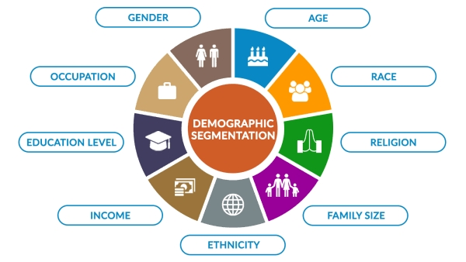
Segmentation is the foundation to establish tailored and successful marketing campaigns and plans. This market segment analysis contributes to decision-making on the strength, especially in segments, of marketing activities. In order to determine the best environments for opening its retail outlets, Wal-Mart applies market segmentation and identifying the best products for stock in its stores. The organization primarily uses two types of division policies: regional segmentation and demographic division. Wal-Mart group its customers according to their physical position under a regional segmentation (Porter & Ramirez-Vallejo, 2017). In 2019, no snow shovels are stocked by Wal-Mart in towns that barely suffer from snowfall like San Diego, according to Noel and Hulbert. It only keeps snow shovels in towns with common snowfall. Wal-Mart classes its consumers according to their physical position under regional segmentation. Wal-Mart doesn't stock snow pads in towns that have barely snowfalls such as San Diego, according to Noel and Hulbert (2001). Snow shovels are kept only in cities where frequent snowfall occurs. Wal-Mart stocks its goods in a given area based on consumer age under demographic segmentation. In this case, Wal-Mart provides its stores with products that satisfy consumers' tastes and desires according to age. Marketing campaigns by Wal-Mart have always been popular since the company's market segment was well-defined.

Marketing Mix
Marketing Mix of Walmart aims at discussing Walmart marketing plan for a brand/business covering 4P (Product, Price, Location, Promotion). By 2020, the brand has been helping to expand with various marketing strategies, such as product innovation/services, marketing investments, customer interactions, etc. Marketing Strategy allows businesses to accomplish business objectives and goals, and the marketing mix (4Ps) is the general sense in which strategies are described. This post addresses Walmart's goods, pricing, and advertisement and delivery methods.
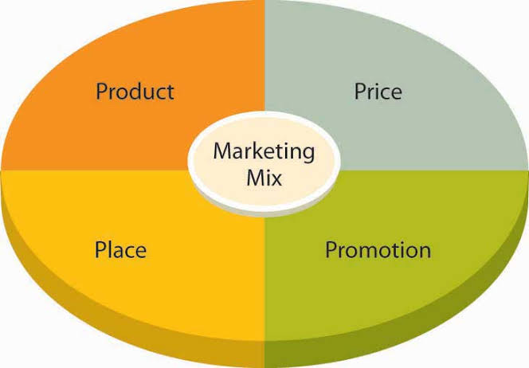

Product
Walmart's marketing approach and the combination can be explained as:
Walmart is a multi-brand discount store; thus, all departments are merged. The numerous departments in Walmart include electronics and offices, films, music and books, home, furniture & patio, home-improvement, clothes, shoes and jewellery, baby and childcare, toys & video games, food, domestic & animals, pharmacy, health & beauty, sports and exercise facilities (Porter & Ramirez-Vallejo, 2017). Walmart also has unique seasonal departments including Halloween costumes.
Price
Walmart is successful in the industry, but it costs its item very competitively. By pricing its product least, it records its marketing mix pricing strategy. It produces very large quantities of goods worldwide, and its products can thus easily be priced less than their rivals and therefore benefit from economies of scale. Around 15% lower Walmart charges the goods than its rivals. Depending on the purchasing behaviour of consumers, they use various price strategies. Unique words such as "Ever low prices" and "Everyday low prices" were invented to show that every commodity, depending on demand and time, prices differ every hour.
Place and Distribution
Walmart has over 11,500 retailers worldwide, including over 4,600+ US Walmart banners, 650+ SAM clubs and over 62,200+ Walmart International banners in 28 countries. The distribution plan involves direct distribution to retailers by wholesale distributors. The goods are shipped to the shops in large quantities. Walmart has more than 150 distribution centres using a cross-docking scheme. Walmart uses the hub & talk system in which the items are based and then delivered to the individual (KUMAR & BHARDWAJ, 2018).
Promotion
Walmart supports its aggressive pricing strategy through a host of promotional initiatives such as product categories. Walmart is implementing an aggressive brand growth policy as part of its promotional marketing mix. The website for e-commerce attracts clients, giving their customers a donation. Walmart uses promotional tactics, which lead to the company's maximum profits. The sites use slogans such as 'Take it before it' to draw their customers so their goods can be bought without worrying too much that the deal is not expired (Muda, 2018).

Stakeholder engagement and their impact on marketing activities
The overall strategy of the company is determined by Walmart's stakes. These stakeholders are the individuals or entities that indirectly or directly influence the company. They thus increase influence on the company Walmart to urge it to take its interests into account. Walmart has many stakeholders through its large corporate scale and global reach. However, only a few parties involved have a big influence on the business. Managers need to recognize these stakeholders and their priorities to appreciate the complexities of the interaction between stakeholders and the company. To achieve good management positions in stakeholders Walmart can use this knowledge (Jindal et al., 2020).
The stakeholders of Walmart can be classified according to their shared values. These key stakeholders also have specific aims, depending on the convictions and regulations of the organization. In Walmart's corporate social responsibility policy, the key stakeholder classes are grouped as per the corporate goals of the company:
- Investors
- Employees
- Customers
- Suppliers
The investors are Walmart's most significant stakeholder community, while providers are of the lowest importance. Nonetheless, the decision-making process of the organization takes into account all these stakeholder categories. Walmart prioritizes its stakeholders like those of several corporations and typically gives investors top priority.

Investors
The key focus of the investors is on earnings. They would like more Walmart, meaning cash dividend or wages per stock. In this respect, investors are also involved in reducing the company's operating expenses. Lower prices also contribute to higher earnings, which benefit investors from Walmart.
In its plans, Walmart gives preference to investors. This is why Walmart is also cutting prices, for example by reducing salaries (Chen, 2019).

Employees
The staff of Walmart are a big factor in the decision-making of the business. There are two primary concerns of employees: protection at work and higher pay. Job protection means ensuring that Walmart keeps its employees in its company. Higher salaries are a typical interest, especially when the company still gives its workers low wages.
The expectations of its employers as stakeholders are only partly successful. The organization has strategies and tactics that offer substantial job protection. Walmart, however, continues its salary reduction stance. While some workers are stockpiled in the business, many of them have an economic interest in the company only because their work is their main source of revenue. You want Wal-Mart to do better, and then you can retain your work and income stream. They are sustained by their Wal-Mart monetary damages. Wal-Mart has over 885,000 national workers (Gupta, 2018).

Customers
Generally, consumers are included in business as a stakeholder group. In the case of Walmart, consumers are interested in low prices or the reasonable quality of goods provided that the quality of these items is appropriate. Particularly for American users, who tend to gravitate to low priced retailers like Walmart. Walmart deals with clients' needs as stakeholders. The company continues its generic cost control policy, which includes the lowest possible costs. Indeed, because of its low prices the company is famous. Walmart is active in discussing consumer desires as stakeholder groups in this context (Leuprecht & Sokolsky, 2015).

Suppliers
Providers want more of their items to be sold profitably in Walmart stores. This interest does not only include the sale of the goods of the manufacturers, but also the sale of these products at an appropriate price. As firms, Walmart manufacturers are stakeholders who want their goods to be sold at higher prices. Even a minor price rise will profit suppliers considerably.
Suppliers are at the very end of Walmart's stakeholder priority. Providers have in their shops the products the business wants.

Impact of Stakeholder engagement
Walmart serves successfully the needs of investor and consumer stakeholder groups. Yet the company only slightly satisfies workers' needs as they also earn low salaries. The business also doesn't meet the suppliers' interests. Walmart thus operates just roughly 50% to address the needs of stakeholders (Chang & Hu, 2020).
Walmart would need to incorporate certain improvements in its company to boost its efficiency in order to please stakeholders. For instance, the company may usually raise salaries marginally but significantly. Walmart may also strengthen the relationships with suppliers by meeting suppliers in the centre rather than insisting on unfairly low prices. The success of Wal-Mart is associated with the shareholders, and shareholders are concerned about the growth of the organization because it will impact the shareholders’ interests if the company fails its operations. This study addresses why the global market is not ideal for Wal-Mart. Wal-Mart's key explanation for facing challenges today is internal and external. Internal problems included management and disputes between workers, while external problems involve environmental and supplier conflicts. These conflicts may force Wal-Mart to invest in its share price and the trust of its shareholders.
Successful participation of stakeholders adds to the bottom line both directly and indirectly. This post gives a sample for the key stakeholder groups some demonstrated benefits of stakeholders' participation (Harrison, 2019).
Many organizations and individuals play a part in what Wal-Mart does to assess Wal-Mart's public relations plan. These players can be split into two groups: the industry and stakeholders outside the market. The market players are the groups and individuals who engage economically in what the business does. The non-market parties are the organizations and individuals who engage in what direction the business takes, either economically or politically.
Walmart stakeholders have another obligation to maintain a strong image for the organization in society. Social responsibility can be accomplished by the business. A good reputation is crucial for the company, as it can attract more customers and others and ensure business success (Neebe, 2020).
Customers claim to obtain the best services at a reasonably low price from the company. In the other hand, workers would like to receive the proper care and a healthy working climate and good pay for their services. Walmart managers and staff are solely responsible for taking decisions. Decisions require deciding whether the organization’s right or wrong. Stakeholders determine how to boost organizational efficiency. The correct decision is often taken. It is essential to ensure. Furthermore, it is important to continually develop ways by which decisions are taken (Casadesus-Masanell & Elterman, 2019).
It would make sure that the organization's management and staff discover new ways to fulfil their duties. It is important to remember that due to technological advances, the existing market climate is continuously evolving. Managers should communicate to their workers about the correct direction, then to the other parties concerned, including clients and shareholders. Innovation, on the other hand, is a matter for all parties concerned. Creativity would allow the organization, with the competition, to increase the quality of its services and products.

References
Casadesus-Masanell, R., & Elterman, K. (2019). Walmart Ecommerce (B): Omnichannel Pursuits.
Chang, Y., & Hu, J. (2020). “Analysis on the Mode of Multinational Retail Enterprises Entering Chinese Market—Take Walmart, Carrefour and Metro as Examples. Modern Economy, 11(01), 17”.
Chen, X. (2019) Corporate Social Responsibility Analysis of Walmart in China.
Fadel, S. (2019). “Encyclopedia of major marketing strategies”, volume 4: edited by Mathew Miskelly, Farmington Hills, MI, Gale, 2019, 500 pp., $683.00, ISBN 978-1-4103-8934-3”.
Gupta, A. K. (2018). “Walmart: a roadmap for globalization”. The Business & Management Collection.
Harrison, V. (2019). “Legitimizing private legal systems through CSR communication: a Walmart case study”. Corporate Communications: An International Journal.
Jindal, R. P., Gauri, D. K., Li, W., & Ma, Y. (2020). “Omnichannel battle between Amazon and Walmart: Is the focus on delivery the best strategy? Journal of business research, 122, 270-280”.
KUMAR, N., & BHARDWAJ, S. (2018). Amazon and Walmart on collision course.
Leuprecht, C., & Sokolsky, J. J. (2015). “Defense Policy “Walmart Style” Canadian Lessons in “Not-So-Grand” Grand Strategy”. Armed Forces & Society, 41(3), 541-562.
Muda, I. (2018). “Dimension of an Islamic Model Value on the Existence of Syariah Walmart”. In Proceedings of MICoMS 2017. Emerald Publishing Limited.
Neebe, K. (2020). “Sustainability at Walmart: Success over the Long Haul”. Journal of Applied Corporate Finance, 32(2), 64-71.
Porter, M. E., & Ramirez-Vallejo, J. (2017). Walmart: Navigating a Changing Retail Landscape.

