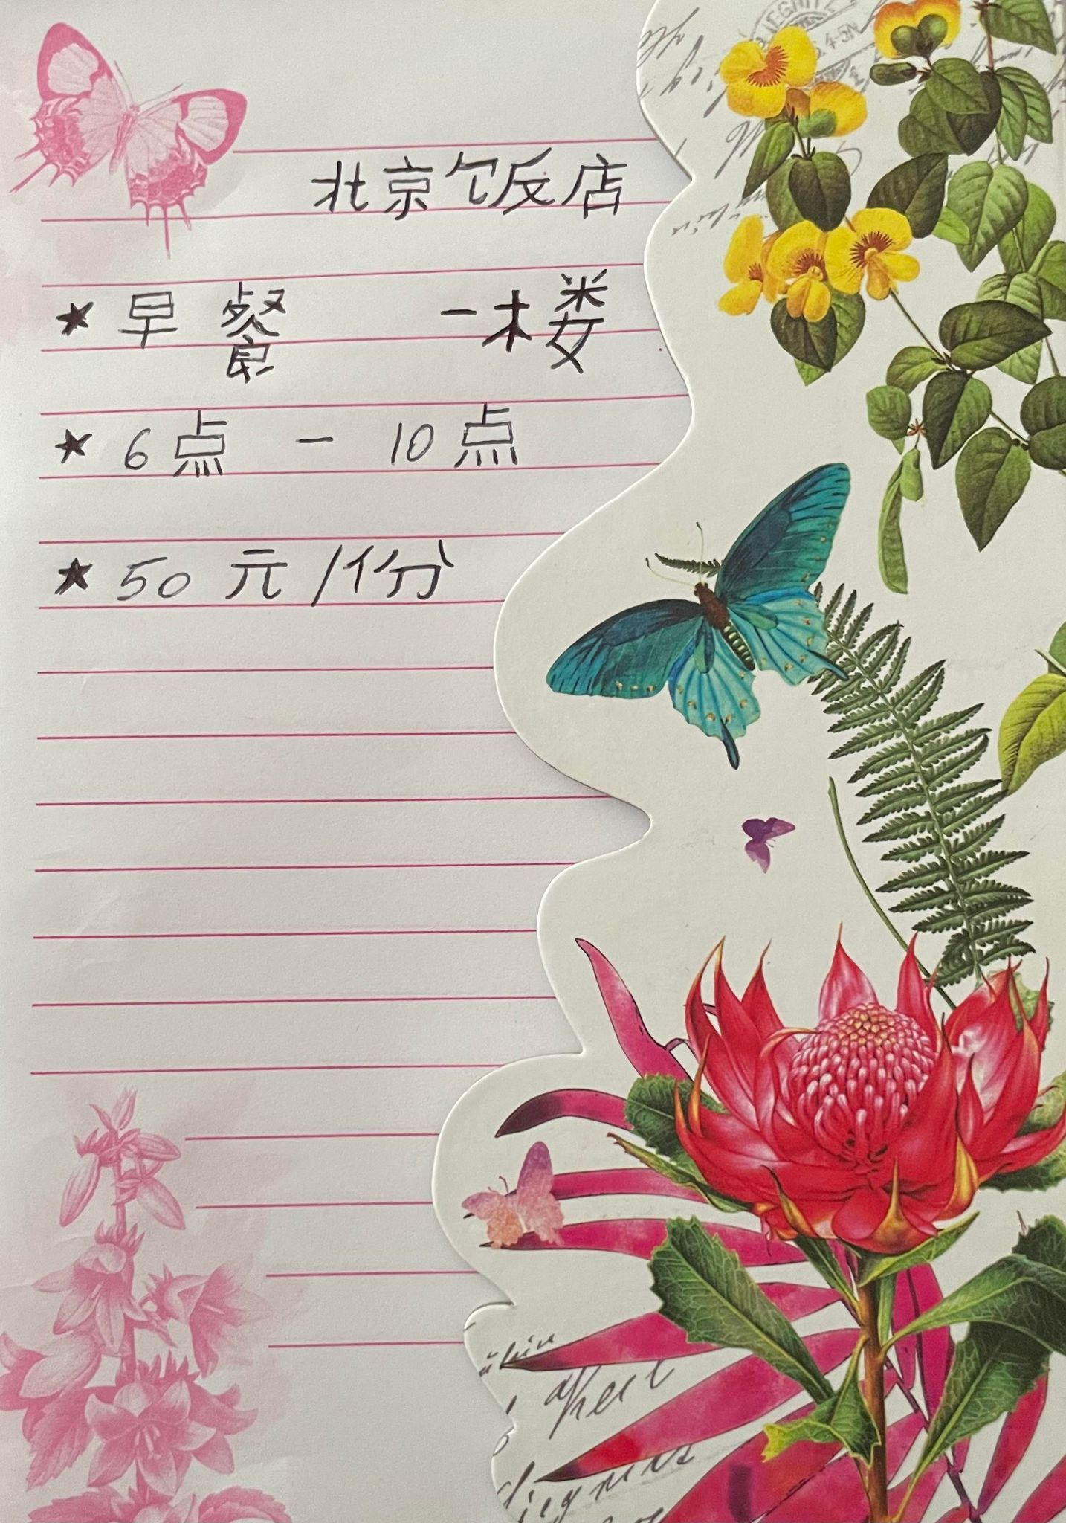

Student name:Alexandra Craescu
Student id:2111926
Foreign Languages & Cultural Awareness(BMIH5003)
Module tutor:Jinping Li

