NOSS Assignment 2:
Benjamin-David Crook
20/05/2022

Table of Contents
- Task 1
  - Share permissions
  - Accessing the file share/server over the network
  - Utilising Group Policy Management Console to better facilitate network object management

- Task 2
  - Deploy core services
  - Installing and configuring the Routing and remote Access Service
  - Filtering
    - Filter 1: Stopping ‘anyone’ in PrivateNet1 from Pinging the Router Firewall Service
    - Filter 2: Restrict Access to FTP Service running on Server2 to only hosts in Privatenet2
    - Filter 3: Only allow specific hosts in PrivateNet1 to access the FTPService running on Server2

- Task 3
  - Observational Tasks
    - What are sound password principles and why are they important
    - How are these principles used in modern network environments
      - Unique Passwords
      - Character length
      - Do not use personal information
      - Change passwords regularly
  - Cases of passwords being exploited
  - Multifactor authentication protocols
    - Examples of Multifactor authentication
      - SMS Token Authentication
      - Email Token Authentication
      - Biometric Verification
  - Failover clustering for high availability systems/services
    - What is failover cluster
  - Concepts that need careful consideration when considering the usage of using a failover cluster system
    - What is failover cluster
    - Concepts that need careful consideration when considering the usage of using failover cluster system
    - How windows server OD environment that could provision these requirements
    - Role being configured to work with Hyper-V virtual Machines
    - Importance of a failover cluster for a network
  - Network Administrator of an Enterprise Network
    - Network Policy
      - Architecture of the design
    - Critical business applications
      - High availability practices of the network
      - Security practices of the network

- Bibliography

Task 1: Manging and maintaining network resources using network policy and security practices

Server 1 - The below image is displaying an account that belongs to the Administrators group.
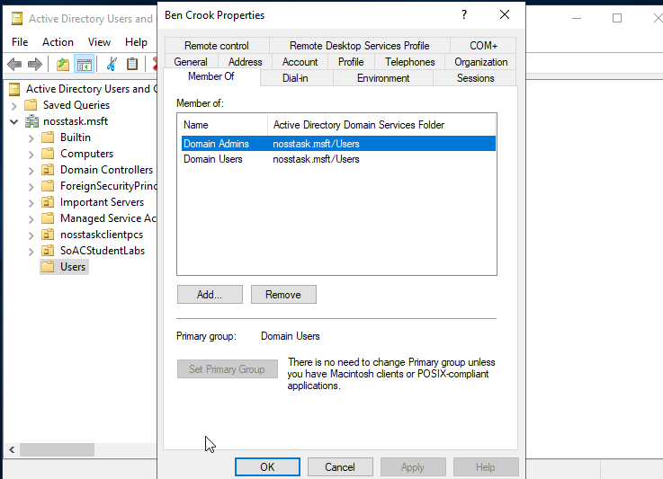

Client 1 - Logging into the Windows 10 Client with an account that belongs to the Adminstrators group
- Admin account
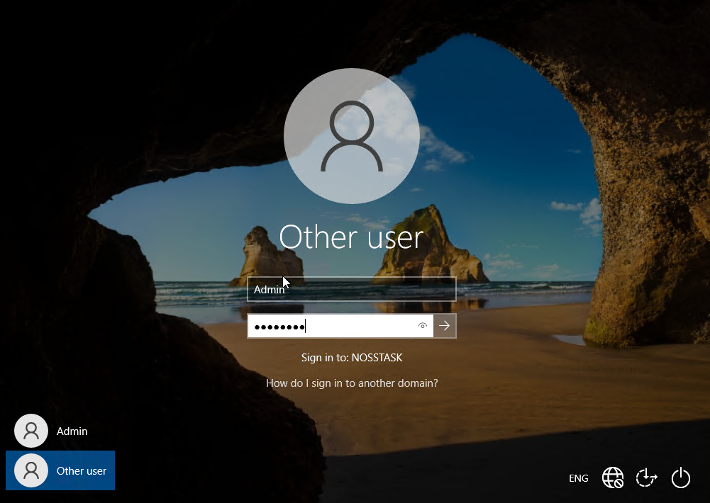
Client 1 - Creating a new folder in the Windows C: drive called ‘share_files_noss’
- File name – ‘share_files_noss’
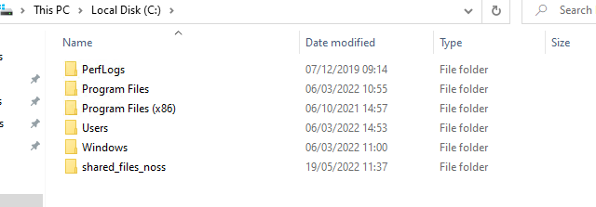

Client 1 – Creating a text file document
- To demonstrate NTFS permissions
- File re-named ‘important_files’
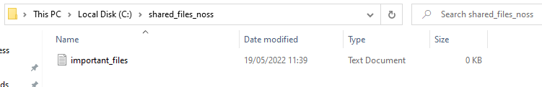

Client 1 – Disabling inherited permissions
- Remove all inherited permissions from this object
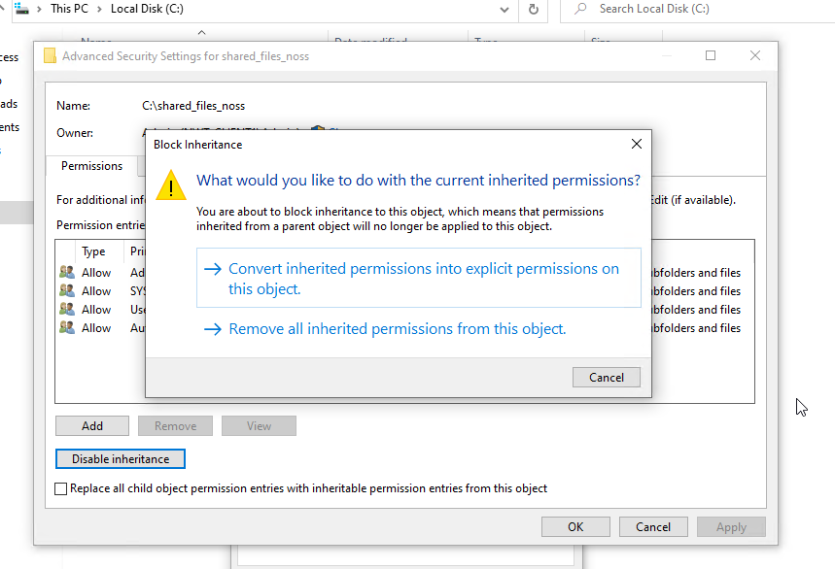

Client 1 – Adding account back to allow for access
- Add ‘Admin’ account
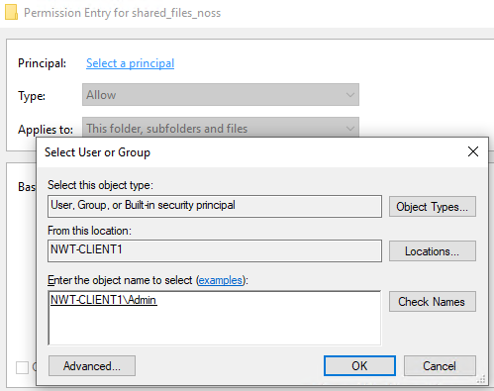
Client 1 – Permission has been set for ‘Admin’ account
- Admin account now has permission
- Only 1 access control entries present ‘Admin’ account
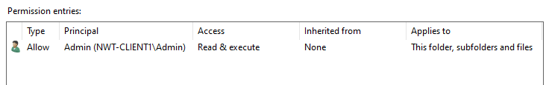

Client 1 - Reducing the user’s permissions
- List folder contents
- Read
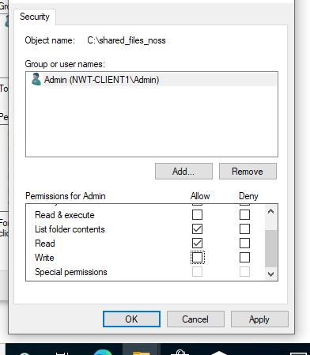

Client 1 – User cannot modify the text file
- Important_files.txt
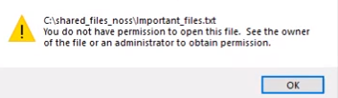

1.2 Share Permissions
Server 1 – Creating a new share on the ‘File and Storage Services’
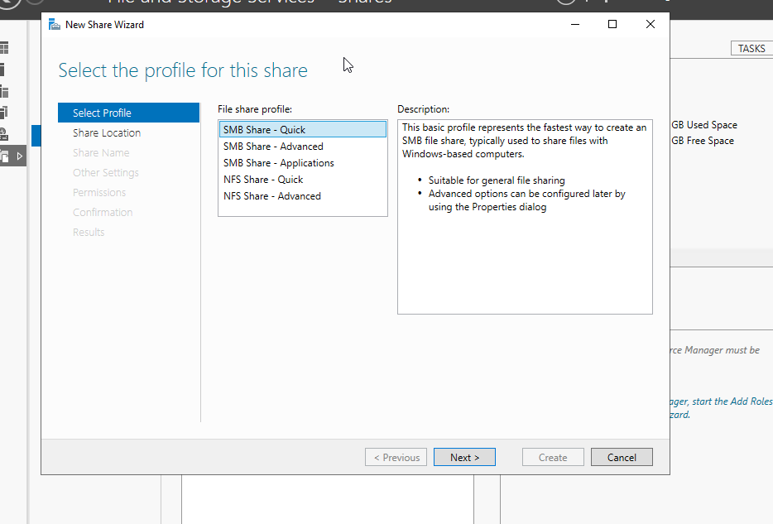
Server 1 – Share by volume
- Select by volume
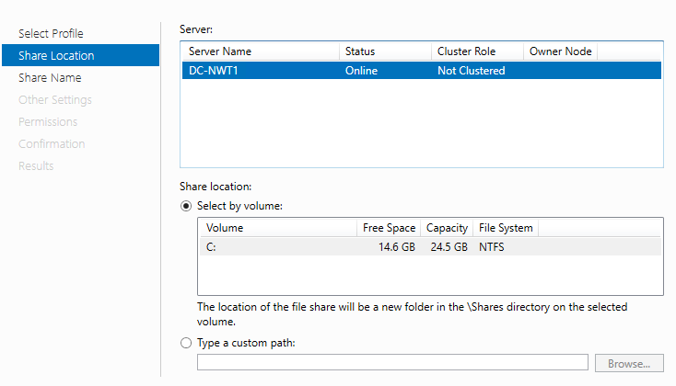

Server 1 – Creating share name
- Share_Files_NOSS$
- Local path – C:\Shares\Share_Files_NOSS$
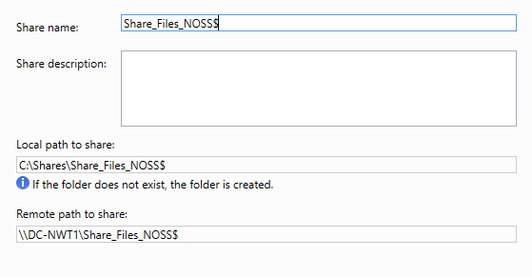

Server 1 – Configuring share settings
- Enable access-based enumeration
- Allow caching of share – allows to display folders even offline
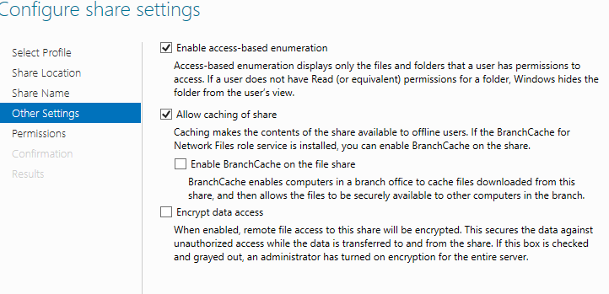

Server 1 – Setting permissions
- Administrator - full control
- Ben Crook – full control
- John Wick – Read & execute
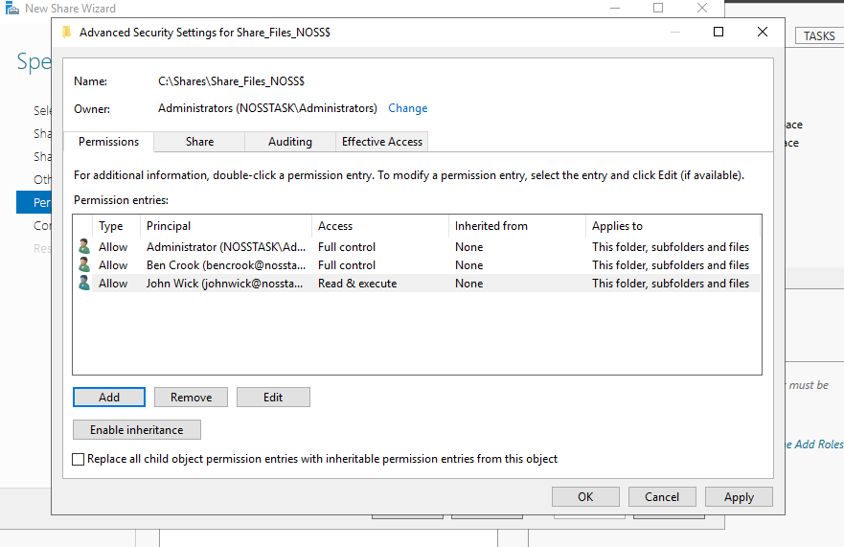

Server 1 – Share successful created
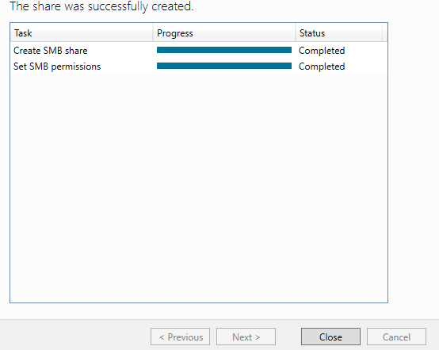

1.3 Accessing the file share/server over the network
Client 1 – Viewing Map Network Drive
- Folder - \\dc-NWT1\SHARE_FILES_NOSS$
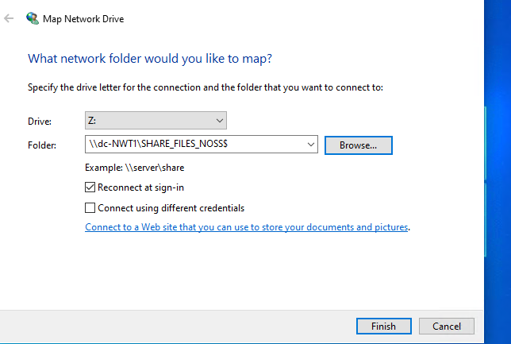
Client 1 – Viewing Map Network Drive in ‘This PC’
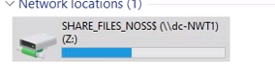

2.0 Utilising Group Policy Management Console to better facilitate network object management

Server 1 – Example of Group Policy Management
- Everything is viewable in the yellow containers (OU’s)
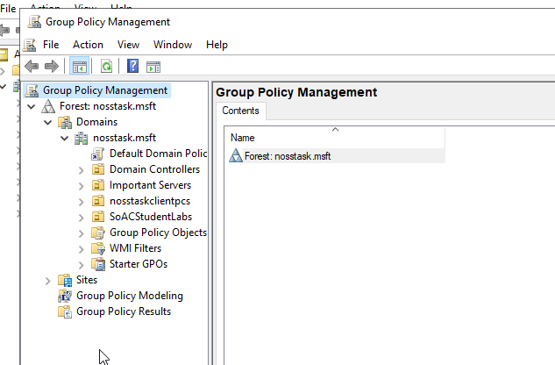
2.1 Configuring User Environment and Computer Environment. ‘Network Group Policy Objects’

Server 1 – Creating non admin organizational unit
- File name – ‘Non admin users’
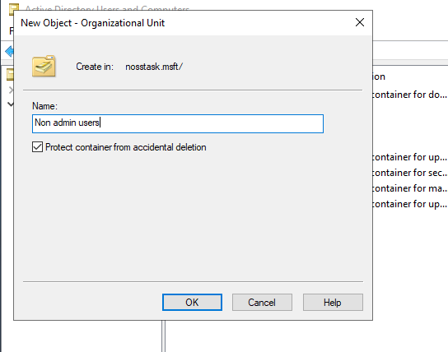

Server 1 – Creating new user in non admin user’s unit
- User ‘Tim Wish’
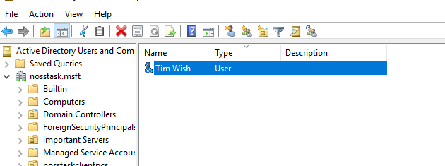

Server 1 – Creating a new group policy object in the Non admin user’s unit
- NoCtrlPanAccess – No control panel access
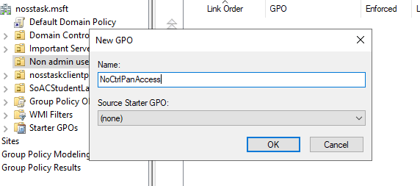

Server 1 – Enabling group policies
- Enable via settings
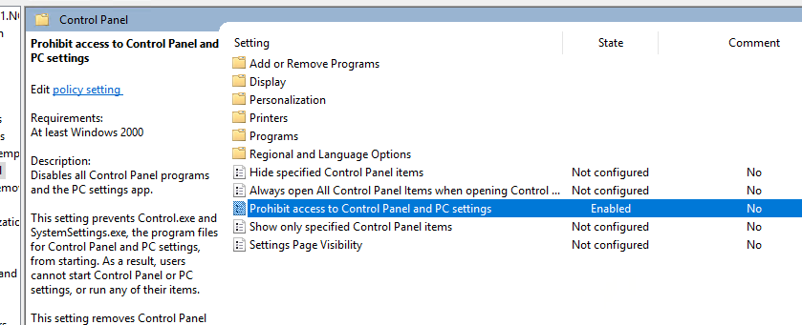

Server 1 – Updating server policy via command prompt
- Gpupdate /force
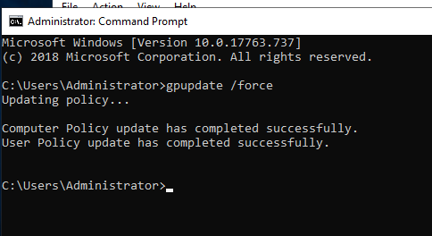
Client 1 – Removing command promote for newly created non admin account
- User – Timwish
- This is useful as users could cause damage to the network if they are able to gain access
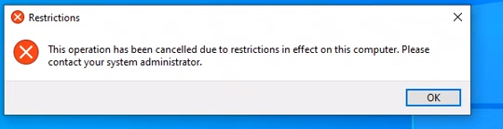
Server 1 – Creating new Group Policy
- NoCMDPrmptAccess

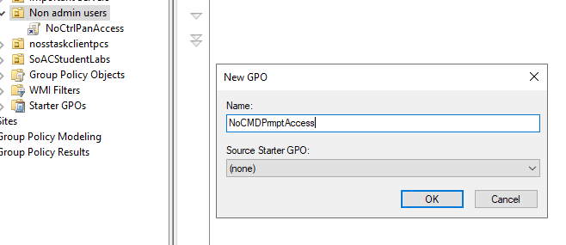
Server 1 – Preventing access to the command prompt
- Enabled
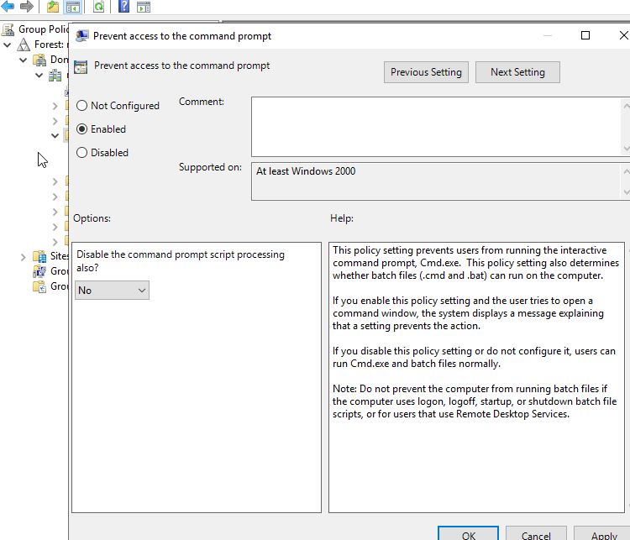

Server 1 – Updating new group policy via command prompt
- Gpupdate /force
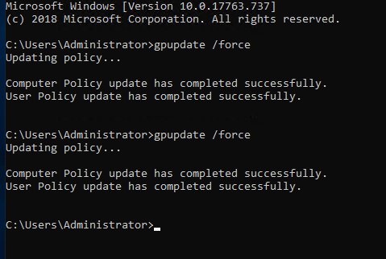
Client 1 – Displaying that command line has been displayed by administrator
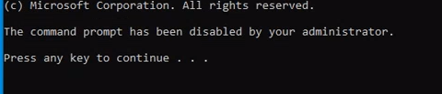

Server 1 – Creating third policy to remove media drives
- NoRemDriveAccess
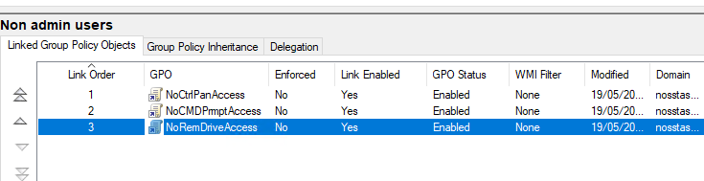

Server 1 – Removing storage classes: Deny all access
- Enabled
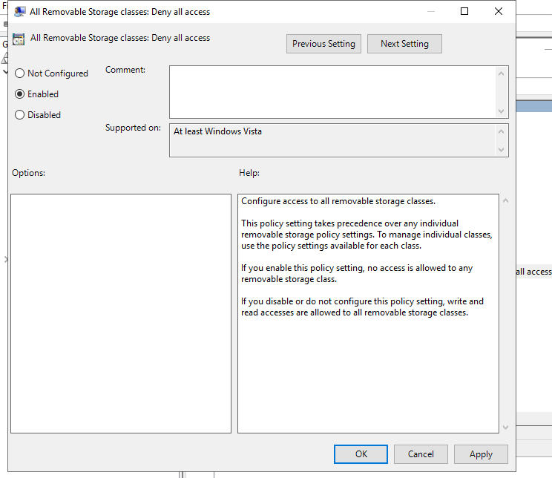

Server 1 – Creating a new organizational unit
- NWClientComputers
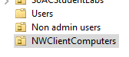

Server 1 – Moving NWT-CLIENT into NWClientComputers
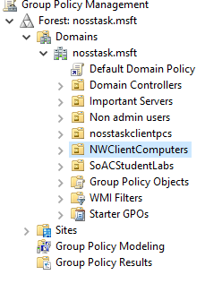

Server 1 – Creating new organizational unit
- File name – NoUnauthSwareInstalls
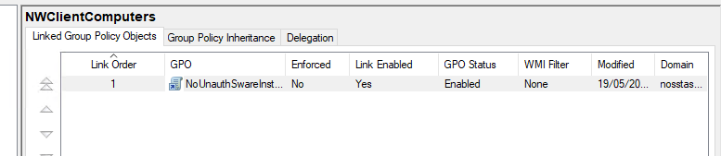

Server 1 – Prohibiting user installs
- Enabled
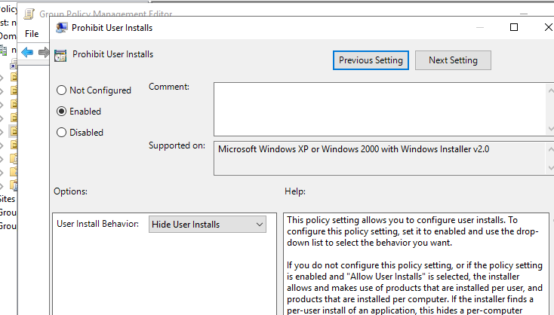

Server 1 – Updating group policy
- Gpupdate /force

Client 1 – Testing if user can download software
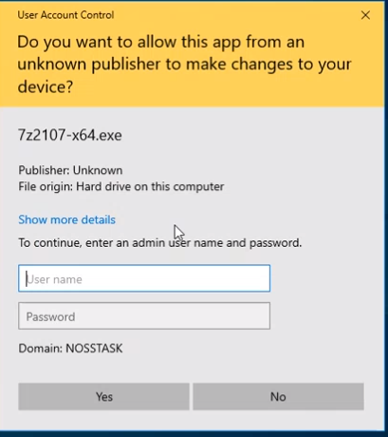

Server 1 – Setting Password policy
- 6 passwords remembered
- 10 days
- 1 days
- 8 characters
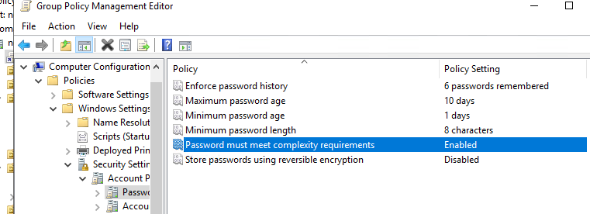

Server 1 – Updating newly added password policy via command prompt
- Gpupdate /force
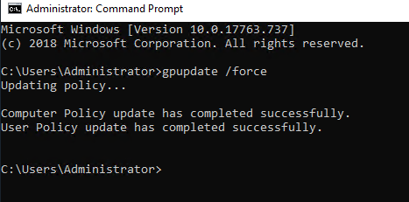

Server 1 – Creating a new user and testing password if a password below 8 characters can be set
- Password – 1234
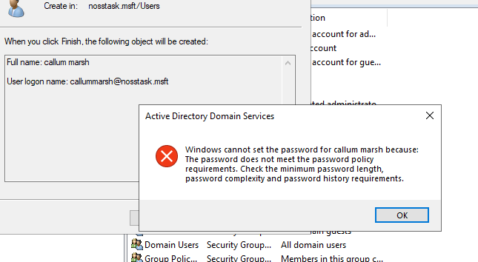

Server 1 – New user created based on meeting the password complexity requirements
- P@ssw0rd1234
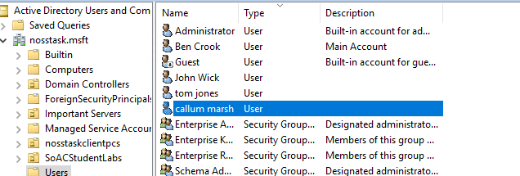

Server 1 – Running command prompt
- Enter command - ARP -A
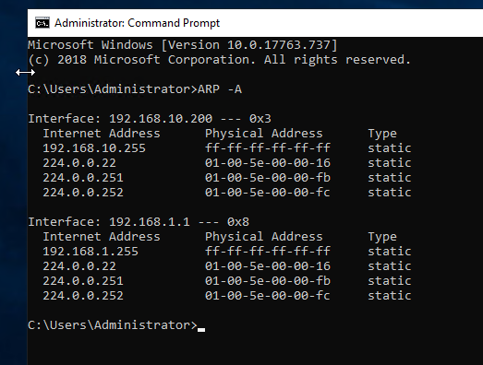

2. Deploy core services (FTP Server)

Server 2 - Adding roles and features via server manager
- Role-based or feature-based installation
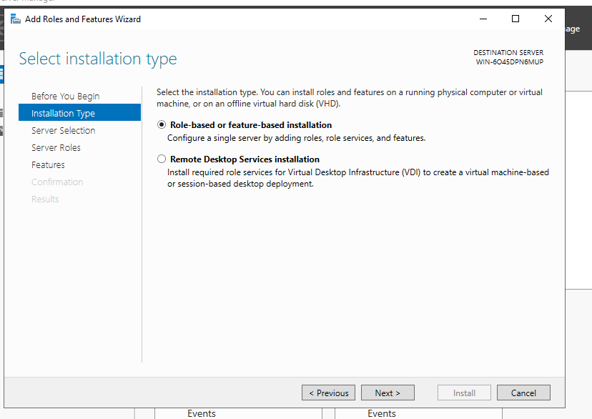

Server 2 – Adding server roles
- Click Web Server (IIS)
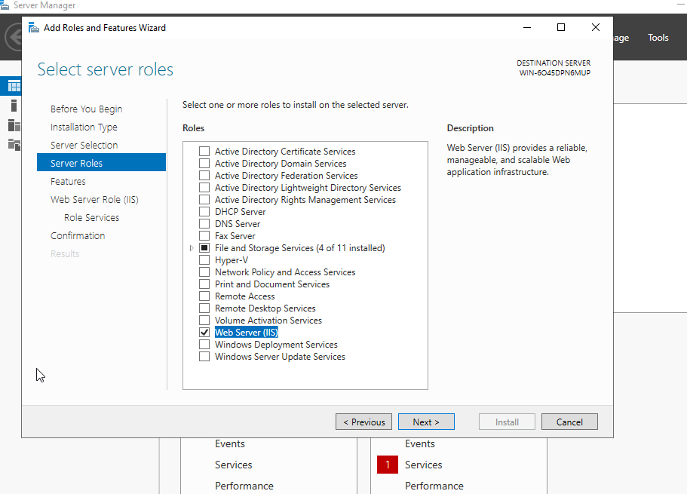

Server 2 – Web Server Role (IIS)
- FTP Server
- FTP Service
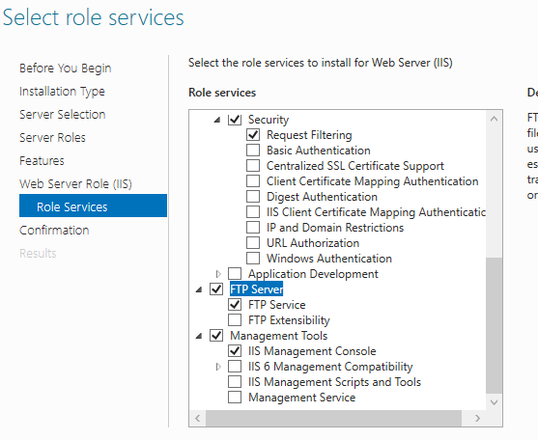

Server 2 – Creating a user account to test FTP to the server
- Name: ftpuser22
- Password: P@ssw0rd
- Check off ‘user must change password at next logon setting’
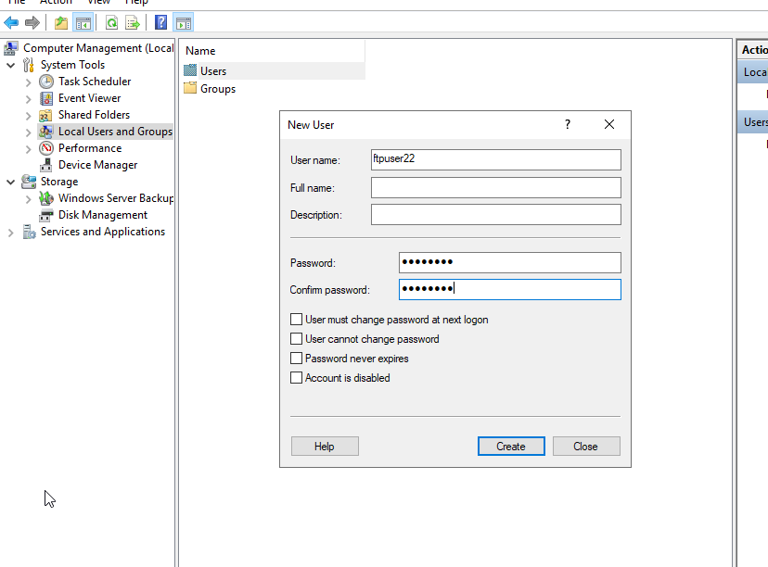

Server 2 – Add FTP Site
- Name: MYFTPSITE
- Path: C:\inetpub\ftproot

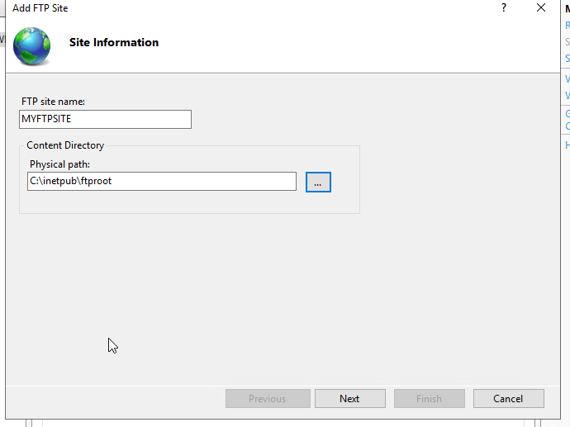

Server 2 – Binding and SSL Settings
- No SSL
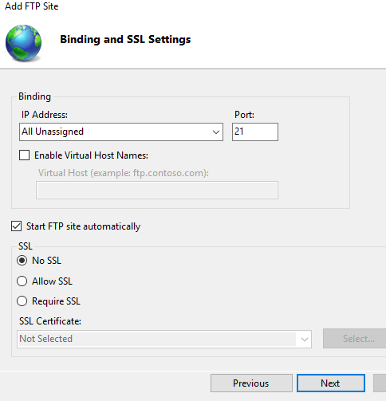

Server 2 – Authentication and Authorization Information
- Authentication: Basic
- Allow Access to: Specified users
  - Server2.2\ftpuser22
- Permissions
  - Read
  - Write
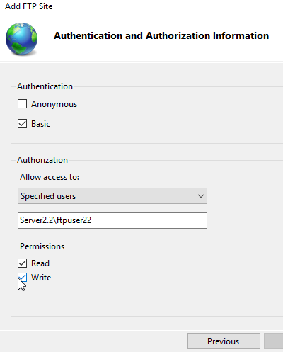

Server 2 – Adding FTP messages on MYFTPSITE
- Banner: “Test message in Banner field”
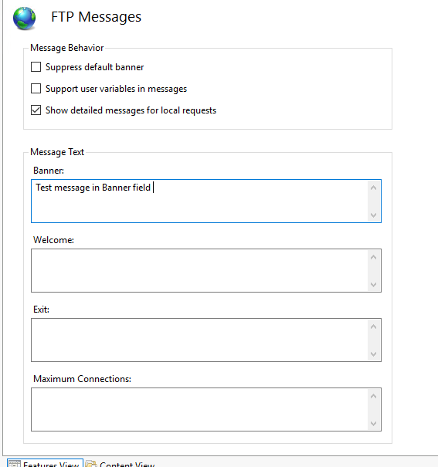

Server 2 – Adding created user to allow for permissions
- Ftpuser22
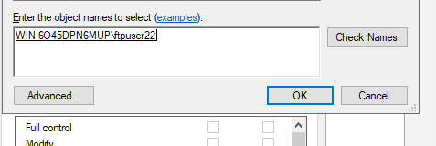
Server 2 – Creating new folder in C:\inetpub\ftproot
- Folder name: MyFtpuploads
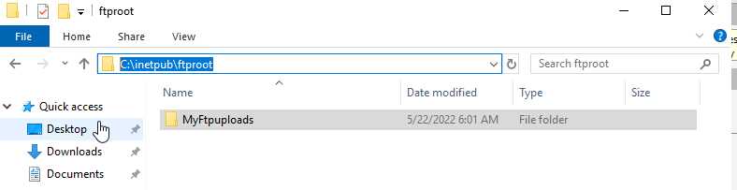
Server 2 – Turning off Firewall
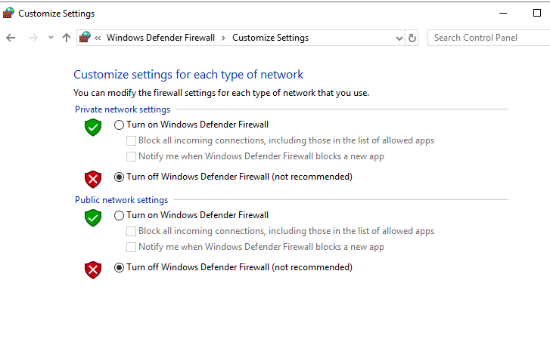

Server 2 – Viewing added txt document from Client 2
- Myftpfile2upload.txt
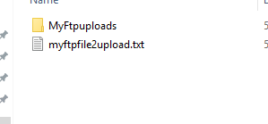

3. Installing and configuring the Routing and Remote Access Service

Server 1 – Adding roles and features via server manager
- Role-based or feature-based installation
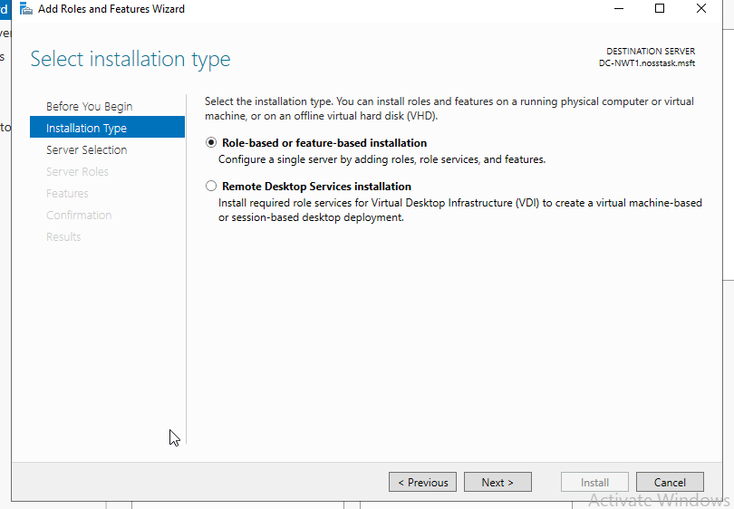
Server 1 – Select server from server pool
- DC-NWT1.nosstask.msft
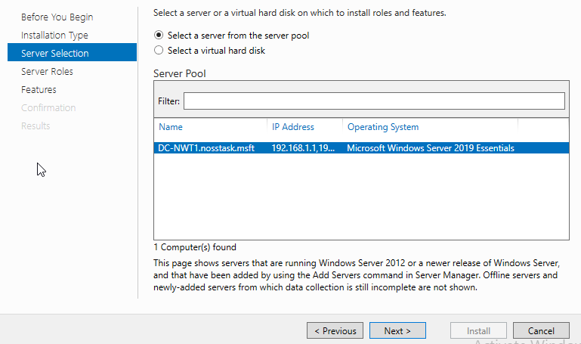
Server 1 – Server roles
- Select Remote Access
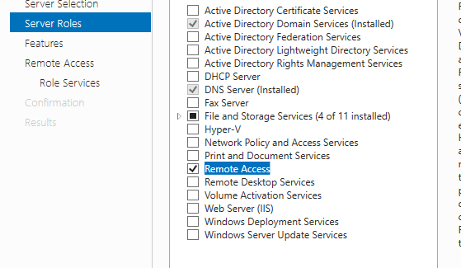

Server 1 – Role Services
- DirectAccess and VPN (RAS)
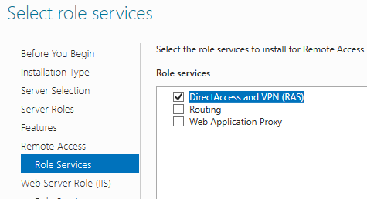

Server 1 – Configure remote access
- Deploy VPN only
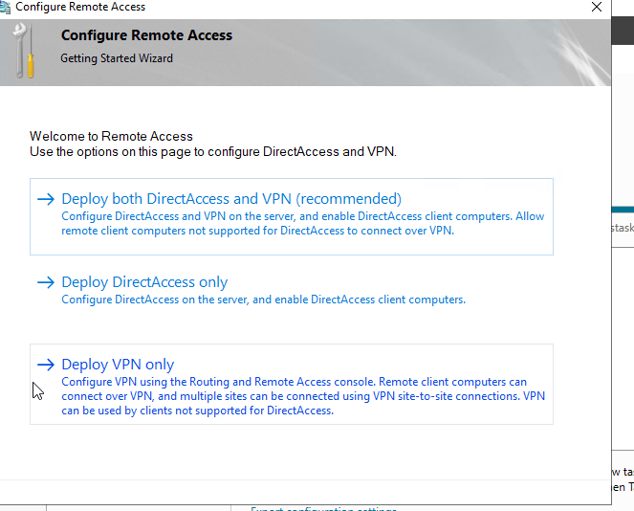

Server 1 – Routing and Remote Access Server Setup Wizard
- Custom configuration
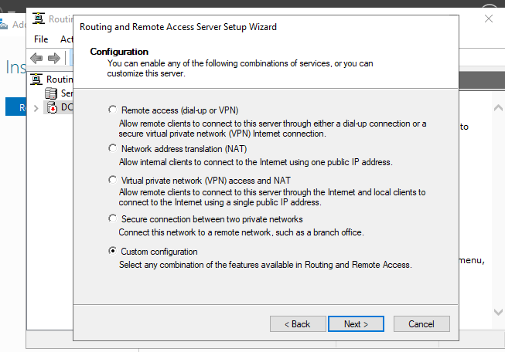

Server 1 - Routing and Remote Access Server Setup Wizard
- LAN routing
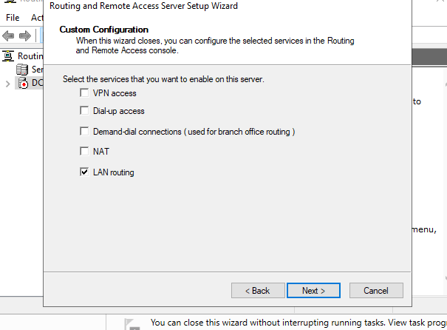

Server 1 – Services are now running
- Arrow has turned green
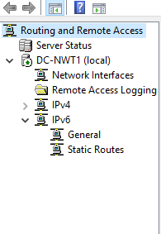

Server 1 – Adding the server into RIP
- PublicNet
- PrivateNet1
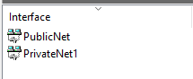

Server 2 – Adding roles and features wizard
- Role-Based or feature-based installation
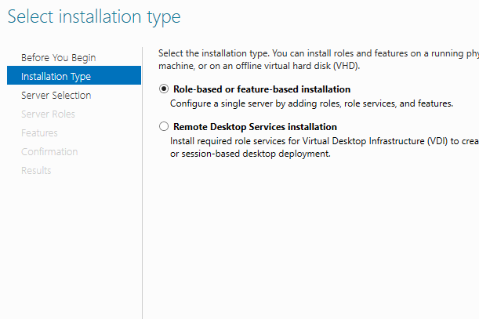

Server 2 – Server roles
- Remote Access
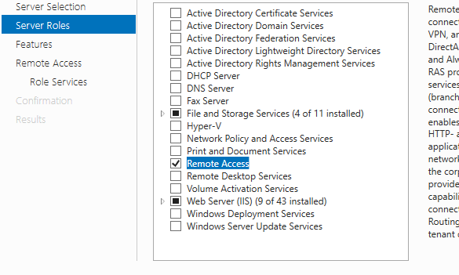

Server 2 – Role services
- DirectAccess and VPN (RAS)
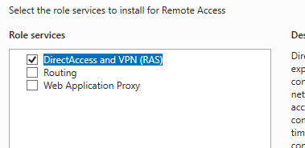

Server 2 – Configure Remote Access
- Custom Configuration
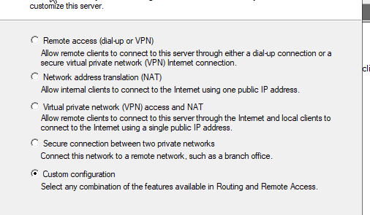

Server 2 – Custom Configuration
- LAN routing
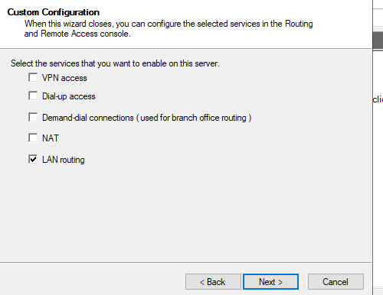

Server 2 – Start Service
- Start Service
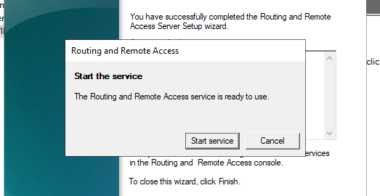

Server 2 – Service as started
- Icon is now presented ‘green’ from ‘red’
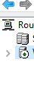
Server 2 – IPV4
- New routing protocol added (RIP)
- Routing protocols added to RIP

Server 1 – Pinging Server 2 on its ‘PublicNet’ IP address
- Public address pinged from server 1
- 192.168.10.201
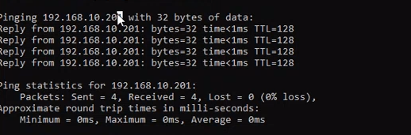
Client 1 – Default Gateway
- IP Address: 192.168.1.2
- Default Gateway: 192.168.1.1
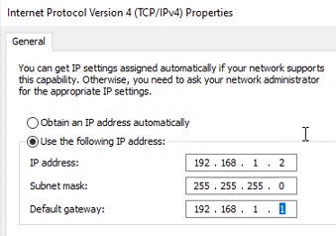
Client 1 – Pinging Client 2 VM, on its PrivateNet2 IP address
- Ping 192.168.11.2

Filter 1: Stopping ‘anyone’ in PrivateNet1 from Pinging the Router Firewall Service

Server 1 – Routing and remote access
- Inbound filters
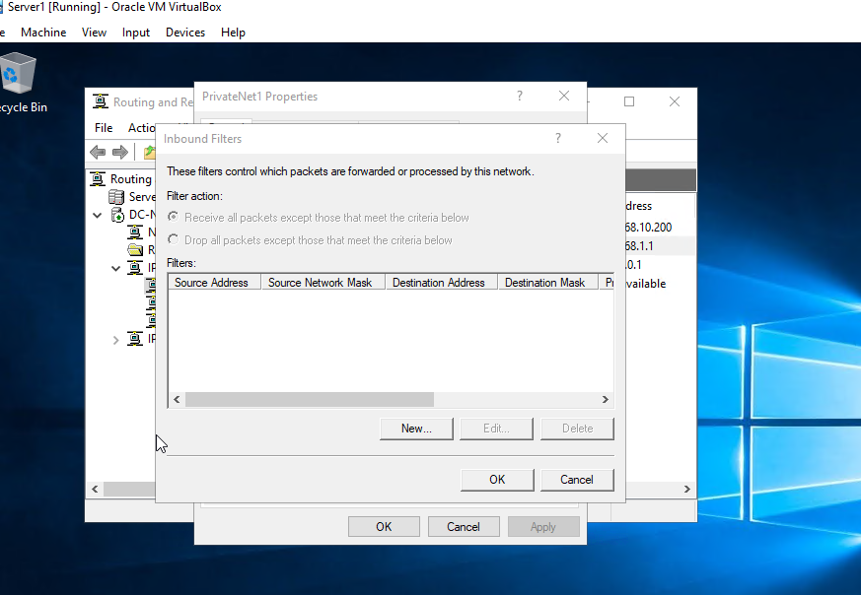

Server 1 – Destination network
- IP Address: 192.168.1.1
- Subnet mask: 255.255.255.255
- Protocol: ICMP
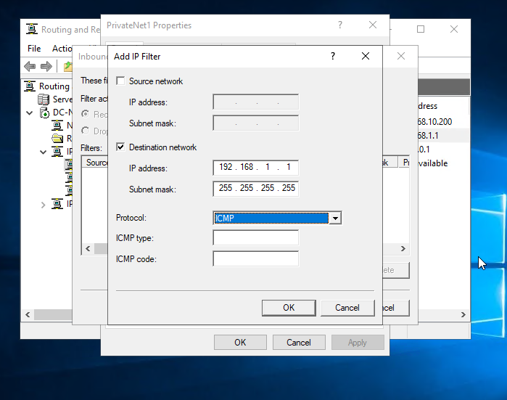

Server 1 – Filter Action
- Receive all packets expect those that meet the criteria below
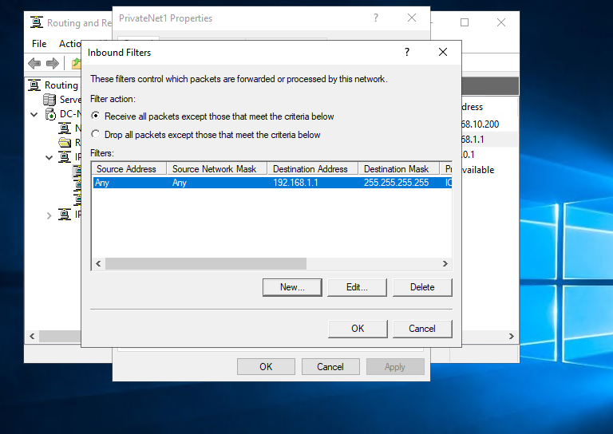

Client 1 – Making sure Client 1 cannot ping Server 1
- ICMP blocking packets from being sent to set IP address
- Request timed out
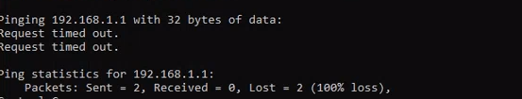

Filter 2: Restrict Access to FTP Service running on Server2 to only hosts in PrivateNet2

Server 1 – Routing and Remote Access
- Outbound filter
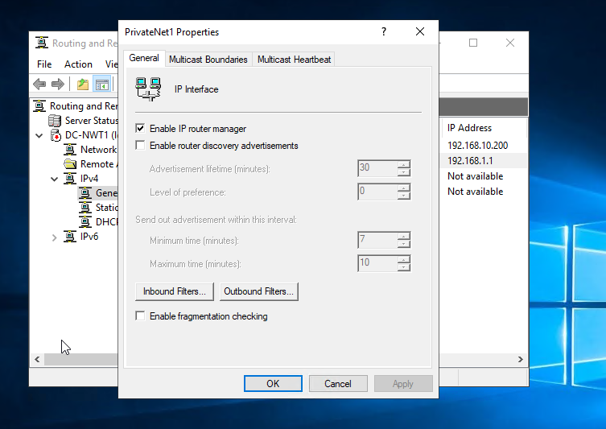

Server 1 – Restricting Privatenet1
- IP Address: 192.168.10.201
- Subnet Mask: 255.255.255.255
- Protocol: TCP
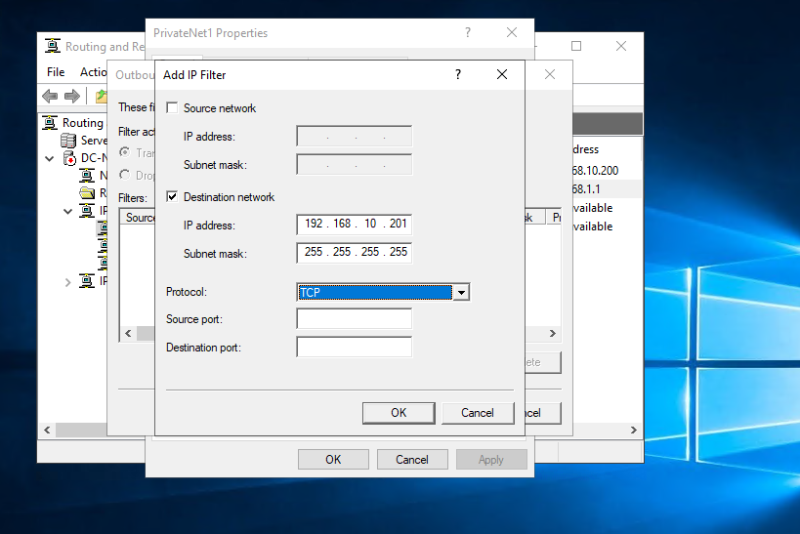

Server 1 – Outbound filters
- ‘Transmit all packets expect those that meet the criteria below’
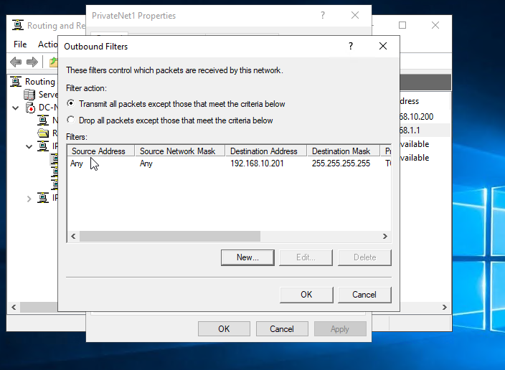

Client 1 – Testing ftp
- 192.168.10.201
- Command timed out
- Ping still works due to protocol only blocking FTP not IP
- Below screenshot displaying ping protocol still works
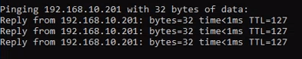

Filter 3: Only allow specific hosts in PrivateNet1 to access the FTPService running on Server2

Server 1 – Routing and Remote Access
- Inbound filters
- IP Address: 192.168.11.1
- Destination port: 21
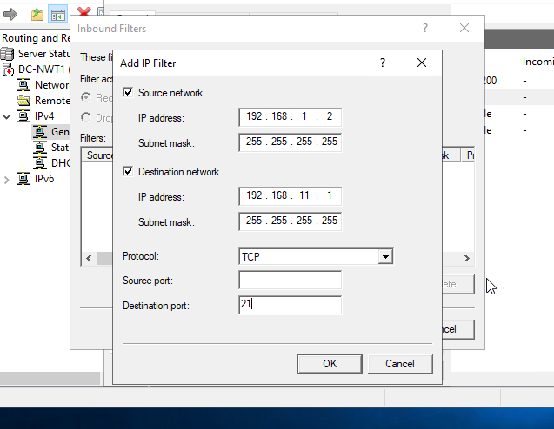

Server 1 – Routing and remote Access
- Inbound filters
- IP Address: 92.168.10.201
- Destination port: 21
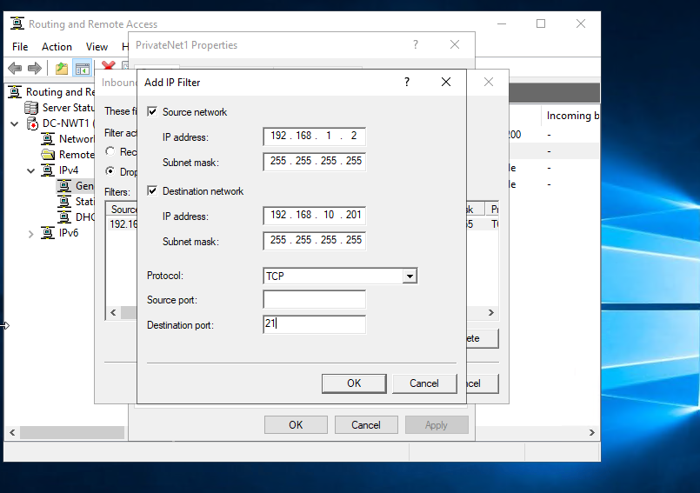

Server 1 – Inbound filters
- Drop all packets except those that meet the criteria below
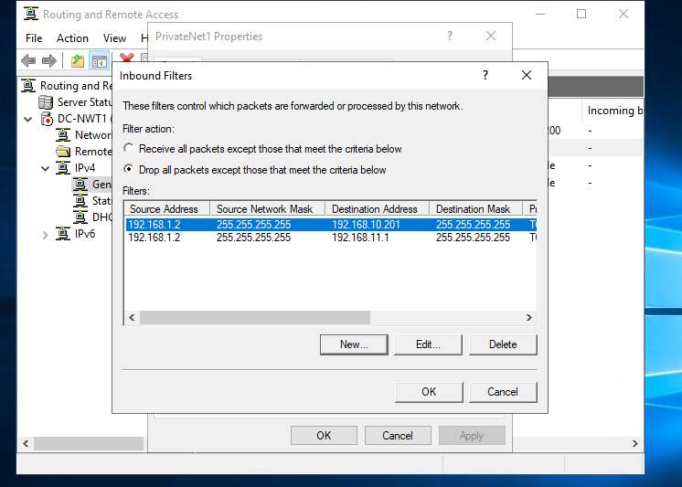
Client 1 – Testing connection via command line
- ftp 192.168.11.1
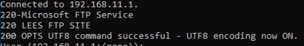

Task 3:

- Observational Task

- What are sound password principles and why are they important
Passwords are important as they are the first line of defence against people trying to gain access to a user’s personal account via cyber attacks [1].
It is important that a user has a strong unique password for each account they create and have access too, [2] these passwords could be. The stronger the password created by the user, the less of chance of your computer being hacked or data being stolen [3].

- How are these principles used in modern network environments
  - Unique Passwords
The first principle used in networking environments would be ensuring each of the employees or users use a unique password for each of their important accounts [4]. The reasoning behind this if one account gets compromised, they wouldn’t have the rest of your passwords.
  - Character length
A password should be at least 8 characters long. This unique password should contain a number of different numbers, symbols, numbers and upper and lower case letters [5].
The longer the password the more protection is offered, and this will make it more difficult for attackers to gain control [6].
  - Do not use personal information
    - Using personal information would allow people who are closer to you to have a better chance of gaining access to your sensitive data [7].

  - Change passwords regularly
    - Avoid using the same password for each of your created accounts [8]. The reasoning behind this is that if an attacker gets hold of on account such as Hotmail, they would be able to get into most of apps and social

- Cases of passwords being exploited
Over 61% of data breaches involved the user of brute force [9]. A brute force attack is a type of method that attackers use as a trial and error method to get users passwords [10].
At the start of 2021, DailyQuiz suffered a huge data breach that allowed hackers to access their database that contains around 13 million accounts with user’s personal details [11]. The type of details stolen where the plaintext passwords, email addresses and IP addresses. This sensitive information was put up for sale on the Dark Web [12].
A company story sensitive data in plaintext not in an encrypted format is a massive risk that a lot of organizations make. If this type of data is encrypted, it will be useless to the attacker [13].
Having unique passwords for each of your person accounts is important as if one password is compromised, they will not be able to gain access to your other account via the compromised password.
- Multifactor authentication protocols
Multifactor authentication is an authentication method that would take extra steps for the user to take to ensure that the correct user is able to connect to their account [14]. This massively decreased the chances of a cyber-attack.
  - Examples of Multifactor authentication
    - SMS Token Authentication
This method of authentication isn’t as complex as it is made out. After a user sign’s in using their personal credentials for their account they will receive a text message of the given phone number on their account contain a SMS authentication code [15]. This method has been implemented in many big organizations due to this being so simple but effective it is a no brainer to be implemented [16].
    - Email Token Authentication
This methos of email authentication it provides a way for users to verify that it is them trying to gain access to their account. Token based authentication is a web authentication protocol.
This gives the user a uniquely one time generate encrypted token that they can use to prove it is them. [17]
    - Biometric Verification
This type of verification is a biometric check where a user can be uniquely identified by one of their distinguishing biological traits [18].
Face recognition is a type of technology that it being massively used as a type of verification, the process of this scans the characteristics in the user’s face to compare it to the users ID card or passport [19].

- Failover clustering for high availability systems/services
  - What is failover cluster
A failover cluster is a bunch of independent computers with the aim of increasing the availability and scalability of clustered roles [20]. The created clustered server is all linked up via physical cables and by software [21].
If one of the created cluster nodes fail, the other create nodes begin to provide service this is where the name failover is known [22].
  - Concepts that need careful consideration when considering the usage of using a failover cluster system
This is a great tool to use to get high availability in an organization’s environment. This is not easy the configuration there takes a lot of careful steps but once [23].
Before implementation of the failover cluster a user understand that a lot of different things needs to put into place. At least 2 servers with the same hardware requirements need to put into place [24]. HYPER-V hardware requirements need to put into place, the reasoning behind this it needs to link with the created servers [25].

  - How Windows Server OD environment that could provision these requirements

The operating system would need to have up to date licenses for example ‘Windows Server 2016 Datacentre’. If creating a VM the user would have to ensure Windows Firewall is disable this will allow you to manage the created Nodes [26].
The use of PowerShell can be used to disable the Windows Firewall in both created nodes [27].
  - Role being configured to work with Hyper-V Virtual Machines
Each highly available virtual machine is thought to be considered as a role in Failover terminology. A role in a cluster ensures the protection item itself [28].
The use of Hyper-V in created VM’s allows the roles node to be configured and view the items that the cluster is protecting [29].
Below is a display of the types of roles that the user wants to be able to configure for high availability.
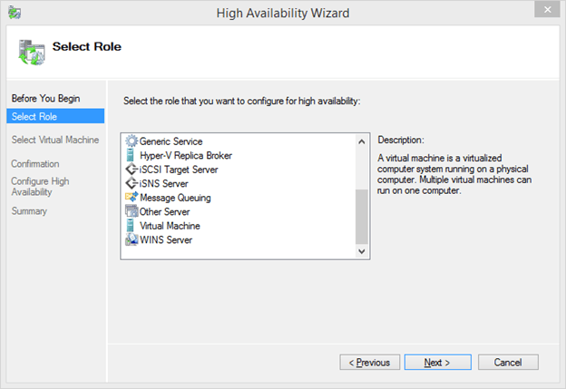
Figure 1 - Image displaying roles being selected [30]

  - Importance of a failover cluster for a network
A cluster provides protection against anything that may cause downtime for important applications or different types of services that may need to be always online. The fact that even if one event causes a failure in one system, there will be able service that is available [31].
It is critical for a network to minimize all the protentional things that can cause a delay in production or productivity. Using cluster networks helps minimize the possible thought of risk over partitions of the network.
- Network Administrator of an Enterprise Network
  - Network Policy
Network policies are sets of conditions, constraints, and the settings that allow the user to assign who is authorized to be able to gain access to the network and the circumstances under what they can and cannot do. [32]
    - Architecture of the design
Network architecture refers to a network’s structural and logical layout [33].
Having multiple locations means all the offices/locations would have to be able to connect to each other. To connect many distant employees at once, all these different locations nationwide must be able to access the same network resources [34].
The common practice for companies to use is to install Wide Area Networks to connect remote offices [35]. WANs are used to connect to LANs from disparate offices [36].
  - Critical business applications
    - High availability practices of the network
Highly available architecture involves the use of many components working together to ensure uninterrupted service during a specific set period [37].
Implementing architecture such as cloud computing enables this key to continuous operation of the critical applications and services [38].
    - Security practices of the network
A good network security system helps businesses or organizations help reduce the risk of having their data stolen or sabotaged. Different types of network security help protect the workstations from harmful attacks such as spyware [39].
Performing a network audit is a great first step in the right direction to secure a network. This helps identify the weakness in the network posture and design [40]. This checks for open ports and presence of security vulnerabilities [41].
Disabling file sharing feature is a simple say to ensure file sharing is on a few independent and private servers. This should be disabled on all employee devices. [42]
Finally updating antivirus and anti-malware software, most newly laptops come with the latest version of anti-virus and anti-malware software built in. Ensuring this is up to date with the latest rules and updates is important for the security of the network. [43]

4. Bibliography

Bibliography

[1] | O. Ncsu, "Oit Ncsu," [Online]. Available: https://oit.ncsu.edu/2017/06/12/use-sound-password-practices-to-protect-your-data/. [Accessed 20 05 2022].
[2] | O. News, "oit ncsu," [Online]. Available: https://oit.ncsu.edu/2017/06/12/use-sound-password-practices-to-protect-your-data/. [Accessed 20 05 2022].
[3] | u. Ottawa, "it uottawa," [Online]. Available: https://it.uottawa.ca/security/identity-authentication-theft#:~:text=Passwords%20provide%20the%20first%20line,all%20accounts%20on%20your%20computer.. [Accessed 20 05 2022].
[4] | uottawa, "it uottawa," [Online]. Available: https://it.uottawa.ca/security/identity-authentication-theft#:~:text=Passwords%20provide%20the%20first%20line,all%20accounts%20on%20your%20computer.. [Accessed 20 05 2022].
[5] | Uottawa, "it uottawa," [Online]. Available: https://it.uottawa.ca/security/identity-authentication-theft#:~:text=Passwords%20provide%20the%20first%20line,all%20accounts%20on%20your%20computer.. [Accessed 20 05 2022].
[6] | uottawa, "it uottawa," [Online]. Available: https://it.uottawa.ca/security/identity-authentication-theft#:~:text=Passwords%20provide%20the%20first%20line,all%20accounts%20on%20your%20computer.. [Accessed 20 05 2022].
[7] | uottawa, "it uottawa," [Online]. Available: https://it.uottawa.ca/security/identity-authentication-theft#:~:text=Passwords%20provide%20the%20first%20line,all%20accounts%20on%20your%20computer.. [Accessed 20 05 2022].
[8] | uottawa, "it uottawa," [Online]. Available: https://it.uottawa.ca/security/identity-authentication-theft#:~:text=Passwords%20provide%20the%20first%20line,all%20accounts%20on%20your%20computer.. [Accessed 20 05 2022].
[9] | expertinsights, "expertinsights," [Online]. Available: https://expertinsights.com/insights/the-most-significant-password-breaches/. [Accessed 20 05 2022].
[10] | Fortinet, "Fortinet," [Online]. Available: https://www.fortinet.com/resources/cyberglossary/brute-force-attack. [Accessed 20 05 2022].
[11] | expertinsights, "expertinsights," [Online]. Available: https://expertinsights.com/insights/the-most-significant-password-breaches/. [Accessed 20 05 2022].
[12] | expertinsights, "expertinsights," [Online]. Available: https://expertinsights.com/insights/the-most-significant-password-breaches/. [Accessed 20 05 2022].
[13] | expertinsights, "expertinsights," [Online]. Available: https://expertinsights.com/insights/the-most-significant-password-breaches/. [Accessed 20 05 2022].
[14] | onelogin, "onelogin," [Online]. Available: https://www.onelogin.com/learn/what-is-mfa#:~:text=For%20example%2C%20you%20only%20have,SMS%2C%20Voice%20and%20Oauth%20Token.. [Accessed 20 05 2022].
[15] | okta, "okta," [Online]. Available: https://www.okta.com/uk/blog/2020/10/sms-authentication/. [Accessed 20 05 2022].
[16] | okta, "okta," [Online]. Available: https://www.okta.com/uk/blog/2020/10/sms-authentication/. [Accessed 20 05 2022].
[17] | Swoop, "swoopnow," [Online]. Available: https://swoopnow.com/token-based-authentication/. [Accessed 20 05 2022].
[18] | ID, "IDNOW," [Online]. Available: https://www.idnow.io/glossary/biometrics/#:~:text=A%20biometric%20check%20is%20a%20process%20by%20which%20a%20person,the%20ID%20card%20or%20passport.. [Accessed 20 05 2022].
[19] | ID, "idnow," [Online]. Available: https://www.idnow.io/glossary/biometrics/#:~:text=A%20biometric%20check%20is%20a%20process%20by%20which%20a%20person,the%20ID%20card%20or%20passport.. [Accessed 20 05 2022].
[20] | Microsoft, "Microsoft," [Online]. Available: https://docs.microsoft.com/en-us/windows-server/failover-clustering/failover-clustering-overview. [Accessed 20 05 2022].
[21] | Microsoft, "Microsoft," [Online]. Available: https://docs.microsoft.com/en-us/windows-server/failover-clustering/failover-clustering-overview. [Accessed 20 05 2022].
[22] | Microsoft, "Microsoft," [Online]. Available: https://docs.microsoft.com/en-us/windows-server/failover-clustering/failover-clustering-overview. [Accessed 20 05 2022].
[23] | askme4tech, "askme4tech," [Online]. Available: https://askme4tech.com/how-prepare-and-install-failover-clustering-windows-server-2016. [Accessed 20 05 2022].
[24] | askme4tech, "askme4tech," [Online]. Available: https://askme4tech.com/how-prepare-and-install-failover-clustering-windows-server-2016. [Accessed 20 05 2022].
[25] | askme4tech, "askme4tech," [Online]. Available: https://askme4tech.com/how-prepare-and-install-failover-clustering-windows-server-2016. [Accessed 20 05 2022].
[26] | askme4tech, "askme4tech," [Online]. Available: https://askme4tech.com/how-prepare-and-install-failover-clustering-windows-server-2016. [Accessed 20 05 2022].
[27] | askme4tech, "askme4tech," [Online]. Available: The operating system would need to have up to date licenses for example ‘Windows Server 2016 Datacentre’. If creating a VM the user would have to ensure Windows Firewall is disable this will allow you to manage the created Nodes [26]. . [Accessed 20 05 2022].
[28] | Altaro, "Dojo," [Online]. Available: https://www.altaro.com/hyper-v/failover-cluster-manager/roles/. [Accessed 20 05 2022].
[29] | altaro, "Dojo," [Online]. Available: https://www.altaro.com/hyper-v/failover-cluster-manager/roles/. [Accessed 20 05 2022].
[30] | altaro, "Dojo," [Online]. Available: https://www.altaro.com/hyper-v/failover-cluster-manager/roles/. [Accessed 20 05 2022].
[31] | Networksandservers, "NetworkandServers," [Online]. Available: https://networksandservers.blogspot.com/2011/04/failover-clustering-i.html#:~:text=A%20cluster%20provides%20protection%20against,will%20be%20available%20on%20another.. [Accessed 20 05 2022].
[32] | Microsoft, "Microsoft," [Online]. Available: https://docs.microsoft.com/en-us/windows-server/networking/technologies/nps/nps-np-overview. [Accessed 20 05 2022].
[33] | fusionconnect, "fusionconnect," [Online]. Available: https://www.fusionconnect.com/blog/what-is-network-architecture#:~:text=Network%20architecture%20refers%20to%20a,and%20size%20of%20the%20network.. [Accessed 20 05 2022].
[34] | insider, "businessinsider," [Online]. Available: https://www.businessinsider.com/the-5-most-cost-efficient-ways-to-set-up-your-companys-technology-network-across-multiple-offices-2011-4?r=US&IR=T#1-choose-a-mode-of-communication-1. [Accessed 20 05 2022].
[35] | Insider, "businessinsider," [Online]. Available: https://www.businessinsider.com/the-5-most-cost-efficient-ways-to-set-up-your-companys-technology-network-across-multiple-offices-2011-4?r=US&IR=T#1-choose-a-mode-of-communication-1. [Accessed 20 05 2022].
[36] | businessinsider, "insider," [Online]. Available: https://www.businessinsider.com/the-5-most-cost-efficient-ways-to-set-up-your-companys-technology-network-across-multiple-offices-2011-4?r=US&IR=T#1-choose-a-mode-of-communication-1. [Accessed 20 05 2022].
[37] | phoenixnap, "phoenixnap," [Online]. Available: https://phoenixnap.com/blog/what-is-high-availability#:~:text=A%20highly%20available%20architecture%20involves,only%20online%2C%20but%20also%20responsive.. [Accessed 20 05 2022].
[38] | phoenixnap, "phoenixnap," [Online]. Available: https://phoenixnap.com/blog/what-is-high-availability#:~:text=A%20highly%20available%20architecture%20involves,only%20online%2C%20but%20also%20responsive.§. [Accessed 20 05 2022].
[39] | ecpi, "ecpi university," [Online]. Available: https://www.ecpi.edu/blog/importance-of-network-security-safety-in-the-digital-world#:~:text=A%20good%20network%20security%20system,shared%20data%20is%20kept%20secure.. [Accessed 20 05 2022].
[40] | resources.infosecinstitute, "infosecinstitute," [Online]. Available: https://resources.infosecinstitute.com/topic/9-best-practices-for-network-security/. [Accessed 20 05 2022].
[41] | resources.infosecinstitute, "infosecinstitute," [Online]. Available: https://resources.infosecinstitute.com/topic/9-best-practices-for-network-security/. [Accessed 20 05 2022].
[42] | nfosecinstitute, "resources.infosecinstitute," [Online]. Available: https://resources.infosecinstitute.com/topic/9-best-practices-for-network-security/. [Accessed 20 05 2022].
[43] | resources.infosecinstitute, "infosecinstitute," [Online]. Available: https://resources.infosecinstitute.com/topic/9-best-practices-for-network-security/. [Accessed 20 05 2022].

