Tomos Butterworth (2409888)
UWTSD Civil Engineering
Geotechnical soil testing portfolio

Abstract.
This portfolio displays results found from three key laboratory tests: the permeability tests (constant and falling head), the Atterberg limits test (liquid and plastic limits), and the sieve analysis test. These aim to give a detailed insight into the overall behaviour of the soil, helping to understand and predict how it would behave under different environmental and loading conditions. The separate soil samples used in the permeability tests were greatly contrasting- one identified as a clean sand, and the other a sand-gravel mixture. The clean sand was found to have a much greater permeability than the sand-gravel mixture due to its increased grain size. The Atterberg limits test used a different soil sample to the permeability test, being identified as a silt of intermediate plasticity, indicating moderate compressibility and sensitivity to moisture change. The sieve analysis provided data on the particle size distribution, allowing for accurate classification based on its gradation characteristics.
Although the samples were different throughout the three tests, they collectively highlight the correlation between texture, composition, and hydrology. The findings demonstrate how multiple different laboratory tests are needed for a thorough understanding a soil’s behaviour.

Table of Contents
1.0 Introduction to Soil Testing 4
2.0 Constant Head Permeameter 4
2.1 Introduction 4
2.2 Equipment List 5
2.3 Methodology 6
2.4 Results 8
2.5 Analysis 10
2.5.1 Constant Head 10
2.5.2 Falling Head 10
2.5.3 Comparative Conclusion 11
2.6 Conclusion 11
2.6.1 Limitations 12

3.0 Atterberg Limits 13
3.1 Introduction 13
3.2 Equipment of Liquid Limit Test 13
3.3 Methodology of Liquid Limit 15
3.4 Equipment of Plastic Limit Test 18
3.5 Methodology of Plastic Limit 19
3.6 Results 22
3.7 Analysis 24
3.8 Conclusion 24
3.8.1 Limitations 25

4.0 The Sieve Analysis Gradation Test for Textural Classification of a Soil Sample 26
4.1 Introduction 26
4.2 Equipment List 27
4.3 Methodology 28
4.4 Results 32
4.5 Analysis 33
4.6 Conclusions 34
4.6.1 Limitations 34

5.0 Conclusions 35
6.0 References 36

1.0 Introduction to Soil Testing.

Soil testing is one of the most important aspects of geotechnical and civil engineering, as it allows for an understanding of the physical properties of soils, giving insight into loading potential, stability, and behaviour with water. These are critical factors to help civil engineers select the correct drainage configuration, and foundation type. There are a few essential laboratory tests that give numerical values to help classify the soils, helping to predict their behaviour while undisturbed in-situ.
This portfolio will focus on three important laboratory tests, which are all commonly used in geotechnical engineering and soil testing in the UK. The Atterberg Limit tests help to understand the liquidity and plasticity and overall consistency of a finer grained soil, providing information into its potential to change volume, increasing and decreasing water (Biology Insights, 2026). The permeability tests, which includes the falling and constant head, aims to gather insight into a soil samples ability to allow water to flow and drain through it (Mavs Open Press, n.d), helping to understand any drainage risks on site. The third test discussed in this portfolio for soil testing is the sieve analysis. The sieve analysis helps to understand the particle distribution in the sample
Together, these soil tests help geotechnical engineers understand the soils properties by examining the samples overall consistency, permeability, and grain size. By combining the results from the three test types, a comprehensive understanding of the soils behaviour can be understood, helping for effective foundation construction and design.

2.0 Constant Head and Falling Head Permeameter.
2.1 Introduction.
The constant head permeameter test is used by engineers to determine the coefficient of permeability, given as k, in less cohesive and more permeable soils, such as sands, and the falling head test is commonly used for more cohesive soils with a lower permeability (Mavs Open Press, n.d).
Permeability is a key consideration in geotechnical engineering as it has an influence over the drainage and seepage of the soil, having effects on the stability of the foundations and the structure which lays upon it. The tests are based on Darcy’s law, which describes “the flow of a fluid through a porous medium”, as described by Atangana (2018). This source comes from a geotechnical research paper, meaning its information is credible. The permeability test is aligned with the BS EN ISO 17892, which standardises laboratory soil testing (VJ Tech, 2020). These British standards highlight how samples are prepared, ensuring reliable permeability results.
2.2 Equipment List
Figure 3. The Collection Cylinders
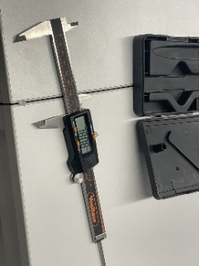  Figure 1. A Calliper. | Calliper used to measure the diameter of the cylinder used to test the sample.
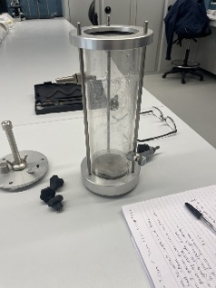  Figure 2. Testing Cylinder | The cylinder used to contain the samples for testing, which is secured on both sides
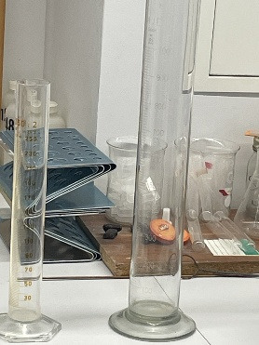 | The collecting cylinders are used to collect the outflowing water that has passed through the sample, measuring it against time.
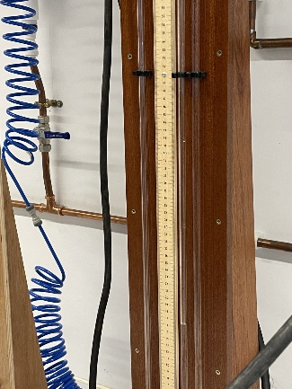  Figure 4. The Measuring Ruler | The ruler used to check the height of the head on each test. This figure is needed to calculate the coefficient of permeability.
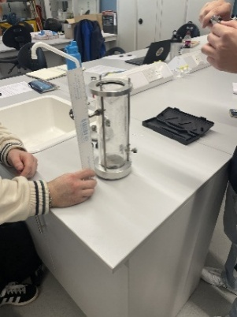  Figure 5. Measuring the Cylinder | The ruler used to measure the size of the sample cylinder.
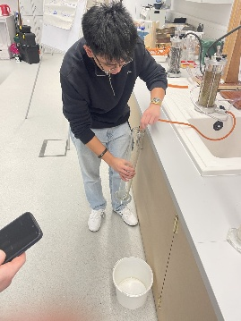  Figure 6. Releasing the Rubber Hose. | The rubber hose that facilitates the water flow, being collected in the collection cylinders and measured.
 | Stopwatch used, on phone, to accurately record the time taken.

2.3 Methodology
Step |  | Method | Photos
1 |  | Prepare a disturbed soil sample and place in the permeameter for testing | 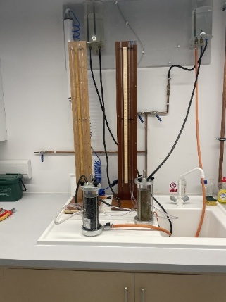  Figure 7. The soil in the Permeameter Testing Setup
2 |  | Place filters on the top and bottom- preventing soil loss. | 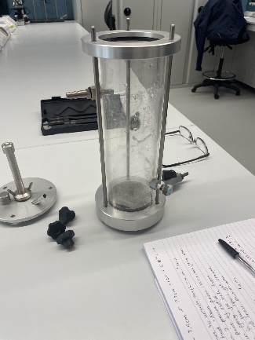  Figure 8. The Cylinder to Hold the Sample
3 |  | Connect the permeameter to a de-aired water supply to allow water to flow through to remove any oxygen bubbles, saturating the sample
4 |  | When the sample stops ‘spitting’ (releasing oxygen from the cylinder), the water has a constant from through the soil. Testing can begin when water flows stable | 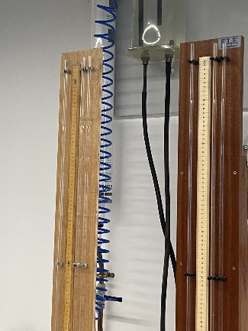  Figure 9. The Sample After It Has Stopped Spitting.
5 |  | Just before testing the flow, pinch the end of the water outlet and place in the collecting cylinder whilst starting timer | 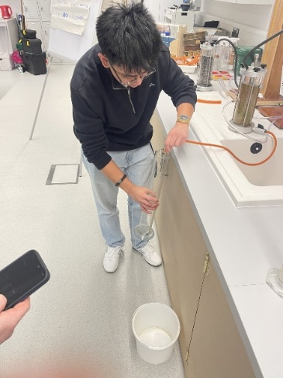  Figure 10. The water being released.
6 | Repeat 3 times for constant head permeameter and 3 times for falling head permeameter |  |  | 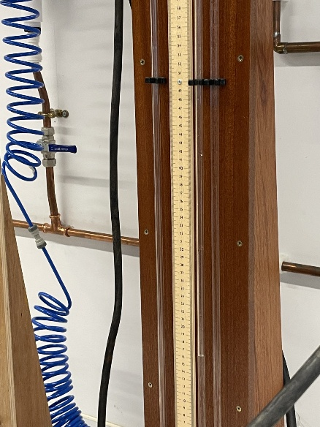  Figure 11. The constant and falling head levels.

2.4 Results
Run Number | Time (Seconds) | Flow over time in m/s | Coefficient of Permeability
Constant Head
1 | 20 | 1.86x10-4m3 | 1.37x10-1m/s
2 | 40 | 3.98x10-4m3 | 1.47x10-1m/s
3 | 60 | 5.95x10-4m3 | 1.47x10-1m/s
 |  | Average | 1.44x10-1m/s
Falling Head
4 | 40 | 3.6x10-4m3 | 1.99x10-4m/s
5 | 80 | 7x10-4m3 | 1.93x10-4m/s
6 | 100 | 9.15x10-4m3 | 2.02x10-4m/s
 |  | Average | 1.98x10-4m/s

The coefficient of permeability is calculated using the formula

K= $\frac{Q x L}{(A x h x t)}$

Where…
Q | Flow over time ‘t’ ($m^{3}/s$)
A | Area of flow ($m²)$
L | Length of the flow line (m)
H | Hydraulic head difference (m)
t | Time, in seconds

Length of the flow line (L)= 14.7cm- 7.5cm= 7.2cm= 0.072m
Cross sectional area (A) = $π \text{× }\frac{{0.0788m}^{2}}{2}={0.00487}^{2}$
Internal Diameter= $\frac{78.72mm+78.86mm+78.74mm}{3}=78.77mm=0.0788m$

Calculating K for the falling head perimeter test
K=
$$\frac{2.3 ×a ×L ×(Log\frac{(h0)}{h1}}{A ×t}$$
Where…

a | Cross sectional area of the standpipe (m)
L | Length of the original sample (m)
A | Cross sectional area of the sample cylinder ($m^{2})$
h0 | Head height before the test (m)
h1 | Head height before the test (m)
t | Length of time for the head to drop, in seconds

2.5 Analysis
2.5.1 Constant Head
The high permeability shown in the results indicates that the sample can be classified as a clean sand. Clean sands usually display large voids with coarse grains, giving it high levels of permeability to water (Zamara, 2025). The results from the three runs are reliable, with minimal variation and no anonymous results. The constant head permeability test is appropriate for course grained soils, such as sand and gravel, as it allows water to flow constantly through the sample, producing accurate permeability results, which are an essential component for civil engineers to understand.

2.5.2 Falling Head
The lower permeability results indicate that the soil sample may fall under the category of a sandy gravel, where finer grained particles fill the voids left by courser grained particles, slowing the rate of water. Compared to the clean sands, the second sample displays a lower permeability. The results from the three runs are closely related, with minimal difference, and no anomalous results. The falling head test is appropriate for finer grained soils, as it allows greater precision in measurement under decreasing hydraulic head conditions (Elementary Engineering, 2020)
2.5.3 Comparative Conclusion
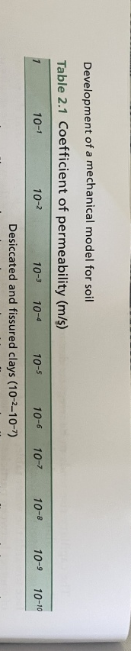
Between the two samples, the permeability differs greatly. The clean sand sample had a much greater permeability due to its less dense, courser grained particles. The sandy gravel displays a much lower permeability due to its mix of courser and finer grained particles. The finer grained particles fill the voids left by the courser grains, reducing the void ratio of the sample (Flayh and Ahmed, 2017). These two tests show the influence of pore and particle size on the permeability of the soil. Soils with coarse, more uniform grading allow for rapid drainage of fluids through the sample.

Figure 12. The coefficient of permeability of a soil sample (Knappett and Criag, 2019, p. 34.

2.6 Conclusions
The permeability test was successful and effective in determining the permeability of two soil samples with different particle sizes. The first sample, which was tested three times, contained a sample of clean sand. This sample displayed very high permeability (${1.44×10}^{-1}m/s$), which means water can flow rapidly through it due to its uniform structure, and course particles (Green Fingers, 2025). In the second sample, run 4-6, the sample was identified as a gravel sand mixture. This sample produced a much lower permeability value $({1.97 ×10}^{-4}$), displaying that the sample must contain finer particles, restricting flow through the sample. This can also be identified by the sieve analysis.
These results show how important soil composition is for engineers. Different permeability of soil requires different foundation types due to its drainage. Clean sands are appropriate for construction due to its ability to drain water from its structure as water accumulation can cause erosion and structural damage (Vxcel Piling, 2024). Gravel-sand soil can also be appropriate due to its low degree of shrinking and swelling, causing less settlement and foundational damage compared to clay-rich soils, something very important due to the high degree of variation in rainfall in the United Kingdom (British Geological Survey, 2020).
The BS EN ISO 17892-11:2019 specifies the methods used in laboratory testing to determine the characteristics of soil and its permeability (ISO, 2019). Any change from the British standards may affect the permeability results. Overall, the constant and falling head tests are reliable dependant on the operators, and the equipment used. The falling head and constant head tests gave accurate and repeatable results.

2.6.1 Limitations
Hydraulic Head Difference | The very small difference in the hydraulic head, found to be 0.001m, will have a smaller sensitivity to any incorrect measurements. This incorrect reading could potentially effect results due to its inclusion in calculations.
Pinch and Release Inaccuracies | The pinch and release of the water outlet was conducted by different operators, inaccuracy in timing efficiency can occur. This means that more water would be released from the water outlet than was expected, making the results inaccurate.
Incorrect Measurements | Inaccuracies in the head measurement could also influence results, causing inaccurate calculations
Timing | When timing is conducted by different operators, the reaction time can differ. This means more water could be released in the allocated time, giving an inaccurate flowrate
Air Bubbles | Any air bubbles present in the tubes can alter the flow and can possibly give inaccurate readings.

.3.0 Liquid Limit and Plastic Limit
3.1 Introduction
The behaviour of fine soils is directly linked to their moisture content. The most common method of testing soil moisture content is called the Atterberg Limit, helping to determine the state of the soil (Biology Insights, 2026). The Atterberg Limits, also known as the consistency limits, defines the four stages of soil state: brittle-solid, semi-solid, plastic, and liquid (Gilson Company, 2016). The liquid limit of a soil sample is the water content where the sample starts to behave more like a liquid rather than a solid (Engineer Fix, 2025).
Understanding the Atterberg limits are essential for engineers, as it allows for understanding into behaviour under different loading conditions. Soils with higher plasticity, such as clays, are subject to settlement in foundations and can result in failure (British Geological Survey, n.d). conversely, soils with lower plasticity with a lower moisture content tend to provide greater stability. The Atterberg limits are commonly used in classification systems, such as the British Soil Classification System (Igne, n.d). When a laboratory has been accredited by the United Kingdom Accreditation Service (UKAS) for the Atterberg Limit test, the laboratory is checked for compliance for British Standard EN ISO/IEC 17025:2017, checking for staff compliance, and ensuring testing equipment is calibrated correctly (Igne, n.d) This helps to ensure that the testing is correct and accurate, if incorrect, it can lead to the miscalculation of soil, incorrect foundation selection, and failure (Igne, n.d).
3.2 Equipment of Liquid Limit Test
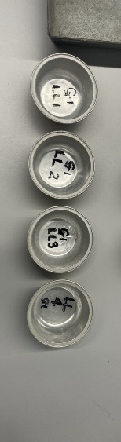  Figure 13. The sampling containers | The containers are used to collect the four different samples with four different moisture contents. These four containers will eventually be placed in the oven to determine the moisture content.
  Figure 14. The spatula used. | The spatula is used to bind the soil sample with the moisture to form the required consistency. This will also be used to collect the sample and place it in the cassagrande apparatus.
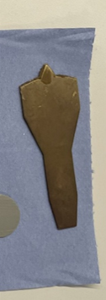  Figure 15. The grooving tool used | The grooving tool is used to cut the soil sample in the cassagrande apparatus in two, giving a gap of around 12mm (NL Scientific, n.d).
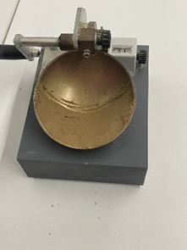  Figure 16. The Cassagrande apparatus | The Casagrande apparatus for liquid limit testing with a sample prior to dividing the sample with the grooving tool. The Casagrande apparatus is where the blows are delivered to the sample, as displayed on the counter.
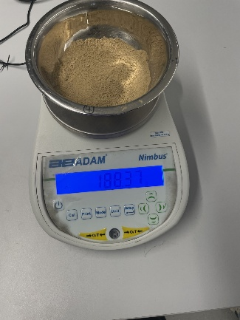  Figure 17. The sample before testing | The original sample, which must be weighed, that will be used for the four different moisture contents.
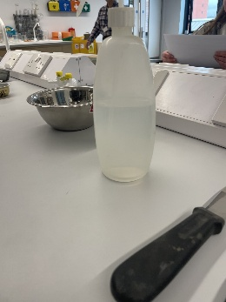  Figure 18. The water bottle used to add water. | The water use, in small amounts, to saturate the sample before each turn of testing.

3.3 Methodology of Liquid Limit

Step | Methods | Photos
1 | Choose 4 containers and mark them with LL1, LL2, LL3, and LL4 and record the container weight | 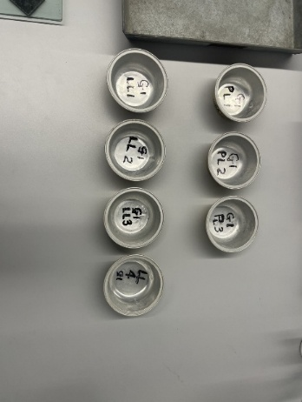  Figure 19. The sampling containers
2 | Place the soil sample, which came out to 188.37g, in a mixing bowl. | 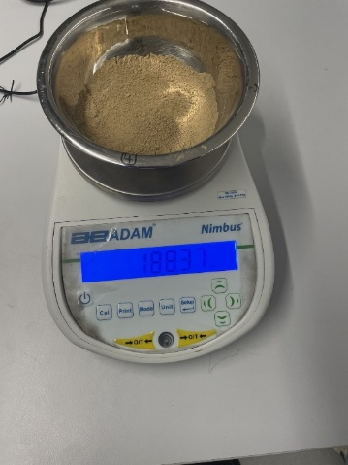  Figure 20. The soil sample.
3 | Thoroughly mix with small drops of water, one to two ml at a time, by stirring, mixing and chopping with a spatula. Mix until a clay like substance is produced, which will take 30-35 blows on the Cassagrande apparatus to close a groove of 12mm. This step is trial and error. If the correct consistency is not met after testing, add more water and test again. | 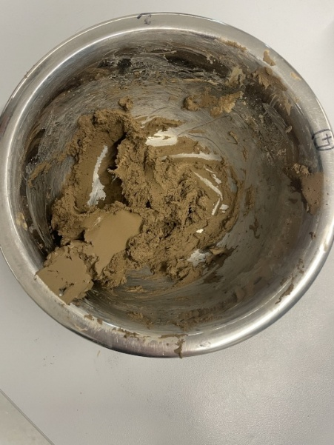  Figure 21. The saturated sample
4 | When the right consistency is found, place a portion of the sample onto the cup bowl, squeezing it down with the spatula and spread it flat to a depth of 10mm. | 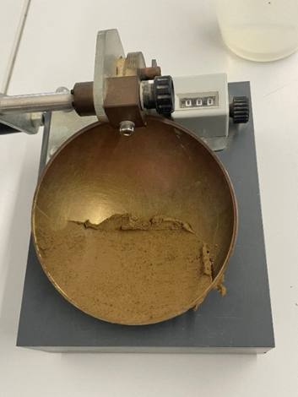  Figure 22. Sample on the Cassagrande apparatus

5 | From front to back, dig a groove using a gauging groove tool in no more than three swipes to avoid a tear until the bowl is visible. | 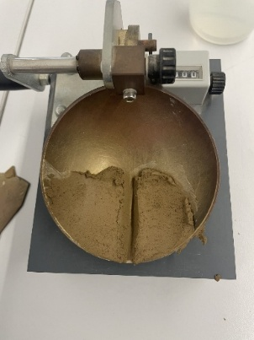  Figure 23. The sample with a groove.
6 | Ensure that the drop counter on the cup apparatus is at zero, | 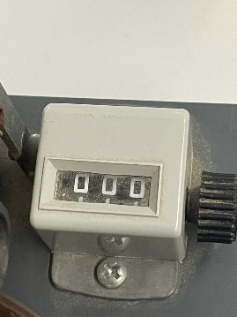  Figure 24. The drop counter.
7 | Lift and drop the cup by turning the handle at two turns per second until the two sides of the groove close over a distance of 12mm and record the number. | 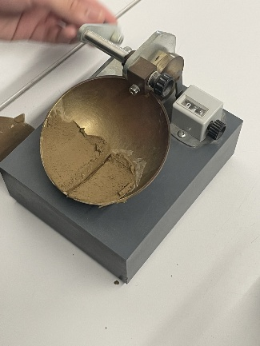  Figure 25. The sample receiving blows
8 | Remove a sample of the soil in the bowl with the spatula, moving from right to left | 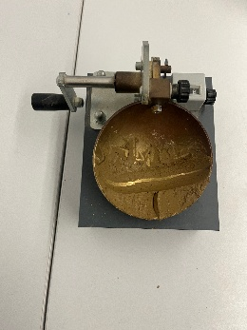  Figure 26. The sample after receiving blows.
9 | Place this into the marked container and weigh the sample and the container together. | 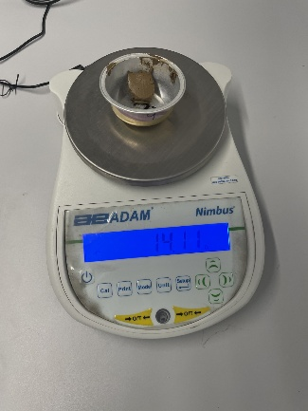  Figure 27. Weighing the sample
10 | Repeat for the four samples and gradually increasing the moisture content to reduce the number of blows required to close the gap, making sure that the last sample (LL4) is around 12-15 blows | 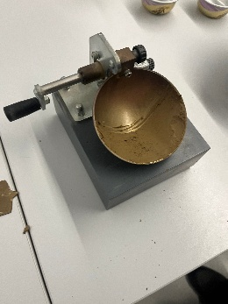  Figure 28. The sample on the Cassagrande apparatus
11 | Dry the sample in the oven for 24h at 120°C and weight the dry sample with the container weight to determine the moisture content. | 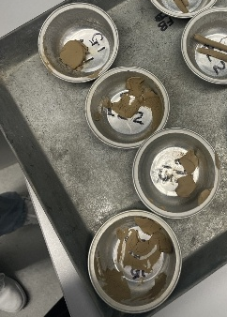  Figure 29. The four samples, dried.

3.4 Equipment of Plastic Limit Test
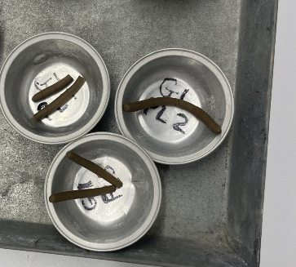  Figure 30. The three samples, dried | The three containers used to collect the three samples. The three containers will be dried for 24 hours to calculate the moisture content of the sample.
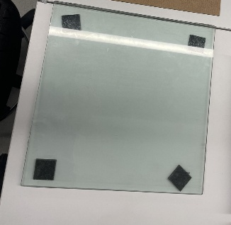  Figure 31. The plate used to roll the sample. | The glass plate used to roll the three samples on
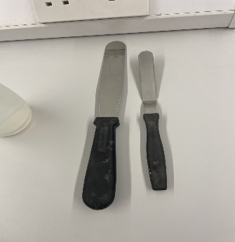  Figure 32. The spatula | The spatula is used to reintroduce the dry sample back into the wet soil, aiming to reach the required consistency.
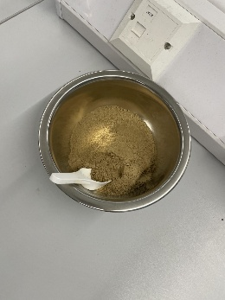  Figure 33. The sample after LL testing | The sample used for the plastic limit testing; the same sample used in the liquid limit test.

3.5 Methodology of Plastic Limit

Step | Method | Photos
1 | Pick out 3 containers, and label them PL1, PL2, and PL3. Record the containers weight. | 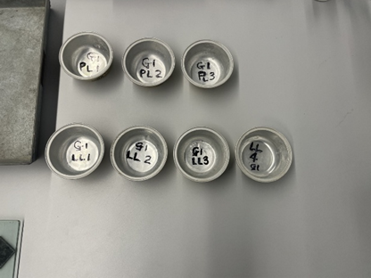  Figure 34. The seven containers
2 | Kneed the clay sample and add some dry sample to adjust the moisture content to the required limit. | 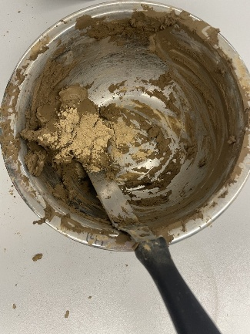  Figure 35. reintroducing soil to the saturated sample
3 | Mould a small ball of clay between fingers and roll between the palms of hands so that the heat off skin dries the sample.
4 | When the ball shows signs of cracking on the surface, divide the sample into 3 equal balls of around 10g each.
5 | By measuring against the glass rod shown, roll each ball into a thread of around 6mm in dimension, ensuring that it’s still intact. | 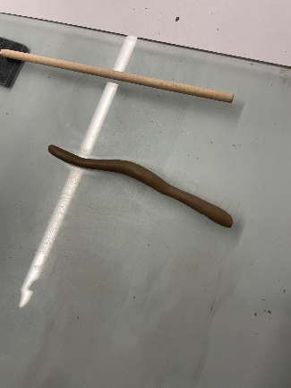  Figure 36. The rolled sample for testing.
6 | Using gentle pressure from the palm of hand, reduce the diameter to 3mm. |  | 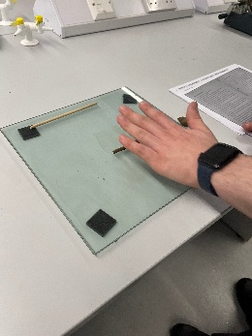  Figure 37. Rolling the sample
7 | Repeat the step until the thread begins to crumble at around the 3mm mark, ensuring uniform rolling pressure across the entire thread.
8 | It is important that the crumbling occurs due to the lack of moisture and not due to external pressure. The crumbling point is the plastic limit moisture content.
9 | At the crumbling stage, gather the crumbs and place them in a container, weighing the wet soil and container together. |  | 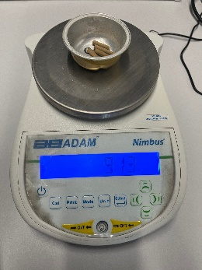  Figure 38. Weighing the sample.
10 | Repeat the above method 2 further times.
11 | Dry the three containers with the sample in the oven. When dry, calculate the moisture content by weighing the container and dry soil together, taking the average of all 3 to calculate the mean |  | 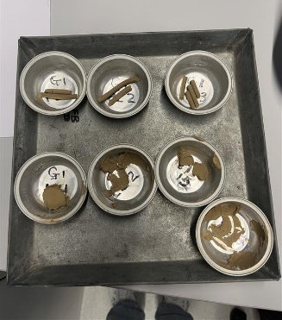  Figure 39. all seven containers after drying
12 | This moisture content mean is the plastic limit moisture content indicator.

3.6 Results
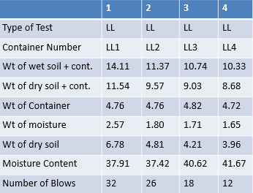

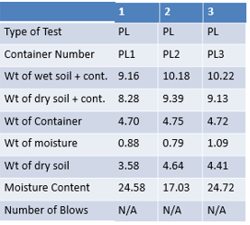6
25.65
10.58
Liquid Limit= $\frac{37.91+37.42+40.68+41.67}{4}=38.80\%$
Plastic Limit= $\frac{24.58+25.65+24.72}{3}$= 24.98%
Plasticity Index (ψ)= Liquid Limit- Plastic Limit.
38.80%- 24.98%= 13.82%
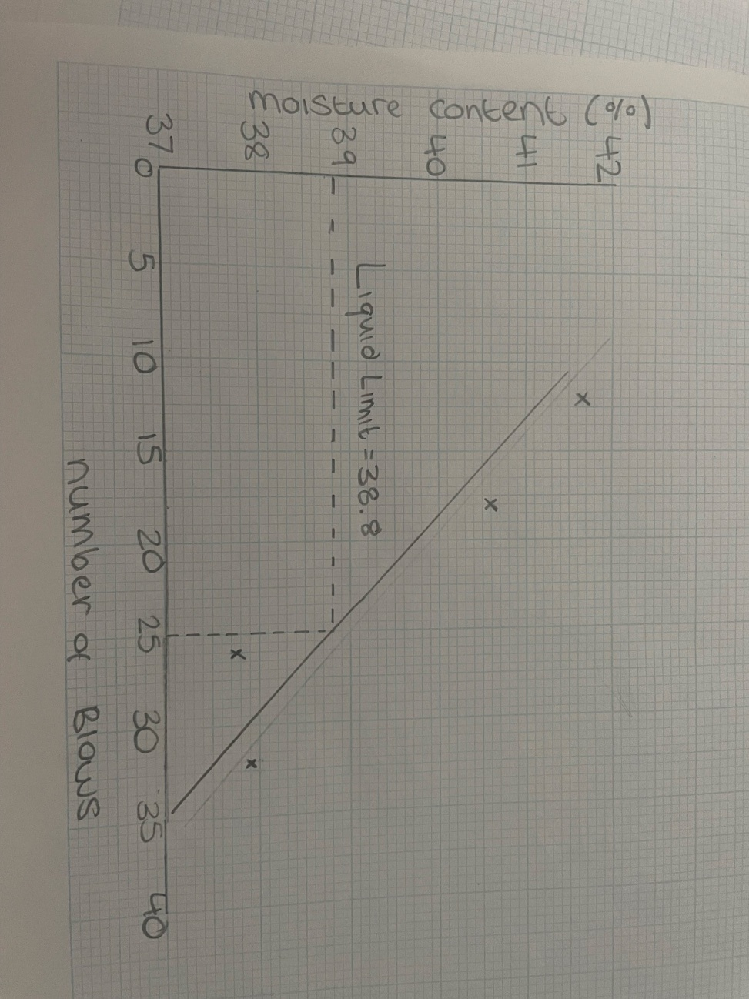
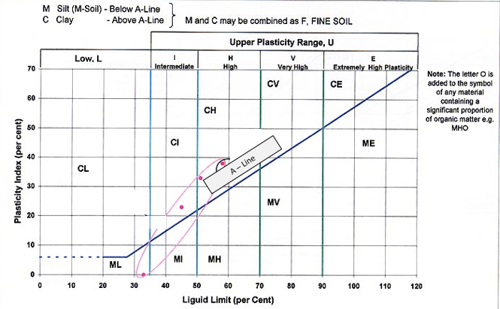
A graph to show the liquid limit of the sample.

3.7 Analysis
The flow curve shows the inverse relationship between moisture content and the number of blows, where a higher moisture content leads to less blows being required to close the groove. The data does show this, with some slight variation. This could be due to a difference in groove closure judgement, as the experiment was handled by more than one person. As the gaps weren’t measured, it was measured by personal judgement, which can differ. However, the results follow expected patterns.
With the liquid limit being 38.80% and the plastic limit was calculated to be at 24.98%, the plasticity index is calculated to be 13.82, which puts it in the category of medium plasticity. When plotting on the plasticity chart, the soil sample was found to be just below the A line, falling under the category of an intermediate plasticity silt. This means that during construction processes, such as the installation of foundations, soil stabilisation techniques must be used due to its high expansion and contraction properties (Soil Connect, 2025). Some of these techniques include introducing adequate drainage systems, altering soil compaction, and preparing specialised foundational designs to counteract the soils contracting and expanding forces (Soil Connect, 2025). If this isn’t managed correctly, it can cause structural damage to the foundation. However, with adequate management and drainage, it can be a reasonable soil for construction.
3.8 Conclusions
The Atterberg limits test was successful in determining the soils key characteristics, such as the liquid limit, plastic limit, and plasticity index. The results determined that the liquid limit was 38.80% and the plastic limit was 24.98%, determining the plasticity index to be 15.89%. A liquid limit of 38% and a plasticity index (ψ) of 13.82% means the soil sample falls within the category of silt of intermediate plasticity, meaning that it has moderate ability to retain water, before transitioning to a liquid consistency (Atkinson, 2000).
From an engineering perspective, an intermediate plasticity silt, classified under British standards, such as BS 5930 (BSI Group, 2020) have variation in behaviour, acting more like a sand when dry, and more like a clay when saturated.
Long droughts and long rainfall periods will have significant effects on the soil, causing possible damage to foundations. However, if moisture content can be sufficiently managed, such as using gutters to allow the water to drain for the clay and choosing the correct foundation type for the plasticity index value, these issues can be controlled efficiently (HM Structures, 2025). To conclude, the Atterberg limit tests are seen as reliable, being commonly used throughout geotechnical soil testing due to its simple and repeatable framework (O’Kelly, 2023). The results given by the Atterberg limit tests provide a reliable indication of the soil’s plastic, and liquid behaviour and is suitable for soil classification.
3.8.1 Limitations
Condition of the Cassagrande Apparatus | Any damage to the equipment can cause inaccurate readings, according to O’Kelly (2021). This can give inaccurate liquid limit values which, consequently, gives an inaccurate plasticity index value. This means the soil can be incorrectly classified, which could lead to the wrong foundation type being selected
Human Error (Liquid Limit) | While conducting the blows for the liquid limit, and observing the groove closure, human error can occur. The closure relies on the operator’s judgement which, when changing operator between samples, means the results can be inaccurate.
Rolling Technique Variation (Plastic Limit) | Variability in the rolling technique of the sample in the plastic limit test can affect the structural integrity of the thread, which can affect the samples moisture content values.
Sample Moisture Loss (Plastic Limit) | Moisture loss when rolling the sample for the plastic limit testing is also a limitation and can lead to inaccurate readings. This can be due to heat from the operator’s hands or the room which, in turn, can dry the sample and cause it to crack prematurely.
Clean Cassagrande Apparatus (Liquid Limit) | Between testing samples during the trial and error state of liquid limit testing, the bowl must be cleaned thoroughly without water as the sample in the bowl contains a different moisture content, making it inaccurate.

4.0 The Sieve Analysis Gradation Test for Textural Classification of a Soil Sample
4.1 Introduction

The sieve analysis of a soil sample involves establishing the percentage of each particle size, 2mm to 0.002mm, in a chosen sample (Knappett and Craig, 2019, p. 13), (Nurhimawan, 2025). The sieve analysis test is crucial to understanding the classification and suitability of a soil sample for different engineering projects, including building construction, road construction, and drainage systems. During testing, the soil is passed through multiple sieves with varying mesh sizes (Knappett and Craig, 2019, p. 13) all according to BS 1377‑2:2022 (Civil Eng Hub, 2022).
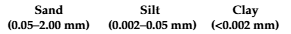
Understanding the particle-size distribution of a soil sample is important as variations in grain size can influence the soil’s permeability, compressive strength, and shear strength (Lees, 2024) Understanding this is crucial before any site work is undertaken. The results of the test are displayed using a triangular graph of soil texture and a gradation graph, giving us a visual representation of the proportions of each particle size. Soils are classified by considering the proportion of sands, silts, clays, and gravels in each sample. There are categorised according to their size, as show in figure 40.
Figure 40. categorising different soil types by their particle size (Polakowski et al, 2021)

Well graded soils, containing many particle sizes, usually show greater stability and stability in-situ whereas poorly graded soils with a low range of particle sizes are usually contain greater void ratios and can more commonly display failure (Joes, 2025). The objective of this testing was to determine the particle distribution of the soil sample, using the particle size distribution curve, and the triangle for soil texture.

4.2 Equipment List
  Figure 41. the sieves stacked on top of the shaker | The sieve shaker equally passes the sample through the sieves, preventing the soil sample from ‘clumping together’ and allowing them to pass through and collect accordingly.
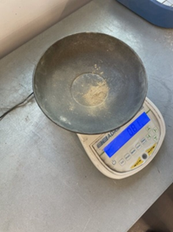  Figure 42. the scale, calibrated at 0. | The scale and bowl are used to collect the mass of sample passing through each sieve. The scale must be returned to 0 grams before the next sample is weighed.
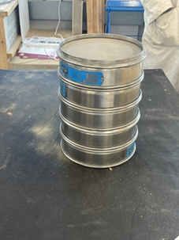  Figure 43. The sieves | The sieves collect the different aggregate sizes to be weighed. The sieves vary from 2mm to 0.02mm.

4.3 Methodology

Step | Method | Images
1 | Prior to beginning the testing, it is important that the appropriate Person protective equipment (PPE) is worn, including lab coats, face masks and gloves in case of any allergens. This is important as fine soils can be released in the form of dust which, according to the Control of Substances Hazardous to Health (COSHH) regulations, can cause lung conditions, such as cancer (HSE, n.d). Technical standards for this experiment follow BS EN ISO 14688-1 and 14688-2 (2018) (Knappett and Craig, 2019, p. 17). | 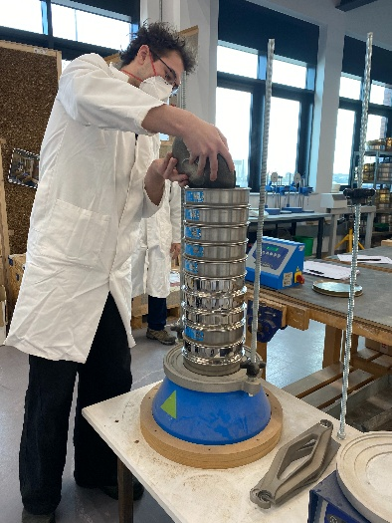  Figure 44. pouring the sample into the sieves
2 | The scale used to weight the sample must be calibrated and zeroed prior to use to ensure that the initial soil sample mass (1400.04g) is recorded accurately. | 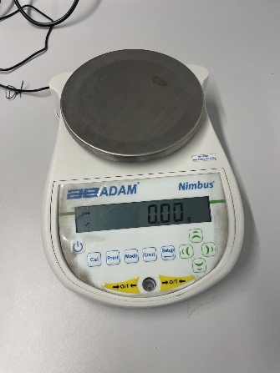  Figure 45. the scale, at 0.
3 | The sample of soil should then be quartered randomly, keeping the sample unbiased, and weighed close to 1500g and recorded to the nearest 0.1g. | 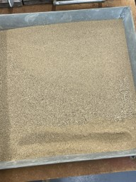  Figure 46. The original sample
4 | Following this, the sieves must be arranged in descending order of opening size, with the largest at the top, positioned securely above the pan for sample collection, | 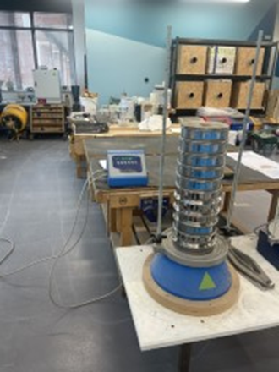  Figure 47. the sieves stacked in order
5 | The sample is then poured on to the top sieve carefully as to avoid the loss of fine aggregate in the form of dust which could possibly give inaccurate results. | 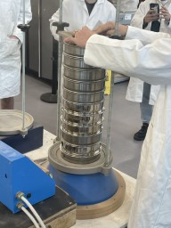  Figure 48.. each sieve being removed from the stack
6 | The stack of sieves must then be placed on top of the sieve shaker and vibrated for two minutes to allow the sample to pass through the sieves. After the two minutes has passed, stop the machine and carefully remove the lid to avoid the loss of fines. | 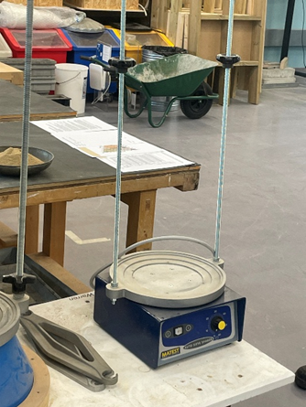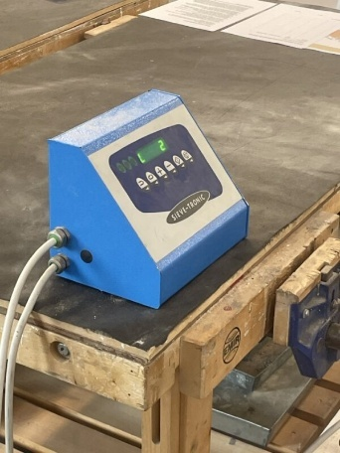  Figure 49. and Figure 50. The sieve shaker.
7 | Then, pour each sieve onto a tray with a plastic sheet and brush the sieve to ensure that no material is lost and is accounted for. The plastic sheet must also be brushed to remove the sample as the static can retain the fine aggregate. The sample is then transferred to the scale and weighed to the nearest 0.1g, repeat this step for each sieve size. | 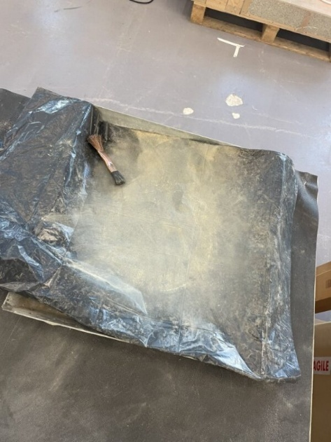  Figure 51. the sample stuck to the sheet.
8 | The process must be repeated until the weight of material in each sieve has been recorded, including the pan at the bottom of the stack, record the percentages to the nearest 0.1% for each size of aggregate retained on each sieve and the percentage of aggregate that has passed through the sieve. | 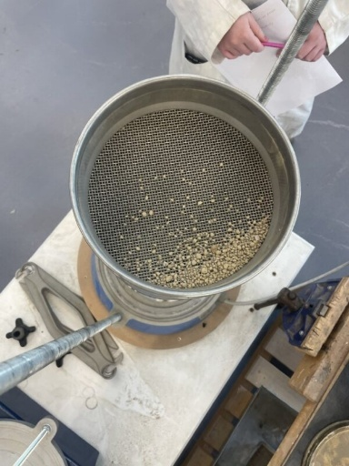  Figure 52. the sample stuck in the sieve.
9 | When transferring samples, take care to prevent loss of material. However, if there is a discrepancy of 0.2% between the original sample and the sum of the weights, accept the test, however, if the discrepancy is over 0.2%, then rerun the testing.
10 | Plot sieve size against the percentage passing of the sample on a graph.

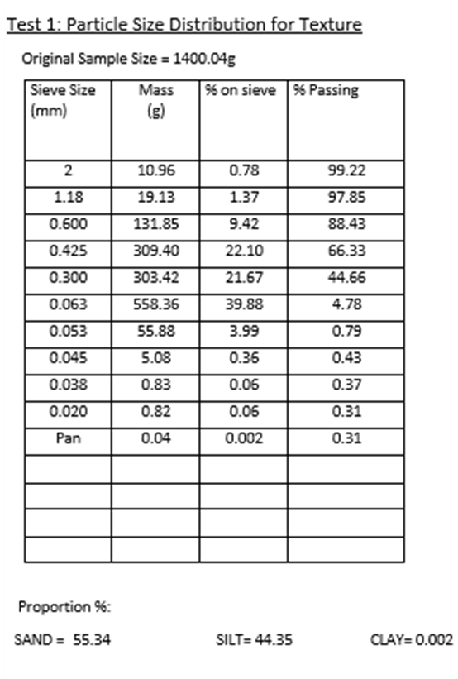
4.4 Results
Figure 53. A graph to show the percentage of each particle size passing through the sieves
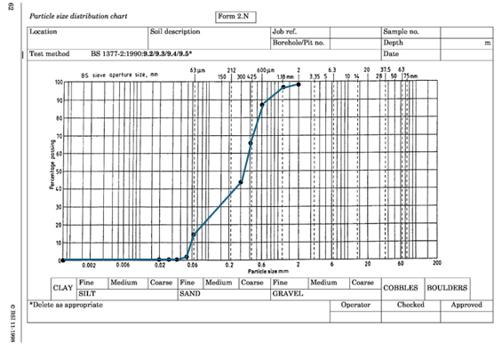

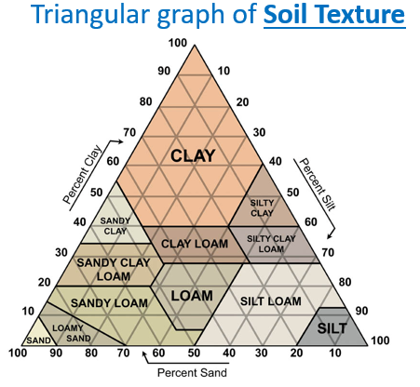
After conducting the testing, it was found that the sample contained 55.34% sand (63 micrometres and above), 44.35% silt (20 micrometres and above) and 0.002% clay (below 20 micrometres).
Percentage retained = (mass retained / total mass) × 100

4.5 Analysis
As shown on the triangular graph of soil texture, the sample was determined to be a sandy loam. This was supported by the particle size distribution curve, which was plotted using results found for the percentage passing against sieve size. The curve shows a steep drop from 0.6mm to 0.06mm, possibly suggesting that most of the sample falls in a similar catagory, hinting at poor grading. The curve lays mainly in the silty sand category, with low clay content. This means the sample may act more like a fine grain soil in-situ, reducing its compatibility. The low clay content suggests a low plasticity soil sample, which would need to be tested using the atterberg limits for a definite result.
From an engineer’s perspective, the 55,34% sand content means it can drain water effectively through the voids, reducing its risk of flooding. However, the silt can lose bearing strength when saturated with water, possibly leading to settlement. A sandy loam would exibit less of a shrink- swell behaviour compared with clay due to a lower density and finer particles (British Geological Survey, 2020) (Horst Excavating, 2023)

4.6 Conclusion
The sieve analysis test was successful in determined the particle size distribution of the soil sample given. The sample was found to be a silty sand, with a substantial amount of fine particals with a significantly low clay content. The soil sample was found to be poorly graded, as displayed by the particle size distribution curve, showing a limited range of different particle sizes. When the soil distribution test is accompanied alongside the atterberg limit test, and permiability test, the results provide a comprehensive and consistant overview of the soil sample. In conclusion, the sieve analysis can be reliable, depending on the equiptment, the personnel, and the overall size of the sample (Kintek Solutions, 2026). If all steps are carried out in accordance with BS EN ISO 14688-1 and 14688-2 (2018) (Knappett and Craig, 2019, p. 17). The sieve analysis is very reproducable as its method is simple, and uses British Standards, being trusted in many industries for many years (Kintek Solutions, 2026).
4.6.1 Limitations
Sample Loss | When pouring the sample into the set of sieves, a proportion of fine dusts is given off. These fine dusts, as minimal as the mass is, are a component of the orignal sample and wont be properly accounted for in the analysis, possibly causing an incorrect soil classification
Equiptment Issues | The equiptment could possibly being damaged, and not being up to the standards in BS 1377-2:2022 (Kajastie, 2022). The sieves, when damaged, can allow particles to pass through that shouldn’t, which can effect the final results and classsification.
Static on Plastic Sheet | Another issue is the When transferring the sample from the sieve to the plastic sheet, the sample of soil can statically stick to the sheet, meaning not all the sample is accounted for when being weighed. The sample must be brushed off the sheet every time to minimise sample loss. If not, the soil classification may not be accurate.
Moisture in Room | After drying, the sample can gain moisture through heat in the room, altering its structure.
Fines Stuck in Sieve | The finer the particle, the greater the chance of it getting stuck in the sieves. This can alter the proportion of passing through each sieve, possibly altering the classification.

5.0 Conclusions
Although the three tests conducted and analysed in this soil portfolio were testing three different soil samples with different classifications, the three tests give a thorough understanding of the soils properties. These can be combined to develop a broad understanding of the soils behaviour in-situ. The soils are, however, disturbed and may not act how they would on site, a concideration that must be made. Each test develops an understanding of a different key characteristic of the soil: its consistancy, permeability, and the consistancy when saturated and dried.
The sieve analysis helps to provide accurate soil classification through the process of identifying the soils particle distribution, looking for sands, silts, and clays. This is crucial for engineers to understand as the particle size and its mechanical behaviour are directly corrilated. The Atterberg Limit tests and the sieve analysis combined help to give a detailed classification of finer grained soils, determining how moisture content affects the soils plasticity.This is essential for understanding how soils behave under changing moisture levels, such as high rain fall as this can cause a shrinking and swelling effect. The permeability tests which include the constant and falling head methods, calculate the rate that water can flow through different soil samples. While the tests were analysed using different soil samples, with different behaviours, the results reliably shown how permeability is determined by particle size and structure, ideas previously discussed in the sieve analysis and in the Atterberg limit test.
When combining the three tests, patterns are shown consistanty throughout: coarser grained soils (sands) shown greater drainage and flow of water while displaying low plasticity, while finer (clay) soils tend to drain water slower, displaying a greater degree of plasticity. By applying these tests in combination, civil and geotechnical engineers can gain a detailed understanding of a soils behaviour and condition with varying soil types on site. These laboritory tests are essential for accurate predictions of soil performance, allowing for safer and more efficient engineering practices.

6.0 Reference List
Atangana, A. (2018) ‘Chapter 2 - Principle of Groundwater Flow’, Fractional Operators with Constant and Variable Order with Application to Geo-Hydrology, pp. 15-47. Available at: https://www.sciencedirect.com/science/chapter/monograph/abs/pii/B9780128096703000023 (Accessed: 16 April 2026).

Atkinson, J. (2000) ‘Soil description and classification’, University of the West of England, (May). Available at: https://environment.uwe.ac.uk/geocal/soilmech/classification/soilclas.htm (Accessed: 15 April 2026).
Biology Insights (2026) What Is the Liquid Limit of Soil and How Is It Measured?. Available at: https://biologyinsights.com/what-is-the-liquid-limit-of-soil-and-how-is-it-measured/ (Accessed: 15 March 2026).
British Geological Survey (2020) Swelling and shrinking soils. Available at: https://www.bgs.ac.uk/geology-projects/shallow-geohazards/clay-shrink-swell/ (Accessed: 4 April 2026).
BSI Group (2020) Code of practice for ground investigations has been updated. Available at: https://www.bsigroup.com/en-GB/insights-and-media/media-centre/press-releases/2020/july/code-of-practice-for-ground-investigations-has-been-updated/ (Accessed: 15 April 2026).
Civil Eng Hub (2022) BS 1377‑2 — Methods of test for soils for civil engineering purposes. Available at: https://www.civilenghub.com/NewSamples/BSI/172141473/BS-1377-2-2022-1.pdf (Accessed: 11 April 2026).
Elementary Engineering (2020) ‘Constant Head Permeability Test’, 13 March. Available at: https://elementaryengineeringlibrary.com/civil-engineering/soil-mechanics/constant-head-permeability-test/ (Accessed: 17 April 2026).
Engineer Fix (2025) What Is the Liquid Limit of Soil and Why Is It Important?. Available at: https://engineerfix.com/what-is-the-liquid-limit-of-soil-and-why-is-it-important/ (Accessed: 11 March 2026).
Flayh, M.S. Ahmed, M.D. (2017) ‘The Effect of Fine Particle Migration on Void
Ratio of Gap Graded Soil’, International Journal of Scientific & Technology Research, 6(12). Available at: https://www.ijstr.org/final-print/dec2017/The-Effect-Of-Fine-Particle-Migration-On-Void-Ratio-Of-Gap-Graded-Soil.pdf (Accessed: 17 April 2026).
Gilson Company (2016) Atterberg Limit: A Quick Reference Guide. Available at: https://www.globalgilson.com/blog/atterberg-limits-a-quick-reference-guide (Accessed: 15 March 2026).
Green Fingers (2025) ‘Which soil types are most common in the UK, and how do they affect plant growth?’, 1 March. Available at: https://majinate.co.uk/which-soil-types-are-most-common-in-the-uk-and-how-do-they-affect-plant-growth/#:~:text=They%20are%20common%20across%20much%20of%20the%20UK%2C,In%20summer%2C%20they%20can%20become%20rock-hard%20and%20crack. (Accessed: 18 April 2026).
HM Structures (2025) Building on Clay Soils in the UK: What Homeowners Need to Know About Foundations. Available at: https://hmstructures.co.uk/2025/11/10/%F0%9F%A7%B1-building-on-clay-soils-in-the-uk-what-homeowners-need-to-know-about-foundations/ (Accessed: 15 April 2026).
Horst Excavating (2023) ‘How Does Soil Type Affect Construction?’, 18 January. Available at: https://www.horstexcavating.com/news-and-blog/how-does-soil-type-affect-construction/ (Accessed: 11 April 2026).
HSE (n.d) Construction Dust. Available at: https://www.hse.gov.uk/construction/healthrisks/hazardous-substances/construction-dust.htm (Accessed: 22 February 2026).
Igne (n.d) Atterberg Limits: Why They Matter. Available at: https://www.igne.com/news/atterberg-limits-why-they-matter (Accessed: 4 April 2026).
ISO (2019) ‘Geotechnical investigation and testing — Laboratory testing of soil — Part 11: Permeability tests’. Available at: 18 April 2026).
Joes, B. (2025) ‘What Is Well Graded and Poorly Graded Soil? – Soil Quality Explained’ 17 July. Available at: https://gardenerbible.com/what-is-well-graded-and-poorly-graded-soil/ (Accessed: 11 April 2026).
Kajastie, N. (2022) ‘Revised geotechnical soil testing standard published’, Ground Engineering, 9 May. Available at: https://www.geplus.co.uk/news/revised-geotechnical-soil-testing-standard-published-09-05-2022/ (Accessed: 12 April 2026).
Kintek Solution (2026) How accurate is a sieve analysis? Achieve Reliable Particle Size Distribution Data. Available at: https://kindle-tech.com/faqs/how-accurate-is-a-sieve-analysis (Accessed: 12 April 2026).
Knappett, J. and Craig, R.F. (2019) Craigs Soil Mechanics, CRC Press. Lees, A. (2024) ‘What is Particle Size Distribution in Soils?’, Tensar, 29 August. Available at: https://www.tensar.co.uk/resources/articles/what-is-particle-size-distribution-in-soils (Accessed: 26 March 2026).
Mavs Open Press (n.d) Permeability Test. Available at: https://uta.pressbooks.pub/soilmechanics/chapter/permeability-test/ (Accessed: 25 March 2026).
NL Scientific (n.d) Soil Testing Equipments. Available at: https://nl-test.com/products/soil-testing-equipments/product/211-liquid-limit-apparatus-nl-5008-x-001 (Accessed: 9 April 2026).
Nurhimawan, R. (2025) Why Sieve Analysis Is Important in Soil Classification. Available at: https://www.geosynergy-solution.com/importance-sieve-analysis-soil-classification/ (Accessed: 15 February 2026).
O’Kelly, B.C. (2021) ‘Review of Recent Developments and Understanding of Atterberg Limits Determinations’, Geotechnics, 1(1), pp. 59-75. Available at: https://moodle.uwtsd.ac.uk/course/section.php?id=178750 (Accessed: 16 April 2026).
O’Kelly, B.C (2023) ‘Theory of liquid and plastic limits for fine soils, methods of determination and outlook’ Geotechnical Research’, Geotechnical Research, 11(1), pp. 43-61. Available at: https://www.sciencedirect.com/org/science/article/pii/S2052615623000030#s6 (Accessed: 16 April 2026).
Polakowski, C. Ryżak, M. Sochan, A. Beczek, M. Mazur, R. and Bieganowski, A. (2021) ‘Particle Size Distribution of Various Soil Materials Measured by Laser Diffraction—The Problem of Reproducibility’, Minerals, 11(5) (April). Available at: https://www.researchgate.net/publication/351186896_Particle_Size_Distribution_of_Various_Soil_Materials_Measured_by_Laser_Diffraction-The_Problem_of_Reproducibility (Accessed: 11 April 2026).
Soil Connect (2025) Plasticity Index and Soil Type: A Guide for Builders. Available at: https://www.soilconnect.com/blog/plasticity-index-and-soil-type-a-guide-for-builders (Accessed: 9 April 2026).
VJ Tech (2020) ‘Introduction to Permeability Testing’, 11 September. Available at: https://www.vjtech.co.uk/introduction-to-permeability-testing/ (Accessed: 17 April 2026).
Vxcel Piling (2024) ‘What is soil permeability (and why does it matter for piling)?’. Available at: https://vxcelpiling.co.uk/what-is-soil-permeability-and-why-does-it-matter-for-piling/ (Accessed: 18 April 2026).
Wong, S.T.Y., Ong, D.E.L. and Robinson, R.G. (2017) 'Behaviour of MH silts with varying plasticity indices,' Geotechnical Research, 4(2), pp. 118–135. Available at: https://www.emerald.com/jgere/article/4/2/118/440726/Behaviour-of-MH-silts-with-varying-plasticity (Accessed: 19 April 2026).
Zamara, K (2024) ‘Soil Permeability: Definition, Tests, and Formulae’ Tensar, 29 August. Available at: https://www.tensar.co.uk/resources/articles/the-permeability-of-soils-explained (Accessed: 17 April 2026).

