Student name:Mirish Salieva
Student number:1913122
ACE-BMSW4001
Lecturer: Magdalena Wronska
Contents
Page 1. Introduction
Page 2. The importance of organising study
Page 2. Analytical and critical thinking
Page 3. CV and Cover writing
Page 4. Creating presentation and speaking
Page 4. Reflective writing
Page 5. Conclusion, References

Introduction
Employability skills play a substantial part to powerful overall performance within place of work. The corporation angle, to be employable is set demonstrating which you have the talents and personal qualities that needed in place of work. These should permit you to get, keep and process successfully to the benefit of each yourself and the business enterprise. When you have invested time and energy in growing non-professional skills through the university research, this can considerably improve our Employability upon graduation. The aim of my writing is to reflect my learned information from this module. There is so many things we learn during our studies and will focus on few of them, on the topic were more interesting and helpful for myself. With this module we increase our knowledge about academic and employability skills, we learnt how we can be more successful in future. The employability skills become important as result of raise interest by employers for people with relevant qualifications. High employability depends of few factors, self believes, knowledge and ability to demonstrate qualifications. This report is based on our gained academic and employability skills before to focus to choose our professional path. Trough our subjects we learn how to approach in job search, to develop CV writing skills, how to provide effective interview techniques and importance of the cover letter. Although, we received all supporting information through our studies, about how to write and structure essay or report, reflective writing skills, how to do presentation, how to speak front of public, analytical and critical reflection and many more. To be more compelling, we should build up portfolio of our developed skills, during in our time spent at the university.
The importance of organising study
Being organise and know how to start you study is really important, time we spent in research for relevant article and read some literature. During in our first term we had a lesson about organising study where we have learn how to manage our time, organise our space, organise our resources and create time-table. Time management is the key of success in all aspects of our life, being organised and able to spread our time equally will make our life easy.
. Setting time limits
After long break from school I am personally needed some techniques to organise my study. When we had the a lesson about time management and that give me a chance to think and do research how more productive could be my study if I set the times for my learning. According to( Jessica Holsman, Deakin Phsyhology Graduate) the most productive time of studying is first 25-30 minutes, that’s why is better to structure of 30 minutes blocks. In my personal opinion that study system works well for me, and if I can have some few minutes break between the studies can help you to concentrate again.
. Prioritising the tasks
As a mature student we often have different thing to do, work homework and to do our studies. We have to sort the thing to be easy and simple to be done on time. We have to create list to-do so, during our studies and skip the stuff that is not that important and can be done later. Task prioritising gives you mostly enough time to be prepare and have a good performance in our learning. Although, during our busy schedule we are not always able to prioritise the right task as therefore we can se low results of that.
. Setting specific goals and use you most energetic period
Doing the things without set it goals it can be very difficult, for example if I read whole book most like to remember few things but if I set specific goals, to learn one chapter it will be easy and more effective. We all have our best time of learning, when we feel more energetic and be more productive. My personal best time of learning is during the night, I can be more focused and concentrated on the specific task.
Analytical and Critical thinking
Analytical thinking and critical thinking is part of all universities studies. Analytical thinking is finding solutions or others ways of the certain topics. The skills required to solve the problem with most creative method and find always of some alternative varieties. The critical thinking is almost come together with the analytical thinking, when we find some soliton we always finds the way to criticise and get better results.
. Analytical thinking
The main point of analytical thinking, is to learn to be better communicator, better thinker and become creative thinker. This method of thinking teaches as to be better problem solver, and be able effectively find the solutions. Some of examples we can use our analytical skills are in some research, as I mentioned in creativity, budgeting in some diagnostic and many other places.
. Critical thinking
The critical thinking is the key aspect that needs to apply in our studies and workplace. During our studies I’ve learn that I have to be critical about the information I found, the specific recourse and question them, find and seek alternative answers. The way of that thinking give me chance to explore and learn more about the topics and subjects I study, to read about different opinions and think about my on view.
CV and Cover writing
The module name and the aim are to gain academic and employability skills, and for the employability skills or to be employed we need to write and create our effective CV- (Curriculum vitae). For the better results and effects would be great if that would be send it together with the cover letter.
. Writing CV
The during our class we had the topic about how we can write and structure our CV,the document where we are written our personal, educational and professional information. I found very interesting the all information, how to structure what to include how that can affect my future job applications. The thinks like what we can use and what we suppose to not use in our CV was very helpful.
. Cover letter writing
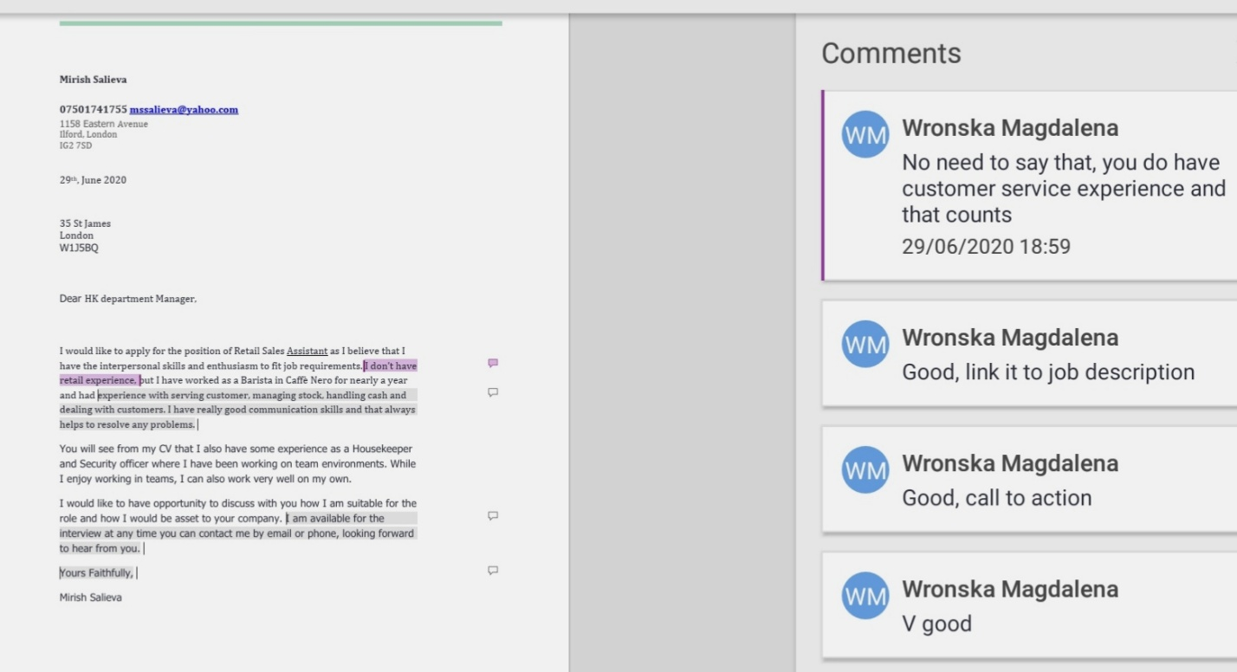
Based on my experience I almost never used the cover letter in my job applications. After the topic we had I realised that is important as it CVs itself, show our interest about position and give an advance information about us. The short explanation for who I am and why I am applying for the relevant position. Even though we can give some information where we found the job application and what makes us to think we are great candidate for that. During our class activities I wrote my sample of cover letter received feedback from my lecturer ( see the attached document bellow ).
Creating presentation and Speaking
Part of our study we learn how to do PowerPoint presentations and the same time how to presented. When we start our studies, we learn how to create our power point presentation. However, but the skills to present is needs more preparation and practical experience. Although we are not always able to practice during our studies but able to use advice and tips we learn through our classes.
. Preparation
We have to arrive or be prepared few minutes earlier as in our case we did online. Our outfits must be smart and professional, switch of any distracted things like mobile phones TV and etc. Go through the all topics once again before starting, prepare you voice and focus of the you behaviour.
. Speaking
I am personally always been nervous about to speak of front of audience, to achieve success I need to practice a lot more. The fact someone Is listening me carefully and I could be judge get E to the point where I can forget most of the things. Although, I will share some useful things I found that I’ve learn and they help me out. First to look to the audience but not specific person eyes, speaking clearly and take a quick look on the notes.
Learning to speak will be less stressful when we realise that we can use the skills that we already have. When we speak with friends or relatives, we automatically checking on them that they understood us correctly. We can use our already commutations skills to connect with audience. Although public speaking requires more preparation and understanding of the audience interest.
Reflective writing
Based on my understanding reflective writing can take few types of forms. We Ben ask to reflect our own learning outcomes from this module and my theory about it. There is simple rule when we have to reflect our classroom experience. Description in my case it is to describe what I’ve learn and how I am able t reflect my learnings. Analysis – thinking deep of all the aspects and from different perspectives. I am aware of that I still have to improve my reflective writing skills.
. Action of reflective writing
The actions is the progress we made during our 1st and 2nd term of the university. We can take a example of Gibbs Cycles (an American sociologist 1988)which is description of feelings, evaluation, analysis, conclusion and ending with action plan which takes you back to the description. This example of circle often make people to think about activities and thing experienced even in more detailed, reflecting them of their on actions.
. Kolb’s learning styles
David Kolb’s (1974) learning style and cycle is more close to my learning way. In his theory is learning style is in two levels and four stages of cycles. The cycle to concentrate, reflective observation, abstract conceptualisation and active experimentations. This kind of learning give me perspective to see the things in different ways. Prefer to watch rather than do the things, getting a relevant information.
Conclusion
With writing this report I intend to reflect my learning during my course at the University, but for the person who writes reflective document for the very first time was bit changed. I covered mainly the topics that were more interesting for me and easy to reflect on them. As an individual Lerner I need more practice, more researching, more spending time in reading and in general to improve my learning skills. This document itself is exanimate my reflective writing skills, my work against established criteria, analyse effectiveness of mine effort and plan of improvement. When I started to study in very beginning I was sceptic about this module, I was thinking we do not have much things to learn as the result of that we are already employed. However, I was wrong and understood that in very beginning of our course. There I found lots of different information the some of them were challenging but interesting, although we missed our few classes and we were confused with different lecturers teaching styles but again it’s all about how we learn and how much effort we have. The other weak part of our learning, is the fact we were away from the school for very long period and returning back and getting to the past self studying mode is habit we have to make it. When I started I were very excited that I can be in class and have some more interaction with the other students, but that was prevented by unexpected virus. However, the all above reasons are excuses we can use but we all aware of that if we spent enough time of study that can give us the results we want. Successful people learn from their mistakes, and reflect on that can help them to realise that. Being able to criticise my on work is the way shows that I have a control of my life, actions and emotions.
References

Jessica Holsman, Deakin psychology graduated, Published by Mango Group
https://journals.sagepub.com/doi/abs/10.1177/0033688208096843?joiurnalCode=rela
Mercy V. Chaita (2016-06-01) Developing Graduate Employability Skills
https://www.monash.edu/rlo/assigment-samples/education/education-refletive-writing/reflective-writing-structure

.

