PROFESSIONAL CAREER DELVELOPMENT

(BMSW4005_LON)
ASSISNMENT TITLE: PROFESSIONAL CAREER DEVELOPMENT REPORT AND ROLE PLAY
(INTERVIEWEE AND INTERVIEWER)
STUDENT NAME: IDOWU LOWO
STUDENT ID: 1919461
NAME OF LECTURER: PROF. NADEEM MIRZA

ABSTRACT

Right from childhood, like every other kid I envisage or look forward to becoming a reputable personality or having a specific profession in the future. As a result, many think either to become a doctor, engineer, Accountant, Lawyer, Pilot, to mention but few among others. However, attaining these position, or achieving these dreams come through will, require focus, dedication and proper planning. Having said that, can only, be accomplished by first, identifying what we are good at and try to point out the areas that we need to ameliorate ourselves. Based, on these, it has been my ambition from my very younger age to work, in a big supermarket, or any public organisation that would afford me opportunities to communicate or relate with people, listen to their problems and proffer solutions to them. For this singular reason, I followed the part of a customer service in one of the big stores in the country to attain my dream and aspiration.

INTRODUCTION

In my writing, I will talk about Professional Development plan, its definition and the importance of professional development plan in every individual / employee life. I will also write about the stages or phases involved to, attain any chosen professional height in life. These stages will be examined by critically looking at all necessary ingredients or skills needed in achieving every set target. Furthermore, I will talk about my personal development plan, my set goals, and means of accomplishing it. In addition, I will reflect on a play role involving the interviewer and the interviewee under recruitment and selection processes, what my experience was after the interview, and lastly, its impact on my career development. Finally, I will dual in my writing on the Gibbs Reflective Circle Theory and go further to explain the importance in reflective writing.

WHAT IS A PROFESSIONAL DEVELOPMENT PLAN

A Personal Development Plan (PDP), also known as Employee Development Plan or Individual Development Plan, is, used to record career goals and expedite a formula or strategy on how to accomplish them. (Katie Martinelli. (September 20th, 2017). Though creating a PDP could take you, time and preparations. By doing that, and properly implemented can help to identifying and developing the professional skills needed to reach your goals, and keep you on the right route to success. Development plan (PDP) takes time. It starts with asking two questions: Where are you now? Where do you want to be? However, Personal Development Plan PDP is different from the one your company gives you during the annual performance review process. Reason, been that, the employer’s ultimate goal is for the company to be more successful, while personal professional development goals are about you and may even include a plan to switch careers absolutely. (Stephanie Olsen. November 30th, 2019).

PROFESSIONAL DEVELOPMENT IMAGE GOALS

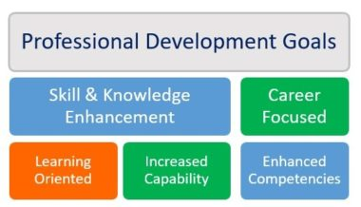
Figure 1
KEY STEPS IN PLANNING A PROFESSIONAL DEVELOPMENT PLAN

Accessing Where I am Are Now: Appraising my professional interests, knowledge, and skills, is a brilliant point for me to begin a professional strategy. For example, if am great in sales enablement, but find myself retrieving behind in other areas, this will compel me to address those lapses in my knowledge. The next level is to take note of my career goals. By distinguishing success, and what drives me, i will be able to get a clear understanding as to i you wanted in the long term. Another important step is to give my plan form, prioritise the goals and set deadlines.

IDOWU LOWO (19194610)
PERSONAL DEVELOPMENT PLAN (PDP))
A personal development plan is the process of improving oneself through conscious habits and activities. It is an anticipation of personal growth development to enhance the state of life and accomplish one’s dream and aspirations. (BRAIN TRACY. 7th Feb,. 2019). According to Amber Rolfe “Creating your own personal development plan not only help you effectively plan for the future and manage your own learning and development, but it can also help you give some directions and move forward in your career”.

STEP 1
TO DEFINED MY GOALS
- It was my ambition, is to progress to a sales executive in my career
- I may likely look into other career lines which are mostly related to sales, that could more, happier, and fulfilled.
- I would like to improve on my IT skills and knowledge.
- Meeting my set goals and aspirations are achievement that most significant to me in life.

STEP 2
PRIORITISING MY GOALS
- Being realistic of what i want to achieve, either, short or long term, big or small. I make sure that the most important come first, followed by the important, and the less important.
STEP 3
IDENTIFYING MY CURRENT STRATEGIES
- What are the attributes I already have that could, help the goals come to reality?
- Do i have any transferable skills that i can utilise for the purpose?
STEP 4
DECIDING ON MY KEY AREAS FOR DEVELOPMENT
- What are my weakness, and what area’s
- Identify main areas of my career or skills that need to be improve upon
- How do i turn this weakness into strength
STEP 5
- I need to research the skills i will need to gain, for me to achieve my set goals
- I need to do in-depth research on what it takes to achieve my set goals
- Try to outline what kind of skills, knowledge, qualifications that will help to overcome my key weakness.

STEP 6
PUT IN PLACE SOME ACTIONS
- Considering all the above, i should be ready to set some cogent actions to put me on the right track to achieving this goals.
- Making sure that my actions was whole, based on my weaknesses and areas of improvement.
- Identify what skills i will needed to go ahead with your ambitions.
STEP7
GIVE MYSELF A CLEAR TIME-FRAME FOR EACH GOAL
- Setting a deadline for each one of my goal will give me a visible target to reach.
- Being realistic with my time-frames and taking into account how long each individual action will take.
- In all, I needed to consider the potential obstacles that could delay me along the line.
STEP 8
- Finally, I needed to monitor my overall development.

THE “SWOT” ANALYSIS
However, for me to achieve my long term set goals, I will use the “SWOT” analysis to give me a clearer insight into my areas of strength, weaknesses, opportunities, and threats, and create a better chance for me towards achieving my career goals. “SWOT” analysis is, a, powerful strategic planning techniques i have used to identify strength in my development career development, and uses this as a support to areas of my weaknesses. Through the swot analysis, I was able to identify opportunities along my career part, take advantage and effectively utilised. Furthermore, since there is every possibility to face some threats along the line, through this analysis, i was able to identify and work against its negative effect on my career development by utilising the available strength in me to stabilised, my career journey. Finally, applying the swot analysis is my career development, gave me the boldness to built, on my strength to do well, and address those skills I was lacking, minimises risks and take the greatest possible advantage of chances for my success.

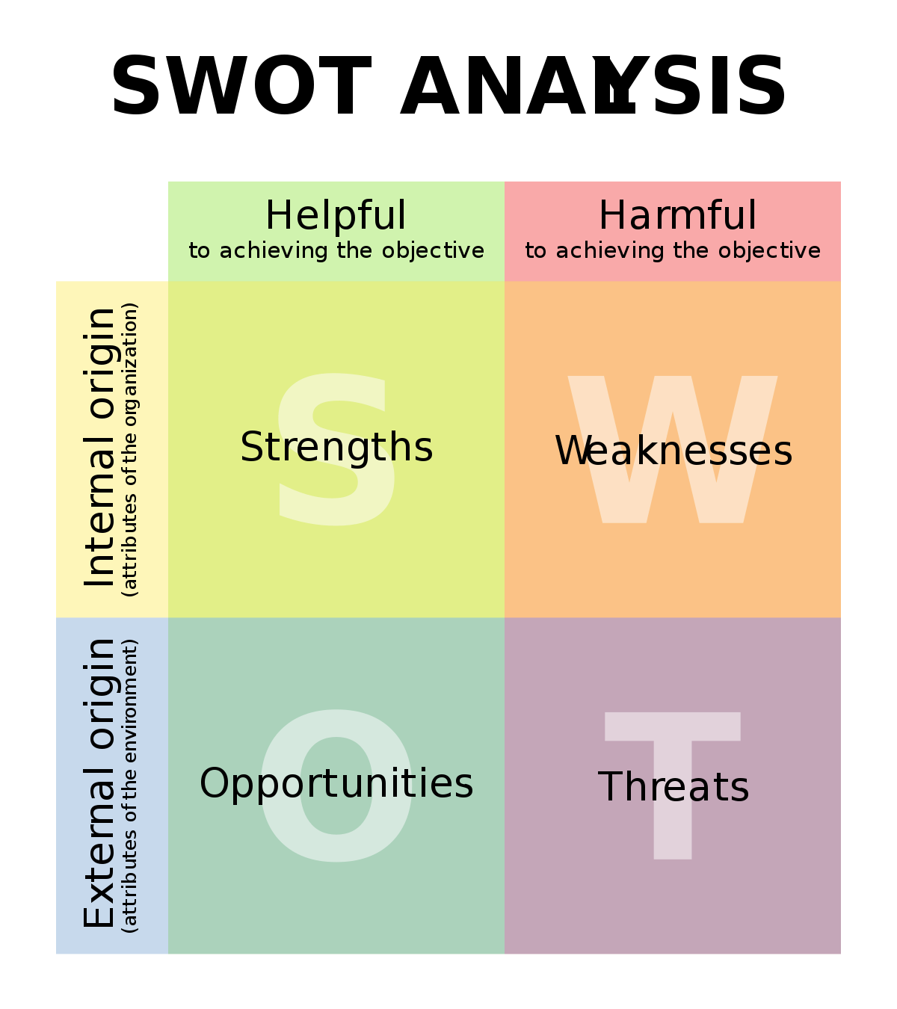
Diagram 2

MEDIUM TERM PERSONAL GOALS
- Graduate from the University with good results
- Pay off my auto loan
- Buy my own personal house
- Accumulate whatever amount legally possible in my savings that fits my current financial situation.

SHORT TERM PERSONAL GOALS
- Build a Morning Routine
- Double My Production level
- Practice Daily Family Ritual
- Explore Something New Every Day
- Develop One Good Habit Every Morning.

ATTRIBUTES EMPLOYERS LOOK FOR WHEN RECRUITING GRADUATES
- Leadership. Most employers look for evidence of leadership qualities when recruiting
- Teamwork. The ability to work with other colleagues
- Communication and Interpersonal Skills.
- Analytical Skills. Ability to recognise problems, and propose effective solution.
- Dependable and a Strong Work Ethic. Showing, responsibility, reliability, dependability, and consistency.
- Maturity and Professional Attitude.
- Adaptability and Flexibility.
- Good Personality. Showing required qualification for the job.

THE TOP 10 SKILLS SET TO ACHIEVE AT THE END OF MY GRADUATION
- Communication Skill
- Commercial Awareness (or business oriented)
- Teamwork Skill
- Negotiation and Persuasion Skill
- Problem Solving Skill
- Leadership Skill
- Organisational Skill
- Perseverance and Motivation Skill
- Ability to Work under Pressure
- Confidence
(https://targetjobs.co.uk)

IMPORTANCE OF PERSONAL DEVELOPMENT PLAN TO ME (PDP)

- They create a spark, treating learning like a project
- They turn my life into game. I engaged, fail, keep score, defeat enemies of personal growth and more importantly level up.
- They force me to grow. They push me out of my comfortable zone because of my proposed action plan.
- They help me prioritizes. It helps in putting what is important in my life in a vintage position.
- They make me focused: when, I dedicated time for learning, and practicing, my understanding become primed to be, focused.
- They provide me a structure: When everything seems to be in a disorganised form, but with a structure, i take day- to- day decision-making out of the equation, and your mind can utilised that energy to spend on learning.
- They help me practise deliberately: When i self- accessed or get feedback from colleagues, or a coach, i improve much faster and move in the direction as i learn intentionally.

MY REFLECTIVE WRITING ON THE PLAY ROLE (INTERVIEWER AND INTERVIEWEE USING THE GIBBS REFLECTIVE CYCLE
GIBBS - REFLECTIVE CYCLE

Gibbs’ Reflective Cycle was, developed by Graham Gibbs in 1988 to give structure to learning from experiences. It provides a framework for analysing experiences, given its intermittent competent bestow itself well to repeat experiences, allowing individual to learn and plan from things that either went well or did not go well. This reflection cycle is one of the most outstanding, model taking me through six levels exploring - experiences: description, feelings, evaluation, analysis, conclusion, and action plan. Professor Gibbs emphasised in his model that by reflecting on my experience, it gives me chance to better my performance as it is happening, as well as stepping forward in it towards my future. In the absence of this reflection on my own learning, it is therefore difficult to improve for the next time. (Professor Graham Gibbs. November 22nd 2019).


DIAGRAM 3:

RECRUITMENT AND SELECTION
PERSONAL REFLECTION ON ROLE PLAY (INTERVIEWER&INTERVIEWEE)
When I was asked to do a role play, I was I bit scared and uncomfortable because I am by nature a shy person, but since it was part of my school assessment which was very vital to my career, I comported my- self and was bold about the whole exercise. On the role play day with my partner, I was able to co-ordinate and relate brilliantly well regarding the way I responded to the five questions asked. Finally, I felled satisfied after the whole exercise.
I will be reflecting on the role- play under the recruitment and selection, using the Gibbs reflective model in my writing. Right from infancy, it has been my ambition to be a sales personal, simply because, among other reasons, I used to accompany my grandmother to market where she sells food- stuffs. Therefore, finding me, in the field today is not by accident. In pursuance of this ambition, I apply for a customer role with my present company, and there I am to present. I felt, that was a stepping- stone toward my goal, believing there still few step to get there. There was an advertisement in one of the dailies for a vacant role of a customer sales leader, I viewed this as an opportunity for my career progression and I quickly applied. Fortunately, I was among the candidates shortlisted for an interview for the job role. However, I look at this opportunity from two perspectives- if I eventually secure the job, I will improve on my experience, skills and it will serve as a step forward in my career development. I felt some sense of elevation in me, though it would amount to additional challenge and responsibilities, which I am, convince, could cope with my former experiences. At, long last, the day for the interview came and I attended. It was not as easy as expected because most of the questions asked where professional one based on the job role, and related situations. Furthermore, some tricky questions where, also asked to test my general knowledge which I provided answers to the best of my ability. In addition, some academics questions were also asked to confirm my qualification standard according to my application form. All the questions I believed are to confirm my suitability for the job. These are the questions asked: Tell us what you know about our company Why did you think you are the most suitable candidate for the job, Can you tell us what you considered your greatest achievement, Please tell us your full name, current address and briefly about yourself, and lastly, How would you handle this situation assuming a customer walk into your store, screaming or shouting at one your colleagues over item or product bought from your store, but dissatisfied with.
Thereafter, the interviewer demanded if I have any question for her, and my reply was yes, and this are the two important questions asked: What advice will you give to the successful candidate who want to do really well in his or her role, secondly, What challenges are the business facing right now and how could I help in this role to overcome it. In all, the exercise lasted for about thirty minutes to finish.
From the interview, I learnt some few things I believed will, be beneficial to me in my career pursuit as an interviewee and an interviewer on how to conduct an interview, types of questions to ask, how to start an interview and other important information required for both part. However, everything went well except my time management, because, I exceeded, time limit by about ten munities extra. Hopefully, next time I should be able to my time slot. Aside from this, I believed the role play went very well.
CONCLUSION
In conclusion, after couples of weeks I received a letter from the company congratulating me for my success in the interview- they have offered me the job based on my performance. This decision was taking after vigorous screening of all the candidates present. According to the letter, it was, agreed at the executive meeting held on selection and recruitment department. I felt very happy so much so because it was a plus for me toward my career goal. However, I am still aspiring further in my career learning’s. (Prahka Verma. July 1st2019)“The key to thriving as a higher achiever is to never top learning. Becoming a lifelong learner is must if you want to accomplish more in life. However, lifelong learning is not enough. To gain an unfair advantage, you must be strategic about how you learn and grow.”

REFERENCES

- Katie Martinelli. (September 20th, 2017)
Professional Development Plan
https:.//www.highspeedtraining.co.uk
Accessed online 16/4/21

- Stephanie Olsen (November 30th, 2019)
How to write a professional development plan
https://inhersight.com
Accessed online 16/4/21

- Richard Conn (November 19th 2020)
How to plan a Comprehensive Professional Development Strategy
https://infobase.com
Accessed online 16/4/21

- Mizzou Career Tools
Desired Candidate Attributes
https://careers.missouri.edu.desired
Accessed online 21/4/21

- Brian Tracey (7th February 2019)
Turn all your dreams into a reality with a personal development plan.
https://www.briantracey.com
Accessed online 15/4/21

- Gibbs.G (11th November 2020)
The University of Edinburgh
https://www.ed.ac.uk/reflection
Accessed online 21/4/21

- Gibbs.G (22 November 2019)
Gibbs reflective cycle and learning
https://www.learningperformance.com
Accessed online 21/4/21

- Prakhar Verma (1ST July 2019)
How to create a personal development plan for active growth
https://www.linkedin.coom
Accessed online 17/4/2021

Appendices

Appendices A:
My employment application form
Appendices B:
Role-play (Interviewer and Interviewee)
Questions and my Answers

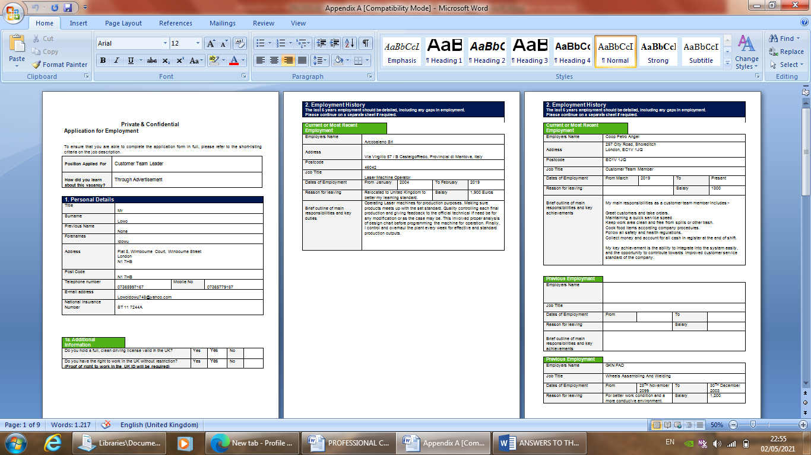

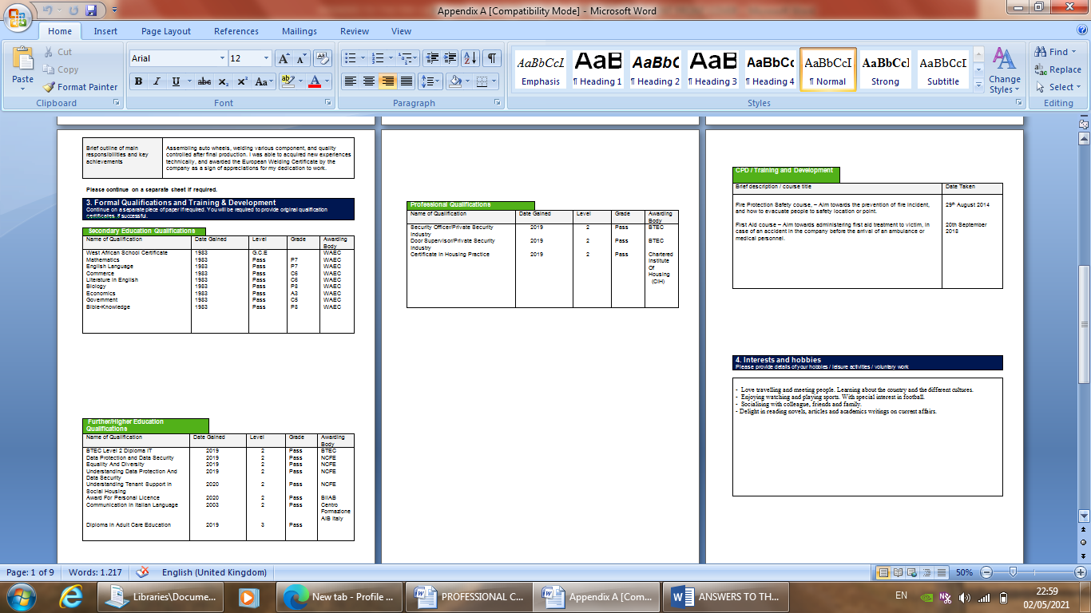

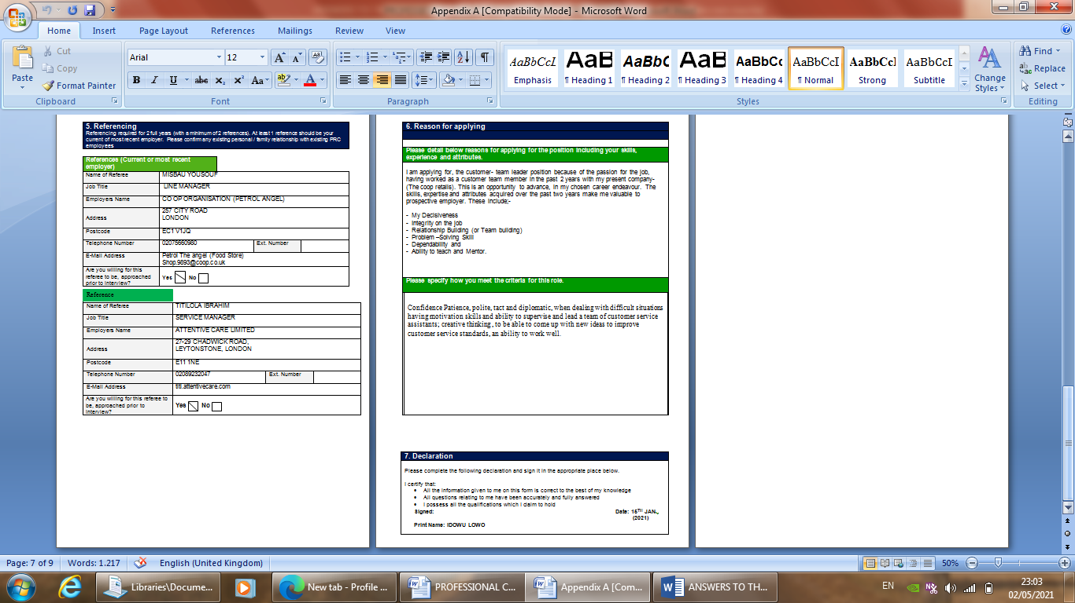

APPENDIX B
ROLE PLAY RECRUITMENT AND SELECTION
(BMSW4005_LONDON)
(INTERVIEWER AND INTERVIEWEE)
THE FIVE QUESTIONS GENERATED FROM MY APPLICATION FORM & ANSWERS:
(QUESTION 1)
Please tell us your full name, current address, and briefly about yourself
(QUESTION 2)
Tell us what you know about our company.
(QUESTION 3)
Why did you think you are the most suitable candidate for the job?
(QUESTION 4)
Can you tell us what you considered your greatest achievement?
(QUESTION 5)
How would you handle a situation where a customer came into your store screaming and shouting at one of your team member over a particular item or product bought, but dissatisfied about?

(BELOW ARE THE TWO QUESTIONS FROM THE INTERVIEWEE TO THE INTERVIEWER)

(QUESTION 1)
What advice will you give to the successful candidates who want to do really well in his or her role?
(QUESTION 2)
What challenges are the businesses facing right now, and how could I help in this role to overcome it?

ANSWERS TO THE FIVE QUESTIONS ASKED IN MY INTERVIEW
ANSWER TO QUESTION 1

Thank you madam, my name is Idowu Lowo; my current address is Flat 8, Wimbourne Court, Wimbourne Street, Hackney, London. I am a full time student of University of Wales Trinity Saint David, London Campus studying the Certificate in Higher Education Skills for Workplace. An employee of Coop Angel as a customer, service team member since 2019.rm I had my West African School Certificate (GCE) in the year 1983 with passes in seven subjects as shown in my application form. I later attended the New City College, London Campus where I obtained five level two (2) Certificates in various fields. A registered standard member of Chartered Institute of Housing Practise, Alumni of “CACHE” a professional body responsible for awards in Care, Health and Education. I own a level three (3) certificate in Adult Care, and a level two (2) certificate in “BIIA” which give a the right of authority to supervise over the sales of alcohol and cigarettes for my company. Finally, I gained employment into my present work place through an advertisement on line.

ANSWER TO QUESTION 2
Have heard so much about your company through different avenues: friends, some of your employees, through the media, did my personal research on it. The co-operative, trading as co-op, is a British Consumer Co-operative with a diverse family retails businesses including food retail and whole sales, e-pharmacy, insurance services, banking, legal and funeral care. Your company was, founded on the 13th of December 1884, about 177years ago in Rochdale Lancashire, England. The company headquarter is in One Angle Square, Manchester, United Kingdom. Number of locations is well over 7,000. The Group Chairman is Allan Leighton and Steve Murrells as the Chief Executive. Sources of income for the company include; Food, Funeral care, Insurance, Banking, Legal Services, Academic Trust. The company revenue is about £9.5 billion (2017), Net income £72 million, Active member 4.6 million, Number of employees over70000, and their subsidiaries company includes Nisa Retail, The Manx Co-operative limited, plus 100 more. Finally, your company website – https//www.cooperative.coop.

ANSWER TO QUESTION 3
Over the years, I have acquired relevant skills and experience, which I shall bring to your organisation. I have also worked tirelessly on my communication abilities and team- work skills, which I will put to use in my future career, which would be in your organisation if I, am selected for the customer team leader role. I have given my 100% effort in my past companies and this has enabled me to, recognised my capabilities and limitations. If I channelize them further, they will bring fruitful results to me also to your esteemed organisation. Thank you ma

ANSWER TO QUESTION 4
Successes to me from a professional perspective, means a sense of accomplishment and career progression. Regarding my greatest achievement, it was all about the turning around success story of my employers, sales department. When I joined the company, the entire team including the line manager where struggling and failing to strike our quarterly goals in sales. Initially, I was, hired as a team member to back up the existed team. After some weeks, I proposed a new sales strategy designed by my- self to my line manager, and he reluctantly accepted, however, went on to implement my strategy without any guidance. Sincerely, within six months, we were achieving 20-25% increase above our goals, and my proposed strategy brought in, additional £35,000 as revenue for my branch, through the second half of last year. Furthermore, this additional revenue generated not only rescues our branch, but the company from operating loss that quarter to profitability. Considering this my contribution, I counted as my greatest achievement.

ANSWER TO QUESTION 5
Thank you ma, if faced with this scenario, I must maintain a high level of customer service by bringing my problem-solving skills to play. I will try to calm the customer and ask what the problem was, making sure I give all my attentiveness to listen to his or her complaint. After which I will apologises for any inconvenience this must have caused and promise to proffer solution immediately. In doing all these, I will make sure that the aggrieved customer is taking to a conducive position to avoid distractions to other prospective customers in the store then. I will immediately make a replacement of the contested item. After all these, I will, apologetically and sympathetically thank the customer for spirit of understanding displayed. In addition, I may ask for the customer phone number as a follow up because customer satisfaction goes beyond the shop floor, even outside the store. However, that is not to say that all customer found in similar situation can be easily resolve, at times, customer complaints can be difficult to handle, particularly in instances where they get angry In a situation I feel threatened, I can always seek out my line manager to deal with them instead.
Thank you very much for giving me this wonderful opportunity, I look forward to hearing from you soon.
Bye ma.

