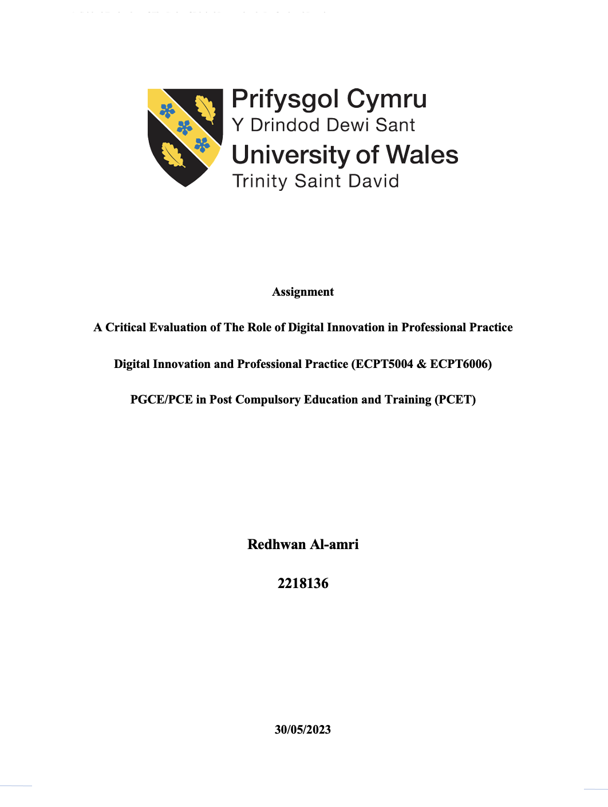

Table of Contents
The Role of Creativity and Digital Innovation in Enhancing Teaching and Learning Within the Post-Compulsory Classroom 3
Introduction 3
Literature Review 3
Conclusion 8
Digital Innovation Tool (Kahoot) 10
Overview 10
Kahoot as a Digital and Innovation Tool for Teaching 11
Kahoot Section Justification 11
Conclusion 13
Digital Innovation Tool Implementation 14
Chosen Application 14
Lesson Plan 14
Evidence of Implementation 19
Evaluation and Reflection 22
Reflection Model 22
References 24

The Role of Creativity and Digital Innovation in Enhancing Teaching and Learning Within the Post-Compulsory Classroom

Introduction
In the modern world, digital innovation and creativity have taken centre stage in various aspects of life. Education is no exception, and its integration has led to significant changes in the teaching and learning process (Starkey, 2020). The post-compulsory classroom is a critical learning environment where students acquire knowledge, skills, and attitudes that shape their future (Ross, 2022). It is therefore essential to explore how creativity and digital innovation can enhance the teaching and learning experience in this classroom setting (Enomoto, 2018). With the advent of the digital age, educators have access to a vast array of technological tools and resources that can enhance student engagement and improve educational outcomes (Dunn and Kennedy, 2019). Additionally, creativity has been identified as a key component of 21st-century skills, which are essential for success in the modern workforce (Yılmaz, 2021). Therefore, integrating creativity and digital innovation into the post-compulsory classroom can lead to a more dynamic and effective learning environment (Boys and Ford, 2023).
Digital innovation refers to the use of technology to enhance and transform teaching practices, from traditional classroom instruction to online learning platforms and educational apps (Agasisti, Frattini and Soncin, 2020). It involves the integration of digital tools, such as online learning platforms, educational apps, and multimedia resources, into traditional teaching methods to provide more engaging, personalized, and effective learning experiences for students (Oke and Fernandes, 2020). Digital innovation also encompasses the development of new teaching methods, such as flipped classrooms and gamified learning, that leverage technology to promote active learning and improve educational outcomes (AlSaad and Durugbo, 2021). This report explores the role of creativity and digital innovation in enhancing teaching and learning within the post-compulsory classroom.

Literature Review
Digital innovation is the use of technology to develop new products, services, or processes (Ciriello, Richter and Schwabe, 2018). In education, digital innovation is the integration of technology into the teaching and learning process (Konstantinidis, Bamidis and Zary, 2021). It has transformed the traditional methods of teaching and learning by providing new opportunities for teachers and students to access and exchange information (Budnyk et al., 2021). Creativity, on the other hand, is the ability to use imagination to come up with new and original ideas (Walia, 2019). In education, creativity is the ability of teachers and students to apply innovative and original approaches to teaching and learning (Shaheen and others, 2010).
Creativity and digital innovation can play a crucial role in enhancing teaching and learning for students including those with additional learning needs (Mohamed Hashim, Tlemsani and Matthews, 2022). The combination of creativity and digital innovation can lead to innovative and effective teaching and learning practices (Zain, 2021). By leveraging technology and creative teaching methods, educators can create more engaging and accessible learning experiences that cater to the unique needs of students (Mohamed Hashim, Tlemsani and Matthews, 2022). As such, digital innovation has significantly impacted pedagogy, and various learning theories can be applied to understand how digital technologies can be used effectively to enhance teaching and learning (Lewin, Cranmer and McNicol, 2018). Here are some of the main theories:
- Constructivism: This learning theory emphasizes the importance of students constructing their knowledge through active engagement with their learning environment (Fosnot, 2013). Digital innovation can provide students with a range of multimedia resources and interactive tools that can facilitate this process, allowing them to explore, experiment, and collaborate with others to build their understanding (Mattar, 2018).
- Connectivism: This theory posits that learning is a networked process that involves connecting with others and engaging with diverse sources of information (Goldie, 2016). Digital innovation provides students with access to a vast array of online resources and enables them to communicate and collaborate with peers across geographical boundaries, expanding their knowledge networks and enhancing their learning experiences (Dziubaniuk, Ivanova-Gongne and Nyholm, 2023).
- Social Learning Theory: This theory emphasizes the importance of social interactions and the role of the learning community in facilitating learning (Akers and Jennings, 2015). Digital innovation can provide opportunities for students to engage in online discussions, participate in virtual communities of practice, and collaborate with peers to develop their understanding (Nyambane, 2021).
- Cognitive Load Theory: This theory posits that learning is most effective when students are presented with information in a way that is aligned with their cognitive abilities (Plass, Moreno and Brünken, 2010). Digital innovation can be used to present information in a variety of formats, allowing students to process and understand the material in a way that is most suited to their learning style (Mhlanga, 2022).
- Self-Determination Theory: This theory emphasizes the significance of autonomy, competence, and connectedness in fostering intrinsic motivation and active engagement in the learning process (Ryan and Deci, 2022). Digital innovation can provide students with opportunities to take ownership of their learning, explore their interests, and develop their skills and competencies in a way that is meaningful and relevant to them (Oga-Baldwin, 2015).
Overall, these learning theories highlight the potential of digital innovation to enhance pedagogy and support student learning. By understanding how these theories apply to the use of digital technologies, educators can design effective and engaging learning experiences that meet the needs and preferences of their students (Zain, 2021). In designing, implementing, and testing a specific tool or technique, it is crucial to consider digital pedagogy to ensure that the tool or technique is effective in supporting student learning (Beetham and Sharpe, 2019). Hence, the role of creativity and digital innovation in enhancing teaching and learning in the post-compulsory classroom can be summarized as follow:
- Personalized Learning
The post-compulsory classroom is a diverse learning environment where students have different learning needs, interests, and abilities. Digital innovation and creativity can enhance teaching and learning by providing personalized learning opportunities (Frolova, Ryabova and Rogach, 2019). Technology-based learning platforms can help teachers create and deliver customized learning experiences that cater to each student's needs (Mohamed Hashim, Tlemsani and Matthews, 2022). For example, a teacher can use digital tools to create learning resources such as videos, interactive games, and quizzes that match the learning style of each student. The teacher can also use data analytics to monitor each student's progress and provide feedback that helps them improve their learning outcome (Race and Pickford, 2007).
- Collaborative Learning
Collaborative learning is an instructional approach where students collaborate and cooperate with each other to accomplish a shared objective (Verster and van den Berg, 2021). Digital innovation and creativity can enhance collaborative learning by providing opportunities for students to work together irrespective of their geographical location (Ciolacu et al., 2021). For instance, digital tools such as video conferencing and collaborative platforms can facilitate group discussions, project work, and peer-to-peer learning. Students can share their ideas, knowledge, and skills with each other, and this can result in a more profound comprehension of the content.
- Active Learning
Active learning is a teaching approach that involves students actively engaging in the learning process (Seo et al., 2021). Digital innovation and creativity can enhance active learning by providing interactive learning resources such as simulations, games, and virtual reality. These resources can help students visualize complex concepts and engage in hands-on learning experiences that promote deeper understanding (Ramraj, 2018). For example, a biology teacher can use a virtual dissection tool to teach students about the anatomy of animals. The tool allows students to interact with the subject matter and gain a better understanding of the concepts.
- Flexible Learning
Digital innovation and creativity can enhance flexible learning by providing students with opportunities to learn at their own pace and convenience (Eradze, Dipace and Limone, 2020). For example, a student can access learning resources such as videos, podcasts, and e-books at any time and from any location. This flexibility enables students to manage their academic workload alongside other obligations, such as employment and familial commitments. It also allows students to revisit learning materials as many times as necessary to reinforce their understanding of the subject matter (Lee and Tan, 2023).
- Authentic Learning
Authentic learning is a teaching approach that involves students solving real-world problems or engaging in real-world scenarios (Kuipers et al., 2019). Digital innovation and creativity can enhance authentic learning by providing opportunities for students to engage in authentic learning experiences (Rajaram, 2023). For example, a teacher can use virtual reality to create a simulated environment that allows students to practice skills such as problem-solving and critical thinking. The simulation can be based on a real-world scenario, and this can help students apply their learning to real-life situations (Abelsson, 2017).
Despite the numerous benefits of using creativity and digital innovation in enhancing teaching and learning in the post-compulsory classroom, several challenges may arise. Some of these challenges include:
- Technological Challenges
Digital innovation involves the use of technology, and as such, it is subject to technological challenges such as power outages, network failures, and hardware malfunctions (Nurhas et al., 2022). Such challenges can disrupt the learning process, making it difficult for students to access learning resources or for teachers to deliver their lessons effectively (Weber-Lewerenz, 2022).
- Lack of Technical Skills
The integration of digital innovation into the teaching and learning process requires technical skills (Sumalinog, 2022). Teachers and students need to be proficient in using digital tools and technologies. However, not all teachers and students possess the technical skills necessary to use these tools effectively (Coman et al., 2020). This can hinder the adoption and implementation of digital innovation in the classroom.
- Cost
Digital innovation requires significant financial investment, which may be beyond the reach of some schools and students. The cost of acquiring and maintaining the necessary infrastructure, software, and hardware can be prohibitive, especially for schools in low-income areas (Vicente et al., 2020).
- Resistance to Change
The adoption of digital innovation and creativity in the post-compulsory classroom requires a significant shift in the traditional methods of teaching and learning. Some teachers and students may resist this change due to their attachment to traditional teaching methods (Ferrari, Mura and Diamantini, 2018). This resistance can hinder the effective integration of digital innovation in the classroom (Al-Takhayneh et al., 2022).
- Ethical Concerns
Digital innovation and creativity raise ethical concerns such as privacy, security, and intellectual property rights (Hai, Van and Tuyet, 2021). The use of digital tools and technologies in the classroom requires the collection and storage of personal data, which may be subject to misuse or unauthorized access (García-Peñalvo, 2021). For example, there is a risk of plagiarism when students use digital resources without proper citation or attribution.

Conclusion
The integration of creativity and digital innovation in the post-compulsory classroom has the potential to enhance teaching and learning. Digital tools and technologies can provide personalized, collaborative, active, flexible, and authentic learning experiences for students. By incorporating digital pedagogy principles in the lesson plan, educators can create effective and engaging learning materials that support student learning and meets the needs of today's digital students. However, several challenges may arise, including technological challenges, lack of technical skills, cost, resistance to change, and ethical concerns. These challenges can be addressed through proper planning, training, and investment in infrastructure and resources. Overall, the benefits of using creativity and digital innovation in the post-compulsory classroom outweigh the challenges, and their effective integration can lead to better learning outcomes and prepare students for the future.
The future role of creativity and digital innovation is poised to greatly enhance teaching and learning within the post-compulsory classroom. As technology continues to advance and become increasingly integrated into educational settings, educators have the opportunity to leverage digital tools and platforms to foster creativity and engage students in unique and meaningful ways. By incorporating digital innovation, such as virtual reality, augmented reality, gamification, and interactive learning platforms, teachers can create immersive and interactive learning experiences that cater to diverse learning styles and promote active participation. These technological advancements not only enable students to explore complex concepts more interactively and engagingly but also provide avenues for collaborative learning, critical thinking, and problem-solving. Furthermore, creativity plays a vital role in the educational process, as it encourages students to think outside the box, explore new ideas, and express themselves in innovative ways. By embracing digital innovation and nurturing creativity, educators can transform the post-compulsory classroom into a dynamic and inclusive learning environment that empowers students to become active participants in their education, fostering a lifelong love for learning and preparing them for the challenges of the digital age.

Digital Innovation Tool (Kahoot)

Overview
Kahoot is a web-based platform designed to create an interactive and engaging learning experience for students. It provides teachers with the capability to generate quizzes, surveys, and games that students can access and engage with using their own devices (Zhang and Yu, 2021). The platform was developed in 2013 by a Norwegian company and has since gained worldwide popularity. It offers a range of customizable features, such as the ability to add images and videos to questions and the option to set time limits for answering questions (Wang and Tahir, 2020). Kahoot also includes a leader board that displays the scores of all participants, adding a competitive element to the learning experience. It has numerous benefits for both teachers and students (Kohnke and Moorhouse, 2022). One of the main advantages of the platform is its ability to engage students and promote active learning (Donkin and Rasmussen, 2021). The game-based format encourages participation and motivates students to learn. Kahoot offers extensive customization options, enabling teachers to design quizzes and games that are specifically tailored to the unique needs and interests of their students (Martín-Sómer, Moreira and Casado, 2021). Additionally, the platform provides immediate feedback to students, helping them to identify areas where they may need additional support (Murciano-Calles, 2020).
Studies have found that using Kahoot can increase student engagement, motivation, and participation (Wang and Tahir, 2020). Furthermore, Kahoot has been shown to improve students' retention of information and their ability to recall facts (Zhang and Yu, 2021). However, the impact of Kahoot may vary depending on the subject area and the specific learning objectives of the lesson (Licorish and Lötter, 2022). For example, some educators may prefer more traditional methods of assessment, such as written exams. Another potential disadvantage is that the platform may not be suitable for all students, particularly those who struggle with technology or have additional learning needs that prevent them from using certain devices (Garbe et al., 2020).

Kahoot as a Digital and Innovation Tool for Teaching
Digital innovation and creativity theories both support the use of technological tools as an educational platform, since it integrates technology, engage students in active learning, and align with effective teaching strategies (Ng, 2015). Theories related to digital innovation emphasize the importance of technology in facilitating learning, and Kahoot is a prime example of how technology can be used to engage students and enhance their learning experience (Rivera Trigueros et al., 2020). Kahoot combines game-based learning with digital innovation to provide an interactive and engaging learning experience for students (Wang and Tahir, 2020).
At the same time, theories related to creativity emphasize the importance of creative teaching practices in facilitating learning (Henriksen et al., 2021). With Kahoot, teachers can design personalized quizzes and games that cater to the specific needs and interests of their students, fostering creative teaching practices that have the potential to enrich the learning experience (Zhang and Yu, 2021). By incorporating creative teaching practices into Kahoot, teachers can promote critical thinking and problem-solving skills in their students (Wang and Tahir, 2020). Furthermore, Kahoot also provides opportunities for self-directed learning, which is an important aspect of digital innovation and creativity theories. Students can create their quizzes and games, promoting self-directed learning and encouraging students to take ownership of their learning process (Ali et al., 2021).

Kahoot Section Justification
Aligned with the UK professional standards framework, through the use and value of appropriate learning technologies (Advance-He, 2011). Kahoot can be effectively integrated with the Technological, Pedagogical, and Content Knowledge (TPACK) framework to enhance teaching and learning experiences (Baszuk and Heath, 2020). TPACK emphasizes the intersection of technology, pedagogy, and content knowledge, and using Kahoot within this framework allows educators to leverage its features and capabilities to create engaging and effective instructional practices (Paristiowati et al., 2020). By using Kahoot in conjunction with the TPACK framework, educators can create a dynamic and interactive learning environment that leverages technology, pedagogy, and content knowledge effectively (Baszuk and Heath, 2020). This integration allows for a holistic approach to teaching, combining subject expertise with effective instructional practices and technology-enhanced learning activities (Koh, 2020). Kahoot's features and capabilities provide a versatile platform to support teachers in implementing the TPACK framework and facilitating meaningful learning experiences for their students (Zhang and Yu, 2021). There are several justifications for selecting Kahoot as a digital tool for teaching:
Kahoot provides an engaging and interactive learning experience for students. The game-based format, vibrant visuals, and interactive quizzes capture students' attention and make learning fun (Plump and LaRosa, 2017). This engagement enhances their motivation, participation, and active involvement in the learning process (Seo et al., 2021). Furthermore, Kahoot enables formative assessment, allowing teachers to gather real-time feedback on students' understanding and progress (Murciano-Calles, 2020). Through the platform, teachers can assess students' knowledge, identify areas of strength and weakness, and adjust their instruction accordingly. This immediate feedback promotes personalized learning and helps students track their progress (Frolova, Ryabova and Rogach, 2019).
In addition, Kahoot promotes active learning by requiring students to actively participate in quizzes and games (Donkin and Rasmussen, 2021). Students are actively involved in answering questions, making decisions, and competing with their peers. This active participation enhances their retention of knowledge, critical thinking skills, and problem-solving abilities (Wang and Tahir, 2020). Similarly, Kahoot provides teachers with the ability to customize quizzes and games according to their specific learning objectives and student needs (Zhang and Yu, 2021). Teachers can create tailored content that aligns with the curriculum, addresses specific topics, or reinforces key concepts. This customization allows for a more personalized and meaningful learning experience (Frolova, Ryabova and Rogach, 2019).
Moreover, Kahoot fosters collaboration and healthy competition among students (Donkin and Rasmussen, 2021). The platform enables team-based activities and encourages students to work together to solve problems. The competitive element adds excitement and motivation, while still promoting a supportive and inclusive classroom environment (Licorish et al., 2018). Besides, Kahoot is accessible to students through various devices, including computers, tablets, and smartphones (Lobo, 2023). The platform is user-friendly, with a simple interface that makes it easy for both teachers and students to navigate. This accessibility and ease of use contribute to seamless integration into the classroom setting (Jones et al., 2019). Also, Kahoot provides teachers with data analytics and progress-tracking features (Licorish et al., 2018). Teachers can analyse students' performance, identify learning gaps, and make data-informed decisions to improve their instructional practices. This data-driven approach enhances teaching effectiveness and supports student success (Seo et al., 2021).

Conclusion
Overall, Kahoot, when integrated with the TPACK framework, offers a powerful tool for educators to enhance their teaching practices. By combining technology, pedagogy, and content knowledge, teachers can create interactive and engaging learning experiences that promote active learning, collaboration, and assessment. Kahoot's user-friendly interface, gamified format, and data-driven insights make it an effective platform for implementing the TPACK framework and fostering meaningful learning outcomes in the classroom. Its game-based format and customizable features make it an engaging and effective platform for promoting active learning. While there are some limitations to its use, the benefits of Kahoot far outweigh any potential drawbacks. By incorporating Kahoot into their teaching practices, educators can create a more interactive and engaging learning experience for their students. Finally, the selection of Kahoot as a digital tool for teaching is justified due to its ability to engage students, promote active learning, provide formative assessment, offer customization and flexibility, foster collaboration, and competition, ensure accessibility, and enable data analysis for progress monitoring. These features make Kahoot a valuable asset in enhancing the teaching and learning experience in the classroom.

Digital Innovation Tool Implementation

Chosen Application
Kahoot was chosen to be incorporated into the lesson plan to promote active learning, engagement, collaboration, and formative assessment. It transforms the traditional classroom into an interactive and dynamic learning environment, fostering a positive and effective learning experience for students.

Lesson Plan


Lesson Plan

Topic: Introduction to Computer Science |  | Class: Level 4
Date: 24 /04/ 2022 | Length of lesson: 2 Hours |  | Number of students: 9
Resources/ Materials required:
- Computer with Internet access
- Presentation software or whiteboard
- Smartphone/IPad for online activities
- Examples of different programming languages
Aim of Lesson
Toward the end of the lesson, students should demonstrate the ability to:
- Introduce the fundamental principles of computer science including (the importance of computer science in today's world components of a computer, programming languages, and career opportunities)
Learning Outcomes – The Students Should Be Able To:

- Define computer science and understand its importance in today's world.
- Identify key components of a computer system and their functions.
- Recognize different programming languages and their applications.
- Explore career opportunities in the field of computer science
Previous student knowledge required for the session:
- Basic computer skills: Students should have basic familiarity with using a computer, including navigating the operating system, opening and closing applications, and using a keyboard and mouse.
- Internet usage: Students should have some experience using the internet, including conducting searches and accessing websites.
- Basic Math skills: A foundational understanding of basic math concepts such as arithmetic operations, numbers, and logic is beneficial as computer science involves logical reasoning and problem-solving.
- Logic and critical thinking: Students should have some ability to think logically, analyse problems, and follow step-by-step instructions.
- Basic technology terminology: Familiarity with common technology terms like hardware, software, files, and folders will help students grasp the concepts more easily.

Anticipated difficulties (if applicable):
- Use of technology/online activities: Students might face a challenge accessing/using online activities.
- Installing software: Students might need assistance in installing programming software
Professional Standards (where are these being met within the session)
Areas of Activity
- A1: Through the creation of an interactive online quiz using https://www.Kahoot.com/, which incorporates educational videos and a gamified quiz format, the aim is to assess the students' comprehension of the subject matter covered.
- A2: By establishing a question-and-answer session to provide assistance and support to students.
- A3: By delivering feedback on the completed online quiz.
Core Knowledge
- K2: By creating PowerPoint slides that encompass both theoretical explanations and visual aids to enhance the understanding of the concept.
- K5: Through the creation of an online quiz, students' comprehension of the lesson can be tested and evaluated.
Professional Values
- V1: By acknowledging and valuing diverse perspectives regarding the subject matter and promoting an inclusive learning environment.
- V2: By providing all students with equal opportunities to participate and ask questions.

Lesson Detail:

Stage | Focus | Strategy | Time
Introduction | - Begin the lesson by reviewing the previous lecturer.  - Next, ask the students about their understanding of computer science.  - Discuss the importance of computer science in everyday life, highlighting its impact on technology, communication, and problem-solving. | - Evaluate the previous lecture by prompting students to recall what they remember.  - Present the new subject matter and emphasizing its significance and relevance.  - Discuss the importance of computer science in everyday life, highlighting its impact on technology, communication, and problem-solving. This would include presenting some facts and statistics to support my discussion. | 20 Minutes
Development | - Components of a Computer System | - Display a visual depiction of a computer system that encompasses essential components such as the central processing unit (CPU), memory, input/output devices, and storage.  - Explain the function of each component and how they work together to perform tasks.  - Engage students in a short discussion about the role of each component and its relevance to computer science. | 20 Minutes
Development | - Engagement Activity 1 | - Conduct online activity using Kahoot as an online platform | 10 Minutes
Development | Break |  | 10 Minutes
Development | - Programming Languages | - Introduce the concept of programming languages and their role in computer science.  - Present examples of popular programming languages such as Python, Java, and JavaScript.  - Discuss the applications and purposes of different programming languages, highlighting their strengths and areas of use.  - Facilitate a short activity where students match programming languages to their applications. | 30 Minutes
Development | - Exploring Careers in Computer Science | - Present various career opportunities in the field of computer science, such as software development, cybersecurity, data analysis, and artificial intelligence.  - Discuss the skills and qualifications required for these careers and the potential impact they can have on society.  - Encourage students to explore their interests in computer science and consider potential career paths. | 10 Minutes
Development | - Engagement Activity 2 | - Conduct online activity using Kahoot as an online platform | 10 Minutes
Plenary/conclusion | - Wrap-up and Reflection  - Q&A | - Summarize the main points covered in the lesson.  - Allow students to ask questions or share their thoughts about computer science.  - Assign a short reflection activity, such as writing a paragraph about what they find most interesting or exciting about computer science. | 10 Minutes

Assessment Strategies: when and how are they included within the lesson?

During the lesson, students will participate in an online quiz using the Kahoot platform to assess their comprehension of the material. Feedback will be provided to enhance their understanding.

Informal reflection (to be completed after the session)

Evidence of Implementation

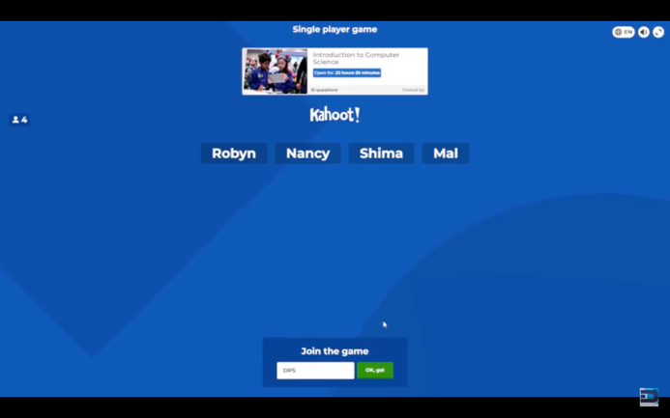 | 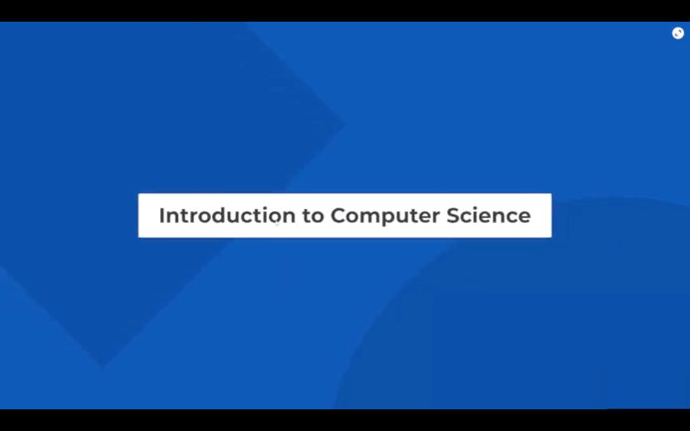
Students will be joining the quiz by either scanning the QR code provided in the slides or the link. The moment a student joins his/her name will appear in the system. | The goal of this quiz is to test the students' understanding of the subject “Introduction to Computer Science”.
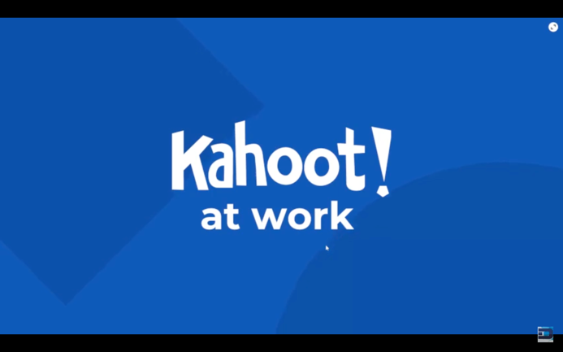 | 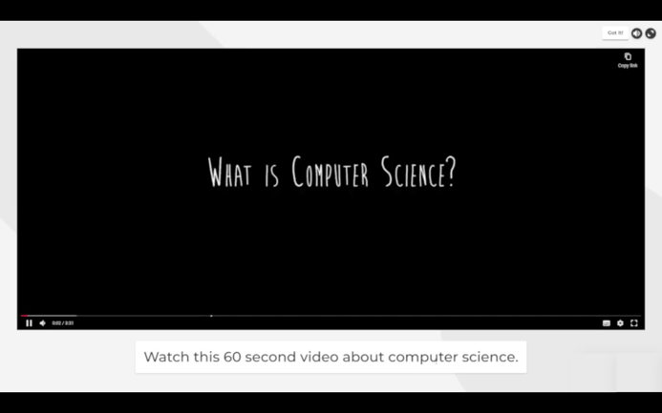
The quiz consists of several short videos that will be played once followed by different types of questions such as “true, false, multiple choice, etc.” | Each 60-second video will be discussing important concepts related to computer science.
 | 
Students will be asked to answer questions that were discussed in the videos | True and false is one of the types of questions available for this quiz. Students have to respond fast as this is a timely manner quiz.
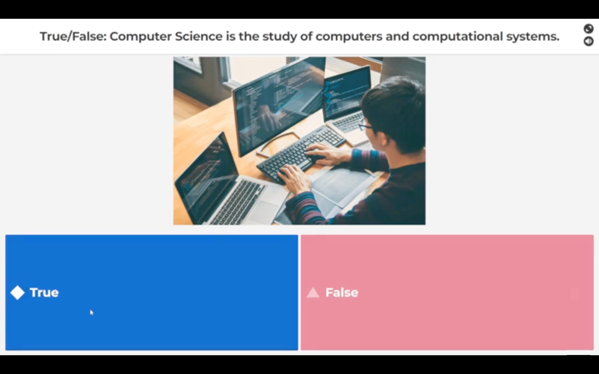 | 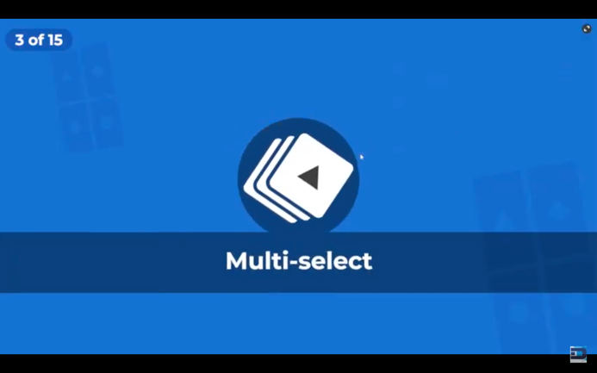
The system will provide immediate feedback on the answer, if correct then it will be marked in green colour and if wrong it will be marked in red colour. | Multi-select is another type of question where students have to select one answer.
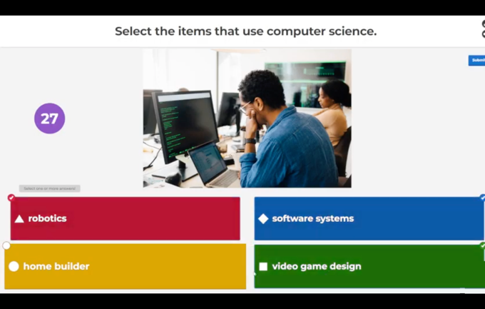 | 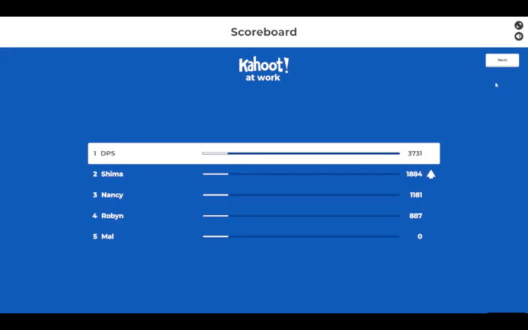
Students will have to select the correct answer. | Grades will change according to answers for the participants which will create a motivational environment among the students.
 | 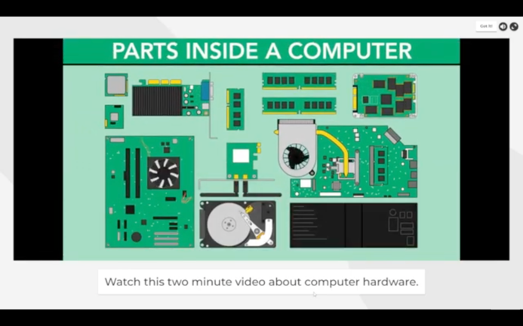
The moment the questions of the first video are over, the second video will start playing to introduce another topic where the students will be tested over it. | A simulation of the working component of the computer will be played to help illustrate to the students how a computer works.
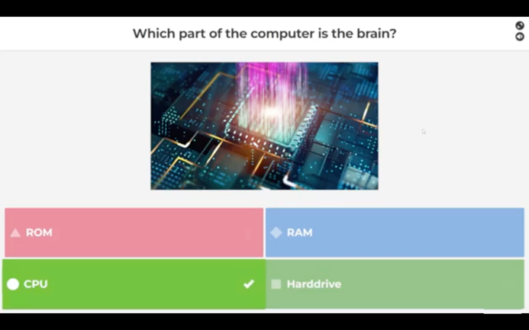 | 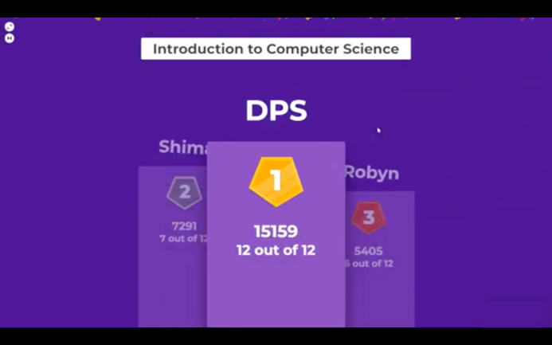
Videos and simulation will be followed by questions to test the students' understanding | Toward the end of the quiz, the system will generalise the overall results and will show the top 3 participants.

Evaluation and Reflection

Reflection Model
The utilization of the Gibbs reflection model has been employed in constructing this reflection report as it provides a structured approach for analysing incidents. This model enables educators to gain valuable insights and make improvements based on experiences, whether they were successful or challenging, throughout their tenure as educators (Gibbs, 1988).
Description:
I recently incorporated Kahoot into my lesson plan on Introduction to computer science for level 4 students undertaking a bachelor’s degree in computer science. The lesson took place on Monday 24 April 2023, at 9:00 AM in UWTSD IQ Building Room 1.9. The objectives were to introduce the students to the key concepts of computer science and engage them in active learning. Kahoot was used as an interactive tool to enhance student engagement and assess their understanding.
Feelings:
At the beginning of the lesson, I felt excited and hopeful about using Kahoot as I had heard positive feedback from other educators. I wanted to create an engaging and enjoyable learning experience for my students with also aligned with the UK Professional Standards for Higher Education in designing and planning learning activities (Advance-He, 2011). However, I also had some concerns about the technical aspects and ensuring that all students could actively participate.
Evaluation:
During the Kahoot activity, I observed high levels of student engagement and enthusiasm. Students were actively participating, answering questions, and competing with their peers. The competitive element provided by Kahoot added an exciting and motivating factor to the learning process (Wang and Tahir, 2020). I was pleased to see how eager they were to learn and demonstrate their knowledge. The immediate feedback provided by Kahoot was invaluable in assessing student understanding. I noticed that some students struggled with certain concepts, and the real-time feedback allowed me to address their misconceptions and provide further explanations. This formative assessment aspect of Kahoot helped me gauge the effectiveness of my instruction and make timely adjustments (Murciano-Calles, 2020).
Analysis:
The use of Kahoot facilitated collaboration and peer interaction among students (Donkin and Rasmussen, 2021). Students were able to form teams and worked together to answer questions, discuss solutions, and support each other. This promoted a positive and inclusive classroom environment where students felt comfortable sharing their ideas and learning from one another (Rivera Trigueros et al., 2020). Moreover, the customization feature of Kahoot allowed me to tailor the quizzes to meet the needs and abilities of my students (Zhang and Yu, 2021). I could adjust the difficulty level and content to ensure that every student had a chance to participate and succeed. This personalized approach contributed to their sense of confidence and improved their overall learning experience (Ali et al., 2021).
Conclusion:
The incorporation of Kahoot in my lesson plan proved to be a valuable and effective teaching strategy. It enhanced student engagement, provided immediate feedback, and fostered collaboration and peer interaction (Murciano-Calles, 2020). The customization feature allowed for differentiation, ensuring that every student could actively participate and learn at their own pace (Zhang and Yu, 2021). I am pleased with the positive impact Kahoot had on student learning outcomes and plan to continue using it in future lessons.
Action Plan:
Moving forward, I will continue to explore different ways to integrate Kahoot into my lessons which are aligned with the UK professional standards framework, through the use and value of appropriate learning technologies (Advance-He, 2011). I will explore advanced features such as creating multimedia questions and incorporating images and videos to make the quizzes more interactive and visually appealing. Additionally, I will seek feedback from my students to understand their preferences and suggestions for improving the Kahoot experience. This feedback will help me refine my implementation and ensure that it aligns with their learning needs and preferences.

References
Abelsson, A. (2017) ‘Learning through simulation’, Disaster and Emergency Medicine Journal, 2(3), pp. 125–128. doi: 10.5603/DEMJ.2017.0027.
Advance-He (2011) ‘The UK Professional Standards Framework for teaching and supporting learning in higher education’, Learning, p. 8. Available at: http://www.heacademy.ac.uk/ukpsf.
Agasisti, T., Frattini, F. and Soncin, M. (2020) ‘Digital innovation in times of emergency: Reactions from a school of management in Italy’, Sustainability (Switzerland), 12(24), pp. 1–17. doi: 10.3390/su122410312.
Akers, R. L. and Jennings, W. G. (2015) ‘Social learning theory’, The handbook of criminological theory, pp. 230–240. doi: 10.1002/9781118512449.ch12.
Al-Takhayneh, S. K. et al. (2022) ‘Teachers’ psychological resistance to digital innovation in jordanian entrepreneurship and business schools: Moderation of teachers’ psychology and attitude toward educational technologies’, Frontiers in Psychology, 13. doi: 10.3389/fpsyg.2022.
Ali, M. F. et al. (2021) ‘To assess students’ perception about Kahoot! as an innovative learning tool in oral pathology-a qualitative study’, J Pak Med Assoc, 71(10), pp. 2426–2428. doi: 10.47391/JPMA.01-194.
AlSaad, F. M. and Durugbo, C. M. (2021) ‘Gamification-as-innovation: a review’, International Journal of Innovation and Technology Management, 18(05), p. 2130002. doi: 10.1142/S0219877021300020.
Baszuk, P. A. and Heath, M. L. (2020) ‘Using Kahoot! to increase exam scores and engagement’, Journal of Education for Business, 95(8), pp. 548–552. doi: 10.1080/08832323.2019.1707752.
Beetham, H. and Sharpe, R. (2019) Rethinking pedagogy for a digital age: Principles and practices of design. Routledge.
Boys, J. and Ford, P. (2023) The e-revolution and post-compulsory education: using e-business models to deliver quality education. Taylor \& Francis.
Budnyk, O. et al. (2021) ‘Preparation of future teachers for the introduction of digital innovation in a rural school: problems and prospects’, Revista Brasileira De Educação Do Campo, 6, pp. e13124--e13124. doi: 10.20873/uft.rbec.e13124.
Ciolacu, M. I. et al. (2021) ‘Education 4.0 Lab for Digital Innovation Units-Collaborative Learning in Time of COVID-19 Pandemic’, 2021 IEEE 27th International Symposium for Design and Technology in Electronic Packaging, SIITME 2021 - Conference Proceedings, pp. 268–271. doi: 10.1109/SIITME53254.2021.9663606.
Ciriello, R. F., Richter, A. and Schwabe, G. (2018) ‘Digital Innovation’, Business and Information Systems Engineering, 60(6), pp. 563–569. doi: 10.1007/s12599-018-0559-8.
Coman, C. et al. (2020) ‘Online teaching and learning in higher education during the coronavirus pandemic: Students’ perspective’, Sustainability, 12(24), p. 10367. doi: 10.3390/su122410367.
Donkin, R. and Rasmussen, R. (2021) ‘Student perception and the effectiveness of Kahoot!: a scoping review in histology, anatomy, and medical education’, Anatomical Sciences Education, 14(5), pp. 572–585. doi: 10.1002/ase.2094.
Dunn, T. J. and Kennedy, M. (2019) ‘Technology Enhanced Learning in higher education; motivations, engagement and academic achievement’, Computers and Education, 137(March), pp. 104–113. doi: 10.1016/j.compedu.2019.04.004.
Dziubaniuk, O., Ivanova-Gongne, M. and Nyholm, M. (2023) ‘Learning and teaching sustainable business in the digital era: a connectivism theory approach’, International Journal of Educational Technology in Higher Education, 20(1), pp. 1–23. doi: 10.1186/s41239-023-00390-w.
Enomoto, K. (2018) Innovative teaching and learning practices in higher education. Libri Publishing.
Eradze, M., Dipace, A. and Limone, P. (2020) ‘Hybrid flexible learning with MOOCs: a proposal to reconceptualize the COVID19 emergency beyond the crisis’, in 2020 IEEE Learning With MOOCS (LWMOOCS), pp. 174–179. doi: 10.1109/LWMOOCS50143.2020.9234358.
Ferrari, M., Mura, G. and Diamantini, D. (2018) ‘Digital innovation in education: Occupational stress and attitude toward change among schoolteachers’, American Journal of Educational Research, 6(2), pp. 142–148. doi: 10.12691/education-6-2-9.
Fosnot, C. T. (2013) Constructivism: Theory, perspectives, and practice. Teachers College Press.
Frolova, E. V., Ryabova, T. M. and Rogach, O. V. (2019) ‘Digital technologies in education: Problems and prospects for “Moscow electronic school” project implementation’, European Journal of Contemporary Education, 8(4), pp. 779–789. doi: 10.13187/ejced.2019.4.779.
Garbe, A. et al. (2020) ‘COVID-19 and remote learning: Experiences of parents with children during the pandemic’, American Journal of Qualitative Research, 4(3), pp. 45–65. doi: 10.29333/ajqr/8471.
García-Peñalvo, F. J. (2021) ‘Avoiding the dark side of digital transformation in teaching. an institutional reference framework for eLearning in higher education’, Sustainability (Switzerland), 13(4), pp. 1–17. doi: 10.3390/su13042023.
Gibbs, G. (1988) ‘Learning by doing: A guide to teaching and learning methods’, Further Education Unit.
Goldie, J. G. S. (2016) ‘Connectivism: A knowledge learning theory for the digital age?’, Medical teacher, 38(10), pp. 1064–1069. doi: 10.3109/0142159X.2016.1173661.
Hai, T. N., Van, Q. N. and Tuyet, M. N. T. (2021) ‘Digital transformation: Opportunities and challenges for leaders in the emerging countries in response to covid-19 pandemic’, Emerging Science Journal, 5(Special Issue), pp. 21–36. doi: 10.28991/esj-2021-SPER-03.
Henriksen, D. et al. (2021) ‘Creativity and technology in teaching and learning: a literature review of the uneasy space of implementation’, Educational Technology Research and Development, 69(4), pp. 2091–2108. doi: 10.1007/s11423-020-09912-z.
Jones, S. M. et al. (2019) ‘A “KAHOOT!”approach: the effectiveness of game-based learning for an advanced placement biology class’, Simulation \& Gaming, 50(6), pp. 832–847. doi: 10.1177/10468781198820.
Koh, J. H. L. (2020) ‘Three approaches for supporting faculty technological pedagogical content knowledge (TPACK) creation through instructional consultation’, British Journal of Educational Technology, 51(6), pp. 2529–2543. doi: 10.1111/bjet.12930.
Kohnke, L. and Moorhouse, B. L. (2022) ‘Using Kahoot! to gamify learning in the language classroom’, Relc Journal, 53(3), pp. 769–775. doi: 10.1177/00336882211040270.
Konstantinidis, S. T., Bamidis, P. D. and Zary, N. (2021) ‘Introduction to digital innovation in healthcare education and training’, in Digital Innovations in Healthcare Education and Training. Elsevier, pp. 3–15. doi: 10.1016/B978-0-12-813144-2.00001-5.
Kuipers, D. A. et al. (2019) ‘Maximizing authentic learning and real-world problem-solving in health curricula through psychological fidelity in a game-like intervention: Development, feasibility, and pilot studies’, Medical Science Educator, 29, pp. 205–214. doi: 10.1007/s40670-018-00670-5.
Lee, W. C. and Tan, B. C. Y. (2023) ‘Workplace learning strategies, enablers, and challenges in the context of digital innovation’, Journal of Workplace Learning, 35(2), pp. 192–209.
Lewin, C., Cranmer, S. and McNicol, S. (2018) ‘Developing digital pedagogy through learning design: An activity theory perspective’, British Journal of Educational Technology, 49(6), pp. 1131–1144. doi: 10.1111/bjet.12705.
Licorish, S. A. et al. (2018) ‘Students’ perception of Kahoot!’s influence on teaching and learning’, Research and Practice in Technology Enhanced Learning, 13(1). doi: 10.1186/s41039-018-0078-8.
Licorish, S. A. and Lötter, A. L. J. (2022) ‘When Does Kahoot! Provide Most Value for Classroom Dynamics, Engagement, and Motivation?: IS Students’ and Lecturers’ Perceptions’, Journal of Information Systems Education, 33(3), pp. 245–260.
Lobo, J. (2023) ‘Lecture-based performance augmentation via game-based application “Kahoot!” in Physical Education: a 5-week experimental study’, Physical Education of Students, 27(1), pp. 4–9. doi: 10.15561/20755279.2023.0101.
Martín-Sómer, M., Moreira, J. and Casado, C. (2021) ‘Use of Kahoot! to keep students’ motivation during online classes in the lockdown period caused by Covid 19’, Education for Chemical Engineers, 36(June), pp. 154–159. doi: 10.1016/j.ece.2021.05.005.
Mattar, J. (2018) ‘Constructivism and connectivism in education technology: Active, situated, authentic, experiential, and anchored learning’, RIED. Revista Iberoamericana de Educación a Distancia, 21(2018), pp. 201–217. doi: 10.5944/ried.21.2.20055.
Mhlanga, D. (2022) ‘Digital Transformation in Education: Relevant Paradigms and Theories of Teaching and Learning in the Industry 4.0’, in Intelligent Systems in Digital Transformation: Theory and Applications. Springer, pp. 453–470. doi: 10.1007/978-3-031-16598-6_19.
Mohamed Hashim, M. A., Tlemsani, I. and Matthews, R. (2022) ‘Higher education strategy in digital transformation’, Education and Information Technologies, 27(3), pp. 3171–3195. doi: 10.1007/s10639-021-10739-1.
Murciano-Calles, J. (2020) ‘Use of kahoot for assessment in chemistry education: a comparative study’, Journal of Chemical Education, 97(11), pp. 4209–4213. doi: 10.1021/acs.jchemed.0c00348.
Ng, W. (2015) New digital technology in education, Switzerland: Springer. Springer.
Nurhas, I. et al. (2022) ‘Understanding the challenges of rapid digital transformation: the case of COVID-19 pandemic in higher education’, Behaviour \& Information Technology, 41(13), pp. 2924–2940. doi: 10.1080/0144929X.2021.1962977.
Nyambane, R. (2021) ‘The future of the printed book in the era of technological advancement: an imperative for digital innovation and engagement’, Journal of Information, Communication and Ethics in Society, 19(4), pp. 537–559. doi: 10.1108/JICES-10-2020-0106.
Oga-Baldwin, W. L. Q. (2015) Supporting the needs of twenty-first century students: A self-determination theory perspective, Motivation, leadership and curriculum design: Engaging the net generation and 21st century students. Springer.
Oke, A. and Fernandes, F. A. P. (2020) ‘Innovations in teaching and learning: Exploring the perceptions of the education sector on the 4th industrial revolution (4IR)’, Journal of Open Innovation: Technology, Market, and Complexity, 6(2), p. 31. doi: 10.3390/JOITMC6020031.
Paristiowati, M. et al. (2020) ‘Analysis of Technological Pedagogical and Content Knowledge (TPACK) of Prospective Chemistry Teachers through Lesson Study’, in Journal of Physics: Conference Series, p. 42069. doi: 10.1088/1742-6596/1521/4/042069.
Plass, J. L., Moreno, R. and Brünken, R. (2010) Cognitive load theory. Cambridge university press.
Plump, C. M. and LaRosa, J. (2017) ‘Using Kahoot! in the classroom to create engagement and active learning: A game-based technology solution for eLearning novices’, Management Teaching Review, 2(2), pp. 151–158. doi: 10.1177/2379298116689783.
Race, P. and Pickford, R. (2007) Making teaching work: Teaching smarter in post-compulsory education. Sage.
Rajaram, K. (2023) ‘Authentic Learning Digital Transformation and Innovations’, in Learning Intelligence: Innovative and Digital Transformative Learning Strategies: Cultural and Social Engineering Perspectives. Springer, pp. 217–302.
Ramraj, U. (2018) ‘USING DIGITAL TOOLS TO ENHANCE LEARNING’, in INTED2018 Proceedings, pp. 4534–4538. doi: 10.21125/inted.2018.0884.
Rivera Trigueros, I. et al. (2020) ‘Dynamizing theory-based classes in the undergraduate degree programme in Translation and Interpreting studies: the use of Kahoot!’ doi: 10.21125/inted.2020.0098.
Ross, J. (2022) Digital futures for learning: Speculative methods and pedagogies. Taylor \& Francis. doi: 10.4324/9781003202134.
Ryan, R. M. and Deci, E. L. (2022) ‘Self-determination theory’, in Encyclopedia of quality of life and well-being research. Springer, pp. 1–7. doi: 10.1007/978-3-319-69909-7_2630-2.
Seo, K. et al. (2021) ‘Active learning with online video: The impact of learning context on engagement’, Computers \& Education, 165, p. 104132. doi: 10.1016/j.compedu.2021.104132.
Shaheen, R. and others (2010) ‘Creativity and education’, Creative education, 1(03), p. 166.
Starkey, L. (2020) ‘A review of research exploring teacher preparation for the digital age’, Cambridge Journal of Education, 50(1), pp. 37–56. doi: 10.1080/0305764X.2019.1625867.
Sumalinog, G. G. (2022) ‘Barriers of online education in the new normal: Teachers’ perspectives’, International Journal of Learning, Teaching and Educational Research, 21(1), pp. 33–50. doi: 10.26803/ijlter.21.1.3.
Verster, B. and van den Berg, C. (2021) ‘Design principles for interdisciplinary collaborative learning through social, digital innovation’. doi: 10.4995/HEAd21.2021.13092.
Vicente, P. N. et al. (2020) ‘Higher education in a material world: Constraints to digital innovation in Portuguese universities and polytechnic institutes’, Education and Information Technologies, 25(6), pp. 5815–5833. doi: 10.1007/s10639-020-10258-5.
Walia, C. (2019) ‘A dynamic definition of creativity’, Creativity Research Journal, 31(3), pp. 237–247. doi: 10.1080/10400419.2019.1641787.
Wang, A. I. and Tahir, R. (2020) ‘The effect of using Kahoot! for learning – A literature review’, Computers and Education, 149(January), p. 103818. doi: 10.1016/j.compedu.2020.103818.
Weber-Lewerenz, B. C. (2022) ‘Education and Training in the Digital Era: A Compass for “Building Forward Better”’, in Digital Transformation. IntechOpen. doi: 10.5772/intechopen.102678.
Yılmaz, A. (2021) ‘The effect of technology integration in education on prospective teachers’ critical and creative thinking, multidimensional 21st century skills and academic achievements’, Participatory Educational Research, 8(2), pp. 163–199. doi: 10.17275/per.21.35.8.2.
Zain, S. (2021) ‘Digital transformation trends in education’, in Future directions in digital information. Elsevier, pp. 223–234. doi: 10.1016/B978-0-12-822144-0.00036-7.
Zhang, Q. and Yu, Z. (2021) ‘A literature review on the influence of Kahoot! On learning outcomes, interaction, and collaboration’, Education and Information Technologies, 26(4), pp. 4507–4535. doi: 10.1007/s10639-021-10459-6.

