A report on

Advanced Industry 4.0

ACPA 7000 Assignment 1

University of Wales Trinity Saint David
(MADE Project)



By
Darren Bright (2134166)
27/04/2022

Wales Institute of Science and Art
Mahesh Kannath

Summary
This report outlines new business models that have added value to manufacturing operations based on Industry 4.o technologies. After reviewing emerging industry 4.0 technologies I have outlined based on my own company’s experience how industry 4.o can be optimised to improve the business model. Some key business models are implemented within industry 4.0 already but I will outline other models and new avenues for operational adjustment assessing the value in procedures and practices. To close I will look at the impact of such technologies and how they are applied to manufacturing.

Contents

- Introduction ………………………………………………………………………………………………………….…. Page 3

- The internet of things (IOT)………………………..……………………………………………………………..Page 6

- Control systems ………………………………………………………………………………………………………….Page 7

- 3D printing…………………………………………………………………………………………………………..…….Page 9

- Digitalisation ………………………………………………………………………………………………….…………Page 10

- Impacts, applications and conclusions………………………………………………………………………..Page 11

- Appendices………………………………………………………………………………………………………………...Page 12

- Bibliography……………………………………………………………………………………………………………….Page 19

Introduction
It is now common knowledge in manufacturing that we are experiencing a wave of new technologies that will completely redraw the techno- economic paradigm underpinning our economy and society. Technologies such as Robotics, AI, IT, Renewable energy, smart sensors and 3D printing are these days normalised and readily available for manufacturers.
These technologies create the opportunity to create new production model inside the factory, between factories and between integrators. Three main changes capture the emerging manufacturing model.
- Digital technologies are increasingly adopted throughout the production process, and Inside factories, intelligent machines enhance uptime, productivity and the flexibility. Smart sensors, digitalisation and robots are altering manufacturing factories.
- New technologies lend themselves to efficiently scaling down productions, opening up new opportunities for small producers which can tap into market niches for personalised, customised and innovative products. Digital communications and 3D printing technology, for instance, enable innovators and inventors to again become manufacturers, as was the case during the First Industrial Revolution, and to connect directly with markets. Closer interaction between innovators, manufacturers and customers translates into more distributed manufacturing, whereby customers source or commission the making of products locally.
- Almost all new technologies can be deployed to enhance the environmental sustainability of production processes and consumption via energy saving, bio- based products and remanufacturing or reusing of components. Adoption of new technologies will vary depending on individual companies capabilities and processes and buy in from directors and business owners may not be there from the outset.
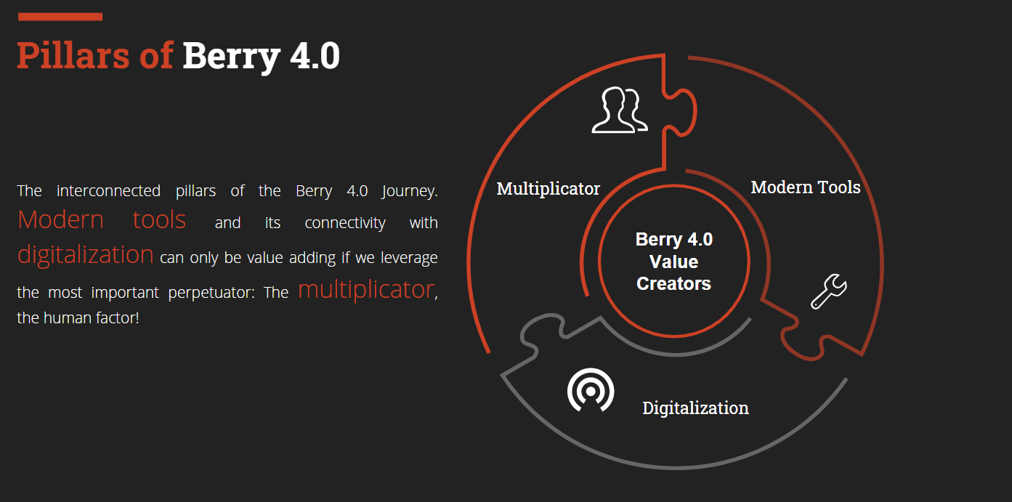

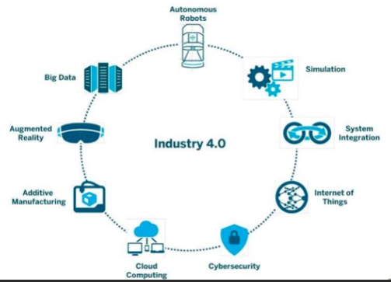

The internet of things (IOT)
The Internet of Things (IoT) has arrived as one of the biggest changes to disrupt the digital world and in a much bigger way than what the internet did a few decades ago or evolution of computers did half a century before. It is driven by the need not just for manufacturers but also individuals to be able to follow and communicate with objects by combining the physical and digital world. (Sudrip Misra, 2021) IT and computing power has changed the world we live in over the last few decades but both business’s and individuals at home have not embraced technological change perhaps as quick as they should have. Even down to laser printers using smart sensors and algorithms to pre order new toner before things run empty allowing less stock to be held in storage is still in its early infancy in some business’s . A lot of new Machine systems, programs and processors use individual IP addresses, interfaces or Wi-Fi and Bluetooth connections allowing access from the outside world or links into the digital world. With these type of connection it allows big data collection and analytics to be a whole lot easier.
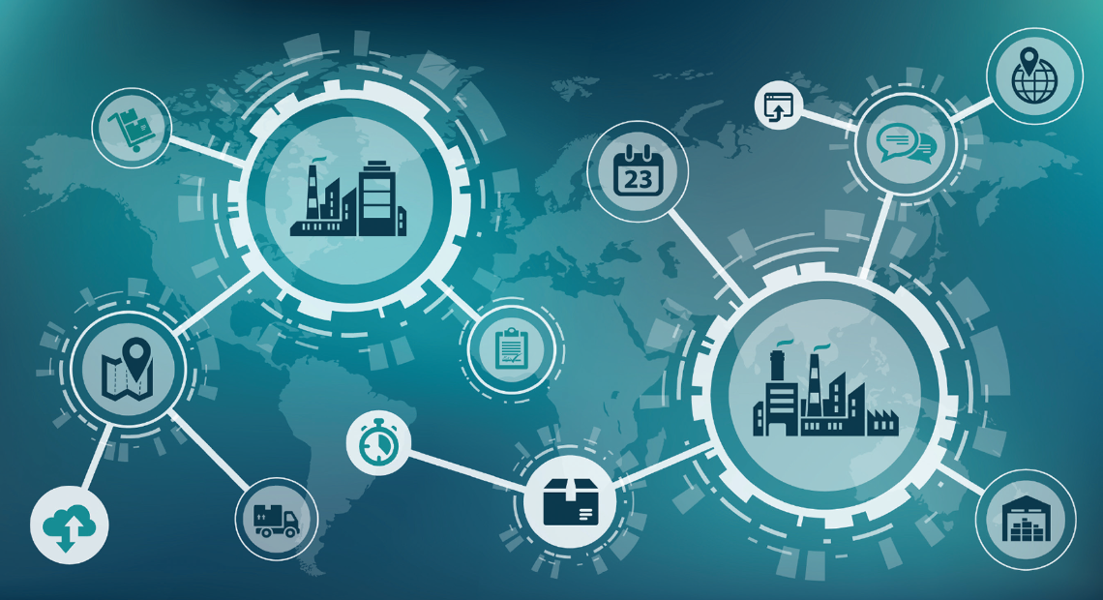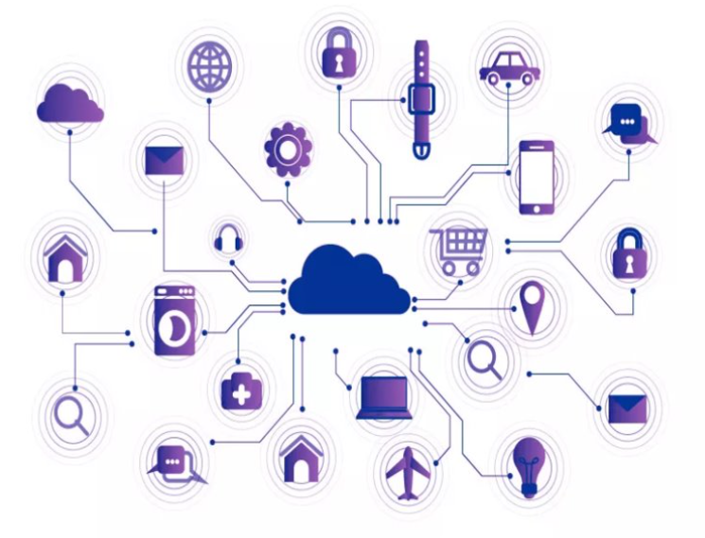

At home we can save our data on cloud based systems or dial into smart CCTV and door bells using Wi-Fi or static address’s. Energy data is readily available to us in the form of smart meters. The same or even improved technologies are available for the work place.

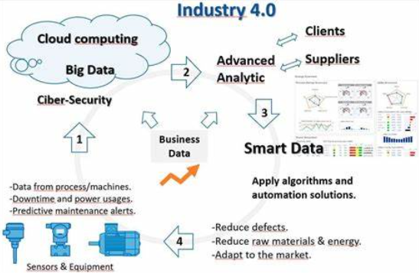

Control systems
Industrial automation uses control systems to handle industrial processes and machinery and can range from very basic systems such as thermostats that control heating to large process automation.
At an entry level discrete control systems with closed loop single control are used and are still common in manufacturing. Within extrusion machines closed loop PID controllers are used to bring on heaters and fans when temperatures are reached switching on solid state relays providing power to heaters. In single circuits this is more than acceptable but when more control or finer control is required distributed control will be found most commonly in the form of PLC’s.
Distributed control (DCS) tend to be digital and is generally used in plants or processes where control functions are distributed throughout the system. Common control such as PLS’s provide the option for custom-designed processors as controllers with individual types of communication connections. These connection can then be in the form of inputs and output that could be analogue, current loop or even bus type signals.
Although distributed control provides modern and fine systems the natural path from there is to SCADA control systems for increases levels of automation and data acquisition. SCADA systems are highly distributed systems used to control dispersed assets that are often a long way away from the source of control. They are used although manufacturing and in lots of distributed systems such as water distribution, oil and gas pipelines and electrical power grids. SCADA monitoring performs centralised monitoring and control for fields over a long distance along with providing big data collect. (Hayden, 2015).
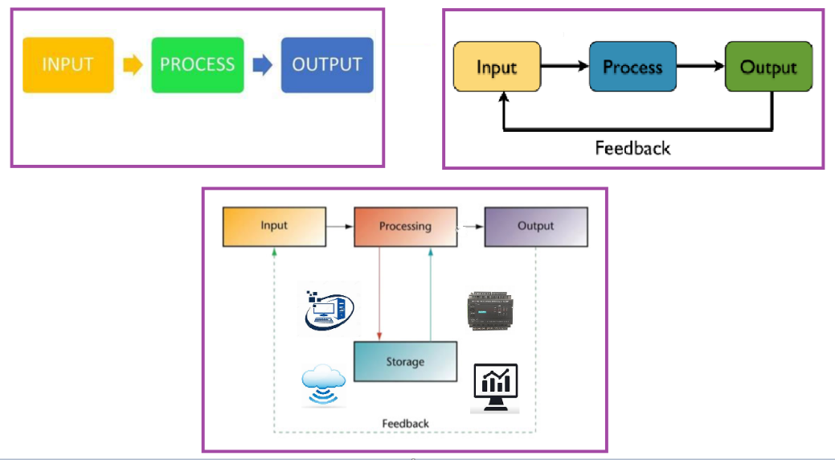
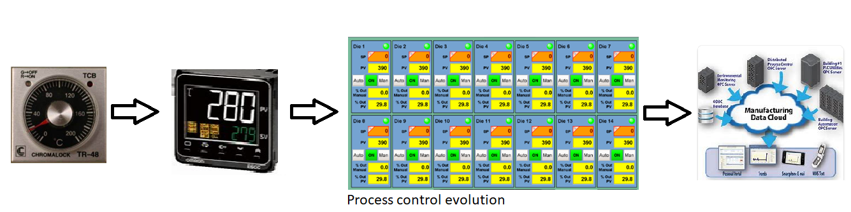
As control system move from SCADA engineered control system to more IT based and cloud based control systems. With most systems now able to integrate and digitally talk to each other systems are getting user friendly but he challenges we will see as engineers is It and security risks that need to be built into control systems.

3D printing
3D printing is a revolutionary manufacturing method that allows the productions of engineering parts almost directly from modeling software on a computer. With 3D printing technology, future manufacturing could become vastly efficient. However, the procedures used in 3D printing differ substantially among the printers and from those used in conventional manufacturing (garcia, 2014). 3D printing covers a wide scope of processes from solidified, joined or deposited products being joined together layer by layer. At a site visit it to Hellerman Tyton almost decade ago I had my first exposure to 3D printing where by they used 3D printed prototypes as the first step to helping us validate design concepts. As material on a spool was being feedthrough a heating element and nozzle we were able to see our prototype coming to life as layer and layer of melted plastic built our component. £d printers in the area we were in were also printing much more complex component for a very well known automotive company and it allowed concepts to be made quickly. From my experience we were able to design a component on a computer package in the morning and have new design trial component in our hands just a few hours later. Our Indusrty 4.0 programme had Ultimaker 3D printers help us understand the gains from 3D printing with thier concept of breaking away from traditional manufacturing and supply chain models and produce parts locally and on demand using 3D printing. (Salazar, 2020).
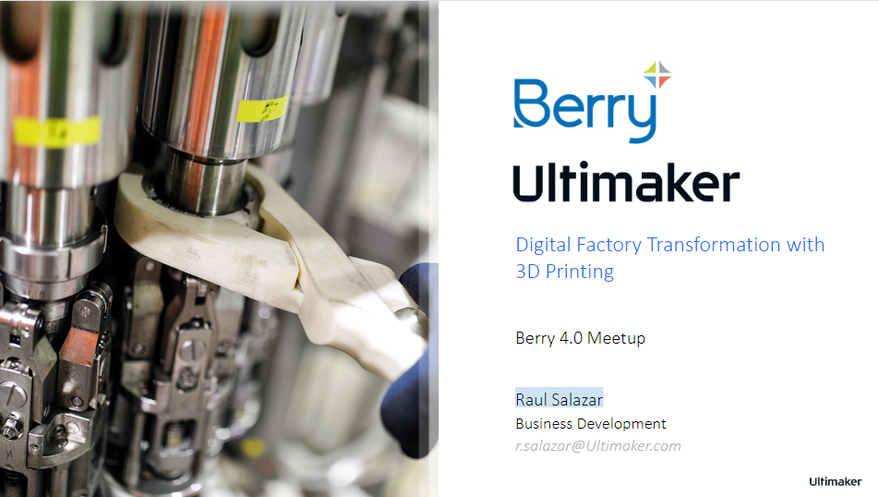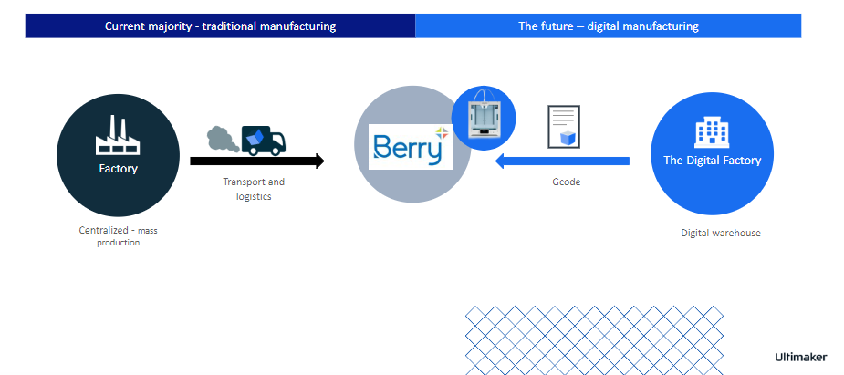

Digitalisation
Digitalisation is transforming our society in several ways, bringing several new opportunities and challenges for firms operating in this dynamic setting. Within my manufacturing setting the digital influence has provides us with new ways of performing tasks and streamlining reports. Research around digitalisation focuses on the technological innovation however, digitalisation impacts not only digital capabilities but also business models, operational processes, and customer experiences. According to Orlikowski and Iacono (2000), such an impact is not merely restricted to the internal organisational structures, but also has consequences for the external interconnected environment of the organisation and are made up of four levels (Mattias Elg, 2020)
1. Process level – changes in how work tasks and activities are carried out by implementing new digital tools or digitalising previously manual activities.
2. Organisation level – new ways of providing existing offerings, as well as providing new offerings enabled by digitalisation
3. Business domain level – changing roles and value chains
4. Society level – reshaping types of work, competence, and infrastructure for digitalisation
Our digitalisation started with the automation of completed production lines using digital systems and smart sensors to control machines and collect data along with problem detection and SCADA systems. The SCADA system then allowed Automation to be developed further, enhanced communications through TV’s and cloud based access and eventually a change to business models. Advanced data analytics is a result of the smart sensors and allows predictive power and accuracy in KPi’s, workflows and predictive maintenance.

Impacts, applications and conclusion
Industry 4.0 (I4.0) represents a radical change in firms operations that is particularly challenging for small and medium sized enterprises (SMEs) due to the substantial need for capital and knowledge (Matt, 2021). The main reason SME’s look to get on board with industry 4.0 is to digitalise, communicate between humans and machine, collect real time data with the end impact of improved production, accurate data and smarter tools allowing collaboration of everyone and everything in the manufacturing area. Consequently, I4.0 arises from its elementary technologies, which lay the foundation for the integration of intelligent machines, humans, physical objects, production lines, and processes to form a new kind of value chain across organizational boundaries, featuring intelligent, networked, and agile production (Alcácer and Cruz-Machado 2019). One thing I’ve not spoken about in my report is the environmental need of industry 4.0 and energy monitoring. With so much focus on rising costs, smarter and more digital energy monitoring will play a big part in most sectors most certainly within plastic manufacturing where after Raw materials, energy is the biggest cost. Another interesting application is cyber security which as we become more digital is going to play a big part into our own Industry 4.0 journey. As a company we are perhaps behind lots of others on our I4.0 journey but each and every topic I have spoken about are tools we are working with in our Business models and are adding real time value to sustaining business and business growth.

Appendices
IOT- (ZELMERLÖW, 2018)
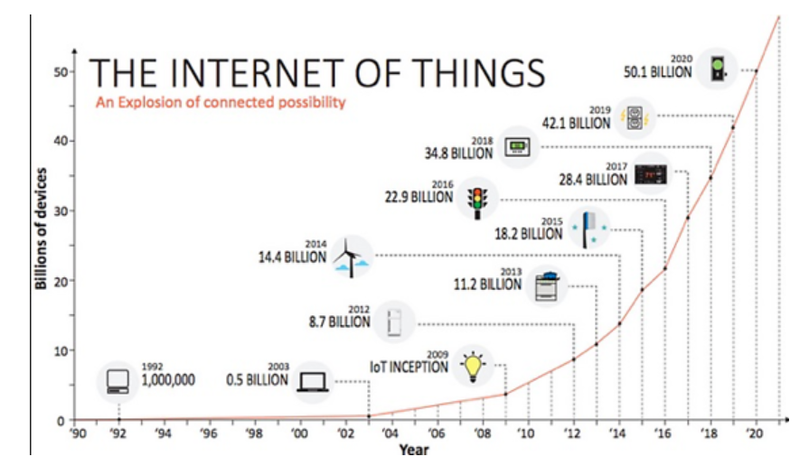
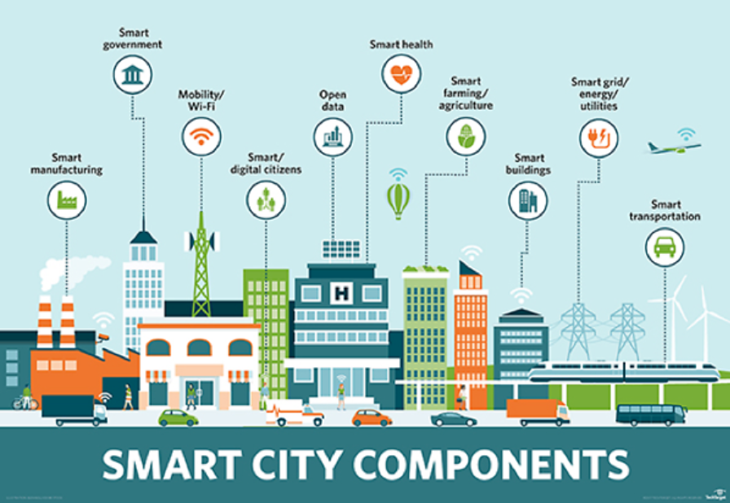

(analytics, 2018)
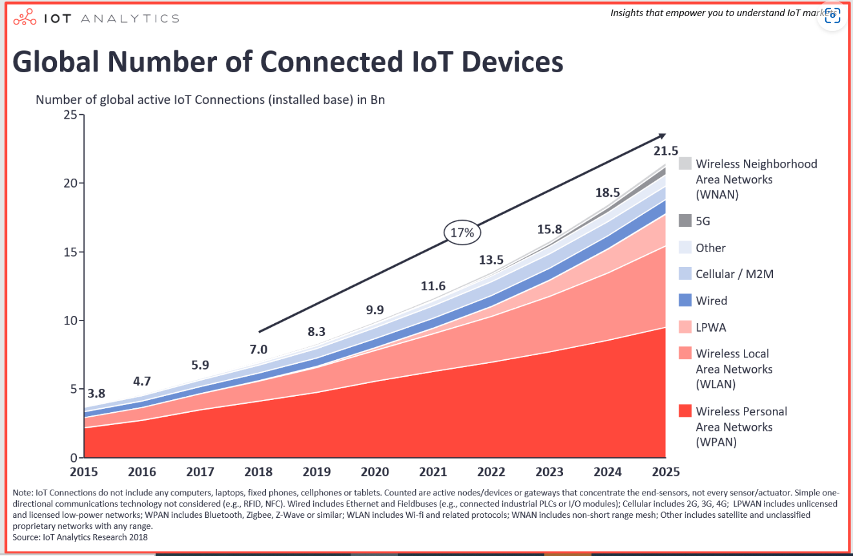

Control systems
(coach, n/A)
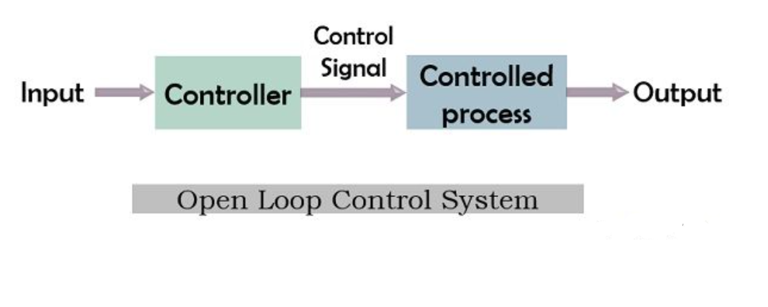
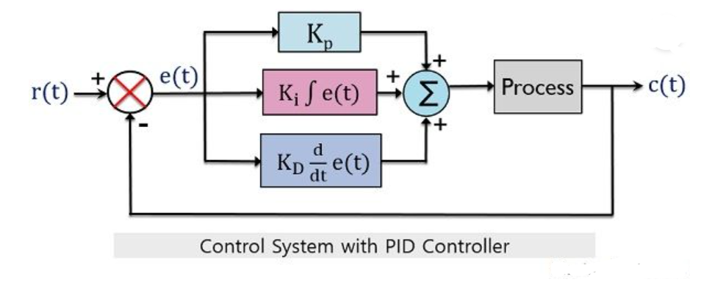
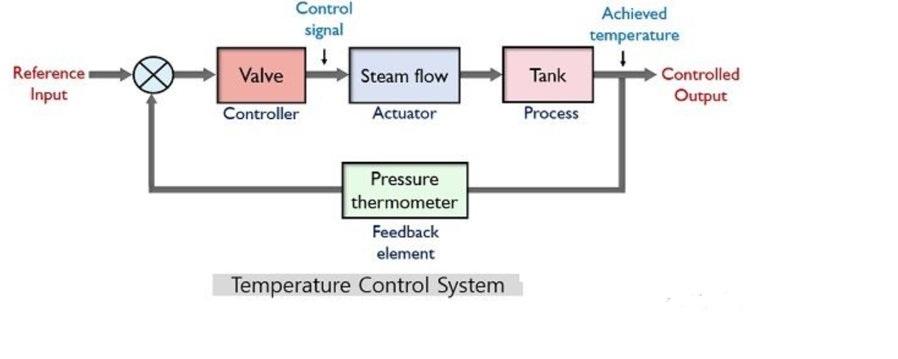

(cooling, N/A)

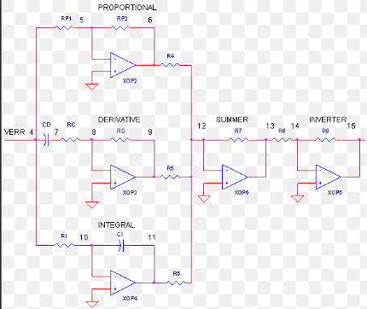

3D printing
(Chapman, 2022)
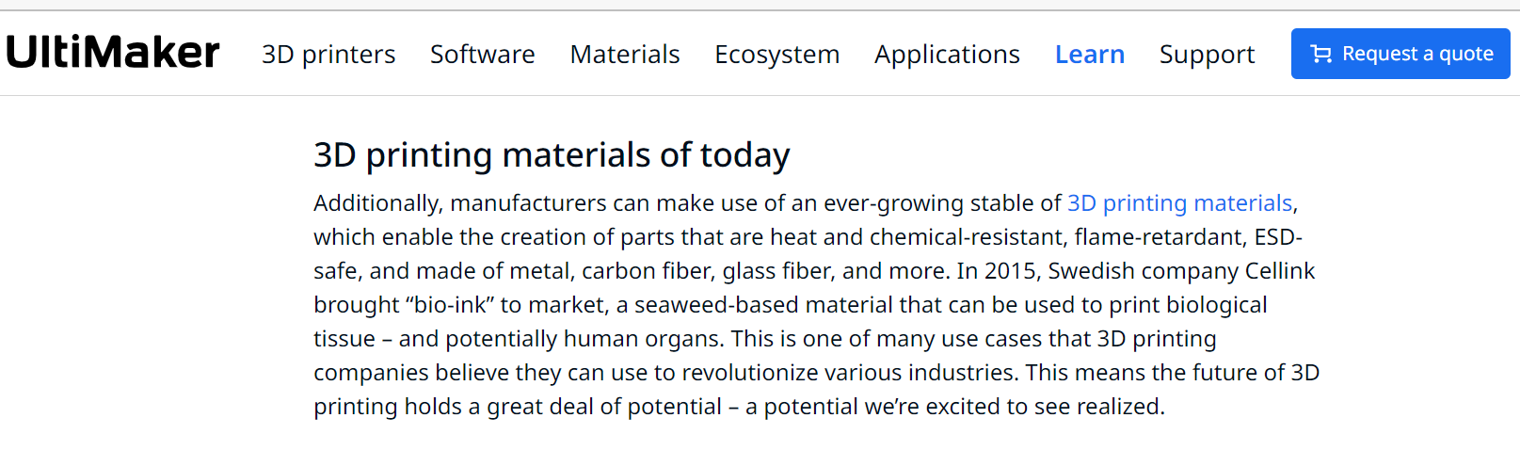
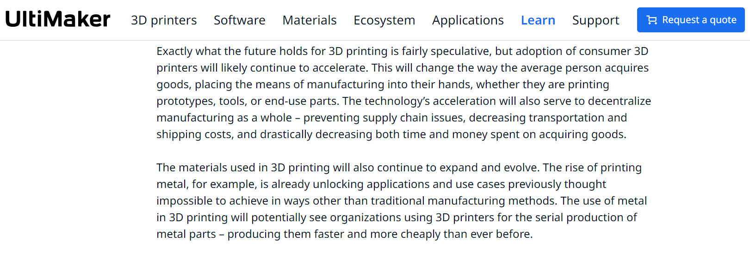
https://www.forbes.com/sites/michaelmolitch-hou/2022/04/25/three-areas-holding-back-the-106b-3d-printing-industry/?sh=2fa87a6f4935
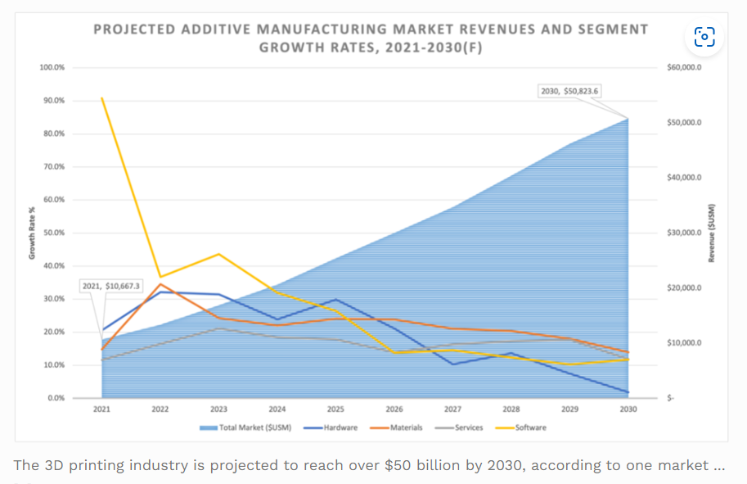
Digitalisation
https://whatfix.com/blog/digital-transformation-in-manufacturing/
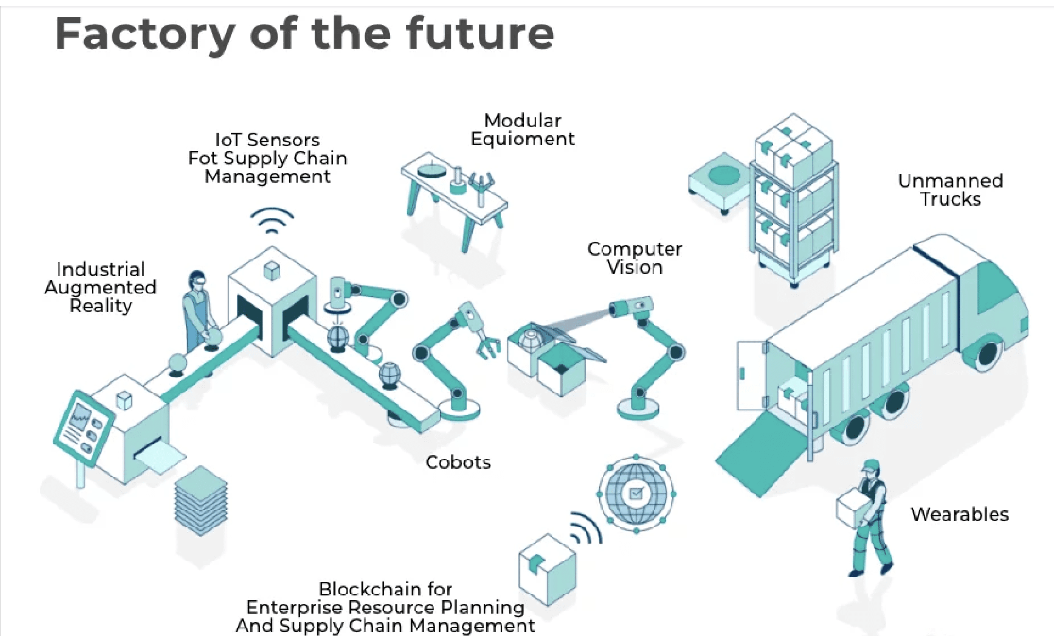
https://www.advantech.com/en/resources/faq/the-next-leap-of-digital-transformation-in-manufacturing
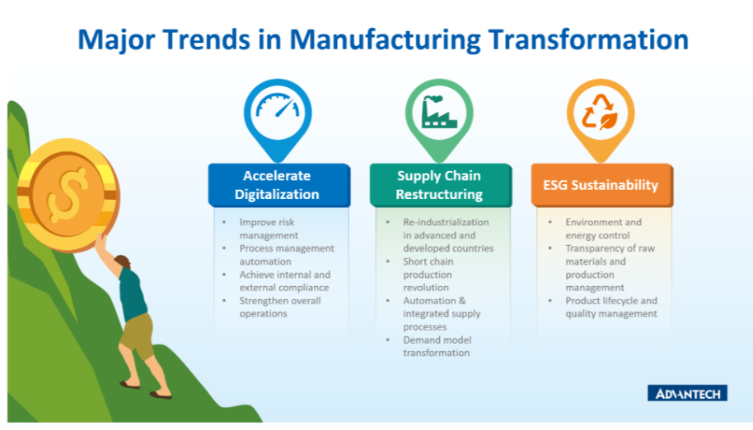
https://www.agilevision.io/blog/top-7-technology-trends-accelerating-digital-transformation-in-manufacturing
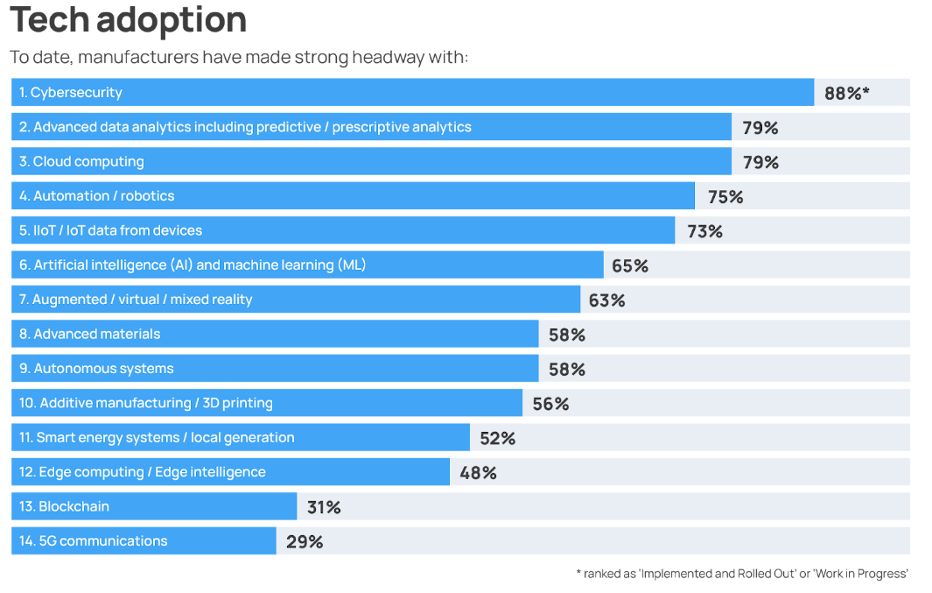

Bibliography
analytics, I., 2018. Number of IOT devices worldwide. [Online]
Available at: https://iot-analytics.com/
Chapman, A., 2022. The complete history of 3D printing. [Online]
Available at: https://ultimaker.com/learn/history-of-3d-printing
coach, E., n/A. Control systems. [Online]
Available at: https://electronicscoach.com
cooling, A., N/A. Temperature Control Units. [Online]
Available at: https://www.aquacooling.co.uk/sales/temperature-control-units
garcia, S. i.-. J., 2014. Evaluations of Mechanical Properties of ABS Parts from Open-Source 3D. 14 04.
Hayden, E., 2015. An Abbreviated History of Automation & Industrial. [Online]
Available at: https://www.giac.org/paper/gicsp/95/abbreviated-history-automation-industrial-controls-system-cybersecurity/139645
Lachance, P., 2021. A History of Maintenance & How CMMS Has Changed. [Online]
Available at: https://www.brightlysoftware.com/en-gb/blog/history-maintenance-how-cmms-has-changed-200-years
Malhotra, V., 2018.
Matt, D. T., 2021. Implementing Indusrty 4.0 in SME's. s.l.:Palgrave Mac millan.
Mattias Elg, A. B.-J. I. G. J. M. &. U. M., 2020. Production Planning & Control. Digitalisation and quality management: problems, p. 15.
Salazar, R., 2020. [Online]
Available at: https://ultimaker.com
Sudrip Misra, A. M. R., 2021. Introduction to IOT. s.l.:Cambridge University Press.
Zaptic, n.d. [Online]
Available at: https://zaptic.com/resources-downloads
ZELMERLÖW, M., 2018. Blue Science Park on Internet of Things. [Online]
Available at: https://www.sisp.se/start/members-signature-blue-science-park-on-internet-of-things

