PROJECT MANAGEMENT

Name: Rabah Rahimi
Student Id: 1602966
BA(Hons) Business Management
Lecturer name: Sir Molly Jack
University Of Wales Trinity Saint David

Contents

INTRODUCTION 3
THE SCOPE OF PROJECT 3
OBJECTIVES 3
REQUIREMENTS 4
DELIVERABLES 4
HUMAN RESOURCES 4
WORK BREAKDOWN STRUCTURE 5
TASKS 5
SCHEDULE OF THE PROJECT 7
RISK FACTORS 7
RISK PRIORITY GRAPH 8
CONTINGENCY PLAN 8
PROJECT ORGANIZATIONAL STRUCTURE 9
STAKEHOLDER ANALYSIS 10
POWER INTEREST GRAPH 11
REPORTING STAKEHOLDERS 11
COST ASSUMPTIONS 12
CRITICAL PATH OF THE PROJECT 13
REFERENCES 15

INTRODUCTION
This documentation is a Project Initiation Document in reference to the project plan for a singing competition to be carried out in University of Wales Trinity Saint David. The program is named as Voice Out (VO). The document aims to outline what VO is trying to achieve including the scope of the project, its goals and objectives, deliverables, the work breakdown structure, how the stakeholders will be managed, risk factors as well as the budget of the entire project.
Voice Out will be an event in which students of University of Wales TSD London will be allowed to participate to perform as singers demonstrating their talent. This event will be held after the assessments so the students can be provided with a platform to enjoy themselves.

THE SCOPE OF PROJECT
Project scope is one of the most important parts of project planning. It comprises of defining and recording main aspects of the project including project deliverables, goals and objectives and costs in some cases. According to Mirza et al., (2013), a project scope can help decide whether to proceed with the project or not. An inefficient project scope or its definition can have a huge impact on the project’s life cycle (Fageha and Aibinu, 2013).

OBJECTIVES

The main objective of this project is to carry out an event (Voice Out) for students to show their singing talent. The objectives of the project outlined can enable the stakeholders to identify what activities will be involved in the project and what the project is trying to achieve (Berry and Thomas, 2008). Each objective has been designed using the SMART technique (Specific, Measurable Achievable, Responsible and Time Bound) in order to make them achievable and operative.

First Objective
To start promotional activities for the event using notice boards, announcements on social media and University sitting areas to create awareness of the show so the students can register to participate

Second Objective
To initiate auditions for the registered participants for the event which should be conducted in a day announced prior the auditions.

Third Objective
To utilize the amount provided to buy/rent equipment and decorative items for the event day including prices for the winner and the runner ups.

Fourth Objective
To carry out rehearsals (hosts), testing equipment including microphones, sound system and organizing the venue for the event day.

Fifth Objective
Carry out performances on the event day by the participants lasting 2 to 3 hours maximum. Furthermore, concluding the event and winners to be announced by the judges awarding them with the prize.

REQUIREMENTS
This section outlines the resources which will be required in order to initiate the project and its completion within the given time.
- Promotional Banners, posters and online posts
- Venue
- Microphone and sound system for the singers/hosts/participants
- Stage decoration items
- Lights (extra for spotting)
- Chairs and tables for the judges and audience
- Photographer
- Money

DELIVERABLES
The deliverables of the project are either physical or virtual product or a service which are to be presented after the completion of the project in front of the stakeholders (Too and Weaver, 2014). The deliverables of this project includes, the university would be able to acknowledge the talent within the students and also, as the students are mostly distressed due to the continuous classes and assignments, the project would create an energetic environment in the university

HUMAN RESOURCES
Human resource management is a strategic component which holds extreme importance in project management. In the initiation of the project the human resources are planned to be managed according to the objectives that are to be achieved in the project. The first thing required to be done while implementing the human resource management is to identify the roles and responsibilities that are to be assigned in a project (Gatewood et al., 2015). This planning process allows the project manager to deal with the staff management. In project management, the project HRM aids in providing thorough description of those processes that can enable the project manager to lead and organize the project team effectively. According to Pinto (2007), if the human resources in a project management are dealt in a proficient way then the project deliverables would have exceptional qualities. Snell et al., (2015) also believes that by having control over the human resources, quality can be controlled easily.
In case of project of VO, in order to achieve the objectives of the project the project manager is required to recognize the capabilities and potential of the project members and assign them project roles in accordance to their level of expertise. Also, it is important that the team that is selected has capabilities that are required for the fulfilment of objectives. The project manager would attempt to improve the interaction among the team members, enhancing competencies which would help in acquiring a stabilized, organized and energetic team environment serving to enhance the overall team and project performance. After the allocation of responsibilities and motivating the team members, the project manager must keep track of the project processes in order to judge and observe the performance of the team members to find out whether they are performing their tasks up to the required level or not. The project manager would demand updates from all the team members and would provide feedback for resolving the issues that are being faced in the project processes and would also modify the project if required so that the project performance would be optimized.

WORK BREAKDOWN STRUCTURE

This part of the project plan highlights the Work breakdown structure. Work breakdown structures can assist the project manager to easily identify the objectives and tasks of the project plan and brief to its team members. Work breakdown structure can help dividing the work equally amongst the team which can increase efficiency of the workers (Miller, 2008).

TASKS

Task 1
To seek permission for the event to take place in the University (to be asked by the Project Manager from Principal/Dean of the University). This task would take about 3 days.

Task 2
To start promoting the event after permission granted. Registering participants for auditions and updating students about the event. This task would be done within 20 days.

Task 3
Collecting the money from the finance officer in order to utilize it to buy/rent equipment, refreshments and prizes for the winners which would take 3 days.

Task 4
Organizing and testing the equipment for the event and setting up the venue for the event day. This task would consume 7 days

Task 5
Arrangement of refreshments for the judges and the audience. (3 days)

Task 6
Holding auditions. (2 days)

Task 7
Rehearsals of the host/hostess and briefing the judges about the regulations of the event. (7 days)

Task 8
To make sure photography of the event on the event day is planned accordingly (2 days)

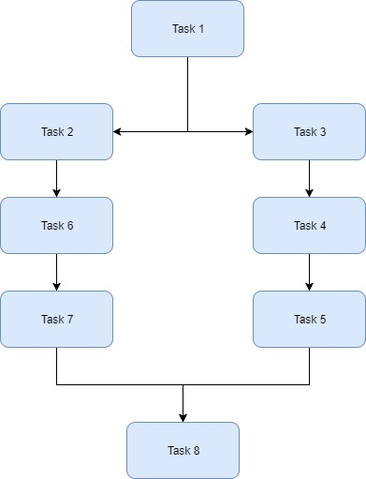
WBS for the event (Voice Out)

SCHEDULE OF THE PROJECT

The schedule of the project determines the time control and limitation of the project. The Gantt chart is used to show the timeline of the project in order to evaluate in a representative way which tasks are required to be fulfilled on how much of duration.

RISK FACTORS

Anything that can have a potential affect upon the timeline of the project is called as risk and required to be identified in order to procure the project processes from those factors (Moran, 2014). According to Team, (2014) risk identification and analyzing is a significant aspect to deal with as it allows you to create a proper response against it and keep the project on its track to achieve the desired goals of the project. Cagliano et al., (2015) believes that risk management holds strategic and effective importance towards the project and it must be dealt chiefly in the planning process. Risk management is said to be categorizing and identifying the risk factors before they appear as threats or becomes issues for the project.
In this project, the project manager would attempt to identify all the possible risks that might create issue in the completion of the project process. Also, the team members would also be enabled to share their perspectives about the possible risks that might be encountered in the project.

 | RISK FACTORS | PROBABILITY | IMPACT
1 | Event Permission | High | High
2 | Less participation by students | Medium | High
3 | Lack of resources for the event | Medium | High
4 | Schedule delay | Low | Medium
5 | No judges or organizers | Medium | High
6 | Low cost for the event | High | High
7 | No venue available for the event | Low | High

RISK PRIORITY GRAPH
Those risks which hold potential pressure and threat towards the project are prioritized and measures are taken to reduce or avoid those risks.

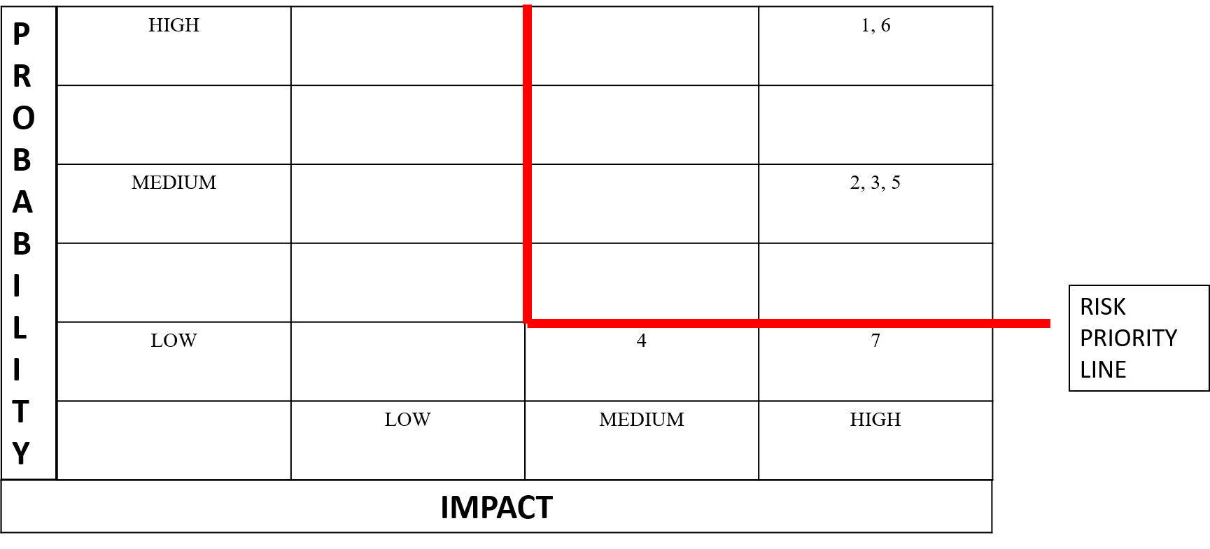

CONTINGENCY PLAN
Contingency plan is prepared for those risks that can affect the project on a great scale and influence its progress.

Risk 1
Event permission is a challenge for the project manager to attain as it can be denied due to any known or unknown reason. Thus, if the plan is rejected, then the idea would be modified and presented with an aspect which is beneficent for the university.

Risk 2
The participation of university students is important but due to continuous assessments some students might not show interest but to cover that risk the team members would promote the event that a way which can motivate students to participate in the event.

Risk 3
There can be a lack of resources in the event which can be preserved by convincing the executive and supplier of the project to aid some of the resources for the event.

Risk 5
Absence of judges and organizes can create a massive issue in the project so by continuous reminding and requesting the judges prior to the event would resolve the issue.

Risk 6
To prevent the issue of having low cost of the project several meetings would be conducted to manage the cost effectively.

PROJECT ORGANIZATIONAL STRUCTURE
Project organizational structure is something that facilitates the management of team members and helps the team to identify and witness those individuals that hold high authority levels over the project operations. By presenting properly structured organizational structure of the project, many conflicts and issues can be resolved and the team members would be aware of the person that has the main authority and has power over the project. In the decision making process, there are several issues encountered which can be managed if there is a clarified project organizational structure.

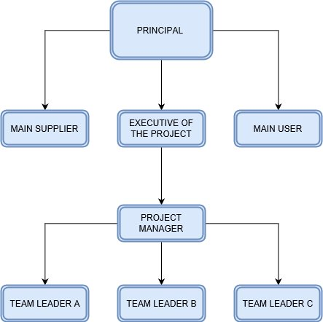

Organizational structure of the project (Voice Out)

STAKEHOLDER ANALYSIS

To attain successful results in the project, the project manager must recognize the potential stakeholders and acknowledge their needs, standard of satisfaction, expectations and requirement of quality (Eskerod and Huemann, 2013). Though, all stakeholders are not the same as each stakeholder has different expectations from the outcomes of the project which means that they must be handled in accordance with their requirements. According to Bourne and Walker, (2008) if any potential stakeholder is not recognized by the project manager and the team members then in later the project manager faces difficulties in several aspects regarding the completion of the project. Rowlinson and Cheung, (2008) states that the decision making process in the project must be considered rationally in order to manage the project within the terms of the stakeholders. In this project, the stakeholder analysis is carried out by the project manager and the team operatives who help in determination of each of the stakeholder’s power and interest degree into the project processes. It depends upon the importance of stakeholders how they would be dealt in the project. The stakeholders that hold high power towards the project would be dealt in an effective way and would be provided satisfaction accordingly.

Stakeholder | Power | Interest
- Financer/Investor | High | Low
- Project Manager | High | High
- Principal | High | High
- Participants/Hosts | Low | High
- Judges | Low | High
- Teachers | Low | Low
- Equipment suppliers | High | High
- Social Media | Low | High
- Students | Low | High
- Team Members | Low | High

POWER INTEREST GRAPH

In order to show the intensity of the stakeholders in the project the power interest graph is created which helps the project team to operate accordingly. By the help of the power interest graph, the influential intensity of the stakeholders is determined which would help in creating communication methods with the stakeholders according to their importance towards the project.

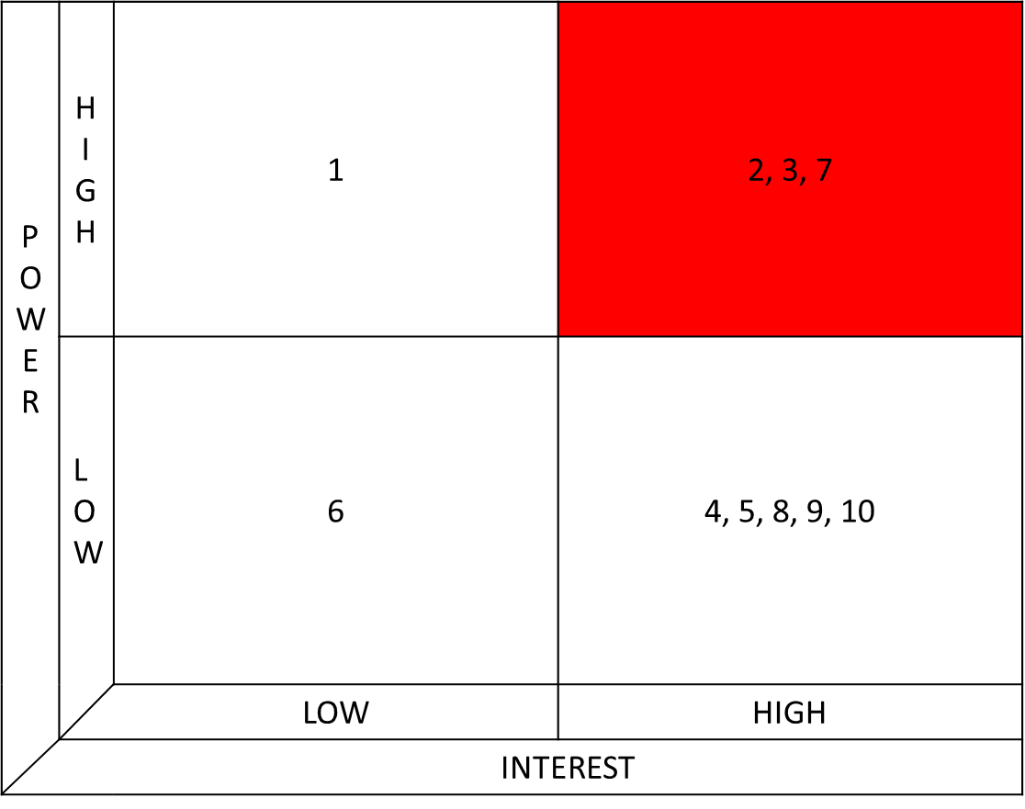
Power interest graph of stakeholders of Voice Out

REPORTING STAKEHOLDERS
The reporting framework allows an understanding that how the stakeholders would be communicated in the project. It is essential that the stakeholders must be aware of current situations and progress of the project which provides them guidance about the project as well as keep them interested about the project. Following is the reporting framework provided for this project (Voice Out) which shows how often the stakeholders would be communicated and what are the methods of communicating with them. These methods and durations of communicating would be made according to the level of interest and power of the stakeholders towards the project.

Stakeholders of the project | What would be reported | Schedule of reporting | Methods of reporting | Frequency of reporting | Format of reporting
Principal | Project Idea | Before initiation | Meeting | 1 time | PID of Voice Out via email
Executive | Progress of the project and any obstacles faced during the project | Alternate days | Meeting and Email | Each week during the project | Hardcopy reports and email
Organizers and Judges | Schedule of the project and any modifications made | 2 weeks before the official event | Meeting and Email | 1 time | Detailed instructions explained via email
Participants of the event | Acknowledgement regarding the event | 2 weeks before the official event | Announcements, meetings and emails | Each week during the project | Emails and Announcements
Managing team | Details and roles in the project | Before the official event | Meeting and Email | 1 time | Emails
Project members | Tasks of the project | Before initiation | Meetings and Emails | Everyday | Team briefing and emails
Project Operatives | Tasks of the project | Before initiation | Meetings and Emails | Everyday | Team briefing and emails

COST ASSUMPTIONS

Making cost assumptions in a project holds fundamental importance in management of the project. Creating a budget plan provides limitations to the project members. Also, making budget assumptions provide clear understanding in utilization of funds for different operations. To successfully produce the deliverables of the project, it is vital to make efforts and carry out tasks in an organized way which requires cost. The cost assumptions can be made by assuming the total tasks that are shown in the work breakdown structure making the total budget of the project. Cost assumptions are mostly created before the initiation of the project as it allows the project manager to make as many changes required so that a near cost assumption is made for the project.

CRITICAL PATH OF THE PROJECT

To recognize the level of importance of tasks in a project, critical path analysis is carried out. There are three ways by which critical path analysis is beneficial for the project which includes reducing the timeline of the project, helps in the management of resources, helps in comparing the planning with the actual situations. When a critical path is created it is easy to look upon the tasks and analyze which of the activities are taking place on how much of the duration due to which a new method of having insight into the project timeline is provided. As carrying out a project is a complex and challenging task, critical path allows the project manager to manage the human resources affectively because a clear direction is provided by the critical path which shows what is required to happen and who is responsible to perform it. By showing forward and backward passes, a critical path can be easily identified.

FOrward pass
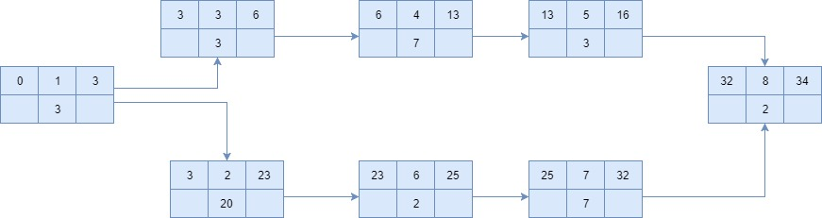

backward pass
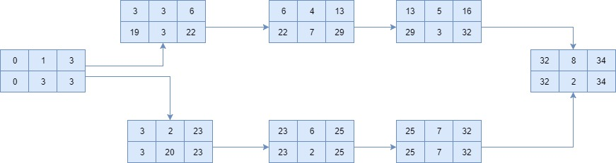

Critical path

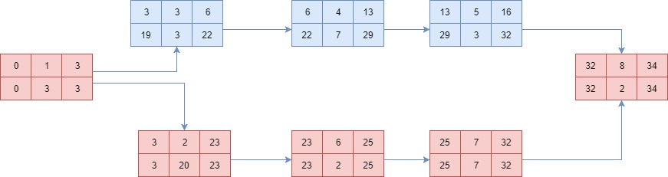

REFERENCES

- Berry, S. and Thomas, R., 2008. Use SMART objectives to focus goals, plans, and performance. Retrieved December, 20, p.2010.
- Bourne, L. and Walker, D.H., 2008. Project relationship management and the Stakeholder Circle™. International Journal of Managing Projects in Business, 1(1), pp.125-130.
- Cagliano, A.C., Grimaldi, S. and Rafele, C., 2015. Choosing project risk management techniques. A theoretical framework. Journal of Risk Research, 18(2), pp.232-248.
- Eskerod, P. and Huemann, M., 2013. Sustainable development and project stakeholder management: what standards say. International Journal of Managing Projects in Business, 6(1), pp.36-50.
- Fageha, M.K. and Aibinu, A.A., 2013. Managing project scope definition to improve stakeholders’ participation and enhance project outcome. Procedia-Social and Behavioral Sciences, 74, pp.154-164.
- Gatewood, R., Feild, H.S. and Barrick, M., 2015. Human resource selection. Nelson Education.
- Miller, D.P., 2008. Building a project work breakdown structure: Visualizing objectives, deliverables, activities, and schedules. CRC Press.
- Mirza, M.N., Pourzolfaghar, Z. and Shahnazari, M., 2013. Significance of scope in project success. Procedia Technology, 9, pp.722-729.
- Moran, A., 2014. Project Risk Management. In Agile Risk Management (pp. 17-32). Springer International Publishing.
- Pinto, J.K., 2007. Project management: achieving competitive advantage. Upper Saddle River, NJ, USA: Pearson/Prentice Hall.
- Rowlinson, S. and Cheung, Y.K.F., 2008. Stakeholder management through empowerment: modelling project success. Construction Management and Economics, 26(6), pp.611-623.
- Snell, S.A., Morris, S. and Bohlander, G.W., 2015. Managing human resources. Nelson Education.
- Team, F.M.E., 2014. Project Risk Management.
- Too, E.G. and Weaver, P., 2014. The management of project management: A conceptual framework for project governance. International Journal of Project Management, 32(8), pp.1382-1394.

