

Blake Auchterlonie

Testing AZ31 Magnesium Alloy as a liner within shaped charges

Advanced Physics for OME
ACDB5015

BEng OME
Academic Year: January 2026

Supervisor: Prof Kelvin Donne

Academic integrity declaration
I declare that:
- the thesis submitted has been written by me alone.
- the thesis submitted has not been previously submitted to this university or any other.
- that all content, including primary and/or secondary data, is true to the best of my knowledge.
- that all quotations and references have been duly acknowledged according to the requirements of academic research.
I understand that to knowingly submit work in violation of the above statement will be considered by examiners as academic misconduct.

Abstract
This report investigates the behaviour of shape charge jets using simulations within Abaqus. The warhead of an RPG-7 was used as a basis to test the validity of the simulations, by modelling the warhead in the software and comparing the results to real life test data. This was modelled using a combination of the Johnson–Cook damage model and the Mie–Grüneisen equation of state in order to give the most accurate damage model for the simulation.

The copper liner results were then used as a benchmark for evaluating an AZ31 magnesium alloy liner. Due to its lower density, the magnesium liner produced a longer jet with significantly higher average velocities, reaching approximately 11 km/s compared the coper liner which averaged 6 km/s.

A more realistic 3d simulation was then created to validate ethe effect of a magnesium liner. Maximum principles where then recorded for this simulation and used to validate why the martial acts hydrodynamics.

Table of Contents
Academic integrity declaration i
Abstract ii
List of Figures iv
List of Tables v
List of Equations vi
1 Shape charge Background 1
1.1 Brief history of shape charges 1
1.2 Jet formation mechanism 2
2 Materials 4
2.1 Damage models used within Abaqus 4
2.2 Copper 4
2.3 Magnesium 5
2.4 TNT 7
2.5 Steel 7
3 Meshing methods 9
3.1 Lagrangian 9
3.2 Eulerian 9
3.3 Arbitrary Lagrangian Eulerian 10
4 2D Sketching 11
4.1 Liner 11
4.2 High Explosive 12
4.3 Steel jacket 13
5 2D Meshing 14
6 Copper results for 2d simulations 17
6.1 Copper simulation 17
6.2 Copper Jet Velocity Time results 23
7 Magnesium results for 2d simulations 25
7.1 Magnesium simulation 25
7.2 Magnesium Jet Velocity Time results 27
8 3d Sketching 29
8.1 Overclosure 29
8.2 Finite element conversion to SPH particles 30
8.3 Very fine liner mesh 31
9 Results from 3d simulation 33
9.1 3d simulations 33
9.2 3d Magnesium Jet Velocity Time results 37
9.3 Maximum principal stress within the jet 38
10 Conclusions 40
11 References 41

List of Figures
Figure 1 Sketch of the metallic liner 11
Figure 2 Sketch of the TNT high Explosive 12
Figure 3 Assembly before meshing 13
Figure 4 To many elements in the mesh due to it being too fine 14
Figure 5 Mesh elements not aligned, causing simulation errors 15
Figure 6 The final mesh used in the 2d simulations 16
Figure 7 Initial pressure graph of the detonation with the TNT at time step 10 17
Figure 8 Pressure graph of the detonation at time step 27 18
Figure 9 Copper liner deformation at time step 35 19
Figure 10 Propagation of the copper jet with the high explosive removed 20
Figure 11 Continued formation of the copper jet 21
Figure 12 The final frame of the copper simulation prior to crashing 22
Figure 13 Velocity Time Graph for the copper jet 23
Figure 14 Magnesium jet forming 25
Figure 15 continued propagation of the magnesium jet 26
Figure 16 Magnesium jet in the last frame before simulation crahing 27
Figure 17 Magnesium jet without high explosive element 27
Figure 18 Velocity time graph for the magnesium jet 28
Figure 19 Cord overclosure within the initial mesh for the 3d shape charge 29
Figure 20 Very fine mesh forming a jet 31
Figure 21 Pressure wave within the high explosive 33
Figure 22 Magnesium jet forming as the shockwave impacts the liner 34
Figure 23 Magnesium jet becoming fully formed 35
Figure 24 Alternat view of the magnesium jet becoming fully formed 36
Figure 25 Final frame of the 3d simulation 37
Figure 26 Velocity time graph for the 3d simulation 38
Figure 27 Maximum principal stress of the formed jet 39

List of Tables
Table 1 Copper data for Johnston-Cook and Mie-Grüneisen 5
Table 2 Magnesium data for Johnston-Cook and Mie-Grüneisen 6
Table 3 TNT data for Johnston-Cook 7
Table 4 Steel data for Johnston-Cook 8

List of Equations
(1-1) 24

Shape charge Background

Brief history of shape charges
Shaped charges are specialized explosive devices designed to focus the energy released by a detonation into a narrow region by the use of the Munroe effect [1]. When lined with a thin liner the explosive is capable of producing a high-velocity jet capable of penetrating solid materials far beyond what an equivalent amount of explosive could achieve in an unshaped form. The principle behind shaped charges was discovered more than a century ago, with early observations of energy focusing effects in hollow cavities explosives by Charles Edward Munroe in 1888 while working at the U.S. Naval torpedo laboratory [2].

The first military use of shaped charges was the second World War [3], with the United Kingdom, United states, Sweeden and Germany developing their own systems mostly simulations and independently. They were used as anti-tank warheads and all shared a similar design of a copper cone surrounded with high explosives [4]. The systems developed rapidly though the war, with early models only capable of penetrating around 60mm of Rolled Homogeneous Armor equivalent [5], to later models capable of penetrating up to 160mm [6] as lessons were learned such as cone thickness and standoff distances.

Post war additional research and funding was allocated to shaped charge design by country’s that would later form NATO in order to combat the increasingly heavy Soviet tanks. Breakthroughs in hydrodynamic theory’s also assisted in development as they were better able to explain the jet formation and penetration mechanics [7]. These developments lead to increasingly novel use us military shaped charges including the use of Tandem charges, where multiple shaped charges are stacked in parallel, as well as top attack munitions which used explosive geometry to direct the formed jet perpendicular to the direction of travel allowing vehicles to be hit while behind cover. More modern systems are able to combine these into a single system such as the TOW-2B anti-tank guided missile [8].

Shaped charges do also play a significant role in civilian engineering. In the oil and gas industry, they are inserted in to drill holes to crack rocks to release oil trapped between there. While shape charges are generated explosively, the jet that I formed penetrates mainly by kinetic means and not heat, and therefore it is safer to extract oil this way rather than via a high friction drill [9].

Demolition and construction also use shaped charges to cut steel beams and bore holes efficiently. They are mainly used in construction as it allowed for a lower number of overall explosives as the shape charge channels the energy in to a single direction. This greatly increases safety as it allows for a minimal number of high explosives to be used as well as making the likelihood of cutting structural beams the first time [10].

Jet formation mechanism
Shaped charges operate by the use of the Munroe effect. This effect occurs in an explosive when a hollow cavity of a uniform geometric shape is cut in to the end of an explosive [11]. This cavity causes the gaseous products formed during detonation of the explosive material to be focused, causing intense localised force and pressure. This detonation pressure is greater than what could be achieved by a solid cylinder of explosive, despite more explosive material detonating in the cylinder with no cut cavity.

If the hollow cavity is then lined with a thin layer of metal, this metal liner will then be accelerated to very high velocities, around 8km/s for a typical 120mm diameter TNT filled shaped charge [12]. The liner is then under intense pressure, approximately 200GPa for the same shaped charge. The converging detonation wave then collapses the liner inward producing a high-velocity jet that can travel at several thousand km/s

While the exact values change due to design factors such as; the explosive fill, cavity shape, and liner material, for explosive fill of the high explosive, the conical liner material will remain as a solid throughout the formation of the jet. This is due to the extreme pressures acting on to the jet from the concentrated explosive shock waves. This in turn cases the metal liner to act under fluid dynamics.

Materials

Damage models used within Abaqus
The material property for the liner, outer jacket and high explosive. For the metals, both a Johnston-Cook damage model as well as Mie-Grüneisen was used. Johnson-Cook is used as the main simulation method as it is able to simulate the material behaviour under normal conditions. It uses a progressive damage model that takes into account both the elastic and plastic deformations that the material will undergo during damage. It is also able to simulate dynamic failure of the material.
The Mie-Grüneisen Equation of State in contrast is used to assist in simulating materials under extreme shock. Due to the explosives used in the simulation some of the materials act as fluids under shock physics. Johnston-Cook is not able to accurately simulate the elements while they act in that was and as such Mie-Grüneisen Equation of state is used to assist, allowing for phase transitions and better accuracy of the particles. An additional Dynamic, Explicit step was in Abaqus was required for this to function properly.

Copper
Copper is the most used liner material used in shape charges due to its high ductility and relatively low density for metals [13]. These features allow it to more easily form a continuous and stable jet which is essential for penetration. The specific type of copper used in the report is Deoxidised High Phosphorus Copper (DHP Copper). This was chosen due to the removal of oxygen from its alloy during manufacture. This lack of oxygen allows it to be more ductile and less susceptible for cracking during the high heat and pressure of jet formation. This should give it ideal penetration characteristics during the simulation. If the experiments where to evolve past simulations in to live fire test then DHP Copper is also readily available and easy to manufacture which would make it ideal for testing. Table 1 contains the values used for copper.

Table 1 Copper data for Johnston-Cook and Mie-Grüneisen
Density | Shear Modulus | _{c}0 | s | Gamma0 | C | Epsilon dot zero
8960 | 47.7x10⁹ | 3940 | 1.489 | 2.02 | 0.025 | 1

A | B | n | m | Melting temp | Transition temp
90x10⁶ | 292x10⁶ | 0.31 | 1.09 | 1356 | 298

Magnesium
AZ31 is a magnesium alloy consisting mainly of magnesium with approximately 3% aluminium and 1% Zinc. It is light weight at and highly machinable which are properties that it shares with copper. It is also less dense than copper at 1.77 g/cm³ compared to coppers density of 8.96 g/cm³. AZ31 is not typically used in military shaped charges, they have seen some application as the primary charge of tandem charges [14]. This is because the first charge in a tandem warhead is designed to defeat explosive reactive armour (ERA).

ERA works by having an explosive compound, typically PBX, between two metal sheets such as steel. When hit by the jet of a shaped charge, the shock wave caused by the jet penetrating the metal plate causes the sandwiched explosive to detonate. This detonation interrupts the formed jet, steeply diminishing the effective penetration of the shaped charge. As such tandem charges use two shaped charges in parallel, the first smaller change to detonate the ERA plate with enough time for the shockwave from the explosion to dissipate before the second shaped charge detonates to penetrate the main armour.

This should give the jet produced by a shaped charge using AZ31 Mg a higher velocity than a copper liner as its lower overall mass will give it lower inertia. This however may also cause it to have worse over all penetration performance than that of copper due to its lower inertia. Table 2 contains the values used for Magnesium.

Table 2 Magnesium data for Johnston-Cook and Mie-Grüneisen
Density | Shear Modulus | _{c}0 | s | Gamma0 | C | Epsilon dot zero
1730 | 17x10⁹ | 4520 | 1.242 | 1.54 | 0.013 | 1

A | B | n | m | Melting temp | Transition temp
141.6x10⁶ | 271.7x10⁶ | 0.2105 | 1.83 | 891 | 293

TNT
While the RPG-7 has used multiple types if high explosive fill during its life, TNT was chosen for the explosive fill due to its widespread use as a baseline explosive. In order to ensure an accurate model, the Jones-Wilkins-Lee (JWL) equation of state is used for the simulation [15]. The following data (Table 3) was used to model the TNT high explosive fill. The detonation point for the simulation was also set to be at the upper left-hand corner of the model as this would be the position where the electrical detonator would be placed in a real-world example.

Table 3 TNT data for Johnston-Cook
Density | Wave detonation speed | A | B | Omega | R1 | R2 | Detonation energy Density | Pre-detonation Bulk Modulus
1630 | 6930 | 373.8x10⁹ | 3.747x10⁹ | 0.35 | 4.15 | 0.9 | 36.8x10⁶ | 0

Steel
Stainless steel was used for the outer case of the warhead. As this is only a structural object, only the Johnston-Cook damage model data was included as it did not contribute to the final results [16]. Table 4 contains the values used for Steel.

Table 4 Steel data for Johnston-Cook
Density | Young’s Modulus | Poisson’s Ratio | C | Epsilon dot zero
7850 | 210x10⁹ | 0.3 | 0.013 | 1

A | B | n | m | Melting temp | Transition temp
553x10⁶ | 600x10⁶ | 0.234 | 1 | 1733 | 293

Meshing methods
There are three main types of meshing methods that can be used for a simulation of a shaped charge. They are Lagrangian, Eulerian and Arbitrary Lagrangian Eulerian meshing. For the shaped charge simulation Lagrangian was the main method used, however Arbitrary Lagrangian Eulerian was also used to see if it could resolve some node errors in the simulations.

Lagrangian
Lagrangian meshing is the standard formula used in Abaqus for finite element models. It works by calculating the load on every individual node and then applying the resultant force from the node on to its neighbour elements. This allows for accurate simulation of stresses and strains thought the materiel as a whole. This is especially useful for electric-plastic analysis during material deformation.
However, in simulations where large deformations occur, for example the high stresses as a detonation shockwave passes through a material, Lagrangian meshes can become highly distorted. These small distortions can case inaccuracy’s when calculated though the whole mesh. Larger errors can case elements to become highly stretched and distorted, which eventually lead to the program to crash.

Eulerian
Eulerian meshing on the other hand is used for problems where materials undergo extremely large deformations. In this case the mesh is fixed in space and the material flows through the elements rather than deforming with them. This allowed Abaqus to treat the material closer to a fluid rather than an elastic-plastic solid material. This process is most commonly used for materials such as soil interactions as well as granular flow rather than a single solid uniform material.

Arbitrary Lagrangian Eulerian
Arbitrary Lagrangian Eulerian (ALE) meshing however can be used in place by using adaptive meshing during the simulation. While the main simulation runs as a Lagrangian simulation, once elements begin to distort excessively, the software is able to automatically smooth the mesh using Eulerian formula. This should then allow the simulation to run past the point it would normally crash using pure Lagrangian meshing calculations.

2D Sketching

Liner
The shape charge design was originally based on a design for an RPG-7 warhead. This was chosen as the RPG-7 was first produced by the Soviet Union in 1958 and has around 12 million copy’s being made, as such its design and performance have been widely documented in open-source literature.

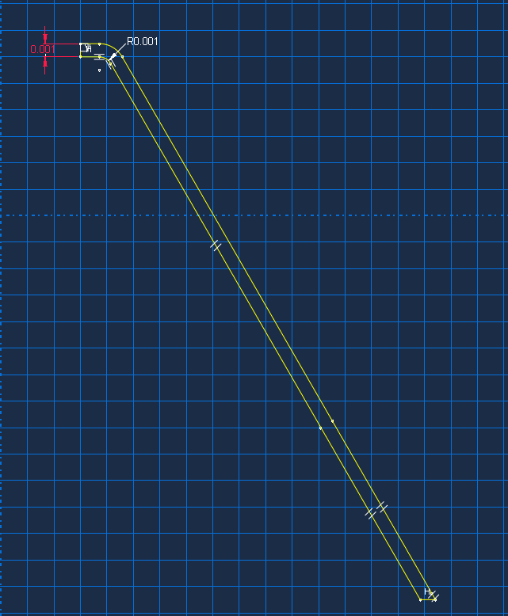
A sketch was made on Abaqus for the copper liner of the shaped charge. As the warhead of the RPG-7 is quite small, all measurements were done in meters. The thickness of the copper liner was 1mm with a 1mm radious curve at the top of the liner. This does differ to the fesign of the RPG-7 somewhat as it used a shaper angel due to the copper jacket usualy being stamped dueing manufacture. From previous simulations using abaqus I did forsee this being an issue with such a sharp angel being at the point where the copper will distort the most. As such the small curve was added to help aid the simulation and to pruduce better results.
Figure 1 Sketch of the metallic liner

High Explosive
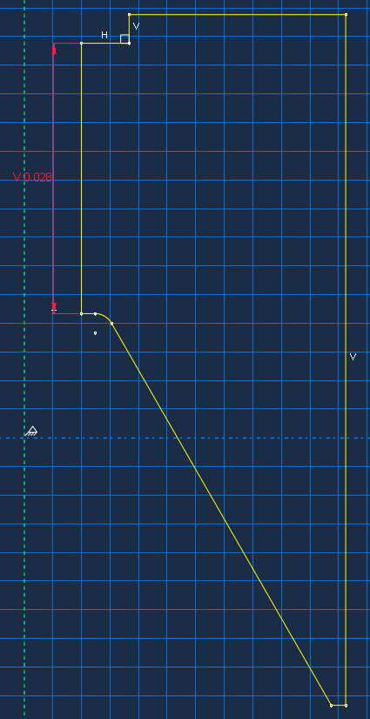
After saving the sketch the main high explosive fill was created using the liner as a guide. While this also contained sharp angels which could case errors in the simulation, these where at points where the mech would me more course, and as such would not provide as many errors as the impact point of the liner.
Figure 2 Sketch of the TNT high Explosive

Steel jacket
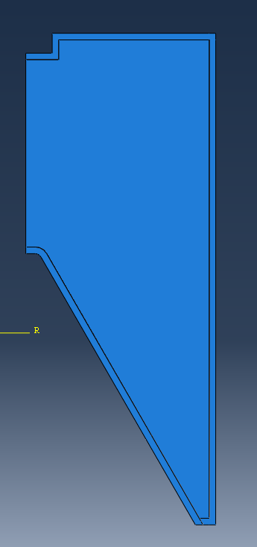
Finaly the jacket for the warhead was created. This has little effect on the formation of the jet, however it allowed for the detonation to propagate properly within the high explosive and as such will give the simulation a realistic result. Figure 3 shows the 2d cut away of the shaped charge after assembly.
Figure 3 Assembly before meshing

2D Meshing
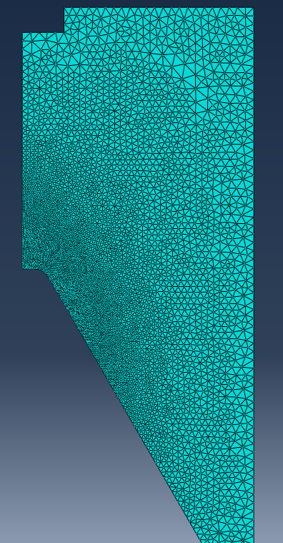
After loading the materials, a mesh was made for the three parts. Local Seeds were used to control the size nodes. They were created to be most dense around the leading edge of the metallic liner so that the most accurate results could be obtained. Initially the mesh around the top of the liner was set to 0.001 and to taper off to 0.001. While simulating this proved to be far too small of a mesh with elements distorting after an extremely long simulation time of around 3 hours.
Figure 4 To many elements in the mesh due to it being too fine
This was determined to be an unacceptable time for the simulation to take as there was multiple variants that I wished to test. As a result, the local seed was decreased to be 0.003 to 0.001. While this is a small change, it dramatically decreased the number of elements that where required to be simulated. This cut the simulation time down to a much more acceptable average of 10 minutes.

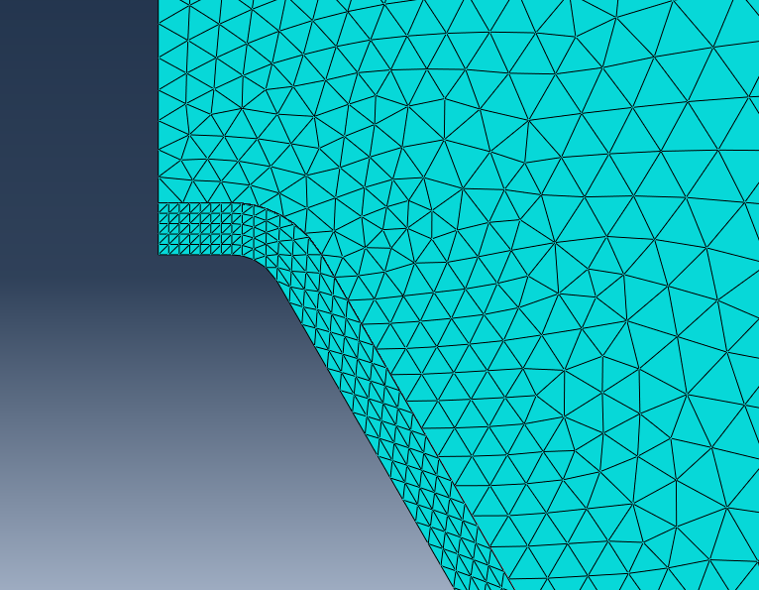
A second issue that I had with meshing was that nodes did not properly interact between objects, such as the explosive and the liner. Initially I believe this to be an interaction issue, however I discovered that it was due to the difference in sizes of mesh between the liner and explosive. The inconsistancey of mech ment that lements where distorting and passing though its neigbours before they had realised that the mesh had moved. This was rectefied by matching the meshes for both the parts, using one as a guide to ensure they exacly lined up.
Figure 5 Mesh elements not aligned, causing simulation errors

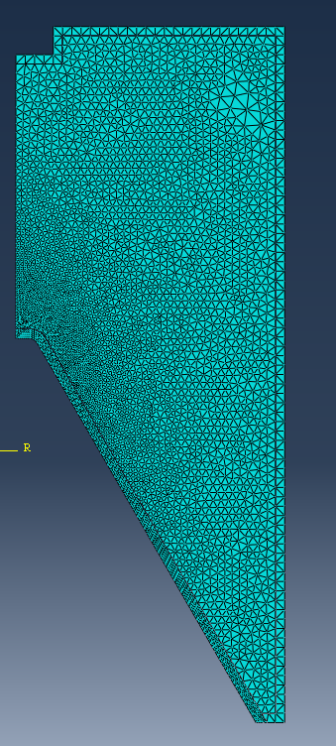
Figure 6 The final mesh used in the 2d simulations

Copper results for 2d simulations

Copper simulation
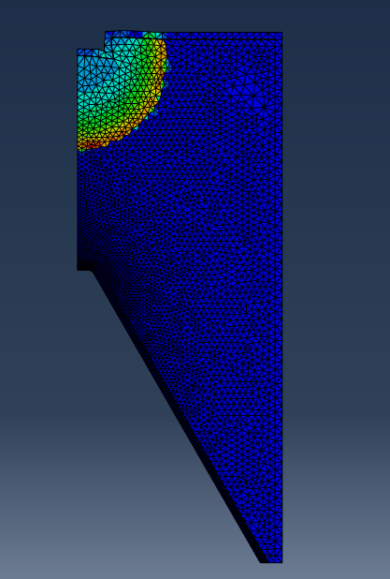
The first run of simulations was for a copper liner. This was done as a baseline so that results could be obtained prior to the magnesium model so that results can be compared. Figure 7 shows the detonation front within the high explosive at time step 10. The steel outer case can be seen distorting as the high pressure wave at the detonation front propagates evenly away from the point of detonation.
Figure 7 Initial pressure graph of the detonation with the TNT at time step 10
Figure 8 shows the continued propagation of the detonation wave just as it reaches the top of the copper liner. While it continues to move evenly away from the point of detonation, there is a higher-pressure region along the steel case. This is due to the to the incident shock wave hitting the boundary wall and being reflected back inwards. This turns the shock wave parallel to the surface causing constrictive interference with the incoming waves, increasing the pressure and temperature along the boundary region.
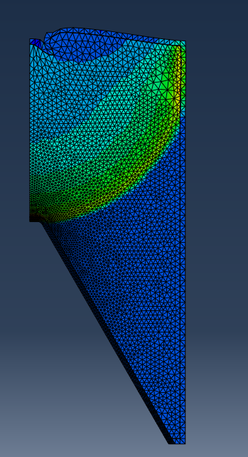
Figure 8 Pressure graph of the detonation at time step 27

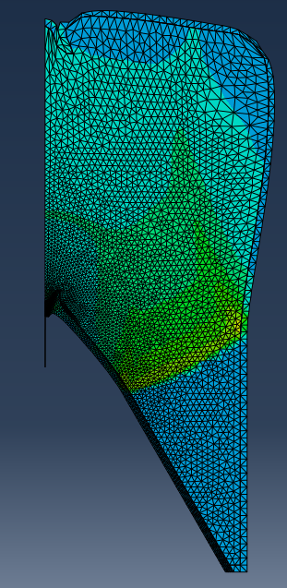
Figure 9 shows the formation of the copper jet as the high explosive continues to detonate. The high pressure of the TNT can be seen buckling the liner of the copper as the detonation wave passes it, forcing it outwards and downwards. The low pressure region inside the high explosive behind the detonation wave would be gasses from the detonated TNT. These combusted gasses are difficult for Abaqus to model correctly as the elements distort randomly on unrealistic ways as the simulation continues. As such further figures have had the high explosive element removed. The forces acting upon the copper liner still do exist with the program, removing the high explosive element is only done for visual clarity.
Figure 9 Copper liner deformation at time step 35
Figure 10 shows the continued formation of the copper jet. The tip of the jet is from copper that was hit first by the high explosion detonation wave. As this was the first region to be hit as well as being hit parallel to the direction of motion this region has had the highest energy imparted to it. As such it moves forward with the highest velocity.

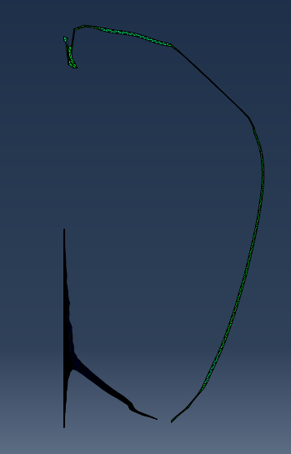
Figure 10 Propagation of the copper jet with the high explosive removed
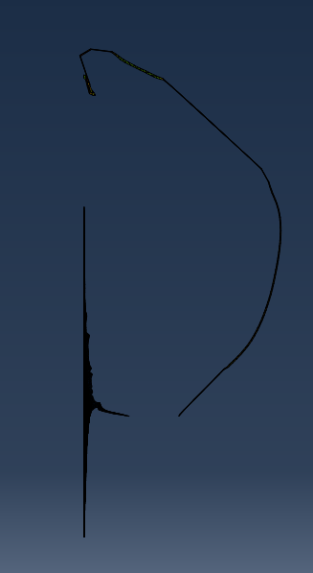
Figures 11 and 12 show the continued formation of the jet until the crash of the simulation. They both show a near ideal jet formation and what would be expected from a shaped charge modelled of the RPG-7 warhead. While the simulation crashed after figure 12, this is not a concern that there is an error with the modelling or meshing. It is most likely due to excessive distorted elements due to the Lagrangian mesh formula used for element calculation. There were runs both with and without the inbuilt Abaqus element deletion feature to see which was most viable. While enabling element deletion to remove the worst distorted elements did enable the simulation to run for 6 more steps, the highly distorted high explosive after it had completely combusted still ended up being the main cause or the crashes. However, by that time the Jet had fully propagated, and velocity plots could be obtained so it was not deemed an issue.
Figure 11 Continued formation of the copper jet
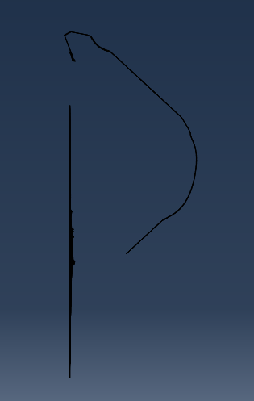
Figure 12 The final frame of the copper simulation prior to crashing

Copper Jet Velocity Time results
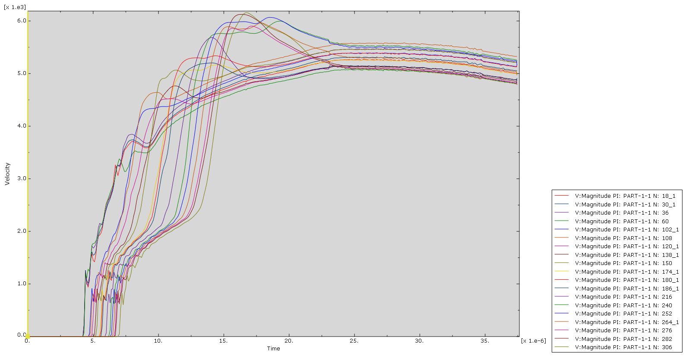
As copper jet propagated as expected, a selection of 20 nodes was selected across the length of the jet so that a velocity time graph could be produced (Figure 13). The elements at the very tip of the jet where not selected as these could be distortions and could add errors to the data. The graph is what would be expected, with elements near the tip of the jet traveling close to 6km/s before slowing down. This is slightly less than an RPG-7’s maximum jet speed of around 6.5km/s [17] however it is most likely down to the simulation not fully taking in to account the increase in gasses after combustion.
Figure 13 Velocity Time Graph for the copper jet

The TNT combustion reaction (Equation 1-1) is incomplete due to lack of enough oxygen within its molecular structure. As such the products of confined TNT include carbon monoxide. As the detonation begins to shatter the case and oxygen from the atmosphere begins to mix with the hot, compressed gasses the carbon monoxide can the react with pure oxygen to produce carbon dioxide. This is an additional exothermic reaction which the simulation probably does not account for, and as such could explain some of the decreased speed of the jet.

2C₇H₃(NO₂)₂→12CO+5H₂+3N₂+2C | (1-1)

Despite this, the rest of the velocity time graph is as what would be expected. The decrease in speed of the copper elements as they move further away from the tip of the jet is due to the copper liner experiencing different impact pressure from the high explosive as it detonates. This is what untimely cases the jet to break up and dissipate and is expected.

From this result, it can be concluded that the simulation for the works as an acceptable simulation of the known shaped charge, the RPG-7, and as such changing the liner to magnesium will be likely to give accurate results.

Magnesium results for 2d simulations

Magnesium simulation
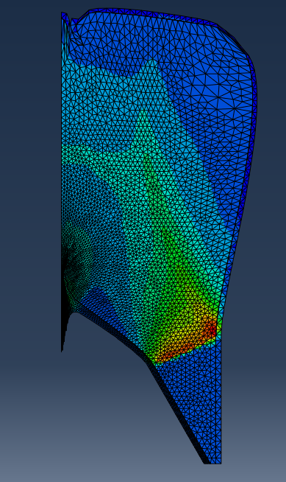
The magnesium simulation initially happened in the same way as the copper simulation due to there being no changes in the high explosive charge or steel case. As such figure 14 shows the magnesium lined shaped charge at the same positions the copper lined charge in figure 9. The tip of the forming jet can be seen to be slightly more formed when compared to copper jet, this is due to the lower density of the magnesium allowing it to be more easily accelerated by the same pressure.
Figure 14 Magnesium jet forming

Figures 15, 16 and 17 show the continued jet formation as the shaped charge fully detonated. The simulation for the magnesium lined charge ran for 6 microseconds less than that of the copper lined charge, however despite the shorter simulation time the magnesium jet propagated fully and was considerably longer than the copper jet. This again is due to the lower density if the magnesium metal allowing it to accelerate faster under the same pressure as the copper. Despite this the jet still formed as expected and behaved like an ideal shape change.
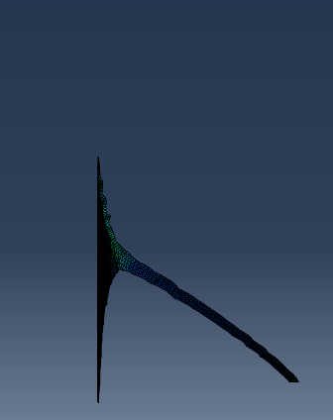
Figure 15 continued propagation of the magnesium jet

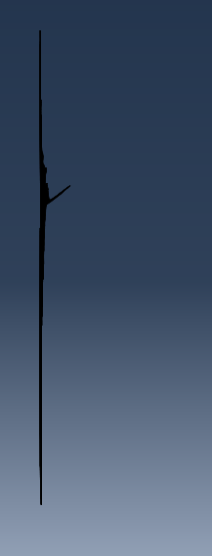
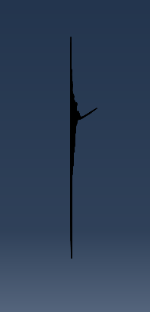
Figure 16 Magnesium jet in the last frame before simulation crahing
Figure 17 Magnesium jet without high explosive element

Magnesium Jet Velocity Time results
The same method of sampling points for the velocity time graph was done for the magnesium points as it was done for the copper. The results can be seen in Figure 17. The main differences between the magnesium and copper velocity time graph awas the far higher average speed of the jet. From the 20 elements from where the data was taken, they averaged a maximum velocity of 11km/s. While the average speed for the magnesium as jet was expected to be higher, the extent to which it was unexpected.
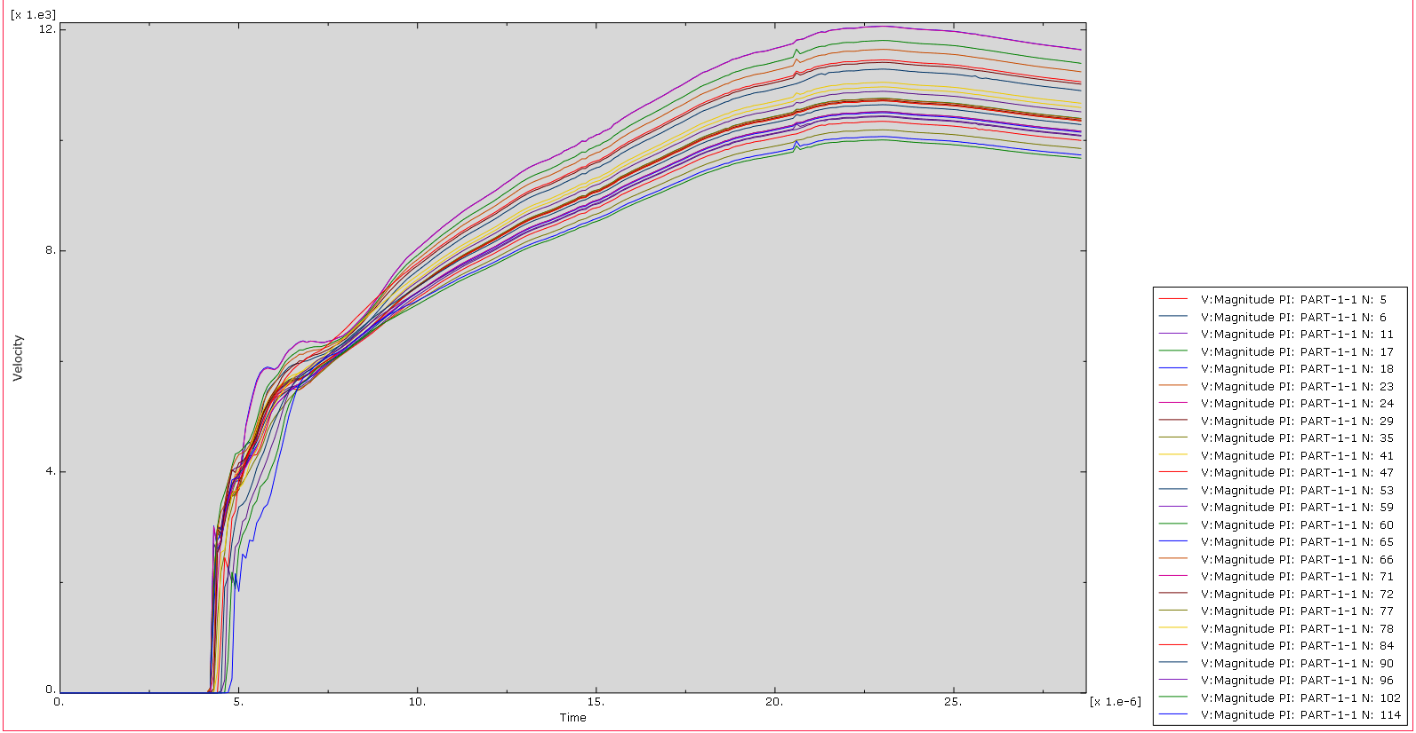
Figure 18 Velocity time graph for the magnesium jet
A second difference between the two was the time at which the two metals reached their maximum velocity. The copper jet reached its average maximum velocity at 16 microseconds after the simulation start, approximately 11 microseconds after the pressure wave from the high explosive hit the metal liner. In contrast the maximum velocity for the magnesium happened at 23 microseconds after simulation start. This is due to Newtons second law of inertia.

As the pressure wave transfers the momentum into the two different metal liners for the same impulse, the lighter materials undergo a larger change in velocity. The lighter material will also be under the effects of the positive influence of the pressure wave for a longer time before the pressure front decays significantly enough to no longer cause to to accelerate.

From the results obtained from the 2d simulations, it was determined that the magnesium liner should be made in a three-dimensional simulated model to test to see if the same results could be obtained from there.

3d Sketching
The sketching for the 3d mesh was done using the 2d sketch as a baseline so that the exact geometry could be matched. This was then rotated though 180 degrees. While this could be rotated 360 degrees in order to get a full shape change, this would be difficult to see the internal mechanism of the shape charge. As a result, the half rotation was done and then the flat face of the shape charge bounded to simulate a full conical charge. This gives both the benefit of the simulation acting as if there is additional material there with also being able to see the internals.

Overclosure
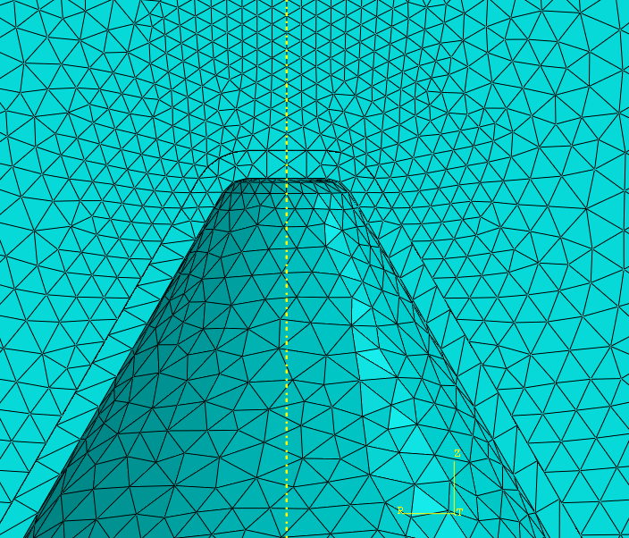
A major issue that occurred when meshing the 3d model was overclosure. This occurred as the liner and the high explosive components had slightly different but distinct geometry that where in contact with each other. As the simulation program cannot simulate curves well with its elements, it instead approximates the curves. As the elements are different sizes, the approximation for the inner and outer curve is different and can then overlap as seen in Figure 19.
Figure 19 Cord overclosure within the initial mesh for the 3d shape charge
While this was somewhat fixed with a redesign of the mesh, ensuring that both the touching elements had identical spaced nodes to make the geometry as close as possible, the general contact interaction also needed to be adjusted. In Abaqus small overclosures are treated with strain-free adjustments by default at time step 0. This is done to smoot the simulation and account for issues in the geometry due to meshing. However, as standard this is only done to relatively few overclosures due to the overclosure adjustment size limit determined by the general contract interaction. This can be manually changed to increase the maximum size of overclosures that are adjusted. This proved to be effective when used with the updated matching geometry of the mesh, stopping simulation errors from elements passing through each other.

Finite element conversion to SPH particles
While the simulation was done using a Lagrangian mesh, as the situation went on the distorted elements crashed the program prematurely. In exploring a solution to fix these issues a second step was added to the program. At 1.8e-5 seconds after the simulation had started, Abaqus would stop using Lagrangian mesh and instead treat the rest of the model as Smoothed Particle Hydrodynamics. In this method the elements are treated as discrete, free flowing particles to simulate the way metals behave under extreme shock. While it is possible to simulate the entire program in this way, it is very processor intensive and as such takes a long time to complete a single step. To get the best of both methods, the program simulated using a Lagrangian mesh to begin with, switching just before the program began to crash. This was 1.8e-5 seconds after the start of simulation.

While in theory this should have been able to increase the simulation time and lead to better results, the Abaqus 2024 program was not able to handle the SPH particles during simulation. This caused the program to crash even earlier than just using Lagrangian mesh by itself.

Very fine liner mesh
Another aspect that was explored in order to get better results was to increase the number of elements present within the liner by decreasing element size. As the liner was the part that was causing the most program crashes by distorted elements, using a much finer mesh was looked at. In theory it should have allowed the mesh to move more freely under the pressure from the high explosive without any single element having to distort as much.
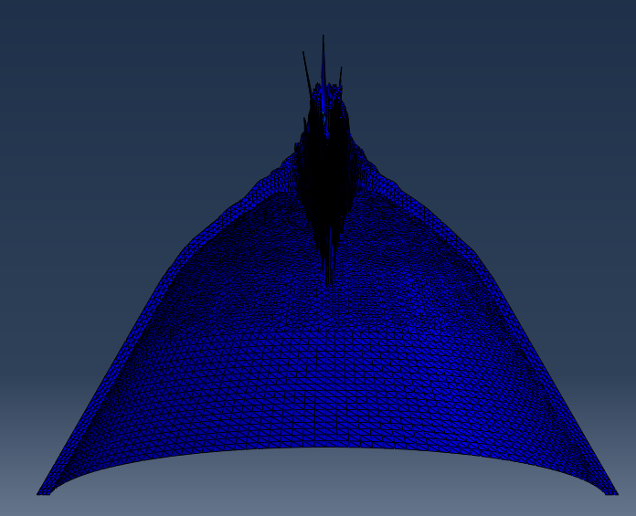
Figure 20 shows the fine mesh under blast load from the high explosive, as well as the magnesium jet forming. While this is likely to be a more true representation of the exact shape of the jet forming compared to a less fine mesh, the additional elements cased issues with the simulation. As can be seen from the figure some of the nodes have not been displaced with the rest of the material. This inadvertently caused more of the issue of warped nodes that this solution was trying to fix. The finer mesh also had the issue of being far more resource intensive on the desktop processor, casing the simulations to take upwards of an hour per run while leading to less over all completed steps than a courser mesh.
Figure 20 Very fine mesh forming a jet
Because of these two reasons a less fine mesh was chosen to run the simulation with. With additional mesh work to refine it further as well as more available compute time, then the very fine mesh will have most likely given the best and most accurate results. However, due to time limitations this was not possible and the less fine mesh was pursued instead.

Results from 3d simulation

3d simulations
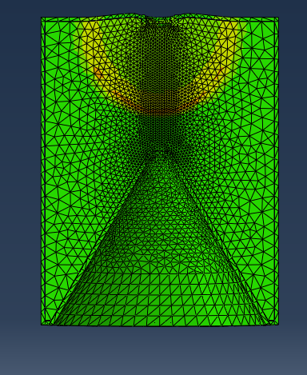
The start of the simulation happened in much of the same way as the 2d simulations. The TNT detonated as expected and the shock front propagated symmetrically from its initiation point. Figure 21 shows the reassure front within the high explosive charge and the steel case beginning to warp.
Figure 21 Pressure wave within the high explosive

The shock wave reflection can be seen again in the steel case as well as the magnesium as was seen in the 2d simulations. Figure 21 also shows how the constructive waves impact the magnesium liner. There is a clear primary shock wave impacting the liner, with a smaller secondary and tertiary wave hitting it shortly after caused by the reflecting waves. This can be seen on the inside of the magnesium liner, just behind the forming jet.

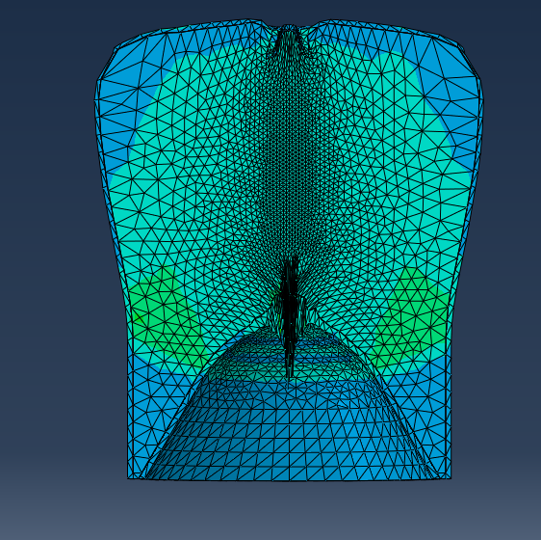
Figure 22 Magnesium jet forming as the shockwave impacts the liner

The high explosives and steel elements have been removed visual to show the full formation of the magnesium jet. Figure 23 and 24 shows the jet starting to fully form, the magnesium liner being pushed away from the TNT blast.
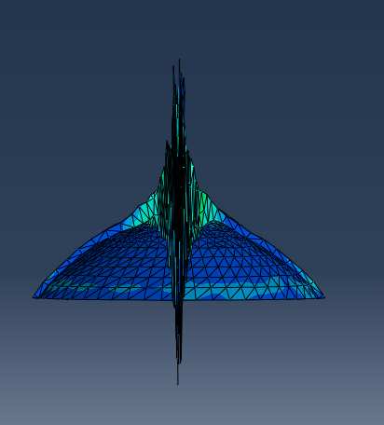
Figure 23 Magnesium jet becoming fully formed

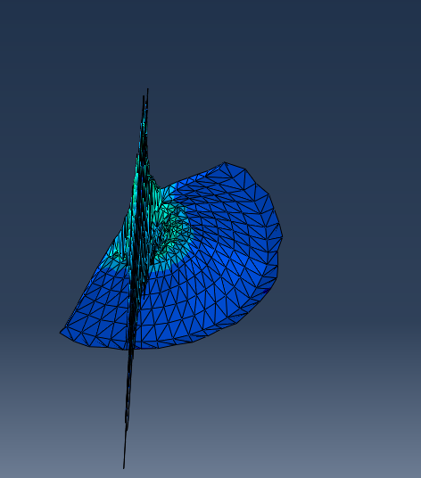
Figure 24 Alternat view of the magnesium jet becoming fully formed
Figure 25 shows the final frame of simulation for the 3d jet. The magnesium jet is forming almost ideally. There are a few irregularities with the symmetry of the jet formation, however there are two main causes that could explain this.
The first is due to the sysemtry of the 3d mesh not being compleay perfect. As the simulation is only half of a cilinder the program is not able to make every single element compleay identical due to the required cutout. This coud casue the small vareations to the stem of the jet as seen in Figure 25.
Another reason could be the element delition feaure that was enabled suing the simulation. This was the same one that was jused for the 2d simulations, used to deleate any expessivly streched elements in order to not crash the progam. As this only deleats elemets that are casuing issues for the program, it may have deleated them non systemtricly, this leaving the shape of the jet non sysmetrical. Despite this minor visual feature however, the magnesium jet formed exactly as it was expected to.
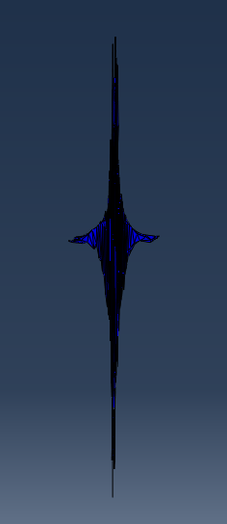
Figure 25 Final frame of the 3d simulation

3d Magnesium Jet Velocity Time results
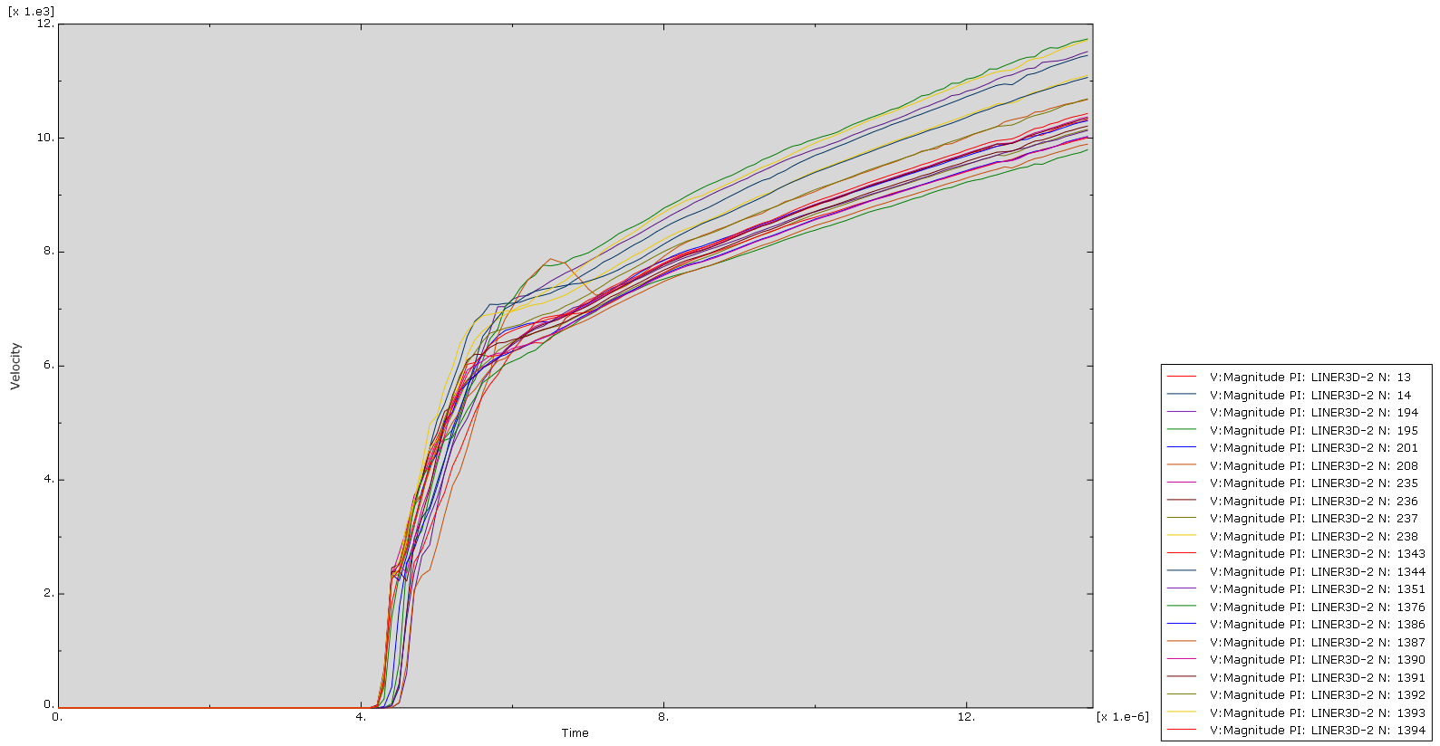
A Velocity time plot was taken to compare to the results of the 2d magnesium simulation. This is presented in Figure 26. While the maximum average velocity was the same for both simulations, the key feature of the 3d graph is that it has two different gradients, representing a sharp change of velocity in the magnesium 6 microseconds after simulation start.
Figure 26 Velocity time graph for the 3d simulation
This may be due to this is the same point at which the high explosive finishes detonating within the simulation. However, if this is what the sole case is, this behaviour would have also been expected to be seen in the 2d simulation as well.

Maximum principal stress within the jet
The maximum principal stress where also recorded in the formed jet as can be seen in Figure 27. Predictably the areas of highest normal stress are the tip of the jet, as well as the parts of the liner that are undergoing shock and just starting to deform. The maximum stress at these regions is almost reaching 400GPa. It is these stresses that case the metal to act hydrodynamically.
It can also be seen that the tail of the jet is not experiencing the same stresses as the tip. This gradual decrease in dress as the material moves way from the tip is caused by the particles within the jet moving at different speeds. This eventually causes the jet to break up, decreeing penetrative effectiveness.

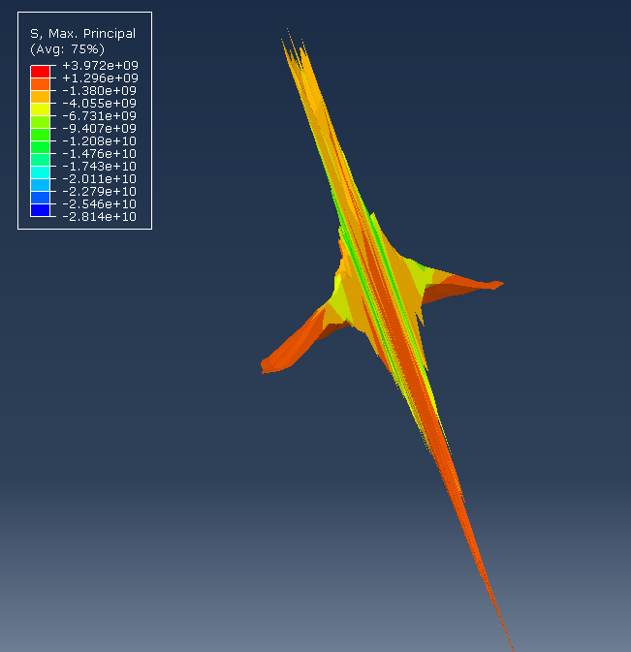
Figure 27 Maximum principal stress of the formed jet

Conclusions
The initial copper 2d simulation proved the validity of Abaqus to simulate a shaped charge. A design of a well document type of warhead, the RPG-7, was able to be recreated and expected results were able to be obtained. It was not an identical match to real life testing data; however, it was within a close range considering the limitations of the software to simulate all the properties of a high explosive with a negative oxygen balance.

From this data, a magnesium liner was then able to be simulated to compare its effectiveness as a shaped charge liner. The less dense material was able to be accelerated to much greater velocity of appreciably 11km/s compared to the coppers 6km/s. However, while magnesium jets are faster, their lower inertia suggest that this does not necessarily translate to superior penetration performance. Additional simulation work with the two jets impacting targets would need to be done in order to which is superior in penetrative performance.

The 3d simulation was able to show the maximum principal stresses within the formed jet. The extremely high stresses seen explains why the jets behave hydrodynamically. The decreasing stresses can also be seen between the jet tip and tail. This indicates the particles with the jet moving at different speeds, and therefore indicates why the jet eventually begins to break up after a short distance.

References

[1] | Balistics Research Labatroy , “The shaped chagr concept, Part 1, Introduction,” U.S Army Labatroy Command, Maryland, 1990.
[2] | “The Discovery and Benefits of The ‘Munroe Effect’,” November 2018.
[3] | global security, “Shaped Charge - History,” 6 12 2017. [Online]. Available: https://www.globalsecurity.org/military/systems/munitions/bullets2-shaped-charge-history.htm. [Accessed 14 Decemner 2025].
[4] | W. Walters, “A Brief History of Shaped Charges,” 12 2008. [Online]. Available: https://www.researchgate.net/publication/235195918_A_Brief_History_of_Shaped_Charges. [Accessed 2 January 2026].
[5] | C. Ankerstjerne, “Panzerfaust,” 21 02 2021. [Online]. Available: https://panzerworld.com/panzerfaust. [Accessed 4 January 2026].
[6] | National Air and Space Museum, “Rocket, Anti-Tank, 88mm Raketenpanzerbuechse 54 (Panzerschreck),” [Online]. Available: https://airandspace.si.edu/collection-objects/rocket-anti-tank-88mm-raketenpanzerbuechse-54-panzerschreck/nasm_A19890575000. [Accessed 6 January 2026].
[7] | A. Q. M. M. Ahmed, “A Review of Works on Shaped Charges,” enginering, Technology and Applied Schience Research , vol. 7, no. 5, pp. 2098-2103, October 2017.
[8] | L3 Harris, “TOW 2A / 2B,” [Online]. Available: https://www.l3harris.com/all-capabilities/tow-2a-2b. [Accessed 11 December 2025].
[9] | Drilling Manual, “Shaped Charges For Oil Well Perforating,” 20 12 2023. [Online]. Available: https://www.drillingmanual.com/shaped-charges-oil-well-perforating/. [Accessed 13 December 2025].
[10] | EBad, “Linear Shaped Charge (LSC),” [Online]. Available: https://ebad.com/products/linear-shaped-charge-lsc/. [Accessed 27 Decemner 2025].
[11] | T. M. .. Mohammad H. Keshavarz, The property of energetic mayerials, Deutsche Nationalbibliothek.
[12] | “120mm Tank Gun HE Ammunition,” [Online]. Available: https://nointervention.com/archive/military/weapons/120he-mp.htm. [Accessed 12 December 2025].
[13] | Z. H.-R. Wang Tie-Fu, “Copper-Tungsten Shaped Charge Liner and its Jet,” Propellants, Explosives, Pyrotechnics, vol. 21, no. 4, pp. 193-195, 1996.
[14] | C. D. Y. H. Z. W. J. C. Jianping Yin, “Numerical Simulation of Tandem Shaped Charge Penetrating Armored Target under Explosive Loading,” Shock and Vibration, vol. 2021, no. 1, 2021.
[15] | A. K. A. M. D. G. Jagriti Mandal, “Numerical Modeling of Shallow Buried Tunnel Subject to Surface Blast Loading,” Journal of Performance of Constructed Facilities, vol. 34, no. 6, September 2020.
[16] | D. W. J. Mohanraj Murugesan, “Johnson Cook Material and Failure Model Parameters Estimation of AISI-1045 Medium Carbon Steel for Metal Forming Applications,” [Online]. Available: https://pmc.ncbi.nlm.nih.gov/articles/PMC6416717/. [Accessed 28 December 2025].
[17] | S. Way, “Shaped Charge,” [Online]. Available: https://army-guide.com/eng/article/article_839.html. [Accessed 7 January 2026].

