School
Prospectus
Trinity Primary School

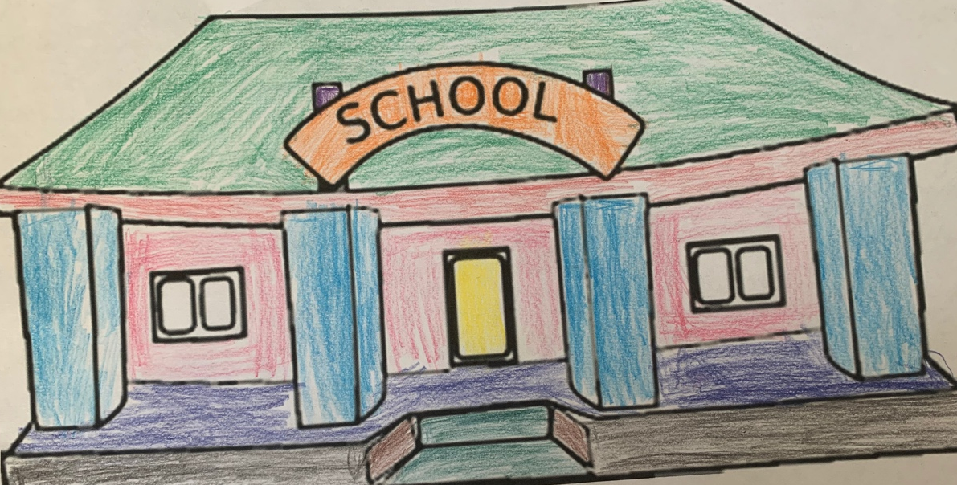

Content
Introduction………………………………………………………………………………………………………..3
Letter of welcome……………………………………………………………………………………………………….4

Contact details………………………………………………………………………………………………………..5

School background………………………………………………………………………………………………………6

Mission statement………………………………………………………………………………………………7

Ethos, Aims & Visions………………………………………………………………………………………………7 & 8

School times………………………………………………………………………………………………8 & 9

Break times……………………………………………………………………………………………………….. 9

Breakfast, Snacks, Lunch & Dinner……………………………………………………………………………… 9 & 10

Ratio………………………………………………………………………………………………………..10

Admissions……………………………………………………………………………………………………….. 10

Attendance & Absences……………………………………………………………………………………………10 & 11

Lateness……………………………………………………………………………………………………….. 11

School Structure…………………………………………………………………………………………………….. 12

Curriculum ……………………………………………………………………………………………… 13, 14 & 15

Assessments……………………………………………………………………………………………………….. 15

Pedagogy……………………………………………………………………………………………………….. 16

Why our school……………………………………………………………………………………………………….. 16 & 17
Conclusion……………………………………………………………………………………………………….. 17
Reference ……………………………………………………………………………………………………….. 18 & 19

Introduction
Throughout this prospectus you will learn about Trinity Primary School, be able to read a letter from the headteacher, how to get in contact with the school when needed, the age group we as a school cater for, see and have an understanding of the curriculum and how we will carry out assessments for the child. It will give you an idea of what the school is like and what the children will do during their hours at Trinity Primary.

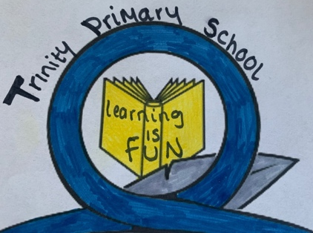

Welcome to Trinity Primary School
Dear Parents/Guardians,

I would like to say a very warm welcome on behalf of myself, the staff, the pupils and the governors to all the new pupils and their parents/guardians to Trinity Primary School.
This prospectus is designed to provide information about the school, our aims, visions, our ethos, school and break times, the curriculum in place for your child(ren), and how they are assessed. If you need any more information , than please do not hesitate to ring up the school and ask.

Trinity Primary School is a happy, welcoming and friendly school. We promote a caring and positive environment, with wonderful staff who are very committed into providing a high and rich quality of learning where all the children are able to reach their fullest potential.
All members of staff work very hard to make sure that the school is safe, secure and a happy environment and to provide an active, creative curriculum where children are at the centre of their learning, where they are able to flourish, are encouraged to do their best, and skills thar are needed to prepare your child for their future education.
We believe that children will do better in school when their parents/guardians and us work together. So we encourage that parents/guardians are being active within their child’s learning by effective communication, regular talks or letters sent out about their child’s learning and development, reading books and homework. We also hope throughout the time your child spends at Trinity Primary you will support the school and involved with your child’s education. Staff are always available to talk about your child’s learning and development.
Children’s needs and development are at the centre of our planning, we also see what the child can do themselves and what they may need help in. We encourage the children to enjoy learning, enjoy their work, have a sense of reasonability and showing consideration to themselves and others.
If you need any additional information or have questions, please get in touch.
We look forward to see you!
Headteacher: H.Caswel

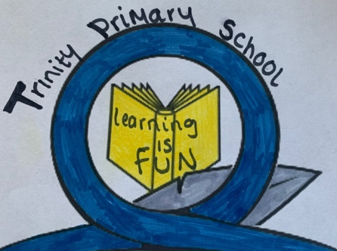

Contact details
Name  of school | Trinity Primary School
Address | Trinity Street, Swansea SA8 0UW
Telephone Number | 00125123508
Fax  Number | 00125124508
E-mail | trinityschoolswansea@school.uk
Headteacher | Ms Kay Caswel
Deputy  Headteacher | Mr Alex Gibson
Age range of  pupils | 3 to 11 years old
Number on roll | 300
Language | English medium

School background
Trinity Primary school opened in 1999, and is right at the centre of Swansea. Few minutes’ walk away from the beach and parks.
The school is a two storey building and caters for children between the ages of 3 to 11 year olds, which includes a morning and afternoon nursery and we currently have 300 children on the roll. Trinity school is a very diverse school with children from all over the world with different backgrounds, culture and beliefs, and approximately 46% of our children have English as their second language. We love the diversity our school has and celebrate it, and it is obvious as soon as you come into the school, and how happy, vibrant, caring and safe environment it is for the children, staff, and parents/carers.

The lower floor is for nursery, reception, year one and year two classes. There is a large hall for the children to do their P.E and have their school lunch or dinner. Also, there is a small library corner for the children, it has a nice homely feel filled with loads of books and children can go and get a book to read on their own, with a teacher or can take it home. We also have a room downstairs called the ‘reflection room’ this is a place where the child can go and receive help to understand their feelings and this room can also be used as a one to one support for work.
All the classes in the lower floor are very big and spacious, the classrooms have recently installed new whiteboards that are touch screen and this will help develop the children’s ICT skills
The juniors is on the upper floor for classes year three to six. The classrooms are very big and spacious, and they have also had new whiteboards installed. They have a large hall with a stage, which is used for performances and assemblies and the juniors also have a library filled with books to help with their work or they can take them home and read. Right next to the library there is an IT room with 18 computers where the children can do their work, research, print things out and have IT lessons all supervised by the teacher, and the school also has provided ipad’s for every classroom for children and the teachers to use.
The school has two big yards for the children to play in one for the infants and one for the juniors. We also have a garden which is right next to the main doors of the school, it has a mural wall full of flowers and minibeasts, bird feeders and benches. The garden can be used as an outdoor classroom and sometimes even gardening for children to do.

Providing an environment where children are safe, secure and happy where they can learn, play and to develop in each child confidence, self-esteem and positive attitude to learning.
Our Mission Statement
Our Ethos

At Trinity Primary School, we believe that everyone learns new things every day. We believe that learning should be fun, enjoyable and rewarding. Our priority is to develop a love of learning where the environment is rich, stimulating, relaxed, happy, safe and where the children feel valued.
Putting the child at the centre of their learning, celebrating the diversity within our school and local community, and celebrating all the achievements no matter how small or big is at the heart of our school. Every child should be able to participate in all school activities in a safe and secure environment and protected from harm, and this the responsibility of every staff member who are employed. We believe children have a right to voice their opinions and staff members will work with the children to deal with any of their concerns, we also believe that it is important that children are aware of their rights and how they have the United Nations Convention on the Rights of the Child which has 42 rights for children and young people, and these rights give them what they need to grow up healthy, safely and happily.
Our Aims

Here at Trinity Primary School we aim to:

- Respect the UNRCR rights of the children.
- Be an open and welcoming school to children and their parents/guardians.
- An environment that is stimulating and creates a positive attitude towards learning.
- Keep the child’s parents or guardians informed about their child’s development and progression.
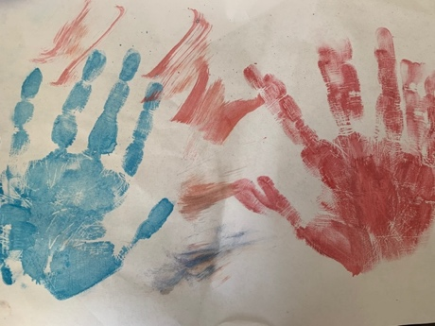
- Work in partnership with home, school, and any other professional agencies.
- Providing an environment where children feel safe, secure and happy.
- Encourage and develop a positive self-image, self-esteem and confidence in each child.
- Equal opportunities for all children to experience learning.
- Celebrate the diversity of cultures and beliefs.
- Celebrate each and every child’s success, talents and achievements.
- To respect and be aware of moral, social and religious values.

Our Vision
Respect everyone
Learn new skills and knowledge

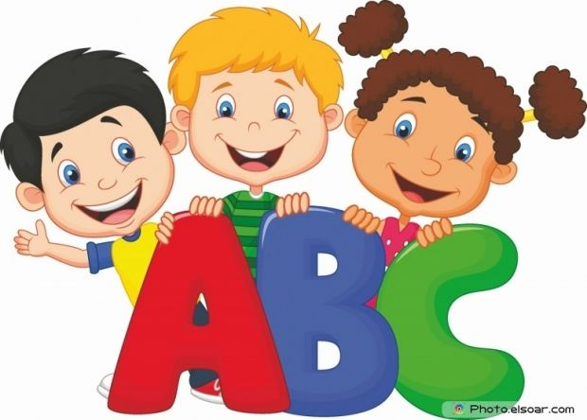
Achieve our full potential

Active in their learning

Safe and sensible
To be the best we can be
We include everyone

Trinity Primary School Times
Nursery morning session: 8:50am till 11:30am
Nursery morning break time: 10:50am till 11:15am

Nursery afternoon session: 12:45pm till 3:20pm
Nursery afternoon break time: 1:50pm till 2:15pm

Reception to year 2: 8:50am till 11:50am
11:50 am till 1pm is lunch/break
1pm till 3:20pm

Year 3 to year 6: 8:50am till 12:15pm
12:00pm till 1pm is lunch/break
1pm till 3:20pm

We ask that parents and children arrive ten minutes before the bell rings. A member of the teaching staff will be on duty at the start and end of the school day. In addition to this, on wet days the children will be allowed to come inside the school before the bell is rung. Nursery, reception, year one and two will wait in the hall downstairs, whilst the rest of the year groups (3 to 6) will wait in the upstairs hall and the children will be supervised so it is not needed for the parents to wait with them.

Break times
Morning: 10:20am till 10:55am
Afternoon: 2:10pm till 2:20pm
Nursery will have their own playground area away from the other years and will have their own times, as sometimes breaktime may change for them e.g. longer outdoor time. Reception, year one and two will share a playground and year three to year six will also have their own playground.

Breakfast
We do have a breakfast club, which is free and available for the children. If parents or guardians need to go to work early, they can drop their child off at 8am each day or whenever needed, and it allows the child to be cared for and given breakfast. The breakfast club starts at 8am and will last till 8:30am.
Snacks
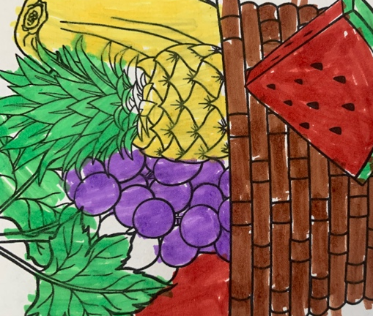
Parents/guardians of nursery and reception are more than welcome to send in a healthy snack for their child, but we do provide them with snacks such as fruits, vegetables with milk or water. If your child is allergic to milk or drinks something else, please let us know so that we can provide other options, or parents/guardians are welcomed to bring something else in and we can keep it in our fridge. Year one and two also do have milk (optional), and again if they are allergic please let us know so we can offer something else or they can bring something else into drink (no fizzy or sugary drinks). Year one to year six children can also bring in their own healthy snack or fruit is available for them from our fruit shop, which costs £1 a week. If snacks are provided by parents/guardians we kindly ask not to give any sweets, chocolates crisps etc.
Lunch & Dinner
If your child does have school dinners, we do have an online payment system. You can contact the main office for a letter to register and if you believe your child is intitled to get free school meals, than please get a form from the school office.
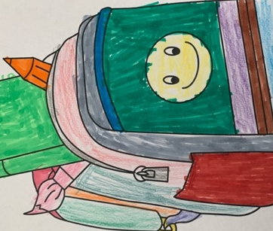
If your child does not have school dinners, they can bring in their own packed lunch from the house. Please ensure that the packed lunch is in a secure container and labelled with your child’s name on it, so that it does not get lost.
We would appreciate if children do not bring in cans or glass bottles for health and safety purposes, and instead bring in a water bottle or flask. Also, if your child forgets their packed lunch we can provide them with a school dinner and you will be able to pay as back later. School dinners are cooked every day and with a very high standard which is maintained. There will be a choice and vegetarian options are also provided for children. The cost of school dinners is available from the front office.

Ratio
3-4 years old- one adult to four children.
4-8 years old- one adult to six children.
8-11 years old- one adult to eight children.
This will also depend on the needs and abilities of the children, what activity it is and we may need more adults. Even though this is the ratio of adult and children, we will always have at least two adults present. During trips we may also sometimes ask if parents/guardians would want to come along with their child.

Admissions
We are always happy to welcome a visit from the parents/guardians who are or may be considering a place here for their child(ren). When you do come in for a look around the school, you can also have the opportunity to come into a class and have an observation. You can contact the main office to schedule a tour around the school and have a classroom observation, your child is welcome to come along and see what their day would look like in our school.
During the meeting/ tour you do have the opportunity to ask questions and we may also ask questions just to find out more about you and your child(ren) e.g. any allergies.
Once, you have had the tour and meeting and the school is for your child, and you would like to apply for a place, all applications will be processed by admission team in the Local Authority. Once, the application has been completed, you can send it directly to the email address that has been provided in the form or if it is easier you can return it to the school office and we will happily forward it for you. Your child will be able to come and join us for a transition visit, this is just to help them make the change from home. This will be a chance for the child to join, get to know the other children in their classroom, and getting use to their daily school routine.
Attendance & Absences
We do take attendance here quite seriously, and we do ask that the parents/guardians to ensure that their child does attend school when possible. Attendance in school is vital for a child’s learning, so please try to ensure that effort is made to get your child in school as every absence does mean that your child will miss learning and it can leave gaps within their learning. We value each individual attendance and children do get rewarded on a weekly and termly basis.
When a child is absent parents should call up and inform the school, we would prefer at the start of the school day. To notify of an absence it can be done by calling in or in person at the reception, and if we are not notified a member of staff at the office will give a call.

The school will authorise absences if:
- The child is too ill to come into school.
- If the child has a doctors, any medical or dental appointment.
- Special circumstances e.g. bereavement.
- Permission from the school e.g. a holiday or religious observation.
We would prefer that holidays are taken during the school holiday times, but we do understand sometimes there are certain circumstances that cannot be avoided. If needed than please request a holiday form that is available at the reception, which will than need to be completed, and ensure to check that the school has authorised it. In addition to this, please let us know when your child has any medical or dentist appointments. You may need to present medical evidence e.g. an appointment card. We will not allow any children to leave during school hours without an adult picking them up and please ensure that you report to the main office when you are collecting your child for an appointment.

We do have to inform the Local Authority regularly if any children who are quite absent from school, or they have an irregular attendance or have missed more than 10 days of school without permission from the school. As schools we do have a safeguarding duty, which is under 175 section of Education Act 2002, which would allow us to investigate unexplained absences.
There is an Education (Penalty Notices) Regulation that came out in 2013. A penalty notice is a fine, which is for the parents who do not ensure that their child attends school regularly and it can be £60 if paid within the 28 days of the notice, however, if it has not been paid it can go up £120, it is important that you make sure that your child does attend school and arrives on time.
Lateness
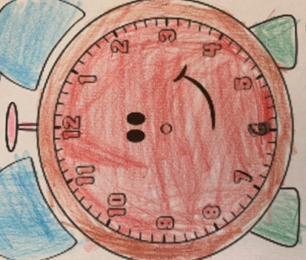
School does start at 8:50am and class registers will be done by 9:15am to 9:20am. It is important to make sure that the children do come to school on time. Children that do arrive late to school must report to the main office to sign in, we do keep a record of any latecomers and if it keeps on being repeated we will either get in contact with the child’s parent/guardian or send out a letter. We also do lock the gates during the day to ensure the safety and security of the children and staff.

Morning & afternoon nursery | Nursery morning: 8:50am till 11:30am  School Structure  Nursery afternoon: 12:45pm till 3:20pm | The doors will open at 8:50am for morning nursery and 12:45pm for afternoon nursery and the children will be greeted by their teacher or a teaching assistant. Once, the children have come in they will have their names on the table for them to pick and put on the mood board and once that is done teachers will get the children to settle in and do the register. After, the register the teacher will go around asking the children how they are and how they are feeling, and on Mondays we usually do circle time just to catch up with everyone and how their weekend has been. The nursery children will have a lot of outdoor play, as we believe that is the best way they learn and providing them with different materials. Some of the activities the children will do are P.E., mark making, interactive whiteboards. We have a role play area which usually changes e.g. a café, shop, a house, we have a dressing up area, sand and water area. At the end of the day the teacher will usually read a book to the children before it’s time to go home.
Reception to year six | Reception to year six start at 8:50am – 3:20pm | The children will line up on the playground and doors will open at 8:50am. Once, the children are in the registration will be taken and can have a bit of social interaction within their tables. Reception to year two will also have circle time on Mondays.  There is usually an assembly that takes place in the upstairs hall.  They will have English and math lessons, IT lessons, P.E. learn about space and the planets, geography, science and do simple experiments in the classroom or in the playground.  Sometimes the teachers may plan day outs that are related to the subjects the children are learning.
Break & Snack times | Nursery morning break: 10:50am till 11:15am.  Nursery afternoon break: 1:50pm till 2:15pm  Reception to year six morning break : 10:20am till 10:55am  Afternoon break : 2:10pm till 2:20pm | We give our children three breaks throughout their day. This allows the children to get fresh air and socialise with their friends. Let go off any built up stress and for them to get ready for their next lessons and concentrate. Sometimes the nursery children may stay outside all day (depending on weather also) and do their activities outside. Before going outside for their breaks the nursery and reception children will usually have their snacks and milk/water inside. Year one to six are allowed to have their snack outside. They can have their snack during first or second break, it is up to them. Parents can provide their child with snacks, but it must be a healthy snack. The children can take their water bottles outside if wanted, but we do ask them to be labelled and no cans and glass bottles.
Lunch & Dinner time | Reception to year two will start their lunch at 11:50am till 1pm.  Year three to six will start lunch at 12pm till 1pm. | All the children will get an hour lunch and dinner break. This allows the children to fuel up for the rest of their school day, and once they have finished their lunch the children are allowed to go outside and play with their friends for the rest of their lunch break.

Curriculum
The curriculum at Trinity Primary is the Montessori curriculum that we follow. It was developed by Dr Maria Montessori and as (Meinke, H 2019) states it’s a specific child-centred method of education that involves child-led activities (referred to as ‘work’).
The curriculum gives the children a wide range of activities which than allows the child to be able to explore and experience, and Dr Montessori believed that children learn better when they’re choosing what to learn (Meinke, H, 2019).
The classroom will be prepared by the teachers to meet all the children’s needs and their development. The classroom will be filled with materials and activities that are spontaneous and stimulating for your child. Everything will be chosen with a goal for the child and will be child sized, so that it is easy for the children to have access to it. The children are able to play on their own, groups, in pairs, outdoors and indoors, they are able to move around freely throughout the classroom and choose what sparks their interest.
Children have an enormous capacity to learn if given an appropriate and prepared environment, which would enable them to unlock their potential and develop their self-confidence and self-esteem. (The Children’s Room, n.d.).
The Montessori curriculum will have five areas of learning, which are:
- Sensorial-
This is where a child will learn through their senses and to understand the surroundings. The five senses are used; taste, sight, smell, touch and hearing around their environment. The children using their senses, it is allowing them to understand the different materials and they will provide them to explore the different shapes, colours, sounds and textures.
- Practical life -
Includes life skills that will help your child develop their independence, self-control, awareness and confidence. Can include; taking care of their environment e.g. watering plants.
- Maths-
Linked with sensorial as the materials given do start to be introduced into maths to the children.
- Language
Children are natural learners and pick up on anything. Within the classroom and outdoors children will have freedom of speech and movement, this can help them with their language skills. Allows them to tell us how they’re feeling, thoughts, what they have learnt and so on. Learn language by singing, reading, listening to stories and talking to their friends and teachers.
- Culture
We will bring it into the classroom, this may be done through puzzle, maps, globes and picture cards. It’s important for us that children understand and know about different cultures and countries. Furthermore, if there is a religious celebration e.g. Eid we may get a parent to come in and talk about what they do for Eid, what they may wear and so on.
Everything is hands on all the time and the teacher will only interrupt when it is needed or help guide their learning, and then taking a step back so that the child can play and learn. There will always be a teacher or a teaching assistant nearby observing and if help is needed, but not to interfere. Understandably, some children may be more reserved and shy than other children, and some may need more direction and if that is the case than we can intervene and help the child get started with their activity.
We do focus more on a child centred approach and this is where children take learning into their own hands, as opposed to being directed or promoted by a teacher. Children take responsibility for making choices about what they will learn and explore. (The Compass School, 2015). The child centre approach is important, because it can show us;
- The child’s perspective
- Allows them to explore
- Question their ideas
- Learn through experiences and by doing
- The child to make decisions and solve problems
Children being able to go outdoors is very important to us, as it is allowing the children to engage in the natural world that is surrounding them. We are lucky enough to have our own garden as well as a playground and a park just a few minutes away.
Most days when the weather is good, we will usually be outside in the playground, some will be in the garden or the outdoor learning area, and taking turns. Sometimes we do go outside whilst it is raining, so it is always good for your child to have their wellies in school and a raincoat.
We also notice that once the children are outside they are much happier, calmer, their creative and imaginative side come out, make more friends which can also help their social/language skills. It allows them to take risks and help them discover what is safe for them, and its testing their limits. By learning through this safe and healthy risk-taking leads to ‘I can do it’ mindset, which supports success, and contributes to children’s long-term emotional well-being and resilience” (Sandwich Montessori).
Juniors (year 3 to year 6)
The work that is used in key stage 1, will be advanced as they go through school. Numeracy and literacy are important skills for the children, and as the children have been introduced to language, literacy and numeracy, they will continue to practice their reading, start to do more analysing of sentences, and more creative writing. So in key stage 2 we will group children according to their ability, learning style, their spelling etc, and this will be the same for numeracy.
English
Developing more skills in speaking, listening, reading and their writing with teachers providing them with a range of stimulating activities and that go in line with the literacy framework.
Maths
Taught shape, space and measuring, and numbers etc. Activities will go in line with the numerary framework but also making it fun and stimulating for the children
Science
We encourage children to ask questions, observe their surroundings, and experiment to find things out and then make their own conclusions.
Welsh
Children are taught welsh by reading, writing and oracy. There will be posters in classrooms and around the school in welsh to promote it and for the children to see it and use it.
Physical education (PE)
The children will have gym apparatus, dancing, games and a lot of outdoor activities. Each year in the key stage 2 will have swimming lessons.
Religious education (RE)
RE will be taught with the agreed syllabus from the Local Authority. They will learn about the major religions such as; Buddhism, Christianity, Islam, Judaism, Hinduism, Sikhism.
History
Children will be taught about Tudors, Victorians, Egyptians and learn about the local history.
Geography
Made aware about the environment, studying different locals, places and environments. They will be using maps to focus on different countries and they can compare two countries together.
ICT
It can help the children to learn the basic skills of IT that will be used in their future and allow them to gain confidence in using these technology.
Art
They can experiment with different materials and techniques, and classes can visit art galleries and explore the different arts.
Assessments
Teachers are always assessing and this will happen right from the moment children start. Way we assess is by doing observations and we will record the observations by digital platform (iPad) or written notes. Doing observations, allows us to see how the children are doing and if any extra support is needed. Also, shows us how they are developing, likes and dislikes, and how the child is as an individual. Furthermore, we can see if a child is struggling and ensure there get the right support from school and home. Also by doing observations every educator observes children to get to know them better and get a sense of their knowledge, needs, interest, skills and how they learn best. This information helps us know how to approach learning opportunities and what we as educators need to do to shift or add to our planning to further support each child’s learning and development (Kids Churchill Park Blog).
We use baseline testing where teachers are required to carry out statutory baselines assessment of all pupils within six weeks of their entry into reception class (Eurydice, n.d.). This is to help us know what the children’s needs are, collect information about your child’s development when they are entering a new year group of setting. This has become a statutory requirement since September 2015 and must be carried out within the first six weeks of the child entering reception.
Key stage two assessments are where year 6 will be assessed by their teachers. The subjects will be; Maths, English, Science and Welsh. For more information you can have a look at; ‘Statutory assessment arrangements for the Foundation Phase, and end of year Key Stages two and three’. We also have a national reading and numeracy test, this is for ages 6 to 7, and 7 to 11. The tests were introduced in 2013 which is under ‘The education (national curriculum) (assessment arrangements for reading and numeracy) (Wales) order 2013.’
The reading numeracy will also now be online but it will automatically adjust the levels of the question to match the child individually.

Pedagogy
Pedagogy is the method of teaching children. We focus on constructivism, constructivism is where teachers believe that in order to learn, students need as many hands-on experiences with objects, skills and people as possible. Constructivism provides students with rich experiences and encourages them to reach their own conclusions (Gonzalez, 2015).
Constructivism theory is where children will be learning through the experiences and reflections, and it puts the child at the centre of their learning. This is why we adopted a Montessori method and as she believed that education is not something which the teacher does, but a natural process which develops spontaneously in the human being. It is not acquired by listening to words but in virtue of experiences in which the child acts on his environment (Discover Early, n.d.).
At the centre of their learning will always be the child, and the teacher will always be there and only intervene when they are needed. We may take the children onto trips, as this will allow the child to experience and put their thoughts and concepts together.
We also focus on social constructivism pedagogy, this is where it will usually be a blend of child centred and teacher guided. Lev Vygotsky developed the social constructivism, and believed that learning can happen in a social context and that learning was a collaborative process with the child and their teacher. He believed that children will learn through conversation and interactions with others around them and their teachers. Social constructivism will come be implemented into our classroom, we will apple it by, encouraging conversations between all the children, team work and use the Zone of Proximal Development (ZPD), and this is where we can see what the learner can do on their own/without help, what they can do with help, and what they can’t do. For example, if a child is struggling with a math question, we may put them with another child that does understand what to do, because sometimes the child may understand it more when it comes from another child because of the language the child has used or how they have phrased it, if not then the teacher will work with the children to help them with the question. We will also sometimes do activities in groups and discuss about different topics and see what the children know, and let them add onto what the others know so that they are learning off of each other.
Constructivism allows the children to gain their own knowledge, rather than have someone telling them everything. They will learn new information and incorporate it into their existing knowledge, and their learning will be active process and hands on learning. Plus, it gives them ownership of their learning.
When looking at constructivism one of the disadvantages is that, there may be lack of structure, and sometimes some students may need a structured environment so it is important to give children maybe a bit of both structured and unstructured learning environment.

Why our school
Why our school? Well because we put the child at the centre of their learning, work alongside with parents and carers of the child. Many schools do not offer forest schools, whereas we do. Forest schools are for our year one to year six classes where they will go out with the teachers (who are trained). Forest schools are children centred learning, it supports their play, allows them to take risks, exploration, helping them with their self-confidence and self-esteem and they are getting that hands on experience. They develop more of their fine and gross motor skills, taking care of themselves, they will learn failure through trial and error and to keep trying. Being outdoors helps the children to learn about their environment, the weather and season changes. Helps build relationship with other children in the class and helps their communication skills. There will be a high ratio of adults with children, and sometimes we even encourage the parents to come along and see how their child is learning.
We celebrate all their achievements no matter how big or small they are, and celebrating all the different cultures that is in our school, and offering them an environment where they can learn and play safe and reach their fullest potential.

Conclusion
Overall, as a school it is important to focus on the child and put the child at the centre of their learning. Providing them with a rich environment to learn, play and socialise with one another. Have a good relationship with the child’s parents and get them involved, as they can support their child in the house. Important to have both structured and unstructured lessons because not every child may learn in an unstructured environment and it could put a delay in their development. Communicating with parents and carers is important, as it gives the parents/carers to see where the child is at with their development this can be done via school reports, emails, and face to face meetings.

Reference
Churchill Park. (2018) Why observations are important? Available at: https://www.churchillpark.ca/why-observation-is-important/ (Accessed: 22nd October 2020).

Children’s Commissioner of Wales. (n.d.) UNCRC. Available at: https://www.childcomwales.org.uk/uncrc-childrens-rights/uncrc/ (Accessed: 12th April 2021).

Discover Early. (n.d.) A comparison of Piaget, Vygotsky, and Montessori. Available at: https://discoverearlychildhoodedu.org/resources/teaching-styles/comparison-piaget-vygotsky-montessori/#constructivism_explained (Accessed: 10th April 2021).

Eurydice. (2019) Assessment in primary education. Available at: https://eacea.ec.europa.eu/national-policies/eurydice/content/assessment-primary-education-50_en (Accessed: 22nd October 2020).

Education Act. (2002) Relation to welfare of children. Available at: https://www.legislation.gov.uk/ukpga/2002/32/section/175/enacted (Accessed: 19th October 2020).

Gonzalez, J. (2015) Know your terms: constructivism. Available at: https://www.cultofpedagogy.com/constructivism/ (Accessed: 12th April 2021).

Meinke, H. (2019) Exploring the pros and cons of Montessori education. Available at: https://www.rasmussen.edu/degrees/education/blog/pros_cons_montessori_education/ (Accessed: 12th April 2021).
Swansea council. (2017) Education Penalty Notice. Available at: https://www.swansea.gov.uk/educationpenalty (Accessed: 24th October 2020).
Sandwich Montessori. (2019) The Importance of outdoor play at Sandwich Montessori. Available at: https://www.sandwichmontessori.org/sandwich-montessori-blog/outdoorplay (Accessed: 19th October 2020).

The education (2013).(national curriculum) (assessment arrangement for reading and numeracy) (Wales. (2013). Available at: https://www.legislation.gov.uk/wsi/2013/433/contents/made (Accessed: 24th October 2020).

The Children’s Room. (2014) Nursery. Available at: https://www.the-childrens-room.co.uk/nursery/ (Accessed: 20th October 2020).
The Compass School. (2016) A child-centred approach. Available at: https://www.thecompassschool.com/blog/what-is-child-centered-kindergarten/ (Accessed: 20th October 2020).

Welsh Government. (2008) National literacy and numeracy framework. Available at: https://hwb.gov.wales/curriculum-for-wales-2008/national-literacy-and-numeracy-framework-curriculum-for-wales-2008-version/framework/?lang=en (Accessed: 24th October 2020).
Welsh Government. (2019) Statutory assessment arrangements for foundation phase and endof key stages 2 and 3. Available at: https://hwb.gov.wales/api/storage/53889241-676d-4e36-8e69-b9129f8ccf51/statutory-assessment-arrangements-for-the-foundation-phase-and-end-of-key-stages-2-and-3-190909.pdf (Accessed: 24th October 2020).

